Meeting Date | 23 October 2026 | Agenda Item | 2.1
Name of Meeting | Finance and Performance Committee
Report Title | Financial Report – Month 06 2026/27
Report Author | Samantha Moss, Deputy Director of Finance  Gemma Pearson, Finance Business Partner  Crystal Davies, Principal Finance Manager
Report Sponsor | Executive Director of Finance
Presented by | Claire Osmundsen-Little, Interim Director of Finance
Freedom of Information | Open
FoI Closed detail | If closed, choose detail
Impact Assessment Summary Outcome |  | IA Completion date
N/A |  | Click or tap to enter a date.
Purpose of the Report | For Assurance
Report Summary; detailing any action required
The report advises the Performance & Finance Committee of the Health Board on the financial position for Month 06 2026/27 (September 2026) and risks regarding the current forecast revenue year end outturn.

Key Issues
The report invites the Performance & Finance Committee to note the detailed analysis of the financial position for Month 06 2026/27 (September 2026).

The report and the appendices, includes a summary of the key drivers of the position either at a service level or by expenditure type (i.e. Non-Pay/Pay). It also provides information of the current position with regards to Health Board reserves to ensure transparency in the overall Health Board position.

Risk will have been considered on the basis of the information provided within the report and the score updated where necessary.

Whilst the key messages are provided within the main body of the report, further information is provided within the accompanying Annex.

Decision / Action required | No
Recommendations
Members are asked to: -
- CONSIDER the 2026/27 Financial Plan, and the Health Board’s and Welsh Government’s inability to approve it given the original planned deficit of £76.6m, reduced to £71.6m post Welsh Risk Pool adjustment.
- CONSIDER the actions in place with regards to Welsh Government’s expectation that the Health Board delivers the £65m savings to support the delivery of the 2026/27 Financial Plan.
- CONSIDER and comment upon the Health Board’s financial performance for Month 06 2026/27 and the Year to Date (YTD) position.
- CONSIDER the risks to the position at Month 06.
- SUPPORT the position with regards to Health Board reserves.
FINANCIAL REPORT – MONTH 06 2026/27

- INTRODUCTION
The Annual Plan submitted to the Welsh Government on 31 March 2026 for assessment and scrutiny included a financial assessment, as summarised in the table below.
During September NWSSP Informed all Health Boards of a reduction in the 2026/27 Welsh Risk Pool (WRP) forecast versus the original planning assumptions. This will result in a reduction in the risk share attributable to SBUHB of £4.959m. The Health Board is required by the Welsh Government to reduce its planned deficit by the equivalent value. The revised 2026/27 deficit Plan for SBUHB because of the change in the WRP is £71.64m (from £76.6m), but the savings requirement remains at £65m as a minimum.
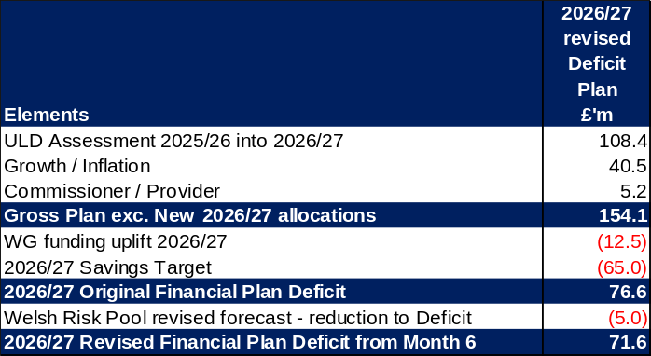

In month 6 there was an improved underlying financial position, reporting an underspend against Plan of £1.3m, as summarised in the table below.
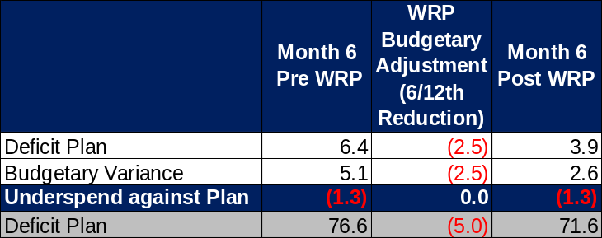

The cumulative deficit was £40.3m prior to the risk pool adjustment or £38.3m post risk pool adjustment and represents a £2.0m overspend against the YTD Plan (see below table), which is an improvement on the position at Month 5.
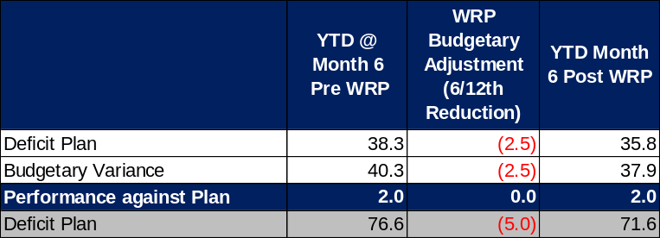

The WRP adjustment of £4.959m was transacted in Month 6 on a YTD basis; as shown in the above tables, this adjustment impacts the reported in-month position but does not affect performance against Plan due to revised Plan value.
Actual savings delivery increased by £2.8m to £7.2m in month, recognising this remains insufficient and further focus to drive further recurrent improvement is necessary. At Month 6 a review of operational underspends commenced and resulted in the identification of £1.5m YTD that has been converted to savings in the month. The estimated full year effect of this is £3m. However, this conversion does not improve the overall financial position.
The Health Board’s actual performance against the revised planned deficit shows that at the end of Month 6 the reported deficit in-month (including WRP adjustment) is £2.6m, which is £1.3m below the planned position. The table below provides the reconciliation of £2.6m Month 6 variance and the split between performance against operational budget and performance against savings target, with the second table reconciling the movements both in-month and YTD
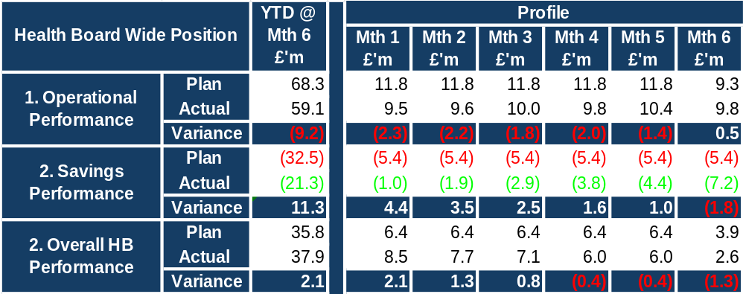
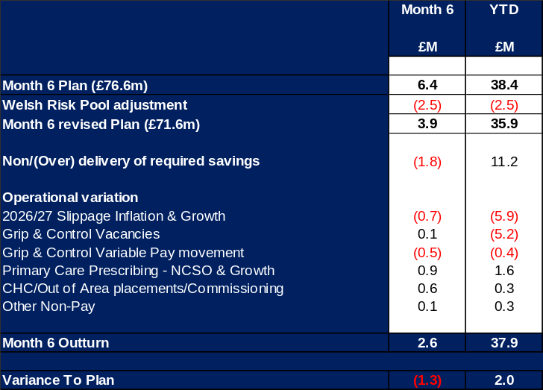
In summary the Health Board is focused on delivering the £71.64m plan. The current £2.04m variance to plan represents delivery within approximately 97% of the revised plan, providing a reasonable level of confidence in the delivery of the plan by the 31 March 2027. However, this level of confidence is conditional on actions to mitigate the risks which continues to be an area of focus, and the conversion to full delivery of the £7m of savings schemes which remain amber.

- BACKGROUND – Financial Performance

KEY PERFORMANCE INDICATORS
TARGET | ACTUAL PERFORMANCE
Cash Balance Bank < £6.0m | £8.881m
In Month Performance Revenue Resource Limit ≤ 1/ 12th £71.6m | £2.596m
YTD Performance Revenue Resource Limit ≤ 6/12th £71.6m x YTD Months | £37.863m
YTD Performance Capital Resource Limit ≤ £0m | (£1.463m)
YTD Performance Public Sector Payment Policy > 95% | 96.65%

FINANCIAL REPORT REVENUE – MONTH 06

At Month 6, excluding the WRP adjustment there was an In-Month overspend of £5.1m, which is £1.3m better than the planned deficit of £6.4m (£76.6m/12). After the WRP adjustment the In-Month overspend was £2.6m, against an in-month plan value of £3.9m, which remained £1.3m better than plan target for the month.

With regards to the overall financial performance, Graph 1 below reflects the actual financial performance in each month (post WRP adjustment), with the orange bars reflecting the performance required to achieve the revised plan of £71.6m. Graph 2 outlines the savings delivered to date as the blue bars against the monthly target set (red line), and the orange bars reflect the level of savings required in future months to achieve the £65m target aligned to the £76.6m plan.
Graph 1: Performance Graph 2: Savings
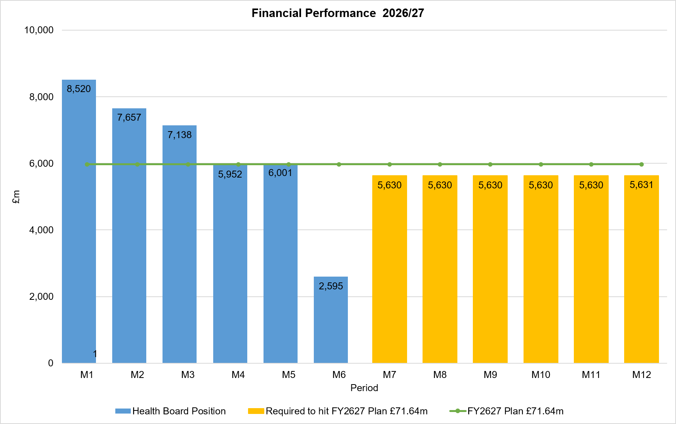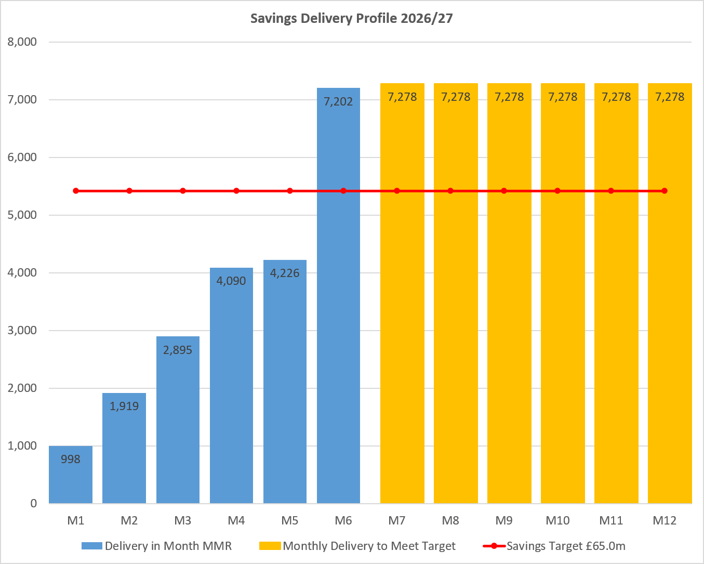

KEY DRIVERS OF THE IN-MONTH POSITION
The key movement from plan based on the Month 6 position is summarised in the table reported in Section 1 above. Further detail at a Health Board level of expenditure on Income, Pay and Non-Pay, is provided within Annex 1.

SAVINGS
Full details on savings are provided in Annex 1, but in summary the in-month delivery in Month 6 was £7.2m against a target of £5.4m and remains the key driver of the Health Board overspend. YTD delivery is £21.3m against a target of £32.5m.
Further Actions
- Additional interventions to close the gap to the original savings plan
  - Exec oversight of variable pay
  - Additional capacity reduction
  - Non pay bans / restrictions

BUDGET SETTING PROCESS
In May budget letters were issued to all 67 identified Senior Leaders along with invites to attend a budget holder training session with additional procurement training. The return of the signed letters and Budget Holder access to the QlikSense finance dashboard is being tracked and reported within Annex 1, Appendix 2-3.

- GOVERNANCE AND RISK ISSUES

Two Board level financial risks:

- Achieving financial plan (HBR92) with the key elements as follows: -

- Risk of delivery of savings quantum
- Risk of operational overspend being in excess of funding available agreed via the Financial Plan
- Risk of commitment of reserves (e.g. NICE) being above reserves available.
- Risk of achieving the actions and options outlined in the 2026/27 Financial Recovery & Sustainability Assessment.

Whilst the in-month position achieved a performance of £1.3m under against plan for Month 6, the Health Board remains cumulatively above plans, and there remains a gap in the overall delivery of savings to achieve the deficit plan of £71.6m for 2026/27. Therefore, it is recommended that the Health Board Corporate Risk Register continues to reflect a risk score of 25.

- Availability of capital (HBR93). This risk was re-opened in 2022/23 given the reduction in discretionary capital allocation. Due to the additional capital funding provided during 2024/25 the risk score was reduced to 12. The score was increased in June 2025 to reflect risks regarding Emergency Department and Adult Acute Mental Health. However, following further assessment at start Quarter 4 2025/26 and based on funding received the risk score reduced to 12. It is recommended the risk score remains at 12.

For Month 6 the key risks to the delivery of the Deficit Plan reported to the Welsh Government in the MMR, linked to HBR92 are detailed below:
- Shortfall in Savings Delivery: The Health Board has identified £48.7m of Green and Amber savings. There remain further operational variance benefits which combined with the current Green/Amber savings alongside the further savings being worked on by the Delivery Unit, continues to provide a greater level of confidence in total delivery of savings and deficit plan. However, as £7.0m of the savings remain Amber there is a risk on delivery.
- CHC growth/inflation £2.5m: Growth pressures above plan level were expected to be mitigated by the identification of mitigating actions in addition to the planned savings delivery. There remains a risk that CHC will continue to see growth in the remaining 6 months of the financial year.
- Energy risk provided by NWSSP £0.8m: not all the energy requirements for 2026/27 have been purchased in advance. The assessment provided by NWSSP on 07/09/26 highlighted a risk of £0.798m, which has not changed in the Month 6 MMR submission. This will be updated once the HB receives next set data from NWSSP, however the Health Board is not yet seeing these pressures materialise within the position to the forecast provided.
- Impact Resident doctor contract changes £2.0m: The contractual changes will be phased from August 2026 to August 2028. Initial assessment by the Health Board suggested there is a risk of between £2m – £2.5m. Further work is being undertaken to assess the impact of this during October.
- Primary Care prescribing £1.4m: An element of the pressure has been reflected in the position (for Growth and NCSO) but based on the Month 5 assumptions and assuming the current pressures remain for next 6 months of 2026/27, which has seen an increase from previous financial year, a risk of £1.4m has been included in the table. This will continue to be reviewed as further PAR reports are received.
- GPOOH National Pay and Terms of Engagement Framework: There are currently no standardised national terms and conditions governing the engagement of GPs working in Out of Hours services across NHS Wales. This has contributed to variation in rates of pay, competition between organisations, and increasing employment tribunal risk, particularly in relation to worker status and holiday pay claims. In response, a national tripartite process involving NHS Wales Employers, the Welsh Government and the British Medical Association (BMA) have developed draft worker terms of engagement, a proposed national pay scale, worker enhancement rates, a consultancy agreement for contractors, and a revised employment status assessment process. The initial assessment of this by the HB has indicated a potential cost pressure of £0.176m, which is above the Annual Plan assumptions.
- Out of Area Placements (Temporary Adult Mental Health placements: Original £76.6m plan had an assumed level of Out of Area Mental Health Placements, which would taper off to zero during Q3 of 2026/27. During the opening 4 months of 2026/27 the number of patients had reduced to 9, which is below the target of 11 recognised by WG. However, during August there was a stepped increase in the numbers of patients requiring Out of Area Placements, with the majority detained under the Mental Health Act. During August the number reached a peak of 32. The patient numbers at the end of September were 22, down from the 33 seen at highest point in August. There is an expectation of 6 discharges in the opening week of October 2026, leaving 16 patients. The cost pressures above Plan assumptions could be £2.4m if there is an unexpected increase in Quarter 3/4. Again, this is reviewed and updated each month based on the latest data and assessment available

- OPEN AUDIT RECOMMENDATIONS

Status at Month 6 is provided below, where actions have been reported as closed or assessed as complete in previous reports, these will have been excluded from the table.

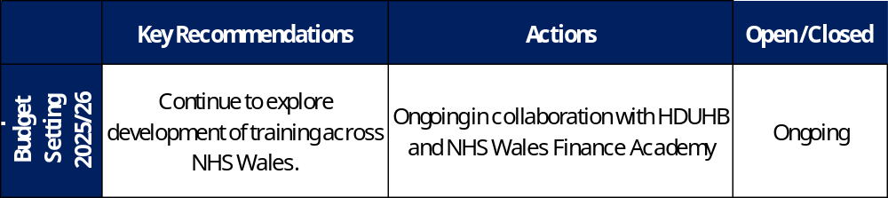

- RECOMMENDATION
Members are asked to:
- CONSIDER the 2026/27 Financial Plan, and the Health Board’s and Welsh Government’s inability to approve it given the original planned deficit of £76.6m, reduced to £71.6m post Welsh Risk Pool adjustment.
- CONSIDER the actions in place with regards to Welsh Government’s expectation that the Health Board delivers the £65m savings to support the delivery of the 2026/27 Financial Plan.
- CONSIDER and comment upon the Health Board’s financial performance for Month 06 2026/27 and the Year to Date (YTD) position.
- CONSIDER the risks to the position at Month 06.
- SUPPORT the position with regards to Health Board reserves.

Governance and Assurance
Strategic Objectives
Strategic Objectives  (please choose which is impacted) | People of Swansea Bay live healthier, fairer and more prosperous lives | ☐
Strategic Objectives  (please choose which is impacted) | Care is high quality, safe, efficient and delivers the best possible outcomes for people in partnerships | ☐
Strategic Objectives  (please choose which is impacted) | Care is delivered in partnership with our communities in safe and appropriate setting, supported by innovation | ☐
Strategic Objectives  (please choose which is impacted) | The health board is a great place to work where staff feel valued and work together towards a common goal | ☐
Strategic Objectives  (please choose which is impacted) | The health board is a resilient, sustainable and responsible organisation | ☒
Health and Care Standards
Standards (please choose which applies) | Safe Care | ☐
Standards (please choose which applies) | Timely Care | ☐
Standards (please choose which applies) | Effective Care | ☐
Standards (please choose which applies) | Efficient Care | ☒
Standards (please choose which applies) | Equitable care | ☐
Standards (please choose which applies) | Person-centred Care | ☐
Standards (please choose which applies) | Staff and Resources | ☐
Enablers (please choose which applies) | Whole Systems Approach | ☒
Enablers (please choose which applies) | Leadership | ☐
Enablers (please choose which applies) | Workforce | ☐
Enablers (please choose which applies) | Culture | ☐
Enablers (please choose which applies) | Information | ☐
Enablers (please choose which applies) | Learning, Improvement and Research | ☐
Quality, Safety and Patient Experience
Financial Governance supports quality, safety, and patient experience.

Financial Implications
The Board is reporting a forecast year-end deficit financial outturn.

Legal Implications (including equality and diversity assessment)
No implications

Staffing Implications
No implications

Long Term Implications (including the impact of the Well-being of Future Generations (Wales) Act 2015)
No implications

Report History
Updates on the financial position are provided at every meeting.

Appendices
Annex 1 – Detail on Financial Position @ Month 6

