Meeting Date | 23 October 2026 | Agenda Item | 3.4
Name of Meeting | Finance and Performance Committee
Report Title | Update report on Clinically Optimised Patients
Report Author | Alison Gallagher, Interim Assistant Director of Operations, UEC.
Report Sponsor | Chief Operating Officer
Presented by | Jon Scott, Chief Operating Officer.
Freedom of Information | Open
FoI Closed detail | If closed, choose detail
Impact Assessment Summary Outcome |  | IA Completion date
N/A |  | N/A
Purpose of the Report | For Discussion
Report Summary; detailing any action required
This report outlines current performance against the Health Board trajectory for clinically optimised patients, the principal risks to delivery, and the impact of delayed discharge on patients, hospital capacity and urgent and emergency care. It also summarises progress with the Discharge to Recover and Assess programme and compares delivery with expected outcomes.
Key Issues
- There has been evidence of delivery against trajectory however there has been a growth in the number of clinically optimised patients during August - October 26.
- The Health Board’s ability to provide timely urgent and emergency care is compromised by the clinically optimised patient cohort occupying acute and non-acute hospital beds thus preventing flow from the Emergency Department and assessment areas.
- The financial burden of accommodating the clinically optimised patient cohort is estimated at circa £18 m based on 25/26 calculations – this includes the bed day utilisation and the use of surge capacity and associated variable pay costs to staff the areas.
- There is patient impact resulting from prolonged hospital stay in terms of deconditioning, loss of independence and longer-term reliance on ongoing care in the community.
- The Health Board are providing an alternative to timely social care provision at the cost of delivering timely access to urgent and emergency care.
Decision / Action required | No
Recommendations
The Finance and Performance Committee is asked to:
- ACCEPT the current increase in clinically optimised patients and the associated impact on patients;
- ACCEPT the effect on urgent and emergency care access, capacity and flow;
- ACCEPT the estimated cost of occupied bed days and surge capacity; and
- ACCEPT delivery of the improvement programme and management of winter risks.

Update report on Clinically Optimised Patients (COP)

- INTRODUCTION

This report provided at the request of the Finance and Performance Committee provides an overview of the Clinically Optimised patient position in respect of:
- Current performance against trajectory and risks to delivery
- the impact of the clinically optimised patient cohort on the Urgent and Emergency Care (UEC) pathway, system capacity and the delivery of urgent and emergency care services.
- An overview of the ongoing work programme in relation to reducing the number of clinically optimised patients occupying hospital beds.

- BACKGROUND

The Health Board continues to face significant challenges in discharging COP promptly, working with Local Authority partners. A significant number of patients who no longer require hospital care remain in acute and non-acute beds. This restricts patient flow and adversely affects the delivery and performance of UEC services

The Welsh Government Hospital Discharge Policy indicates that Health and Social Care partners should adopt a ‘Discharge to Recover & Assess’, (D2RA) model enabling discharge of this patient group within 48 hours of being deemed clinically optimised. The aim of the D2RA pathways is to enable assessment of care needs in an appropriate environment outside of the hospital setting.

The D2RA model describes discharge to assess in four pathways as follows:

Pathway 0: is for those individuals who do not require any further community care support to leave hospital than when they arrived, whether at an emergency department, assessment areas or as an inpatient.

Pathway 1: People can return home with new or additional care packages of support from health and/or social care and be promptly assessed in their own environment to then inform any additional care package of support from health and/or social care. This includes people requiring intensive support or care at home that can be safely implemented.

Pathway 2: People are supported in a short-term facility to enable recovery, rehabilitation, reablement, assessment, care planning or short-term intensive support in a 24-hour bed-based setting, before returning home.

Pathway 3: People who require complex 24-hour support includes people discharged to their usual place of residency, a care home for the first time, existing care home residents returning to their care setting with an increased change in needs.

Current performance against trajectory:

The table below compares actual performance with the local trajectory for pathway-of-care delays and occupied bed days. Patient numbers performed better than trajectory between April and July 2026. Performance deteriorated in September 2026, when the number of clinically optimised patients and associated bed-day use increased. Average length of delay remained at 51 days. Expected and observed bed-day and length-of-delay figures are identical before August 2026 because these measures were introduced in that month.

Ambition | Status | Apr-26 | May-26 | Jun-26 | Jul-26 | Aug-26 | Sep-26 | Oct-26 | Nov-26 | Dec-26 | Jan-27 | Feb-27 | Mar-27
The number of Pathway of care delays should be <100 at any one time by 31 March 2027 | Expected | 210 | 200 | 190 | 180 | 170 | 160 | 150 | 140 | 130 | 120 | 110 | 100
 | Observed | 200 | 192 | 173 | 159 | 172 | 180
The sum of the total number of bed days that patients who are reported as having been delayed at the census date had been waiting up until that point (i.e. from start of delay not im month) | Expected | 9930 | 9879 | 8978 | 8615 | 9520 | 9280 | 9000 | 8680 | 8320 | 7920 | 7480 | 7000
 | Observed | 9930 | 9879 | 8978 | 8615 | 8820 | 9271
Avg length of delay | Expected | 50 | 51 | 52 | 54 | 56 | 58 | 60 | 62 | 64 | 66 | 68 | 70
Avg length of delay | Observed | 50 | 51 | 52 | 54 | 51 | 51

Risks to Delivery:

Although performance improved earlier in the year, winter pressures may reverse this progress. Historically, pathway-of-care delays increase during winter, with growth in both patient numbers and length of stay. Key risks are:
- Workforce shortages and increased absence across health and social care teams;
- Reduced Local Authority provision over Christmas and New Year, followed by a recovery period in January 2027;
- Reduced capacity on Pathways 1 and 3 because of staff absence and care-home closures associated with seasonal illness; and
- Delayed discharge for patients exposed to, or recovering from, infection.

Overview of the current position:

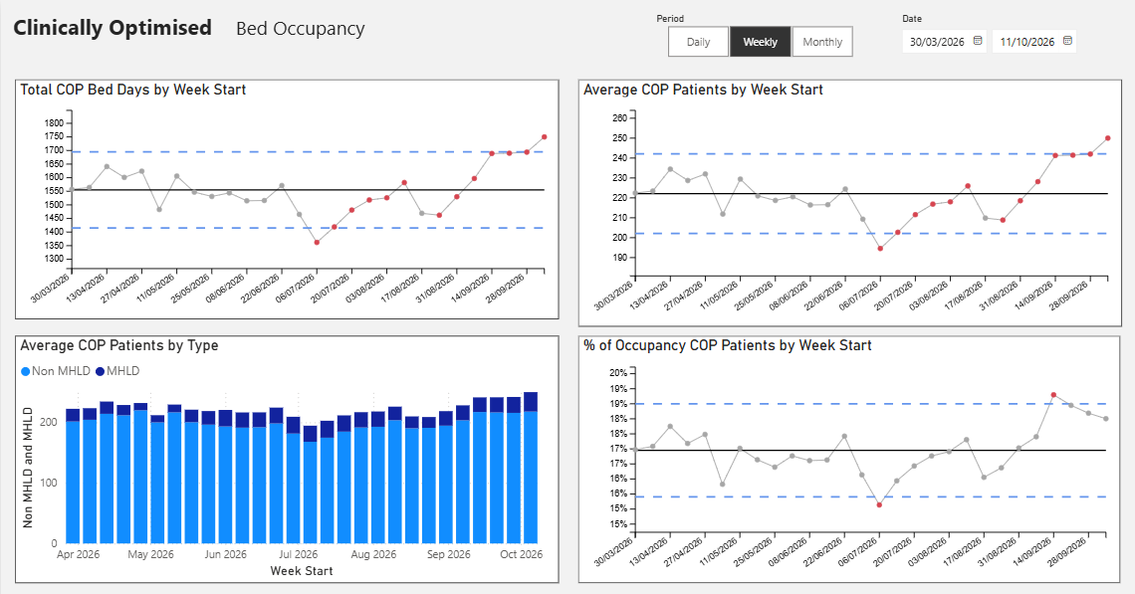

The graphs above set out the clinically optimised position in respect of bed occupancy, patient numbers, Mental Health & Learning Disabilities (MH&LD) versus non-MH&LD and the bed days used by this patient cohort. These areas are explored below:

Average COP patients by date:

Average clinically optimised patient numbers are circa 222 at the mean, with the range between 202 and 250. There has been a significant increase in September with bed day utilisation and the number of COP exceeding the upper control limit suggesting special cause variation. The Local Authority partners have advised that this was due to:
- Annual Leave and sickness in Social Work teams
- Fluctuating capacity in community based social care teams due to staff absence
- Mismatch in care package availability versus the demand
- Increased discharge complexity

Recent conversations with Local Authority partners have indicated that these issues are now largely resolved and that ‘normal’ activity will continue. However, the progress against the trajectory remains impacted. A revised trajectory is being discussed.

Average COP patients by type:

Non-MH&LD patients account for most of the COP occupancy. The MH&LD clinically optimised cohort is small but consistent in volume.

Clinically optimised patient occupancy:

The clinically optimised patient cohort occupy between 15 – 20% of the Health Board bed pool. There has been a growth in occupancy in August and September with circa 19% of the bed pool currently occupied thus impacting system flow and increasing urgent care system pressures.

Housing and adaptation delays:

An increasing number of patients remain in hospital because of homelessness or delays to home adaptations. These cases are referred to local authority housing services rather than hospital social work teams. They often involve complex social, financial and legal issues and can result in prolonged hospital stays. The table below summarises these patients by hospital site, reason for delay and number of delayed days.

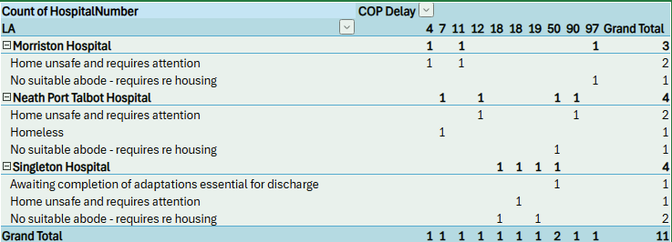

COP by D2RA Pathway: as at 16:00 hrs 13 Oct 26.

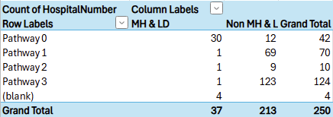

COP by delay reason: as at 16:00 hrs 13 Oct 26.

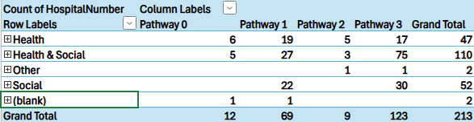

The Health Board continues to focus on Health-related delays to mitigate the overall number of patients. The focus is predominantly on Pathway 0 and Pathway 1 patients where numbers are now lower than in previous reports.

The impact of the COP cohort on system flow.

COP occupy approximately 16%–19% of hospital beds. The resulting reduction in available capacity contributes to:

- Overcrowding in emergency and assessment services;
- Longer stays and poorer patient experience in emergency and assessment areas;
- Care being delivered in corridors, waiting rooms and other non-designated clinical areas;
- Poorer performance against four-hour, 12-hour and ambulance handover standards;
- Use of elective beds to relieve emergency pressures; and
- Delayed transfer from high-cost critical care beds.

Patient impact of pathway delays

The impact of prolonged hospitalisation on elderly patients is well understood.

If you are 80 years old and in hospital for just one week you will experience a 20% loss of muscle power, 1.5 kg loss of muscle mass and 10% decrease in aerobic capacity. If this is combined with inactivity associated with non-value-added hospital stays then there is additional accelerated bone loss, respiratory and swallowing issues, incontinence in 50%, muscle weakness that persists for 3-5 years with a 48% increase in disability. These changes result in postural hypotension, falls, delirium, pneumonia, delayed recovery, poor nutrition and hydration and increased infections and result a 5-fold increase in the need for institutional care on discharge as well as an increased risk of death.

National figures show that 1:6 older people who normally walk independently need help with walking on discharge from hospital, 1:3 is discharged with a significant disability that was not present on admission and only 30% are back to their usual level of function within a year.

Reducing both the number of COP and the lengths of stay of this patient cohort will result in the following patient benefits:

- Avoidance of delay related harm and deconditioning from prolonged and non-value-added hospitalisation.
- More patients will get home or to their next destination earlier in their pathway.
- The patient’s likelihood of maintaining pre-hospital functionality /independence is increased if they can leave hospital when their acute care episode is completed.

Work programme to reduce the clinically optimised patient cohort:

The UEC Programme Board oversees an extensive improvement programme, which reports to the regional Older Persons Board. The programme focuses on redesigning individual pathways, developing enabling policies and establishing the infrastructure required for a revised operating model.

Key achievements:

Key achievements | Intended outputs | April 26 baseline | Current
Redesign of Pathway 1 with standardisation of the processes across the region. | Reduced pathway variation and reduced time from COP to POC available. | Reduced length of stay P1: 15.1 days | September 26: 13.77 days
Development of the Health Board Discharge policy which encompasses optimal hospital flow, patient choice and reluctant discharge. | Reduced length of stay resulting from application of patient choice and reluctant discharge policies | All COP: Average Health Board length of stay (discharge)  Pathways 1, 2 & 3  41.39 days | All COP: Average Health Board length of stay (discharge)  Pathways 1, 2 & 3  39.01 days
Trusted assessment model agreed – partially implemented – dependant on a resourced Integrated Discharge Hub. | Increased trusted assessment pathways | Trusted assessment in use as at April 26:  -Bonymaen House  -Glyn Nedd  -Singleton Ward 3 | Extended trusted assessment:  -NPT Hospital
Process mapping of all pathways with revised processes to reduce pathway delays. | Reduce process steps in pathway and reduce waste. | Pathway 1 complete with agreement to move to a regional Pathway 1 model | Regional Pathway 1 model implemented in June 26
Revised clinically led pathway management for stroke rehabilitation. | ‘Pull’ model of flow from acute stroke to rehabilitation to ensure appropriate patient transfer and to reduce length of stay  Data source – SAFER & Ward Dashboards | Number of transfers to Neath Port Talbot Ward B2  WC 20/04/26, 4  Total in month Admissions/Transfers 22  Neath Port Talbot Ward B2, Average Length of stay (month)  25.20 days | Number of transfers to Neath Port Talbot Ward B2  WC 21/09/26, 4  Total in month Admissions/Transfers 33  Neath Port Talbot Ward B2, Average Length of stay (month)  22.95 days
Development of an optimal hospital flow dashboard with key performance indicators that can be accessed by ward teams. | To improve system flow and to accelerate earlier bed availability by focussing on ‘Home 4 Lunch’  Data source – SAFER Dashboard | Discharge before midday, Morriston, Specialties - General Medicine and Medicine for the Elderly  30.93%  Morriston, Ward L Gower & Anglesey  44.45% | Discharge before midday, Morriston, Specialties - General Medicine and Medicine for the Elderly  32.17%  Morriston, Ward L Gower & Anglesey  47.47%
Launch of a designated Pathway 3 ward in Neath Port Talbot Hospital in September 26 to test a revised model of working for an eligible group of Pathway 3 patients. Social Work, designated Discharge Liaison Nurse resource and the Long-Term Care team are part of the ward operating model which is the first time this multi-disciplinary resource has been aligned to ward base. | Reduced Pathway 3 length of stay through accelerated assessment and reduced delays  Data source – Activity Summary Dashboard & Local data collection | D2RA Pathway 3  SBUHB  Average length of stay (discharge) 66.97 days | D2RA Pathway 3 SBUHB  Average length of stay (discharge)  59.57 days  D2RA Pathway 3 Pilot –  Average length of stay on Neath Port Talbot Ward D (discharge) 13.4 days

Work in progress:

- Development of pathway event timescales with escalation framework for management of pathway delays to further drive down length of stay.
- Development of an internal web page designed to support ward multi-disciplinary teams with navigation to pathway specific referral forms, policies and patient information.

- GOVERNANCE AND RISK ISSUES

The main body of the report discusses the risks to patients who are clinically optimised and the wider system impacts.

There is joint working between the Health Board and Local Authority partners aimed at reducing the number of COP and the length of stay of patients. The focus of the work programme has been based on pathway and process redesign, however, there has been no work in relation to right sizing community capacity. The performance and metrics associated with the COP cohort are monitored through Service Group performance meetings, UEC and Older Persons regional partnership Boards and at executive level through the Health Board Performance escalation meetings with NHS Performance and Improvement, (NHS P&I).

There is a monthly meeting with the Pillar 3 team, part of the NHS P&I department where the data and local actions are discussed and challenged with a particular emphasis on accurate reporting.

- FINANCIAL IMPLICATIONS

The estimated cost of COP remaining in hospital, together with the surge response required when patient flow is compromised, was approximately £18.1 million in 2025/26. Reducing delayed discharge would improve patient flow and safety and could allow inpatient capacity to be reduced, contributing to the Health Board’s financial recovery

- RECOMMENDATIONS

The Finance and Performance Committee is asked to:
- ACCEPT the current increase in clinically optimised patients and the associated impact on patients;
- ACCEPT the effect on UEC access, capacity and flow;
- ACCEPT the estimated cost of occupied bed days and surge capacity; and
- ACCEPT delivery of the improvement programme and management of winter risks.

Governance and Assurance
Strategic Objectives
Strategic Objectives  (please choose which is impacted) | People of Swansea Bay live healthier, fairer and more prosperous lives | ☐
Strategic Objectives  (please choose which is impacted) | Care is high quality, safe, efficient and delivers the best possible outcomes for people in partnerships | ☒
Strategic Objectives  (please choose which is impacted) | Care is delivered in partnership with our communities in safe and appropriate setting, supported by innovation | ☐
Strategic Objectives  (please choose which is impacted) | The health board is a great place to work where staff feel valued and work together towards a common goal | ☐
Strategic Objectives  (please choose which is impacted) | The health board is a resilient, sustainable and responsible organisation | ☐
Health and Care Standards
Standards (please choose which applies) | Safe Care | ☐
Standards (please choose which applies) | Timely Care | ☒
Standards (please choose which applies) | Effective Care | ☒
Standards (please choose which applies) | Efficient Care | ☐
Standards (please choose which applies) | Equitable care | ☐
Standards (please choose which applies) | Person-centred Care | ☐
Standards (please choose which applies) | Staff and Resources | ☐
Enablers (please choose which applies) | Whole Systems Approach | ☒
Enablers (please choose which applies) | Leadership | ☐
Enablers (please choose which applies) | Workforce | ☐
Enablers (please choose which applies) | Culture | ☐
Enablers (please choose which applies) | Information | ☐
Enablers (please choose which applies) | Learning, Improvement and Research | ☐
Quality, Safety and Patient Experience
The paper sets out the impact that clinically optimised patients may be exposed to as a result of prolonged stays in hospital. The paper also explores how this further impacts the organisations’ ability to provide timely urgent and emergency care with reference to overcrowding in the Emergency Department and associated potential harms.
Financial Implications
The financial implications associated with the clinically optimised cohort bed day utilisation and the failure response to the compromised patient flow is estimated at circa £18m, based on 25/26 calculations.
Legal Implications (including equality and diversity assessment)
Staffing Implications
The staffing implications relate to the care and management of the clinically optimised patient cohort who do not benefit from acute hospital models of care and do not require the staffing models aligned to the ward areas where they are cared for.
Long Term Implications (including the impact of the Well-being of Future Generations (Wales) Act 2015)
Report History
Previous updates provided to both Performance and Finance Committee and Quality and Safety Committee.
Appendices
None.

