Meeting Date | 22 September 2026 | Agenda Item | 2.1
Name of Meeting | Finance and Performance Committee
Report Title | Financial Report – Month 05 2026/27
Report Author | Samantha Moss, Deputy Director of Finance  Gemma Pearson, Finance Business Partner  Crystal Davies, Principal Finance Manager
Report Sponsor | Executive Director of Finance
Presented by | Claire Osmundsen-Little, Interim Director of Finance
Freedom of Information | Open
FoI Closed detail | If closed, choose detail
Impact Assessment Summary Outcome |  | IA Completion date
N/A |  | Click or tap to enter a date.
Purpose of the Report | For Assurance
Report Summary; detailing any action required
The report advises the Performance & Finance Committee of the Health Board on the financial position for Month 05 2026/27 (August 2026) and risks regarding the current forecast revenue year end outturn.

Key Issues
The report invites the Performance & Finance Committee to note the detailed analysis of the financial position for Month 05 2026/27 (August 2026).

The report and the appendices, includes a summary of the key drivers of the position either at a service level or by expenditure type (i.e. Non-Pay/Pay). It also provides information of the current position with regards to Health Board reserves to ensure transparency in the overall Health Board position.

Risk will have been considered on the basis of the information provided within the report and the score updated where necessary.

Whilst the key messages are provided within the main body of the report, further information is provided within the accompanying Annex.

Decision / Action required | No
Recommendations
Members are asked to: -
- CONSIDER the 2026/27 Financial Plan, and the Health Board’s and Welsh Government’s inability to approve it given the planned deficit of £76.6m.
- CONSIDER the actions in place with regards to Welsh Government’s expectation that the Health Board delivers the £65m savings to support the delivery of the 2026/27 Financial Plan.
- CONSIDER and comment upon the Health Board’s financial performance for Month 05 2026/27 and the Year to Date (YTD) position.
- CONSIDER the risks to the position at Month 05.
- SUPPORT the position with regards to Health Board reserves.

FINANCIAL REPORT – MONTH 05 2026/27

- INTRODUCTION
The Annual Plan submitted to Welsh Government on 31 March 2026 for assessment and scrutiny included a financial assessment, as summarised in the table below:
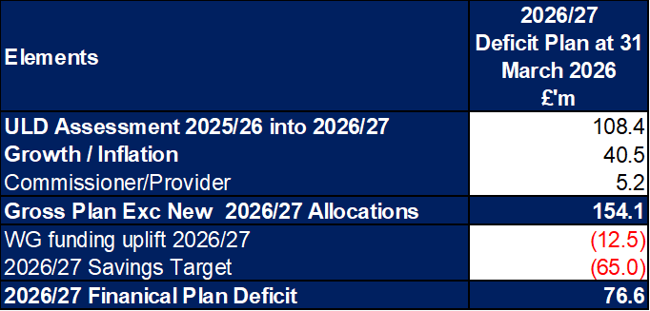

The Health Board accepts that this financial assessment is not acceptable or supportable for the Welsh Government and does not meet the statutory duties of the Health Board. A strengthened reiteration was submitted to the Welsh Government 1 July 2026 which included the assessed savings position at that point, with the Health Board continuing its work on finalising the detailed delivery plan in respect of the £65.0m savings target set out in the draft plan submitted in March along with mitigations to the recognised £10m risks.

The Health Board’s actual performance against the planned deficit shows that at the end of Month 5 the reported deficit in-month is £6.0m, which is £0.4m below the planned position. The table below provides the reconciliation of £6.0m Month 5 variance and the split between performance against operational budget and performance against savings target, with the second table reconciling the movements both in-month and YTD.
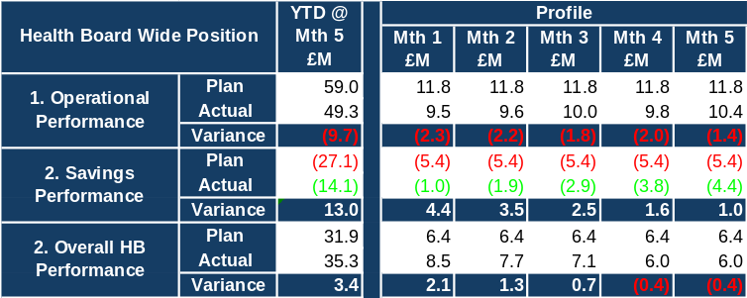
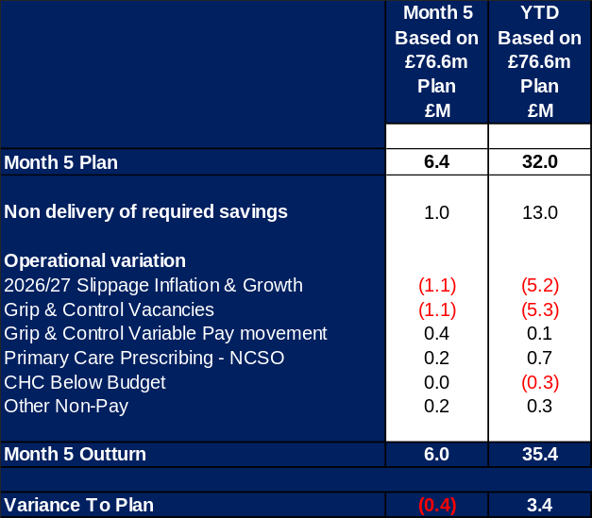
Cumulatively the Health Board is operating above the £76.6m deficit plan by £3.4m at the end of Month 5. Certainty on the delivery of the balance of savings of £23.7m is essential and hence the need to strengthen the pipeline and continue the reduction in expenditure in future months.

Given the financial position, actions to mitigate growth and generate further stretched savings are being undertaken. Progress on these plans are part of the Recovery & Sustainability Board and work that the Delivery Unit is supporting.

- BACKGROUND – Financial Performance

KEY PERFORMANCE INDICATORS
TARGET | ACTUAL PERFORMANCE
Cash Balance Bank < £6.0m | £5.663m
In Month Performance Revenue Resource Limit ≤ 1/ 12th £76.6m | £6.001m
YTD Performance Revenue Resource Limit ≤ 5/12th £76.6m x YTD Months | £35.266m
YTD Performance Capital Resource Limit ≤ £0m | (£1.152m)
YTD Performance Public Sector Payment Policy > 95% | 96.69%

FINANCIAL REPORT REVENUE – MONTH 05

At Month 5 there was an In-Month overspend of £6.0m, which is £0.4m better than the planned deficit of £6.4m (£76.6m/12).

With regards to the overall financial performance, Graph 1 below reflects the actual financial performance in each month, with the orange bars reflecting the performance required to achieve the original plan of £76.6m. Graph 2 outlines the savings delivered to date as the blue bars against the monthly target set (red line), and the orange bars reflect the level of savings required in future months to achieve the £65m target aligned to the £76.6m plan.
Graph 1: Performance Graph 2: Savings
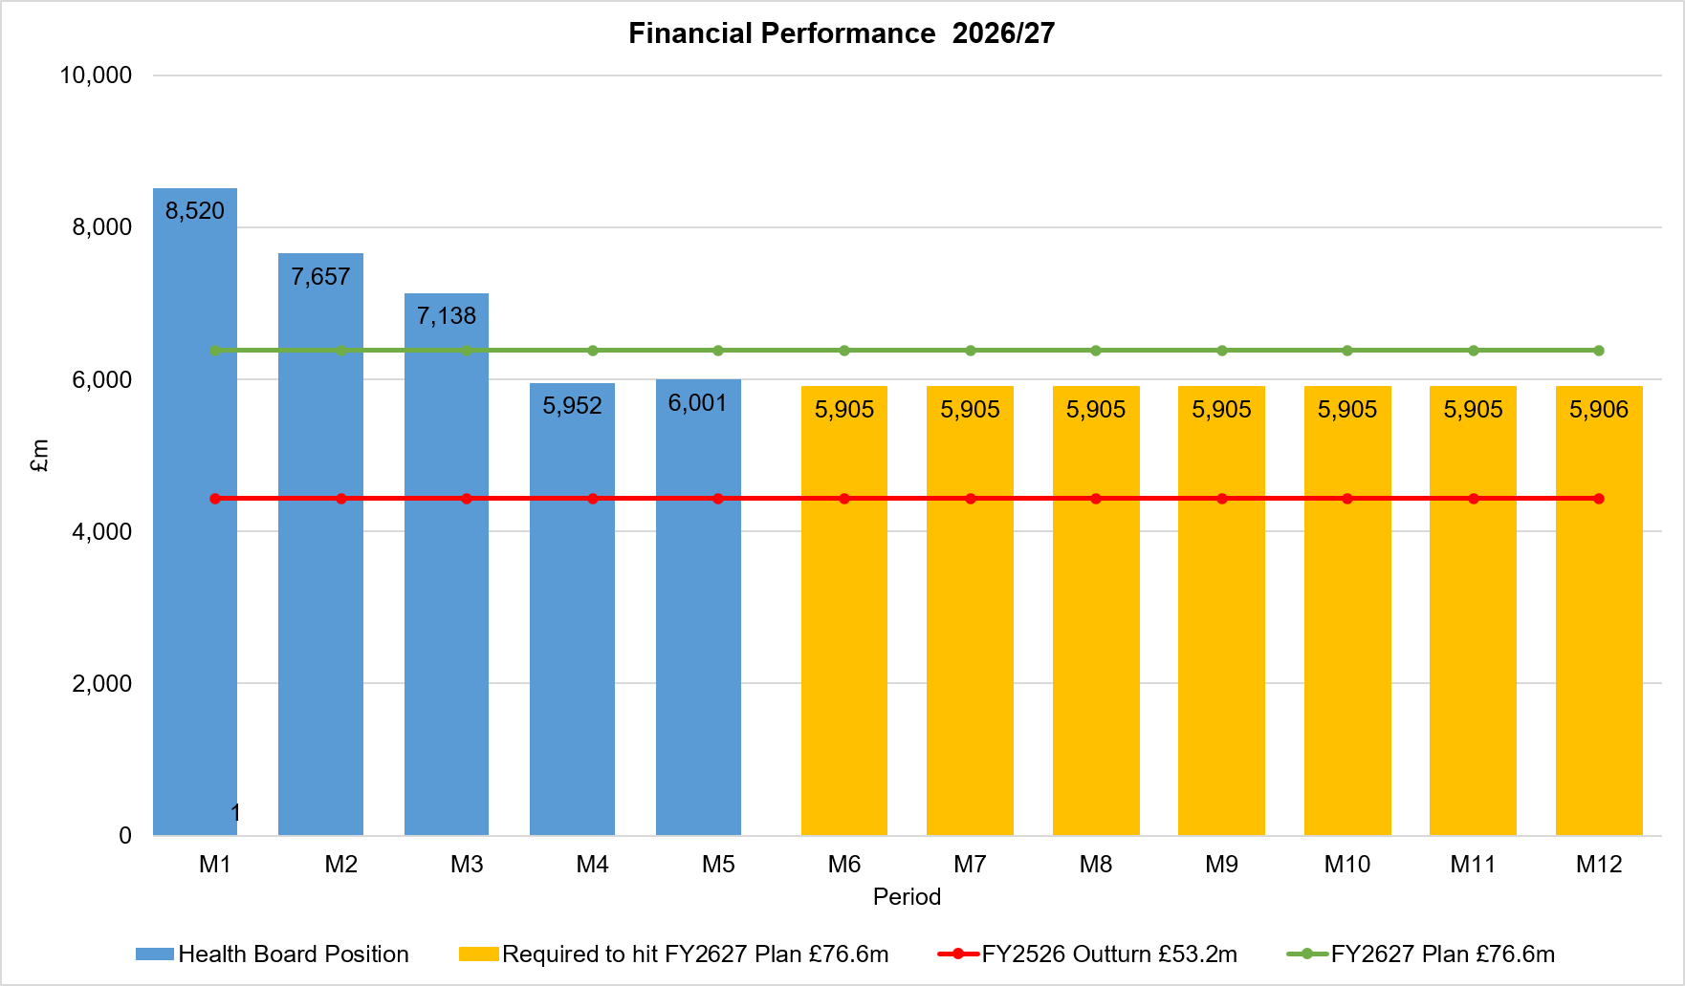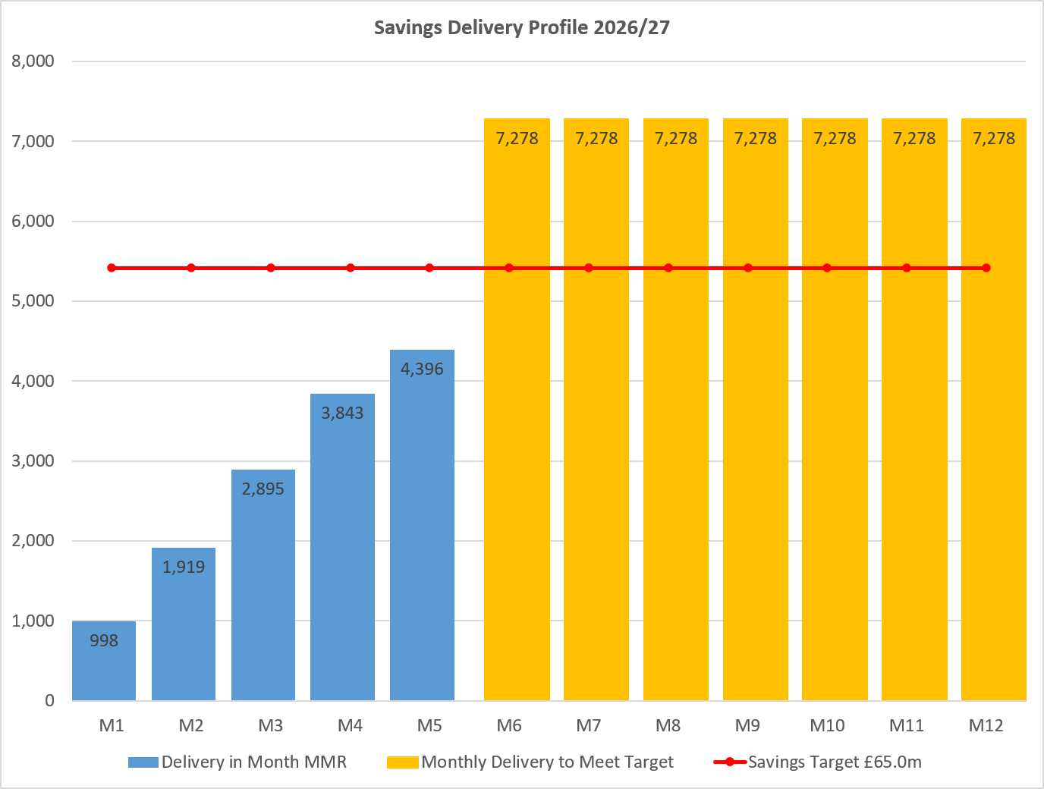

KEY DRIVERS OF THE IN-MONTH POSITION
The key movement from plan based on the Month 5 position is summarised in second table reported in Section 1 above. Further detail at a Health Board level of expenditure on Income, Pay and Non-Pay, is provided within Annex 1.

SAVINGS
Full details on savings are provided in Annex 1, but in summary the in-month delivery in Month 5 was £4.4m against a target of £5.4m and remains the key driver of the Health Board overspend. YTD delivery is £14.1m against a target of £27.1m.
Further Actions
- Additional interventions to close the gap to the original savings plan
  - Exec oversight of variable pay
  - Additional capacity reduction
  - Non pay bans / restrictions

BUDGET SETTING PROCESS
In May budget letters were issued to all 67 identified Senior Leaders along with invites to attend a budget holder training session with additional procurement training. The return of the signed letters and Budget Holder access to the QlikSense finance dashboard is being tracked and reported within Annex 1, Appendix 2-3.

- GOVERNANCE AND RISK ISSUES

Two Board level financial risks:

- Achieving financial plan (HBR92) with the key elements as follows: -

- Risk of delivery of savings quantum
- Risk of operational overspend being in excess of funding available agreed via the Financial Plan
- Risk of commitment of reserves (e.g. NICE) being above reserves available.
- Risk of achieving the actions and options outlined in the 2025/26 Financial Recovery & Sustainability Assessment.

Whilst the in-month position achieved a performance of £0.4m under against plan for Month 5, the Health Board remains cumulatively above plans, and there remains a gap in the overall delivery of savings to achieve the deficit plan of £76.6m for 2026/27. Therefore, it is recommended that the Health Board Corporate Risk Register continues to reflect a risk score of 25.

- Availability of capital (HBR93). This risk was re-opened in 2022/23 given the reduction in discretionary capital allocation. Due to the additional capital funding provided during 2024/25 the risk score was reduced to 12. The score was increased in June 2025 to reflect risks regarding Emergency Department and Adult Acute Mental Health. However, following further assessment at start Quarter 4 2025/26 and based on funding received the risk score reduced to 12. It is recommended the risk score remains at 12.

For Month 5 the key risks to the delivery of the Deficit Plan reported to WG in the MMR, linked to HBR92 are detailed below:
- Shortfall in Savings Delivery: The Health Board has identified £41.3m of Green and Amber savings and whilst it continues to scrutinise delivery of these via the Recovery & Sustainability Board (chaired by the CEO), the role of the Delivery Unit is to quickly translate these plans to deliverable schemes in year supported by the Finance Team. The Health Boards has also identified further opportunities (currently in Red or Pipeline, to support the delivery of the £65m target). Combining the Green/Amber and those remaining Red/Pipeline, there is a greater level of confidence in total delivery of £54m savings (85%) (assuming LTA performance remains consistent) and as such £10m has been reflected as risk in the table at this point on planned mitigations yet to be finalised, with £3.6m on unplanned mitigations requiring redress.
- CHC growth/inflation: Growth pressures above plan level were expected to be mitigated by the identification of mitigating actions in addition to the planned savings delivery. The Health Board acknowledges that this is challenging in the context of the savings position. At end Q1 a review of the assessed risk has been completed, following a Month 5 outturn position of £2.1m relating to CHC we have estimated the total remaining risk for CHC in 2026/27 is £2.9m.
- Energy risk provided by NWSSP: Not all the energy requirements for 2026/27 have been purchased in advance. The assessment provided by NWSSP on 07/09/26 highlighted a risk of £0.798m, which is an increase from previous risk of £0.498m. This will be updated based on the data from NWSSP, however the Health Board is not yet seeing these pressures materialise within the position.
- Impact Resident doctor contract changes: The contractual changes will be phased from August 2026 to August 2028. Initial assessment by the Health Board suggested there is a risk of between £2m – £2.5m. A report is being prepared to assess the implications and look at risks and mitigations for Board.
- Primary Care prescribing (NCSOs): Assuming the current pressures, which have seen an increase of £0.236m per month from previous financial year continue for remaining 7 months of 2026/27, the total pressure from NCSO is £2.6m.
- NEW Month 5 GPOOH National Pay and Terms of Engagement Framework: There are currently no standardised national terms and conditions governing the engagement of GPs working in Out of Hours services across NHS Wales. This has contributed to variation in rates of pay, competition between organisations, and increasing employment tribunal risk, particularly in relation to worker status and holiday pay claims. In response, a national tripartite process involving NHS Wales Employers, Welsh Government and the British Medical Association (BMA) have developed draft worker terms of engagement, a proposed national pay scale, worker enhancement rates, a consultancy agreement for contractors, and a revised employment status assessment process. The initial assessment of this by the HB has indicated a potential cost pressure of £0.176m, which is above the Annual Plan assumptions.
- NEW Out of Area Placements (Temporary Adult Mental Health placements: Original £76.6m plan had an assumed level of Out of Area Mental Health Placements, which would taper off to zero during Q3 of 2026/27. During the opening 4 months of 2026/27 the number of patients had reduced to 9, which is below the target of 11 recognised by WG. However, during August there was a stepped increase in the numbers of patients requiring Out of Area Placements, with the majority detained under the Mental Health Act. During August the number reached a peak of 32. Since then, the MH/LD Service Group have been working on supporting discharge and by the last week of August there were plans in place to discharge 13 during September. However, this level remains above the level within the original plan. With the Health Board unlikely to reach the original financial planning assumptions of zero and assuming the levels will not be lower than 11 at any point in the remainder of 2026/27 an indicative value for the risk, above the original planning assumption has now been included in the MMR. This is based on an average of 11 patients per month above plan at a cost of £1k per day. This will be reviewed monthly basis on the number of admissions and planned discharges untaken within each month.

- OPEN AUDIT RECOMMENDATIONS

Status at Month 5 is provided below, where actions have been reported as closed or assessed as complete in previous reports, these will have been excluded from the table.

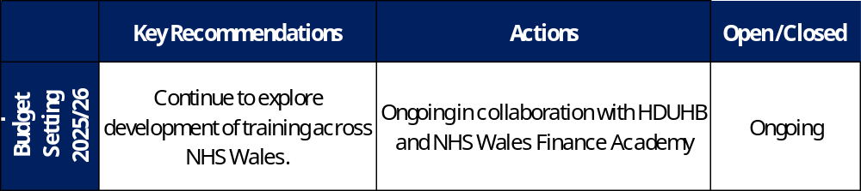

- RECOMMENDATION
Members are asked to:
- CONSIDER the 2026/27 Financial Plan, and the Health Board’s and Welsh Government’s inability to approve it given the planned deficit of £76.6m.
- CONSIDER the actions in place with regards to Welsh Government’s expectation that the Health Board delivers the £65m savings to support the delivery of the 2026/27 Financial Plan.
- CONSIDER and comment upon the Health Board’s financial performance for Month 05 2026/27 and the Year to Date (YTD) position.
- CONSIDER the risks to the position at Month 05.
- SUPPORT the position with regards to Health Board reserves.

Governance and Assurance
Strategic Objectives
Strategic Objectives  (please choose which is impacted) | People of Swansea Bay live healthier, fairer and more prosperous lives | ☐
Strategic Objectives  (please choose which is impacted) | Care is high quality, safe, efficient and delivers the best possible outcomes for people in partnerships | ☐
Strategic Objectives  (please choose which is impacted) | Care is delivered in partnership with our communities in safe and appropriate setting, supported by innovation | ☐
Strategic Objectives  (please choose which is impacted) | The health board is a great place to work where staff feel valued and work together towards a common goal | ☐
Strategic Objectives  (please choose which is impacted) | The health board is a resilient, sustainable and responsible organisation | ☒
Health and Care Standards
Standards (please choose which applies) | Safe Care | ☐
Standards (please choose which applies) | Timely Care | ☐
Standards (please choose which applies) | Effective Care | ☐
Standards (please choose which applies) | Efficient Care | ☒
Standards (please choose which applies) | Equitable care | ☐
Standards (please choose which applies) | Person-centred Care | ☐
Standards (please choose which applies) | Staff and Resources | ☐
Enablers (please choose which applies) | Whole Systems Approach | ☒
Enablers (please choose which applies) | Leadership | ☐
Enablers (please choose which applies) | Workforce | ☐
Enablers (please choose which applies) | Culture | ☐
Enablers (please choose which applies) | Information | ☐
Enablers (please choose which applies) | Learning, Improvement and Research | ☐
Quality, Safety and Patient Experience
Financial Governance supports quality, safety, and patient experience.

Financial Implications
The Board is reporting a forecast year-end deficit financial outturn.

Legal Implications (including equality and diversity assessment)
No implications

Staffing Implications
No implications

Long Term Implications (including the impact of the Well-being of Future Generations (Wales) Act 2015)
No implications

Report History
Updates on the financial position are provided at every meeting.

Appendices
Annex 1 – Detail on Financial Position @ Month 5

