

Meeting Date | 24th September 2024 |  | Agenda Item |  | 2.2
Report Title | Financial Report – Month 05 2024/25
Report Author | Samantha Moss, Deputy Director of Finance  Gemma Pearson, Finance Business Partner
Report Sponsor | Darren Griffiths, Executive Director of Finance and Performance, Acting Deputy Chief Executive
Presented by | Darren Griffiths, Executive Director of Finance and Performance, Acting Deputy Chief Executive
Freedom of Information | Open
Purpose of the Report | The report advises the Performance & Finance Committee of the Health Board on the financial position for Month 05 2024/25 (August 2024) and risks regarding the current forecast revenue year end outturn.
Key Issues | The report invites the Performance & Finance Committee to note the detailed analysis of the financial position for Month 05 2024/25 (August 2024).  The report includes a summary of the key drivers of the position either at Service level or by expenditure type (i.e. Non-Pay/Pay). It also provides information of the current position with regards to Health Board reserves to ensure transparency in the overall Health Board position.  Risk will have been considered on the basis of the information provided within the report and the score updated where necessary.  Whilst the key messages are provided within the main body of the report, further information is provided in the Appendices.
Specific Action Required | Information | Discussion | Assurance | Approval
Specific Action Required | ☐ | ☐ | ☒ | ☐
Recommendations | Members are asked to:  - Consider and comment upon the Board’s financial performance for Month 05 2024/25.  - TAKE ASSURANCE from the actions to ensure delivery of a balanced financial position for all service areas as per the accountability letters issued, which now require:  - Presentation of the draft 2024/25 Plan to In-Committee PFC for recommendation to Board scheduled for 25th September.  - If approved, submission of the revised 2024/25 Plan to Welsh Government on 26th September.  - Establishment of the new R&S Board, reporting to PFC to provide the oversight of all aspects of the Recovery & Sustainability Programme.  - Continuation of work to refine ‘Landing Plan’ for 2024/25.  - Oversight of the formal responses from the Accountability Letters provided in Appendix 4.  - TAKE ASSURANCE that the ‘saving’ reduction target set are per the accountability letters and ensure actions are logged on the savings trackers, with the additional Green/Amber savings identified and agreed from the 14th August submission to be reflected in Savings Trackers by the end of September and Red to be added by the middle of October pending approval of the revised 2024/25 Plan.  - CONSIDER the risks to the position at Month 05.  - SUPPORT the position with regards to Health Board Reserves.  - CONSIDER all actions and updates to support the management of the 2024/25 financial position.

FINANCIAL REPORT – MONTH 05

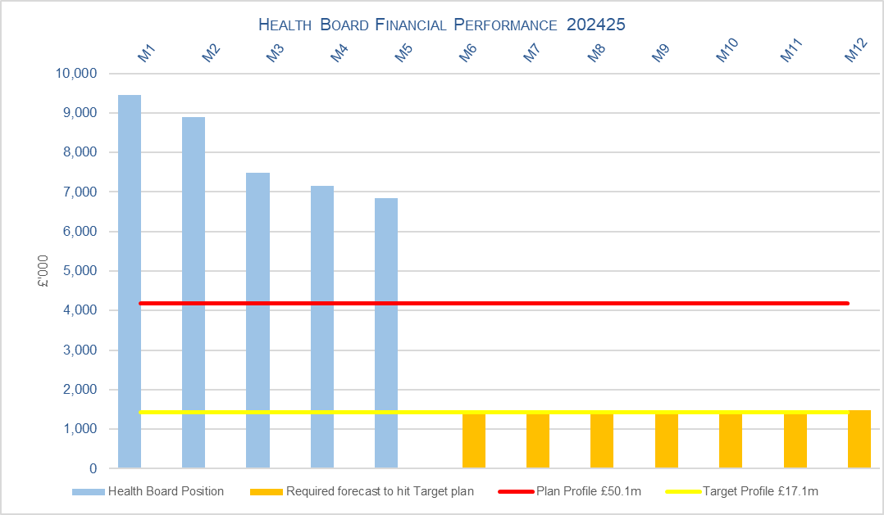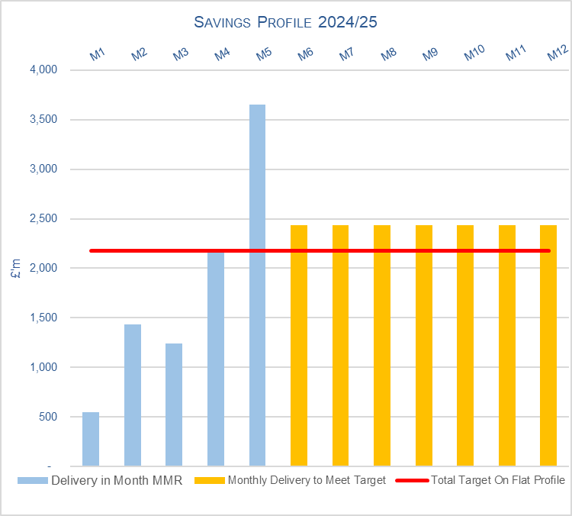

SUMMARY OF REVENUE PERFORMANCE

Target | In Month  £’m | Year To Date (YTD)  £’m
Delivery Against Revenue Resource Limit (RRL) DEFICIT / (SURPLUS) | 6.851 | 39.822
Performance Against Plan DEFICIT / (SURPLUS) | 2.676 | 18.947

In summary the Month 5 financial position was £6.9m overspent, this was £2.7m higher than the forecast deficit for the month.

The Annual Plan submitted on 28th March 2024 reported a deficit of £50.1m after the delivery of £26.1m of savings. The expectation was that the in-month position would reflect a 12th of the £50.1m deficit. For Month 5 the Health Board (HB) has reported a deficit of £6.9m against a 12th of the deficit plan of £4.2m and is £39.8m overspent against cumulative deficit plan of £20.9m. Clearly this position is unacceptable and immediate actions are being taken.

The components and the respective impact on the £6.9m are visualised in the chart below:

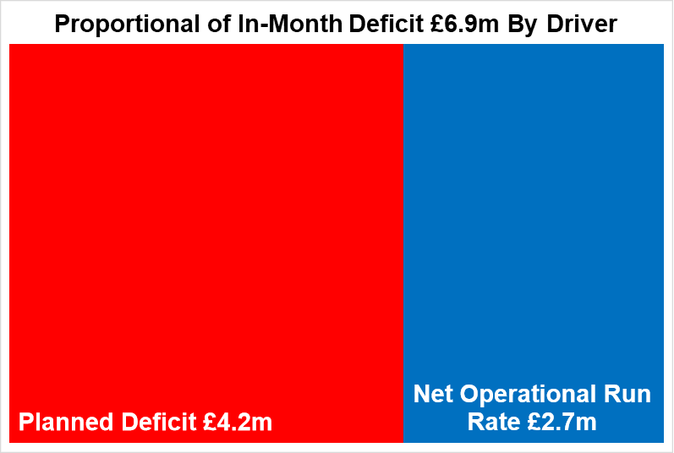

- FINANCIAL PLAN 2024/25
The Health Board submitted an Annual Plan on 28th March 2024 which reported a deficit of £50.1m. This has not been approved by Welsh Government (WG) with the request that as a minimum the Health Board reduces its deficit to £17.1m or better; work and discussions are ongoing. In order to meet the £50.1m deficit plan operational savings totalling £26.1m are required and all service areas are required to breakeven to their delegated budgets. This will require the need for a significant reduction to the Health Board’s run rate of expenditure.

The Health Board has been asked to submit a revised Plan for 2024/25; this is currently being drafted, with details on the actions in Section 2.4 below. The revised 2024/25, which will be shared with all In-Committee PFC on 18th September 2024 in draft, before finalising for Public Board on 25th September, with submission to WG on 26th September. This work brings together the work of the Programme 1 and Programme 2 of the Recovery & Sustainability Programme Board.

- KEY DRIVERS OF THE IN-MONTH POSITION
The key drivers of the Month 5 and YTD position are summarised in the tables below. Further detail at a Health Board level of expenditure on Income, Pay and Non-Pay, is also provided in Appendix 1.

  - Key Drivers by Service Area In-Month

  - Key Drivers by Service Area YTD

  - Summary By Expenditure Type

- Income
The Joint Commissioning Committee (JCC) Income as a provider deteriorated in-month, with an in-month underachievement of £0.13m, largely due to activity levels being significantly higher in Burns & Plastics, Bariatric and TAVI/Cardiology procedures in Month 4, which have returned to more standard levels in Month 5. The YTD underachievement is £0.6m.

Dental Contract Income underachieved by £0.04m in-month, with an YTD underachievement of £0.6m.

- Pay
The Month 5 pay overspend was £1.0m (Month 4, £2.2m), largely driven by Medical & Dental and Additional Clinical Services across the acute sites and MH&LD. The pay pressures are driven by a number of factors including the continuation of staffing surge bed capacity, pressures on services across the organisation and high levels acuity, coupled with high levels of sickness.

  - Action being Taken to Mitigate Position

The table below provides a summary of the actions being taken by the Health Board during July and those planned through to the end of October to provide assurance and details on how the improvement in financial performance will be achieved, linked in the main to revised 2024/25 Plan.

There are three areas of work underway linked to the Recovery & Sustainability (R&S) Programme:
  - Programme 1 focusing on immediate actions to address controllable expenditure.
  - Programme 2 focusing on Short Term Service Changes that will impact on run rates and savings delivery, including the governance linked to the original accountability letters culminating in the re-submission of the 2024/25 Plan.
  - Programme 3 focus on medium term sustainability to support the 2025/26-2027/28 Plan to deliver financial balance during this period.

Date | Action
14th Aug | Programme 2 R&S - Updated options to mitigate operational pressures, run rate reductions and address savings target submitted. This is the revised submissions required on 31st July, following the first round of Star Chamber meetings.
19th - 23rd Aug | Programme 2 R&S - Star Chamber meetings Round 2 Chaired by the CEO; there was also a focus on Estates and Hotel Services in this round of meetings.
27th Aug | Programme 2 R&S – Briefing to Performance & Finance Committee on the outcomes of Star Chamber and the development of the revised Plan.
30th Aug | Recovery & Sustainability Overarching – follow up meeting with WG/NHS Executive (NHSE), building on the discussion from 5th June.
2nd Sept | Programme 2 R&S – Briefing to Independent Members on the progress of the revised Plan
4th Sept | Programme 2 R&S – Formal Executive Team meeting to discuss all Red options submitted on 14th August. Output from meeting was a recommendation on each of the 148 red schemes to support the revised 2024/25 Plan.
9th Sept | Programme 2 R&S – Informal Executive Team meeting to continue discussions on Red options submitted on 14th August to finalise the recommendation to support the submission of the draft revised Plan at the Board Briefing on 10th September.
10th Sept | Programme 2 R&S – Board Briefing to discuss draft of revised 2024/25 Plan.
12th September 2024 Completion and Submission Month 5 MMR
16th Sept | Programme 2 R&S – Informal Executive Team discussion on draft revised 2024/25 Plan.
17th Sept | Programme 2 R&S – Presentation to In-Committee PFC on the latest 2024/25 Plan for recommendation to the Board scheduled for 25th September.
18th Sept | Programme 2 R&S – Finalisation of the 2024/25 Plan for submission to the Board.
25th Sept | Programme 2 R&S – Public Board which will include the discussion and approval of the revised 2024/25 Plan.
26th Sept | Programme 2 R&S – Submission of revised Plan for 2024/25 to WG.
26th Sept – 9th Oct | Landing Plan to 31st March 2025 – Building on the work done as part of the revised 2024/25 Plan continue to refine the Landing Plan for 2024/25 to support meeting on 9th October.
30th Sept | Programme 2 R&S – All Green & Ambers schemes linked to the options presented to be recorded on the Savings Trackers.
Oct 2024 | Programmes 1-3 R&S – establishment of the new R&S Board, reporting to PFC to provide the oversight of all aspects of the Recovery & Sustainability Programme.
9th Oct | Recovery & Sustainability Overarching – further discussion with WG/NHSE on the revised 2024/25 Plan submitted, output from Month 6 and trajectory to 31st March 2025.
9th Oct Onwards | Landing Plan to 31st March 2025 – continued refinement and identification of non-recurrent opportunities to support the 2024/25 Financial Performance.
11th October | Submission Month 6 MMR – updated so the outputs from the revised 2024/25 Plan and other actions from the Landing Plan are reflected with the relevant I&E Tables of the MMR.
18th October | Programme 2 R&S – All Red schemes linked to the options presented and approved to be recorded on the Savings Trackers.

- SAVINGS
The position reported in the Monthly Monitoring Return (MMR) only allows the reporting of Green and Amber schemes and this is provided in the table below:

Savings Table 1

Overall, there has been progress in the identification of opportunities and further pipeline ideas, aligned in part to the actions described in Section 2.4 above. As the Health Board will need to deliver mitigating cost reduction actions to address the YTD overspend and run rate pressures the overall level of savings and mitigating actions required will be more than the £26.1m planned target.

A summary of the total opportunities, including Red Schemes at 6th September 2024, is provided in the table below:

Savings Table 2
The total level of all identified opportunities pending inclusion of the final additional Green/Amber of Reds linked to the actions outlined in section 2.4, is £34.2m. The first call on savings identified by service areas is to address the £26.1m target. Once a service area has identified their target all other opportunities will be deployed to manage run rate pressures. So, in the table above whilst £34.2m has been identified £13.3m is to support run rate pressures, leaving a net value of £20.9m to meet the £26.1m target. However, unlike Table 1 this will include red/pipeline ideas.

For clarity, the Savings Table 1 above do not currently reflect all the Green/Amber schemes proposed as part of the revised 2024/25 Plan or the further red opportunities but is a summary of the trackers at a point in time. All Service Areas have until end of September to ensure all Green and Amber schemes are entered onto the savings trackers. However, a reconciliation of the work completed for the revised plan and the current Green and Ambers in the table above indicate that there is potentially a further £13.1m of Greens/Ambers to be included next month.

Savings Table 2 is missing both some of the Green/Ambers as mentioned in the paragraph above but also does not include those Red Schemes being considered by the Board as part of the Plan. Once the Plan has been approved those schemes agreed are to be added to the savings trackers by the 18th October from inclusion in the Month 7 reporting.

- GOVERNANCE AND RISK
Two Board level financial risks:

- Achieving financial plan (HBR92) with the key elements as follows: -

  - Risk of delivery of savings quantum
  - Risk of operational overspend being in excess of funding available agreed via the Financial Plan
  - Risk of commitment of reserves (e.g. NICE) being above reserves available.
  - Risk of achieving the actions outlined in the 2024/25 Landing Plan.

Based on the financial performance at Month 5, it is proposed that the Health Board Corporate Risk Register retain the existing risk score to 25 given the unacceptability of the current financial position and the variance from plan at the end of August 2024.

This will be reviewed pending the submission of the revised 2024/25 Plan and the delivery against this through Months 7-9.

- Availability of capital (HBR93). This risk was re-opened in 2022/23 given the reduction in discretionary capital allocation. Whilst work is underway to manage schemes to reduce commitments in 2024/25 and to produce a balanced plan, the risk varies during the year as more details on schemes emerge and potential slippage funding is made available by Welsh Government.

A score of 20 is suggested at this stage as whilst the plan is now balanced, a number of schemes are on hold and the flexibility within the plan is extremely limited given the reduction in the allocation.

- RECOMMENDATIONS
Members are asked to:
  - Consider and comment upon the Board’s financial performance for Month 05 2024/25.
  - TAKE ASSURANCE from the actions to ensure delivery of a balanced financial position for all service areas as per the accountability letters issued, which now require:
    - Presentation of the draft 2024/25 Plan to In-Committee PFC for recommendation to Board scheduled for 25th September.
    - If approved, submission of the revised 2024/25 Plan to Welsh Government on 26th September.
    - Establishment of the new R&S Board, reporting to PFC to provide the oversight of all aspects of the Recovery & Sustainability Programme.
    - Continuation of work to refine ‘Landing Plan’ for 2024/25.
    - Oversight of the formal responses from the Accountability Letters provided in Appendix 4.
  - TAKE ASSURANCE that the ‘saving’ reduction target set are per the accountability letters and ensure actions are logged on the savings trackers, with the additional Green/Amber savings identified and agreed from the 14th August submission to be reflected in Savings Trackers by the end of September and Red to be added by the middle of October pending approval of the revised 2024/25 Plan.
  - CONSIDER the risks to the position at Month 05.
  - SUPPORT the position with regards to Health Board Reserves.
  - CONSIDER all actions and updates to support the management of the 2024/25 financial position.

Governance and Assurance

Link to Enabling Objectives  (please choose) | Supporting better health and wellbeing by actively promoting and empowering people to live well in resilient communities
Link to Enabling Objectives  (please choose) | Partnerships for Improving Health and Wellbeing |  | ☐
Link to Enabling Objectives  (please choose) | Co-Production and Health Literacy |  | ☐
Link to Enabling Objectives  (please choose) | Digitally Enabled Health and Wellbeing |  | ☐
Link to Enabling Objectives  (please choose) | Deliver better care through excellent health and care services achieving the outcomes that matter most to people
Link to Enabling Objectives  (please choose) | Best Value Outcomes and High Quality Care |  | ☒
Link to Enabling Objectives  (please choose) | Partnerships for Care |  | ☒
Link to Enabling Objectives  (please choose) | Excellent Staff |  | ☐
Link to Enabling Objectives  (please choose) | Digitally Enabled Care |  | ☐
Link to Enabling Objectives  (please choose) | Outstanding Research, Innovation, Education and Learning |  | ☐
Health and Care Standards
(please choose) | Staying Healthy |  | ☐
(please choose) | Safe Care |  | ☐
(please choose) | Effective Care |  | ☐
(please choose) | Dignified Care |  | ☐
(please choose) | Timely Care |  | ☐
(please choose) | Individual Care |  | ☐
(please choose) | Staff and Resources |  | ☒
Quality, Safety and Patient Experience
Financial Governance supports quality, safety, and patient experience.

Financial Implications
The Board is reporting a forecast year-end deficit financial outturn.

Legal Implications (including equality and diversity assessment)
No implications

Staffing Implications
No implications

Long Term Implications (including the impact of the Well-being of Future Generations (Wales) Act 2015)
No implications

Report History |  | Updates on the financial position are provided at every meeting.
Appendices |  | Appendix 1 – Variances by Area and Type of Spend  Appendix 2 – Reserves and Central Budgets  Appendix 3 – Savings  Appendix 4 – Accountability Letters

APPENDIX 1 – FURTHER DETAIL ON VARIANCES BY AREA & TYPE OF SPEND

- Overview Financial Position

- Overview of Income

A correction was made in Month 2 to reflect the subjective being used in R&D between Income & Non-Pay totalling £3.9m

- Overview of Pay Variances

Overall Variance by month

Actual Variable Pay by month and type

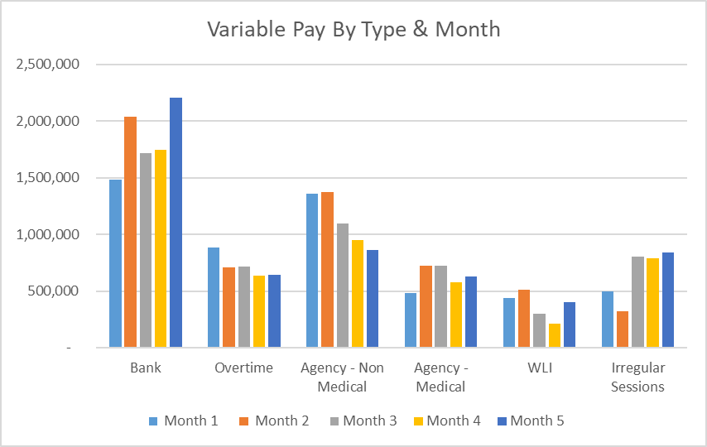

- Overview Non-Pay

A correction was made in Month 2 to reflect the subjective being used in R&D between Income & Non-Pay totalling £3.9m

Below are further details on the key areas of non-pay:

  - Clinical Consumables
This area continues to be a significant pressure with an in-month position of £1.6m (Month 4, £1.3m). There are 80+ subjective lines within this category including secondary care drugs but areas seeing most pressures YTD continue to be general consumables (M&SE), laboratory products and implants (which in part will be driven by activity).

  - Energy
An update was received on 10th June 2024 from NWSSP regarding the forecast which has been validated and included in Month 3 MMR submission. As a result, Month 1 and 2 actuals have been restated. There is no change at Month 5.

  - Primary Care Prescribing
Currently prescribing is balanced in month and there is a small YTD underspend of £0.3m. We have at this point received 3 months of PAR data. The Q1 data is below the anticipated levels at this point in the year. However, the data developed in partnership with Pharmacy colleagues is indicating that price concessions linked to Cat M and NCSO may increase significantly in Q2. Therefore, the position is being maintained as relatively balanced pending further PAR data in the coming months.

  - CHC
The overall variance against budget for CHC is £0.2m overspent in-month. An analysis of actual expenditure and patient numbers for 2024/25, along with the average values from 2024/25 is provided in table below.

CHC Analysis by Month

Please note:
- The above numbers include Domiciliary care cases.
- PCT Group does not include the Singleton/NPT element. The NPTS element which covers Children and Young People CHC patients is provided internally by the Health Board and as such is part of the wider NPTS position and is not recorded in the ledger as PCT/MH/LD CHC is recorded.

  - COVID Public Enquiry
The costs for this are allocated to a dedicated Cost Centre (6F25). A breakdown of spend YTD is provided below:

  - Maternity Review
In the 2024/25 Financial Plan £0.7m was set aside to support the Maternity Review. A breakdown of spend YTD is provided below:

In August to improve the oversight of this area a dedicated Cost Centre was established (6F34).

  - Z Codes (Section 1,3-4 Table Point 1 Appendix 1)
The narrative below groups together the key elements of the Z codes detailed in Point 1 of this appendix.

- Contracting: SLA /LTA performance: WHSSC, LTA and SLA contract income and expenditure are transacted within this area and performance reported. NICE approved high-cost drugs and associated LTA’s are also transacted and monitored against targets set. In addition to this, non-contracted activity income in relation to English foundation trusts invoiced on a quarterly basis are reported.

- Capital: The Finance Capital Team manage a number of cost centres covering the PFI, IFRS16 and Depreciation charges for assets both owned and donated are transacted here.

- RRL and Central Reserves: The WG funding received at the start of the year is tracked within this area along with the £50.1m deficit. Any anticipated allocations in year are also transaction through these codes. Other HB wide funding received from HEIW and SIFT is also captured in here. All central reserves remain within the Z cost centres and details of these are provided in Appendix 2.

- Corporate income and expenditure. Any income and expenditure that is not service group specific is transacted and reported through a number of corporate Z cost centres, examples include, payroll and pension costs, VAT recovery, losses and receipts in relation to funding from Welsh Risk Pool, overseas visitors income and Road Traffic Accident income.

APPENDIX 2 – DETAILS ON RESERVES & CENTRAL BUDGETS

- SUMMARY RESERVES
Overall management of the reserves is as per the Health Board Budget Management document.

  - Balances Main & NICE
For 2024/25, the Health Board will hold two central reserves and the purpose of these reserves are below:
- Main – this holds funding from WG or the plan that has yet to be issued to Budget Holders. These items are not surplus but either due to timing have not been issued or is an area where funding is issued based on actual values consumed in future month.
- NICE – this holds the total Health Board funding for all NICE costs (drugs and infrastructure) and is issued to the service each month based on the actual costs consumed as reported through the Pharmacy system.

Details on the balances and movements are provided in the Table below:

- COVID RECOVERY
As part of the Financial Plan WG Funded £15.2m for Local COVID Recovery and £19.5m for Regional COVID Recovery. The funding remains in Central Reserves and reported in Main reserves in Section 1 above. This funding is then issued to service areas based on the actual costs committed. A summary of the actuals to date and forecast costs against the funding total of £34.7m is summarised in the table below.

APPENDIX 3 – SAVINGS

1. Summary
Section 3 in the core report focuses on only those savings attributed £26.1m target. The tables below reflect the information from the savings trackers to address both the £26.1m savings target and savings to mitigate the current in year run rate pressures.

In summary the table below shows a forecast savings delivery of £34.2m in year, (or £20.9m net of run rate mitigations) and £27.9m forecast recurrently (or £22.4m net of run rate mitigations) and includes Red schemes and schemes in progress of being developed. Therefore, this year, with a net forecast delivery of £20.9m, against a target of £26.1m, there is a shortfall of £5.2m in year.
Within the £34.2m forecast, £31.9m is considered deliverable with a Green/Amber risk rating. However, £2.2m (6%) are considered high risk of delivery this year (£1.2m, 4% recurrently) and are rated as Red, a significant improvement on the previous month.

If we take the Green/Amber schemes which have a higher chance of delivery, then Primary Care, Community & Therapies (PCCT) Service Group has the lowest % of Green / Amber Savings, therefore have the highest risk of delivering on their Savings Target this financial year. The £1.5m red scheme within PCCT is for Dental Clawback this year. MHLD and Singleton/Neath Service Groups have the highest confidence of delivery in-year with no Red schemes.

However, recurrently, Morriston and Corporate Directorates (Digital) have the highest risk of delivery, whilst Singleton/Neath, MH+LD and PCCT have the highest chance of delivery with no savings classified as Red.

- Profiling of Savings against £26.1m 24-25 In Year

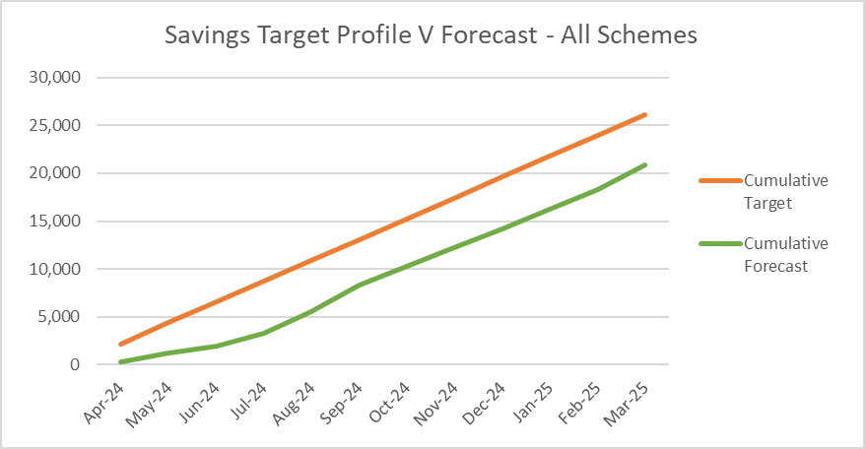
The profile shows the timeline of the forecast savings (net of run rate) of £20.9m for 24-25 against the £26m target. Currently this is for all Risk rated schemes. September offers the highest level of expected savings, although fairly flat lined delivery across the year. However, the savings gap of £5.2m will need to be achieved in months 6-12 (Sept-Mar).

- Type of Savings Forecast at Month 5

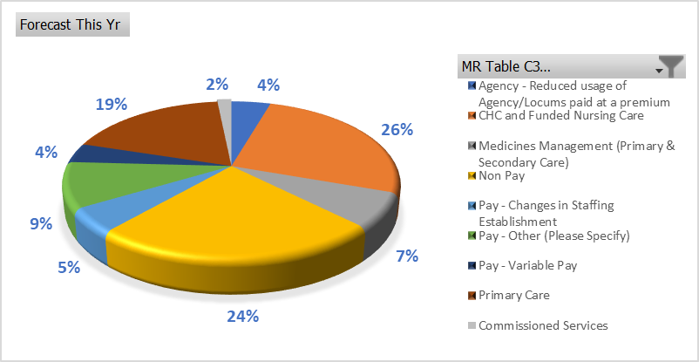

The largest type of savings to month 5 are CHC and Funded Nursing Care at £8.8mm (26%) which include managing CHC growth and inflation, reviewing support, decommissioning, planned step downs and repatriations. Primary Care savings at £6.3m (19%) include management of Optometry and Pharmacy contracts, managing levels of investments, dental clawback and in year slippage. Non-Pay / procurement are at £8.2m (24%) of savings and include procurement savings identified by local and All Wales procurement teams, managing SLA’s, capping investments and managing maintenance contracts.

- SBUHB Savings Repository

To continually support the identification of opportunities for the Recovery & Sustainability programmes in 2024/25 and in future years, as well as ensuring all opportunities from the National Value & Sustainability are captured and shared within the Health Board, the Repository of Opportunities introduced as part of the Planning process is being re-developed to ensure ease of navigation of the data.

The Repository is now live and can be access using the link below:

https://sbushare.cymru.nhs.uk/sites/Finance/Corp/Resources/savresp

The Repository is split into three sections:
- National Efficiency Reports - this will include details of the NHSE FP+D Vault, NHS Wide Value and Sustainability Board Updates including Medicines, and the Carter Report
- National Benchmarking – this will include the latest CHKS Benchmarks, NHSBN reports and analysis, and summary of the NHS Wide Savings schemes for comparisons.
- Local Reports and Benchmarking to include SBUHB Procurement dashboard, Medical Staffing, and some Pay and non-Pay potential opportunities.

- Value and Sustainability Update

Procurement and Non-Pay – The group led by Hywel Jones (WG) focusses on the following priorities: Price and Volume, Contract Negotiations and Management, Management of Service Contracts.
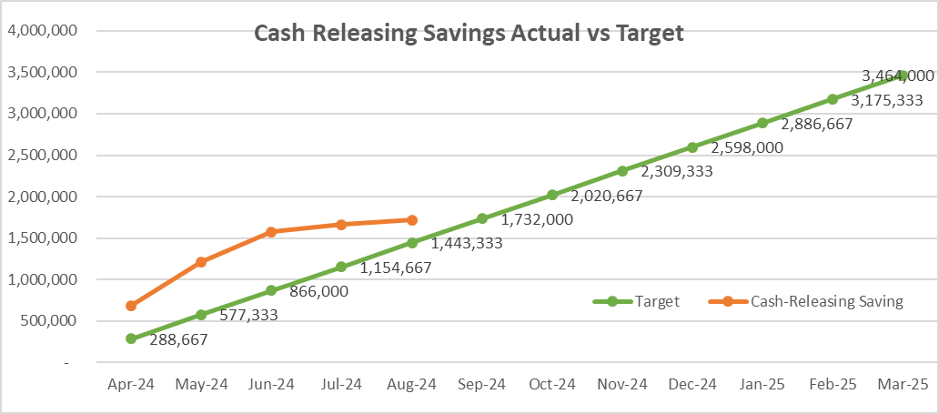
The NWSSP has set an annual target of cash releasing savings of £37m across NHS Wales. The savings achieved to the end August was £13m across Wales. The SBUHB savings plan has been updated to £3.464m. Currently SBUHB are reporting a cash releasing saving of £1.7m to August.

Workforce – The group is led by Liz Rogers (WG) focusses on the following priorities: monitoring reduction in agency costs, development of an international recruitment plan, nurse staffing levels and roster management and benchmarking. SBUHB update: Working to agree an all-Wales rate for ADH’s to avoid competition between HB’s; working with NHS Wales on international recruitment but SBUHB already a leader in this with estimated 75 International nurses expected by end of year; working on Nurse Staffing Headroom to ensure consistency across 25B Wards.

CHC – The group is led by Jeremy Griffith (WG) focusses on the following priorities: High-cost cases, private provider model, data on commissioned care, invest to save. During 2023/24, the NCCU, working alongside the FP&D, were tasked with reviewing high-cost patients utilising services across Wales. For 23/24, the NHS Wales saved £5.6m on a recurrent basis with a £14m of full year effect opportunities. SBUHB identified 46% of patients identified by NCCU with financial opportunity valuing £32k in 23/24. Key actions for 2024/25 include, a national management information system, upskilling of assessors, review of inflationary and cost pressures, and continuing of high-cost patients, and potential benchmarking across Wales.

Medicines Value and Sustainability – The group is led by Alex Slade and Andrew Evans (WG) and focusses on the following priorities: Reducing spend through lower cost biosimilar, exclusive use of generic medicines, ending outsourcing of particular medicines, reviewing off contract procurement, reducing spend on low priority drugs. SBUHB Update - Where a biological medicine is indicated, all new patients in SBU are initiated on a biosimilar medicine where one is available. For generic switches, Apixaban and Sugammadex switches were implemented as soon as the generic product became available to purchase.

APPENDIX 4 – SUMMARY OF THE REPLIES TO THE ACCOUNTABILITY LETTERS @ 9th SEPTEMBER

No: | Name | Date Pro Forma Returned
 | Ceri Gimblett – SNTP | Formal reply letter received 31/05/24 but not the set pro forma
 | Sue Moore – Morriston | 31st May 2024
 | Janet Williams & Dermot Nolan – MH&LD | 30th May 2024
 | Brian Owens – PCTSG | 6th Sept 2024
 | Hazel Lloyd – Corporate Governance | 16th May 2024
 | Deb Lewis – COO | 12th June 2024
 | Richard Thomas – DICE | 3rd June 2024
 | Matt John – Digital | 22nd May 2024
 | Anjula Mehta – Medical  Raj Krishnan - Medical | 22nd May 2024
 | Anjula Mehta – Medical  Raj Krishnan - Medical | 14th May 2024
 | Gareth Howells/Hazel Powell – Nursing | Pro forma from HP signed 13th May 2024
 | Jennifer Davies – Public Health | Queries on specific funding streams which under review
 | Nerissa Vaughan – Strategy | 31st May 2024
 | Sarah Jenkins – W&OD | 30th May 2024
 | Darren Griffiths – Finance and Estates | 13th May 2024
 | Christine Morrell – Therapies | 23rd May 2024

