

Meeting Date | 24 September 2024 |  | Agenda Item |  |  | 4.2
Report Title | Urgent and Emergency Care Report
Report Author | Neil Cooper, Assistant Director of Operations – Urgent and Emergency Care  Jonathon Baglow, Business Intelligence Analyst
Report Sponsor | Deb Lewis, Chief Operating Officer
Presented by | Neil Cooper, Assistant Director of Operations – Urgent and Emergency Care
Freedom of Information | Open
Purpose of the Report | To provide a summary of the Urgent and Emergency Care (UEC) improvement programme to improve the delivery of timely, safe patient care and the UEC care standards.
Key Issues | UEC performance has been escalated into Targeted Intervention by Welsh Government with the Chief Operating Officer holding oversight and assurance against developing and monitoring a UEC improvement programme.  The delivery of Tier 1 performance standards remains a significant challenge and the risk of patients coming to harm due to delays relating to timely handover of ambulances. Early assessment and treatment remain a key focus for the Emergency Department (ED) and ward based clinical management teams.  The overcrowding of the ED linked to poor flow and delayed admission of patients into the in-patient bed pool results in poor patient experience.  There are key system performance indicators that explain the challenges associated with delivering timely and safe patient care and thus the required levels of performance and these are discussed in the paper.  Service development schemes are in place and continue to be developed and implemented to support the recovery of UEC performance.  A structured approach in response to targeted intervention monitoring and the UEC programme, approved by NHS Wales 6 goals programme is in place to support, deliver and monitor the schemes reporting to the UEC Board
Specific Action Required  (please choose one only) | Information | Discussion |  | Assurance | Approval
Specific Action Required  (please choose one only) | ☒ | ☐ |  | ☐ | ☐
Recommendations | Members are asked to:  - NOTE the UEC performance position and the ongoing actions taken to support its recovery and Improvement.

Urgent and Emergency Care Report

- INTRODUCTION
The report below describes urgent and emergency care (UEC) activity and performance to date including progress against the UEC care standards. Wider system indicators are also used to demonstrate the flow constraints that exist resulting in poor access to timely urgent and emergency care and poor patient experience. The report provides a detailed response to actions pertaining to the increased monitoring to of the UEC tier 1 performance targets and updates on the strategic and operational programme to improve the delivery of acute services to patients and on local improvement actions.

- BACKGROUND
The flow of Emergency patients within the Health Board and the wider UEC system, continues to be significantly compromised due to the high occupancy levels within its hospitals. This is further exacerbated by the system flow challenges impacting patients transferring in a timely way into services outside the hospital sites which in turn increases delays in clinically optimised patients and increases the number of patients being treated outside of their core bed base. The impact of the lack of flow also has unintended consequences in other parts of the UEC system including:

- Delay in patients transferring from ambulances into the Emergency Department (ED);
- Delays in patients accessing inpatient beds
- Increase in utilisation of surge capacity across the Hospital footprint and patients placed in inappropriate spaces i.e.Same Day Emergency Care (SDEC)
- Delays in patients transferring to the next stage of their recovery – complex and general rehabilitation at peripheral sites
- Discharge home

In line with the 6 goals programme, wider health board schemes targeting admission avoidance and earlier discharge are in place or in trial phase to support the wider system flow agenda.

- PERFORMANCE – Tier 1 URGENT & EMERGENCY CARE STANDARDS

The Charts below present performance against the ED Access Standards and Ambulance handover targets (12-month rolling position). Overall, 4-hour performance has improved and similarly, the number of patients waiting for 12 hours or more also reduced.
Despite the improvement, the ongoing challenging situation and generally poor performance against the 4-hour standard at Morriston Hospital translates operationally into poor patient experience. Patients can wait several hours for assessment by a clinician during which period their condition may be more serious than as assessed at triage, or may have deteriorated.

15 months to 31st August 2024
Front Door Measures – Swansea Bay UHB

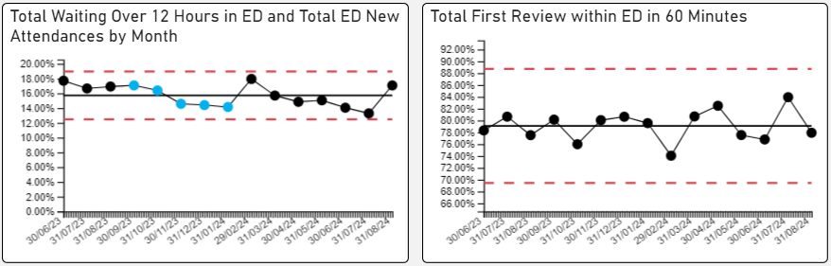

3.1 Ambulance attendance and handover delays >1 hour

- Ambulance handover is of significant concern and has been a key focus from Welsh Government. The UEC programme is addressing this matter as one of its most critical areas for improvement

15 months to 31st August 2024
Number of Emergency Ambulances Waiting for Handover

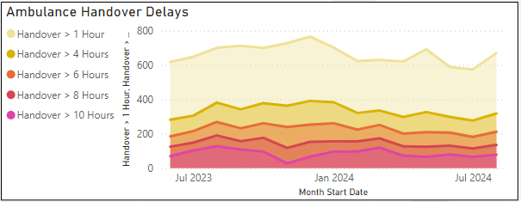

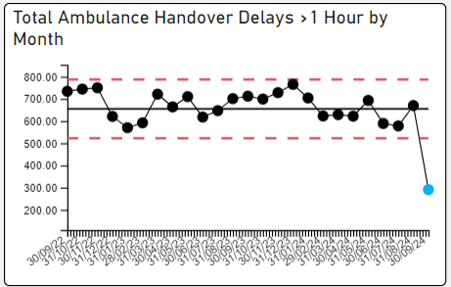

15 Months to 31st August 2024
Number of Emergency Ambulance Hours Lost Waiting for Handover
WEEKLY

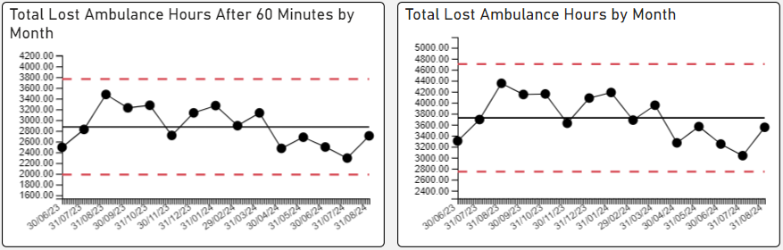
15 Months to 31st August 2024
Mean Number of Ambulances Waiting For Handover

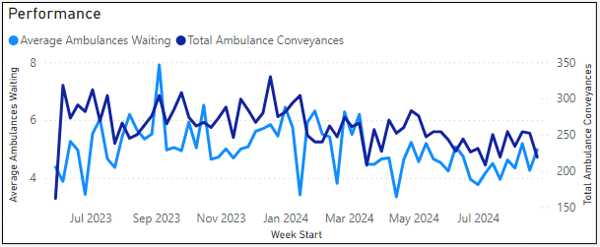
The reasons for the delays in handover are multi-factorial and include:
- Surges in demand from the ambulances or self-presenting patients – average ambulance arrivals have historically been 55-60 per day, increasing recently to 60-65 per day and reaching peaks of 80 per day;
- Availability of ED / AMU capacity to manage demand – both departments are regularly starting the day with 30 to 40 patients waiting to be admitted to down-stream wards.
- Onward flow to a hospital bed.
- Availability of onward hospital transfer
- High number of Clinically Optimised Patients (COPs) in the acute setting

3.2 Clinically optimised position

The clinically optimised position in the Health Board remains a critical issue with significantly high numbers of patients occupying acute beds waiting to move to more appropriate settings to continue their care pathway or waiting for community support/placement.

Morriston Hospital Clinically Optimised Patient Level 5th June 23 to 1st Sept 24
Monthly

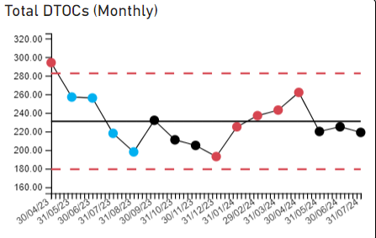

- Wider system measures and actions:
.
The Health Board has been placed into Targeted Intervention (TI) by Welsh Government for its performance and outcomes within the UEC system.

The expectations mirror the HB’s own aspiration and the plan currently being developed to support system improvement. Our agenda listed below will consist of 4 key themes all linking to National 6 Goals Programme and a consistent thread linking the UEC programme boards GMO’S for 2024/25

- Admissions Avoidance
- Discharge & Transfer
- Front Door
- Inpatients

The criteria used for consideration to de-escalate out of TI is captured in the table below along with progress to date

Criteria to Achieve | Current Performance (June July & August)
- A continuous reduction of ambulance handovers over an hour of at least 11% in three consecutive months and maintained for 3 months (Based on quarter 2 and 3 2023 baseline). | - 15.1% - in June 18.36% in July 5.37% in August
- Continuous improvement towards no more than 7% of patients waiting over 12 hours at each individual site and across the health board. | - 8.4% - in June 8.1% in July 10.2% in August
- Median time from arrival at an emergency department to assessment by a clinical decision maker should not exceed 60 minutes. | - 76.8% in June 83.9% in July 77% in August
- A continuous reduction in delayed pathways of care of 5% for three consecutive months and then maintained for three months (based on Oct-Dec 23 baseline). | - Slight reduction (219 for July)
- Assessment of declared BCIs, including reasons why, actions taken, and lessons learnt. | - Only one BCI declared so far in 24/25

Despite improvements in all performance metrics in July August has seen a deterioration in performance due to peak leave and a challenging IPC position across all Hospital sites in the Health Board

Actions being taken to improve include:

- Frailty strategy – approved via Management Board – phase two coming on line in September
- Grip & control operational management – Full Capacity protocol and zero tolerance on chair and trolley waits planned for launch in October 2024
  - Review of community capacity and operating models: ACT & Virtual Wards
- Senior decision makers at front door services
  - Rota proposals shared with Acute Physicians
  - Recruitment drive commenced for x5 Acute Geriatricians and x5 Acute Physicians
  - Plan to implement new interim rota in October 2024 whilst recruitment takes place
- Pathway of Care Delays (PoCD) – Multi Agency Discharge Event (MADE) undertaken in August and 6A’s audit follow up took place to improve discharge and transfer processes.
  - Singleton & Morriston COP capacity under redesign for October 2024
- Reconfiguration of Emergency Dept – funding received to develop reconfiguration plans – lead by Capital Planning.
- Revised flow operating model: with consistent tactical command at Level 4 and introduction of revised internal escalation processes

- Recommendation
Members are asked to:
- NOTE the UEC performance position and the ongoing actions taken to support its recovery and Improvement.

Governance and Assurance

Link to Enabling Objectives  (please choose) | Supporting better health and wellbeing by actively promoting and empowering people to live well in resilient communities
Link to Enabling Objectives  (please choose) | Partnerships for Improving Health and Wellbeing |  | ☒
Link to Enabling Objectives  (please choose) | Co-Production and Health Literacy |  | ☐
Link to Enabling Objectives  (please choose) | Digitally Enabled Health and Wellbeing |  | ☒
Link to Enabling Objectives  (please choose) | Deliver better care through excellent health and care services achieving the outcomes that matter most to people
Link to Enabling Objectives  (please choose) | Best Value Outcomes and High Quality Care |  | ☒
Link to Enabling Objectives  (please choose) | Partnerships for Care |  | ☒
Link to Enabling Objectives  (please choose) | Excellent Staff |  | ☒
Link to Enabling Objectives  (please choose) | Digitally Enabled Care |  | ☒
Link to Enabling Objectives  (please choose) | Outstanding Research, Innovation, Education and Learning |  | ☒
Health and Care Standards
(please choose) | Staying Healthy |  | ☒
(please choose) | Safe Care |  | ☒
(please choose) | Effective Care |  | ☒
(please choose) | Dignified Care |  | ☒
(please choose) | Timely Care |  | ☒
(please choose) | Individual Care |  | ☒
(please choose) | Staff and Resources |  | ☒
Quality, Safety and Patient Experience
To improve the delivery of timely, safe patient care and the UEC care standards.

Financial Implications
There are no direct financial implications arising from the recommendations in this report.
Legal Implications (including equality and diversity assessment)
There are no direct legal implications arising from the recommendations in this report.
Staffing Implications
There are no direct staffing implications arising from the recommendations in this report.
Long Term Implications (including the impact of the Well-being of Future Generations (Wales) Act 2015)
Report History |  | N/A
Appendices |  | N/A

