Meeting Date | 24 September 2024 |  | Agenda Item |  |  | 4.3
Report Title | Update on Stroke Performance
Report Author | David West – Directorate Manager
Report Sponsor | Neil Cooper – Assistant Director of Operations  Fiona Hughes – Associate Service Group Director
Presented by | Neil Cooper – Assistant Director of Operations
Freedom of Information | Open
Purpose of the Report | To provide the Performance & Finance Committee with an update on Stroke performance.  This report includes plans and timescales for improving Stroke performance.  This report includes an update on the establishment of a Comprehensive Regional Stroke Centre (CRSC)
Key Issues | - Compliance against the 4-hour access target for admission to the Acute Stroke Unit remains challenging due to system wide pressures.  - High compliance of consultant review and OT/PT/SALT assessments within 24 hours remains.  - High level of swallow assessment compliance.  - Reducing door to needle time for Thrombolysis is an area for improvement.  - Increase of Mechanical Thrombectomy a priority.  - Embedding of CT Perfusion and MRI Perfusion.  - WAST Direct to CT pilot continues.  - Expanded CNS hours remain in place.  - Stroke improvement plan revised in line with Audit recommendations.  - Pre-triage pilot being developed to reduce assessment times in a busy ED department.
Specific Action Required  (please choose one only) | Information | Discussion |  | Assurance | Approval
Specific Action Required  (please choose one only) | ☐ | ☐ |  | ☒ | ☐
Recommendations | Members are asked to:  Note the content of the report and endorse actions to improve performance.

Update on Stroke Performance

- INTRODUCTION

This report aims to provide the committee with an update on performance against the stroke pathway in SBUHB. Continued year-round pressures on acute hospitals such as Morriston mean that performance against access targets has been challenging to improve. This report will illustrate Morriston’s performance against other Welsh centres who are also experiencing the same challenges.

Stroke rehabilitation for NPTH and the current performance for that site is also highlighted in the body of this report.

With investment received into the Stroke service in 2023/24 recruitment has been underway with only consultant posts remaining vacant entering 2024/25.

A programme a plan for performance recovery and improvement has been developed and will be enhanced further as required in line with updated performance measures taking effect in 2024.

***Targets of 95% is aimed for in most measures covered in this report as that generates 100 points per measure in the Sentinel Stroke National Audit Programme (SSNAP).
**Mechanical Thrombectomy is aimed at 10% nationally in Wales.
*Thrombolysis rate is aimed at 20% nationally in Wales.

- BACKGROUND

  - Stroke Performance
Summary of main Stroke Quality Improvement Measures (QIMs) for May 2024 – July 2024 illustrated below:

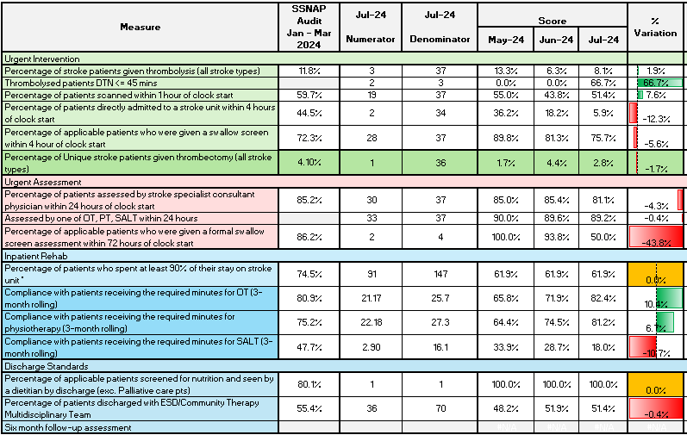
4 Hour Admission to ASU – (National Target – 95%)
Performance was 5.9% in July 2024 against a national target of 95%.
Access to dedicated Stroke beds continues to impact on performance. Compliance remains low around the 4-hour target compared to pre-pandemic levels, but future service developments should further improve access for patients.

The Acute Stroke Unit (ASU) faced infection control issues throughout July and into August which has meant reduced transfers out to rehabilitation sites and limited ability to move patients into the ward due to COVID and Norovirus outbreaks closing bays.

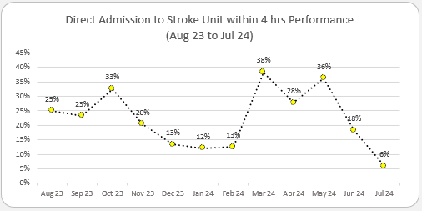
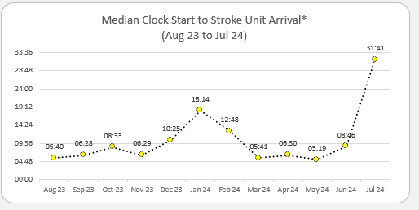

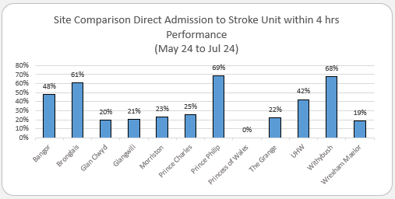

Performance is discussed weekly in the Stroke performance meeting held at Morriston alongside clinicians, ED staff and bed site managers. NHS executive colleagues have also attended monthly for assurance.

As of 10th July 2023, Morriston was asked to ringfence 18 Stroke beds for Stroke to improve 4 hours compliance further. To date this has rarely been achieved with medical outliers regularly exceeding the limit of 6 that should be in place.

Immediate actions to address 4 Hour Access to ASU compliance:

Recommendations/ Action | Lead | Start Date | Implementation / End Date | Progress/ Remarks | Expected Benefit/ Impact on SSNAP Score
Decompression of ED with opening of Acute Frailty Unit | Gareth Cottrell | Apr-24 | Sep-24 | Acute frailty unit coming online in September 2024 is expected to absorb 40% of the medical take from ED decompressing the department and allowing quicker assessment times for patients including those suffering stroke who may not be clinically obvious. | Expected improvement in 4 hours compliance
All site matrons reminded that breach of a Stroke bed needs authorisation from Silver & Gold. | Rebecca Davies | May-24 | May-24 | All staff reinformed of this 8/5/2024  Breach proforma reintroduced May 2024  Complete | Expected improvement in 4 hours compliance
Medical outliers should be capped at 6 on Ward F. Morriston to link in with NPTH around maximising use of rehabilitation facilities to improve flow | Rebecca Davies / David West | Apr-23 | May-24 | David West & Rebecca Davies to meet with Melanie Collins to speed up Stroke transfers. To be done May 2024.  Complete | Expected improvement in patient flow resulting in improvement in 4 hour compliance.

4-hour access issues are also affecting the other major admitting sites in Wales, such as POW and The Grange hospitals. SBUHB 4-hour performance is in line with other sites of similar size. Sites dealing with smaller volumes of Stroke patients such as Bronglais and Bangor have much higher access rates as demonstrated below. Cardiff and Vale UHB do enforce strict ringfencing of Stroke beds and their compliance far exceeds other sites in Wales on this measure despite seeing more Strokes than any other site.

Thrombolysis rates – (National Target 20%)

Thrombolysis rates as of July 2024 was 8.1% against a national target of 20%. This is historically an area where Swansea Bay generally performs well. For June and July in particular this rate has fallen substantially with Ward closures and sustained unscheduled care pressures meaning a greater proportion of patients are not suitable for Thrombolysis by the time they are triaged, and the Stroke team alerted.

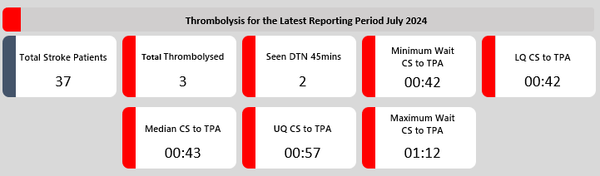

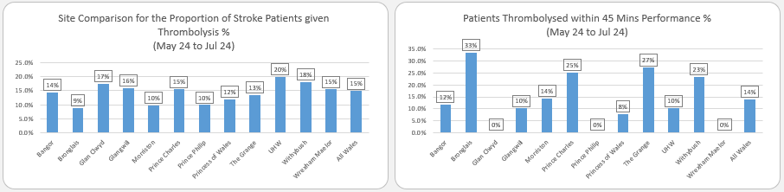

Immediate actions to address Thrombolysis compliance:

Recommendations/ Action | Lead | Start Date | Implementation / End Date | Progress/ Remarks | Expected Benefit/ Impact on SSNAP Score
Thombolysis pathways to be reissued to all medical and ED staff | Tal Anjum /Mark Poulden | May 2024 | May-24 | Dr Polden and Dr Anjum to send out guidance to capture all eligible patients for thrombolysis.  Updated on COIN and reissued already.  Complete | Expected improvement in thrombolysis compliance by ensuring all eligible patients are given this treatment.
Recruitment to develop 7 day a week 8am-10pm cover | Tal Anjum/ David West | May 2024 | October 2024 | 2 substantive PA’s to be recruited in place of locum SHO ED team. – interviews 17/5/24.  These 2 PA’s will join with 2 already in post substantive PA’s as well as 6 ANP’s and 3 CNS’s to form 7 day a week extended cover  PA’s now started in post.  Development of rota ongoing | Expected improvement in thrombolysis compliance by ensuring specialist teams are available all throughout the week.
Thrombolysis door to needle time <45 minutes (Target 95% of eligible patients)

66.7% of patients eligible for Thrombolysis received this in July 2024 but the overall number of patients identified for thrombolysis was low.

A comparatively high volume of patients suffering a Stroke receive thrombolysis at Morriston, but these patients require observation when given this treatment. Clinical Nurse Specialists (CNS) and doctors are not always able to leave a patient who has received thrombolytic therapy to attend any other call or alert that goes off.

Developing an ANP workforce as per the Comprehensive Regional Stroke Centre (CRSC) plan will allow these members of staff to attend to other patients suffering a Stroke and reduce door to needle time. 6 Trainee ANP’s are now in post ahead of regional service plans for 2026 by which time all should be qualified.

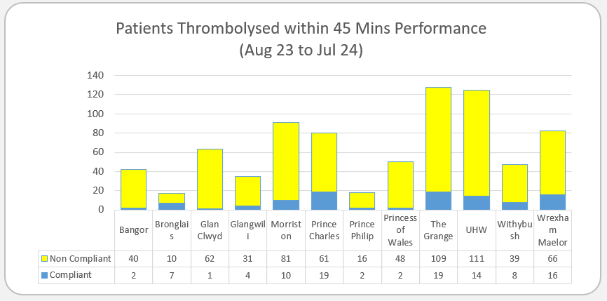

CT head within 1 hour - (National Target – 95%)

Performance for July 2024 is 51.4% against a national target of 95%
CT head scans <1hr were consistently improving prior to the pandemic. However, due to assessment delays and increasingly busy ED department, performance against this target has fallen back to where it was 2017-2018 but remains consistent at between 40 and 60% month on month.

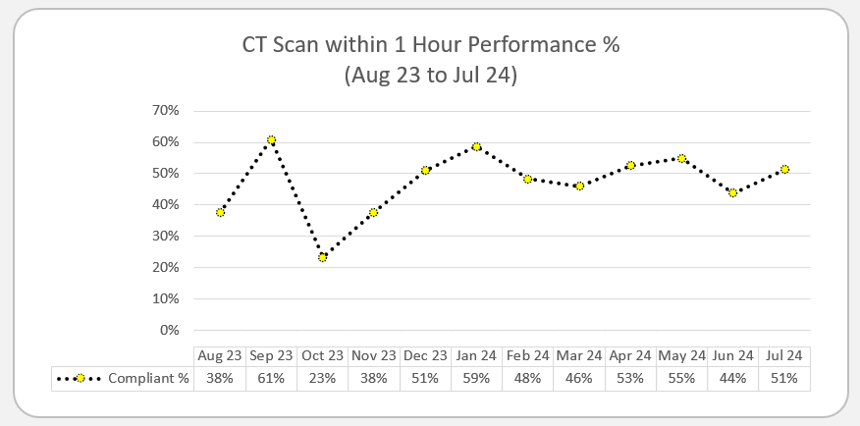

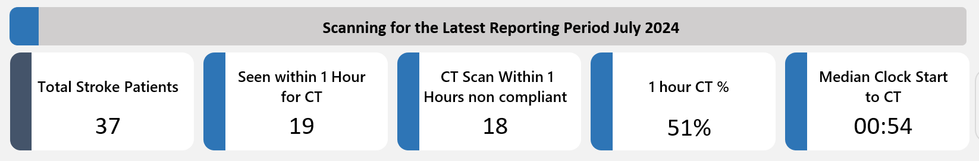

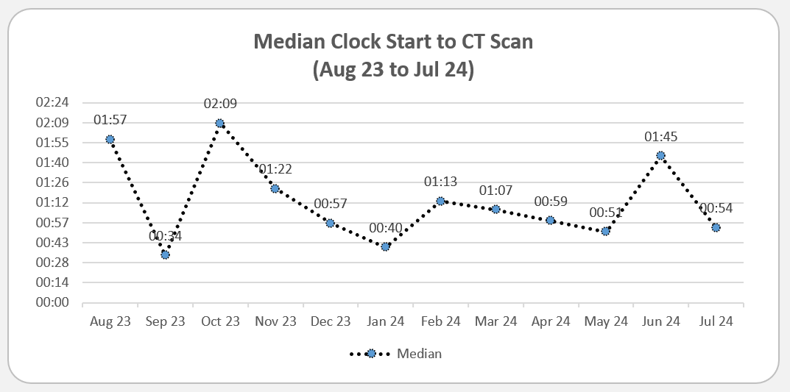

Overall median clock time to CT is reducing which should aid in increasing compliance against this target. One measure put in place is a Direct to CT pilot in conjunction with WAST.

Stroke Pre-Alert Direct to CT pilot

The embedded pathway was agreed at Morriston Board 31st January 2023 and was enacted from July 2023 to reduce CT times for pre-alerted patients coming via WAST.

From July 2023 – August 2024 a total of 548 Strokes were recorded with 183 of these being conveyed into Morriston Hospital via WAST. 139 of the 183 patients or 76% of WAST Pre -alerts went straight to CT and have benefitted from this pilot which will continue.

Overall only 33.4% (183 of the 548) are conveyed by WAST so whilst this pilot is benefitting those conveyed via this method the majority of patients in SBUHB are walk-ins or arrive via other means. Direct to CT would benefit more patients if vehicles could be released from the ED forecourt more quickly.

Artificial Intelligence CT analysis

Brainomix e-Stroke suite is an artificial intelligence clinical decision-making support tool and is supported by the cyber team. Its implementation remains subject to the locally developed SOP approved by the Radiology Quality, Safety and Risk meeting.

Procured by the then WHSSC, the support tool allows for rapid diagnosis of ischaemic stroke by appropriate trained individuals. This implementation should assist long term with timely decision making in patients who are being considered for thrombectomy. This system went live in SBUHB 27th November 2023.

CT perfusion

To maximise the potential benefit from revascularisation treatments and the acute management of intracerebral haemorrhage, a corresponding increase in the availability of advanced imaging techniques is required, and all hyperacute stroke services should have timely access to brain imaging including CT or MR angiography and perfusion. This is featured In the 2023 national Stroke Guidelines.

In SBUHB to comply with this recommendation Radiology began offering this service routinely from 25th March 2024 with a Monday -Friday 9am-5pm service in place. The first case being undertaken on 2nd April 2024.

There are 17 CT radiographers on the on-call rota that will all be trained to expand the hours that CT perfusion can be performed but as CT perfusion is beneficial in a small subset of strokes there are a limited number of scans for them to be trained on.

Stroke Pre-Triage Screening Pilot

From weekly scrutiny meetings is has been noted that delays to several patients having CT and subsequent thrombolysis and thrombectomy treatments may be partially due to delayed triage and stroke calls being put out for the Stroke team to attend.

To counter this a Pre-Triage Screening Pilot based in ED is in development with the SOP and idea to be taken to the Acute team with the aim of the Stroke team directly screening patients in the ED waiting room following booking in to assess if they are a likely Stroke or not and to trigger the pathway earlier.

Immediate actions to address CT within 1 hour compliance:

Recommendations/ Action | Lead | Start Date | Implementation / End Date | Progress/ Remarks | Expected Benefit/ Impact on SSNAP Score
Refreshed audit of WAST pilot patients going Straight to CT to update November’s report and to assess if this pilot can be adopted as policy | Tal Anjum | May 2024 | June 2024 | Patient data to be audited and assessment times analysed.  Meeting to be arranged with WAST following this to see if it can be adopted as policy  Complete | Greater compliance with CT <1 hour.
Expansion of CT perfusion service from Monday-Friday 9-5pm to 24/7 | Hannah Khirwadkah | May 2024 | July 2024 | 17 radiographers to train on CT/MRI perfusion so being trained as and when cases present. | Greater compliance with CT<1hour as well as increased thrombectomy rate from increased ability to identify salvageable brain following Stroke.
 |  |  |  | Training ongoing
Decompression of ED with opening of Acute Frailty Unit | Gareth Cottrell | Apr-24 | Sep-24 | Acute frailty unit coming online in September 2024 is expected to absorb 40% of the medical take from ED decompressing the department and allowing quicker assessment times for patients including those suffering stroke who may not be clinically obvious. | Expected improvement in CT compliance due to quicker identification of patients presenting with Stroke who don’t attend via WAST and maybe not clinically obvious.  Increased WAST conveyance due to reduced community delays resulting in greater numbers benefitting from direct to CT.
Training of ED/AMU reception Staff to highlight suspected strokes or expedited triage | Tal Anjum | May 2024 | June 2024 | Reception staff being trained in BEFAST tool to identify suspected Stroke patients to expedite triage by nursing staff  Complete | Quicker identification of walk in stroked to reduce time to CT, Thrombolysis and thrombectomy.

Mechanical Thrombectomy – National Target 10%

Patients with acute ischaemic stroke in the posterior circulation within 12 hours of onset should be considered for mechanical thrombectomy (combined with thrombolysis if eligible) if they have a confirmed intracranial vertebral or basilar artery occlusion and their NIHSS score is 10 or more.

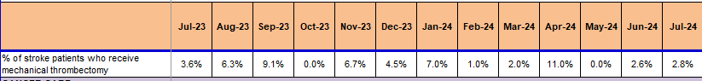

Thrombectomy is offered to SBUHB patients by an agreement in place with North Bristol NHS Trust.

Immediate actions to maximise use of Thrombectomy treatment:

Recommendations/ Action | Lead | Start Date | Implementation / End Date | Progress/ Remarks | Expected Benefit/ Impact on SSNAP Score
Expansion of CT perfusion service from Monday-Friday 9-5pm to 24/7 | Hannah Khirwadkah | May 2024 | July 2024 | 17 radiographers to train on CT/MRI perfusion so being trained as and when cases present.  Training ongoing | Greater compliance with CT<1hour as well as increased thrombectomy rate from increased ability to identify salvageable brain following Stroke.
Continued education to On-call staff about thrombectomy options and NBNHST operating policy to be cascaded | Tal Anjum | May 2024 | May 2024 | Extended opening hours of this service has been cascaded to senior and junior staff  complete | Increased utilisation of thrombectomy service in North Bristol.
Extended ANP cover due to 2 now been signed off to independently see Stroke patients. Another 4 to come on line over the next 12-24 months | Tal Anjum | May 2024 | May 2025 | 2 trained as of May 2024, 4 more ANP colleagues to qualify over the next 24 months | Greater use of thrombectomy services due to quicker identification and referral to Bristol in conjunction with reduced CT and Thrombolysis times.

Other Measures (National Target 95%)

High level of compliance for consultant assessment within 24 hours as well as high levels of therapy input compared to peers.

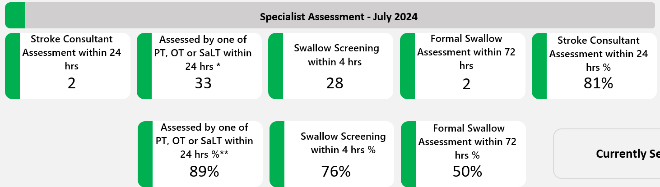

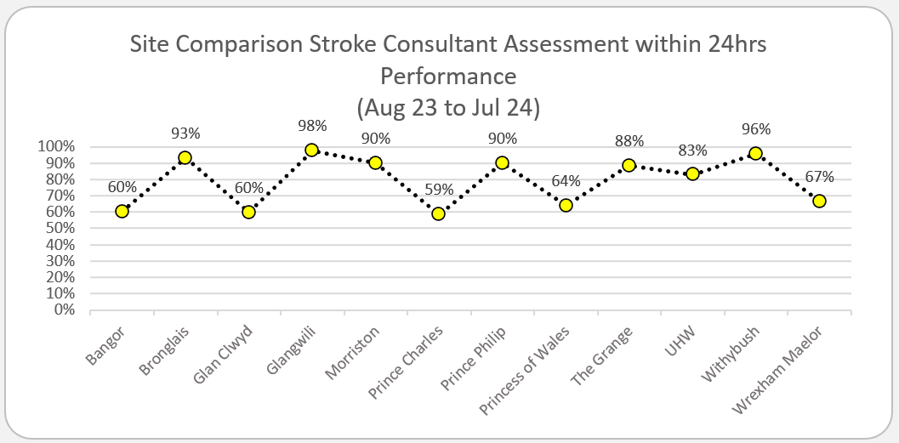

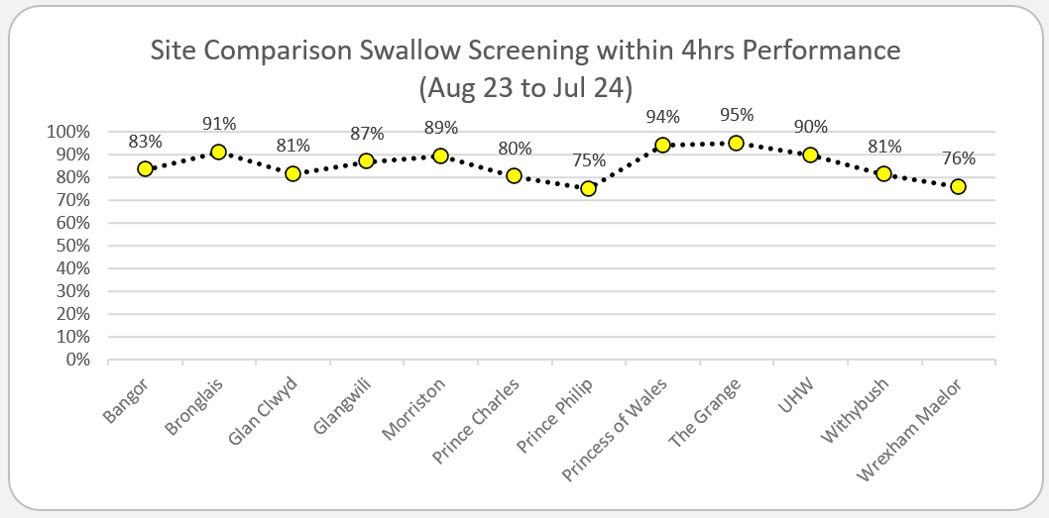
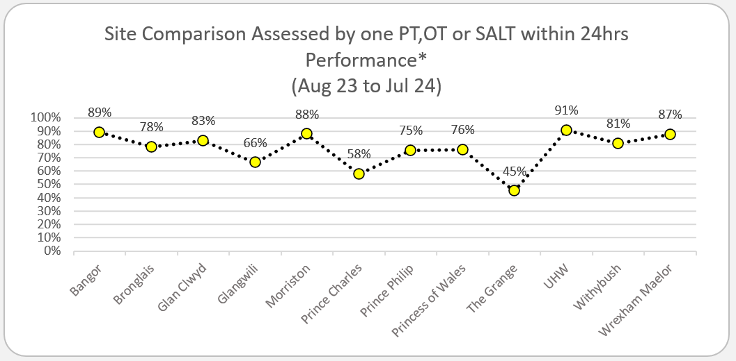

Morriston Discharge Standards (National target 95%) – July 2024

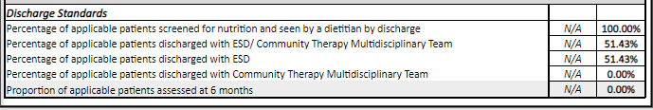

Development of an ESD team was accepted as a Tier 1 priority in the Recovery and Sustainability plan for 2023-24 and therefore we as a department are moving towards meeting this with recruitment having taken place and rehab sites being bolstered. As well as this Development of an Integrated Community Stroke Service will also be pushed.

Recruitment into therapies has taken place as part of the 3-year investment plan for Stroke which is almost fully recruited too.

A further GMO for 2024-25 will be to work towards a Integrated Community Stroke Service (ICSS).

Rehabilitation Performance

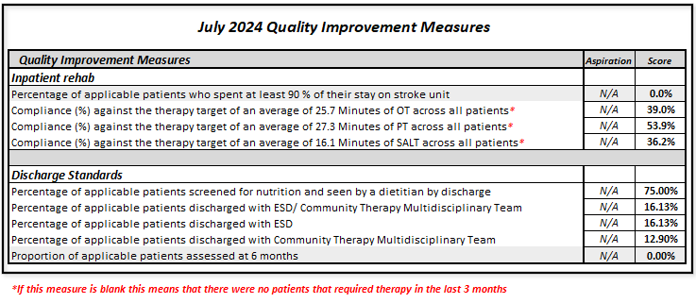
Rehabilitation services for Stroke are now consolidated on 1 site, 28 beds in Neath Port Talbot.

The tables below show the rehabilitation Quality Improvement Measures for August 24. These measures focus on therapy input and the discharge process.

Attached as an appendix at the bottom of this paper is a summary paper of measures being taken and recruitment efforts made to increase compliance with measures.

2.2 Comprehensive Regional Stroke Centre (CRSC) Development

The South West Wales region covers the areas served by Swansea Bay University Health Board (SBUHB) and Hywel Dda University Health Board (HDUHB), which is the largest geographic region in Wales with currently 5 Acute Stroke Service admitting sites.
In March 2023, a Business Case was developed for Morriston Hospital to become a Comprehensive Regional Stroke Centre (CRSC) with an intake of patients from SBUHB and Carmarthenshire residents. However, the cost of establishing a CRSC were determined to be prohibitive at time and it was also acknowledged that both health boards needed to focus on and improve their services first before a regional model could be established. It was agreed that the health boards would meet periodically to maintain relationships, keep each other informed of developments within the service and share best practice.
Since then, SBUHB has continued with it investment of £1.5 million in revenue funding over three years to increase staffing across the stroke pathway, resulting in improved SSNAP and WG tier 1 measures; SBUHB has increased its SSNAP rating, consistently scoring a C for Acute Services and a B for non-acute services in the last quarter. Work is also being carried out to investigate the possibility of Community Discharge as well as Early Supportive Discharge within the health board.
In HDUHB, there has been an investment of £500,000, through the Welsh Government Community AHP funding stream, to develop the Integrated Community Stroke Service; early supportive discharge (ESD) is an integral part of this development. This service now covers the three counties, delivering stroke rehabilitation in the patient's home rather than in a hospital bed. The provision of Stroke also a service that the Health Board will focus on as part of the development of their Clinical Service Plan.
The South West Wales Regional Stroke Programme Managers has also been working with the National Stroke Programme to develop the programme to all worked to be completed Once for Wales.
Over the past 9 months several work streams have been set up these are
- Innovations and Service Improvement
- Workforce and Education
- Data
- Demand and Capacity
- Comms and Engagement
- Hyper Acute Stroke Service
- Prevention and Early Detection
- Service Specification Pathways

2.3 Recruitment into Acute Stroke Services.

1x Stroke consultant post filled – candidate starting in January 2025 but acting up from September 2024.

2 x Further Stroke consultant posts to go out to advert in 2024/25 subject to funding issues being resolved.

2 x Further Physician Associates commenced in post from 2nd September 2024

Integrated Community Stroke Service development is in Health Board GMO’s for 2024/25 and this will result in a host of additional community posts If the business case being developed is agreed.

- GOVERNANCE AND RISK ISSUES

Four main areas of risk highlighted below. The inability to admit patients in a timely manner into the Acute Stroke Unit, inadequate staffing numbers of therapies and lack of a dedicated rota and lack of oxygen ports on the ASU in general which affects the ability to admit as highlighted in the paper.

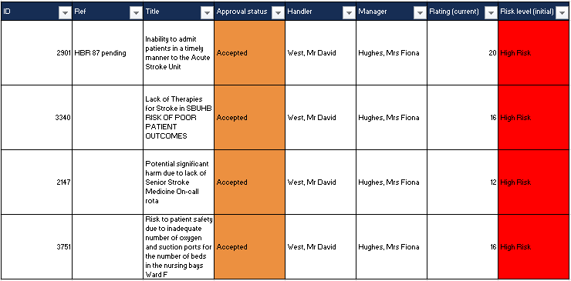

- FINANCIAL IMPLICATIONS

£1.5m expenditure plan over the next few years approved at management board in 2023.
Funding previously agreed to and minuted in management board has not been forthcoming in 2024/25 therefore the two further consultant posts that need to be recruited to may not be able to proceed.

- RECOMMENDATION

The committee is asked note the content of the report for assurance.

Governance and Assurance

Link to Enabling Objectives  (please choose) | Supporting better health and wellbeing by actively promoting and empowering people to live well in resilient communities
Link to Enabling Objectives  (please choose) | Partnerships for Improving Health and Wellbeing |  | ☐
Link to Enabling Objectives  (please choose) | Co-Production and Health Literacy |  | ☐
Link to Enabling Objectives  (please choose) | Digitally Enabled Health and Wellbeing |  | ☐
Link to Enabling Objectives  (please choose) | Deliver better care through excellent health and care services achieving the outcomes that matter most to people
Link to Enabling Objectives  (please choose) | Best Value Outcomes and High Quality Care |  | ☒
Link to Enabling Objectives  (please choose) | Partnerships for Care |  | ☐
Link to Enabling Objectives  (please choose) | Excellent Staff |  | ☐
Link to Enabling Objectives  (please choose) | Digitally Enabled Care |  | ☐
Link to Enabling Objectives  (please choose) | Outstanding Research, Innovation, Education and Learning |  | ☐
Health and Care Standards
(please choose) | Staying Healthy |  | ☐
(please choose) | Safe Care |  | ☐
(please choose) | Effective Care |  | ☒
(please choose) | Dignified Care |  | ☐
(please choose) | Timely Care |  | ☒
(please choose) | Individual Care |  | ☐
(please choose) | Staff and Resources |  | ☐
Quality, Safety and Patient Experience
Four main areas of risk highlighted below. The inability to admit patients in a timely manner into the Acute Stroke Unit, inadequate staffing numbers of therapies and lack of a dedicated rota and lack of oxygen ports on the ASU in general which affects the ability to admit as highlighted in the paper.

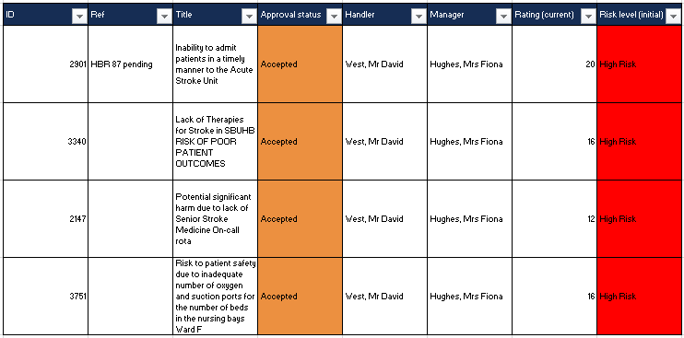

Financial Implications
£1.5m expenditure plan over the next few years approved at management board in 2023.

Funding previously agreed to and minuted in management board has not been forthcoming in 2024/25 therefore the two further consultant posts that need to be recruited to may not be able to proceed.

Legal Implications (including equality and diversity assessment)
No implications to note.

Staffing Implications
None to note.

Long Term Implications (including the impact of the Well-being of Future Generations (Wales) Act 2015)
Briefly identify how the paper will have an impact of the “The Well-being of Future Generations (Wales) Act 2015, 5 ways of working.
- Long Term – Providing enhanced Stroke Services for the SBUHB region.
- Prevention – Enabling timely intervention in patient’s pathways resulting in better outcomes for Stroke survivors.
- Integration – Integrating with other hospital sites to ensure rehabilitation pathways are utilised.
- Collaboration - Acting in collaboration with any other areas such as other hospital sites and tertiary organisations such as the Stroke Association.
- Involvement – Stroke performance is monitored weekly by a range of staff from different backgrounds as well as being scrutinised before a regular executive board.
Report History |  | V1
Appendices |  | Appendix 1 – Improvement Plan

