Meeting Date | 09 September 2025 |  | Agenda Item |  |  | 2.1
Name of Meeting | Population Health Committee
Report Title | Cancer survival and incidence in Wales
Report Author | Kimberley Cann, Consultant in Public Health
Report Sponsor | Gill Richardson, Executive Director of Public Health
Presented by | Dyfed Huws, Director Welsh Cancer Intelligence and Surveillance Unit
Freedom of Information | Open
Purpose of the Report | This paper supports the presentation to the Committee by Dyfed Huws, Director of the Welsh Cancer Intelligence and Surveillance Unit, Public Health Wales.  It summarises the latest data on cancer survival in Wales. Highlighting the stark inequalities in survival from cancer by level of deprivation.  It also summarises the findings of new research exploring the effects of different socio-demographic characteristics on cancer incidence in Wales at an individual level.
Key Issues | Cancer survival worsens with increasing levels of area deprivation. The deprivation gap is wider in men than in women and is not improving. For colorectal cancer and lung cancer the inequality gap in survival by area deprivation is increasing.  Cancer incidence varies by ethnic group as does stage at diagnosis. Those with Mixed ethnicity have the highest proportion of Stage 4 (late) diagnoses. People living in overcrowded accommodation have a cancer incidence rate seven times higher than those living with two or more spare rooms and those who live in social housing have a cancer incidence rate nearly three times higher than those who own their home outright.
Specific Action Required  (please choose one only) | Information | Discussion |  | Assurance | Approval
Specific Action Required  (please choose one only) | ☒ | ☐ |  | ☒ | ☐
Recommendations | Members are asked to:  - RECIEVE the inequalities in cancer survival and cancer incidence in Wales.

CANCER SURVIVAL AND INCIDENCE IN WALES

- INTRODUCTION

Cancer is the leading cause of death in Wales. Wales has the second highest cancer mortality in the UK and the UK has one of the highest cancer mortality rates of all OECD countries. Mortality rates are significantly worse for people living in deprived areas and the gap between the most and least deprived is growing.

The Welsh Cancer Intelligence & Surveillance Unit (WCISU) is the National Cancer Registry for Wales and its primary role is to record, store and report on all incidence of cancer for the resident population of Wales wherever they are treated. WCISU provides information on cancer incidence, survival and mortality over time and monitors trends in cancer to facilitate planning of cancer services for prevention, diagnosis, cure and care.

In June 2025, WCISU were able to link cancer registry data to data from the 2011 Census in England and Wales for the first time. This provides a new, granular snapshot of the socio-demographic profile of people diagnosed with cancer in Wales. Previously cancer statistics could only present inequalities for people in Wales’ characteristics based on age and biological sex. People were assigned to a level of socioeconomic deprivation based on the area in which they live rather than looking at individual characteristics. This may not necessarily reflect their personal level of inequity or deprivation, and area-level analysis of cancer incidence by deprivation can lose detail. This new analysis allows us to see individual or household measures of inequity.

- BACKGROUND

2.1 Cancer survival in Wales

- The latest net cancer survival estimate for Wales shows that for people diagnosed from 2017 to 2021, 63.1% survived cancer 5 years from diagnosis on average.
- Long-term historic improvement in 5-year net cancer survival has stagnated since the 2014-2018 diagnosis period. This stalling in improvement started before the Covid-19 pandemic and has continued beyond it.
- One-year net cancer survival stopped improving appreciably each year of diagnosis from 2014 to 2019, then dipped to 71.9% in 2020, the first full year of the pandemic. This improved significantly to 75.2% in 2021, but only returned survival to the pre-pandemic level (see Figure 1).

Figure 1: 5-year age-standardised net survival (%), all cancers excluding NMSC, persons aged 15-99, Wales.

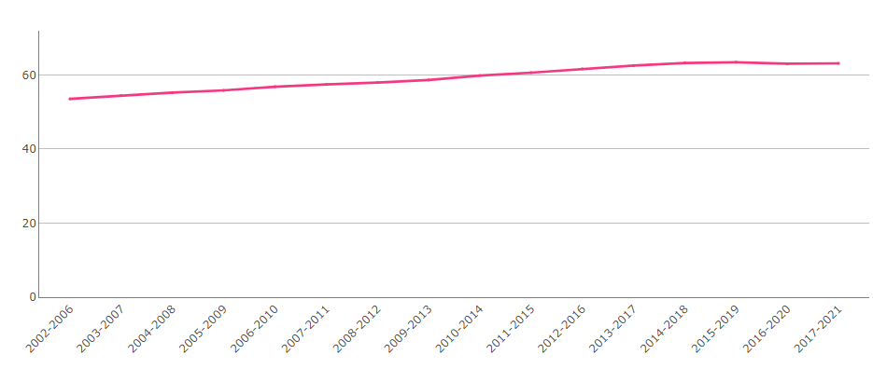

- For specific cancer sites, since the pandemic 1-year lung cancer net survival has not recovered as well as for other major cancers. For men with breast cancer, 5-year net survival (unstandardised) has increased rapidly from 64.3% to 94.5% since the 2009-2013 diagnosis period to 2017 to 2021. In comparison, survival from the much more common female breast cancer has increased from 86.3% to 91.2%.
- For men aged 15-54 diagnosed with colorectal cancer, 5-year net survival declined sharply, falling from 66.9% in 2008-2012 to 53.3% in 2017-2021. A similar but smaller decline can be seen in England and Scotland.
- Since the 2013-2017 diagnosis period, 1-year net survival for liver cancer has declined from 50.7% to 31.8% in those aged 15-54, falling below outcomes for 55-74-year-olds. A similar but smaller decline trend can be seen in England and Scotland.

- Cancer survival worsens with increasing levels of area deprivation (see Figure 2). For the 2017-2021 diagnosis period, 70.1% of people from the least deprived areas survived to 5 years, compared to 51.8% of people from the most deprived areas. This wide deprivation gap has not widened since diagnosis between 2002-2006.
- For 5-year net cancer survival, the deprivation inequality gap remains wider in men (21.5% difference) than women (14.9% difference) in the 2017-2021 period.

Figure 2: 5-year unstandardised net survival (%), all cancers excluding NMSC, persons, all ages, Wales by deprivation fifths.

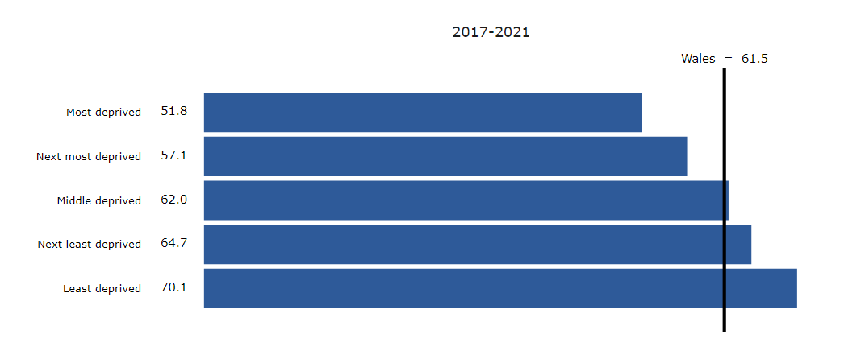

- For people diagnosed with colorectal cancer, 5-year net survival was 49.1% for those living in the most deprived areas compared to 66.0% for those living in the least deprived areas. This inequality gap in net survival is wider than it was for the previous period.

Figure 3: 5-year age-specific net survival (%), colorectal cancer, men aged 15-99, Wales.
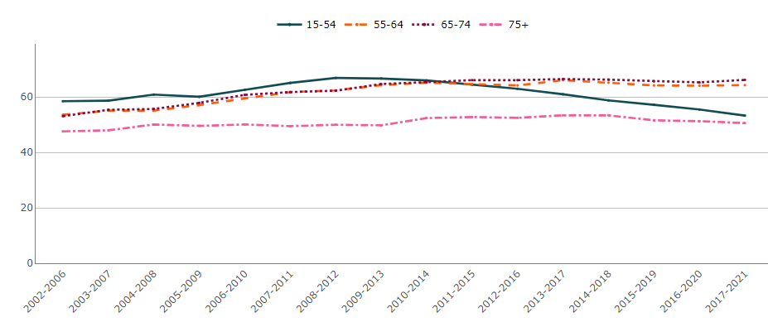

- Between the diagnosis periods 2009-2013 and 2013-2017, 10-year net survival for lung cancer greatly improved in the least deprived areas (from 8.3% to 14.7%), but much less so for the most deprived (from 6.8% to 8.5%), widening existing deprivation inequalities.

Figure 4: 10-year unstandardised net survival (%), lung cancer, persons, all ages, Wales by deprivation fifths.
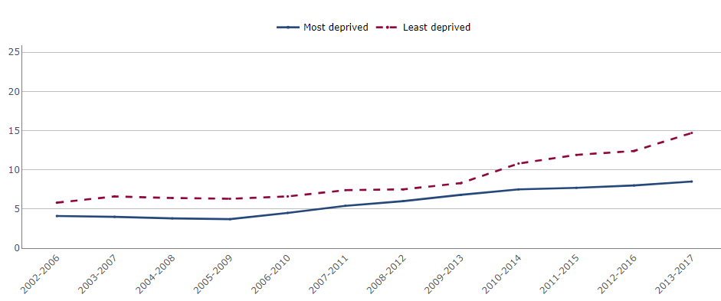

2.2 Cancer incidence by ethnicity

- Recording of ethnicity in health data is often incomplete. Use of Census data has allowed identification of ethnicity and new insights into potential inequalities in cancer incidence between ethnic groups in Wales.
- The White ethnic group had the highest age-standardised rate of cancer incidence in Wales in 2020 (see Figure 5); 1.6 times higher than the lowest rate which was in the Asian group; and 1.5 times higher than the rates for the Black and Other ethnicity groups. It is unclear whey rates were highest in the White population once accounting for different age structures. More work is needed to investigate factors such as deprivation, genetics, or prevalence of risk factors such as smoking and obesity.

Figure 5: Incidence of ethnicity of all cancers combined excluding NMSC, European age-standardised rate per 100,000 persons, all ages, Wales, 2020.
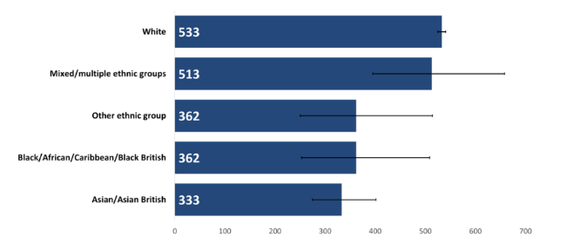

- There are differences in the types of cancers diagnosed in each ethnic group in Wales (see Figure 6). The Asian group has a higher proportion of female breast cancer diagnoses compared to other cancer types, whilst the Black group has a higher proportion of prostate cancer diagnoses.

Figure 6: Proportion (%) of each cancer type within each ethnic group, persons, all ages, Wales, 2011-2020.

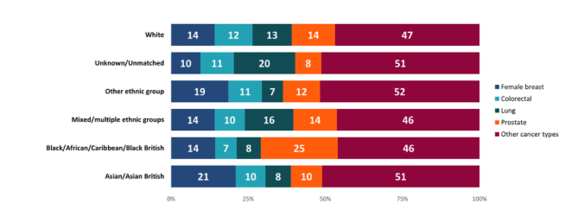

- An earlier stage at diagnosis is associated with improved outcomes. The Mixed ethnicity group had a higher proportion of late-state (Stage 3 and 4) diagnoses, whilst the Asian and Other ethnicity groups had higher proportions of early-stage (Stage 1 and 2) diagnoses. The Black group had a higher proportion of Stage 2 diagnoses compared to other stages. These results may indicate variation in types of cancer diagnosed in people of different ethnicities, differences in health-seeking behaviour or access to health services and experiences along the care pathway.

Figure 7: Proportion (%) of each stage at diagnosis by ethnic group, all cancers combined excluding NMSC, persons, all ages, Wales, 2011-2020.

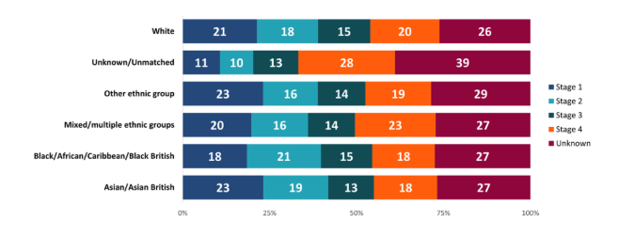

2.3 Cancer incidence by overcrowding

- Overcrowding may indicate levels of deprivation. Deprivation is a risk factor for cancer in part because it is linked to higher prevalence of smoking, obesity, and alcohol consumption. It also contributes to barriers to accessing healthcare or seeking help, and experiences of longer wait times for care.
- The age-standardised rate of cancer incidence was 70% higher for those with fewer bedrooms than required compared to the next highest rate in people with one spare bedroom (see Figure 8). If no factors other than overcrowding were at play, we would expect to see people with a standard number of bedroom having the next highest rate. Instead people with one spare bedroom had the second highest rate of cancer diagnoses. This could be because people living in housing with fewer bedrooms than required may be more likely to be experiencing material or financial deprivation.

Figure 8: Incidence of all cancer combined excluding NMSC by number of bedrooms, European age-standardised rate per 100,000 persons, all ages,2020.

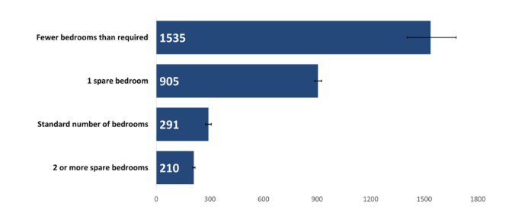

- The ‘one spare bedroom’ and ‘two or more spare bedrooms’ categories had higher proportions of people over 65 years of age (see Figure 9). However, a large proportion of people with cancer diagnosed between 2011 and 2020 had fewer bedrooms than required were also 65 years of age or over.

Figure 9: Proportion (%) of age at diagnosis for incidence counts of all cancers combined excluding NMSC by number of bedrooms, persons, Wales, 2011-2020.

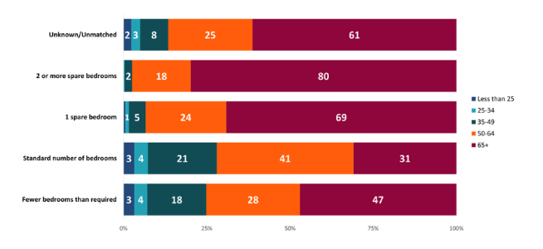

2.4 Cancer incidence by household tenure

- Housing tenure may indicate levels of deprivation, with those owning their own property being less likely to be deprived compared to those who do not own their own home. Lower quality housing is a major driver of health inequalities and poverty in the UK and can majorly impact people’s health and well-being.
- The age-standardised rate for those living in social rented housing was 3 times higher than for those who owned their home outright (see Figure 10). The lowest rate was seen in those who owned their home outright.
- A large majority of those owning their home outright or living rent free were over 65 years of age (see Figure 11). There was a high proportion of cancer in those aged 50-64 who owned their home with a mortgage or loan.

Figure 10: Incidence of all cancers combined excluding NMSC by household tenure, European age-standardised rate per 100,000 persons, all ages, Wales, 2020.

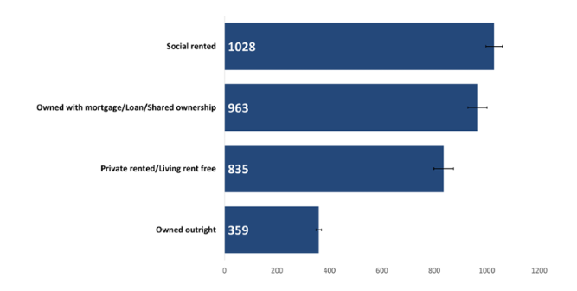

Figure 11: Proportion (%) of ages for all cancers combined excluding NMSC by household tenure, persons, Wales, 2011-2020.
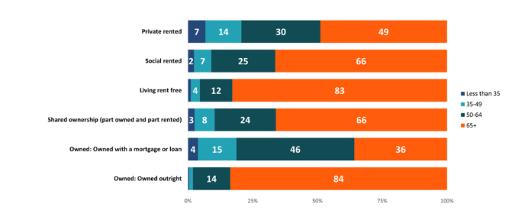

2.5 Cancer incidence by occupation

- Cancer incidence was significantly higher in retired people whose previous roles were within machine operation, skilled trades or elementary jobs such as factory works, tradespeople, retail workers, cleaners and labourers, compared to retired people in other occupational groups. Rates were lowest in technical and professional occupations.
- There was less difference between the highest and lowest rates of cancer incidence in people in active occupation compared to in retirees. The highest cancer incidence rate for those in active occupation was also smaller than the lowest rate seen for retirees, reflecting the impact of age on cancer incidence.
- Female breast cancer was often diagnosed in female-dominated jobs and prostate cancer diagnosed in more male-dominated jobs when looking at active occupation groups (see Figure 12).
- Those in professional occupations had a higher proportion of early-stage diagnoses compared to those working in elementary occupations, such as cleaners or labourers, who had a higher proportion of late-stage diagnoses.

Figure 12: Proportion (%) of each cancer type by active occupation, persons aged 16+ years, Wales, 2011-2020.

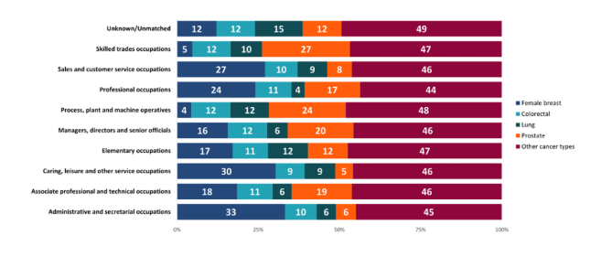

- GOVERNANCE AND RISK ISSUES

There is a risk that people living in the most deprived areas of Swansea Bay have worse outcomes from Cancer in terms of mortality when compared with those living in the least deprived areas.

- FINANCIAL IMPLICATIONS

Treating cancer at later stages is costly personally and financially for services. Financial provision will be needed for improved screening uptake and primary care training as well as health literacy programmes in deprived areas of Swansea Bay.

- RECOMMENDATION

Members are asked to:
- RECIEVE the inequalities in cancer survival and cancer incidence in Wales.

Governance and Assurance
Link to Enabling Objectives  (please choose) | Supporting better health and wellbeing by actively promoting and empowering people to live well in resilient communities
Link to Enabling Objectives  (please choose) | Partnerships for Improving Health and Wellbeing |  | ☐
Link to Enabling Objectives  (please choose) | Co-Production and Health Literacy |  | ☐
Link to Enabling Objectives  (please choose) | Digitally Enabled Health and Wellbeing |  | ☐
Link to Enabling Objectives  (please choose) | Deliver better care through excellent health and care services achieving the outcomes that matter most to people
Link to Enabling Objectives  (please choose) | Best Value Outcomes and High Quality Care |  | ☐
Link to Enabling Objectives  (please choose) | Partnerships for Care |  | ☐
Link to Enabling Objectives  (please choose) | Excellent Staff |  | ☐
Link to Enabling Objectives  (please choose) | Digitally Enabled Care |  | ☐
Link to Enabling Objectives  (please choose) | Outstanding Research, Innovation, Education and Learning |  | ☐
Health and Care Standards
(please choose) | Staying Healthy |  | ☒
(please choose) | Safe Care |  | ☐
(please choose) | Effective Care |  | ☐
(please choose) | Dignified Care |  | ☐
(please choose) | Timely Care |  | ☐
(please choose) | Individual Care |  | ☐
(please choose) | Staff and Resources |  | ☐
Quality, Safety and Patient Experience
None

Financial Implications
Treating cancer at later stages is costly personally and financially for services. Financial provision will be needed for improved screening uptake and primary care training as well as health literacy programmes in deprived areas of SBUHB.

Legal Implications (including equality and diversity assessment)
None

Staffing Implications
None

Long Term Implications (including the impact of the Well-being of Future Generations (Wales) Act 2015)
Reducing inequalities in cancer survival and incidence supports The Well-being of Future Generations (Wales) Act 2015. In particular, the Well-being Goals of a more equal Wales and a healthier Wales.

Report History |  | None
Appendices |  | None

https://phw.nhs.wales/services-and-teams/welsh-cancer-intelligence-and-surveillance-unit-wcisu/about-us/
https://phw.nhs.wales/services-and-teams/welsh-cancer-intelligence-and-surveillance-unit-wcisu/inequalities-in-cancer-incidence-in-wales-by-socio-demographic-characteristics-2011-2020/
Cancer survival - Public Health Wales
Overcrowding is based on the number of persons per bedroom in household indicator in the ONS 2011 Census. Those living in communal establishments such as care homes were excluded.

