
Pictured: Upper Valleys LCC business development and implementation manager Martyn Goss and cluster development support manager Helen Gray.

A primary care team has been supporting its community to live an even healthier lifestyle by hosting its first health and wellbeing events.

The Upper Valleys Local Cluster Collaborative (LCC) organised the events where people could learn more about services and support available to them.

The LCC, which covers the Swansea, Dulais and Neath valleys, held its first event at the Pontardawe Wellbeing Hub, with a second event following a week later at Glynneath Leisure Centre.

Members of the public were able to chat to a range of community groups and organisations and even try out yoga and kickboxing sessions.

It is hoped more events will be held in the coming months.

Niki Watts, Upper Valleys LCC lead, said: “We decided to host wellbeing events to raise the profile of the Upper Valleys Cluster, promote health literacy and educate the public about self-care.

“The purpose was to raise awareness of the wide range of health and wellbeing related services and bodies available in the Upper Valleys area.

“It was also an opportunity for those services to link up and be aware of what they can support and signpost people to as well.”

There were a number of stalls at both events, including staff from organisations such as Swansea City AFC Foundation (pictured), In Work Support Service and Neath Port Talbot Community Voluntary Service.
“It was also an opportunity for those services to link up and be aware of what they can support and signpost people to as well.”

There were a number of stalls at both events, including staff from organisations such as Swansea City AFC Foundation (pictured), In Work Support Service and Neath Port Talbot Community Voluntary Service.

Staff from the health board’s diabetes prevention programme, end of life care and immunisation services also attended to answer questions and offer advice.
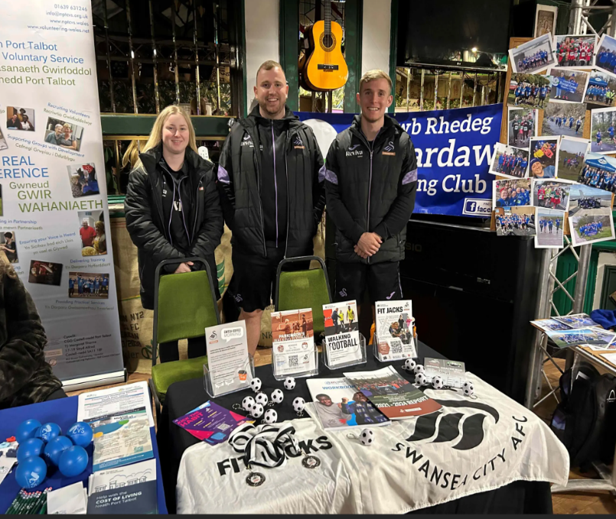
Rachel Long, diabetes prevention dietician, said: “The diabetes prevention programme supports the clusters to help support patients at risk of developing diabetes.

“Our dietetic support workers provide information around healthy eating and lifestyle.

“We attended the events to promote the service, as well as healthy eating and lifestyle messages, and to offer mini health checks around height and weight.

“We also signposted people to the Know Your Risk online tool where people can see their risk of diabetes.”

Annette Thomas and Louise Jenkins, deputy immunisation coordinators, were also on hand to answer questions around vaccinations.

They said: “We attended to give people an opportunity to ask the questions specific to them around immunisation.

“We can give people the information they need to make the decisions they want to make and to give them the opportunity to discuss any worries.

“We can signpost people to the right information and provide reassurance on any misinformation.”

By making people aware of the organisations and services available to them in the community, it is hoped they can access support directly when needed.

Niki added: “Historically patients have relied heavily on GP practices for advice and support which isn’t always the best route for them.

“There are so many support services out there that people can access and which may be better suited to accommodating their needs whilst being easier and quicker to access too.

“Accessing more appropriate services will also help to ease the burden on GP practices. Very often it isn’t clinical intervention that is required.

“An example of this would be yoga sessions which can help people both physically and mentally, and especially support with frailty in patients and falls prevention.”

