Meeting Date | 08 September 2026 | Agenda Item | 2.2
Name of Meeting | Population Health Committee
Report Title | Child Measurement Programme
Report Author | Lynnette Thomas, Assistant Director – Health Improvement and Wider Determinants
Report Sponsor | Executive Director of Public Health
Presented by | Lynnette Thomas, Assistant Director – Health Improvement and Wider Determinants
Freedom of Information | Open
FoI Closed detail | If closed, choose detail
Impact Assessment Summary Outcome |  | IA Completion date
n/a |  | Click or tap to enter a date.
Purpose of the Report | For Assurance
Report Summary; detailing any action required
This report summarises population level data of the key findings of the Child Measurement Programme (CMP) for the 2024/25 academic year for the purposes of surveillance.
Key Issues
- Participation in the CMP remains high in Swansea Bay at 95.9%, providing robust data on child health trends.
- Childhood obesity has increased from 11.6% to 13.0%, with 27.5% of children now living with overweight or obesity.
- Significant health inequalities remain, with obesity rates almost twice as high in the most deprived communities (16.9%) compared to the least deprived (9.3%).
- The data suggests the gap between the most and least deprived communities may be widening, reinforcing the need for targeted prevention and early intervention.
- The findings will inform Healthy Weight, Healthy Wales and local health improvement programmes, supporting action to improve child health and reduce inequalities across Swansea Bay.

Decision / Action required | No
Recommendations
Members are asked to:
- TAKE ASSURANCE of the CMP data and implications for tackling health inequalities of children in Swansea Bay.

CHILD MEASUREMENT PROGRAMME

- INTRODUCTION
This paper provides an update on the annual Child Measurement Programme (CMP) Survey which measures the height and weight of children in reception class (aged 4-5).

Public Health Wales is responsible for the coordination of the CMP and every health board across Wales participates in the programme.

This paper summarises the data collected during the 2024/25 school year.

- BACKGROUND

  - Methodology
The CMP provides a systematic approach to monitoring children in reception year. School Nursing staff measure the height and weight of all reception-aged children, unless a parent or guardian has opted their child out of the programme. Parents may also request that their child is measured while choosing not to have the results included in the programme dataset.

Height and weight measurements are recorded by Health Board staff within the child’s electronic health record. At the end of each academic year, anonymised measurement data are submitted to the Public Health Wales Observatory for analysis. The data is assessed at local authority, Health Board and national levels to monitor patterns and trends in child growth and weight status. All data is transferred and processed in a manner that protects confidentiality, ensuring that individual children cannot be identified by those responsible for analysis and reporting.

The methodology aligns with that used elsewhere in the UK, including the National CMP in England, enabling robust comparisons across nations.

Childhood obesity is associated with an increased risk of adverse physical and mental health outcomes and is more likely to persist into adulthood. Continued surveillance is therefore essential to understanding trends over time, identifying population groups at greater risk, and informing targeted prevention strategies, service planning and policy development aimed at improving health outcomes and reducing health inequalities.

During the 2024/25 academic year, 28,512 children were measured in Wales, resulting in a participation of 94.7%. This is the highest all-Wales participation since the programme began in 2013/14. A total of 3,412 children were measured in Swansea Bay, resulting in a participation of 95.9% for 2024/25. This was a similar to the previous year in 2023-24 (95.7%) and higher than the Wales average.
2.2 Comparisons with other parts of the UK
The prevalence of obesity among children measured through the England National Child Measurement Programme (NCMP) 2024/25 was 10.5%, representing an increase compared with the previous three years. Despite this increase, prevalence remained lower than that reported in Wales (12.8%). Comparisons with Scotland should be interpreted with caution, as children typically start school several months older than their counterparts in England and Wales. In Scotland, the prevalence of obesity among Primary 1 children was 11.8%. The Northern Ireland Statistical Report on Children’s Health 2024/25 has not yet been published and comparable data is therefore unavailable.
Figure 1: Proportion of children aged 4-5, overweight and obese, 2005-25
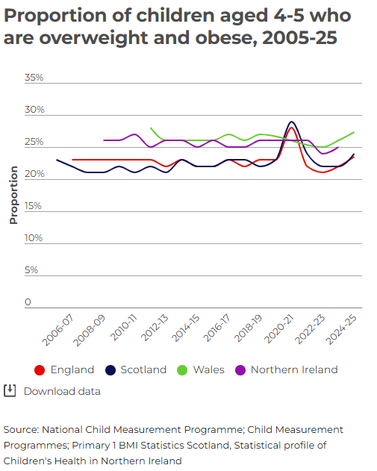
In 2024-25 around a quarter of 4-5-year-olds were overweight or living with obesity in England (23.5%) and Scotland (24%). This was similar in Wales (27.3%) and Northern Ireland (25%) in 2023-24. These rates have not changed significantly in any of the four nations.

2.3 Comparisons within Wales

2.3.1 Obesity
The prevalence of children with obesity in Swansea Bay UHB in 2024/25 has increased to 13.0% compared with 11.6% for the previous year.

Figure 2: Prevalence of children aged 4-5 years with obesity, Health Boards, 2024-25

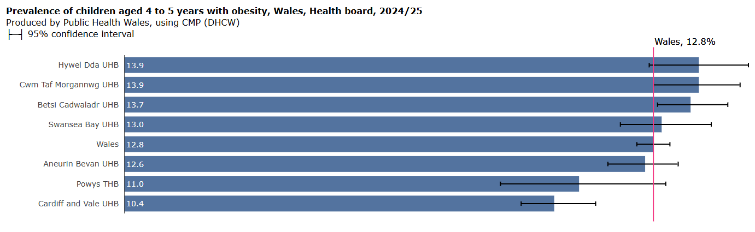

Figure 2 highlights that Swansea Bay is slightly higher than Welsh average for obesity (13.0% cf Wales 12.8%) and ranks 4/7 of all Welsh Health Boards. This masks the difference between local authorities: Swansea at 12.7% and Neath Port Talbot (NPT) at 13.6%. Figure 3 highlights NPT as 9th highest in Wales and Swansea is 13th our of 22 local authorities in Wales.

Figure 3: Prevalence of children aged 4-5 years with obesity, Local authorities, 2024-25

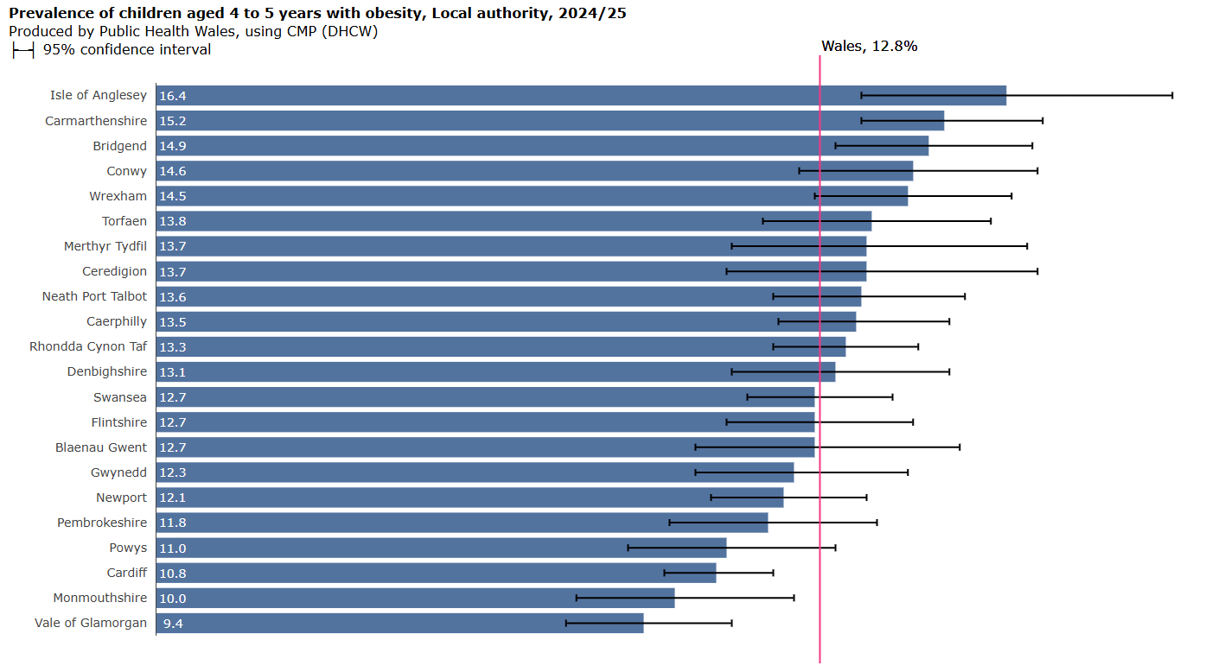
2.3.2 Overweight or obesity
The prevalence of children with overweight or obesity was 27.5%. This compares with 25.4% which was reported for the previous year.

Figure 4 highlights that Swansea Bay is around about the Welsh average for overweight/obesity (27.5% cf Wales 27.3%).

Figure 4: Prevalence of children aged 4-5 years with overweight or obesity, Wales, Swansea Bay, Local authorities, 2024-25
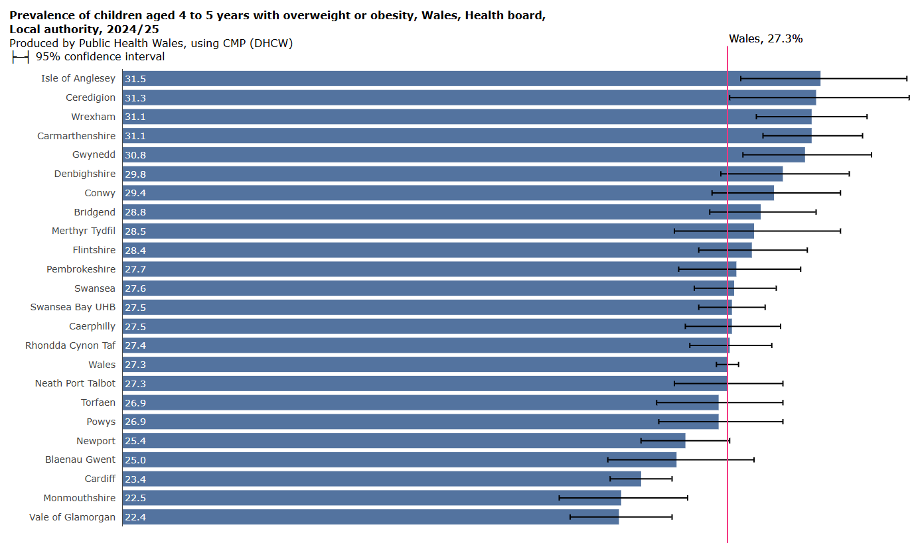

2.3.3 Underweight
The reported prevalence of children in the Health Board measured with underweight was 0.7%, compared to 0.9% for the previous year. It was 0.9% as a Wales average. Swansea was 14/17 local authorities in Wales with 0.7% and NPT was 15/17 with 0.6% as highlighted in Figure 5.

Figure 5: Prevalence of children aged 4-5 years with underweight, Wales, Swansea Bay, Local authorities, 2024-25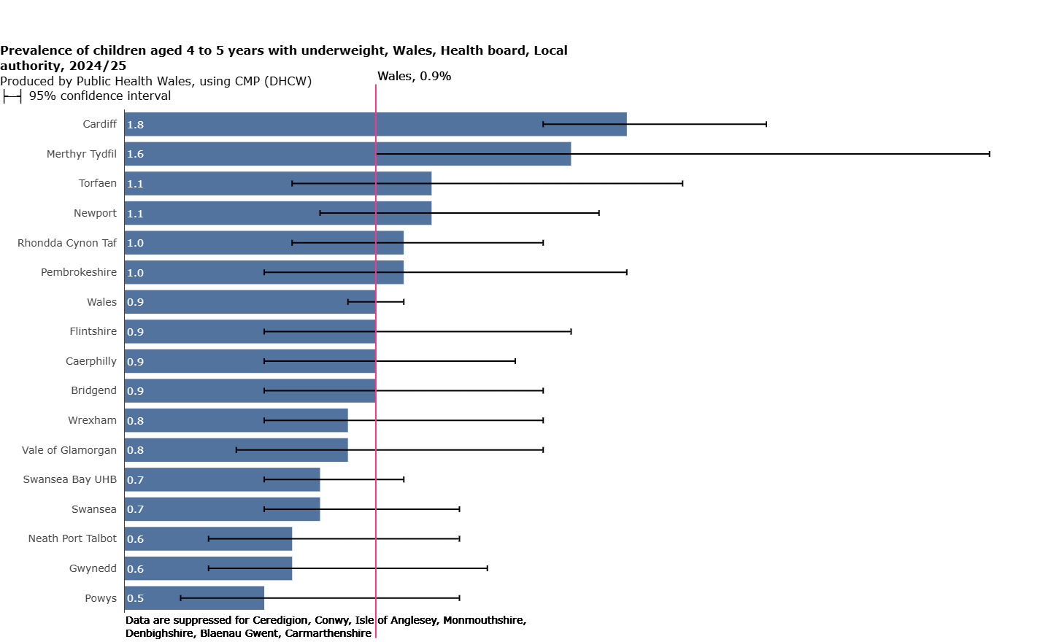

2.3.4 Sex
At Health Board level, the prevalence with obesity was similar for boys (13.7%) and girls (12.4%).

In NPT the prevalence of boys living with obesity was 15.3% compared with 12.0% of girls. In NPT the prevalence of boys living with overweight or obesity was 29.8% (over Wales average 27.5%) compared with 24.8% of girls (under Wales average 27.1%).

Girls in Swansea are over the Wales average in overweight or obesity (27.5% cf 27.1%) and obesity (12.7% cf 12.2%. Boys in Swansea are over the Wales average in overweight or obesity (27.8% cf 27.5%) and under on obesity (12.7% cf 13.3%).

2.3.5 Rurality
This data is only available at a Wales level. The prevalence of children living with overweight or obesity in rural areas was slightly higher at 28.2% compared with 27.0% in urban areas, although this cannot be confirmed as statistically significant.

2.3.6 Deprivation
Within Swansea Bay there was a statistically significantly higher prevalence of children with obesity in the most deprived fifth (16.9%) compared to the least deprived (9.3%). In the most deprived fifth, 32.5% of children were living with overweight or obesity. There is variation over time, although it appears that this gap has widened in 2024/25 compared with the previous year. However, this result should be interpreted with caution as there is not enough data observations to confirm trends. Figure 6 highlights the trend over time. Whereas the least deprived fifth appears to be decreasing or stabilising over time, the most deprived fifth has increased in the last year.

Figure 6: Prevalence of children aged 4-5 years with obesity, local deprivation fifths, 2016-17 to 2024-25
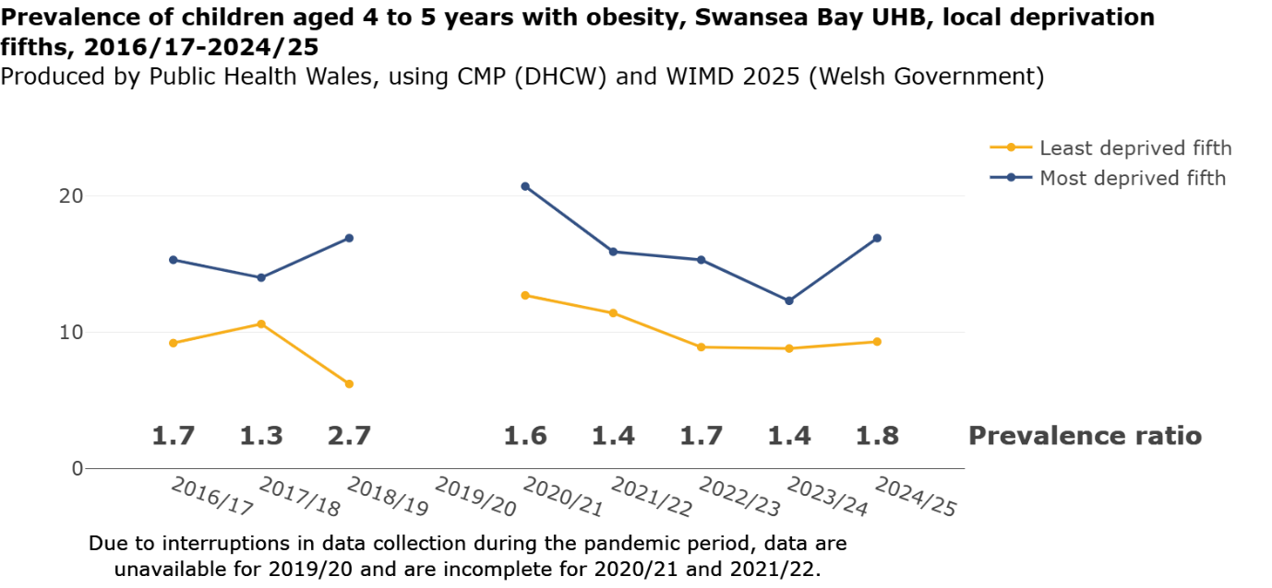

2.4 Primary Care Clusters
The prevalence of children with obesity ranged from 8.2% in the Upper Valleys to 16.7% in City Health (Figure 7). Figure 8 highlights the variances in map form.

Figure 7: Prevalence of children with obesity, Primary Care Cluster, 2024-25
Cluster | %
City Health | 16.7
Afan | 15.8
Penderi | 14.3
Neath | 14.1
Cwmtawe | 12.5
Bay Health | 10.9
Llwchwr | 10.1
Upper Valleys | 8.2
Figure 8: Prevalence of children with obesity, Primary Care Cluster, 2024-25
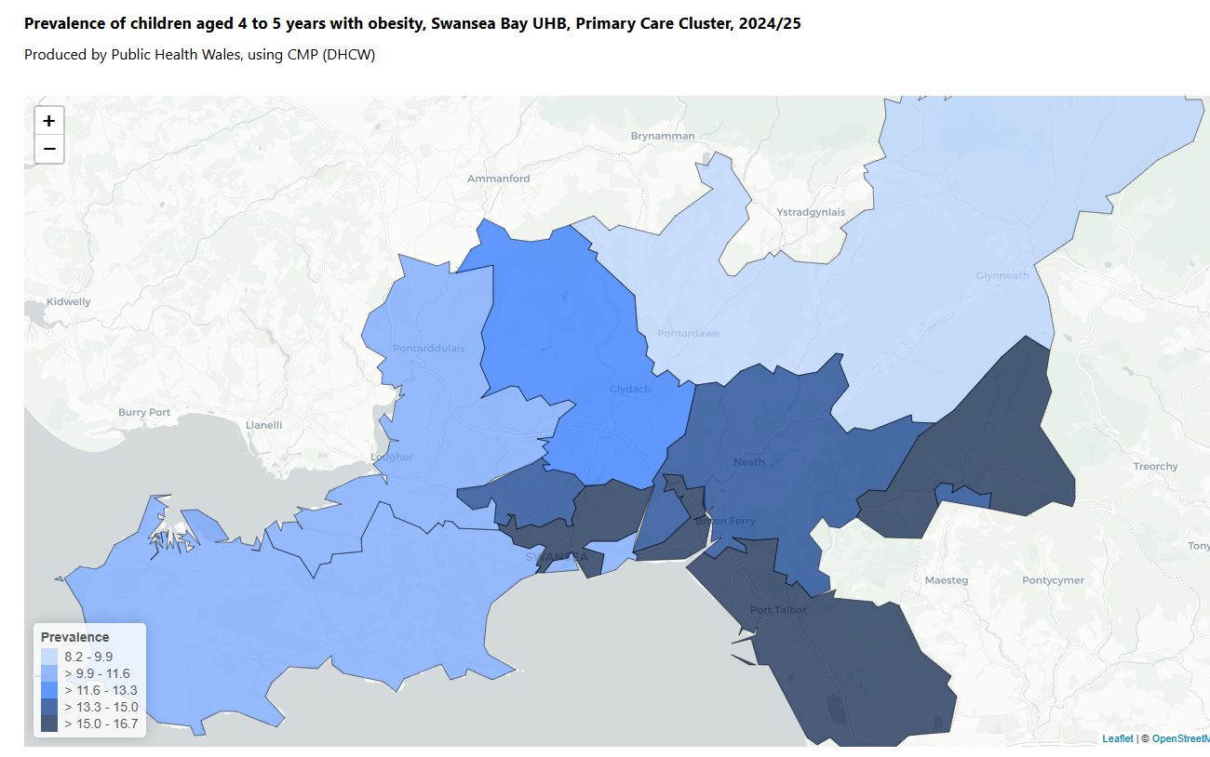
Figure 9: Prevalence of children with overweight or obesity, Primary Care Cluster, 2024-25
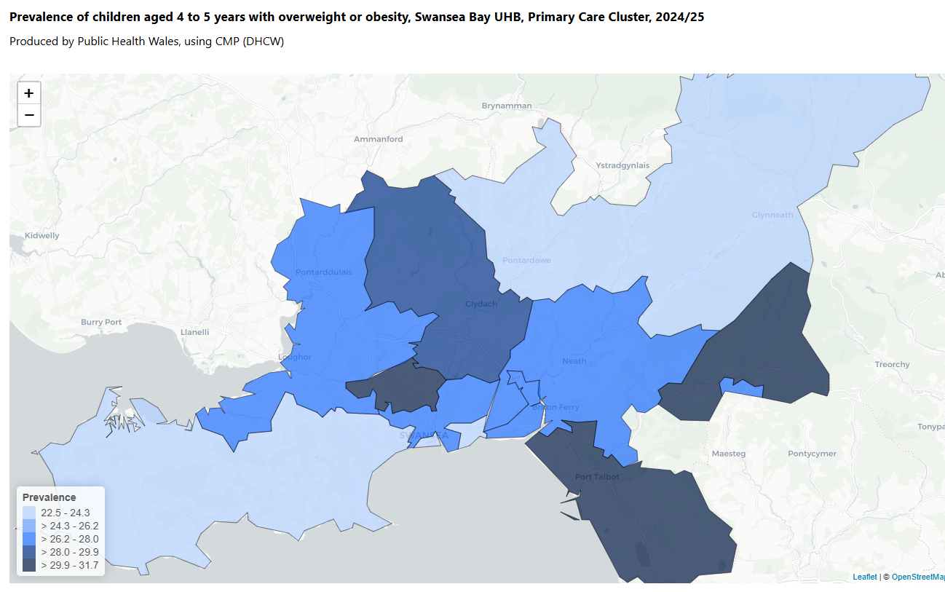
The Penderi cluster had the highest prevalence of overweight or obesity in the Health Board at 31.7% and the Upper Valleys had the lowest at 22.5% as demonstrated in Figures 9 and 10.

Figure 10: Prevalence of children with overweight or obesity, Primary Care Cluster, 2024-25
Cluster | %
Penderi | 31.7
Afan | 30.4
Cwmtawe | 28.9
Llwchwr | 27.6
City Health | 26.6
Neath | 26.5
Bay Health | 24.2
Upper Valleys | 22.5

- GOVERNANCE AND RISK ISSUES
These findings reinforce risks already recognised by the Health Board relating to:

- Increasing demand on health and care services associated with obesity-related ill health across the life course.
- Persistent health inequalities linked to deprivation and wider determinants of health.
- Reduced opportunities for children and families to achieve healthy weight outcomes, particularly in disadvantaged communities.

The CMP helps to mitigate these risks by providing robust surveillance data that enables evidence-based planning, targeting of resources, and evaluation of interventions. Findings will continue to inform Healthy Weight, Healthy Wales priorities, school nursing activity, public health programmes, and collaborative work with local authority partners and the Public Service Boards to address obesity and wider determinants of health. Particular focus will be given to targeting prevention and early intervention activity in areas demonstrating the highest prevalence and greatest inequalities.

The data identifies significant inequalities in childhood obesity outcomes associated with socioeconomic deprivation, with children living in the most deprived communities within Swansea Bay significantly more likely to be living with obesity or overweight than those in the least deprived communities. The key mitigating action is the continued use of this intelligence to target prevention and health improvement interventions proportionately towards communities experiencing the greatest burden of obesity and deprivation, thereby supporting the Health Board's objectives to reduce inequalities and improve population health outcomes.
- OPEN AUDIT RECOMMENDATIONS
There are no open audit recommendations related to this paper.

- FINANCIAL IMPLICATIONS
There are no financial implications related to this paper.

- RECOMMENDATION
Members are asked to take cognisance of the CMP data and implications for tackling health inequalities of children in Swansea Bay.

Governance and Assurance
Strategic Objectives
Strategic Objectives  (please choose which is impacted) | People of Swansea Bay live healthier, fairer and more prosperous lives | ☒
Strategic Objectives  (please choose which is impacted) | Care is high quality, safe, efficient and delivers the best possible outcomes for people in partnerships | ☐
Strategic Objectives  (please choose which is impacted) | Care is delivered in partnership with our communities in safe and appropriate setting, supported by innovation | ☐
Strategic Objectives  (please choose which is impacted) | The health board is a great place to work where staff feel valued and work together towards a common goal | ☐
Strategic Objectives  (please choose which is impacted) | The health board is a resilient, sustainable and responsible organisation | ☐
Health and Care Standards
Standards (please choose which applies) | Safe Care | ☐
Standards (please choose which applies) | Timely Care | ☒
Standards (please choose which applies) | Effective Care | ☐
Standards (please choose which applies) | Efficient Care | ☐
Standards (please choose which applies) | Equitable care | ☐
Standards (please choose which applies) | Person-centred Care | ☐
Standards (please choose which applies) | Staff and Resources | ☐
Enablers (please choose which applies) | Whole Systems Approach | ☒
Enablers (please choose which applies) | Leadership | ☒
Enablers (please choose which applies) | Workforce | ☐
Enablers (please choose which applies) | Culture | ☐
Enablers (please choose which applies) | Information | ☒
Enablers (please choose which applies) | Learning, Improvement and Research | ☒
Quality, Safety and Patient Experience
There are anticipated positive impacts on quality, safety or patient experience arising from this report.

Financial Implications
There are no financial implications related to this paper.

Legal Implications (including equality and diversity assessment)
There are no legal implications related to this paper. Services should be encouraged to target prevention and health improvement interventions proportionately towards communities experiencing the greatest burden of obesity and deprivation.
Staffing Implications
There are no staffing implications related to this paper.

Long Term Implications (including the impact of the Well-being of Future Generations (Wales) Act 2015)
The findings support the Well-being of Future Generations (Wales) Act 2015 by strengthening the evidence base for prevention, early intervention and reducing health inequalities. The programme contributes to the well-being goals of a Healthier Wales and a More Equal Wales by informing targeted action in communities with the greatest need. It also supports collaborative working across health, education and local government to address the wider determinants of health. There are no specific implications for the Welsh language.

Report History
Population Health Committee, December 2025, Agenda item 3.2: Child Measurement Programme Report 2023-24
Appendices
Additional information can be obtained from:
https://www.gov.uk/government/statistics/national-child-measurement-programme-ncmp-annual-report-academic-year-2024-to-2025-england
https://phw.nhs.wales/topic/child-measurement-programme/

State of Child Health | RCPCH

