Meeting Date | 08 September 2026 | Agenda Item | 3.3
Name of Meeting | Population Health Committee
Report Title | Diabetes Redesign
Report Author | Kerith Jones, Head of Value Based Healthcare
Report Sponsor | Executive Medical Director
Presented by | Kerith Jones, Head of Value Based Healthcare
Freedom of Information | Open
FoI Closed detail | If closed, choose detail
Impact Assessment Summary Outcome |  | IA Completion date
N/A |  | Click or tap to enter a date.
Purpose of the Report | For Assurance
Report Summary; detailing any action required
This report provides an update on the Diabetes Redesign Programme and the proposed approach to refreshing the Diabetes Community Model business case. The programme seeks to develop an evidence-based, sustainable model of care that improves outcomes for people living with diabetes, reduces health inequalities, supports prevention and enables more care to be delivered closer to home.

The proposed programme of work is currently being reviewed through Delivery Unit prioritisation processes to determine its alignment with organisational priorities and the availability of transformation resource. The outcome of this review will inform recommendations to Executive colleagues regarding the future delivery approach for the programme.

Key Issues
Diabetes prevalence and service demand continue to rise across Swansea Bay, with an estimated 8,000 additional people expected to be living with diabetes by 2035/36.

At the same time, reductions in recurrent Wales national Diabetes Prevention Programme funding are requiring changes to prevention delivery arrangements. The Diabetes Redesign Programme is reviewing current pathways, workforce and service capacity to develop a sustainable community model of care that improves outcomes, reduces inequalities and supports care closer to home.

Decision / Action required | No
Recommendations
Members are asked to:

- CONSIDER the update on the Diabetes Redesign Programme.
- CONSIDER the findings from the review of the existing Diabetes Community Model business case.
- CONSIDER the proposed programme approach, including stakeholder engagement, demand and capacity assessment, and pathway mapping across diabetes services, recognising that progression of the programme remains subject to ongoing organisational prioritisation discussions and resource availability
- CONSIDER that a refreshed business case may be developed, subject to the outcome of organisational prioritisation discussions, incorporating updated demand, capacity, workforce, financial and benefits information.
- RECEIVE a further update on programme findings, recommendations and any proposed next steps following completion of the Delivery Unit prioritisation review.

DIABETES REDESIGN

- INTRODUCTION
This report provides an update on the Diabetes Redesign Programme and outlines the proposed approach to reviewing and refreshing the Diabetes Community Model business case. The programme seeks to develop an evidence-based, sustainable model of care that improves outcomes for people living with diabetes, reduces health inequalities, supports prevention and enables more care to be delivered closer to home. The proposed programme of work is currently being considered through organisational prioritisation processes to determine its alignment with Health Board priorities and the availability of transformation resources. The outcome of this review will inform recommendations regarding the future pace, scope and resourcing of the programme.

- BACKGROUND
Diabetes continues to represent a significant and growing challenge across Swansea Bay University Health Board (SBUHB), impacting population health outcomes and creating increasing demand across primary, community and secondary care services. Previous work identified the need to redesign diabetes services to support earlier intervention, improve patient outcomes and deliver more care closer to home through the development of an integrated community-based model of care.

The existing Diabetes Community Model business case (Dec 2025) identified a compelling case for change, citing rising diabetes prevalence, increasing demand across services and the need to reduce reliance on hospital-based care through the implementation of a community diabetes model. The proposed model aligns with the Health Board's strategic objectives, as well as alignment with the principles and strategic direction set out through the Transforming for the Future SBUHB Clinical Services Strategic Plan (under development), and the wider All Wales ambition to optimise diabetes care, improve access to the right clinical expertise and support care closer to home that’s aligned to the Community by Design national priority work programme.

The previous business case highlighted that approximately 24,000 people in Swansea Bay were living with diabetes, alongside significant system pressures including diabetes-related admissions, longer lengths of stay, high amputation rates and increasing demand for specialist services. If current trends continue, it is estimated around an extra 8000 adults will be living with diabetes in Swansea Bay by 2035/36. Swansea Bay also remains the only Health Board in Wales without a dedicated community diabetes model. In addition, whilst the Diabetes Prevention Programme had been expanded to deliver across all eight clusters, reductions in ongoing funding are leading in changes to the model of delivery of the prevention programme to support future sustainability.

Whilst the strategic case for change remains valid, further work is required to strengthen the evidence base underpinning the business case. There is a need to validate population health need, demand and capacity assumptions, review workforce requirements, establish measurable benefits and ensure future investment decisions are supported by robust data.

As reliable patient-level and operational data has not been available to undertake a comprehensive baseline review, the programme proposes to gather need, demand, capacity and workforce information directly from clinical teams and stakeholders. This will be supported by pathway mapping across primary care, secondary care, podiatry dietetic, and wider prevention services to establish a clear understanding of current service delivery, unmet need, and identify opportunities for redesign.

Outcomes and next steps from first two workshops:
Two stakeholder workshops have been completed to inform development of the Diabetes Service Redesign Programme. The workshops reviewed the current model of care, identified challenges relating to prevention, patient flow, workforce, digital infrastructure and increasing demand, and explored options for a more integrated community-based model.

Key outcomes included:
- agreement on the need for greater focus on prevention,
- improved movement between primary, community and secondary care,
- strengthened data and workforce arrangements.

Subject to organisational prioritisation decisions and resource availability, the proposed next steps include wider stakeholder engagement, need, demand and capacity assessment, end-to-end pathway mapping, workforce planning and development of an implementation roadmap and refreshed business case.

- GOVERNANCE AND RISK ISSUES
The programme has been developed through a collaborative approach involving the Diabetes Service, Planning Team, Delivery Unit, Finance and Value Based Healthcare teams.

RISK ONE: A key risk is whilst the Diabetes Prevention Programme had been expanded to deliver across all eight clusters, reductions in ongoing funding are leading in changes to the model of delivery of the prevention programme to support future sustainability.

To mitigate this prevention services will be reviewed through the Diabetes Redesign programme to identify a sustainable delivery model, prioritise highest-risk groups and maximise use of existing primary care, community and population health resources. This risk is held under Dietetics in PCTSDG.

RISK TWO: The absence of sufficiently robust operational data to support the redesign and business case development process. Without an accurate baseline, there is a risk that future workforce, activity and financial assumptions may not fully reflect current service demand.

To mitigate this risk, the programme will undertake structured stakeholder engagement, need, demand and capacity assessment and end-to-end pathway mapping during the discovery phase. This work will ensure recommendations are informed by clinical and operational evidence and supported by realistic assumptions. Below shows proposed Diabetes Redesign roll-out plan:

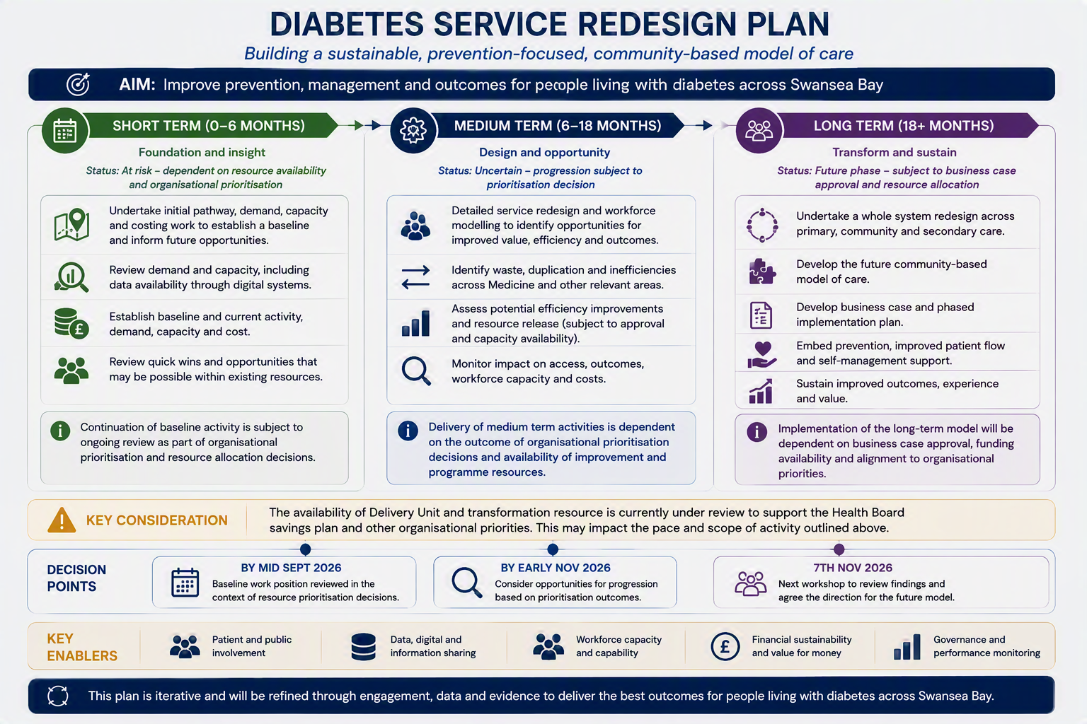

RISK THREE: Delivery of the programme is currently constrained by limited clinical and programme capacity. Ongoing organisational prioritisation discussions may impact the availability of project management and transformation resources required to support programme delivery, pathway mapping and business case development.

Mitigation: The programme's scope, timescales and resource requirements will be reviewed through Delivery Unit prioritisation processes. Following this review, recommendations will be made regarding the future delivery approach, including whether the programme should progress, be re-phased or paused in line with organisational priorities and available capacity.

RISK FOUR: The anticipated short and medium-term benefits associated with the proposed diabetes service model, including medicines optimisation and workforce redesign opportunities, may not be realised within the planned timeframe due to the current prioritisation of organisational improvement and savings resources towards existing Health Board commitments. This may delay the quantification and delivery of potential efficiencies and benefits associated with the proposed model.

Mitigation: Consideration of future support through organisational prioritisation processes, subject to available capacity and alignment with Health Board priorities. Alternative opportunities to progress benefits identification and modelling can be explored where feasible.

ISSUE ONE: Identified through the review of the existing business case is that several proposed benefits require clearer measures, baselines and target outcomes.

Mitigation: Should the programme progress, any refreshed business case will include a comprehensive benefits realisation framework and measurable success criteria to support future evaluation and assurance.

Diabetes 8 Care Process Compliance:
One of the health board’s key priorities over the next five years as part of the Tackling Diabetes Together programme is improving its position against the eight care standards. Each health board is assessed against eight annual care standards as noted below:

- HbA1c (Blood Tests)
- Blood Pressure.
- Cholesterol Level.
- Kidney Function.
- Urine Albumin.
- Foot Surveillance.
- BMI (Height and Weight)
- Smoking Status

The eight care standards are annual checks that an individual should receive to ensure the risk of complications is minimised. Any complications detected early will allow intervention to reduce progression. The treatment targets are checks to ensure risk factors are effectively addressed, particularly for complications such as kidney disease, cardiovascular disease, amputations or stroke and to address risk factors such as obesity or smoking. Overall, the aim is to improve patient outcomes and ensure patients with diabetes live healthier and longer.

The Health Board has implemented a range of strategic and operational initiatives to improve performance against the eight diabetes care processes, including participation in the national Tackling Diabetes Together programme. Governance and oversight are provided through the Diabetes Programme Delivery Group (DPDG), which brings together representatives from the Health Board, Primary Care Clusters, the Wales national Tackling Diabetes Together programme and Diabetes UK.

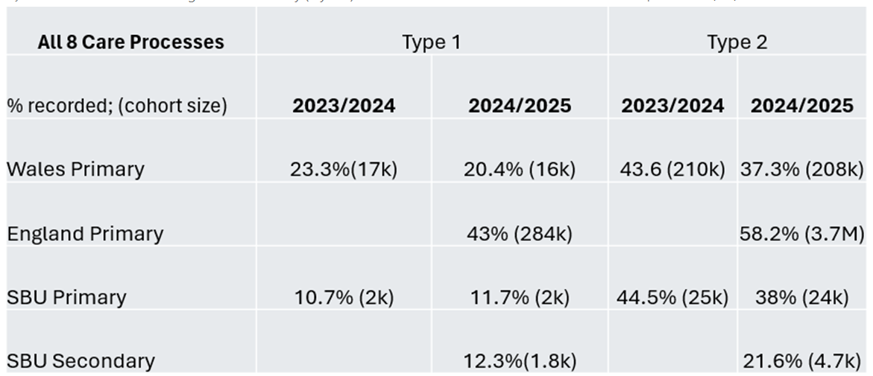
Figure 1: SBU 8 Care Processes Compliance 2023/24 to 2024/25
Ref: National Diabetes Audit Programme - NHS England Digital

The NHS Wales Diabetes Insights & Variation Atlas (DIVA) data currently reflects Primary Care activity only, while the National Diabetes Audit (NDA) incorporates both Primary and Secondary Care data. However, limitations within WISDM (Welsh Information Solution for Diabetes Management) data extraction processes, particularly relating to LIMS (Laboratory Information Management System) data, may lead to an underestimation of performance. The unpublished 2025/26 data (Figure 2) has therefore been supplemented with LIMS data to provide a more complete picture. Further validation will remain constrained until a patient-level dataset combining Primary and Secondary Care information is available. Development of an integrated dataset is being progressed through a data-sharing agreement currently being led by the Chief Digital Officer.

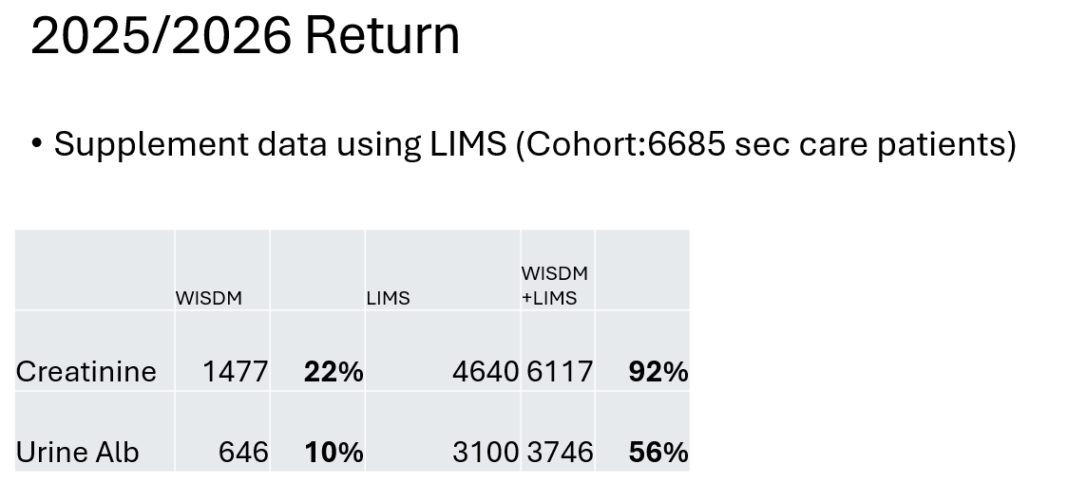
Figure 2: Data extract from WISDM & LIMS

RESOURCE REQUIREMENT:

Short to Medium-Term Support (0-6 & 6-12 months)
Support from the Recovery & Sustainability (R&S) Team would be required to support the scope and quantify potential savings associated with the proposed model, including medicines optimisation and workforce redesign opportunities. Current R&S capacity is prioritised towards delivery of agreed Health Board savings programme commitments and, as this work is not currently included within those priorities, resource is not available to support this activity at this time. Future support would be subject to organisational prioritisation and available capacity.

Long-Term Support (12-18 months)
Delivery Unit support would be required to define the workforce model, map service requirements and ensure alignment with related organisational programmes and dependencies. Subject to organisational prioritisation decisions and resource availability, it is proposed that dedicated project management and service redesign support is identified to progress this work.

- RECOMMENDATION
The Population Health Committee is asked to:

- CONSIDER the update on the Diabetes Redesign Programme.
- CONSIDER the findings from the review of the existing Diabetes Community Model business case.
- CONSIDER the proposed programme approach, including stakeholder engagement, demand and capacity assessment, and pathway mapping across diabetes services, recognising that progression of the programme remains subject to ongoing organisational prioritisation discussions and resource availability
- CONSIDER that a refreshed business case may be developed, subject to the outcome of organisational prioritisation discussions, incorporating updated demand, capacity, workforce, financial and benefits information.
- RECEIVE a further update on programme findings, recommendations and any proposed next steps following completion of the Delivery Unit prioritisation review

Governance and Assurance
Strategic Objectives
Strategic Objectives  (please choose which is impacted) | People of Swansea Bay live healthier, fairer and more prosperous lives | ☒
Strategic Objectives  (please choose which is impacted) | Care is high quality, safe, efficient and delivers the best possible outcomes for people in partnerships | ☒
Strategic Objectives  (please choose which is impacted) | Care is delivered in partnership with our communities in safe and appropriate setting, supported by innovation | ☒
Strategic Objectives  (please choose which is impacted) | The health board is a great place to work where staff feel valued and work together towards a common goal | ☒
Strategic Objectives  (please choose which is impacted) | The health board is a resilient, sustainable and responsible organisation | ☒
Health and Care Standards
Standards (please choose which applies) | Safe Care | ☒
Standards (please choose which applies) | Timely Care | ☒
Standards (please choose which applies) | Effective Care | ☒
Standards (please choose which applies) | Efficient Care | ☒
Standards (please choose which applies) | Equitable care | ☒
Standards (please choose which applies) | Person-centred Care | ☒
Standards (please choose which applies) | Staff and Resources | ☒
Enablers (please choose which applies) | Whole Systems Approach | ☒
Enablers (please choose which applies) | Leadership | ☒
Enablers (please choose which applies) | Workforce | ☒
Enablers (please choose which applies) | Culture | ☒
Enablers (please choose which applies) | Information | ☐
Enablers (please choose which applies) | Learning, Improvement and Research | ☐
Quality, Safety and Patient Experience
The Health Board’s plans relating to diabetes will help to reduce the number of patients developing type 2 diabetes and to better manage patients living with diabetes. The aim is also to bring more patients on board with their own management of their condition, this relieving pressure on the healthcare system, especially the secondary care system.

Financial Implications
There are no immediate financial implications arising from this paper. Any future investment or resource requirements will be subject to organisational prioritisation processes and, where appropriate, approval through the Health Board's governance arrangements.

Legal Implications (including equality and diversity assessment)
There are no legal implications associated with this paper.

Staffing Implications
There are no immediate staffing implications arising from this paper. Any future staffing requirements will be subject to organisational prioritisation and approval through relevant governance processes.

Long Term Implications (including the impact of the Well-being of Future Generations (Wales) Act 2015)
The Diabetes Redesign Programme supports the Health Board's objectives to improve population health outcomes, reduce health inequalities, strengthen prevention and support people to live well with long-term conditions.

Report History
This is the first report since Diabetes redesign resumed, that’s being reported into the Population Health committee.

Appendices
No appendices.

