

Meeting Date | 14 March 2024 |  | Agenda Item |  | 4.1
Report Title | Becoming a Purposeful Anchor Institution – Update
Report Author | Jennifer Davies, Deputy Director of Public Health
Report Sponsor | Keith Reid, Executive Director of Public Health
Presented by | Keith Reid, Executive Director of Public Health
Freedom of Information | Open
Purpose of the Report | This report provides:  - An update on the progress made following the last Committee meeting where the decision taken was to pursue seeking external support in order to baseline ourselves as an anchor institution.  - Estimates the likely financial requirements in pursuing this work.  - Proposed next steps to procure external support, if / when funding is approved.
Key Issues | - The PHS commits us to action, in line with the evidence base, to improve the health and wellbeing of our population through a 4-pillar model, reflecting the functions of the Health Board. Pillar 3 includes acting on our responsibilities as an Anchor Institution.  - Being an anchor institution means we act to improve the health, wealth and wellbeing of our local population and reduce inequalities through the way that we purposefully manage our resources and operations to benefit the communities we serve.  - The foundational economy, described by Welsh Government as the money that is spent by anchor institutions, accounts for four in ten jobs and £1 in every £3 that we spend.  - This is not a new agenda and as a Health Board we are involved to varying extents in different aspects of this agenda. However, the totality of our efforts and hence our starting point, is not known.  - Issues in terms of acting as a purposeful anchor institution, that this work will need to address include:  - Where / how does leadership to this agenda sit/fit within the Health Board?  - Where is(are) the decision-making process(es)? Who actions the ‘purpose’?  - What is its relative priority given competing agendas & demands?  - There are elements of the anchor institution agenda delivered across the Health Board. However, there is no focal point with overall strategic ownership / leadership and no co-ordination of the collective efforts. Our role as an anchor institution is not expressly considered and incorporated into our planning, delivery and assurance activities. Hence no singular mechanism exists currently to take this forward.  - Work has been undertaken to identify potential external sources of support that could help us understand our starting position and potential route map towards becoming a purposeful anchor institution.  - This paper outlines the likely resource requirements which would need to be identified in order to progress this work.
Specific Action Required  (please choose one only) | Information | Discussion | Assurance | Approval
Specific Action Required  (please choose one only) | ☐ | ☒ | ☐ | ☐
Recommendations | Members are asked to:  - Note the progress following the last Committee meeting in seeking external support and potential next steps.  - Consider the estimated financial requirement to progress this work of ~£160K for 2024-25 and constraints to progressing at this stage.  - Consider the next steps to procure external support.

Becoming a Purposeful Anchor Institution – Update

- INTRODUCTION
The Population Health Strategy (PHS) commits us to action, in line with the evidence base, to improve the health and wellbeing of our population whilst tackling the significant health inequalities within our community. In support of delivering against this statutory duty, we have developed a 4-pillar model to reflect the functions of the Health Board.

At the Population Health and Partnerships Committee meeting in December 2023, it was agreed that we would seek to baseline ourselves as an anchor institution (pillar 3) as the first step in becoming a purposeful anchor organisation. Different options for progressing this work were discussed and it was agreed that an update would be brought back to the next Committee meeting.

This paper provides an update on the progress since the last meeting of the Committee in December 2023 and indicative next steps.

- BACKGROUND
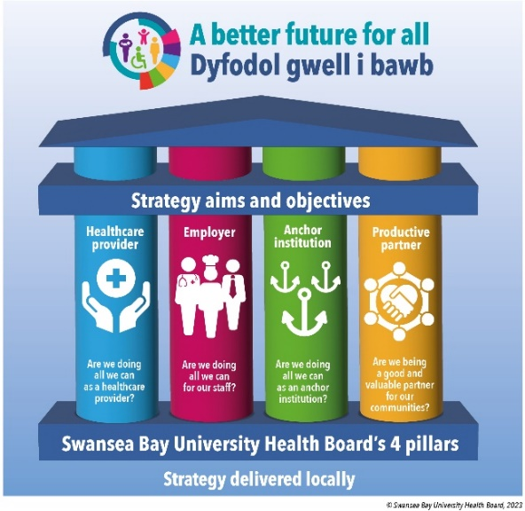
We have a statutory duty to improve the health and wellbeing of our population that goes beyond healthcare provision for those in contact/receipt of our services. This is important as we know that excellence in the provision of health care is a necessary but not a sufficient requirement for improving the health of the local population. Inequalities in health arise because of inequalities in society and the conditions in which people are born, grow, live, work and age – leading to differential levels of vulnerabilities. Our PHS recognises this, drawing on the evidence base and translating this into functional actions within 4-pillars model (shown here) designed to support implementation of strategy locally. Clearly defined is our role as an anchor institution.

In Wales the WFGA provides a supportive policy context for anchor action. A national social value task force has also developed a social value measurement framework and the WG is working to support anchor institutions to develop Community Wealth Building (CWB) approaches, focussing on progressive procurement. The Bevan Foundation has also done some work to advocate for ‘anchor towns’ in Wales. The NHS Wales Finance Academy are leading work looking at the totality of Health Board spend with Welsh and non-Welsh suppliers.

This is not a new agenda and there are several ways this work has developed over years across the UK and beyond. As a Health Board we already have work underway but this is uncoordinated and neither the totality nor the impact of the work are clear. There is learning we can bring from elsewhere to support us in developing a more systematic, objective view of where we are now, where do we want to be and what might be practical steps we can take on that journey.

We reported at the last Committee learning from elsewhere that provides a potential route map of how to progress this work. In particular, the work from the Health Anchors Learning Network (HALN) work on the benefits for the use/development of an appropriate framework to guide the collective efforts both internally and with partners, from our current starting point.

Looking at the learning from across the country, seven steps have been suggested (shown below) which gives us a potential route map to get started.
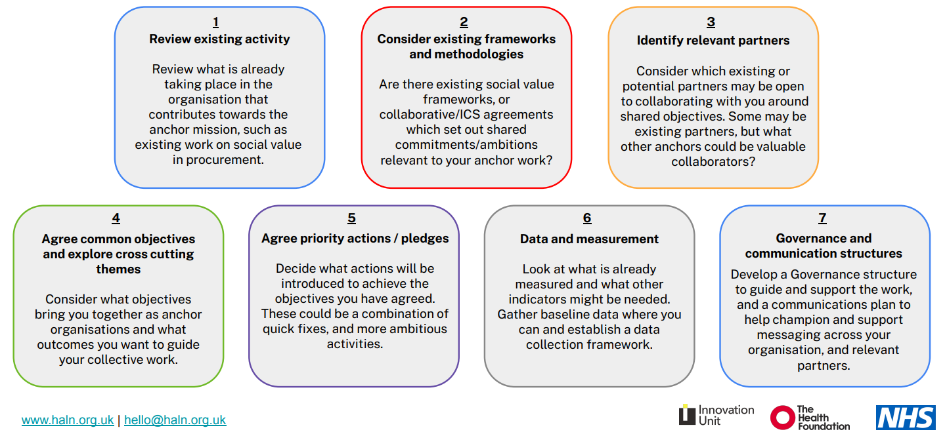
Source: Health Anchors Learning Network (Where to start with… anchor frameworks and charters — Health Anchors Learning Network (haln.org.uk))

Additionally, there is work that has been undertaken in how to develop indicators that measure what matters to us as an anchor institution or partnership which captures progress and holds us to account. Hence, there is learning from elsewhere to assist us.

There is strong alignment with other internal agendas, particularly the implementation of our strategic objectives; development of our strategic indicators; population health capability & capacity development; reorientation of the Health Board’s resource allocation agenda; sustainable Swansea agenda; and partnership agendas within the PSBs and CJC. There is also considerable enthusiasm within our SDGs and with corporate teams/functions to progress this, building on what is already under way.

At the last Population Health and Partnerships Committee we highlighted and discussed 3 options to support this work of becoming a purposeful anchor institution:
- Do nothing
- Seek internal capacity & alignment
- Seek external support to progress initially

The Committee endorsed option 3.

- PROGRESS TO DATE
The Public Health team (PHT) have been identifying options within the current marketplace as well as linking in with established NHS networks who have a focus in this area and can support SBUHB to develop a baseline assessment on our status as an Anchor Institution.

In January 2024, the Public Health team, along with other Health Board colleagues, attended a Welsh Government national foundational economy stakeholder event hosted by Public Health Wales. There were stakeholders from health and social care, government, WFG Commissioners office, academia, commercial, voluntary and third sector. The networking from this event has enabled us to scope current activity and interest across the different, inter-connected agendas of foundational economy, socio-economic duty, circular economy and anchor institution. SBUHB would be the first Health Board in Wales to undertake a baseline assessment on anchor institution.

A number of networks have been uncovered through this work:

Organisation | Strengths | Weaknesses
NHS Benchmarking Network (NHSBN) | - Technical expertise in health services benchmarking.  - Established methodology and data analysis capability.  - SBUHB is already a member of NHSBN  - National network to draw on.  - Appetite to develop an ‘offer’ and capability in this arena due to increasing ‘demand’  - Access to data to enable re-measurement against baseline over time.  - Ability for other Health Boards to utilise methodology and approaches developed with NHSB to benchmark like for like organisations in Wales. | - No previous experience in baselining anchor institution.  - Lack of connectivity / familiarity of this agenda  - Unlikely to have expertise in developmental and partnership elements of agreeing scope / focus / priorities – internally and with partners
Social Value Network (SVN) | - Established consultative delivery model.  - Methodology and products to support change.  - Demonstrable track record of delivering social value in NHS / partners organisations  - Experience that is highly relevant to being developmental aspects of the work in helping to define / clarify priorities  - Development of Social Value Quality Mark award to benchmark / recognise achievement.  - Experience of and recognition of the role of partners, including communities. | - No track record of working within NHS Wales or Welsh legislative context.  - Potential over-focus on achievement of ‘award’ which could lead to unintended consequences in terms of focus/behaviours.  - Degree of flexibility to focus/work outside of the ‘award’ unclear / untested.
Health Anchors Learning Network (HALN) | - Connected community of expertise aligned to NHS organisations.  - Methodology & toolkits to support anchor network development. | - No bespoke / consultative support offering

Learning indicates the development of a baseline position would be the start point in a journey towards becoming a purposeful anchor system. Discussions to date provides us with an indicative timescale for this work:
- 6-9 months: clarifying definitions (differences and synergies with different agendas); agreeing priorities/focus and key value indicators; development of an anchor charter.
- 1-2 years: development of SBUHB as a purposeful anchor institution with clarity on strategic intent and actions
- 3-5 years: development of Swansea Bay as an anchor system working collaboratively with other ‘anchors’ in pursuit of sustainable, measurable population health gains.

- GOVERNANCE AND RISK ISSUES
The importance of having the right governance and delivery structure is also highlighted through the Health Anchors Learning Network (HALN), in order to bring clarity, connect different parts of the agenda and organise them into a cohesive and coordinated programme of activities.

The questions below should be used to guide thinking around an appropriate structure:
- How is the anchor programme structured? Is this by each strategic area?
- Where does the anchor programme ‘sit’ within the organisation? How are the results reported, is it board level with senior sponsor, does it report into a sub-group on health inequalities or social value?
- What resources do you have for anchor work? Are there dedicated anchor programme posts; who is responsible for elements of anchor activity; whose work forms part of the anchor programme?
- Who is invested in the anchor programme? Who may not be directly involved but has a stake in the programme e.g. local populations services?

Answering these would form part of the initial work to baseline. While this work remains in its development phase, the proposal based on the current structures, is that the developmental work would report into the Population Health Development Board during its design phase/stage. A review undertaken in November 2023, recognised that the PHDB is not currently set up in a manner that permits the necessary debates and formative work and has no delegated authority to be able to commit to a particular strategic direction. Hence, to take on the governance role would require a change in the role and membership of the PH Development Board – mandating attendance by senior management from all Service Delivery Groups and linking with Corporate functions. As the work becomes systematised and operationalised, the intention would be to embed the reporting on progress and performance through the appropriate existing performance & governance structures, where these exist.

- FINANCIAL IMPLICATIONS
There are financial implications related to the above, beyond investment of staff time. Through the initial scoping work the likely financial envelope needed to commission a baseline would be approximately £160K. What falls out of the work is what is not possible to predict or quantify currently.

The intention would be that this would be funded out of the population health central reserve funding, along with other areas of work previously approved through Management Board (outlined in the Capacity & Capability Development paper, agenda item 4.2). Due to the financial pressures the Health Board is facing, there is some question over what monies, if any, can be made available into 2024-25 to support these pieces of work and any further work in implementing the PHS, such as this. At the time of writing, we are awaiting formal confirmation of this, including clarity on the governance route for financial decisions to be signed off against the population health reserves. Therefore, at this stage, it is unclear whether/when this work can be progressed.

- Conclusion
This work has highlighted the following:
- There are agencies who can help us take the next steps and build our capability and capacity to develop a robust framework and progress this work sustainably, building on our strengths and working in partnership with others.
- There is interest from our partners regionally across Swansea Bay who are seeking to explore the same issues and welcome a dialogue with us on what is possible.
- Tata steel implications mean this has become more of a need for us to consider this as an appropriate, impactful way of addressing the population health challenges posed by the proposed redundancies and wider community impact
- Significant interest nationally to see progress in this agenda from Welsh Government and others but also an opportunity for shared learning/working with other parts of the NHS in Wales
- We are the only Health Board that has actively sought to recognise and benchmark ourselves as an anchor institution.
- Initial steps need to focus on defining what we mean under the banner of anchor institution and how that will align with other inter-dependent agendas e.g. Foundational Economy, Social Value, Circular Economy etc. Clarifying the terminology will be important for internal clarity and external partnership working.

Having undertaken some initial scoping, we believe there is external support we could commission to work with us in creating a baseline for the Health Board as an anchor institution. Dependent on funds being available, the likely timeframe would be to have secured the external support during quarter 1 of 2024-25, with completion of the work by no later than March 2025.

- RECOMMENDATION
The Committee is asked to:
- Note the progress following the last Committee meeting in seeking external support and potential next steps.
- Consider the estimated financial requirement to progress this work of ~£160K for 2024-25 and constraints to progressing at this stage.
- Consider the next steps to procure external support.

Governance and Assurance
Link to Enabling Objectives  (please choose) | Supporting better health and wellbeing by actively promoting and empowering people to live well in resilient communities
Link to Enabling Objectives  (please choose) | Partnerships for Improving Health and Wellbeing |  | ☒
Link to Enabling Objectives  (please choose) | Co-Production and Health Literacy |  | ☒
Link to Enabling Objectives  (please choose) | Digitally Enabled Health and Wellbeing |  | ☒
Link to Enabling Objectives  (please choose) | Deliver better care through excellent health and care services achieving the outcomes that matter most to people
Link to Enabling Objectives  (please choose) | Best Value Outcomes and High Quality Care |  | ☒
Link to Enabling Objectives  (please choose) | Partnerships for Care |  | ☒
Link to Enabling Objectives  (please choose) | Excellent Staff |  | ☐
Link to Enabling Objectives  (please choose) | Digitally Enabled Care |  | ☒
Link to Enabling Objectives  (please choose) | Outstanding Research, Innovation, Education and Learning |  | ☐
Health and Care Standards
(please choose) | Staying Healthy |  | ☒
(please choose) | Safe Care |  | ☐
(please choose) | Effective Care |  | ☒
(please choose) | Dignified Care |  | ☐
(please choose) | Timely Care |  | ☐
(please choose) | Individual Care |  | ☒
(please choose) | Staff and Resources |  | ☒
Quality, Safety and Patient Experience
Implementation of an effective whole of organisation population health approach will lead to a more consistent approach to prevention. The expectation is that opportunities for patients to be supported to make changes that will reduce their risk of ill-health and which will lead to improved well-being will be offered in a more systematic way across the sector.
Financial Implications
The paper notes that investment is required in order to baseline us as an anchor institution. Investment requirements beyond that are unknown and not quantifiable at this stage.
Legal Implications (including equality and diversity assessment)
No legal implications identified. The incorporation of population health approaches will allow for the identification of equality and diversity issues and development of appropriate responses.
Staffing Implications
The proposed programme will offer an opportunity to significantly increase the organisation’s capacity and capability to adopt different / new ways of working and thinking in order to implement the PHS aspirations through its anchor institution role/function.
The Public Health Team remains small. Additional roles are being created and recruitments underway but progress remains slow.
Development of the implementation plan will identify the skills and workforce requirements.
Long Term Implications (including the impact of the Well-being of Future Generations (Wales) Act 2015)
Population health approaches incorporate a prevention ethos and delivery is contingent on collaboration among partners to deliver better outcomes for our population. A coproduction approach is integral to public health practice and seeks to involve communities and staff in designing services and programmes.
Report History |  | No previous reports
Appendices

