

HEALTH BOARD RISK REGISTER
August 2024
POPULATION HEALTH & PARTNERSHIP
COMMITTEE RISKS

Datix ID Number: TBC  Health Care Standards: |  |  | HBR Ref Number: 99  Target Risk Date: See Rationale |  | Current Risk Rating  5 x 4 = 20
Objective: People of Swansea Bay live healthier, equitable and more equal and prosperous lives |  | BAF Ref: 1 | Director Lead: Jennifer Davies, Interim Director of Public Health  Assuring Committee: Population Health & Partnerships
Risk: Failure to implement the population health strategy approaches at the required scale.  This arises from risk of a failure of the organisation to understand and act on the provisions of the strategy for building whole of system actions across the 4 pillars; and the consequent lack of systems and processes to support the delivery of population health improvements.  Currently identified contributors to this risk include the absence of the tactical level planning required to design and deliver cross-cutting programmes within a federated operational delivery system; lack of systematic review and capture of population health contributions of existing services; limited behaviour change to adopt a population health focus at service and corporate level; uncertainty about the financial commitment to support Population Health Strategy Implementation as well as a lack of clear processes for accessing available funding; a limited focus on prevention; and a lack of consideration of how to act to influence the wider determinants that affect the population’s health and how the Health Board might contribute to addressing these. The outcome if the risk is not addressed is worsening health in our population with widening health inequities. |  |  | Date last reviewed: August 2024
Risk Rating  (consequence x likelihood):  Initial: 5 x 5 = 25  Current: 5 x 4 = 20  Target: 4 x 2 = 8 | 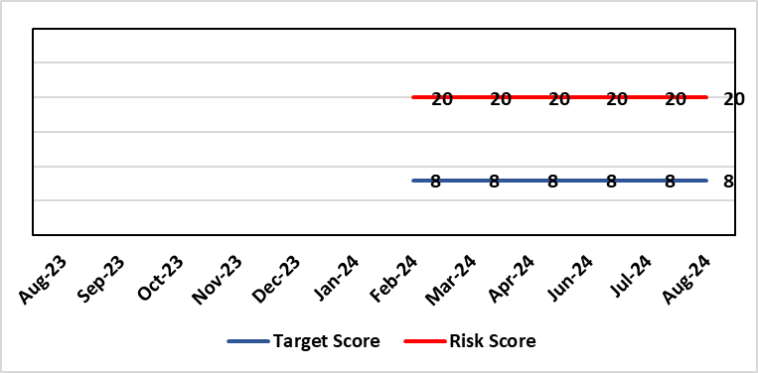 |  | Rationale for current score:  Within SBUHB there is a limited focus on prevention; and a lack of consideration of how to act to influence the wider determinants that affect the population’s health. The Population Health Development Board governance mechanism to enact population health is being reviewed and is not currently operational. We are not in a position where marginal investment is available to begin to develop population health activity. Developing a transformative approach to how we conduct our business is dependent upon the ability of SBUHB to: better understand our population’s needs and address them; focus on actions which foster and maintain health and wellbeing; design services that incorporate prevention and tackle inequities; and develop robust partnerships that tackle the wider determinants of health that ultimately drive demand for healthcare.  Currently there is a lack of capacity and capability in the wider organisation to deliver on this agenda.
Date added to the risk register  14/03/24 |  |  | Rationale for target score:  Given the system wide changes required to mitigate this risk and the requirement to works across organisational boundaries achievement of this target has been be a long term consideration.  Target Risk Date will be reviewed as part of gateway checkpoint on risk/actions.
Controls (What are we currently doing about the risk?) |  |  | Mitigating actions (What more should we do?)
- Population Health Strategy adopted by SBUHB Board 30/03/23.  - Population Health Strategy Audit planned for 2024-25.  - Population Health Strategy aligned to organisational strategic objective 1. Population health integrated into planning infrastructure through R&S plan 24/25 process.  - Population Health and Partnerships Committee and Population Health & Commissioning Management Board established as governance mechanisms for Population Health.  - Mandate through governance to progress on key strategic workstreams:  - Capability & Capacity building  - Anchor Institution baselining  - Anti-poverty  - Strategic Indicators for Population Health  - Repurposing SBUHB financial resource to support population health  - Behavioural change resource identified and procurement process underway to develop behavioural change framework for SBUHB to develop capability and capacity in support of required cultural change.  - Health Intelligence resource needed to lead organisational work to build health intelligence infrastructure has been scoped and identified.  - Local population health actions and measures in development with SDGs for 2025/26, building on work to date, and will be reported quarterly.  - Annual plan population health actions/deliverables to be reported through Annual Plan Oversight Group (APOG) by service group.  - Population Health reserves for 2024/25 confirmed at £250k with delegation through Executive Director of Public Health |  |  | Action | Lead |  | Deadline
 |  |  | Gateway review of progress on governance actions:  - SDG reporting changes;  - Capability and capacity review and development work;  - Population Health Strategy implementation audit to be undertaken. | Executive Director of Public Health / Director of Corporate Governance (support) |  | Targets Refreshed:  31/12/2024  31/03/2025  31/01/2025
 |  |  | Systems working capability development programme in development – for both Health Board colleagues and for external partners | Executive Director of Public Health |  | 31/03/2025
 |  |  | Development of joint work programme for improved health intelligence as part of supporting the implementation of the Digital Strategy | Executive Director of Public Health / Director of Digital |  | 31/12/2024
Assurances (How do we know if the things we are doing are having an impact?)  An approach to capturing activity through the quarterly performance reviews is being piloted with the aim of identifying at Service Delivery Group level how population health gain is being addressed. Progress on 2024/25 Population health GMOs (weight management & tobacco control pathways) through utilising a One Bay Way approach and agreement to be reported through APOG.  Capability and capacity work along with the planned audit will provide a comprehensive set of actionable recommendations on factors limiting implementation. |  |  | Gaps in assurance (What additional assurances should we seek?)  SDG reporting will allow for development of a view of service group level activity and creation of monitoring framework but this is a development journey and there will be a delay of several quarters while this matures. Need for consistent engagement from all SDGs to enable progress to be made.  No mechanism to develop approaches which sit across more than one SDG or which are not directly related to SDG responsibilities.  Available data are fragmented due to federated operational delivery structures in support of population health. Work is underway to identify ‘strategic indicators’ which will provide a framework to monitor the impact of action on population health.  Service delivery remains the primary focus of the health board. Developing partnership agenda but limited focus on prevention and the wider determinants that drive health & wellbeing.
Additional Comments
Given the complexity of the requirements to enable system change at scale the implementation of the population health strategy the organisational journey to becoming population health focused and competent has to be viewed as a long term objective.
Jul 2024: The current financial climate and our targeted intervention status are not conducive to enabling and developing the capability and capacity to enable the required transformative approaches required to realise our strategic ambition.
Aug 2024: The inability to use the dedicated budget allocated to supporting the delivery of the Population Health Strategy due to the immediate financial control requirements is in danger of putting longer term action for more sustainable healthcare provision and population health outcomes at risk.

Datix ID Number: TBC  Health & Care Standards: |  |  | HBR Ref Number: 100  Target Risk Date: 31/03/2025 | Current Risk Rating  4 x 3 = 12
Objective: People of Swansea Bay live healthier, equitable and more equal and prosperous lives |  | BAF Ref: 1 | Director Lead: Nerissa Vaughan, Director of Strategy  Assuring Committee: Population Health & Partnerships Committee
Risk: A lack of a robust approach to partnerships & collaboration  If the health board does not have effective structures, processes and working relationships with its external partners at the Public Services Board (PSB) and/or Regional Partnerships Board (RPB), there is a risk that areas of work dependent upon collaboration with partners may not deliver what is required in a timely way, impacting on the delivery of health board priorities. |  |  | Date last reviewed: August 2024
Risk Rating  (consequence x likelihood):  Initial: 4 x 3 = 12  Current: 4 x 3 = 12  Target: 4 x 2 = 8 | 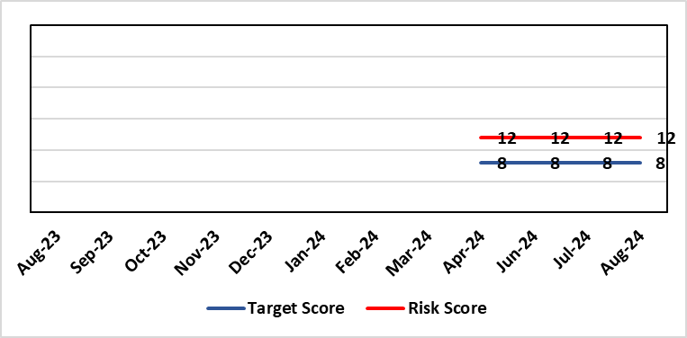 |  | Rationale for current score:  Currently the likelihood of non-delivery of partnership priorities that meet expectations is possible.
Level of Control  = % |  |  | Rationale for target score:  The occurrence of non-delivery of partnership priorities will reduce with an improved partnership approach within the Health Board, although given the complex nature of partnership working it is unlikely to completely eradicate the risk.
Date added to the risk register
29/05/2024
Controls (What are we currently doing about the risk?) |  |  | Mitigating actions (What more should we do?)
- Senior Health Board leadership has been identified across the West Glamorgan Regional Partnerships Board (WGRPB) governance to improve visibility and decision making.  - The newly established Strategic Partnerships Group (SPG) provides oversight of partnership discussions, including the WGRPB and the Public Service Boards (PSB)  In development:  - Organisational Development work is being progressed with the WGRPB Directors  - Collaborative Framework to be developed by the SPG to ensure a joined up and co-ordinated approach to partnership working. The Framework will set-out the roles & responsibilities of Health Board staff and the competencies and skills required to support partnership working.  - Joint working is in development between the Health Board Strategy Team and the West Glamorgan RPB regional team to identify alignment with priorities at the outset. |  |  | SB) | Lead | Deadline
 |  |  | Development of a robust Strategic Partnerships Group and the Collaborative Framework. | Director of Strategy | 31/12/2024
 |  |  | Improve visibility of partnership working across the Health Board | Director of Strategy | Completed
 |  |  | Alignment of Partnership priorities with the Health Board IMTP | Director of Strategy | 31/03/2025
 |  |  | Consideration of the OD working progressed with the WGRPB Directors | Director of Strategy | 31/12/2024
 |  |  | Consideration of Health Board position in relation to identified challenge areas incl. children & young people. | Director of Strategy | 31/12/2024
Assurances (How do we know if the things we are doing are having an impact?)  Strategic Partnerships Group (SPG) established in October 2023 will provide oversight of partnership discussions, including the WGRPB and the Public Service Boards (PSB). |  |  | Gaps in assurance (What additional assurances should we seek?)  There is no framework currently to direct partnership working in a consistent way (Collaborative Framework to be developed to address this)
Additional Comments
20/06/2024: Risk was discussed at Population Health & Partnerships Committee on 6th June 2024. All the actions are within date. There is therefore nothing to add at this stage.
Aug 2024: The Partnership Team will lose a member of the team in October – the Band 7 Planning Manager. The vacancy freeze will put the following work programmes at risk:
- Children & Young People – a large work programme has been initiated as a result of the CYP Summit and partnership discussions and the absence of the band 7 will affect the Team’s ability to take this critical work forward.
- Right Care Right Person – there is growing anxiety amongst staff in relation to the South Wales Police Policy and the Team are leading this work to assess the impact. Morriston has the highest number of AWOL/patient walk outs across Wales in February 2024, and there was a serious incident in August 2024 involving a fatality at the Morrison site. There is a risk that staff are not prepared, and it will have an impact in relation to public protection.
- Visibility at partnership work streams will be impacted as a result of the Team prioritising other work

Risk Score Calculation

For each risk identified, the LIKELIHOOD & CONSEQUENCE mechanism will be utilised. Essentially this examines each of the risks and attempts to assess the likelihood of the event occurring (PROBABILITY) and the effect it could have on the Health Board (IMPACT). This process ensures that the Health Board will be focusing on those risks which require immediate attention rather than spending time on areas which are, relatively, a lower priority.

