


Meeting Date | 29th August 2023 |  | Agenda Item |  |  | 3.3
Report Title | ‘Deep Dive’ Suicide Prevention Quality Priority
Report Author | Jayne Whitney, Suicide Prevention Quality Improvement Lead
Report Sponsor | Stephen Jones, Nurse Director, Mental Health and Learning Disabilities, Senior Responsible Officer, Suicide Prevention Quality Priority  Angharad Higgins, Interim Head of Quality and Safety
Presented by | Jayne Whitney, Suicide Prevention Quality Improvement Lead
Freedom of Information | Open
Purpose of the Report | This report provides an update on progress against the Suicide Prevention Quality Priority to date and goals for the coming period.
Key Issues | - Suicide Prevention is one of the five current quality and safety priorities  - Review of current Goals, Methods, Outcomes (GMOs) and progress to date.  - GMOs for 2023/2024  - Recommendations on actions required to embed Suicide prevention training across service groups and ensure continued progression of the priority.
Specific Action Required  (Please choose one only) | Information | Discussion |  | Assurance | Approval
Specific Action Required  (Please choose one only) | ☐ | ☐ |  | ☒ | ☐
Recommendations | Members are asked to note the report for information and assurance and the investment required for level 2 Suicide Prevention

Quality Priority – SUICIDE PREVENTION

- INTRODUCTION

This report outlines progress against the Suicide Prevention Quality Priority, noting achievements and the focus of activity toward 2023/2024 in order to embed the improvements into business as usual within the organisation.

- BACKGROUND

Information taken by the World Health Organisation and Office of National statistics show that people completing suicide has risen by 20,000 across the world in the past 30 years. Figures published in June 2021 show that 1 in 100 deaths result in suicide with 700, 000 people each year completing suicide. Current data shows the incidents of suicide in Wales (2020) as 10.3 average per 100,000 population (79% Males and 21% Females with an increase of Male suicides by 11% since 2019).

Local intelligence for Neath Port Talbot (NPT) and Swansea shows between 2014 – 2018, there were 89 suicides in NPT and 119 in Swansea. Between March 2020 and March 2021, there were 30 suicides in Swansea and 10 in NPT. This equates to 34 males and 6 females completing suicide, with 63% of all suicides taking place within the person’s own home or a family/partner’s property.

The Welsh Government launched the Talk to me 2 - Suicide and Self Harm Prevention Strategy for Wales 2015-2020. The strategy and action plan addresses this period and builds on previous progress made from 2009 – 2012 Talk to me action plan. Talk to me 2 focusses on smaller achievable objectives and priorities.

The fundamental aim of the Talk to me 2 strategy is to reduce stigma and improve awareness and understanding of suicidal behaviours amongst the public, professionals and people who are in contact with people at risk of suicide and self-harm. Stigma regarding suicide can be a barrier to those people in crisis seeking the appropriate help and to those bereaved accessing post suicidal bereavement support.

The important message underpinning the strategy is that suicide and self-harm are largely preventable if risk factors of individual groups or population levels are effectively addressed. Therefore, encouraging “self-seeking” behaviour and increasing the chances of earlier and timelier interventions are key within suicide prevention. We can all make a difference in suicide prevention by knowing the signs, asking the right questions, and signposting to support and resources. Increasing the right opportunities can decrease a loss opportunity.

However, the approach that will be most effective in tackling suicide and self-harm is dependent on a multi-agency collaborative approach; this includes local Health Boards, Local Authorities working in partnership with the 3rd sector, service users with lived experience, clinicians, and professionals.

Delivery of Quality Priority

Delivery of the quality priority to date has focussed on the following key areas:

- Reduction of the risk of staff suicide through promoting help-seeking behaviours
- Increased awareness of the risk of suicide through delivery of training programme for health board staff
- Contribution to the multi-agency working through the Multi-agency Group (MAG)

This has been led through a health board wide steering group, co-ordinated by the Suicide Prevention Quality Improvement Lead.

Key achievements to date include:
- Delivery of the Arts Council funded Sharing Hope programme.
- Suicide prevention and REACT training across Health Board
- Joint working with the Multi-agency Group (MAG)

A summary of progress against the individual actions to achieve the goals, methods and outcomes of the priority follows:
Table 1: GMOs set 2021/2022

Goals | Methods | Outcomes | Progress
Aid suicide prevention | Multi agency approach | - Define governance structures to support quality priority.  - Task group to agree immediate priorities.  - Establish Quality Priority steering group.  - Engage with Multi Agency Group (MAG) regarding work programme. | - Completed 31/10/2021.  - Completed 08/06/2021.  - Completed 28/06/2021.  - Completed 31/10/2021.
Maximise the opportunities for early recognition of anxiety and depression, to prevent escalation to risk of suicide for staff | Early intervention and recognition of mental health issues & early referral to OH and wellbeing – staff wellbeing paramount. | Reduce triggers to staff overall sickness. Likely post Covid rebound with sickness/anxiety/moral trauma and long Covid. | - Base line data on wellbeing started 1/02/2022 & completed 15/06/2022.  - Improved data collection for wellbeing and parameters & methodology completed 1/6/2022.  - Sharing HOPE – the art of healing together commenced 17/02/2022. Official launch with film September 2022. Funding in place until 2024 - several projects underway in high-risk areas such as ITU & mental health in patient wards. Four Health Board wide events agreed during spring/summer.  - Data and methodologies/ outcomes completed for Sharing HOPE 1/06/2022
Educated Workforce to recognise the early signs & symptoms of an acute depressive illness.  Compassionate employer with recognition of suicide risk throughout all tiers of management and clinical staff | Initial baseline scoping exercise to ascertain learning and training needs for all front-line staff throughout Service Groups – this may require development/purchase of a specific educational package.  To source 2nd stage bespoke training that will assess suicidal risk. | Educate a workforce who can recognise early indicators of suicide & self-harm amongst the population we serve and staff groups. | - Mapping of training and outcomes completed 1.6.2022.  - Training proposal completed 16.06.2022 and identified a 3-tier approach to training.  - React and Suicide Awareness merged to create Tier 1 – React & Introduction to Suicide Prevention launched September 2022.
 |  |  | - Tier 2 – Safety planning/safety tools for qualified professionals. Piloted through slippage money £5000 March 2022 for 20 staff throughout Service Groups. Feedback & evaluation completed. £30,000 is required for funding to train the trainer – aim to secure funding in next financial year. 2024/2025 - business case to be developed.
 |  |  | - Tier 3 – Suicide Prevention/IMV Training - Specialist training for mental health professionals. Pilot study with y Caswell clinic for staff working with female services June 2023. Wider roll out to be agreed with Mental Health division & Q & S group for sign off following pilot study.
Leading HB within Wales in managing risk of suicide and associated harm. | Inspection of estates and undertake ligature risk assessments to identify key areas of risks. Programme of works to remove/replace pull cords, lights, alarms, WCs with ligature free equipment – assessment of areas with poor line of sight. | Reduce incidents of suicide and self-harm on health premises/facilities to zero | - Ligature risk assessments progressed across all service groups. Next steps: discussion to be held with Health and Safety Operational Group regarding how this issue is managed on an ongoing basis.
Improve data collection on agreed baselines, parameters, and methodology. | Agreed parameters and data collection for:  - Suicide Awareness Training  - REACT Training  - TRiM  - Wellbeing Data on MH  - Time to Change Wales  - Sharing HOPE  - Bespoke events facilitated across health board for example world suicide prevention week.  - MH for managers training  - REACT & Suicide Prevention Tier 1 training across the health board & on the NQN induction. | Baseline data collection and dashboard to input date and retrieve each month for reporting. | - Completed process and dashboard developed 01/06/2022.
Development of communication and training plan for intranet | Utilising differing means of communication via the Department of Insight Communication and Engagement. | To highlight the priority within Swansea Bay Health Board and public domain. | Campaigns delivered and ongoing:  - React & Suicide Prevention Training  - Sharing HOPE – The art of healing together (SBUHB & public domain)  - Education week for World Suicide Prevention Day symposium.  - Screen saver on suicide prevention over Christmas and new year 2022  - Article published in Bay News Paper in December 2022.  - Time to Change campaign delivered by those with lived experience.  - Lunch & learn events for all Health Board staff.  - Close working with Mental Health Division  - Staff wellbeing, events calendar, and planning.

Sharing HOPE: The Art of Healing Together

Sharing HOPE is an arts project across the Health Board available to all staff groups. Its aim is to highlight the power of sharing stories & capturing Covid recovery, moral trauma and destigmatising of mental health. Differing art forms can create an arena for healing from the impact of the Pandemic and can facilitate staff recovery. The project focuses on engaging with high-risk areas of care, which evidence notes as being female staff nurses, those working in high-risk environments and critical care workers.
The use of all kinds of art modalities have allowed for a different way of working and engaging staff to tell their story away that is different to existing methods of organisational. Storytelling and the sharing of experiences within the recovery philosophy and research for those experiencing mental health difficulties is well founded. Hope remains the significant factor in both mental health and suicide prevention, which inspires peer conversations and creates feelings of “you are not alone”.
The funding for Sharing Hope is a collaboration between The Arts Council of Wales and The Baring Foundation called “Arts and Minds” To date the project has been awarded £51k since 2021.

Initially it was hoped to engage with 100 staff through the project, we have surpassed this target and 445 staff have engaged with Sharing HOPE since its launch in April 2022.
Engagement sessions:

The table below shows the number of engagement activities that have taken place, which highlights the range of work that has been undertaken.

Month of Event | Number of staff engagements & venues
April 2022 | 50 people engaged with Sharing HOPE recording the poem for the launch cross sites.
June 2022 | 19 people engaged with Sharing HOPE event (NPT Hospital).
Aug 2022 | 21 people engaged across sites (NPT, Morriston, Cefn Coed, Tonna and Singleton Hospital).
Sept 2022 | 25 people attended the Sharing HOPE launch event (Taliesin Swansea Uni).
Sept 2022 | 77 World Suicide Prevention Day.
Oct 2022 | 119 people engaged with Sharing HOPE (Patient Safety Congress (PSC).
Oct 2022 | 9 people engaged with Mother & Baby Unit,
Oct 2022 | 21 people engaged with NPTSSG Professional Nursing Forum (PNF).
Nov 2022 | 25 people engaged with Sharing HOPE across sites (Morriston, Singleton, Community Services).
Dec 2022 | 26 people HB wide engaged with Sharing HOPE held at the Glyn Vivian Art Gallery. 1 staff member engaged with Sharing HOPE from Morriston Service Group.
Jan 2023 | 10 people engaged with Sharing HOPE (Tonna CMHT).
Feb 2023 | 11 people engaged with Sharing HOPE (ITU Morriston Hospital).
Mar 2023 | 31 people engaged with Sharing HOPE across sites (NPT, Morriston & Singleton).
Total amount pf people engaged with Sharing HOPE = 445

Visual Examples of Projects

The Mosaic Project that was used in engagement events and journeyed from site to site. This project was rated as being 5 stars by 100% of participants and people said that it was Relaxing, Peaceful, Calming, Connecting, Sharing and Creative.

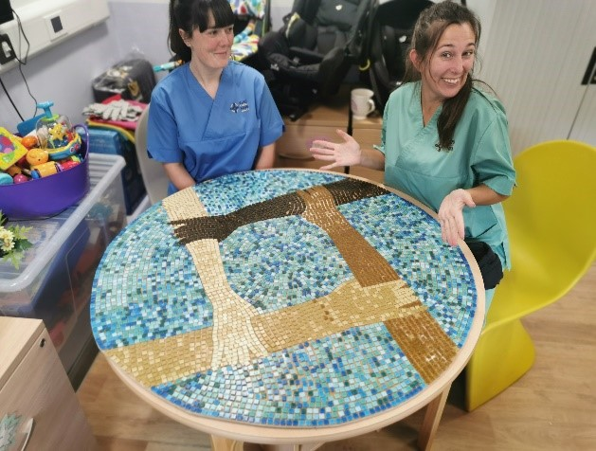
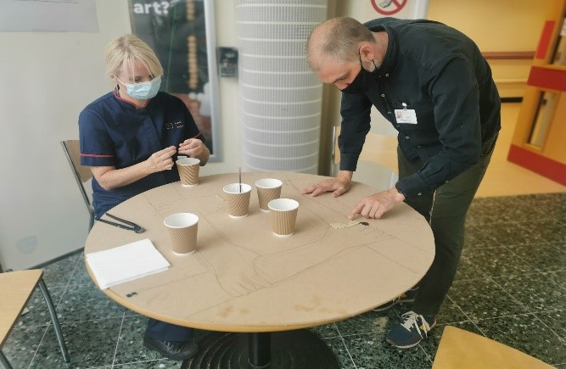

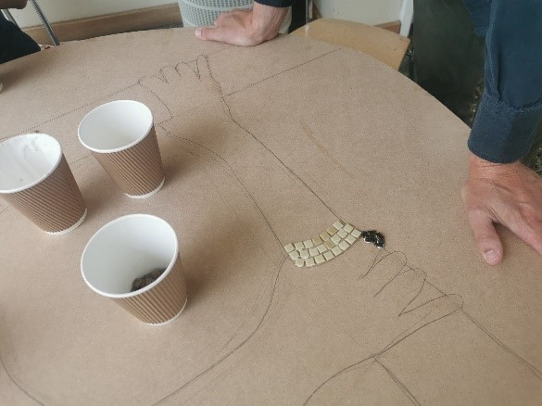
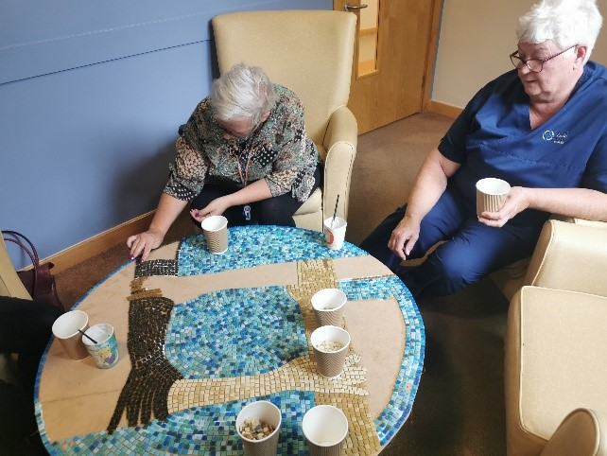

Launch of Sharing HOPE and the first public screening of the poem - 23rd September 2022 Taliesin, Swansea University.
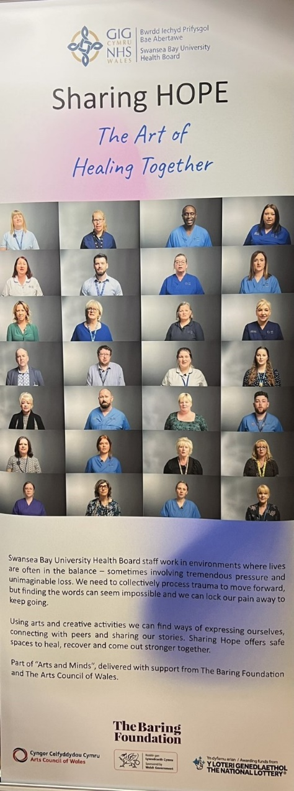
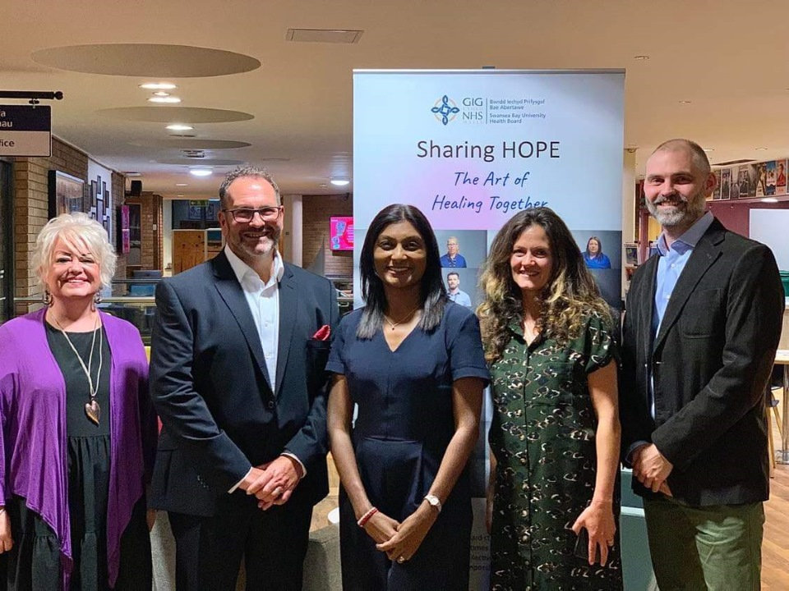

The Sharing HOPE team with Sue Tranker (Chief Nursing Officer for Wales).

Mother and Baby Unit Tonna Hospital to help front line staff to process trauma in a high-risk area.

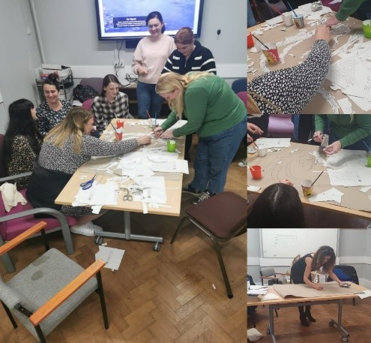

ITU Morriston Hospital

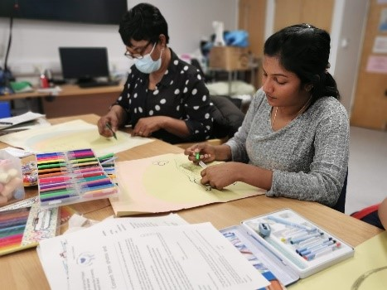
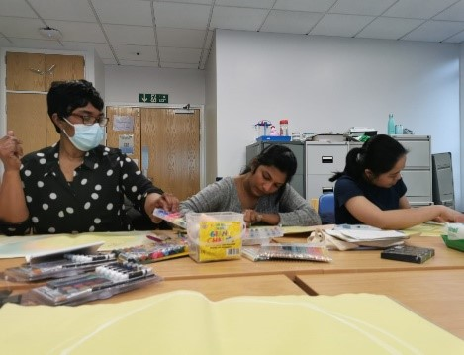

Critical care workers such as staff in ITUs are high risk of trauma, mental health and suicide – the work with ITU is ongoing throughout the year. During the event staff shared powerful stories of incredible resilience through COVID.

Examples of feedback from staff

“I attended the session on Friday and found it so beneficial. It was lovely to take time to really consider how you feel and was something totally different. I look forward to hearing the feedback from staff”. Staff wellbeing member ITU

“Helpful, emotional. I’m glad it’s not just me feeling this way. I was thinking of leaving. But will carry on for a moment”. Anonymous Staff member

“It was a good session. We all got our problems out. We also had a laugh”. Anonymous Staff member

The session was a welcome respite from the business of daily work activities. Working with clay enabled me to utilise different skills and the task prompted both group discussion and periods of self-reflection. It was a pertinent reminder that we all bring something different to the table and ultimately that diversity enriches how we function as a team. Anonymous Staff member

Fun, calming, beneficial - the session provided a great opportunity to complete an activity away from the workplace. It was an enjoyable session and enabled me to focus on my own wellbeing, whilst also spending time with colleagues outside the busy department. Anonymous Staff member

REACT & Suicide Prevention Training

Suicide prevention training was launched in 2019 within the Mental Health service group. The training offers a basic awareness, underpinned by Welsh Government policy and strategies (Time to talk 2). It became a health board wide focus in July 2022 and merged with REACT training in September 2022. REACT training aims to help staff to have ‘psychologically savvy’ conversations with each other about mental health and commenced in 2020.

489 staff attended REACT & Suicide Prevention Training from Sep 22 to Mar 23
887 staff attended Suicide Prevention training including Nurses inductions from Oct 19 to Aug 22
117 newly qualified Nurses induction attended for REACT & Suicide Prevention from Oct 22 to Mar 23
2403 staff attended Bespoke REACT training from Oct 20 to Mar 23
263 NPT Primary care staff attended bespoke BT4L (Protective time by learning) Mar 23
In total 4159 of our staff have been trained in the recognition of the risk of suicide since October 2019

REACT & Suicide Prevention (Level 1) Training

REACT and Suicide Prevention (level 1) combined training started in September 2022.
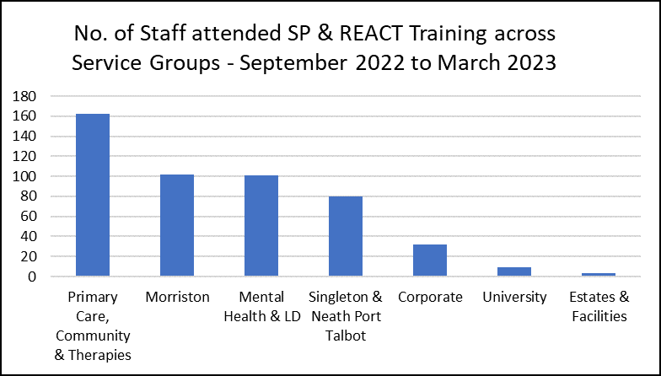

The chart above shows service group attendances across SBUHB. This includes student nurses, Estates and facilities have been identified as a key area to target. A work programme is in place within the REACT and Suicide Prevention training team who are offering bespoke face-to-face sessions as there are barriers to attend training due to lack of IT access.

The following chart below shows that 489 staff members attended the level 1 training across SBUHB from September 2022 to April 2023.

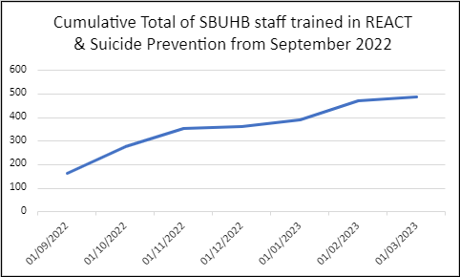

REFERRALS TO WELLBEING
The Wellbeing data is to allow for monitoring of any trends and themes. The trajectory hypothesis agreed is an increase of referrals for mental health. This evidences staff reaching out and talking about suicide and having timely, support and resources.

SBUHB staff can refer into the Wellbeing Service and all referrals are offered an initial contact session where specific questions are asked. The information from these questions have been used as measures to evidence progress within this priority.
Total number of referrals into the Wellbeing Service = 1045 (January 2022 to March 2023).
Number of Mental Health ‘Initial Contact’ sessions delivered = 922 (January 2022 to March 2023).
Chart 1 shows the percentage of cases who reported plans to end life = 3% (This question was introduced to staff from January 2022 to March 2023).
Chart 2 shows the percentage of cases reporting suicidal thoughts in the past 7 days = 5.75% (This question was introduced from March 2022 to March 2023).
Chart 1

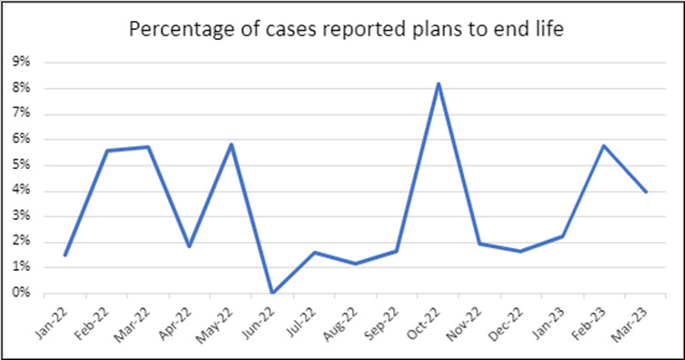
Chart 2

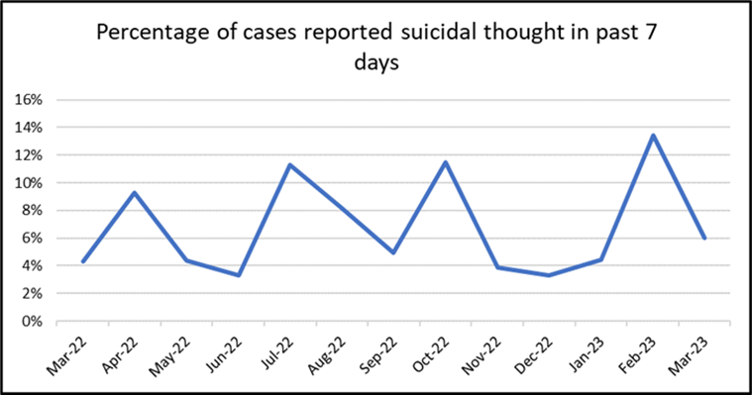
Sustainable Model of Training
In order to ensure that the workforce is trained and skilled in identifying and managing the risk of suicide, training is required at three levels
React & Suicide Prevention Training Level 1
Aim: Develop target areas such as Hotel Services and porters with lack of equipment and progress with face-to-face training within main hospital sites. This is currently delivered by the MH and LD training team and the Suicide Prevention Quality Improvement Lead, but a long term solution is required.
Suicide Prevention Training Level 2
The health board needs to train 8 staff members a to deliver the safety planning/safety tools training. A business case to secure funding is being developed by the Suicide Prevention Steering Group, Suicide Prevention Lead & OD & Workforce.
Suicide Prevention Training Level 3
A pilot study is to commence in Caswell Clinic. Data, evaluation and analysis of study to be shared within Mental Health Service Group. Sign off required in Mental Health Q & S, agreement of training programme to cascade throughout in patient care and high-risk environments & discussions with Mental Health Learning & Development service. 2023.
Table 2: The following GMOs have been agreed for 2023/24
Goals | Methods | Outcomes | By whom | By When | Progress
Quality, Safety, and Improvement Intranet page for priority – Suicide Prevention | Quality & Safety intranet hub  Quality Priority page for Suicide Prevention | A central point for staff to access vital resources & communication regarding suicide prevention to support patients and staff wellbeing | Suicide Prevention Lead & | 31.03.2023 | Commenced 1/11/2022 and 31/03/2023 with on going
SBUHB Suicide & Self Harm Prevention Strategy | Working group to deliver on HB strategy on Suicide Prevention & self-harm | To achieve strategy in line with Welsh Government guidelines that each Health Board required to formulate a suicide prevention strategy | Suicide Prevention Lead  Deputy Director of Nursing  Deputy Director of Public Health  Appropriate SBUHB stakeholders | To be completed by 2024/2025 | Commenced 1/10/2022 – first meeting held with Hazel Powell & Jennifer Davies
Business Case for Tier 2 Safety planning/safety tool training | Train the trainer programme of 8 trainers within Learning & development | To deliver level 2 training to enhance safety planning/safety tools for those at risk of suicide | Suicide Prevention Lead  Suicide Steering Group  SBUHB wide training & development teams | March 2023 to move forward during 2024/2025 | Commenced 1/10/2022 – aim to secure funding and business plan for financial year 2024/25 with an aim to complete and recruit trainers.
Priority People & Places - HMP Swansea Prison | Training & education programme for staff & people in custody/prison | To reduce potential suicides within the high risk – people and places and males. | Suicide Prevention Lead  Suicide Prevention Steering group  Appropriate stakeholders within HMP prison | 1/10/2023 | Commenced 1/10/2022 – initial meetings but delayed due to new Governor appointment (in position by end of February 2023)
SBUHB Response Policy following death of staff member by suicide and family support and review of MH managers training | To create a response policy and working group to develop informative pathways of support | A policy that supports and navigates individuals and managers to seek support and help through the bereavement of suicide | Suicide Prevention Lead  Care after Death Team  Occupational Health & Employee Wellbeing Team. | 1/10/2023 | Commenced 1/10/2022 – working group in situ meetings organised with stake holders February 2023
Suicide Policy and best practice for SBUHB (Mental Health Division) | To produce a best practice policy for suicide prevention | To direct staff on best practice and evidence interventions. | Consultant Clinical Psychologist  Suicide Prevention Policy Working Group | 1/10/2023 | Dates provided and agreed to sit on steering group along with other stakeholders.  Completed with ratification in PRG 27/04/2023
3rd sector engagement with Neath & Swansea Voluntary services | To engage 3rd sector organisations on mental health & suicide prevention | 3rd sector engagement with Mental Health Division & wider public domain within hospital sites for patients & staff | Suicide Prevention Lead  Hafal (Adferiad)  NPTB CVS  Quality Audit and Quality Improvement Service MH & LD division. | 2023/2024 | Commenced engagement in 2022 and continue to build upon those relationships within mental health wards & SBUHB hospital sites. Progression challenged due to representatives leaving posts within Hafal & NPTB CVS
Baton of HOPE – UK event passing through Swansea. | UKs largest suicide prevention event – travelling through major cities in the UK | For SBUHB to be involved in the community event and raise the profile of the suicide prevention work underway within the landscape of SBUHB | Suicide Prevention Lead  Sharing Hope Team | 01/07/2023 | Declared interest as a Health Board to be involved in event summer 2023 – awaiting further communication.  Route changed and Swansea omitted from agreed route.  Plans to progress Sharing Hope in Cardiff 1/07/2023

- GOVERNANCE AND RISK ISSUES

There are no specific governance risks noted at present. Risks to embedding improvements noted within the report.

- FINANCIAL IMPLICATIONS

Funding of £30,000 investment required for Level 2 Suicide Prevention Training. A business case is being developed to support this.

- RECOMMENDATION

Management Board are asked to note the progress made against the GMOS for this quality priority and the need to identify a model for sustainable training provision within the organisation.

Governance and Assurance

Link to Enabling Objectives  (Please choose) | Supporting better health and wellbeing by actively promoting and empowering people to live well in resilient communities
Link to Enabling Objectives  (Please choose) | Partnerships for Improving Health and Wellbeing |  | ☒
Link to Enabling Objectives  (Please choose) | Co-Production and Health Literacy |  | ☐
Link to Enabling Objectives  (Please choose) | Digitally Enabled Health and Wellbeing |  | ☐
Link to Enabling Objectives  (Please choose) | Deliver better care through excellent health and care services achieving the outcomes that matter most to people
Link to Enabling Objectives  (Please choose) | Best Value Outcomes and High-Quality Care |  | ☒
Link to Enabling Objectives  (Please choose) | Partnerships for Care |  | ☒
Link to Enabling Objectives  (Please choose) | Excellent Staff |  | ☒
Link to Enabling Objectives  (Please choose) | Digitally Enabled Care |  | ☒
Link to Enabling Objectives  (Please choose) | Outstanding Research, Innovation, Education and Learning |  | ☒
Health and Care Standards
(Please choose) | Staying Healthy |  | ☒
(Please choose) | Safe Care |  | ☒
(Please choose) | Effective Care |  | ☒
(Please choose) | Dignified Care |  | ☒
(Please choose) | Timely Care |  | ☒
(Please choose) | Individual Care |  | ☒
(Please choose) | Staff and Resources |  | ☒
Quality, Safety and Patient Experience
The aim of the Suicide Quality Project is to aid suicide prevention underpinned by the Welsh Government Strategy Talk to me 2 and appropriate NICE guidelines.
- Educating a workforce to recognise the early signs & symptoms of an acute depressive illness.
- Compassionate employer with recognition of suicide risk throughout all tiers of management and clinical staff
- Educate a workforce who are able to recognise early indicators of suicide & self-harm amongst the population we serve and staff groups.

Financial Implications
Funding of £30,000 investment required for Level 2 Suicide Prevention Training
Legal Implications (including equality and diversity assessment)
None identified.
Staffing Implications
Staff Mental Health, Moral Trauma, absenteeism, presentism, and compassionate fatigue.
Long Term Implications (including the impact of the Well-being of Future Generations (Wales) Act 2015)
To continue to educate stakeholders on suicide prevention and awareness underpinned by the Welsh Governments Talk to me 2 Strategy:
- Local Health Boards & Local Authorities working in partnership with the 3rd sector, service users with lived experience, clinicians, and professionals.
- Focus on priority care providers, priority places and priority people.
- Knowing the signs, asking the question, and signposting to timely resources and support.
Report History |  | Monthly reporting to the Suicide Prevention Steering Group  Management Board.
Appendices |  | None

