Meeting Date | 29th August 2023 |  | Agenda Item |  |  | 4.4
Report Title | Quality and Safety Group Quarterly Report
Report Author | Angharad Higgins, Head of Quality and Safety
Report Sponsor | Hazel Powell, Deputy Director of Nursing and Patient Experience  Gareth Howells, Director of Nursing and Patient Experience
Presented by | Angharad Higgins, Head of Quality and Safety
Freedom of Information | Open
Purpose of the Report | To provide a Chair’s update on the Quality and Safety Group meeting of 18th July 2023 and to brief Quality Management Board and the Quality and Safety Committee on progress on the current quality priorities.
Key Issues | - Highlight report from Quality and Safety Group meeting 18.7.23  - Quarterly report received from Trauma Network  - Update received on Acute Medical Unit action plan  - Annual review of sub-groups received  - Wales Fertility Institute Assurance report received  - HMP Swansea Action Plan update received  - Interim findings of Safeguarding Rapid Review of Child Protection Arrangements received  - Quality Priority monthly progress report.  - Falls rates per 1000 bed days remain below national averages.  - End of Life Care –Safe Care Collaborative projects to introduce Palliative Care Register in three GP practices  - Sepsis: increased engagement required from service group. Sepsis summit planned 13.9.23.  - Suicide Prevention- Sharing Hope project engaged with over 600 staff and shortlisted for HSJ award
Specific Action Required  (please choose one only) | Information | Discussion |  | Assurance | Approval
Specific Action Required  (please choose one only) | ☐ | ☐ |  | ☒ | ☐
Recommendations | Members are asked to  - Receive the feedback from the Quality and Safety Group sub-groups in relation to the effectiveness of the groups and the challenges in terms of administration support to these groups

- Highlight Report from Quality and Safety Group

Name of Reporting Group | Quality and Safety Group (QSG)
Date of Last Meeting | 18.7.23
Author | Angharad Higgins, Head of Quality and Safety
Summary of the Meeting
Patient Story
Received from the Pressure Ulcer Prevention Service within Rehabilitation Engineering received. This is an innovative service who will be linked in with the work on the Prevention Pressure Damage quality priority.

South Wales Trauma Network
Quarterly update received. Risks in relation to major trauma capacity shared, these are being managed through the Operational Delivery Network who are evaluating capacity and rehabilitation needs. A two tier trauma call model is due to be rolled out in Cwm Taff Morgannwg and the evaluation will report into the South Wales Trauma Network. Full report available on request.

Acute Medical Unit Action Plan Update
Focussed action plan in place following internal assurance visit. Fortnightly meeting and action log in place which is making progress. Issues within the locus of control of the service are being progressed and others, for example patient flow and estates issues, require input from other teams within the health board.

Annual Review From Sub-Groups
Annual reviews from the Patient and Stakeholder Experience and Patient Safety and Compliance Groups were presented. Copies available on request. Common themes were
- The groups are working effectively and have found their ‘battle rhythm’ for dealing with their responsibilities
- The groups are discussing important issues, which were not always routinely looked at in previous structures
- Clarity on escalation processes was welcome
- Administration support remains a challenge

Maternity and Neonates Performance Board
Meeting scheduled for 25.7.23 with summit event planned for October.
Staff consultation launched 10th July is for proposed changes to Obstetric Unit as part of midwifery transformation programme. Proposing to increase establishment on each shift and on call cover for periods of high acuity. Labour ward co-ordinators being supernumerary. Additional support roles to be recruited to. Changes to escalation policy.
Implementation proposed for October 2023.

Wales Fertility Institute Update
An update on the action plan from the Human Fertilisation and Embryology Authority (HFEA) review was presented. WFI is being supported by a Gold Command structure and weekly internal improvement board. Wales Health Specialised Services Committee have escalated the service to Level 3 and there is a governance and reporting structures which comes into effect alongside this status.

HMP Swansea Action Plan
Open actions from Health Inspectorate Wales (HIW) 2022 review discussed. A number of actions were closed early on following the issuing of the report. HIW update requested and provided in July 2023. Eight actions remain partially closed, including a review of the nursing establishment within HMP Swansea, identification of permanent funding for this service is being sought. Work to meet the recommendations of the Prison Needs Assessment is being driven by the Healthcare Delivery Plan, many of these actions require a partnership response.

Thematic Review of Medication Incidents
Themes presented by service groups, including description of learning for sharing, namely
- Work with the electronic prescribing system to reduce risk of missed Warfarin doses
- Allergic reactions to chemotherapy drugs now added to DATIX
- Timely investigation of incidents provides early identification of educational needs
- Digital systems have led to increases in the number made audit and investigation more robust
- The Diversion Policy has facilitated early intervention when identifying missing controlled drugs
- Identification of patients’ own controlled drugs on admission is important, as is storage of take home controlled drugs
- Documentation at handover is an issue
- Good practice reported in Mental Health and Learning Disabilities in terms of positive risk taking to support people to manage their own medication where possible and reporting incorrect prescribing prior to any incidents occurring

Patient and Stakeholder Experience Group update
Patient Advice and Liaison Service (PALS) discussed and the goal within the Quality Strategy to conduct a review of the service in order to create parity of access for patients across our care settings.
Department of Insight Communication and Engagement input into the group in order to triangulate patient and community experience is proving valuable.
Increasing concerns from patients regarding pathology results and there is work underway within the service to address this.
Discussions regarding poor patient experience and nutrition and hydration will be fed into the Nutrition and Hydration Steering Group.
Issues for escalation:
- Staff experience when complainants target individuals, are persistent or make demands that cannot be reasonable met. This is being discussed within Quality and Safety Group as part of a focus session on staff health and safety in September 2023.

Patient Safety and Compliance group update
Update on National Safety Standards for Invasive Procedures NatSSIPs 2 received.
Clarification was sought on the procedure for managing safety alerts, in particular for PSN 055 which relates to the safe storage of medicines. This remains a standard agenda item.
Reports received from
Controlled Drug Accountable Officer Governance Group,
WFI HFEA Update Report
Medical Devices
Risk Management
NatSSIPs2
Morriston SG
Singleton SG
Primary Care Community and Therapies
MHLD
Ward Assurance Audits 2023 – Themes Identified
Issues for escalation- the demands of meeting the Duty of Candour with service groups.

Safeguarding update
SBUHB have been involved in a Child Protection Rapid Review involving Swansea Child and Family Services undertaken by Care Inspectorate Wales. The Interim findings were published June 2023 with a full national report being published in the Autumn 2023.
There has been an increase in unexpected child deaths regionally, seven in the reporting period, no themes have been identified

Safe Care Collaborative
Verbal update on Safe Care Collaborative projects received written reports to be presented in future.

Issues for Escalation from Service Groups
Nothing to raise outside of those previously reported.

Virtual Wards and Childrens’ In-reach Nursing Service praised for being shortlisted for RCN awards.

Key Decisions
- None noted
Challenges, Risks and Mitigation
Risk to staff experience when dealing with complex complaints.
Action Being Taken (what, by when, by who and expected impact)
Staff experience to be discussed in greater depth in the September Quality and Safety Group meeting.

- Quality Priority Monthly Update Report

Members are asked to note that this reporting format is under revision and a ‘report on a page’ style report will be introduced from September 2023.

Quality Priority Goals | Methods
Falls Prevention  Reduction in harm from falls  ‘Deep dive’ update provided to Management Board April 2023 | - HB Falls scoping exercise completed – Gap analysis to be completed with OFPSG 6/7/2023  - Improved Quality Assurance through new audit programme – OPMH has completed all sites – awaiting feedback  - Falls Policy updated – out for consultation and feedback  - Focus on Reconditioning as pan health board approach – plan agreed with service groups. Reconditioning environmental audit currently being completed – ACTIVE August launch next month with social media campaign.  - Falls Prevention Summit 2023 Part 2 planned for 18/9/2023 scheduled to coincide with falls awareness week
Measures | Trajectories
- Falls per 1000 bed days | 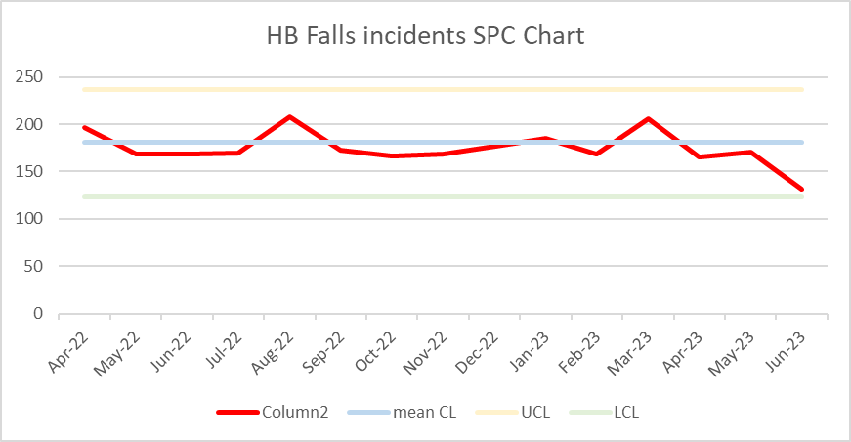
- Continued reduction in overall falls rates with significant drop off during June
- Development of Health Board Falls Strategy in progress
- Safe Care Collaboration project progressing well with good engagement from local authority colleagues

Quality Priority Goals | Methods
End of Life Care  Increase proportion of Swansea Bay residents receiving the right care at the right place at the right time in the last year, months, weeks, days of life | - Increased correct identification of people who may be in the last year of life  - Increase Advance & Future Care Planning across all care settings  - Increased correct identification of people who may be in the last days of life  - Increase the number of staff given education and training to support high quality EOLC  - Identify and produce systems that support sharing of advance and future care planning across all care settings
Measures | Trajectories
- % Swansea Bay UHB resident deaths outside of hospital – this measure may change due to ONS license issues nationally  - % of patients on the Palliative care register  - Number of advance & future care plan notifications in WCP  - Number and % of deaths reviewed by the medical examiner with a care decision guidance document  - % of deaths within 48hrs of emergency attendance  - Number of staff given education and training in EOLC  - Systems enabled to share end of life care/advance & future care planning information across platforms | 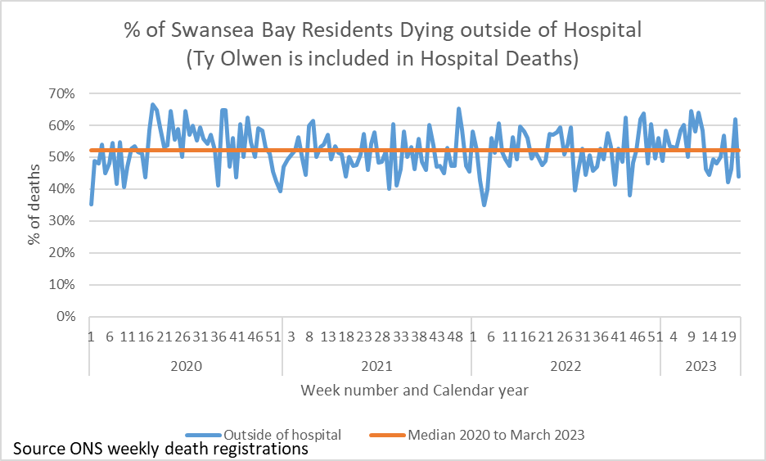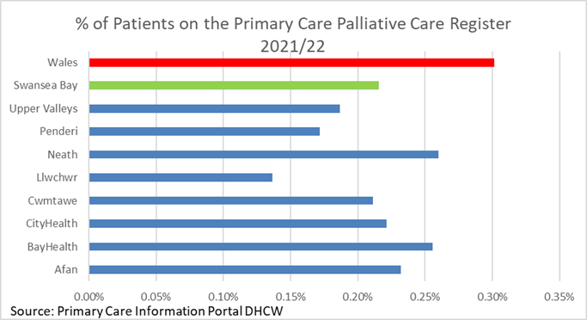  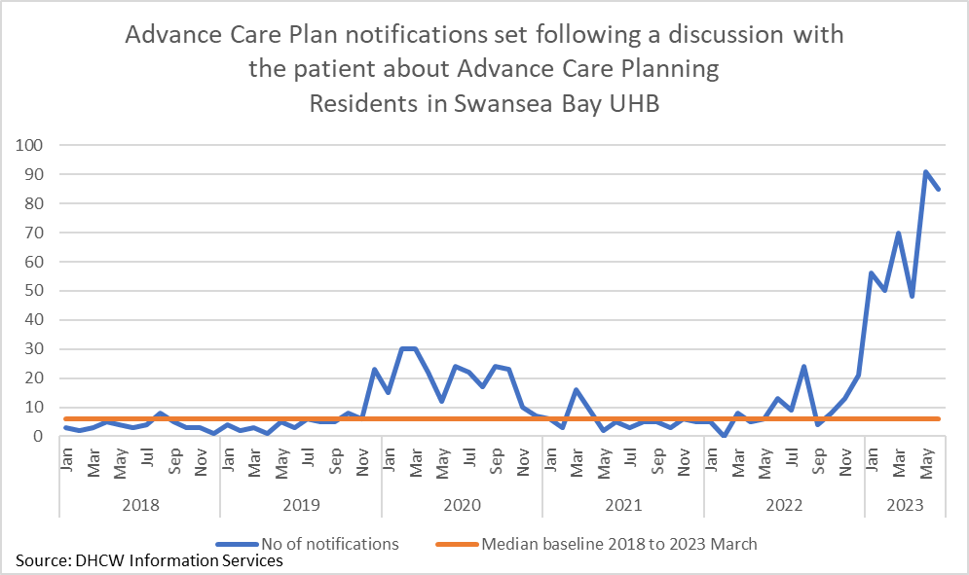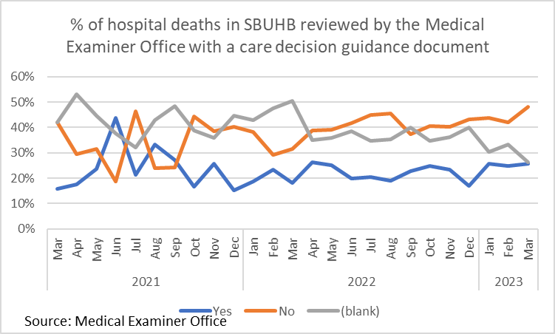  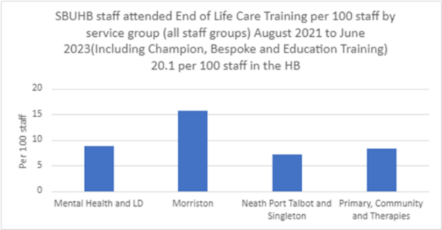
- ONS deaths access issue – Using published ONS data which groups Ty Olwen deaths into hospital, further work needed with Digital Intelligence to understand how we identify these to ensure they are group as deaths outside of hospital and how this can be included in the dashboard
- Palliative care register numbers – only available yearly. Request to participating practices in the project to share monthly data for the duration of the project. This has been agreed and we hope to see data for July 2023 onwards.
- A&FCP notifications in WCP are increasing – request with DHCW to determine which teams this might be, there has been renewed efforts in Specialist Palliative Care.
- Care decision guidance for last days of life is promoted through the EOLC training and will be available in WNCR next year. This is currently only available via the Medical Examiner, the receiving of data is currently being transferred to the Digital Intelligence team therefore no data past March 2023 is available currently.
- Measure for in-hospital deaths within xx hrs being developed.
- Continued delivery of EOLC training through various channels - Champion, Bespoke and Education Training. Champion Training under review and information will need to be reviewed by service group (SG) due to ASMR staff changes. Bespoke training delivered on the request of SGs.
- Solution required to digital issues - need a digital dashboard developed to be accessible to all and understand potential of digital systems to support end of life care – EOLC dashboard location being reviewed in August 2023 with Digital Intelligence. Digital conversations have started re WCP and Signal developments to support EOLC.

Quality Priority Goals | Methods
Sepsis: improvement in the recognition and management of Sepsis | - Resuscitation team have provided a diminishing programme of support for the sepsis audit process over previous three months, May and June audits were done with sepsis champions or ward managers, July resuscitation team reminded ward teams and offered support. It is hoped that this will now be sustained audit programme by the service groups.  - Targeted action plans devised in collaboration with sepsis champions, many of these have focussed around placement of sepsis screening books to ensure timely screening of patients at risk of sepsis.  - Morriston sepsis leads are in discussion with digital planning to provide a digital solution and a focussed piece of work in SDMU looking at training.  - NPTSSG are looking at using existing Signal options to improve communication around sepsis and a targeted training programme.  - Awareness campaign including drop-in training sessions, ward based training sessions and use of sepsis notice board displays are being used across the HB. Around 500 staff have received Sepsis training  - Sepsis webpage containing variety of resource going live week commencing 7.8.23  - Sepsis summit planned for September 2023
Measures | Trajectories
- % of patients appropriately screened for Sepsis | - Priority was given to auditing the admitting units where there has been a significant increase in number of forms completed but percentage of appropriate patients screened remains about the same.  - Plans in place to address this including re-audit, training and raising awareness.
   | June 23 | July 23 | Aug 23 | Sept 23 | Oct 23 | Nov 23 | Dec 23
  % of appropriate patients screened in acute wards in Morriston, NPT, Singleton  Baseline May 2023 11%  Median May 2023 0% | >25% | >40%  Poor response from service groups means we unable to provide this information | >55% | >60% | >70% | >85% | >95%
  % of appropriate patients screened in AMU  Baseline May 2023 25% | >50% | >20% June 2023 | >80% | >95% | >95% | >95% | >95%
  % of appropriate patients screened in ED  Baseline May 2023 53% | >60% | >57% July 2023 (targeted 75%) | >85% | >95% | >95% | >95% | >95%
  % wards who have access to Sepsis training and resources | >75% | 100% sessions offered to all wards on a regular basis | 100% | 100% | 100% | 100% | 100%

Quality Priority Goals | Methods
Suicide Prevention | - Engagement in Sharing Hope project  - Delivery of training in suicide prevention across all teams
Measures | Trajectories
- Education of all available staff across the HB in recognising and managing suicide.  Continue to support and work with Swansea Multi Agency Group and other stakeholders across the HB in relation to obtaining a baseline assessment of suicide cases and map against national trends.  - Occupational Health and Wellbeing support for staff with anxiety/depression to prevent escalation in risk of suicide. | 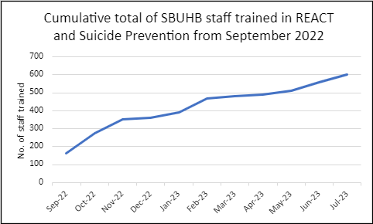
- Successful integration of REACT and Suicide Awareness training.
- Planning for development of HB Suicide Strategy underway
- REACT training to be included in Managers’ Pathway
- Continued success of Sharing Hope – The Art of Healing Together has reached the final of the health boards LOV awards and Best
Staff Wellbeing project of the year at the HSJ Patient Safety Awards.

Governance and Assurance

Link to Enabling Objectives  (please choose) | Supporting better health and wellbeing by actively promoting and empowering people to live well in resilient communities
Link to Enabling Objectives  (please choose) | Partnerships for Improving Health and Wellbeing |  | ☒
Link to Enabling Objectives  (please choose) | Co-Production and Health Literacy |  | ☒
Link to Enabling Objectives  (please choose) | Digitally Enabled Health and Wellbeing |  | ☒
Link to Enabling Objectives  (please choose) | Deliver better care through excellent health and care services achieving the outcomes that matter most to people
Link to Enabling Objectives  (please choose) | Best Value Outcomes and High Quality Care |  | ☒
Link to Enabling Objectives  (please choose) | Partnerships for Care |  | ☒
Link to Enabling Objectives  (please choose) | Excellent Staff |  | ☒
Link to Enabling Objectives  (please choose) | Digitally Enabled Care |  | ☒
Link to Enabling Objectives  (please choose) | Outstanding Research, Innovation, Education and Learning |  | ☒
Health and Care Standards
(please choose) | Staying Healthy |  | ☒
(please choose) | Safe Care |  | ☒
(please choose) | Effective Care |  | ☒
(please choose) | Dignified Care |  | ☒
(please choose) | Timely Care |  | ☒
(please choose) | Individual Care |  | ☒
(please choose) | Staff and Resources |  | ☒
Quality, Safety and Patient Experience
This report outlines the work streams and structures in place across the organisation to promote the quality and safety of our care.
Financial Implications
No financial implications noted in this report.

Legal Implications (including equality and diversity assessment)
The Quality and Engagement Action sets out our responsibilities for quality and safety.
Staffing Implications
No additional implications noted within the report.
Long Term Implications (including the impact of the Well-being of Future Generations (Wales) Act 2015)
Delivery of the Quality Strategy reflects the principles of the Well-being of Future Generations Act and the Population Health Strategy through a focus on early intervention and activation in order to reduce risk of harm.
Report History |  | Quality Management Board August 2023  Quality and Safety Committee August 2023
Appendices

