

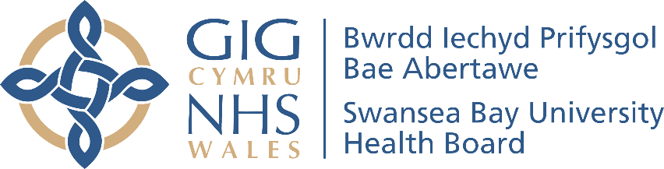

Welsh Language Performance Report 2026

Swansea Bay University Health Board

Welsh Language Performance Report, 2026

Chair’s Foreword 3
Introduction 4
Our Duty of Quality 4
Governance and Accountability 4
Support to Deliver 5
Service Delivery 6
Contacting us by telephone or writing to us 6
Website and social media 6
Reception services 7
Morriston Hospital 7
Singleton Hospital 8
Neath Port Talbot Hospital 8
Primary Care 8
Policy Making Standards 10
Engaging with the public 10
Operational Standards 12
Providing Clinical Consultations in Welsh 12
Using the Welsh language within the organisation 13
Employment Matters 13
Software packages 14
Use of artificial intelligence 14
Intranet 14
Recruitment Administration 15
Building Partnerships 16
Case Example: The future workforce 16
Eisteddfod yr Urdd 2025 18
Staff Engagement 20
Cornel Cymraeg 20
Viva Engage 20
Wales Through Your Eyes – Golwg Gymreig Photo Competition 21
Diwrnod Shwmae Su’mae 22
Cultural Ambassadors 22
Case Study: Why Learning Welsh Makes Me a Better Speech and Language Therapist 23
Our Learning Welsh Pathway 26
Raising Confidence 26
Cymraeg Croeso (2hr) 27
Cymraeg Croeso (10hr) 27
Organisational Operational Priorities 29
Welsh Language Priorities 29
Leadership 29
Leading in a bilingual Country 29
Governance 30
Communicating with our Patients 31
Spiritual Care 31
Bilingual Clinical Provision 31
Developing our staff 32
Record Keeping 33
Appendix 1 - Recruitment 34
Appendix 2 – Staff Competency 35
Appendix 3 – Complaints and Concerns 37
Appendix 4 – Welsh in Swansea and Neath Port Talbot 38
Appendix 5 – Patient Experience 39
Appendix 6 – Overall Compliance 40

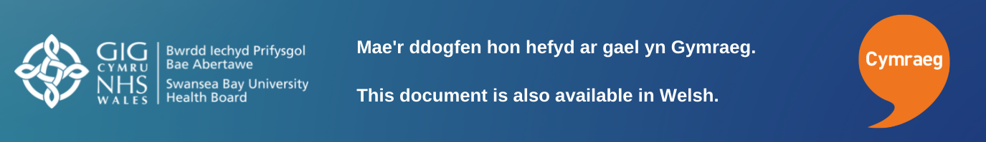


Chair’s Foreword
I am pleased to present Swansea Bay University Health Board’s Annual Welsh Language Report for the period 1 April 2025 to 31 March 2026, highlighting our continuing commitment to the Welsh language and to delivering high-quality, safe, and person-centred care.
Language is a fundamental element of person-centred healthcare. For many people, being able to communicate in Welsh is essential to expressing their needs, understanding information, and participating fully in decisions about their care. Without giving due consideration to the Welsh language, it is not possible to consistently deliver care that is truly safe, effective, and centred on the individual.
During the year, we have continued to strengthen our compliance with the Welsh Language Standards, while promoting greater use of Welsh across our services. Our focus has been on creating meaningful change by ensuring that language needs are recognised, respected and incorporated into the care we provide.
I would like to thank our staff for their dedication and commitment to supporting Welsh language services, and our patients and communities for their valuable feedback, this helps us to continue improving.
The Welsh language belongs to us all, and I look forward to building on this progress as we continue to embed Welsh as an integral part of healthcare across Swansea Bay University Health Board.

Jan Williams OBE FRSPH
Chair



Introduction
Swansea Bay University Health Board has a statutory duty under the Welsh Language (Wales) Measure 2011 to produce and publish an annual report on its compliance with standards set by the Welsh Language Commissioner.

This report will evidence how this Health Board has performed in relation to our compliance notice for the reporting period; 1st April 2025 – 31st March 2026. The report also sets out our commitment to the Welsh language and sets out our priorities for the coming year.

Our Duty of Quality
The Duty of Quality describes the need for health boards to provide Welsh language services in people’s first language as an integral part of person-centred care. Within Swansea Bay University Health Board, we recognise the relationship between language and quality, which is why reporting and accountability for the Welsh language are embedded within our systems for managing quality.
This report should be read in conjunction with our Annual Quality Report, where we describe the achievements and priorities in improving the experience and outcomes for Welsh-speakers.

Governance and Accountability
Our Chief Executive is corporately responsible for compliance with the Welsh Language Standards. The Director of Nursing and Patient Experience is responsible at an Executive level and is supported by the Head of Quality and Safety and the Welsh Language Lead in delivery of strategic objectives.

Responsibility for delivery of bilingual services is overseen by our Welsh Language Planning and Development Group and our Quality and Safety Group, which in turn report into the Quality and Safety Committee of the Board. The Welsh Language Planning and Development Group exists to provide assurance to the Board that systems and processes are in place to enable the organisation to meet its responsibilities under the Welsh Language Measure. This group is chaired by an Executive Director and reports through them to the Quality and Safety Committee, which in turn reports to the Health Board. Membership of this group has been reviewed during this reporting period, and we will continue to review annually as we move to becoming a clinically led organisation. This will ensure that the group is well positioned to take forward the requirements of More Than Just Words and the Duty of Quality.

This report has been complied in line with guidance set out by the Welsh Language Commissioner and has been shared with members of the Welsh Language Planning and Development Group and approved by the Quality and Safety Committee prior to publication.

Support to Deliver
Our Welsh Language Services Team led by the Welsh Language Lead, are positioned withing the corporate Quality, Safety, and Improvement team. This enables the promotion of Welsh language considerations within our wider quality management system. This includes our quality assurance structures and our improvement support.
The strategic guidance that this team offers to managers and staff across our organisation ensures that, as a body, we are interpreting and implementing the standards appropriately. As a result of this work, year on year, we are seeing growth in demand for services offered by the team, namely translation and additional training opportunities.

Service Delivery

Contacting us by telephone or writing to us
Members of the public are welcome to communicate with us in Welsh, and we promote this on our webpages, emails and when writing by letter. If somebody chooses to correspond with us in Welsh, we will respond to their contact within the same timeframe as we would have they written to us in English. Corresponding with us in Welsh will not lead to delayed responses.
Support in achieving this is offered to all departments of the health board by our corporate translation service which is based at our Headquarters in Baglan. This small but efficient team makes sure that we reply on time.

Some members of the public prefer to contact us by phone. We want callers who wish to speak with us in Welsh to have a high-quality experience. Over the past year we have increased the number of telephone lines which have automated answering systems meaning that callers to our main numbers are always greeted and can follow an automated selection process from beginning to end in Welsh. Our internal quality verification processes have evidenced a significant improvement in this regard over the past two years.
When callers to our main numbers opt to have their call directed to one of our switchboard operators, our systems direct the calls based on the callers language choice. Callers that select Welsh are added to a queue to speak with the next available call handler with Welsh language skills.
Our ability to answer these calls is improving year on year, but we do recognise that there are occasions when we are not able to answer them in Welsh every time. To address this, we have an action plan in place which has committed the service to increasing the number of Welsh speaking staff on the team. When recruitment opportunities arise, we advertise those vacancies as ‘Welsh Essential,’ and we further support those we appoint with opportunities to refine their skills through opportunities offered both in-house and through the ‘Dysgu Cymraeg’ programme. 6 of the 20 staff that answer calls to our main numbers can answer calls in Welsh. There are currently 3 vacancies within the team, and we will look to advertise those posts as ‘Welsh Essential’ as soon as we are able.

Website and social media
We maintain a presence on the most popular social media networks. These platforms can be an important tool to communicate with alternative audiences. Our Welsh language accounts have a small following and we see a slight increase in these numbers each year. Availability of the Welsh accounts is promoted on the home page of the equivalent English language accounts where the same posts can be viewed in English.
Our digital presence is an increasingly popular sources of information for our patients and communities. Here people can access information about the wide range of services that we offer. We also use our social media accounts to continually raise awareness of campaigns and activity being carried out by the Health Board with the aim of improving public health.
Here are links to our Welsh language social media accounts.
- On Facebook, our Welsh account has 205 subscribers. (+11)
  - https://Facebook.com/BaeAbertaweGIG
- On X / Twitter, our Welsh account has 350 followers.
  - https://x.com/BaeAbertaweGIG
- On Instagram, our Welsh account has 113 followers. (+15)
  - o https://www.instagram.com/bipbaeabertawe?igsh=Z3Vsc2M0eDZvd2cy
- On LinkedIn, our Welsh account has 42 subscribers. (+6)
  - https://www.linkedin.com/company/73177598/admin/dashboard/

Reception services
Reception areas are often the first-place patients and visitors engage with our services, making them a key point of initial contact. It is essential that staff working in these roles understand the importance of providing a high-quality service.
Offering services in Welsh can significantly enhance the experience of individuals attending our hospitals. By having a clear understanding of the Welsh language abilities within our workforce, we can better plan and develop these skills where there are gaps. The Welsh language proficiency of staff currently working in reception roles (at the time of reporting) is outlined below:

Morriston Hospital
The data we hold for reception staff at Morriston is not as robust as we would like and this is an improvement area that we have recorded. Of the 26 members providing reception services with skills recorded, 3 can provide those services in Welsh (11.5%)
10 directly employed staff provide main Outpatients Department reception services, 2 of whom (20%) are Welsh speaking.

Singleton Hospital
40 members of staff provide reception services across various clinics and wards at the Singleton Hospital site. 3 of these staff members are Welsh speakers. (7.5%)

Neath Port Talbot Hospital
Including volunteers, we have 60 people delivering reception services to patients and visitors. Of those, 6 are Welsh speakers. (10%)
Our recruitment strategy requires managers to consider the need for Welsh language skills when advertising vacant positions. An assessment of linguistic ability within the team is a factor in reaching a determination around skill need. Our aim is to increase the number of Welsh speakers in these roles; however, this is a longer-term ambition as staff turnover is low in these roles. This is why our Welsh language learning pathways for non-Welsh speaking staff are so important.

Primary Care
We support our colleagues in Primary Care to carry out the six duties imposed on them by the Welsh Language Commissioner, namely:
- Notification of Welsh Language Services: Contractors must notify us in writing when they are able to provide services in Welsh.
- Provision of Welsh Language Documents: All documents or forms provided must be available in Welsh alongside English.
- Bilingual Signs and Notices: New signs or notices must include text in both Welsh and English.
- Use of Welsh Language Badges: Staff providing services in Welsh should wear badges to indicate their Welsh language skills.
- Awareness and Training: Staff are encouraged to access information and attend training courses to promote Welsh language awareness.
- Encouragement of Staff Participation: Contractors must encourage staff to participate in training and events to enhance their Welsh language

We regularly circulate information to the sector to raise awareness of these obligations and continue to offer support in promoting any services that they can offer.

Our Primary Care Assurance Framework requires contractors to submit an annual report on their ability to meet service needs in Welsh, and where an ability to deliver services in Welsh is identified, this information is posted to the primary care directory on our website.

Policy Making Standards

Person-centred care and the Welsh language are fundamental considerations at every level of the organisation. Our impact assessment processes have been enhanced in recent years so that the needs, experiences, and language preferences of the people we serve are consistently considered.

We recognise that understanding the potential positive and negative effects of decisions on Welsh speakers is essential to delivering equitable, high-quality care. As such, Welsh language considerations are fully integrated into all impact assessments. Where risks or unintended negative impacts are identified, we take a proactive, collaborative approach to mitigate them and ensure that outcomes remain aligned with our commitment to person-centred care.

The development of all new policies is subject to robust scrutiny through our Stakeholder Reference Group. This includes designated Welsh language champions who ensure that linguistic considerations are not an afterthought, but a core element of policy design, review, and approval.

At Swansea Bay, the Welsh language is embedded as a core principle within the Quality Plan, reflecting our belief that language is integral to safe, effective, and compassionate care. Our quality plan reinforces our organisational commitment to meeting the Welsh Language Standards while recognising that care delivered in a person’s preferred language directly supports dignity, understanding and better outcomes.

This year, our report demonstrates tangible progress against the More Than Just Words framework, including the steps we have taken to expand our capacity to provide clinical consultations in Welsh in key priority areas. This work is helping to embed a culture where language is recognised as a critical component of quality and safety, and where person-centred care is understood to include meeting the linguistic needs of individuals and communities.

There is a shared understanding at Swansea Bay that the Welsh language is no longer an optional add-on, but a core element of person-centred, high-quality healthcare.

Engaging with the public
Our consultation materials clearly set out our commitment to improving the experiences of Welsh-speaking service users, alongside the robust processes we use to assess the impact of decisions on the Welsh language. In addition to standard formats in Welsh and English, we can provide consultation documents in accessible formats, including Braille and audio in Welsh, ensuring a more inclusive and equitable engagement process.

We recognise, however, that providing Welsh-language documentation alone is not sufficient to fully engage with Welsh speakers. Meaningful engagement requires active listening and ongoing dialogue.

Looking ahead, we will strengthen our approach by undertaking targeted listening and engagement activity with Welsh speakers, enabling us to better understand their experiences of our services and to ensure that their voices directly inform our decision-making and the development of person-centred care

Operational Standards

Providing Clinical Consultations in Welsh
In December 2024, we published our five-year plan outlining the actions we will take to strengthen our ability to provide clinical consultations in Welsh. Developed over an 18-month period, the plan sets out a clear programme of work focused on the priority areas identified within More Than Just Words:
- Mental Health, Learning Disabilities and Dementia Care
- Speech and Language Therapy
- Stroke Services
- Care of the Elderly
- Children and Young People’s Services
Since publication, progress has been made across these key service areas and oversight of the five-year plan remains a key focus for the Health Board. Lead managers provide regular updates to the Welsh Language Planning and Delivery Group, enabling progress to be monitored, challenges to be addressed and good practice to be shared across the organisation.
In Mental Health and Learning Disabilities, continued improvements in the recording of staff Welsh language skills have helped managers identify Welsh-speaking staff and support them to develop their confidence and skills through targeted learning opportunities. This work is helping to increase capacity and strengthen the delivery of the Active Offer.
Speech and Language Therapy has also continued to make excellent progress. The number of volunteer ‘anogwyr’ supporting the project has increased, creating greater opportunities for staff to use and develop their Welsh language skills in the workplace. In addition, Welsh-medium clinics have been successfully piloted.
We are seeing a solid understanding amongst service leads that providing care through the medium of Welsh not only helps patients better understand their condition and care plan but also enables clinicians to gain a fuller understanding of their needs, circumstances and preferences – putting the patient right at the centre of their care.

Using the Welsh language within the organisation
The use of Welsh within our Health Board extends beyond communication with patients and communities. As an organisation with Welsh-speaking staff, we have a responsibility—reflected in our We Belong equalities strategy—to respect their language needs and create an environment that encourages wider use and learning of Welsh.
We have established a clear policy outlining our responsibilities for the use of Welsh across internal operations. This supports staff in meeting the Welsh Language Standards while actively promoting the use of Welsh in day-to-day work. Alongside dedicated intranet resources, the policy provides practical guidance to help staff confidently use more Welsh in the workplace.
Over the past 12 months, our ‘Anogwyr’ (Welsh language champions) have continued their work of raising awareness of opportunities to use more Welsh in the workplace, whilst at the same time signposting interested parties to learning provisions offered through our partners at Dysgu Cymraeg. The Anogwyr programme is an exemplar of how peer support can foster a positive environment for use of Welsh to grow.
To both promote and gain assurance in relation to the Active Offer, our Welsh language team have joined a multi-disciplinary team undertaking quality assurance audits of clinical areas over the past year. These visits allow an opportunity to gather insight from patients and staff regarding the use of language within clinical settings, as well as to promote the work of the team more widely.

Employment Matters
A proportion of our staff are Welsh speakers, and Swansea Bay University Health Board issues all employment contracts bilingually. While we use the Electronic Staff Record (ESR) system for leave and absence management, its linguistic limitations mean these processes cannot currently be delivered in Welsh. This is a national issue, and partners including Digital Health Care Wales (DHCW) and NHS Wales Shared Services Partnership (NWSSP) are advocating for improvements, with a replacement system in early development to address this.
We are committed to enabling staff to engage with us in their preferred language. This includes bilingual recruitment processes, where applications and interviews can be conducted in Welsh. Sickness absence is managed at line manager level, with all associated documentation available in both English and Welsh to support Welsh-speaking staff.

Software packages
To facilitate the use of Welsh at work, staff can request that software be added to their computers to support their accurate use of Welsh. Cysgliad and To-bach are both programmes related to grammar which are quick and easy to install. Staff can also apply the Microsoft 365 Welsh language Interface through their personal settings.

We regularly monitor the market for new applications or websites which could support our staff in using their Welsh language skills in the workplace.

Our in-house translation team use translation memory software in their work. During the reporting year, the Health Board have invested in a move to a new software platform which uses machine translation. Our translators have adapted well to this change and as they have become familiar with the platform, we have seen productivity increases.

Use of artificial intelligence
For quality assurance, non-Welsh speakers are not currently permitted to use AI for translating correspondence. While this rapidly evolving technology has potential to expand translation capacity, effective use requires strong Welsh language knowledge to ensure accuracy and context. The Welsh Language Services Department continues to monitor developments in this area.

Intranet
We want to make it as easy as possible for staff to find information about the Welsh language and our responsibilities.
A wide range of resources is available on the Health Board’s intranet to support staff in using Welsh at work.
In the Help and Guidance section, staff can access information on how we meet Welsh language standards. This includes clear guidance on topics such as:
- Responding to correspondence
- Using social media
- Conducting meetings
- Workforce planning
All content is regularly reviewed to make sure the guidance remains up to date and helps make Cymraeg as accessible as possible for everyone.
Through links from this homepage, staff can:
- Access resources such as bilingual posters encouraging patients and visitors to use Welsh
- Order Iaith Gwaith badges and lanyards
- Find commonly translated job titles, departments, and addresses, along with a directory of Welsh email aliases
The content on this site continues to grow, ensuring staff can quickly find the information they need.

Recruitment Administration
Our recruitment practices offer a fully accessible experience to those who wish to apply for a position at Swansea Bay.
We publish adverts, job descriptions, and all other related documents bilingually on our recruitment platform.
Any new or reviewed job descriptions are processed by our job evaluation team and translation of these documents is completed before they are released to recruiting managers. We have adopted bilingual templates as the organisational standard for job descriptions, so that the English version cannot be distributed without the Welsh.
In November 2024, stringent processes were introduced, and authority was given to our recruitment partners at NHS Wales Shared Services Partnership to reject any vacancy advertisement requests for Agenda for Change posts that did not fully meet the requirements of the Welsh language standards.
These processes are now fully embedded in our recruitment practice for all positions.

Building Partnerships
Achieving our objectives depends on effective collaboration with a wide range of organisations. This includes working closely with other NHS bodies as well as partners beyond the health sector.
Our Welsh Language Lead remains an active member of the national strategic Welsh language group, which brings together Welsh language leads and managers from healthcare organisations across Wales. Established to promote collaboration and the sharing of good practice, the group has evolved into an influential forum that collectively represents healthcare organisations on Welsh language matters. Through this work, it provides a coordinated voice in discussions with the Welsh Government and the Welsh Language Commissioner on issues affecting the delivery of Welsh-language services in healthcare.
In addition, our Welsh Language Lead maintains regular engagement with Welsh Government officials to provide updates on progress against the More Than Just Words strategy, discuss emerging priorities, and receive feedback on key developments relating to the Welsh language agenda.

Case Example: The future workforce
We are proud to have become the first Health Board in Wales to deliver a pioneering Welsh language careers challenge in partnership with Careers Wales.
As part of the Work in Focus ‘Cymraeg Cyntaf’ Workplace Challenge, pupils from Cefn Hengoed Community School were tasked with creating innovative resources to empower new Health Board apprentices to use conversational Welsh in the workplace.
Cefn Hengoed Community School is an English-medium secondary school located in the Bonymaen area of Swansea. A significant percentage of students live in areas classified as the most deprived in Wales, highlighting a concentration of socioeconomic challenges. Partnership initiatives with local employers play a vital role in increasing knowledge and awareness about career opportunities and raising aspirations amongst learners.
Alongside colleagues from Careers Wales, our Careers, Widening Access & Work Experience team, presented the challenge to all Year 9 pupils across seven different classes. The challenge was fully accessible to all learners, including those with additional learning needs.
Careers Wales developed work in Focus challenges to embed Careers and Work-Related Experiences (CWRE) into the new curriculum through meaningful employer engagement. Each challenge focuses on real-world tasks that develop learners’ essential cross-curricular skills such as literacy, numeracy, and digital competency, while promoting creativity, problem solving, and critical thinking.
For this challenge, learners worked in small groups to design practical and engaging Welsh language resources tailored to NHS apprentice roles, including Healthcare Support Workers, Catering Assistants, Business Administration Apprentices, IT Technicians and Domestic Assistants. Ideas from the talented pupils included a recyclable cutlery sleeve with key vocabulary for catering staff, lanyard attachments with role-specific Welsh words and phrases and a dedicated Welsh language aide memoire for Healthcare Support Workers.
The overall winning design was an innovative shaped-insert that is designed to attach to the back of a smartphone, featuring key Welsh questions, answers, and role-specific vocabulary. The students behind the winning idea focused on accessibility, practicality, and customisation to suit staff working in different Health Board settings.
Our Widening Access Manager, Victoria Williams, praised the efforts of all the pupils, noting that: “The creativity, teamwork and practical focus shown was impressive. This workplace challenge was a brilliant way to show pupils the real-world value of learning and speaking Welsh, especially within NHS Wales, where we have specific duties to provide bilingual services and to promote and facilitate Welsh language use amongst staff. It was great to have the opportunity to help pupils understand that language is an essential component of effective healthcare, because responding to the individual needs of patients and service users always starts with good communication.”
Andrea John, Business Engagement Advisor for Careers Wales, added: “The enthusiasm and innovative thinking displayed by the pupils was outstanding. They engaged deeply with the challenge, producing resources that not only supported Welsh language learning, but demonstrated a clear understanding of workplace needs.”
This successful pilot highlights how partnerships between employers and schools can bring careers education to life, whilst supporting key national priorities such as the promotion of the Welsh language in the workplace.
Clementine Hollister, Head of Welsh at Cefn Hengoed School said: “Taking part in the challenge was a wonderful experience for pupils. It provided an opportunity to be creative, to innovate and to aspire. We were delighted with our pupils' fantastic designs, which drew so effectively on their knowledge of Welsh. Moreover, it provided pupils with time and space to reflect on career opportunities and to plan for the future.”

Eisteddfod yr Urdd 2025
In May 2025, Swansea Bay University Health Board led a collaborative project to coordinate and deliver an NHS presence at the Urdd National Eisteddfod, held at Margam Park. The event attracts significant attendance from across Wales, as well as large numbers of local residents, providing an important opportunity to engage with children, young people, families, and communities on a wide range of health and wellbeing topics.
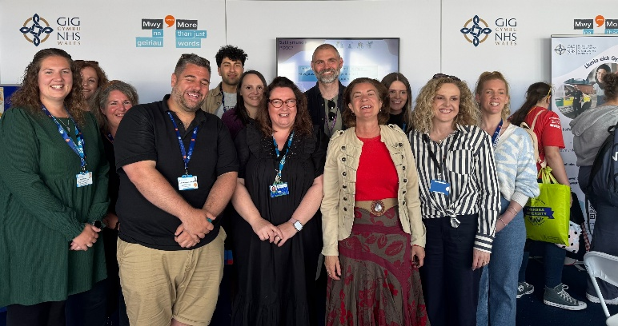
Swansea Bay University Health Board worked in partnership with Health Education and Improvement Wales (HEIW) and NHS Wales Shared Services Partnership to plan and deliver the initiative. Welsh Government supported the presence financially. This collaborative approach enabled NHS organisations to maximise engagement opportunities and showcase the breadth of services available across Wales.
The stand provided information, advice and interactive activities designed to promote health and wellbeing, while encouraging meaningful conversations with members of the public. A wide range of services were represented, including the Burns Service, Mental Health Services, Help Me Quit, Speech and Language Therapy, School Nursing and Vaccination teams. The event also provided an opportunity to raise awareness of digital services and promote digital methods of engaging with patients.
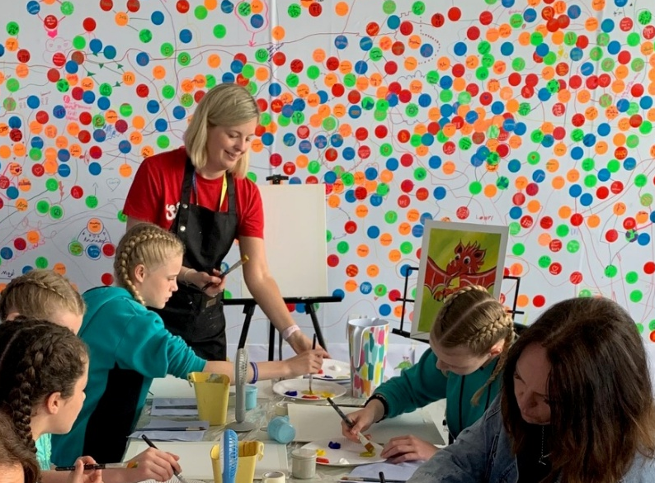
Careers information and advice formed a key part of the offer, providing support for young people considering careers in healthcare, as well as individuals interested in career changes and employment opportunities within the NHS.
Swansea Bay University Health Board’s Arts in Health team delivered a programme of creative activities throughout the week, encouraging children and young people to reflect on the factors that contribute to positive wellbeing and success in life. These activities proved extremely popular, with approximately 3,000 young people participating during the festival.
The project represented the first time that multiple NHS organisations had collaborated on a presence of this scale at the Urdd National Eisteddfod. The success of the initiative established a strong model for future joint engagement activities and demonstrated the value of cross-organisational partnership working. It has created a solid foundation on which Welsh Government, health boards and other health and social care organisations can build to further strengthen their presence and engagement with the public at future national events.
The initiative successfully increased the visibility of NHS Wales services, promoted health and wellbeing messages to a diverse audience, and strengthened relationships with communities across Wales through positive and meaningful engagement.
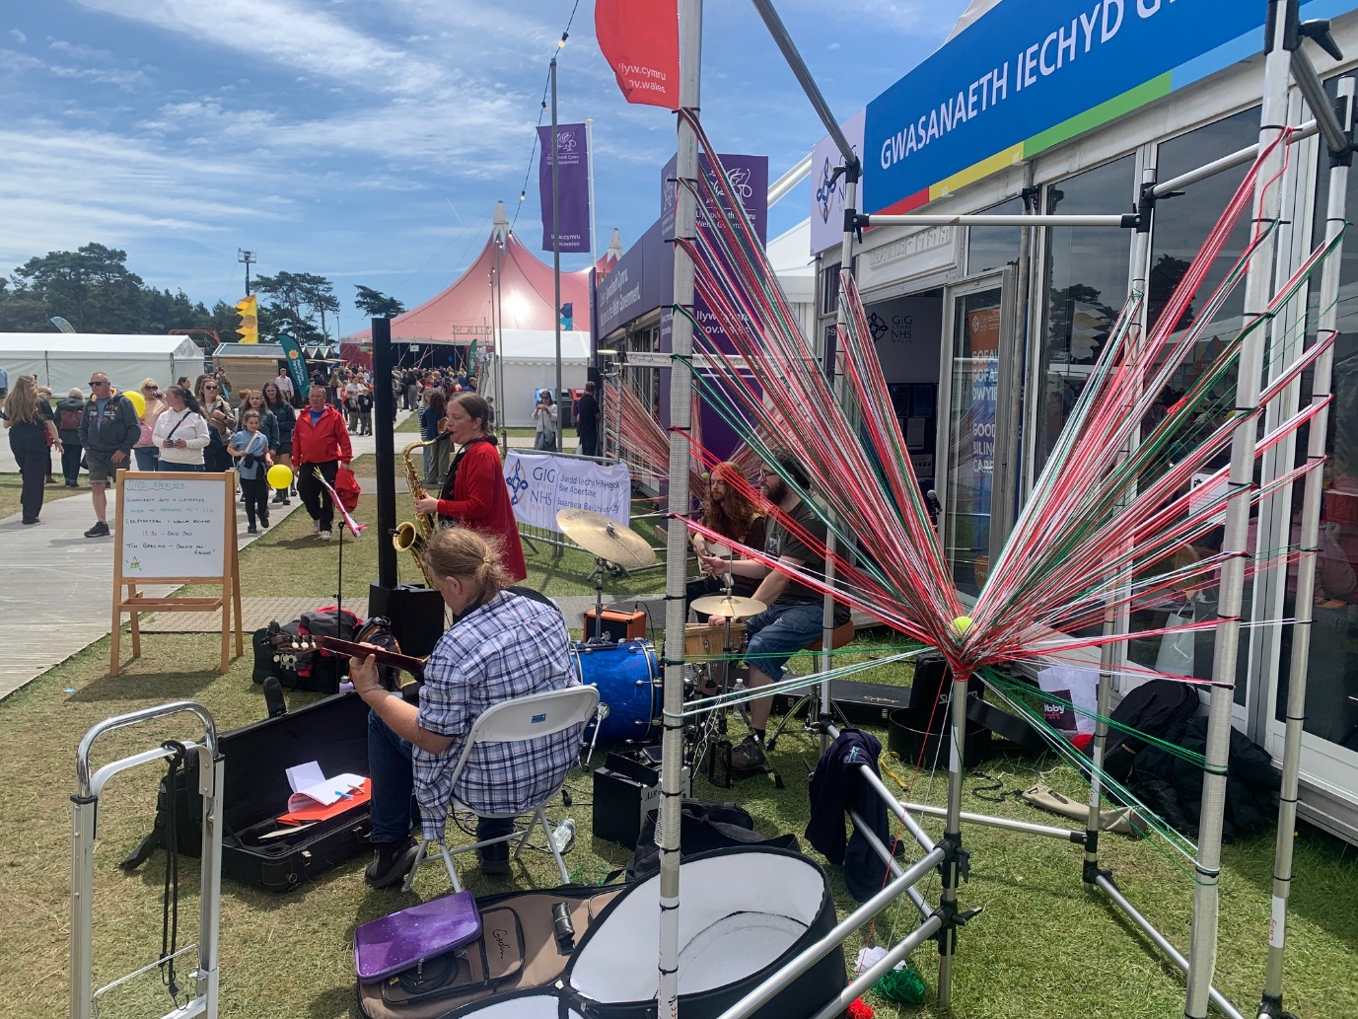
Above: ‘The Iridium Collective’ entertain visitors to the Maes outside the NHS Wales pavilion.
Top Left: Eluned Morgan calls into the pavilion to hear latest progress on The More Than Just Words framework.
Bottom Left: CAMHS staff deliver a well-being workshop for young people.

Staff Engagement

Cornel Cymraeg
A core initiative delivered is Cornel Cymraeg, which provides a friendly and welcoming environment for staff to practise Welsh in an informal and supportive setting.
Sessions are designed to be fully inclusive, catering for all levels of ability—from complete beginners to more confident speakers. The focus is on creating a relaxed atmosphere where participants feel comfortable using Welsh without fear of making mistakes.
Activities typically include:
- Simple, everyday conversations
- Themed vocabulary sessions
- Language games and interactive exercises
- Practical opportunities to use Welsh naturally
The emphasis is on enjoyment and confidence-building, helping staff to gradually increase their use of Welsh in the workplace without the pressure of a formal learning environment.

Viva Engage
Microsoft Viva Engage is a global employee community and engagement platform, designed to help staff connect, share knowledge, discuss topics, and build communities across an organisation. It is used extensively across our health board.
We have a dedicated SBU Cymraeg account which is managed and regularly updated as a key staff engagement platform.
This channel is used to:
- Share useful Welsh language learning resources
- Promote language challenges and tips
- Highlight cultural events and campaigns
- Encourage staff interaction and participation
By maintaining a consistent presence on Viva Engage, the Welsh language remains visible, relevant, and actively used within the organisation. The group now has 135 members

Wales Through Your Eyes – Golwg Gymreig Photo Competition

The Wales Through Your Eyes – Golwg Gymreig photo competition was a successful and engaging initiative that celebrated the beauty, culture, and identity of Wales through the perspectives of Swansea Bay staff. The competition invited individuals to capture what Wales means to them, resulting in a diverse and high-quality collection of photographs that highlighted landscapes, communities, humour, culture, and personal interpretations.
We were delighted by the level of participation and creativity. The entries reflected a wide range of viewpoints, highlighting the richness of Wales from iconic natural landscapes to dynamic everyday moments. The competition not only encouraged creativity but also strengthened engagement with Welsh culture and language across the organisation.

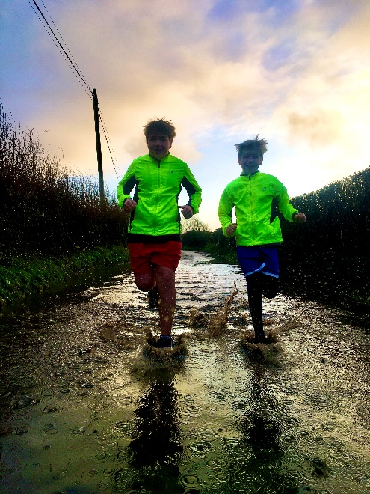
The competition successfully promoted: Engagement with Welsh culture and identity. Creative participation across departments, Positive staff involvement through bilingual activity. The quality and variety of submissions demonstrated a strong appreciation for Wales and highlighted the importance of initiatives that celebrate language, culture, and community.
The winning entry, a photograph of Cadair Idris taken by Ben Davies, a Healthcare Support Worker in Endoscopy can be seen on the front cover of this report.
Top Left: Mumbles by Annie Hill. 2nd Place.
Above Right: Puddle Run by Rebecca Wadley. 3rd place.

Diwrnod Shwmae Su’mae
To celebrate the national day, the Welsh Language Assistant organised a pop-up stand in the staff break area at Morriston Hospital. This provided an opportunity for staff to engage informally, ask questions, and learn more about using Welsh in the workplace.
The aim of the day was supporting the visibility and use of Welsh across both staff engagement and service provision, ensuring alignment with organisational language standards and wider strategic objectives.
Throughout the day, work centred on facilitating staff interaction through the medium of Welsh. This included promoting opportunities for staff to engage with Welsh-language initiatives, as well as supporting colleagues in accessing resources and guidance to increase their confidence in using the language in the workplace. Engagement levels remained encouraging, with positive feedback highlighting the value of creating inclusive and accessible opportunities for staff to participate in Welsh-medium activities.
Overall, the day contributed positively to the broader annual objectives of enhancing Welsh language visibility, increasing staff engagement, and supporting a bilingual work environment.

Cultural Ambassadors
This programme aims to promote the Welsh language, culture, and heritage, particularly among people who are new to Welsh communities. The programme offers three levels of learning, bronze, silver, and gold. Early in 2026, we piloted this programme with a small group of our staff and received positive feedback.
Promoting this to our wider workforce will help us to reinforce the importance of using Welsh but also give many of our staff members a greater insight into Welsh culture and history. We feel that this could be a powerful tool to strengthen our work to increase the visibility of the Welsh language and culture across our spaces.
From September 2026, we will begin to promote this free learning resource to key groups of staff, starting with those who have joined our workforce from overseas. We have set ourselves an ambitious target of supporting 100 staff members to achieve Bronze-level accreditation by the end of March 2027.

Case Study: Why Learning Welsh Makes Me a Better Speech and Language Therapist
"Learning Welsh has transformed not only my language skills, but also the way I understand communication barriers. Experiencing what it feels like to search for words, feel uncertain, or struggle to understand others has helped me become a more empathetic and responsive Speech and Language Therapist.”
Katrina McLaughlin - Clinical Lead Speech and Language Therapist

A Personal Journey Through Language
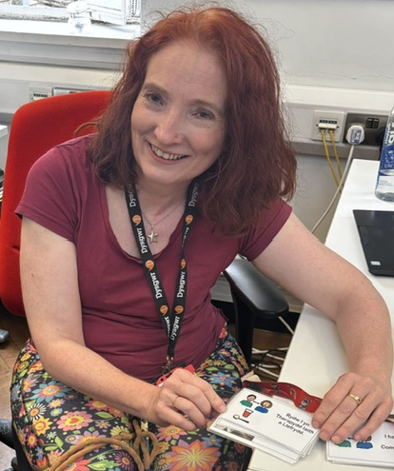
Although Katrina grew up in Somerset with English parents, she always felt a strong connection to Wales through her Welsh grandfather. From childhood stories and Welsh songs to male voice choir concerts, her grandfather nurtured a sense of Welsh identity that remained with her throughout her life.
When Katrina moved to Carmarthenshire in 1996 to work as a paediatric Speech and Language Therapist, she quickly realised she had joined a predominantly Welsh-speaking community. Working with children who spoke little, or no English highlighted the barriers that can arise when services are not delivered in an individual's preferred language.
Through these experiences, Katrina recognised that Welsh is more than a means of communication it is an important part of a person's identity, culture, and sense of belonging.

Learning Welsh Through Determination and Practice
Katrina began learning Welsh as soon as she arrived in Wales and has continued her language journey ever since. Her learning has included evening classes, workplace courses, language apps, reading Welsh books, attending Welsh-language events, and practising with colleagues and members of the community.
Like many learners, she developed her own version of "Wenglish" along the way and learned to embrace mistakes as an important part of the process.
"Learning Welsh has taught me that communication is about much more than speaking correctly. It's about connection, confidence and being willing to try. That's a message I share with everyone considering starting their own Welsh language journey." - Katrina McLaughlin

Understanding Communication Through Lived Experience
As a Speech and Language Therapist, Katrina supports individuals who experience communication difficulties. Through learning Welsh herself, she has personally experienced many of the same challenges faced by those she supports, including:
- Searching for the right words
- Feeling anxious or uncertain when speaking
- Mental fatigue caused by concentrating intensely
- An understanding of when communication becomes difficult
This lived experience has increased her empathy and understanding, helping her to adapt her communication style and reduce unnecessary demands during interactions.

Impact on Clinical Practice
Katrina now actively incorporates Welsh into her daily work wherever possible. She uses Welsh to build rapport, put people at ease and create stronger therapeutic relationships.
Her Welsh language journey has helped her to:
- Develop greater empathy for people experiencing communication challenges
- Become more patient and responsive in interactions
- Adapt communication styles to individual needs
- Better understand the difference between language preference and language ability
- Recognise the importance of emotional connection in effective communication
By embracing Welsh in her professional practice, Katrina is helping to ensure that patients can communicate in the language that feels most comfortable and natural to them.

Inspiring Others
Katrina continues to seek opportunities to develop her Welsh language skills, wearing a learner lanyard, practising with colleagues, and encouraging others to begin their own language-learning journey.
Her message is simple:
“Just start. Use Welsh little and often, don’t aim for perfection and focus on connection rather than correctness.”

Through her commitment to learning and using Welsh, Katrina demonstrates how language skills can enhance both professional practice and patient experience, helping to create a more inclusive and person-centred healthcare service.

Our Learning Welsh Pathway
Our Learn Welsh program is a tailored Welsh skills development provision for health and care workers, with the aim of increasing confidence, fluency and the ability to provide services through the medium of Welsh.

Raising Confidence
During the period covered by this report, 35 members of staff from a wide range of clinical and non-clinical professions were supported on the ‘Codi Hyder’ programme.
The majority of the participants already had some Welsh skills, but often lack of confidence, lack of regular use, or anxiety about making mistakes prevented them from using Welsh in their work. The learners' common goals included:
• Improve confidence to speak Welsh.
• Increase fluency in everyday conversations.
• Develop professional and clinical vocabulary.
• Conduct conversations and assessments with patients in Welsh.
• Feel more comfortable using Welsh in the workplace.
A flexible model of individual and group support was used, focusing on natural conversations, real work situations, role playing, and building vocabulary relevant to each individual's role. Practical resources such as vocabulary cards, posters, consultation scripts and terminology lists have been developed for a variety of clinical areas.
The results show a significant increase in levels of confidence and practical use of the Welsh language. In many cases, an increase was seen from very low scores (1 or 2 out of 5) to high levels of confidence (4 or 5 out of 5) in speaking and willingness to use the Welsh language. A number of participants now:
• Conduct assessments and consultations in Welsh.
• Regularly offer Welsh language services to patients.
• Answer telephones and written communication in Welsh.
• Promote the use of the Welsh language in their teams and services.
Another important effect of the program was to change the attitudes and mindset of staff. Many came to realise that perfect Welsh was not necessary to provide a quality service, and that patients appreciated the effort to communicate in their chosen language. As a result, a number of staff are now actively looking for opportunities to use the Welsh language with patients and colleagues.
As well as developing individual skills, the program has contributed to the creation of support networks and language leaders within services. Several participants have gone on to promote the Welsh language in their departments, organize taster sessions, create local resources and support colleagues to use more Welsh in their work.
In general, the provision has shown a very positive effect on staff confidence, their use of the Welsh language in the workplace, and their ability to provide care that focuses on the linguistic needs of patients. The ongoing aftercare scheme also helps to maintain this momentum and ensure that learners continue to develop their skills after completing the formal programme.

Cymraeg Croeso (2hr)
This is the minimum level of Welsh-language ability that Welsh Government require all NHS staff in Wales to achieve. It is a core target of the More Than Just Words strategy which aims to ensure that people can access healthcare in their preferred language.
The focus of this course is enabling the individual to confidently use words and phrases with correct pronunciation to improve a patient’s experience.
This course helps learners to:
- Greet patients in Welsh
- Pronounce Welsh names correctly
- Use words of comfort and reassurance
- Offer refreshments and
- Ask basic wellbeing questions.
The underlying principle behind the health and social care learn Welsh initiative is that staff do not need to be fluent in order to make a positive difference to a patient’s experience. During this reporting year, 85 members of staff have undertaken this 2-hour learning, with many taking an interest in further learning opportunities.

Cymraeg Croeso (10hr)
The 10-hour Croeso course is heavily tailored for those working in the healthcare sector. Building on the skills gained in the 2-hour session, the course provides staff with a practical introduction to everyday Welsh, equipping them with the language skills and confidence to communicate using simple Welsh with patients, visitors, and colleagues.
It covers greetings, introductions, common questions, numbers, time, places, expressing preferences, making requests and other everyday conversational language, alongside Welsh pronunciation, and core vocabulary.
46 of our staff members have undertaken this learning during the reporting year, and 11 of those have advance to a full 30-week Mynediad course, which is being delivered in-house.
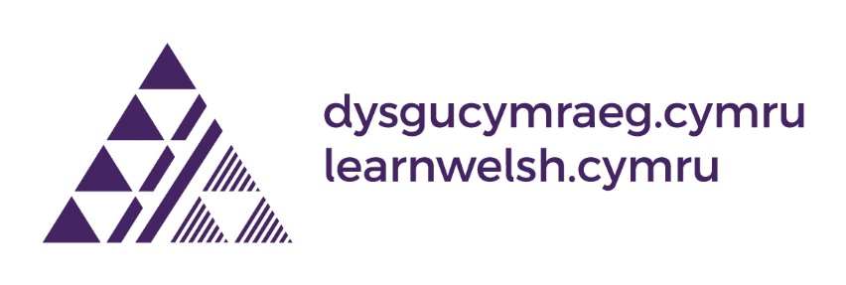

Our formal Welsh-language learning opportunities are delivered by the National Centre for Learning Welsh through their Centre, based at Swansea University.
All courses and formal learning opportunities made available to our staff are fully funded by the Welsh Government.

Organisational Operational Priorities
Our responsibilities towards the Welsh language and its speakers cut-across all our organisational priorities. For this reason, guidance on assessing the impact on the language is included in our Integrated Medium-Term Plan (IMTP) guidance.
We recognise that we need to strengthen how Welsh is considered in our organisational priorities and will be working with colleagues to ensure that the language is considered in our quality improvement work within
- unscheduled care
- planned care
- maternity
- mental health and learning disabilities

Welsh Language Priorities
The following priorities will help us make a tangible difference to the bilingual care we provide for patients and ensure staff are supported to develop and use their Welsh language skills with confidence.

Leadership
Strong leadership is essential if the Welsh language is to become embedded within organisational culture and decision-making. Within Swansea Bay University Health Board, we have enthusiastic leadership from our Chair and are pleased to see how this understanding of the importance of language is cascading through senior teams.
Over the next year, work will focus on supporting Board members, Executive Directors, and senior leaders to increase their use of Welsh within their functions and areas of responsibility. This will include developing a greater appreciation of the role language plays in patient experience, quality of care and service outcomes.
A tailored programme of support will be delivered to Executive Directors and Independent Members to increase their confidence and capability in using Welsh during meetings and formal engagements. By encouraging greater use of Welsh at senior levels, the organisation will demonstrate a visible commitment to bilingual working and create a culture in which the language is actively promoted and valued.

Leading in a bilingual Country
To date, three of our senior managers have been able to take part in the Leading in a Bilingual Country programme. Delivered by Academi Wales on behalf of Welsh Government, this programme gives space for those in leadership positions to explore how a culture of bilingualism can be developed in public and voluntary sector organisations.
Colleagues that have participated in the programme have shared that being able to participate in discussions and hear experiences of leaders from other organisations has led them to consider their own relationship with the Welsh language. This has led to them returning to Swansea Bay energised and committed to drive cultural change.
After taking part in the programme earlier this year, Eleri D’Arcy-Owen, our Clinical Lead Manager for Quality and Safety said "I found the programme incredibly inspiring. As a non-Welsh speaker, I was initially apprehensive, but the facilitators expertly blended Welsh and English, creating an inclusive and engaging experience for everyone. The session challenged my thinking, deepened my understanding of the significance of the Welsh language, and helped me recognise some of the barriers Welsh speakers can experience. It inspired me to go on and complete the Bronze, Silver and Gold Welsh Language Cultural Ambassador levels, and I would wholeheartedly recommend it to others."
We are committed to more of our senior leaders participating in this programme and have already identified those who will take part in the next cohort. We look forward to being offered more dates when they become available.

Governance
Effective governance arrangements are critical to ensuring that Welsh language considerations are embedded within workforce planning and recruitment processes. During the coming year, a more consistent and systematic approach will be adopted to assessing the linguistic requirements of vacant posts.
Services will be supported to undertake meaningful assessments of language requirements when filling vacancies, determining whether Welsh language skills should be identified as essential, desirable or a skill that can be acquired within a defined period following appointment. The rationale for these decisions will be recorded, providing greater transparency and enabling the organisation to better understand its linguistic capacity while ensuring workforce planning reflects the needs of Welsh-speaking patients and communities.

Communicating with our Patients
Providing effective communication in Welsh is a key component of person-centred care. Over the next year, efforts will focus on strengthening how Welsh language services are promoted to patients and ensuring that individuals are aware of their right to communicate and receive care in Welsh.
Alongside this, there will be a greater emphasis on understanding and responding to the experiences of Welsh-speaking patients. Work will be undertaken to strengthen mechanisms for gathering feedback on the quality of Welsh language services, with a particular focus on how patient experiences influence service improvement. Opportunities to capture and share Welsh-medium patient stories will be expanded, helping to provide valuable insights into both good practice and areas requiring further development.
The Welsh language will also be embedded more explicitly within the organisation’s Listening to People framework, ensuring that language considerations form an important part of how patient feedback is collected, analysed, and acted upon. By listening more effectively to Welsh-speaking patients, the organisation will be better positioned to design and improve services that meet linguistic needs and expectations.

Spiritual Care
The ability to access spiritual support through the medium of Welsh can be particularly important during times of illness, distress, and significant life events. Recognising this, a review of spiritual care provision will be undertaken to assess how effectively the needs of Welsh-speaking patients and staff are being met.
This work will consider the accessibility of current arrangements and identify opportunities to strengthen the provision of Welsh language spiritual support. Findings from the review will inform future service development, helping to ensure that linguistic and cultural needs are fully considered within spiritual care services.

Bilingual Clinical Provision
A key priority for the coming year will be increasing opportunities for patients to access clinical services through the medium of Welsh. Particular attention will be given to supporting priority services in implementing their Welsh language action plans and achieving meaningful progress in Welsh-medium care provision.
Work will focus on developing and supporting growth plans within new service areas, including Maternity Services, and End of Life Care. These areas have been identified because of the importance of communication, continuity of care and patient experience within often highly sensitive and emotionally significant clinical pathways.
By working collaboratively with operational and clinical teams, the organisation will seek to identify opportunities for service development and increase the availability of Welsh-medium consultations. This will help ensure that patients can discuss their health and wellbeing in the language they are most comfortable using.

Developing our staff
Supporting staff to develop and use Welsh language skills remains fundamental to the delivery of bilingual healthcare services. During the coming year, work will focus on creating more opportunities for language use within everyday working environments and exploring innovative approaches that encourage confidence and participation.
We will set targets for recruitment of Welsh speaking volunteers. This will support peer learning and provide practical opportunities for staff and service users to use the language in meaningful ways. In addition, partnership opportunities with external organisations will be explored to strengthen language development initiatives and maximise available resources.
The overall aim is to create an environment in which staff at all levels feel supported to learn, develop and use Welsh in their daily work. By increasing opportunities for staff to use Welsh, the organisation can simultaneously improve staff experience and strengthen its ability to provide person-centred bilingual care.

Record Keeping

Appendix 1
Record of New and Vacant Posts

Appendix 2
Welsh Language Staff Competency

Appendix 3
Complaints and Concerns

Appendix 4
The Welsh language in
Swansea and Neath Port Talbot


Appendix 5
Patient Experience

Appendix 6
Overall Compliance

Appendix 1

Recruitment
Statistics relating to the Welsh language status/requirements for jobs advertised by the Health Board during 2025/26 are set out below.
We continue to keep our bilingual skills strategy under review, emphasising the need to ensure that the Welsh language requirements of all vacancies are robustly assessed prior to any advertisements being placed. This will help to ensure the development of a workforce with the capacity to deliver care and services in the recipient’s preferred language.
Over the coming year, we will work to develop a standardised tool to assist managers in assessing the linguistic requirements of vacant posts. This will increase accountability in this area.

Posts advertised by us between 01 April 2025 and 31 March 2026.
During this period, 1, 254 posts were advertised by our Health Board. The Welsh language skills requirements of those posts were assessed as follows:

- Welsh language skills are Essential – 2 Posts advertised.
- Welsh language skills are Desirable – 1,208 posts advertised.
- Welsh language must be learnt on appointment – No posts advertised in this category.
- Welsh language skills are not required – 44 posts advertised.

We are fortunate to have the use of the TRAC website and NHS Jobs which enables us to promote and administer posts through the medium of Welsh. Both gateways enable applicants to submit applications in Welsh, and all communication with the applicant is bilingual. Applications submitted to us in Welsh are given priority by our translation team, so that managers can score the application within a specified timeframe. The electronic application form asks the applicant if they wish any interview to be conducted in Welsh, and we have a process in place to enable this to happen.

Appendix 2

Welsh Language Awareness
The end of March 2026 brought the third anniversary of the introduction of the nationally mandated Welsh Language Awareness module. Our organisational compliance rate for this module has naturally dropped as staff approach their renewal date. On the 31 March 2026, 71.49% of our staff had renewed their compliance with this module. Our target for compliance is 85% and we are confident that this will be reached shortly.

Staff Welsh Language Competency
This Health Board is one of the region’s largest employers, we employ 16, 996 members of staff. This figure includes permanent, locum, and bank staff. On the last day of March 2026, 9,780 (57.54%) of those staff members had recorded at least one language competency through the National ESR system. On the same day, 7,216 (42.46%) members of staff had not yet recorded their language competencies.
Our method for measuring these figures has changed over the past year to offer greater accuracy. We are now only considering the records of primary assignments with the Health Board.
We acknowledge that there is disappointment that we have not been able to increase the amount of data we hold in this area during the reporting period. To address this, our executive team have agreed to mandate the recording of this information for all staff from the 1 May 2026 and have set a target to reach 85% by 1 August 2026.

Breakdown of Welsh language skills of our workforce
The following percentages are based on the staff members who had recorded their language skills with us by 31 March 2026.

Speaking
403 Members of staff have told us that they have speaking and listening skills at Level 5 (4.12%), whilst 367 members of staff felt that their skills were at a level 4 (3.75%).
Fewer staff recorded their skill levels at level 3. 298 Recorded their skill at this level (3.05%). 365 noted their skill at level 2 (3.73%).
The numbers increase significantly when looking at levels 1 and 0. 1,495 recorded their skill at level 1 (15.29%) and 6,846 recorded level 0 (70%).

Reading
Of those who have responded, 429 recorded their reading skill level at level 5 (4.43%), and 344 recorded their reading skill at level 4 (3.55%).
The figure reduces when we look at level 3, with 227 (2.34%) recording this level. 372 staff members recorded their skill at level 2 (3.84%).
Again, the numbers increase significantly when looking at levels 1 and 0, with 1,266 members of staff recording reading skills at level 1 (13.07%), and 7,051 recording a reading skill level at level 0 (72.77%).

Writing
360 members of staff told us they could write in Welsh to Level 5 (3.73%). This figure reduces to 262 when we look at the responses to level 4 (2.72%).
248 members of staff have recorded their writing skill at level 3 (2.57%) and 382 noted skills at level 2 (3.96%).
The pattern of the numbers increasing significantly continues when we look at reading skills at levels 1 and 0. 1,080 members of staff told us their writing skills in Welsh are at level 1 (11.20%) and 7,311 recorded their skills at level 0 (75.82%).

Summary of Welsh language competency at levels 4 and/or 5
Number of staff who have told us that they have Welsh language skills at levels 4 or 5:
Speaking and listening, 770 members of staff. (7.88%)
Reading, 773 members of staff. (7.98%)
Writing, 622 members of staff. (6.45%)

Appendix 3

Complaints
Details of the Health Board’s complaint procedure, including complaints relating to our compliance with the Welsh Language Standards, are published on our website in line with the requirements of our compliance notice.
During this reporting period, our complaints team have not received any complaints relating to a breach of the Welsh Language Standards.
We have not received any complaints, concerns or enquiries relating to our Welsh language provision during the reporting period.
We recognise that this might not reflect satisfaction on the part of our patients and communities. Reflecting on the findings of the Commissioner’s key line of enquiry into concerns management, we have revised our public-facing concerns information on our website to make it clear that we welcome complaints and compliments both in Welsh and in relation to our provision of services in Welsh. We hope that this will encourage more people to provide us with their experiences of language in our care.

Appendix 4

Cymraeg in the Community
The number of people who can speak, read, and write in Welsh is captured as part of the national census. The results of the 2021 census were released last year and data for the communities we serve is shown here.

City and County of Swansea
11.20% of Swansea’s population over the age of 3 can speak Welsh. 8.60% of residents over the age of 3 can speak, read, and write in Welsh.

Neath Port Talbot County Borough
13.50% of residents in Neath Port Talbot over the age of 3 can speak Welsh. 10.20% of residents over the age of 3 can speak, read, and write in Welsh.

Swansea Bay Region
The Health Board’s area incorporates both counties mentioned above.
12.06% of the residents of our region over the age of 3 can speak Welsh.
9.20% of the residents of this region over the age of 3 can speak, read, and write in Welsh.

Office of National Statistics (ONS) data
We use ONS data to guide our ambitions in developing a bilingual workforce. We are aiming to demonstrate a greater correlation between the two data sources as we develop the skills of our current workforce and recruit more Welsh speakers into key roles.

Appendix 5

Patient Experience

During the reporting year, we asked the following questions to 45,580 respondents of our Civica Patient Experience survey:

Which language would you prefer to communicate in?
969 (2.12%) of respondents selected Welsh as their answer.
Those 969 respondents were then asked how frequently they were able to speak in Welsh with a staff member.
407 (42%) of respondents answered that they were Always able to speak in Welsh with a staff member.
80 (8.25%) of respondents answered that they were Usually able to speak in Welsh with a staff member.
266 (27.45%) of respondents answered that they were Sometimes able to speak in Welsh with a staff member.
184 (18.98%) of respondents answered that they were Never able to speak in Welsh with a staff member.
32 (3.3%) of respondents did not answer this question.

Patient Stories
While qualitative data provides us with useful knowledge regarding our services, we are also keen to develop deeper understanding through recording individual patient stories. To date we have developed one digital story regarding the importance of language within health services, this will be shared with our Board. We are also developing a library of stories for internal training and awareness raising.

Appendix 6

Overall Compliance
We keep an assurance rating document which is an active record of our ability to comply with the Welsh language standards. This document measures performance in areas relevant to the standards and lists barriers to full compliance. These ratings are based on internal monitoring and reporting, along with patient feedback. Where compliance assurance is listed as medium or low, steps are outlined which detail how the organisation is working to bring itself closer to compliance.
Where assurance is listed as green, monitoring processes are listed to ensure that compliance is maintained.

Snapshot of assurance levels at end of reporting year.

This chart shows that 75% of the standards imposed on us are rating green, or with a “high level” assurance rating, with 17% in the amber “medium level” rating. 8% are rated as having a “low level” rating.

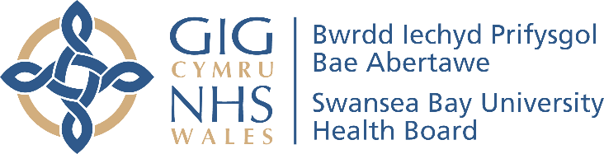

Report Author: Jordan Morgan-Hughes
Date of Publication: 30 September 2026

You may direct questions relating to this report to:
Welsh Language Services Department
Swansea Bay University Health Board
Headquarters
1 Talbot Gateway
Baglan
SA12 7BR
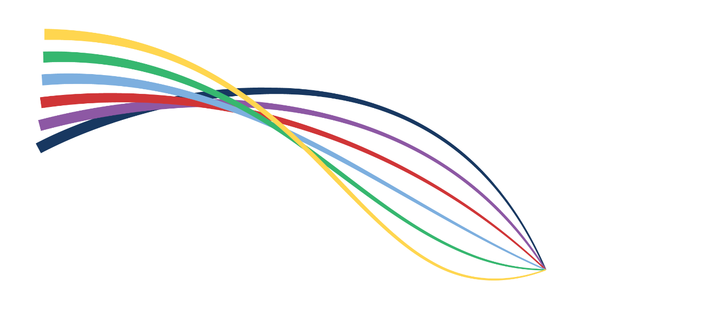
SBU.Cymraeg@wales.nhs.uk

Cover photo: Cadair Idris, Ben Davies, Endoscopy

Duty of Quality Statutory Guidance 2023 and Quality Standards, Welsh Government

