

Meeting Date | 19 December 2023 |  |  | Agenda Item |  | 4.1
Report Title | Prevention of Suicide & Self-Harm
Report Author | Jennifer Davies, Deputy Director of Public Health
Report Sponsor | Keith Reid, Executive Director of Public Health, SBUHB
Presented by | Keith Reid, Executive Director of Public Health, SBUHB
Freedom of Information | Open
Purpose of the Report | - To outline a population health approach to suicide & self-harm prevention  - To provide a high-level situational assessment of the current approach across Swansea Bay in line with a population health and preventative approach  - To highlight the need for a strategic approach in terms of activity to prevent suicide and/or self-harm through existing appropriate governance / partnership structures that are best placed to drive forward progress.
Key Issues | - Suicide rates have been a concern across Swansea Bay (SB) for a number of years.  - Self-harm is also of concern but is often lost within the narrative around suicide. Although often bundled with suicide the two are not the same and the approaches and actions required to reduce harms are different.  - Despite Welsh Government expectations for plans at local authority level, we currently have no regional suicide & self-harm prevention plan that co-ordinates or directs efforts / resources in a way that would contribute to a reduction in suicide or self-harming rates within our population. This is a risk given the likely increase in rates driven by the current economic challenges faced by our communities.  - Suicide is ‘preventable’ but this requires partnership working across agencies. There is a need to consider whether our current arrangements in Swansea Bay are fit for purpose to meet and address these challenges from a governance, partnership, resourcing, strategic leadership and direction setting perspective.  - ‘Prevention’ of suicide is inconsistently and poorly understood. This contributes to a lack of a clear approach to address the known risk factors across the region. To date, prevention has been limited to action at the time of crisis and post-event. Whilst this is important in terms of mitigation, it has meant that the conditions that lead to people choosing to take their life by suicide, have not been addressed in any meaningful way.  - There is no regional forum with responsibility for co-ordinating actions aimed at reducing the risk of suicide. This means that the effort & resources invested in tackling some of these issues by ourselves and others is for the most part, relatively unsighted and uncoordinated.  - There is a lack of generation of insight & intelligence to inform a preventative approach that can respond to changing needs and inform resource allocation. There is no routine reporting of intelligence that could act as an early alert system to inform a collective or within organisation response. Trend data & insight from the rapid response and ‘significant attempts’ review processes have been requested numerous times over the last 3 years but has not been forthcoming.  - There is limited capacity & capability to undertake intelligence analysis which impacts on our ability to adopt an intelligence led approach across Swansea Bay – enabling us to go beyond high level themes / risk factor analysis.  - The Health Board’s efforts to date in this area, directed at reducing risk, have been important and have been delivered diligently. However, the overall HB focus has been limited in scope to activities aimed at reducing risk within a limited set of environments and targeted at specific groups.  - The remaining agenda, good practice and evidence base that would form an organisation wide response to suicide prevention aimed at the whole population, remains absent. The Mental Health and Emotional Wellbeing strategy focuses on the mental health agenda from the perspective of early identification and intervention, with a particular focus on children & young people. It makes no explicit reference to either suicide or self-harm. There is a need to remedy this.  - The RPB is currently acting to develop mental health service provision across the region and has work streams leading development of both mental health services and prevention at the community level. The RPB Emotional Wellbeing and Mental Health programme may be well-placed to take on the regional co-ordination role, however, there is a need to consider the wider risk factors for suicide and these sit beyond the influence of the RPB. Consequently, there is a need to initiate regional discussions on how we would wish to co-ordinate our approaches to suicide prevention in order to maximise the likelihood of success.
Specific Action Required  (please choose one only) | Information | Discussion | Assurance |  | Approval
 | ☐ | ☒ | ☐ |  | ☒
Recommendations | Members are asked to:  - Note the contents of this report.  - Consider the risks / issues highlighted including to what extent current approaches and strategies address risk of suicide in the population.  - Note the contents of this report.  - Consider the risks / issues highlighted  - Note management board has agreed the recommendation to progress this agenda:  - Discussions to be held to establish a regional forum to align the prevention approach from a service & treatment perspective and develop a regional plan with partners accordingly.  - Given that only a third of those who die through suicide are known to services, the Population Health Strategy articulates the actions required to address the root causes contributing to the risk of mental health wellbeing and distress for our population. Implementation of the PHS through those governance/partnership structures will contribute to addressing the broader prevention agenda.

Prevention of Suicide and Self-Harm

- INTRODUCTION
Suicide is a tragic event, which is usually in response to a series of complex reasons that are contextual to the individual. However, if risk factors at the individual, group and population level are effectively addressed suicide is largely preventable.

Suicide & self-harm are terms that are often included together. However, they are not the same behaviours and pattern along different population demographics. Equally, the approach and preventative actions, including key points of intervention, are different. Hence, they need different approaches.

Under the existing Talk 2 Me 2 national suicide prevention strategy, there was a requirement for all local authority areas to have a suicide & self-harm prevention plan. Neither Swansea nor Neath Port Talbot have a plan. A Swansea Bay S&SH Multi-Agency Action Group (MAG) was established in 2019 with the aim of developing an action plan to co-ordinate & stimulate actions across agencies, in line with the six key strategic objectives highlighted within the Talk 2 Me 2 national strategy.

The MAG was successful in stimulating and driving forward a number of key actions primarily focused on responding to mental health crises, preventing contagion after a suicide event and providing support for those bereaved through suicide. During the pandemic, most of the S&SH MAG’s intended actions/activity were halted and a review was undertaken in 2022 recognising the changed landscape and learning from the pandemic. This review concluded that the MAG’s mandate, purpose and authority to act was unclear given the range of partnerships who have a remit for action in this agenda. Hence, the MAG remains in abeyance.

England has recently published its new suicide prevention strategy (September 2023). Our national T2M2 strategy is currently being reviewed and refreshed and a public consultation is due at the end of 2023 with a new strategy launched in 2024.

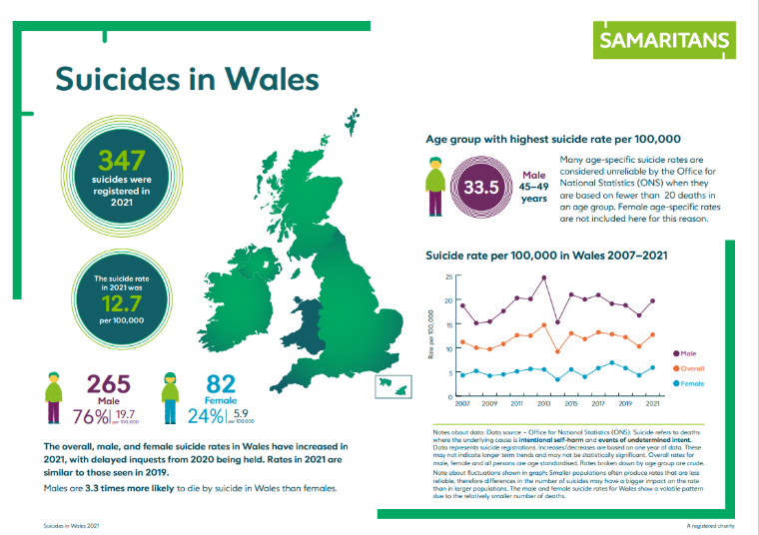
- BACKGROUND
- Suicide
Suicide data are affected by issues including under-reporting; delays in registration; small numbers; year on year fluctuations and age standardised vs crude rates. However, we know that Wales has the 3rd highest rate in the UK.

Historically, Swansea Bay has had some of the highest rates across Wales. The latest data for the period up to 2021 shows that the rates have returned to pre-pandemic levels with males continuing to account for three-quarters of suicide deaths registered in 2021. For Wales the rate was 12.7 deaths per 100,000 people.

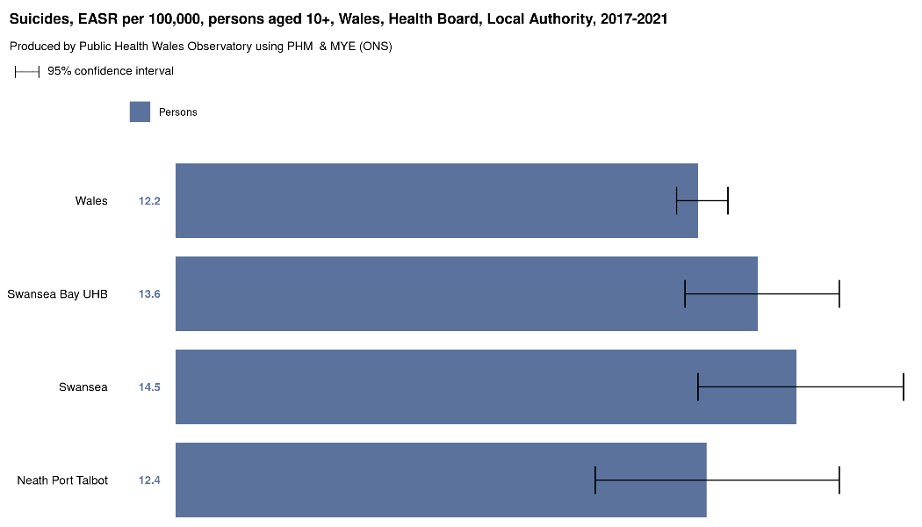
Our suicide rates have remained relatively stable over time and the latest data indicate that whilst our rates are higher than the Wales average they are not statistically significantly so.

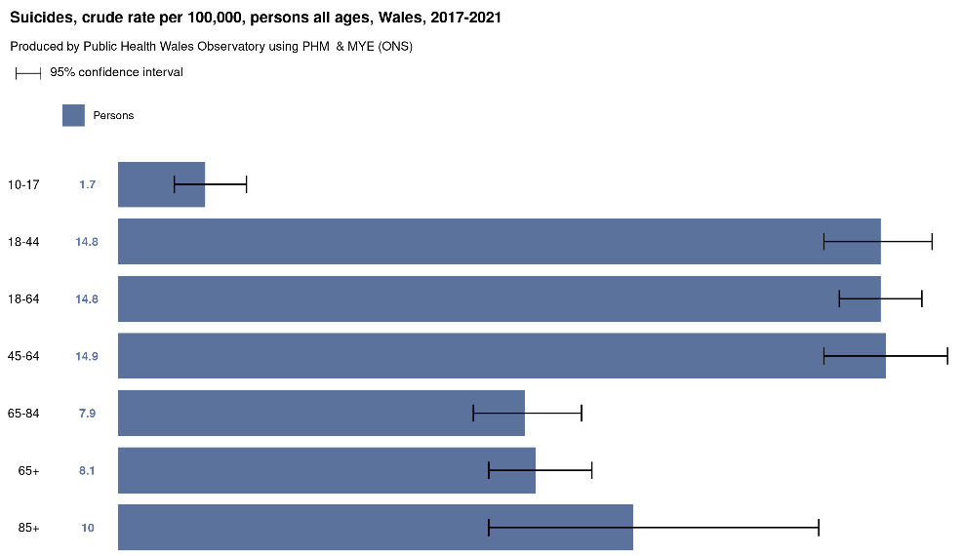
Previous data from 2007-16 indicated that the highest rates in males was between 30 and 49 years, peaking at 40-44yrs. Whilst the most recent analysis presents the data using different age ranges, it is clear that the 45-64 year age range remains a significant contributor to the overall rates observed.

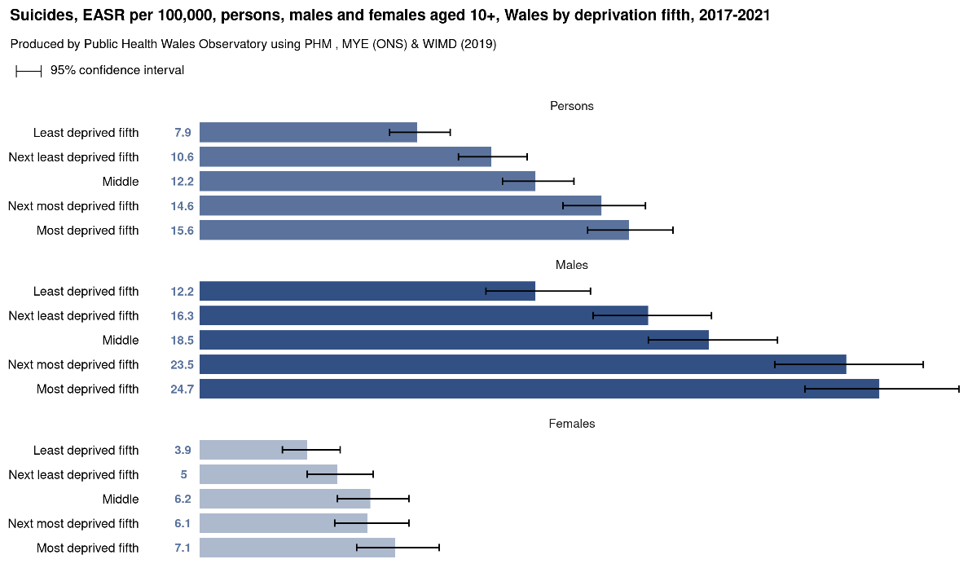
Unsurprisingly, whilst men continue to make up the vast majority of deaths by suicide, there is also a marked and steep/significant gradient between the most and least deprived communities.

That reflects what is known about the impact of social inequalities on mental ill-health – those with mental illness are more likely to have higher rates of poverty; homelessness; incarceration; social isolation; and unemployment.

There is also evidence around protective factors for both mental health and wellbeing as well as suicide at an individual level (e.g. ability to problem solve, self-control of behaviours, thoughts & emotions, sense of hopefulness, reasons for living and optimism, perceptions of positive health); psychosocial level factors (e.g. family relationships; marriage & partnership, social relationships / connectedness, faith & spirituality, employment, access to treatment) it is important to recognise the interplay between a number of risk and protective factors at both levels in attempting to understand which factors promote resiliency and vulnerability to suicide & suicidal behaviour.

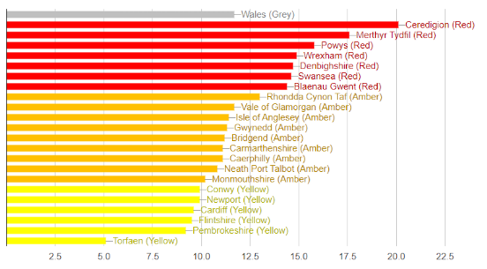
Suicide rates for our local authority areas shows that Swansea has the 6th highest rate in Wales at 14.6 per 100,000 people with NPT being at 10.8 per 100,000 people. Previously NPT has had the second highest suicide rate of all Welsh local authorities, which reinforces the volatile nature of the data but also supports what is known about patterning which is in line with levels of deprivation and inequities.

Source: Samaritans Wales, ONS
To overcome the issue of delays in the availability of suicide data and intelligence to inform action, Wales is adopting a similar approach to England of developing a Real Time Suicide Surveillance System (RTSSS) which uses data from the police of suspected suicides. This is being led by Public Health Wales. Caution is needed in interpreting/using these figures but this approach represents an attempt to have more real-time understanding of what is happening within our local population – trends & changes over time. The first annual report is due out in late 2023 with the intention that quarterly reports will be issued thereafter. The detail within these is, as yet, still unclear but is expected to represent sub-national data & analysis.

- Self-harm
Self-harming data is less routinely available and more difficult to capture and report. The most reliable data is hospital admissions/attendance data. This is likely to under-report the actual self-harming rates as the evidence suggests that many people who harm themselves do not attend health services and of those that do, very few will require admission. The age and sex pattern of admission for self-harm is very different to that for suicide. What the current data also indicates is that:
- Approx. 17% of people will self-harm during their lifetime
- 45% use cutting as their method of self-harming
- Adults and very young children are the least likely group to self-harm with teens & adolescents having the highest rates
- Women are more likely to self-harm than men
- Gay and bisexual people are at higher risk of self-injury.
- Average age of onset of self-harming is 13yrs.

Self-harm and suicide are related but the relationship between them is confusing. There are important differences in the intention as well as the danger. Self-harming is nearly always used to feel better rather than to end one’s life. Whilst some see self-harm as on a suicidal continuum, others emphasize the marked differences and believe they should be addressed separately. Indeed, Scotland has committed to developing a separate self-harm strategy alongside their suicide strategy. It is unknown whether Wales will separate out self-harm from suicide in the refresh of the T2M2 strategy but there are no indications to date that we will see that sort of policy shift.

- What do we understand about causes?
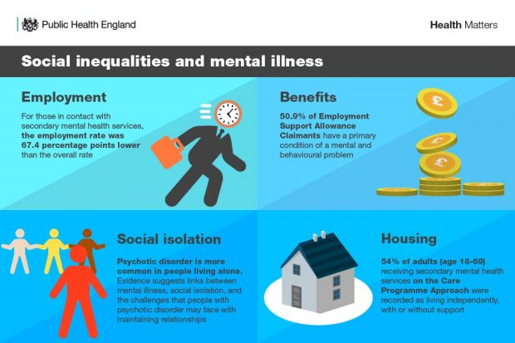
There are a number of risk factors that contribute to suicidal ideation and behaviours including; occupation; employment; financial insecurity; deprivation; negative life events; drug & alcohol misuse; self-harming behaviours; existing mental health diagnosis; and those transitioning into, within and out of the criminal justice system.

In an attempt to understand the drivers leading to suicide, a number of theoretical models have developed over time with the intention of improving our understanding in order to inform preventative action.

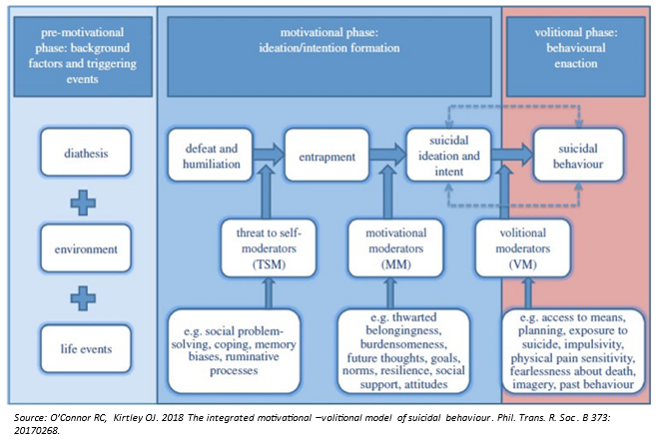
Whilst there is a considerable amount we have and continue to learn and understand about what drives people to take their life through suicide, what is less well developed is the ability to predict, in order to intervene. Emergent work is aimed at addressing this gap in our ability to predict intent and behaviours. An example of this is the Integrated Motivational-Volitional Model shown here. This seeks to address the issues that have been raised about the validity of risk-scoring / assessment tools used in healthcare which have resulted in missed opportunities to intervene and prevent.

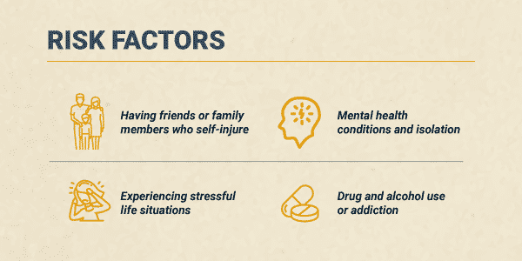
In terms of self-harming, there are a number of risk factors of note. These are similar to those in suicidal ideation and relate closely to the risk factors impacting on the mental health of populations over the life-course.

The implications of the socio-economic impact of COVID and the ongoing impact of inflation, inadequate wages and increasing poverty are yet to be fully described in our local population. The impact on mental health, however, is increasingly recognised. While a recent study suggests that to date there has been no significant increase in suicides as a result of the pandemic there continues to be concern of the increased risk longer term, given that during the 2008-09 recession there was 0.54% increase in suicides for every 1% increase in indebtedness (EU & UK).

- A PREVENTATIVE, POPULATION HEALTH APPROACH
Approximately a 1/3rd of those who take their lives through suicide are in contact with services. Conversely, 2/3^{rds} are not known to services. This means that taking a population health approach to prevention through acting on the known risk factors to the mental health of the entire population is vital in any successful attempt to reduce overall suicide and self-harming rates.

One way of defining mental health and wellbeing is:
“a dynamic state, in which the individual is able to develop their potential, work productively and creatively, build strong and positive relationships with others and contribute to their community.”

“It is enhanced when an individual is able to fulfil their personal and social goals and achieve a sense of purpose in society.” Gov Foresight Report definition (2008):

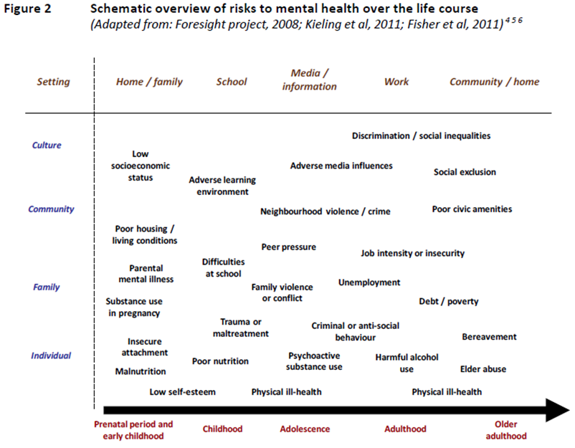

A population health approach provides a framework not only to understand the key drivers that contribute to both suicide and self-harming behaviours but also what action is required at an organisational and system level to reduce the risks for our population.

Our Population Health Strategy provides a framework and foundation to direct action to address the root causes leading to increased risk of suicidal ideation/behaviours. Appendix I outlines an approach to identifying potential evidence informed actions that could be taken to address the known risks. It also recognises that in addition to a population level, preventative approach there is a need to consider preventative action from a service perspective as individuals require different levels of need/crisis.

- Early identification and help/support (level 1) – Intervening at the point of initial crisis/need to avoid escalation [Front door + our staff]
Intervening early in those requiring support is vital and much of the evidence base points to the need for action on reducing stigma, having support mechanisms and services for those seeking help. Interventions include anti-stigma, anti-discrimination activities; training for staff on building confidence and competence to have open, compassionate conversations about people’s mental health including suicidal ideation; settings-based approaches through e.g. schools, workplaces, prisons etc.; pathways of support that include signposting to relevant services etc.

Insight work undertaken locally indicates that our current clinical service approach to those showing early signs of mental health distress, is unhelpful in terms of help seeking behaviours. Also that when engaging with or seeking support, that there is significant variation and that services, across sectors, do not perform well. This evidence and lived experience needs to inform our approach & model of care.

- Tailored, targeted support & services for those with increased risk (level 2) – reducing the risk of suicide in higher risk groups [Within our care + our staff]
Whilst we know that the majority of suicides are within middle-aged men, we also know that specific groups are at higher risk. These include:
- Those from areas of highest levels of deprivation;
- Misuse of drugs and alcohol;
- Transition points as people move into, within or out of the criminal justice system;
- Certain occupations e.g. construction industry, agricultural industry; skilled trades; carers; health professionals (primarily female nurses)
- Existing mental health conditions & mental health service users
- Loneliness & isolation
- Those bereaved through suicide
- Those with a history of self-harming

NICE guidance and the work that has been ongoing for a number of years through the National Confidential Inquiry into Suicide and Safety in Mental Health (NCISH) provides us with a road map of what high quality looks like, against which we can assess/audit ourselves. Some of these actions/recommendations are given below.

CLINICAL CARE | ACUTE CARE
- Need to focus on common factors associated with suicide including:  - Living alone  - Self-harm  - Co-morbid alcohol & drug misuse  - Loss of contact with services – active re-establishment involving family members where possible | - In-patient admission & recent discharge from hospital are high risk periods. Services need to improve safety through:  - Removal of low-lying ligature points  - Ensure pre-discharge leave & discharge planning address adverse circumstances they are returning to  These sit alongside the 10 Ways to Improve Safety NCISH:  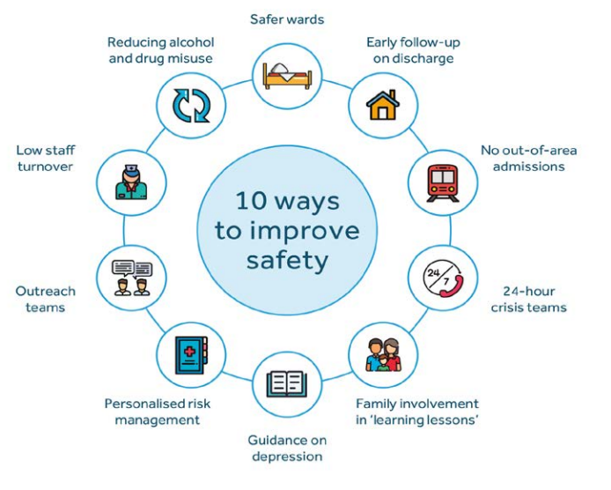
ECONOMIC ADVERSITY | PATIENTS UNDER 25yrs
- Rising costs is an additional risk alongside long-standing socio-economic factors and financial stress  - Frontline staff need to be aware of the risks of new problems e.g. loss of job, benefits, housing etc. & have information to signpost patients to support. | - Increasing numbers of suicide among young people – they have different characteristics & risks relevant to prevention  - Under 18s family & educational settings; management of anxiety & autism are important  - 18-24yrs – treatment of severe mental illness & co-morbid substance misuse.  - Self-harming services are crucial to both age groups
PATIENTS WITH PERSONALITY DISORDER DIAGNOSIS | PATIENTS WHO IDENTIFY AS LGB OR TRANS
- Rates are increasing in this group esp women  - Better models of safe & compassionate care are needed | - Experience of prejudice increases risk.  - Addressing previous trauma important
SUICIDE RELATED INTERNET USE
- This is a feature of suicide by mental health patients of all ages.
- Takes a number of forms including promotion of suicide methods
- Enquiring about exposure to internet risks should be routine part of risk assessment

The range of services/support on offer are provided from both within the Health Board and a range of partners. Currently we have no mechanism by which we are able to understand how we compare to the existing standards in terms of meeting best practice/evidence based standards or know what impact our existing resources/services are achieving with regard to those at risk of suicide or self-harm.

Given there are multiple players involved in this work, there is a need to have a co-ordinated approach to maximise existing resources/efforts and consider future direction and targeting as well as understanding the shifting needs in line with the RTSSS and other sources of intelligence.

- Rapid response for those affected by suicide (level 3) – reducing risk of suicide through contagion [Within our care + our staff + communities]
Those who are bereaved by or affected/impacted by a suicide are at increased risk of choosing to end their life through suicide. The numbers affected by one suicide have been studied over time. Original estimates suggested that 6 people were greatly affected by each suicide death. However, more recent studies have indicated that the numbers severely affected are likely to range between 15 to 30 and for those impacted by suicide could be as high as 135 per suicide.

As such, the immediate response to a suspected suicide to reduce the impact of this risk has been a priority locally and is reflected in the T2M2 strategy and other guidance. Work locally had led to the establishment of a rapid response process, initiated by the police and involving safeguarding colleagues from the local authorities, the Health Board where that is appropriate and any other relevant agencies, dependent on the nature of the suicide, involvement of services/agencies leading up to the suicide and what action is needed to protect & support those impacted.

We currently have rapid response processes for both adult and young people’s suspected suicides for both Swansea & Neath Port Talbot which are managed / governed through the Regional Safeguarding Board. These have been operational for a number of years.

More recently, a similar process for ‘serious attempts’ has been established as part of a tertiary preventative approach to those deemed to be at significantly higher risk of suicide in the near future. Anecdotal reports suggest this has been successful to date in preventing any of these in becoming suicides.

We have been the first Health Board in Wales to have a bereavement service. Whilst this is not solely focused on bereavement through suicide, it has been an important contributor to the support offered to those who have been bereaved by suicide that are in contact with the Health Board. It has also been a contributor to the development of a national bereavement model/service.

- GOVERNANCE
The Multi-Agency Action Group (MAG) was set up in 2019 to produce a region-wide multi-sector and multi-agency action plan to co-ordinate activities to prevent suicides & self-harm across Swansea Bay. At that time, it was agreed the group would report into the joint PSB. It was chaired by Public Health Wales and membership included Swansea Bay UHB, Swansea Council for Voluntary Services (CVS), NPT CVS, Swansea and NPT Social Services, South Wales Police, local authority representatives including education and safeguarding, probation services, Swansea University, Dyfodol and the Ospreys.

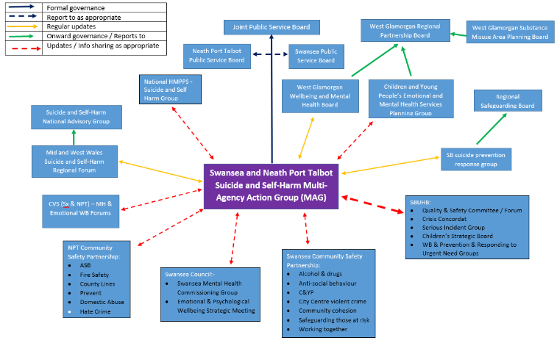
In 2022, partners identified a need to review the current arrangements, reporting mechanisms and ways of working. Members valued the S&SH MAG as it was the only forum that had a sole focus on suicide and self-harm prevention. In particular, they noted the benefit of diverse membership; development of working relationships; sharing of information between organisations; sharing of expertise/skills; opportunity to gather new perspectives, ideas and opportunities for working differently.

However, what members flagged was the lack of clarity on the MAG’s purpose, remit, authority and decision making within the wider partnership landscape (see high level map above). This points to an absence of strategic leadership for suicide as an issue for our region. This in turn impacted on consistency and continuity of attendance from organisations who had historically participated, acknowledging some organisations/members were not represented. Consequently, the MAG has been in abeyance and there is currently no forum that has an explicit focus on leadership for suicide prevention for our region. This is in contrast to other Health Board areas across Wales.

The Regional Partnership Board has confirmed its commitment to be active in the Emotional Wellbeing and Mental Health space with confirmation of a programme supported by four work streams. It might seem consistent with this approach for it to become the regional forum to coordinate actions of services and providers in delivering existing clinical and best practice guidance to reduce the risk of suicide across Swansea Bay. This would also fit with the wider governance structures for this work which is led by the National Advisory Group for Suicide (from Welsh Government). At a sub-national level, there are 3 regional fora and the South & West Wales Suicide & Self Harm Prevention Forum is currently led/chaired by the Swansea Council safeguarding lead.

However, there have not yet been any discussions on the willingness of the RPB to take on leadership in this space nor on how the work programmes developed by the RPB might support a reduction in suicide and self-harm. Given that there is no regional leadership focal point for suicide and self-harm this may reflect that advocacy on this issue has been absent in the development of the emergent RPB approach to Emotional Wellbeing and Mental Health. Nonetheless, the current RPB proposals do make explicit reference to suicide and self-harm reduction and signal an intent to be involved in this area. Whether the RPB sees itself as being the regional focal point for this work is not yet established.

- ISSUES TO NOTE
The challenges include:
- Prevention of suicide is inconsistently and poorly understood. This contributes to a lack of progress and a clear plan for addressing the known risk factors. To date, prevention has focused on action at the time of crisis and post-event. Whilst this is important in terms of mitigation, it has meant that the conditions that lead to people choosing to take their life by suicide, have not been addressed in any meaningful way.
- There is currently no regional forum which takes responsibility for coordinating actions aimed at reducing the risk of suicide or self-harm for Swansea Bay. This means that the effort & resources invested in tackling some of these issues by ourselves and others is for the most part, relatively unsighted and uncoordinated.
- There is a lack of generation of insight & intelligence to inform a preventative approach that can respond to changing needs and inform resource allocation. There is no routine reporting of intelligence that could act as an early alert system to inform a collective or within organisation response. Trend data & insight from the rapid response and ‘significant attempts’ review processes have been requested numerous times over the last 3 years but has not been forthcoming.
- There is limited capacity & capability to undertake intelligence analysis which impacts on our ability to adopt an intelligence led approach across Swansea Bay – enabling us to go beyond high level themes / risk factor analysis.
- There is no ‘collective’ identity or presence for this work which has limitations in terms of how we work together including with those with lived experience.
- The Health Board has acknowledged the need for action to reduce suicide rates as highlighted through the focus on suicide as one of the 5 quality priorities. This has led to a programme of work that specifically focuses on staff mental wellbeing. Given that healthcare staff and female nurses in particular, are one of the higher occupational risk groups, this has been an important development. Equally, the Health Board (HB) has developed a bereavement service which is also contributing to the agenda. However, the HB’s focus has been limited to these activities and the remaining agenda, good practice and evidence base that would form an organisation wide response to suicide prevention, is absent.

Given the RPBs remit, membership and role in mental health services across the life course, it is a key stakeholder in considering and developing a regional suicide prevention plan. The prevention of suicide & self-harm is referenced as part of its work but it has not yet developed a plan that looks at these behaviours and the required actions to address them for our region. Development of a regional suicide prevention plan would help to knit together different streams of work and strategies / plans including the new Emotional and Mental Health Strategy.

- FINANCIAL IMPLICATIONS
There are no financial implications arising from this report. However, to further this agenda, consideration needs to be given to deployment of existing resourcing and how this can be directed to consider adoption and embedding of evidence-based practice through core service provision as well as through all 4 pillars of our function. That is likely to require additional resourcing in the short to medium term.

- RECOMMENDATION
Suicide is a complex issue, usually the result of a number of factors that are both personal and related to wider community and socio-demographic influences. It is nevertheless, preventable. The solutions however are not simple and do not lie within single organisations or single partnership forums. As such, the challenge is one of the need for system (wide) leadership.

Mental distress, self-harm and suicide rates pattern in line with increasing levels of deprivation, inequalities and inequities. Given the high levels of these across Swansea Bay going into COVID, further exacerbated by a number of significant challenges globally, this would indicate a level of vulnerability which is likely to lead to a further widening of health inequities and a worsening of deprivation for many in our population which in turn are significant and real risk factors for self-harm and suicide. We can therefore expect to see increasing numbers and complexity of need in terms of mental health crisis/distress in many forms, including self-harming and suicide.

Members are asked to:
- Note the contents of this report.
- Consider the risks / issues highlighted
- Note management board has agreed the recommendation to progress this agenda:
  - Discussions to be held to establish a regional forum to align the prevention approach from a service & treatment perspective and develop a regional plan with partners accordingly.
  - Given that only a third of those who die through suicide are known to services, the Population Health Strategy articulates the actions required to address the root causes contributing to the risk of mental health wellbeing and distress for our population. Implementation of the PHS through those governance/partnership structures will contribute to addressing the broader prevention agenda.

Governance and Assurance
Link to Enabling Objectives  (please choose) | Supporting better health and wellbeing by actively promoting and empowering people to live well in resilient communities
Link to Enabling Objectives  (please choose) | Partnerships for Improving Health and Wellbeing |  | ☒
Link to Enabling Objectives  (please choose) | Co-Production and Health Literacy |  | ☒
Link to Enabling Objectives  (please choose) | Digitally Enabled Health and Wellbeing |  | ☒
Link to Enabling Objectives  (please choose) | Deliver better care through excellent health and care services achieving the outcomes that matter most to people
Link to Enabling Objectives  (please choose) | Best Value Outcomes and High Quality Care |  | ☒
Link to Enabling Objectives  (please choose) | Partnerships for Care |  | ☒
Link to Enabling Objectives  (please choose) | Excellent Staff |  | ☐
Link to Enabling Objectives  (please choose) | Digitally Enabled Care |  | ☒
Link to Enabling Objectives  (please choose) | Outstanding Research, Innovation, Education and Learning |  | ☐
Health and Care Standards
(please choose) | Staying Healthy |  | ☒
(please choose) | Safe Care |  | ☐
(please choose) | Effective Care |  | ☒
(please choose) | Dignified Care |  | ☐
(please choose) | Timely Care |  | ☐
(please choose) | Individual Care |  | ☒
(please choose) | Staff and Resources |  | ☒
Quality, Safety and Patient Experience
The paper outlines what is needed to progress the suicide & self harm agenda from a population health perspective. Implementation of an effective preventative, population health approach will lead to a more effective impact on suicide & self-harm rates.
Financial Implications
The paper notes that investment is required in order to progress this work. However, that investment is not yet quantified.
Legal Implications (including equality and diversity assessment)
No legal implications identified. The incorporation of an appropriate preventative, population health approach will allow for the identification of equality and diversity issues and development of appropriate responses.
Staffing Implications
In addressing the issues noted and to progress this work along the lines proposed programme will require changes in staff skills in taking a more holistic, trauma informed approach across all aspects of our core business. There are also implications for our staff’s health and wellbeing in adopting good practice standards.
Development of the implementation plan will identify the skills and workforce requirements.
Long Term Implications (including the impact of the Well-being of Future Generations (Wales) Act 2015)
Population health approaches incorporate a prevention ethos and delivery is contingent on collaboration among partners to deliver better outcomes for our population. A coproduction approach is integral to public health practice and seeks to involve communities and staff in designing services and programmes.
Report History |  | No previous reports
Appendices |  | I – potential actions to drive down suicide rates across Swansea Bay

APPENDIX I

Potential actions in support of driving down the number of people taking their lives through suicide across Swansea Bay, in line with our 4 pillar approach.

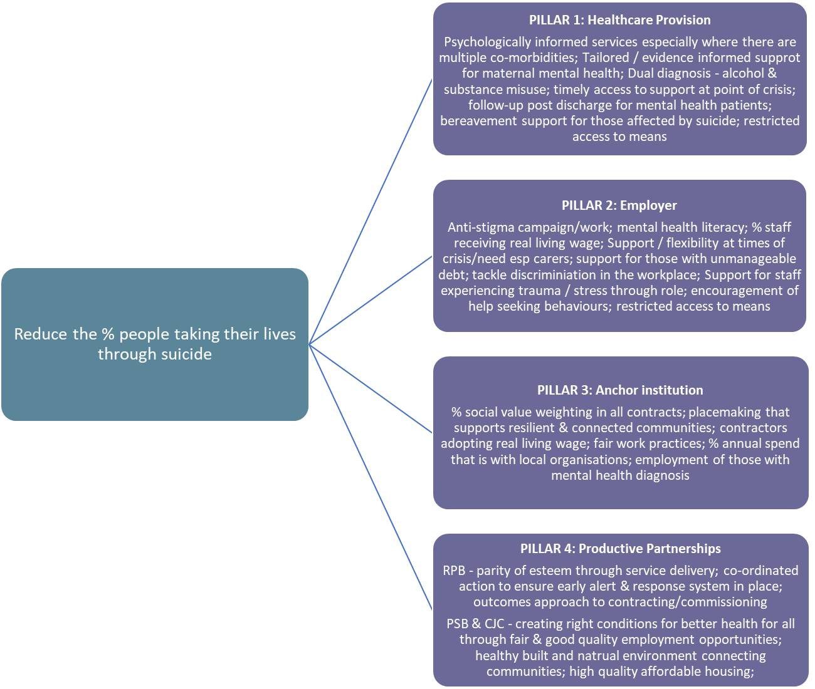

Suicide trends in the early months of the COVID-19 pandemic: an interrupted time-series analysis of preliminary data from 21 countries - The Lancet Psychiatry

