

HEALTH BOARD RISK REGISTER
October 2023 (V2)
RISK ASSIGNED TO THE
QUALITY & SAFETY COMMITTEE



Datix ID Number: 738  Health & Care Standard: 5.1 Timely Care |  |  | HBR Ref Number: 1  Risk Target Date: 31/03/2024 |  | Current Risk Rating  5 x 5 = 25
Objective: Networked Hospitals – A Systems Approach – Urgent & Emergency Care |  | BAF Ref: 3.3 | Director Lead: Deb Lewis, Chief Operating Officer  Assuring Committee: Performance and Finance Committee  For information: Quality & Safety Committee
Risk: Access to Unscheduled Care  If we fail to provide timely access to Unscheduled Care then this will have an impact on quality & safety of patient care as well as patient and family experience and achievement of targets. There are challenges with capacity/staffing across the Health and Social care sectors. (This risk includes ED, AMU and impact in community from ability to release ambulances at both front doors.) |  |  | Date last reviewed: October 2023
Risk Rating  (consequence x likelihood):  Initial: 4 x 5 = 20  Current: 5 x 5 = 25  Target: 3 x 4 =12 | 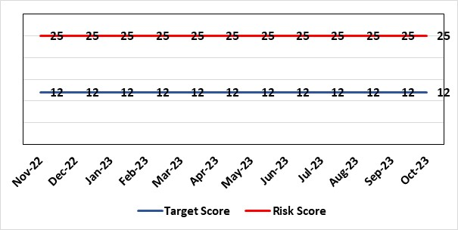 |  | Rationale for current score:  Post wave 2 of COVID 19 Morriston and Singleton have experienced a steady increase in emergency demand to pre-covid levels. Capacity is limited due to covid response and therefore remains a high risk. Current score raised due to increasing pressures. Recent implementation of All Wales Immediate Release Protocol puts additional pressure on already overcrowded ED dept.
Level of Control  = 50% |  |  | Rationale for target score:  Our annual plan is to implement models of care that reflect best practice. This will improve patient flow, length of stay and reduce emergency demand.
Date added to the HB risk register
26.01.16
Controls (What are we currently doing about the risk?) |  |  | Mitigating actions (What more should we do?)
- Increased reporting as a result of escalation to targeted intervention status.  - Phone First for ED model in place in conjunction with 111 to reduce demand.  - OPAS (Older People’s Assessment Service) have undertaken training with nursing homes (on management of patient falls) & set up direct contact details with nursing homes  - Frailty short-stay unit re-established  Additionally, actions to improve the discharge of clinically optimised patients (risk HBR80) expected to assist with patient flow, are anticipated to free capacity to assist to address this risk HBR1 also.  Acute Medical Unit (AMU)  - Medical patient flow within Morriston has been refined between ED, AMU and wards.  Patient flow  Roll out SAFER (Seen, Aim, Flow, Early Discharge and Recovery) continues across all hospitals, 23 wards at Morriston, Gorseinon completed and started at SGH and NPT  - WAST direct access to SDEC  - Expected medical patients conveyed by WAST go direct to AMU rather than ED, medical patients in ambulances outside ED diverted to AMU after initial assessment  - Stroke rehab pathway between MGH and NPT embedded  - Morning “golden” patients identified for early moves to discharge lounge freeing up beds earlier in the day |  |  | Action | Lead |  | Deadline
 |  |  | Increase of hours in SDEC planned. Currently increased hours from Monday to Friday (12 hours per day) | SGD (Morriston) |  | 01/03/2024
 |  |  | OPAS – exploring internal & external funding options. (Currently going through business case) | SDEC Clinical Lead |  | 30/11/2023
 |  |  | Looking to extend OPAS to non-surgical fractures. Resource requirements & options to be quantified and presented to the Chief Executive for consideration. | Head of Nursing (Service Transformation) |  | 30/11/2023
 |  |  | Surgical SDEC opening | Corporate flow team Surgical Division |  | 30/11/2023
 |  |  | Implementation of Continuous flow model (1st phase)  (Work ongoing) | COO |  | Commenced 9th October
 |  |  | Criteria led discharge roll out | Corporate patient flow team |  | September to November 2023
 |  |  | Implement zero tolerance to ambulance waits in excess of 10 hours | Assistant Director of Operation (UEC) |  | 01/11/2023
Assurances (How do we know if the things we are doing are having an impact?)  - New Urgent & Emergency Care Board is meeting monthly.  - Six Goals programme has been reviewed, programme leads appointed  - Update UEC (Urgent and Emergency Care) dashboard has been developed and released by digital |  |  | Gaps in assurance (What additional assurances should we seek?)  The need to deliver sustained service.
Additional Comments / Progress Notes
31/07/2023: The HB is working in partnership with the national Six Goals team and NHS Wales to pilot an alternative flow model call continuous flow. This is part of a pilot to develop a standardised toolkit for NHS Wales. Action completed – Implement criteria led discharge – Pilot implementation completed, review to take place.
11/08/23: SB confirmed as 1 of 3 pilot sites in Wales. Pilot will commence as a service improvement project in Aug 23’. Collaborating with WAST to identify further opportunities for partnership working around falls in the community. Action completed - Care home pilot with pharmacist medicines review and rapid response to avoid hospital admission, monthly reporting in place.
17/10/23: ED/AMU/SDEC pilot completed and scheme continues in line with available resource. Initial findings increase number of pts to SDEC and a decrease on LoS in AMU assessment. Criteria led discharge has been implemented in AMU and a roll out programme for the wards in Morriston is based on the successful roll out of SAFER. Continuous flow model commenced 9th October, initially findings are encouraging with a reduction in medical patients waiting for a bed in ED. Two actions completed - Work ongoing in ED/SDEC to pilot additional initiatives.
Redesign GP referral flow so that all referrals are directed to SDEC in the first instance rather than attend AMU. Following closure of AMSR risk HBR88, this HBR1 risk entry includes update on continuing work to achieve the benefits to patient flow of implementing AMU and other measures.

Datix ID Number: 739  Health & Care Standard: 2.4 Infection Prevention & Control & Decontamination |  |  | HBR Ref Number: 4  Risk Target Date: 31st March 2024 |  | Current Risk Rating  4 x 5 = 20
Objective: Demonstrably Improved Quality, Safety & Reduced Harm |  | BAF Ref: 1 | Director Lead: Gareth Howells, Executive Director of Nursing  Assuring Committee: Quality and Safety Committee
Risk: Risk of patients acquiring infection as a result of contact with the health care system, resulting in avoidable harm, impact on service capacity, and failure to achieve Tier 1 national infection reduction goals. |  |  | Date last reviewed: October 2023
Risk Rating  (consequence x likelihood):  Initial: 4 x 5 = 20  Current: 4 x 5 = 20  Target: 4 x 3 =12 | 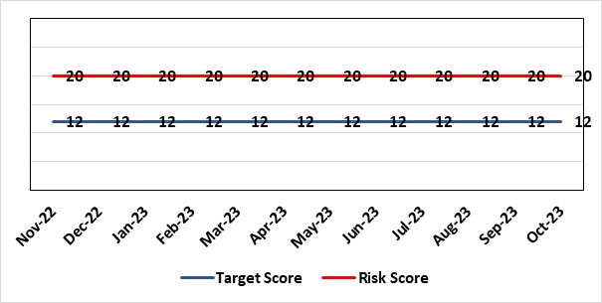 |  | Rationale for current score:  Health Board incidence of key Tier 1 infections per 100,000 population above All Wales rates, indicating Health Board’s population at greater risk of infection. High occupancy rates & frequent ward moves associated with increased risk of infection transmission. Lack of decant facilities compromises environment deep cleaning & decontamination, and planned preventative maintenance programmes.
Level of Control
= 40%
Date added to the HB risk register
January 2016
Date added to the HB risk register  January 2016 |  |  | Rationale for target score:  Improved governance structures for IPC and antimicrobial stewardship will drive improved local ownership and embed responsibility for these priorities for all levels of staff. Adequately maintained & clean environments facilitate good IPC & minimise infection risks. Reduced occupancy & frequency of patient moves mitigate against infection transmission. Compliant ventilation systems and water safety minimise infection risks. Access to timely data on infections, training, antimicrobial stewardship, cleaning at ward/unit/practice level enables Service Groups to identify areas for focused QI programmes, drive improvement, & effectively measure outcomes.
Controls (What are we currently doing about the risk?) |  |  | Mitigating actions (What more should we do?)
- Policies, procedures, protocols and guidelines supplement the National Infection Control Manual.  - Infection Prevention & Control related training provided programmes.  - Surveillance of infections, with early identification of increased incidence, and instigation of controls.  - Infection Prevention Improvement Plans, monitored by Infection Control Committee and Management Board.  - Provision of cleaning service to meet National Standards of Cleanliness.  - Engineering controls for water safety, ventilation, and decontamination. |  |  | Action | Lead |  | Deadline
 |  |  | Drive improvements in prudent antimicrobial prescribing | Cons. Antimicrobial Pharmacist |  | 31/03/24
 |  |  | Reduce Key Tier 1 Infections to no more than WG maximum quarterly profile | Head of Infection Control |  | 31/03/24
 |  |  | Achieve 85% compliance with IPC mandatory training | Service Group Directors |  | 31/03/24
 |  |  | Maintain National Standards of Cleanliness compliance >95% | Support Services |  | 31/03/24
 |  |  | Develop a proactive schedule of IPC-related audit for Service Groups wards & services, and for IPC team. | Head of Infection Control  Service Group Directors |  | 31/03/24
Assurances (How do we know if the things we are doing are having an impact?)  - Clear Corporate and Service Group IPC Assurance Framework in place.  - Infection Prevention Improvement Plans for HB and Service Groups with progress reported at SG Infection Control Committees, HB Infection Control Committee and at Management Board. These include trajectories to meet national targets and report performance against them. This is also reported to Quality & Safety Committee.  - Ongoing monitoring of infection control rates.  - IPC, antimicrobial, decontamination and cleaning audit programmes.  - Compliance and validation systems for water safety, ventilation systems and decontamination. |  |  | Gaps in assurance (What additional assurances should we seek?)  - High occupancy rates & frequent ward moves associated with increased risk of infection transmission.  - Lack of decant facilities compromises environment deep cleaning & decontamination, and planned preventative maintenance programmes.  - Lack of robust system for Board oversight regarding IPC and ANTT training compliance due to ESR limitations.
Additional Comments / Progress Notes
13/10/2023
Progress update re Tier 1 reduction goals 01 Apr- 30 September 2023.
At the 6-month period, exceeded maximum annual number of cases to achieve expected infection reduction goal for both C. difficile and for Staph. aureus bacteraemia.
- C. difficile - 114 cases (2023/24 annual profile – 95 maximum).
- Staph. aureus bacteraemia - 73 (2023/24 annual profile – 71 maximum).
Over trajectory for:
- E. coli bacteraemia -148 (cumulative profile - 123 maximum).
- Klebsiella spp. bacteaemia - 49 (cumulative profile – 43 maximum).
Below trajectory for:
Pseudomonas aeruginosa bacteraemia – 12 (cumulative profile - 13 maximum).

Datix ID Number: 841  Health & Care Standard: Safe Care 2.1 Managing Risk & Promoting Health & Safety |  |  | HBR Ref Number: 13  Risk Target Date: TBC | Current Risk Rating  4 x 4 = 16
Objective: Delivering Care in Safe, Modern Environments |  | BAF Ref: 7 | Director Lead: Darren Griffiths, Director of Finance  Assuring Committee: Quality & Safety Committee
Risk: Health & Safety Compliance – Environment of Premises. Risk relates to compliance in terms of appropriate accommodation in line with Health and Safety Regulations. |  |  | Date last reviewed: October 2023
Risk Rating  (consequence x likelihood):  Initial: 4 x 4 = 16  Current: 4 x 4 =16  Target: 4 x 3 = 12 | 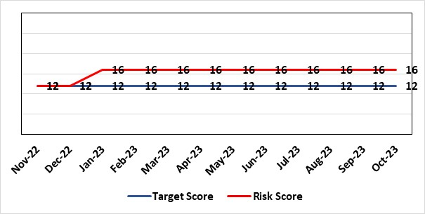 |  | Rationale for current score:  The accommodation is varied in age, tired and in need of upgrading/refurbishment to enable improved condition and compliance to regulations and WHBN/WHTMs. Score has increased following the Health Board commissioning a 6 FACET survey, this has highlighted key areas around compliance that require addressing
Level of Control  = 90% |  |  | Rationale for target score:  Risk assessments of premises.
Date added to the HB risk register
April 2012
Controls (What are we currently doing about the risk?) |  |  | Mitigating actions (What more should we do?)
- Key areas where performance linked to health & safety/fire issues. Health & Safety and Quality & Safety Committees and agreed actions to mitigate impacts.  - Actions addressed through site meetings trade improvements on the 2 acute hospital sites.  - Primary Care premises, audits commissioned and delayed due to Covid.  - Development of estates strategy and DCPs – Approved/adopted May 2023  - Capital programmes  - Priority of discretionary capital funding  - Development of appropriate capital business cases and present to Welsh Government |  |  | Action | Lead | Deadline
 |  |  | A review is currently taking place of current PCST structures and governance arrangements for estates and H&S to cover key compliances and escalation processes | Service Group Director (PCT) & Assistant Director of Health & Safety | 30/03/2024
 |  |  | A Task & Finish Group to be established to further develop with a target of submitting a final, scrutinised Estates Strategy to the Board in May 2023. The Health Board has DCP’s in the strategy and will assist in the overall condition and compliance of the estate. However, this will be over the next 10 years at least. | Assistant Director of Estates  Assistant Director of Capital | Complete
Assurances (How do we know if the things we are doing are having an impact?) |  |  | Gaps in assurance (What additional assurances should we seek?)
Additional Comments / Progress Notes
24/07/23: Site meeting scheduled for 28 July, to agree and pilot the process until end of October 2023. Review of pilot to identify any lessons/recommendations prior to rolling out across the primary care estate in Q4 (Jan –Mar 24).
10/08/23: site meeting was rescheduled to 09/08/23. Some actions agreed and responsible owners identified with further review planned for end August 23 due to some structural changes planned in PC&TSG to cover H&S/Fire/Estates for PC&TSG. Review of site wide cooperation/coordination meeting governance structure being reviewed to capture key actions i.e. fire risk assessment actions and other compliance areas. Target date remains as Q4 23/24. 11/09/23: No additional information, therefore, no change. 16.10.23: no change

Datix ID Number: 840  Health & Care Standard: 5.1 Timely Care |  |  | HBR Ref Number: 16  Risk Target Date: 31/01/2024 | Current Risk Rating  5 x 4 = 20
Objective: Networked Hospitals – A Systems Approach – Planned Care |  | BAF Ref: 3.4 | Director Lead: Deb Lewis, Chief Operating Officer  Assuring Committee: Performance and Finance Committee  For information: Quality & Safety Committee
Risk: Access and Planned Care  There is a risk of harm to patients if we fail to diagnose and treat them in a timely way. |  |  | Date last reviewed: October 2023
Risk Rating  (consequence x likelihood):  Initial: 4 x 4 = 16  Current: 5 x 4 = 20  Target: 4 x 2 = 8 | 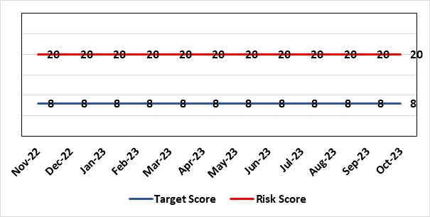 |  | Rationale for current score:  All non-urgent activity was cancelled due to response to the Covid-19 pandemic and has increased the backlog of planned care cases across the organisation. Whilst mitigating measures such as virtual clinics have been put in place new referrals are still being accepted which is adding to the outpatient backlog particularly in Ophthalmology and Orthopaedics. The significant reduction in theatre activity during the pandemic increased the number of patients now breaching 36 and 52 week thresholds.
Level of Control
= 90%
Level of Control  = 90% |  |  | Rationale for target score:  There is scope to reduce the likelihood score to reduce the overall risk to an acceptable level. The Risk target date indicates when we expect to see some reduction in waiting lists – albeit the overall risk level may remain as work continues.
Date added to the HB risk register
January 2013
Controls (What are we currently doing about the risk?) |  |  | Mitigating actions (What more should we do?)
- Post Covid 19 the focus is on minimising harm by ensuring that the patients with the high clinical priority are treatment first. The Health Board is following the Royal College of Surgeons guidance for all surgical procedures and patients on the waiting list have been categorised accordingly.  - There is a bi-weekly recovery meeting for assurance on the recovery of our elective programme.  - Specialty level capacity and demand models set out the baseline capacity and identify solutions to bridge the gap. Non-recurring pump – prime funding is available to support initial recovery measures. Fortnightly performance reviews track progress against delivery.  - A focused intervention is in train to support to the 10 specialties with the longest waits.  - Long waiting patients are being outsourced to the Independent Sector  - Additional internal activity is being delivered on weekends (via insourcing)  - Planned care trajectories developed and submitted to WG as part of IMTP.  - Governance process put in place to monitor performance against trajectories internally, and with Welsh Government.  - External & internal validation has commenced.  - A 10 bedded orthopaedic ward was created at Morriston Hospital in December to address the longest waits in the specialty that can only be operated on at Morriston.  - All long waiting patients are receiving clinical reviews to ascertain continued need for surgery. |  |  | Action |  | Lead | Deadline
 |  |  | Implement demand management initiatives |  | Deputy COO | 31/03/2024
 |  |  | Work ongoing with Finance colleagues to establish the funding allocation for elective recovery for 2023/24. |  | Deputy COO | 30/11/2023
Assurances (How do we know if the things we are doing are having an impact?)  - Weekly meetings in place to ensure patients with greatest clinical need are treated first. |  |  | Gaps in assurance (What additional assurances should we seek?)
Additional Comments / Progress Notes
19/06/2023 – The new elective surgical hub for orthopaedics and urology in NPTH has been opened. This will provide additional capacity for up to 60 cases per week once fully operational.
20/07/2023 – No further updates to report.
18/08/2023 – The Health Board has received an additional allocation of £14m for orthopaedic (NPTH development) which will support the delivery of the 104 week target. The first additional theatre at NPTH will be available from 28 August, providing additional capacity for 20 cases per week. Following the approval of the additional funding, the end of year trajectory based on the service plan will be finalised by the end of August.
09/11/2023: 52 week ministerial target was achieved at the end of Oct 2023 and will be sustained going forward. Alongside the Health Board plans we are looking at regional solutions for Orthopaedics to support SBU patients, and for SBU to support Hywel Dda in Ophthalmology.

Datix ID Number: 1043  Health & Care Standard: Effective Care 3.1 Clinically Effective Care |  |  | HBR Ref Number: 36  Risk Target Date: 31st March 2024 |  | Current Risk Rating  4 x 4 = 16
Objective: Adopting and Developing Innovative Digital Solutions to Support Care Delivery |  | BAF Ref: 5 | Director Lead: Matt John, Director of Digital  Assuring Committee: Workforce & OD Committee  For information: Quality & Safety Committee
Risk: Paper Record Storage: Lack of a single electronic record means there is greater reliance on the provision of the paper record. If we fail to provide adequate storage facilities for paper records, then this will impact on the availability of patient records at the point of care. Quality of the paper record may also be reduced if there is poor records management in some wards. There is an increased fire risk where medical records are stored outside of the medical record libraries. |  |  | Date last reviewed: October 2023
Risk Rating  (consequence x likelihood):  Initial: 4 x 5 = 20  Current: 4 x 4 = 16  Target: 3 x 3 =9 | 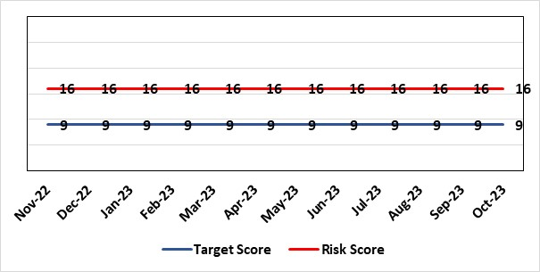 |  | Rationale for current score:  C - Inability to find records for patients could delay care/increase length of stay over 15 days. Could also mean patients receive incorrect treatment. Increased risk of fire where records are stored outside of the medical record libraries.  L - we know this happens from incidents raised
Level of Control  = 70% |  |  | Rationale for target score:  C - The increased development and adoption of the digital record will reduce the need for the paper health record being available at the point of care.  L - The increased development and adoption of the digital record, the introduction of RFID and the approach to management of the paper record identified in the Business case process should reduce the amount of paper required to be stored and managed.
Date added to the HB risk register
June 2016
Controls (What are we currently doing about the risk?) |  |  | Mitigating actions (What more should we do?)
- There is a plan in place to increase the functionality of the electronic record to document patient care. The delivery of the plan is overseen by the Digital Leadership Group and progress provided to Management Board. (Supported by individual project boards as appropriate).  - Records managed by the Medical Records libraries are RFID tagged and location tracked.  - Medical Record libraries are regularly risk assessed for fire by health and safety.  - Alternative offsite storage arrangements have been identified.  - All records must be documented on the Information Asset Register (IAR). |  |  | Action | Lead |  | Deadline
 |  |  | Amended: Re-develop a joint outline Business Case for centralisation of the health records and the scanning model. | Head of Health Records & Clinical Coding |  | 30/11/2023
 |  |  | Welsh Government sign off for long term conditions retention of records | Head of Health Records & Clinical Coding |  | 30/11/2023
Assurances (How do we know if the things we are doing are having an impact?)  - RFID has been implemented for the acute record improving the management and storage of records  - Health Records performance reports developed in line with RFID technology  - Attainment of the Tier 1 Health Board target for clinical coding completeness which relies on the timely availability and quality of the Paper record and electronic sources  - Monitoring complaints and incident reporting.  - Electronic record is being implemented in accordance with the plan eg implementation of WNCR, ETR, HEPMA etc. |  |  | Gaps in assurance (What additional assurances should we seek?)  Investment required supporting the delivery and operational costs of the Digital strategy.  Reliance on DHCW for delivery of the solution for a fully electronic patient record.  Impact of the Infected Blood Enquiry on the Health Boards ability to destroy notes.  Process for ensuring clinical adoption of electronic ways of working and cessation of adding information to the paper record that is already available electronically needs to be agreed and enforced by the Health Board.  Impact of the infected Blood Inquiry on the health boards ability to destroy notes and the change in the records code of practice is being reviewed by the Director of Digital.
Additional Notes
14/06/2023 – A potential suitable unit has been discovered with building work requirements currently being scoped for architects in order to acquire costings for a business case to be submitted to BCAG. Two actions completed - Assessment of the impact of the Records Management code of practice. Develop a revised destruction plan. Destruction of initial 100 boxes commences Monday 12/06/2023.
29/09/2023 - Action 1 is overdue, awaiting building costs for new centralised unit which has been found. Once costs are realised the business case can be re-submitted to BCAG. Timescale moved to 30th November as it is in the process of re-doing the cost of the business case.
16/10/2023 – MC to decide new actions and milestones.

Datix ID Number: 1567  Health & Care Standard: Safe Care 2.1 Managing Risk & Promoting Health & Safety |  |  | HBR Ref Number: 41  Risk Target Date: February 2024 | Current Risk Rating  4 x 4 = 16
Objective: Delivering Care in Safe, Modern Environments |  | BAF Ref: 7 | Director Lead: Darren Griffiths, Director of Finance & Performance  Assuring Committee: Quality & Safety Committee
Risk: Fire Regulation Compliance  Following a review of the fire compliance of the cladding applied to Singleton Hospital, in particular (as a high rise block), the HB commenced a programme of works to remove the non-compliant cladding and replace the cladding with fire compliant materials. |  |  | Date last reviewed: October 2023
Risk Rating  (consequence x likelihood):  Initial: 5 x 3 = 15  Current: 4 x 4 = 16  Target: 3 x 3 = 9 |  |  | Rationale for current score:  Cladding applied to Singleton Hospital front flank is not compliant with fire regulations.  General compliance with fire regulations and WHTM/WHBN requirements.
Level of Control  = 50% |  |  | Rationale for target score:  Once sufficient resources and the cladding is replaced the risk score will reduce significantly. This will be reduced in stages as resources are implemented and cladding replaced.
Date added to the HB risk register
31/05/2018
Controls (What are we currently doing about the risk?) |  |  | Mitigating actions (What more should we do?)
- Fire risk assessments.  - Evacuation plans (vertical and horizontal).  - Fire safety training.  - Professional advice sought on compliance of panels.  - East flank panels removed  - Business case being developed for south panel removal and updating. |  |  | Action |  | Lead | Deadline
 |  |  | Change in fire evacuation plans and alarm and detection cause and effect |  | Head of Health & Safety | 01/11/2023
 |  |  | Replacing the existing cladding and insulation with alternative specifications and inserting 30 minute fire cavity barriers where appropriate |  | Service Improvement Manager | 28/02/2024
Assurances (How do we know if the things we are doing are having an impact?)  - Monitoring through the H&S committee to receive assurance and or identify gaps for key compliance and adherence to applicable legislation.  - NWSSP internal audits  - Site visits/tours to identify compliance and gaps in compliances.  - Completion of FRA’s within targeted schedule |  |  | Gaps in assurance  (What additional assurances should we seek?)  Suitable resources to be in place, all fire risk assessments and actions from them completed. Fire safety audits carried out internally. Fire compartmentation surveyed to provide assurance of fire stopping. Fire schematics updated and fire evacuation drawings updated in in place.
Additional Comments / Progress Notes
16/10/23: Cladding replacement progressing well, approx. 75% complete, with the final phase due for completion end Feb 2024.

Datix ID Number: 1514  Health & Care Standard: Safe Care 2.1 Managing Risk & Promoting Health & Safety |  |  | HBR Ref Number: 43  Risk Target Date: 30th November 2023 |  | Current Risk Rating  4 x 5 = 20
Objective: Mental Health & Learning Disability Services |  | BAF Ref: 3.2 | Director Lead: Gareth Howells, Executive Director of Nursing  Assuring Committee: Quality and Safety Committee
Risk: Deprivation of Liberty Safeguards  Due to a lack of Best Interest Assessor resource, there is a risk of failure to complete and authorise the assessments associated with Deprivation of Liberty within the legally required timescales, exposing the health board to potential legal challenge and reputational damage. |  |  | Date last reviewed: October 2023
Rationale for current score:
Although processes have been planned in order to reduce the breach position they have yet to be fully implemented. The impact is yet to be realised. Risk increased in Feb 2023 following discussion at Mental Health Legislative Committee.
Risk Rating  (consequence x likelihood):  Initial: 4 x 4 = 16  Current: 4 x 5 = 20  Target: 3 x 2 = 6 | 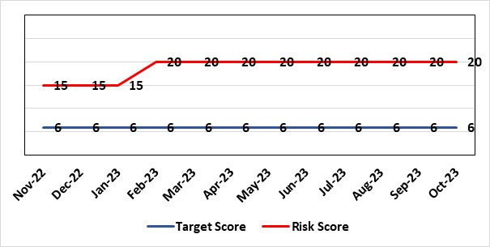
Level of Control  = 40% |  |  | Rationale for target score:  Consequences of DoLS breaches for the Health Board will not change. With controls in place, over time likelihood should decrease.
Date added to the HB risk register
July 2017
Controls (What are we currently doing about the risk?) |  |  | Mitigating actions (What more should we do?)
Additional supervisory body signatories in place – this is being undertaken as overtime using additional WG funds.  Additional funding received from WG to manage the backlog of DoLS assessments.  DoLS assessments are being undertaken via a number of difference sources to address the backlog;  - External BIA’s payment to be increased from £120 to £250 (utilising substantive recurring funding) to encourage a large cohort of BIA’s to undertake role.  - 2 band 6 WTE BIA’s have been appointed (using WG money). This will reduce the need for agency BIA’s.  - Overtime/additional hours agreed utilising WG money for sign off completion.  - DoLS database updated and DoLS dashboard in place, monitoring applications and breaches via dedicated BIAs and Admin.  - Delivery of DOLS Action plan reviewed monthly.  - Regular reporting to Mental Health and Legislative Committee (MHLC).  - Monthly reporting to Unit Nurse Director and Finance on DoLS breaches.  - Health Board presence at National and regional meetings relating to DoLS / LPS.  - Increased IMCA services to support increased BIA resource.  - Current Mental Capacity Act practice reviewed to support MCA DoLS issues in practice. |  |  | Action | Lead |  | Deadline
 |  |  | Overtime/additional hours agreed to fund sign off from nurse assessor team to process the backlog assessments | GND Primary and Community |  | Ongoing
Assurances (How do we know if the things we are doing are having an impact?)  Regular scrutiny at Service Group and Safeguarding Committee and by DoLS Internal Audit; monitoring via DoLS Dashboard this will provide real-time accurate data.  Update report to MHLC, impact of backlog of DoLS breaches and new LPS implementation.  Monthly updates with Unit Nurse Director and Finance. |  |  | Gaps in assurance (What additional assurances should we seek?)
Additional Comments / Progress Notes
19.10.2023 - Risk level remains at 20. The breach time is approximately 6 weeks. Breaches have reduced from 41 (Jan 2023) to 17 (end September 2023). Job Description for a band 8a MCA/DoLS Lead is currently with Vacancy Control. The resources available are limited and there is still an imbalance between the workload for DoLS applications and the resources available. Agreement made 19.09.2023 by board that MCA/DoLS to sit within Primary, Community and Therapies Service Group. Training and Court of Protection to remain at present with Corporate Nursing. Formal response to be made shortly. Bespoke face-to-face training sessions for ward and medical staff is underway to help support the MCA/DoLS training need. This is in conjunction with statutory MCA/DoLS training. Regular updates on progress are provided to the Health Board Safeguarding Committee, and the Mental Health Legislative Committee. The Risk score will continue to be reviewed as this work progresses. Due to sickness with administrative staff the DoLS service is relying on support from Long Term Care Team and Agency cover. This has been added as a risk score of 12 to the risk register.

Datix ID Number: 1761  Health & Care Standard: Timely Care 5.1 Access |  |  | HBR Ref Number: 50  Risk Target Date: 31/12/2023 |  | Current Risk Rating  5 x 5 = 25
Objective: Networked Hospital – A Systems Approach – Cancer Care |  | BAF Ref: 3.5 | Director Lead: Deb Lewis, Chief Operating Officer  Assuring Committee: Performance and Finance Committee  For information: Quality & Safety Committee
Risk: Access to Cancer Services A backlog of patients now presenting with suspected cancer has accumulated during the pandemic, creating an increase in referrals into the health board which is greater than the current capacity for prompt diagnosis and treatment. Because of this there is a risk of delay in diagnosing patients with cancer, and consequent delay in commencement of treatment, which could lead to poor patient outcomes and failure to achieve targets. |  |  | Date last reviewed: October 2023
Risk Rating  (consequence x likelihood):  Initial: 4 x 5 = 20  Current: 5 x 5 = 25  Target: 4 x 3 = 12 |  |  | Rationale for current score:  Risk score based on being off trajectory for SCP.
Level of Control  = 70% |  |  | Rationale for target score:  Target score reflects the challenge this area of work present the Board and where small numbers of patients impact on the potential to breach target.
Date added to the HB risk register
April 2014
Controls (What are we currently doing about the risk?) |  |  | Mitigating actions (What more should we do?)
- Tight management processes to manage each individual case on the Urgent Suspected Cancer Pathway. Enhanced monitoring & weekly monitoring of action plans for top 6 tumour sites.  - Initiatives to protect surgical capacity to support USC pathways have been put in place  - Additional investment in MDT coordinators, with cancer trackers appointed in April 2021.  - Prioritised pathway in place to fast track USC patients.  - Ongoing comprehensive demand and capacity analysis with directorates to maximise efficiencies. This will form part of the remit of the Cancer Performance Group.  - Weekly cancer performance meetings are held for both NPTS and Morriston Service Groups by specialty.  - The top 6 tumour sites of concern have developed cancer improvement plans – weekly monitoring arrangements have been put in place.  - Additional work being undertaken as part of diagnostic recovery and theatre recovery workstreams.  - Endoscopy contract has been extended for insourcing. |  |  | Action | Lead |  | Deadline
 |  |  | Cancer Performance Group to monitor improvement trajectories for both cancer backlog and SCP performance on a monthly basis | Deputy COO |  | 31/03/2024
 |  |  | Full review of gynaecology / gynae-oncology pathway given service constraints to be done. Additional theatre capacity for gynaecological cancer to be agreed to reduce current backlog | Deputy COO |  | 29/03/2024
Assurances (How do we know if the things we are doing are having an impact?)  Backlog trajectories updated at Management Board and will be going to Performance & Finance Committee in August. Cancer Performance Group established to support execution of the services delivery plans for improvements and meeting regularly. |  |  | Gaps in assurance (What additional assurances should we seek?)  Performance and activity data monitored, but delays to treatment continue while sustainable solutions found.
Additional Comments / Progress Notes
18/08/2023 – Issues identified with tracking of cancer patients and variability of approach taken by the Service Groups. Agreement to move management of trackers and MDM co-ordinators to the central cancer team with effect from September 2023. Additional financial support agreed for cellular pathology outsourcing to help reduce current backlog position which is contributing to delay in some pathways.
23/10/2023 - Additional theatre capacity for gynaecological cancer to be agreed to reduce current backlog with appointment of locum consultant. Updated action plans to be developed by tumour site leads by 31st October. These will be monitored on a weekly basis by the operational performance team. External support requested to review the form and function of the cancer performance team to ensure effective management of pathways from an administrative perspective. It is anticipated this will take place in November 2023.

Datix ID Number: 1799  Health & Care Standard: Controlled Drug 2.6 Medicines Management |  |  | HBR Ref Number: 57  Risk Target Date: 31st October 2023 | Current Risk Rating  4 x 4 = 16
Objective: Demonstrably Improved Quality, Safety & Reduced Harm |  | BAF Ref: 1 | Director Lead: Hazel Lloyd, Director of Corporate Governance  Assuring Committee: Quality & Safety Committee
Risk: Non-compliance with Home Office (HO) CD Licensing requirements. The Health Board (HB) currently has limited assurance regarding compliance with HO CD Licensing requirements, nor does it have processes in place in respect of future service change compliance. |  |  | Date last reviewed: October 2023
Rationale for current score:
Legal advice has indicated that failure to comply with the HO CD licensing requirements could result in criminal and civil action, both against responsible individuals and the health board as a public body. The CDAO met with representatives from the Home Office Drugs & Firearms Licensing Unit on the 10th January 2023. At the conclusion of the meeting, the Home Office made clear to the Health Board that at that point in time we were non-compliant with our statutory obligations in this area. The Home Office gave the Health Board a deadline of the 27th January 2023 by which to make any required applications - failure to do so would result in enforcement action by the Home Office.
Several areas where licensing is required have been agreed and the corresponding applications to the Home Office have been made. The CDAO, in conjunction with Director of Corporate Governance continue to explore potential additional licensing requirements around care provided by external providers on SBU Health Board sites and private healthcare provision.
Risk Rating  (consequence x likelihood):  Initial: 5 x 4 = 20  Current: 4 x 4 = 16  Target: 4 x 2 = 8 | 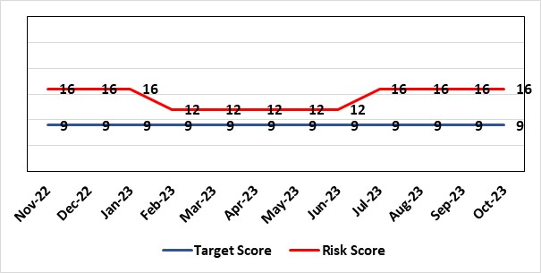
Level of Control
= 80%
Date added to the HB risk register  January 2019 |  |  | Rationale for target score:  Upon completion of mitigating actions, there will be a training session held with all Service Groups supported at Executive level.
Controls (What are we currently doing about the risk?) |  |  | Mitigating actions (What more should we do?)
The CDAO has worked with the Medical Director and Director of Corporate Governance to ensure the Health Board identifies areas where a Home Office Controlled Drugs License is required. Service Group senior teams together with pharmacy colleagues have reviewed controlled drug activity, and in discussion with the CDAO have agreed several areas where licensing is required and have made the corresponding applications to the Home Office. |  |  | Action |  | Lead | Deadline
 |  |  | HB to develop and implement a control system to ensure compliance with HO license requirements. |  | CD Pharmacy | 30/11/2023
 |  |  | CDAO to work with the Medical Director and Director of Corporate Governance to complete review of Home Office Controlled Drug License requirements by the Health Board. |  | CD Pharmacy | 30/11/2023
Assurances (How do we know if the things we are doing are having an impact?)  Services have fed back to the CDAO that a number of Home Office Controlled Drug Licenses have been applied for. |  |  | Gaps in assurance (What additional assurances should we seek?)  The HB will develop a license compliance register, this is expected to be maintained by the Corporate Governance Team thus ensuring there is sufficient segregation of duty.
Additional Comments / Progress Notes
26/07/23 - Several Home Office license compliance visits undertaken in recent weeks - currently awaiting outcome from the Home Office regarding whether licenses will be granted. A number of other Home Office license compliance visits have been confirmed for the coming months. Corporate Governance team exploring options that could provide a control system to ensure ongoing compliance with Home Office CD license requirements. Potential additional licensing requirements around care provided by external providers on SBU Health Board sites and private healthcare provision continue to be explored. Following discussion, it was agreed that the risk likelihood level should revert to the previous level (4) and therefore the overall risk score returned to 16.
11/09/23 - No change since the previous update.
18/10/23 - Several Home Office license compliance visits undertaken in recent weeks - one license granted to date and currently awaiting outcome from the Home Office regarding whether additional licenses will be granted. A number of other Home Office license compliance visits have been confirmed for the coming months. Potential additional licensing requirements particularly around care provided by external providers/other NHS bodies on SBU Health Board sites and private healthcare provision continue to be explored – the Acting Medical Executive wrote to Service Groups regarding this in September 2023. Meeting scheduled for 25/10/23 to discuss implementation of a control system to ensure compliance with HO license requirements.

Datix ID Number: 146  Health & Care Standard: Effective Care 3.1 Clinically Effective Care |  |  | HBR Ref Number: 58  Risk Target Date: 31/03/2024 |  | Current Risk Rating  4 x 3 = 12
Objective: Networked Hospitals – A Systems Approach – Planned Care |  | BAF Ref: 3.4 | Director Lead: Deb Lewis, Chief Operating Officer  Assuring Committee: Quality and Safety Committee
Risk: Failure to provide adequate clinic capacity for follow-up patients in Ophthalmology results in a delay in treatment and potential risk of sight loss. |  |  | Date last reviewed: October 2023
Risk Rating  (consequence x likelihood):  Initial: 4 x 3 = 12  Current: 4 x 3 = 12  Target: 4 x 2 = 8 | 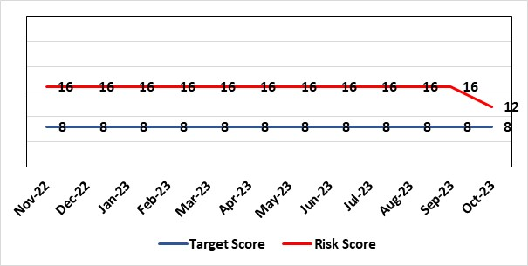 |  | Rationale for current score:  Risk rating increased to 20 in July 2020 due to Covid-19 pandemic but has now been decreased due to the progress made by the department to reduce the number of delayed followed appointments.
Level of Control  = 40% |  |  | Rationale for target score:  Mitigation plan via outsourcing of work to optometrists where possible and re-introduction of pre-covid capacity levels.
Date added to the HB risk register
December 2014
Controls (What are we currently doing about the risk?) |  |  | Mitigating actions (What more should we do?)
- All patients are categorised by condition in order to quantify issue.  - Community optometry scheme successfully implemented to reduce number of diabetic retinopathy patients on follow up list.  - Scheme developed for assessment of glaucoma patients by community optometrists for virtual review by consultant ophthalmologists to reduce follow up backlog.  - Outsourcing of cataract activity to reduce overall service pressures. |  |  | Action | Lead |  | Deadline
 |  |  | An overall Regional Sustainability Plan to be delivered | Service Group Manager Surgical Specialties |  | 31/12/2023
Assurances (How do we know if the things we are doing are having an impact?)  - Deputy COO holds Gold Command meetings on a monthly basis to monitor progress. |  |  | Gaps in assurance (What additional assurances should we seek?)  Regular liaison with patients on extended waiting list/times and validation.
Additional Comments / Progress Notes
19/06/2023 – There has been continued reduction in the number of patients awaiting follow up appointment most notably glaucoma. Additional outpatient capacity has been secured at Singleton to maximise the investment in additional staff and this will result in a further reduction in follow up appointments.
20/07/2023 – No further updates to report.
18/08/2023 – There has been a further reduction in the number of patients on the follow up not booked – down by 29% from the July 22 baseline figure. The backlog for glaucoma follow up appointments has reduced over the same period from 4639 to 3341 (ahead of trajectory for improvement).
24/10/2023 - Additional outpatient capacity now available and running clinics. Risk reduced to 12.

Datix ID Number: 1587  Health & Care Standard: 3.1 Safe and Clinically Effective Care |  |  | HBR Ref Number: 61  Risk Target Date: 31st May 2024 |  | Current Risk Rating  4 X 4 = 16
Objective: Networked Hospitals – A Systems Approach – Planned Care |  | BAF Ref: 3.4 | Director Lead: Deb Lewis, Chief Operating Officer  Assuring Committee: Quality and Safety Committee
Risk: Paediatric dental GA (General Anaesthetics)/Sedation services provided under contract from Parkway Clinic, Swansea. Medical Safety risk as GA are performed on children outside of an acute hospital setting. Repatriation of service to acute site delayed due to theatre capacity which means the health board continues to commission services for delivery outside of national guidance (WHC 2018-09). There is also an associated risk in that the diagnosing clinician does not deliver the care to the patient. |  |  | Date last reviewed: October 2023
Risk Rating  (consequence x likelihood):  Initial: 5 x 3 = 15  Current: 4 x 4 = 16  Target: 4 x 2 = 8 | 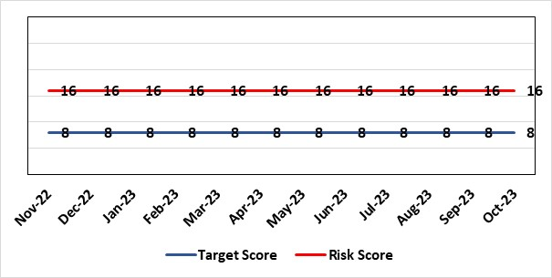 |  | Rationale for current score:  There is no immediate access to crash team/ICU facilities in in Parkway Clinic – the client group are undergoing G/A/sedation. Paediatric GA/Sedation services provided under contract from Parkway Clinic, Swansea continue due to lack of capacity for these patients to be accommodated in Secondary Care.
Level of Control  = 60% |  |  | Rationale for target score:  Relocation of the paediatric GA service [provided by Parkway Clinic] to a hospital site being treated as a priority.
Date added to the HB risk register
4th July 2018
Controls (What are we currently doing about the risk?) |  |  | Mitigating actions (What more should we do?)
Consultant Anaesthetist present for every General Anaesthetic clinic.  Assurance Documentation supplied by Parkway Clinic including confirmation of arrangements in place with WAST and Morriston Hospital for transfer and treatment of patients  New care pathway implemented - no direct referrals to provider for GA.  Multi-drug sedation ceased from Sep 2018 in line with WHC 2018 009  Revised SLA/Service Specification  HIW Inspection Visit Documentation provided to HB  All extended GA cases require approval from paediatric specialist prior to treatment |  |  | Action | Lead |  | Deadline
 |  |  | Transfer of services from Parkway. | Interim Head of Primary Care |  | 31/05/2024
Assurances (How do we know if the things we are doing are having an impact?)  RMC collate referral and treatment outcome data for review by Paediatric Specialist  Regular clinical meeting arranged with Parkway to discuss individual cases/concerns  Regular clinical/ management meeting for CDS/primary care management team to discuss service pathway /concerns/issues arising  Roll out of new pathway to encompass urgent referrals  T&F Group established to lead transfer from community centre to MHSDU. |  |  | Gaps in assurance (What additional assurances should we seek?)  ToR for the task and finish group should continue to include consideration of the pressures on the POW special care dental GA list and this service is considered alongside any plans for the Parkway contract.
Additional Comments / Progress Notes
20/04/2023 The current contract arrangements with Parkway will be extended for a further 12 months from June 2023.
18/08/2023 – Agreement with the Medical Director to maintain status with utilising Parkway. Suggested that Chief Dental Officer (CDO) be invited to visit Parkway for assurance.

Datix ID Number: 1605  Health & Care Standard: 3.1 Safe and Clinically Effective Care |  |  | HBR Ref Number: 63  Risk Target Date: 30/11/2023 | Current Risk Rating  4 X 5 = 20
Objective: Children, Young People & Maternity Services |  | BAF Ref: 3.6 | Director Lead: Gareth Howells, Executive Director of Nursing and Christine Morrell, Director of Therapies & Health Sciences  Assuring Committee: Quality and Safety Committee
Risk: Screening for Fetal Growth Assessment in line with Gap-Grow (G&G). There is not enough Ultrasound capacity within Swansea Bay UHB to offer all women serial ultrasound scan screening in the third trimester in line with the UK perinatal Institute Growth Assessment Programme (GAP). Welsh Government mandate fetal growth screening in line with the GAP programme, which states serial ultrasound growth scans should be performed at three weekly intervals. There is significant evidence of the increased risk for stillbirth or neonatal mortality/morbidity (hypoxic ischaemic encephalopathy) HIE, where a fetus is growth restricted (Intrauterine Growth Restriction - IUGR) and/or small for gestational age fetus (SGA). |  |  | Date last reviewed: October 2023
Rationale for current score:
Current score of 20 is 4 (consequence) x 5 (likelihood). Consequence score of 4 calculated due to the governance and assurance – non-compliance with national standards with significant risk if unresolved and likelihood of 5 as expected to happen daily/>50%.
The service is unable to provide third trimester scans at three weekly intervals in line with the Perinatal Institute recommendations.
Risk Rating  (consequence x likelihood):  Initial: 4 x 3 = 12  Current: 4 x 5 = 20  Target: 3 x 4 = 12 | 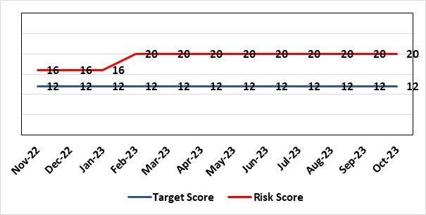
Level of Control
= 60%
Date added to the HB risk register  1st August 2019 |  |  | Rationale for target score:  When the service is able to provide third trimester ultrasound scan in line with GAP recommendations we will be providing care in line with evidence based best national practice as mandated by Welsh Government.
Controls (What are we currently doing about the risk?) |  |  | Mitigating actions (What more should we do?)
All staff are required to complete the GAP GROW e-learning on an annual basis. Compliance is monitored via the Training & Education forum.  A local policy to scan women 4 weekly in place.  Three qualified midwifery sonographers and a midwifery sonography lead who provides training are in place. One midwife sonographer continues training.  Lead sonographers created a governance process for the review of scan images of babies born with a birth weight centile under 10th centile to identify themes and trends within the department and areas for quality improvement. |  |  | Action |  | Lead | Deadline
 |  |  | Midwives provided until revised target of 30/11/2023 to complete training. CPD Midwives to escalate those non-compliant with training to Deputy Head of Midwifery for emails/meetings with staff members. |  | CPD Midwives & Deputy Head of Midwifery | 30/11/2023
 |  |  | Business case to be completed to include administrative support for midwife sonographer clinics to be secured to ensure streamlined service |  | Maternity service business manager | 01/01/2024
Assurances (How do we know if the things we are doing are having an impact?)  Target 95% Gap Grow training compliance by End November 2023 (W/c 16/10/23 Gap Grow compliance level 72%).  Aim is the provision of serial ultrasound scans on a three weekly schedule in accordance with the recommendations from the Perinatal Institute. (Currently the provision of serial ultrasound scans is provided on a four weekly schedule.)  The detection rate of IUGR/SGA will increase leading to improved antenatal management plans and intrapartum planning. We will report a reduced rate of stillbirth and/or neonatal mortality/morbidity with improved management of IUGR/SGA babies.  The administration support for the service will be fully functional.  Lead Sonographers for Singleton and Neath and Lead Midwife sonographer have developed a governance review group to meet monthly to review all ultrasound scan images where there was a baby born under the 10th centile to identify themes and learning for quality improvement. |  |  | Gaps in assurance (What additional assurances should we seek?)  Assurance of maintaining a sustainable third trimester ultrasound service. The provision of serial ultrasound scans on a three weekly schedule in accordance with the recommendations from the Perinatal Institute. (Currently the provision of serial ultrasound scans is provided on a four weekly schedule.)
Additional Comments / Progress Notes
04/07/23 - CPD Midwives reported GAP Grow compliance as 49%. Head of Midwifery to request names of those not compliant to be sent to Deputy Head of Midwifery for one to one contact.
Maternity services business manager to meet with Lead midwife sonographer to review business plan for administration support for midwifery sonographer service, as well as seek support from the Health Board Radiography and Stenography Service where the lead for this service sits.
11/08/23 – Service manager completing business case for radiology. Lead Midwife Sonographer asked to provide data to assess need for administration support as part of radiology business case. Critical staffing levels remain in Maternity and therefore no improvement in compliance. PDM to incorporate GAP Grow as part of mandatory training. Lead Midwife for Quality, Safety and Risk to meet with team for action plan. Mandatory training for new training year starting October 2023. Therefore action date changed. Midwifery sonography team have introduced scanning all low PAAP-A from 1/8/23.
15/09/23 - Unannounced HIW visit on 5.9.23 - summary of controls in place
Mandatory & Statutory Day on 14.9.23 has allocated time to staff to undertake their e-learning and Gap Grow (Priority) – 2 hours allocated for this within the M&S Day. HOM to email individual staff to complete Gap Grow – aim to be 95% compliant by 12.10.23. Obstetric compliance is 88%.
Consultant Lead to chase obstetric team to complete Gap Grow Training to aim to be 100% compliant by 12.10.23 (12 obstetricians outstanding). This will be escalated further at Audit Meeting 18/10/23 and presentation shared Lead of each area to oversee compliance figures of E-learning until improvement between 85% to 100% is achieved. Gap Grow and E-Learning will be reported into the Maternity Training & Education Forum via the Area Leads and exception reported into the Maternity Quality & Safety Group.
18/09/23 - Business case presented to BCAG by Public Health consultant 7 September awaiting feedback. Quality Improvement work around NRT prior to hospital admission, maternal smoking policy development.
13/10/23 - Public Health are funding 2 x band 5's, 1 band 6, 1 band 3 for 18 months ringfenced for maternity services for smoking cessation.
25/10/23: Gap Grow training compliance has improved to 72% overall currently. Gap Grow and E-Learning are reported into the Maternity Training & Education Forum via the Area Leads and exception reported into the Maternity Quality & Safety Group. Further review is to be undertaken of scanning capacity.

Datix ID Number: 2159  Health & Care Standard: Safe Care 2.1 Managing Risk & Promoting Health & Safety |  |  | HBR Ref Number: 64  Risk Target Date: 31st March 2024 | Current Risk Rating  4 X 4 = 16
Objective: Delivering Care in Safe, Modern Environments |  | BAF Ref: 7 | Director Lead: Darren Griffiths, Director of Finance & Performance  Assuring Committee: Quality & Safety Committee
Risk: Insufficient resource and capacity of the health, safety and fire function within SBUHB to maintain legislative and regulatory compliance for the workforce and for the sites across SBUHB. . |  |  | Date last reviewed: October 2023
Risk Rating  (consequence x likelihood):  Initial: 5 x 4 = 20  Current: 4 x 4 = 16  Target: 4 x 3 = 12 | 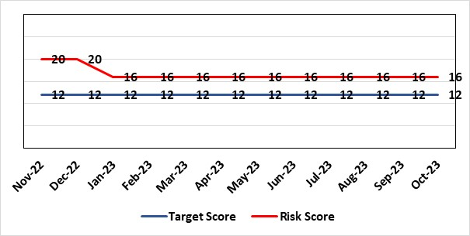 |  | Rationale for current score:  The Health Board received 12 Health & Safety Executive (HSE) improvement notices during 2019-20 covering various Health & Safety legislative breaches covering a range of areas. There is the potential for future multiple notices for not meeting legislative requirements. Score reduced to 16.
Level of Control  = 70% |  |  | Rationale for target score:  Compliance with the notices and to have sufficient resources to implement a sustainable health and safety provision to support the legal requirements of the Health Board and demonstrate that suitable resources are in place to undertake the roles and responsibilities of the department, also to undertake suitable and sufficient training, provide corporate overview/audit to ensure practices are being employed in the workplace.
Date added to the HB risk register
September 2019

Controls (What are we currently doing about the risk?) |  |  | Mitigating actions (What more should we do?)
- Assistant Director of Health and Safety in post to support strengthening and develop the H&S function to support the organisation. Business case submitted for additional resources.  - Health and Safety Operational Group and the Health and Safety Committee monitor compliance. Refreshed the Fire Safety Group with additional controls in place.  - Fire risk assessments are being prioritised with temporary additional resources put in place in March 2021 to reduce the number of FRA overdue.  - Fire training in place and fire wardens in place  - Fire risk assessment schedule in place for the next 12 months to maintain 100% compliance of completion and is regularly reviewed |  |  | Action |  | Lead | Deadline
 |  |  | It has been agreed to identify posts to progress recruitment on a phased approach over the next 12/24 months. This will be dependent upon availability of funding. |  | Assistant Director of H&S | 31/03/2024
Assurances (How do we know if the things we are doing are having an impact?)  - Monitoring through the appropriate group/committees (H&S committee) to receive assurance and or identify gaps for key compliance and adherence to applicable legislation.  - Site visits/tours to identify compliance and gaps in compliances. |  |  | Gaps in assurance (What additional assurances should we seek?)  Agreement of funding for resources identified in business case to implement structure in business case by Q2/3 2022/23 financial year.
Additional Comments / Progress Notes
16.10.23: No change

Datix ID Number: 329  Health & Care Standard: 3.1 Safe and Clinically Effective Care |  |  | HBR Ref Number: 65  Risk Target Date: 31/12/2023 | Current Risk Rating  4 x 5 = 20
Objective: Children, Young People & Maternity Services |  | BAF Ref: 3.6 | Director Lead: Gareth Howells, Executive Director of Nursing  Assuring Committee: Quality & Safety Committee
Risk: Misinterpretation of cardiotocograph and failure to take appropriate action is a leading cause for poor outcomes in obstetric care leading to high value claims. The requirement to retain maternity records and CTG traces for 25 years leads to the fading/degradation of the paper trace and in some instances traces have been lost from records which makes defence of claims difficult. |  |  | Date last reviewed: October 2023
Rationale for current score:
Central monitoring system is now available – risk level to be reviewed (see notes)
Risk Rating  (consequence x likelihood):  Initial: 4 x 4 = 16  Current: 4 x 5 = 20  Target: 4 x 2 = 8 |  |  | Rationale for target score:  A central monitoring station will enable senior clinicians to support decision making across the service, leading to senior involvement in management decisions toward improved outcomes. All CTG traces will be stored electronically and therefore will not fade and cannot be lost.
Level of Control
= 50%
Date added to the HB risk register
31st December 2011
Controls (What are we currently doing about the risk?) |  |  | Mitigating actions (What more should we do?)
All staff receive annual training in fetal surveillance as mandated by Welsh Government.  SBU have appointed a midwife and obstetric lead for training and development of staff  A “fresh eyes” protocol in place requiring intrapartum CTG classification hourly by two clinicians which is monitored via audit of records  A “jump call” policy is available to request additional support where there is disagreement over CTG classification  CTG prompt labels in use to support staff with CTG categorisation. |  |  | Action | Lead | Deadline
 |  |  | SOP created for the identification, reporting and reviewing of incidents in relation to K2 implementation | Project Board | Completed
Assurances (How do we know if the things we are doing are having an impact?)  All Wales Fetal Surveillance Standards for 12hrs Fetal Surveillance Training per year started from October 2023. |  |  | Gaps in assurance (What additional assurances should we seek?)  Assurance all staff are able to transition to a new way of working
Additional Comments / Progress Notes
04/07/2023 - K2 implemented in Singleton hospital w/c 26/6/23. Recommend keeping central monitoring on the risk register for phase of initial implementation, and for a short period post implementation (to ensure the system is working to its optimum. The risk score will then be formally reviewed, and for consideration of removal from HBRR as all actions achieved.
11/08/2023 – 5 incidents reporting regarding K2 implementation. Maternity team identify risk should remain open until assurance provided of embedded practices with K2 implementation. All incidents logged on to K2 log and Maternity team have developed SOP to identify how to review, report and follow up incidents with K2. SOP created for ensuring access for agency and bank midwives.
25/10/23: The risks associated with system implementation and CTG interpretation are going to be reviewed with a view to refreshing this risk entry in the next register cycle.

Datix ID Number: 1834  Health & Care Standard: 5.1 Timely Care |  |  | HBR Ref Number: 66  Risk Target Date: TBC | Current Risk Rating  5 X 3 = 15
Objective: Networked Hospital – A Systems Approach – Cancer Care |  | BAF Ref: 3.5 | Director Lead: Raj Krishnan, Acting Executive Medical Director  Assuring Committee: Quality and Safety Committee
Risk: The demand & complexity of planned treatment regime for cancer patients requiring chemotherapy currently exceed the available chair capacity, risking unacceptable delays in access to SACT treatment in Chemotherapy Day Unit with impact on targets and patient outcomes. |  |  | Date last reviewed: October 2023
Risk Rating  (consequence x likelihood):  Initial: 5 x 5 = 25  Current: 5 x 3 = 15  Target: 2 x 2 = 4 | 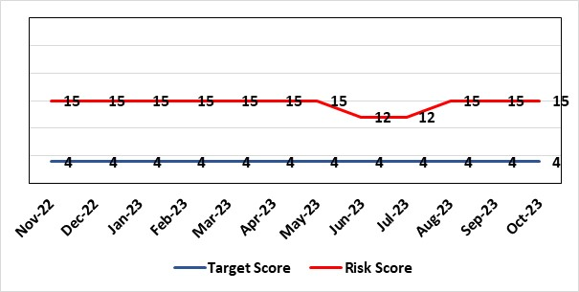 |  | Rationale for current score:  Risk was reduced to 12 in June 2023. Further feedback showed that this was not sustained and that there were still significant workforce challenges in CDU and PTS so the risk was returned to 15.
Level of Control
=
Date added to the HB risk register  30/11/2019 |  |  | Rationale for target score:  Reduced delays in treatment will reduce risk of harm.
Controls (What are we currently doing about the risk?) |  |  | Mitigating actions (What more should we do?)
Review of CDU by improvement science practitioner was completed in 2020. Resulted in change to booking processes to streamline booking process and deferral.  Review of scheduling by staff to ensure all chairs used appropriately.  Business case endorsed by CEO for shift of capacity to home care to be considered by the Management Board  A Daily scrutinizing process in progress to micro manage individual cases, deferrals etc.  Changes made to prescribing & authorising processes to improve workflow for PTS reducing potential delays to supply and administration of treatment.  Responsibility for checking bisphosphonate prescriptions in CDU moved to nursing staff to free up Pharmacy capacity allowing them to focus on key clinical tasks within Pharmacy.  Joint project with Nuclear Medicine to streamline pathways and prioritise SACT patients appropriately halved the average time waiting for MUGA/EDTA tests required before starting SACT. |  |  | Action | Lead | Deadline
 |  |  | Relocation of SACT linked to AMSR programme and phase 2 of home care expansion case brought forward | Service Director Lead for Cancer | 31st December 2023
 |  |  | CDU planned to move into the main hospital Nov/Dec 2023 | Service Director Lead for Cancer | Complete
Assurances (How do we know if the things we are doing are having an impact?)  Additional funding agreed to support increase in nurse establishment to appropriately staff the unit during its main opening hours. Additional scheduling staff also agreed.  Pre-assessment process has been separated from start date in an attempt to fill deferral slots at short notice where possible. Improved communication between MDT to streamline booking and deferral process.  Continue to monitor patient experience via friends and family in conjunction with the Welsh Cancer Patient Experience Survey results under our PTR procedures. Monitoring our waiting times against new SACT metrics, which is a measure based on treatment intent and is no longer reported as average waiting time so is more linked to expected outcomes etc. This performance metric is included in our Cancer Performance report we send to WG and Management Board and internally via governance arrangements with NPTSSG where Oncology services sit. |  |  | Gaps in assurance (What additional assurances should we seek?)  Capital & Revenue assumptions & resources for second business case for increasing chair capacity in 2022/23 to meet increased demand.
Additional Comments / Progress Notes
16.06.23 - confirm that there is a reduction of waiting times with SACT, the additional work streams are in place to move some capacity out of CDU i.e. self-administration of denosumab and group pre-assessments, therefore we can reduce the risk to 12.
20.07.23 – Risk will need to remain at a 15: Further feedback shows that this not a sustained progress currently and that there are still significant workforce challenges in CDU and PTS. If we look at it from a SACT QPI metric on starting treatment we are only now 64% so only 2/3 of P2 category starting within time (better for P3 which was 86%) and this has only started to improve last 3-4 months. CDU planned to move into the main hospital Nov/Dec 2023.
August 2023 - Waiting times and breaches are scrutinised daily to ensure progress is monitored and data is captured. The self-administration of denosumab workstream is almost ready to be implemented. SACT CNS is awaiting comments, prior to going live with this. There is still inconsistency with number of breaches in CDU, therefore, not at a point where the risk can reduce from 15 to 12.
Sept update – There has been an increased number of referrals for SACT in Aug/Sept which is anticipated will remain an increase for forthcoming months. To address this Pre-assessment capacity has been increased by introducing group pre assessments to ensure patients are ready to start SACT if there are any cancellations/deferrals, to avoid further delays.
CDU will move to ward 9 week commencing 25/09/23. Chair capacity is being explored to increase in capacity which will also need to be discussed and agreed with pharmacy.
October 2023 – Current situation has seen increased delays in starting treatments and deferrals have been going to be to next cycle as unable to be fitted in as weeks delay due to increase in number of treatments going through unit. Task and finish group have been arranged to discuss actions required within the Division. CDU is now situated on Ward 9 of the main hospital.

Datix ID Number: 89  Health & Care Standard: 5.1 Timely Care |  |  |  |  |  | HBR Ref Number: 67  Risk Target Date: 31st January 2024 |  |  |  | Current Risk Rating  4 X 5 = 20
Objective: Networked Hospital – A Systems Approach – Cancer Care |  |  | BAF Ref: 3.5 |  |  | Director Lead: Raj Krishnan, Acting Executive Medical Director  Assuring Committee: Quality and Safety Committee
Risk: Clinical risk-target breaches in the provision of radical radiotherapy treatment. Due to capacity and demand issues the department is experiencing target breaches in the provision of radical radiotherapy treatment to patients. |  |  |  |  |  | Date last reviewed: October 2023
Risk Rating  (consequence x likelihood):  Initial: 4 x 4 = 16  Current: 4 x 5 = 20  Target: 2 x 2 = 4 |  | 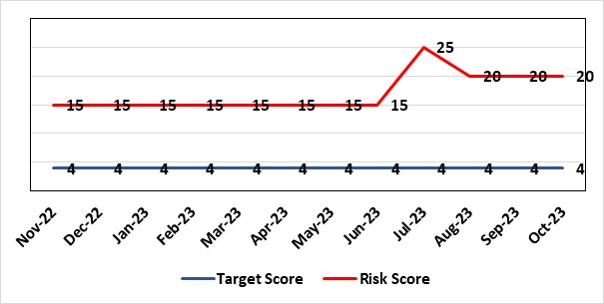 |  |  |  | Rationale for current score:  August 2023 - Current risk update to 20. CT is back in clinical use and backlog reduced. CT remains a single point of failure therefore downgraded to 20.
Level of Control
=
Date added to the HB risk register  30/11/2019 |  |  |  |  |  | Rationale for target score:  Reduced delays in treatment will reduce risk of harm.
Controls (What are we currently doing about the risk?) |  |  |  |  |  | Mitigating actions (What more should we do?)
Capacity for treatment increased across the department with investment in Linac replacement programme.  CT business case submitted for recommissioning of CT1 to increase capacity until the new CT is installed in 24/25. |  |  |  |  |  | Action |  |  | Lead |  |  | Deadline
 |  |  |  |  |  | Business Case to BCAG to recommission CT1 as resilience |  |  | Service Manager RT services |  |  | Complete
 |  |  |  |  |  | Business case for 2nd CT case (capital and revenue) |  |  | Service Manager RT services |  |  | End Qtr 3 23/24
Assurances (How do we know if the things we are doing are having an impact?)  Performance and activity data is being monitored and monthly data shared with radiotherapy management meeting and cancer board. It is also now included in scorecard. |  |  |  |  |  | Gaps in assurance (What additional assurances should we seek?)  Performance and activity data monitored, but delays to treatment continue while sustainable solutions found. Performance for Scheduled and Urgent Symptom Control patients have improved due to increased treatment capacity, however CT capacity is now the bottleneck in the pathway and also a single point of failure.
Additional Comments / Progress Notes
19.04.23 – CT1 (old CT) not currently in use due to absence of maintenance contract.
20.07.23 – Action closed - Currently working on business case to increase CT and Pre Treat capacity by weekend working. CT1 (old CT) Business case for recommissioning to go to BCAG to mitigate against risk of 25. CT unavailable for 7 days in May due to breakdown, this led to a dip in targets in all areas.
16.08.23 - Action complete - New Linac required – Linac case agreed with WG. CT1 recommissioning Business Case taken to SMT - to go to BCAG September 2023. If successful, this would reduce risk further.
Sept update – Re-Commissioning business case approved at BCAG and listed for management board 4th Oct 2023.
October 2023 – CT Recommissioning business case approved at management board. Work is underway which will see the recommissioned machine operational Nov/Dec 23.
Datix ID Number: 1418  Health & Care Standard: 5.1 Timely Access |  |  |  |  | HBR Ref Number: 69  Risk Target Date: See Target Rationale |  |  | Current Risk Rating  5 X 4 = 20
Objective: Children, Young People & Maternity Services |  |  |  | BAF Ref: 3.6 | Director Lead: Deb Lewis, Chief Operating Officer / Gareth Howells, Executive Director of Nursing  Assuring Committee: Quality & Safety Committee
Risk: Risk issues related to adolescent patients being admitted to Adult MH inpatient wards- Inappropriate settings resulting in 'Safeguarding Issues' The WG has requested that HBs identify Secondary Care in -patient facilities for the care of adolescents- in Swansea Bay University Health Board Ward F NPT hospital is the dedicated receiving facility with one bed identified. |  |  |  |  | Date last reviewed: October 2023
Risk Rating  (consequence x likelihood):  Initial: 2 x 3 = 6  Current:5 x 4 = 20  Target: 2 x 3 = 6 | 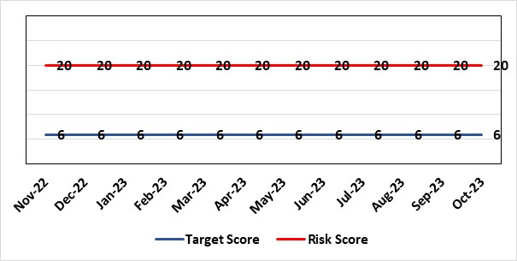 |  |  |  | Rationale for current score:  Every health board is required to have an admission facility for adolescent Mental Health patients. Whilst ward F has been identified as the single point of access in SBU and a dedicated bed is ring-fenced for adolescent admissions it is a mixed sex adult ward. Therefore the facilities are less than ideal for young patients in crisis.
Level of Control
=
Date added to the HB risk register  27/02/2020 |  |  |  |  | Rationale for target score:  The longer term aim for the Health Board remains to create an admission facility for adolescent Mental Health patients but this will not be possible until the new Adult Inpatient Unit is built.
Controls (What are we currently doing about the risk?) |  |  |  |  | Mitigating actions (What more should we do?)
Safeguarding Training for Staff, Joint protocol with Cwm Taf LHB [CAMHS] currently subject to review, Local SBUHB policy on providing care to young people in this environment. This includes the requirement for all such patients on admission to be subject to Level 3 Safe and Supportive observations.  Only Adolescents within 16-18 age range are admitted to the adult ward.  The health board works with CAMHS to make sure that the length of stay is as short as possible. |  |  |  |  | Action |  | Lead |  |  |  | Deadline
 |  |  |  |  | Next service group review of effectiveness of current controls. |  | MH&LD Head of Operations & Clinical Directors |  |  |  | 01/12/2023
Assurances (How do we know if the things we are doing are having an impact?)  Individual Rooms with en Suite Facilities, Joint working with CAMHS, monitoring of staff training, Monitoring of admissions by the MH&LD SG legislative Committee of the Health Board. The ongoing issues with the risks presented by the use of this has recently been raised at an all Wales level with Welsh Government and a formal review is anticipated. The Service Group continues to flag the risk particularly in light of Ward F being identified as the SPOA for AMH in the Health Board which has resulted in an increase in acuity and a greater concentration of individuals who are experiencing the early crisis of admission - this has served to increase the already identified risks for young people in the environment. |  |  |  |  | Gaps in assurance (What additional assurances should we seek?)
Additional Comments / Progress Notes
24/10/2022: No change. Next review date assigned.
31/08/2023: No CAMHS admissions to the unit for past 12 months, however this is not as a consequence to any changes to the patient pathway or service provision. After discussion at MH Legislation Committee it was agreed that this risk is scored correctly.

Datix ID Number: 2595  Health & Care Standard: 3.1 Safe and Clinically Effective Care |  |  | HBR Ref Number: 74  Risk Target Date: 31/12/2023 |  | Current Risk Rating  5 x 3 = 15
Objective: Children, Young People & Maternity Services |  | BAF Ref: 3.6 | Director Lead: Gareth Howells, Executive Director of Nursing  Assuring Committee: Quality and Safety Committee
Risk: Delay in Induction of Labour (IOL) or augmentation of Labour  Due to staffing and capacity to deal with periods of high acuity in Maternity & NeoNates there is a risk of delays in IOL which can introduce avoidable risk and unnecessary intervention which can lead to poor clinical outcome for mother and/or baby. Delays in IOL lead to increased complaints and decreased patient satisfaction. |  |  | Date last reviewed: October 2023
Risk Rating  (consequence x likelihood):  Initial: 4 x 4 = 16  Current: 5 x 3 = 15  Target: 2 x 3 = 6 | 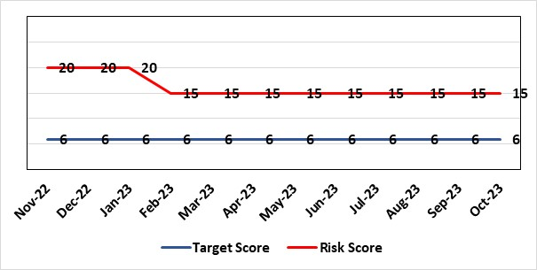 |  | Rationale for current score:  Rationale for score, the likelihood of the score has been assessed as 5 due to the likelihood of occurring daily/over 50% of the time. The consequence of the score is assessed as 3, moderate under patient safety domain. While remains at 15, frequency of delay is has increased since Sep 2023.  Delay in IOL is a frequent occurrence in maternity care. Delays can be for a number of reasons including high acuity, Maternity staffing levels and Neonatal staffing levels. All incidents for delays in IOL are linked to the risk register and reviewed for the level of harm the delay in IOL caused for the service user and unborn. While adverse outcomes as a result of delay in care are infrequent, there may be long term consequences for mother and/or baby leading to high value claims.  The service group are completing work through Datix incident report to review the purpose of the delay (acuity, staffing, neonatal capacity) when reviewing incidents to have a better understanding of the factors which contribute impacting delays in IOL.  The service group recommend this risk continues on the HBRR, as NICE guidance for IOL is changing with IOL being offered at an earlier gestation. This is likely to have an impact on the current score and risk for the service.
Level of Control
= 60%
Date added to the HB risk register
30th April 2021
Date added to the HB risk register  30th April 2021 |  |  | Rationale for target score:  IOL delays are minimal with increased patient flow, increased patient satisfaction and prevent avoidable poor outcomes
Controls (What are we currently doing about the risk?) |  |  | Mitigating actions (What more should we do?)
Daily obstetric consultant ward round to reviews all women undergoing IOL. Ongoing/regular monitoring by cardiotocograph for fetal wellbeing during IOL on hold. Labour ward coordinator and labour ward obstetric lead ensure women on ward 19 for IOL are factored into daily planning of workload on labour ward. Obstetric consultant review when IOL on hold for appropriate pan of care. The MDT (Obstetric, Neonatal and Midwifery) consider individual risk factors and Escalation Policy is implemented. Neighbouring maternity units are contacted to ask if they are able to support by accepting the transfer of women.  Daily acuity is gathered and sent to the senior midwifery management team who can anticipate potential problems and support the clinical team. The matron of the unit is contacted in office hours and the senior midwife manager on call is contacted out of hours. If required midwifery staffing are redeployed including the specialist midwives and the community midwifery on call team. |  |  | Action | Lead |  | Deadline
 |  |  | See Actions in relation to Critical Midwifery Staffing risk (HBRR ref 81) the result of which should minimise disruption in IOL. | See HBR 81 |  | See HBR 81
 |  |  | Working group to be developed for the review of Induction of labour | Operational Midwife for Antenatal ward. |  | In place  complete
Assurances (How do we know if the things we are doing are having an impact?)  The below measures will be reviewed to monitor this risk:  Numbers of IOL delays  Number of adverse events for which IOL delay is causal factor  Number of complaints relating to experience of delay in IOL |  |  | Gaps in assurance (What additional assurances should we seek?)
Additional Comments / Progress Notes
04/07/2023 - Workforce paper completed and presented at board. Senior team continue work on OCP, which is due for dissemination w/c 10th July 2023. Escalation guideline completed and being presented in Maternity Q+S for ratification 31st July 2023. Lead on antenatal ward to develop working group to review induction of labour. Two Actions completed - Prepare midwifery workforce paper to present recommendation for future staffing levels in the obstetric unit to ensure adequate staffing each shift. Review of the Maternity Escalation guideline to include escalation for Induction of Labour and work is progressing in the development of a maternity dashboard to support the oversight of any issues/harm.
11/08/2023 – Working group continue to review induction of labour with reference to benchmarking other HB’s and induction agents.
25/10/2023 – Working group is reviewing indication criteria and induction process itself. Risk to be further reviewed in next cycle.

Datix ID Number: 1832  Health & Care Standard: : 3.1 Safe and Clinically Effective Care |  |  | HBR Ref Number: 80  Risk Target Date: 31/03/2024 |  | Current Risk Rating  4 x 5 = 20
Objective: Networked Hospitals – A Systems Approach – Urgent & Emergency Care |  | BAF Ref: 3.3 | Director Lead: Deb Lewis, Chief Operating Officer  Assuring Committee: Quality & Safety Committee
Risk: If the Health Board is unable to discharge clinically optimised patients there is a risk of harm to those patients as they will decompensate, and to those patients waiting for admission. |  |  | Date last reviewed: October 2023
Risk Rating  (consequence x likelihood):  Initial: 4 x 5 = 20  Current: 4 x 5 = 20  Target: 4 x 2 = 8 |  |  | Rationale for current score:  - Sustained levels of clinically optimised patients (COPs) leading to overcrowding within ED, use of inappropriate or overuse of decant capacity in ED and delays in accessing medical bed capacity, clearly emerged as themes.  - Constraints in relation to all patient flows out of Morriston to a more appropriate clinical setting, identified and included in an expanded risk.  - Delay in discharge for clinically optimised patients can result in deterioration of their condition.
Level of Control  = 25% |  |  | Rationale for target score:  Targeted reduction of Clinically Optimised patients remains a priority for the HB in order to minimise risk of avoidable harm to patients within the HB and in the wider community.
Date added to the risk register
May 2021
Controls (What are we currently doing about the risk?) |  |  | Mitigating actions (What more should we do?)
- Clinically optimised numbers are monitored and reviewed weekly by the MDU. Delays are reported and escalated to try to ensure timely progress along a patient's pathway.  - Review on a patient by patient basis – with explicit action agreed in order to progress transfer to appropriate clinical setting.  - Critical constricts in relation to access/time delays for social workers and assessment for package of care and social placement – lead times in excess of 5 weeks.  - Patient COVID-19 status has added an additional level of complexity to decision making.  - The health board has procured 63 additional care home beds to provide additional discharge capacity.  - Clinically optimised patients have been cohorted into the available capacity at Singleton Hospital to ensure that their needs can be met more appropriately. This has reduced the number of COPs at Morriston Hospital.  Weekly escalation meetings are held with health and social service colleagues to ensure the requirements of the patients are reviewed and patients are pulled through the system where possible. |  |  | Action | Lead |  | Deadline
 |  |  | Develop an Integrated Discharge Hub | Medical Director |  | Integrated Discharge Team (IDT) 31/08/23  Integrated Discharge Hub Sept ‘23  Pilot completed
 |  |  | Roll out of Integrated Discharge Hub | Medical Director |  | 31/12/2023
Assurances  (How do we know if the things we are doing are having an impact?)  - Patient level dashboard allows breakdown by delay type  Close management of utilization of additional care home beds . |  |  | Gaps in assurance  (What additional assurances should we seek?)
Additional Comments
11/08/23: Actions refreshed by new COO. IDT to be set up on Morriston site to provide single point of access and support for complex dischargers prior to IDH being implemented.
09/10/23: IDH pilot completed, data being analysed, initial review shows a positive impact on turning patients around at the front door. Roll out to be completed in Q3.

Datix ID Number: 2788  Health Care Standards: 7.1 Workforce |  |  | HBR Ref Number: 81  Risk Target Date: 31/12/2023 |  | Current Risk Rating  5 x 5 = 25
Objective: Children, Young People & Maternity Services |  | BAF Ref: 3.6 | Director Lead: Gareth Howells, Executive Director of Nursing  Assuring Committee: Quality & Safety Committee  For Information: Workforce & OD Committee
Risk: Critical staffing levels – Midwifery  Unplanned absences resulting from long and short-term sickness, alongside maternity leave, have resulted in critical staffing levels, which undermine the ability to maintain the full range of expected services safely, increasing the potential for harm, poor patient outcomes and/or choice of birthplace. Poor service quality or reduction in services could impact on organisational reputation. |  |  | Date last reviewed: October 2023
Rationale for current score:
The vacancy position has improved for registered staff – however, the current score will remain while the impact of staffing is reviewed. Some aspects of service provision continue to suspended in order to ensure resource is best directed to support safe provision. This is also subject to review.
Risk Rating  (consequence x likelihood):  Initial: 4 x 5 = 20  Current: 5 x 5 = 25  Target: 4 x 4 = 16 | 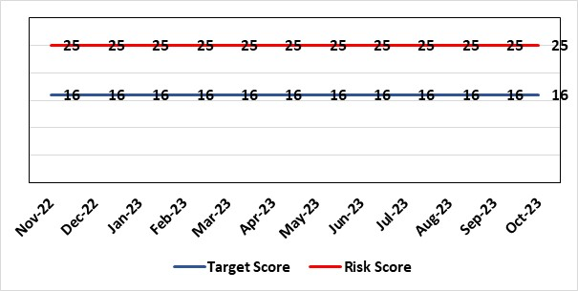
Level of Control  = % |  |  | Rationale for target score:  It is intended that through actions currently identified to address vacancies we can reinstate services fully and reduce the likelihood of the need to suspend elements further.
Date added to the risk register
12/10/2021
Controls (What are we currently doing about the risk?) |  |  | Mitigating actions (What more should we do?)
- All midwives are working at the hours they require up to full time.  - Specialist midwives and management redeployed to support clinical care as required  - Birth rate plus Intrapartum acuity tool completed 4 hourly to guide safe service provision and escalation;  - Escalation meeting held daily during the week to review rotas and reallocate staff as required chaired by Head of Midwifery  - Morning safety huddle for community midwifery teams  - Morning safety huddle for obstetric unit generates RAG-rated daily acuity and shares this with the Service Group for its daily meeting.  - Additional shifts offered via Bank, additional hours and overtime at enhanced rates  - Utilisation of off-contract midwifery agency authorised by Executive Director of Nursing  - Open advert for recruitment on TRAC  - On-Call Manager Rota in place.  - Continue to suspend services in the FMU at NPT.  - International recruitment campaign initiated with MEDACS.  - Offer of additional support worker shifts particularly in the postnatal area for additional support for women  - Maternity Care Assistance (MCA) role in place to support Midwives in providing care in women and their families.  - Regular communication with stakeholders includes: Early warnings to Welsh Government; Verbal and formal communication with CHC; Internal communications on home births, RCM updates; weekly staff briefings and bulletins. |  |  | Action | Lead |  | Deadline
 |  |  | Development and dissemination of the organisational change to practice (OCP). Phase 1 consultation period closed. Outcome has been reviewed and further work is being undertaken to resolve | Head of Midwifery |  | 14/11/2023 (phase1 completion)
 |  |  | OCP Phase 2 consultation period closed 24th Oct 2023. Outcome is to be reviewed and actions completed – target 28th November. | Head of Midwifery |  | 28/11/2023
Assurances (How do we know if the things we are doing are having an impact?)  The following assurance mechanisms in place currently:  Birth-rate Plus Intrapartum acuity tool completed 4 hourly  Daily staff escalation meetings chaired by Head of Midwifery which considers sickness & other absences and daily review of safety and quality outcomes. The Group Head of Quality Safety & Risk is supporting daily oversight of Datix incidents. The following red flag events are monitored:  • Delayed or cancelled elective caesarean sections;  • Missed or delayed care incidents;  • Delayed or cancelled induction of labour;  • Delay of 2 hours or more between admission for induction of labour and beginning of process;  • Delay of 30 minute or more between presentation and triage.  Birthrate Plus assessment outcome (last internal assessment Oct 2023 – now compliant) |  |  | Gaps in assurance (What additional assurances should we seek?)
Additional Comments / Progress Notes
11/08/23 – OCP consultation continues and staff offered drop in sessions and one to one with senior team. Recruitment of 7 midwives Band 5 and Band 6 (variable hours) and 15 newly qualified midwives commencing employment in October 2023. Induction for newly qualified midwives commenced 11/8/23. Action completed - Review of the Maternity Escalation guideline to ensure robust processes in place if acuity is high or critical staffing. Guideline receiving comments following discussion in Maternity Quality and Safety.
13/10/2023 -Incidents continue to be linked. Further advert for recruitment submitted. Band 5's commencing w/c 16.10.2023. OCP consultations continue. Weekly engagement staff meetings ongoing and wellbeing support is being provided.
25/10/23 – Eleven Band 5 midwives commenced in October 2023. Currently band 5 and 6 positions are filled to establishment levels. Some unregistered positions remain vacant. Weekly engagement staff meetings are ongoing with Director attendance and wellbeing support is being provided. Action required following OCP consultation is being reviewed.

Datix ID Number: 2554  Health & Care Standard: Standard 5.1 Timely Access |  |  | HBR Ref Number: 82  Risk Target Date: 1st December 2023 |  | Current Risk Rating  4 x 3 = 12
Objective: Networked Hospitals – A Systems Approach – Urgent & Emergency Care |  | BAF Ref: 3.3 | Director Lead: Raj Krishnan, Acting Executive Medical Director  Assuring Committee: Performance & Finance Committee  For Information: Quality & Safety Committee, Workforce & OD Committee
Risk: Risk of closure of Burns service if Burns Anaesthetic Consultant cover not sustained  There is a risk that adequate Burns Consultant Anaesthetist cover will not be sustained, potentially resulting in closure to this regional service, harm to those patients would require access to it when closed and the associated reputational damage. This is caused by:  - Significant reduction in Burns anaesthetic consultant numbers due to retirement and long-term sickness  - Inability to recruit to substantive burns anaesthetic posts  - The reliance on temporary cover by General intensive care consultants, and Consultants from the Morriston General on-call and Paediatric Anaesthesia rotas, to cover while building work is completed in order to co-locate the burns service on General ITU  - Reliance on capital funding from Welsh Government to support the co-location of the service |  |  | Date last reviewed: October 2023
Risk Rating  (consequence x likelihood):  Initial: 4 x 3 = 12  Current: 4 x 3 = 12  Target: 3 x 1 = 3 | 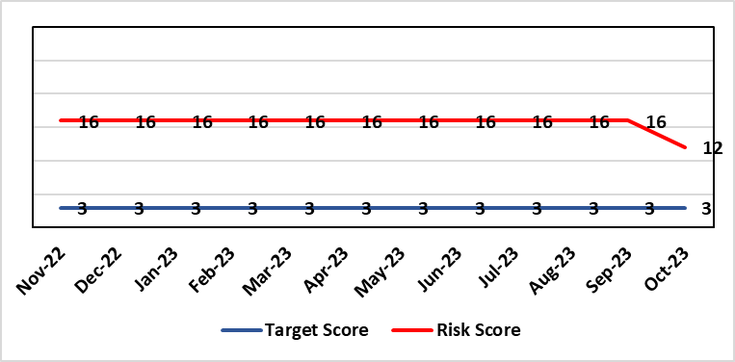 |  | Rationale for current score:  Funding has been confirmed and enabling works are due to start in December with main construction starting in January 2024. This can be de-escalated to 12.
Level of Control  = |  |  | Rationale for target score:  This is a small clinical service with staff with highly specialised skills. While a small service may always be vulnerable to challenges (eg staff) the intention will be to operate a more resilient clinical model that is supported by other clinical groups.
Date added to the HB risk register
December 2021
Controls (What are we currently doing about the risk?) |  |  | Mitigating actions (What more should we do?)
- The general ITU consultants, and some Consultants from the Morriston General and Paediatric Anaesthetists to support the Burns service on a temporary basis, supporting the remaining burns anaesthetic colleagues to provide cover for the Burns service.  - The agreement reached is that they will cover the current Burns Unit on Tempest ward at Morriston hospital for 6-9 months while capital work is underway on general ITU to enable co-location of the service.  - Capital works will be completed by mid-2023 to co-locate the burns patients within the GICU footprint.  - WHSSC as commissioners of the service have been kept fully informed, as has the South West (UK) Regional Burns Network  - Other UK burns units have ICU co-located with Burns ICU, removing the need for dual certified consultants |  |  | Action | Lead |  | Deadline
 |  |  | WG have agreed funding in principle for capital works to progress. Scoping document submitted to WG and discussions ongoing about expediting a decision on an outline/full business case. | Morriston Service Group |  | Complete (Funding agreed and enabling works commencing December 2024)
Assurances (How do we know if the things we are doing are having an impact?)  Effect on patients of the temporary closure of the burns service in Swansea is mitigated by maintaining an urgent assessment/stabilisation service for patients in Wales with severe burns, with onward transfer for inpatient care to another unit in the UK following the initial assessment.  The service reopened fully on 14/02/2022. |  |  | Gaps in assurance (What additional assurances should we seek?)
Additional Comments / Progress Notes
17.01.23 No change to consultant cover, which remains reliant on cross-cover from general critical care and anaesthetics. A business case for the strategic and capital investment of £7.3m has been completed and will be presented to the Board on the 26th January.
03.11.23 Funding agreed for capital works - enabling works are due to start in December with main construction starting in January 2024.

Datix ID Number: 3036  Health Care Standards: 4.1 Dignified Care, 2.1 Managing Risk & 7.1 Workforce |  |  | HBR Ref Number: 84  Risk Target Date: Subject to Review |  | Current Risk Rating  4 x 2 = 8
Objective: Demonstrably Improved Quality, Safety & Reduced Harm |  | BAF Ref: 1 | Director Lead: Raj Krishnan, Acting Executive Medical Director  Assuring Committee: Quality & Safety Committee
Risk: Cardiac Surgery  A Getting It Right First Time review identified concerns in respect of cardiac surgery (including patient pathway/process issues) that present risks to ensuring optimal outcomes for all patients. Potential consequences include the outlier status of the health board in respect of quality metrics, including mortality following mitral valve surgery and aortovascular surgery. This has resulted in escalation of the service by WHSSC. |  |  | Date last reviewed: October 2023
Risk Rating  (consequence x likelihood):  Initial: 5 x 5 = 25  Current: 4 x 2 = 8  Target: 4 x 3 = 12 | 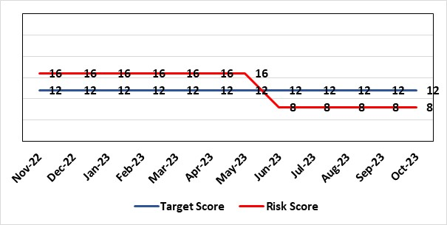 |  | Rationale for current score:  Service had previously been de-escalated by WHSSC from Stage 4 to Stage 3. While now de-escalated to Stage 2, score will remain pending full de-escalation.  Assurance of processes in place through implementation of the improvement plan.
Level of Control  = % |  |  | Rationale for target score:  Cardiac surgery is frequently high-risk surgery and an element of risk will remain.
Date added to the risk register
March 2022
Controls (What are we currently doing about the risk?) |  |  | Mitigating actions (What more should we do?)
- Invited Service Review by Royal College of Surgeons to advise on outcomes, good practice and areas for improvement;  - Implementation of local action plan to address areas of concern; widespread engagement among clinicians in the department.  - All surgery is now only undertaken by consultants and mitral valve repair surgery is undertaken by two mitral valve specialists; a third consultant undertakes mitral valve replacements as agreed with WHSSC.  - Complex heart valve MDT established to make decisions on appropriate surgery including MV repair and MV replacement and to direct to the appropriate consultant.  - Internal review of deaths following mitral valve surgery.  - High Risk MDT implemented, outcome decision documented on Solus.  - Dual surgeon operating mandated for complex cases (determined by the MDT) to improve outcomes.  - MDT discussion to be undertaken for all patients who develop deep sternal wound infections.  - Quality & Outcomes database established capture case outcome metrics in real time. |  |  | Action | Lead |  | Deadline
 |  |  | Develop nursing workforce plan | Service Group Medical Director |  | 31st October 2023
Assurances (How do we know if the things we are doing are having an impact?)  - An improvement plan has been developed in conjunction with WHSSC and agreed. Progress is monitored by Gold Command arrangements.  - Quality & Outcomes database established capture case outcome metrics. |  |  | Gaps in assurance (What additional assurances should we seek?)  Assurance sought via RCS Invited Review on outcomes and governance in the department
Additional Comments / Progress Notes
16/06/23: De-escalated - decrease risk to - maintenance of work done to date. Cardiac surgery service improvement group in place. Downgrade to C4 x L2 = 8. Link to service sustainability risk.
12/08/23: No change. Await nursing workforce plans from Service Group. One action complete - Develop actions for improvement as advised by RCS.
October 2023 – The risk is unchanged. The cardiac surgery dashboard, funnel plots etc. are all satisfactory in terms of clinical outcomes, but the “softer” process measures of length of stay, DOSA, theatre utilisation etc. that reflect service efficiency could be improved. Team work and timely reporting of clinical incidents remain of concern.

Datix ID Number: 2561  Health & Care Standard: Effective Care 3.1 Safe & Clinically Effective Care |  |  | HBR Ref Number: 85  Risk Target Date: 31st December 2023 | Current Risk Rating  4 x 5 = 20
Objective: Children, Young People & Maternity Services |  | BAF Ref: 3.6 | Director Lead: Christine Morrell, Director of Therapies & Health Sciences  Assuring Committee: Quality & Safety Committee
Risk: Non-Compliance with ALNET Act  There are risks to the Health Board’s ability to meet its statutory duties and establish the effective collaborative arrangements required by the ALN Act, which is being implemented through a phased approach. This risk is caused by:  - Lack of staff resource needed to carry out the additional work needed to comply with the ALN Act for operational services, especially those in the PCST Service Group. The size of the gap in terms of staff resource is now better understood.  - Issues around multi-agency working which may impact on levels of demand on operational services, and on existing SLAs through which the Health Board delivers some services to partner LAs.  - Implementation of the Act for those of above compulsory school age (post-16) commences in September 2023. This presents risks because of gaps in service provision.  - Multiple pressures for operational services are impacting on capacity / engagement of leads within impacted services to progress tasks that need to be undertaken to mitigate the risks.  - Issues with Data Quality due to pressure on ALN and Service administration teams, process issues and absence of a robust system to enable data capture and analysis. This means that accurate and up-to-date data regarding the Health Board’s compliance is not available.  Potential consequences of this risk are: non-compliance with statutory duties, parent / carer and young peoples' dissatisfaction leading to complaints. Educational Tribunals and Judicial Reviews (this is new legislation with many points of ambiguity and is highly likely to be legally ‘tested’); reputational impact; and children failing to access the multi-agency support that they need with their learning needs, leading to poor outcomes. |  |  | Date last reviewed: October 2023
Rationale for current score:
Risk score reflects that while controls are in place, there are multiple areas of risks (relating to compliance with legislation; governance and assurance; workforce and OD; and sustainable services); and high probability (especially given multiple risk areas) of at least one of these areas of risk being realised. Caused by implementation timetable for the ALN Act, slippage against plan and need for strengthened governance (as described in ‘Risk’ section).

Risk Rating  (consequence x likelihood):  Initial: 5 x 5 = 25  Current: 4 x 5 = 20  Target: 2 x 3 = 6 |  |  | Rationale for target score:  As the ALN Act is new legislation, there remains some ongoing likelihood of risk events during the initial phases of implementation, though with lessened consequences as a result of mitigating actions.
Level of Control
=
Date added to the HB risk register
14/05/2022
Controls (What are we currently doing about the risk?) |  |  | Mitigating actions (What more should we do?)
- Progressing the necessary work within an appropriate structure (see under ‘ACTIONS’) are constrained by financial and/or service delivery pressures.  - DECLO (Designated Educational Clinical Lead Officer) is in post - this is a statutory requirement.  - Health Board ALN Steering Group has been established, with structure agreed for Operational Group working under the governance of this  - Work is being progressed with Local Authority partners to ensure that activity relating to the ALN Act is grounded in a shared vision and principles to support collaborative working.  - Initial operational processes relating to statutory processes (through which Local Authorities access Health Board involvement) have been established and are in effect and work is being progressed with partners to refine operational approach.  - Advice has been received from WG to resolve key areas of particular ambiguity relating to Health Board duties under the Act.  - Regarding demand / capacity and staffing resource challenges, WG has a phased implementation timetable that has recently been extended from summer 2024 to summer 2025. From summer 2025, the Act will be fully in ‘delivery as usual’. The phased implementation offers partial short-term mitigation of the risks.  - Awareness has been raised at Board level through Development session and thrice-yearly updates are provided to the Quality and Safety Committee.  - A multi-agency group supported by the national ALN post-16 Implementation Lead has been formed to progress key activity in relation to post-16 implementation.  - Welsh Government have been engaging with the Designated Education Clinical Lead Officers on a national basis regarding ALN key performance indicators and compliance. A Welsh Health Circular regarding this is anticipated in the coming months. |  |  | Action | Lead | Deadline
 |  |  | Collaboratively with partner LAs review progress and establish ALN implementation priorities for 23/24 school year | DECLO | 31/12/2023
 |  |  | Assess demand / capacity implications of the ALN for relevant operational children’s services and produce business case if required | DECLO | 31/12/2023
 |  |  | Work with Informatics colleagues to ensure robust data regarding compliance, for which it is anticipated that national reporting will required. Activity is ongoing nationally to establish the national dataset. | DECLO | 31/12/2023
 |  |  | Work with LA colleagues to establish future SLA arrangements for Paediatric Therapies services and to establish the impact of any changes on the Health Board. | Head of Children’s Speech & Language | 31/12/2023
Assurances (How do we know if the things we are doing are having an impact?)  - There is regular reporting in respect of the ALN Act through the Patient Safety and Compliance Group.  - ALN Steering Board has been established, ensuring oversight at a senior level within all impacted operational and corporate areas.  - DECLO meets regularly with ADOTHS / DoTHS of the 3 health boards of South-West and Mid Wales for update and assurance.  - National ALN Reform Steering Group has been formed and will include Health representation (SBU Deputy DOTHS). This will provide a national forum for consideration of risks. |  |  | Gaps in assurance (What additional assurances should we seek?  - Extent of gap in staffing resource (gap between work required and capacity available) has been provisionally quantified, but data is imperfect and there remains some uncertainty. This is in a context where demands will increase significantly over the next year.
Additional Comments / Progress Notes
20.10.2023 – revisions to operational processes through which the Health Board fulfils its key statutory functions under the ALN Act have been completed. A standard operating procedure has been developed and training has been delivered to Health Board, Local Authority and schools staff. The revised process is now ‘live’. Work is progressing to ensure robust and reliable data capture under the new process moving forward. The backlog in reliable data has been discussed with the ALN Steering Group who have agreed that it makes sense to tolerate the gap in recent compliance data and instead focus energies on ensuring that accurate and reliable data is captured moving forward. This action has been closed. Work to establish a mechanism for supporting post-16 implementation of the Act has been completed and this action has also been closed.
There remains a gap in the ALN Project Manager post which is impacting on the scale and pace of other activity required to mitigate the current risk. Efforts to recruit internally have been unsuccessful and we are advertising for the post externally. Some areas of work including activity needed to assess the demand / capacity requirements of the Act will need to have completion dates modified (this requires further discussion before being finalised), and date has been modified for work to establish shared priorities for the next period with Education partners.
Work to establish priorities for the remainder of the current school year is now scheduled for November. Three Actions completed - Collaborative work with partners to ensure effective implementation of the Act for young people aged above 16, from September 2023. Address current backlog in compliance data. Implement revisions to operational processes for statutory requests and responses, to ensure robust, clearly-understood processes and reliable prospective data capture.

Datix ID Number: 3071  Health Care Standards: Staff & Resources 7.1 Workforce |  |  | HBR Ref Number: 89  Target Risk Date: 31/03/2024 | Current Risk Rating  4 x 5 = 20
Objective: Primary & Community Care |  | BAF Ref: 3.1 | Director Lead: Gareth Howells, Executive Director of Nursing (lead) / Deb Lewis, Chief Operating Officer (support)  Assuring Committee: Quality & Safety Committee
Risk: Healthcare Nursing Staff Levels at HMP Swansea  There is a risk that the men in HMP Swansea will not receive the appropriate standard of care. This is due to the fact that the nursing establishment within the prison no longer fully meets the changed demographics and numbers of men being detained. The maximum operational capacity of the Prison can reach circa 480 men. The Health Board investment into the Prison is based on delivering services to 250 men. This was also highlighted as a risk in the recent HIW governance review. In addition there is no head room built into the Prison nursing establishment so periods of sickness, leave and study renders the roster short. |  |  | Date last reviewed: October 2023
Risk Rating  (consequence x likelihood):  Initial: 4 x 5 = 20  Current: 4 x 5 = 20  Target: 2 x 2 = 4 | 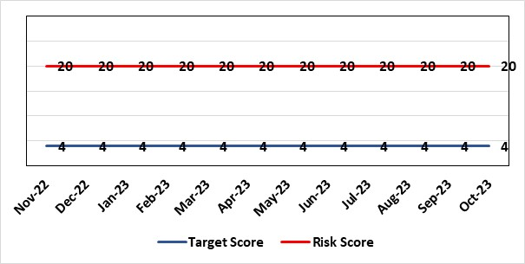 |  | Rationale for current score:  Consequence major – unable to fully deliver on the recommendations of HIW due to low healthcare staffing numbers, further impacted during periods of sickness or absence as no headroom. Likelihood expected – suboptimal care provided on a daily basis.
Level of Control  = % |  |  | Rationale for target score:  Consequence minor – With sufficient staffing numbers the prison will be able to deliver on HIW recommendations and fully implement the actions in the Health Delivery Plan. Likelihood unlikely – With full establishment and headroom, suboptimal care is less likely.
Date added to the risk register
30/11/2022
Controls (What are we currently doing about the risk?) |  |  | Mitigating actions (What more should we do?)
Daily communication with the Governor about the availability and priority of healthcare nursing staff. The prison regime may be amended to reflect numbers.  Review of skill mix and Health Board policy:  - Introduction of a pharmacy technician role who can administer drugs to support nursing establishment.  - Skill mix undertaken in the Prison to introduce Health Care Support Workers to be 2nd checkers for CD drugs and to support substance withdrawal monitoring.  The Health care leads have only the capacity to support the clinical and operational aspects whilst performance, assurance and health promotion work is secondary.  Bank and agency staff are used in a limited way, when skillset allows.  E-roster implemented and scrutinised with regular reporting to Quality and Safety and Prison Partnership Board.  Escalation for overtime and additional hours to fill shortfalls.  PCTG has not been able to identify recurrent funding post the 31st March 2023 to bolster the nurse roster. |  |  | Action | Lead | Deadline
 |  |  | Business case developed included in IMTP and representation made to WG and HB for additional funding. | Head of Nursing & Community Services | Closed (no further funding)
 |  |  | Discussion underway in relation to internal sources of funding following cessation of the SLA with CTM. | PCT Service Group Director | 31/12/2023
 |  |  | Through Prison Partnership Board exploring opportunities to implement the recommendations of HIW and Health Delivery Plan. Next review of progress scheduled for PCT Q&S Group. | Deputy Group Nursing Director | 30/11/2023 (next meeting)
Assurances (How do we know if the things we are doing are having an impact?)  Prison feedback and complaint process  Progress reporting on action plans through Health Board Q&S structures. |  |  | Gaps in assurance (What additional assurances should we seek?)  Implementation and reporting of clinical audits. Audit framework for HMP Swansea in development.
Additional Comments
01.08.2023: The Group received £39k recurrent funding to support a proportion of the headroom. This has funded a band 5 pharmacy tech who can also administer meds to the men to support the nursing deficit.
18.10.2023: To date no additional funding has been identified within the PCTG to support the Prison or via Welsh Government.
There still remains a head room deficit for the nursing establishment as a total and all the risks described remain. In September 2023 a proportion of the Mental Health Inreach team are moved out of Parc Prison as part of a TUPE process to work exclusively in Swansea HMP and there has been an additional successful bid for additional staff secured by the MH Group.
Discussions continue with the MH Group to consider how the nursing deficit gap can be filled utilising an integrated approach under a Trauma informed Approach. This is not yet concluded, but a task and finish group to review and rectify this position is being established, which will be chaired by the EDoN and made up of key staff for MH/LD and PCC.

Datix ID Number: 3432  Health & Care Standard: Safe Care 2.7 Safeguarding Children and Safeguarding Adults at Risk |  |  | HBR Ref Number: 91  Risk Target Date: 31/03/2024 |  | Current Risk Rating  4 x 4 = 16
Objective: Mental Health & Learning Disability |  | BAF Ref: 3.2 | Director Lead: Gareth Howells, Executive Director of Nursing  Supporting Director: Hazel Lloyd, Director of Corporate Governance  Assuring Committee: Quality and Safety Committee
Risk: There is a risk that assessments under the Mental Capacity Act (MCA) are not undertaken and recorded as required.  This is caused by:  - There is no identified MCA structure or designated resource to support the implementation and compliance with MCA across the organisation  - Recent DoLS (Deprivation of Liberty Safeguards) audits show that there are significant deficits in knowledge and awareness of the MCA in some areas, which could result in the Health Board failing to meet its statutory responsibilities.  - Lack of funded budget for Health Board Level 2 and 3 training and a lack of coordination in the review and development of training content  - No agreed structure for oversight and management of HB IMCA (Independent Mental Capacity Advocate) contract  Where the UHB fails in its statutory duty to enact the MCA appropriately this could result in harm to vulnerable individuals, and/or unlawful deprivations of liberty, leading to litigation. Such cases could incur significant financial penalties, cause distress to staff members and patients, and risk damage to the organisations reputation. |  |  | Date last reviewed: October 2023
Rationale for current score:
- The implementation of the MCA is accountable to the Court of Protection, which is a higher-level court equivalent to the High Court. This means that decisions carry precedence and fines are considerably higher and often high profile.
- There is a mixed approach to referral to the Court of Protection, and as such a need to improve the Governance structures around this. There is no current central system up to date with current court of Protection cases
- There is no local agreed MCA Policy in place, although the MCA has associated guidance which provides advice on implementation
- Standard operating procedures have been identified as necessary relating to elements required under the act, but there is a need for these to be centrally identified developed and managed.
- It is difficult to access percentage compliance data with MCA training due to the ongoing challenges with ESR
- This risk is linked to HBRR 43: Deprivation of Liberty and the work ongoing in this area overseen by a Task & Finish Group.
Risk Rating  (consequence x likelihood):  Initial: 4 x 4 = 16  Current: 4 x 4 = 16  Target: 4 x 2 = 8 | 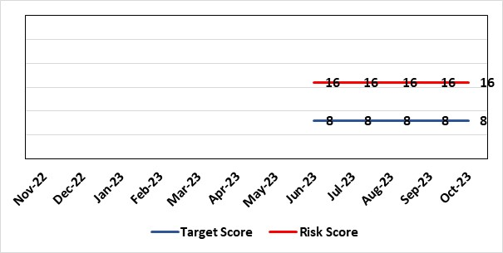 |  | Rationale for target score:  Consequences noncompliance for the Health Board will not change.  Addressing the oversight and Governance will reduce the likelihood of non-compliance.  The Risk Target Date reflects timescale for the MCA lead to take up position and the establishment of governance structures & processes.
Level of Control
=
Date added to the HB risk register
June 2023
Controls (What are we currently doing about the risk?) |  |  | Mitigating actions (What more should we do?)
- Director level responsibility confirmed in principle with the agreement to host the MCA / DoLS structure from April 2024. Head of Nursing MCA to continue to coordinate the various elements in the interim.  - Appointed a band 5 business manager and a band 6 professional development nurse 0.6 to support the coordination of the elements relating to MCA and support the service groups with application in practice.  - Agreement by the PCTSG Board in principle for PCT to host a combined MCA / DoLS team but not to include IMCA or Court of Protection at this point in time.  - Urgent support in practice is provided by the DoLS team lead and there are now three Best Interest Assessors in post to support increased monitoring of compliance and access to advice.  - Escalated and the Director of Nursing and Patient Experience has established a task and finish group to ensure any gaps in compliance are managed, the service is future proofed, and accountability agreed  - Core health board training remains in place. A review has demonstrated low compliance linked to the efficacy of the training to support the practical needs of front line staff. An all Wales benchmarking process showed training delivered in house to be more effective. The development of a training post will support delivery of training more flexibly to meet the needs of clinical staff.  - Corporate Head of Nursing is working with Corporate Governance and Service Delivery Group Governance leads to identify concerns, work to address these and ensure that those responsible for the local implementation of the MCA are aware of their responsibilities. |  |  | Action | Lead |  | Deadline
 |  |  | Agree a required structure with senior accountability for MCA and the DoLS service | Executive Director of Nursing and Nurse Director for PCTSG |  | 31st October 2023
 |  |  | Agreement of accountabilities and structure, an assessment to be undertaken of resource needs and funding options explored | TBC (Following structure agreement) |  | 17th November 2023
 |  |  | A review of training has been placed on the agenda for the MCA / DoLS / Subgroup of the West Glamorgan Safeguarding Board – Agreed to a regional approach to reviewing and planning MCA DoLS training | Head of Nursing MCA |  | 7th December 2023
Assurances (How do we know if the things we are doing are having an impact?)  - Corporate Head of Nursing will provide regular updates and reports to Mental Health Legislative committee including any highlighted concerns.  - The ongoing development work to ensure a robust MCA DoLS process will continue to monitor MCA compliance and provide operational advice and support to the service groups  - Reporting processes are via  - The Mental Health and Legislative Committee  - The safeguarding committee  - West Glamorgan Safeguarding Board |  |  | Gaps in assurance (What additional assurances should we seek?)  Policies, standard operating procedures, accountability and assurance not yet in place.  With LPS not being implemented during this parliament and no agreed future date likely, policies, standard operating procedures, accountability and assurance arrangements for the MCA to be confirmed via the task and finish group established.
Additional Comments / Progress Notes
- There has been an update from Government on 5 May 2023 advising that LPS (Liberty Protection Safeguards) will no longer be implemented during this parliament but Health Boards are required to have a robust MCA / DoLS system in place.
- The Service Delivery Groups need to be assured they are working towards embedding the Mental Capacity Act 2005 (MCA), into everyday practice.
- To safeguard vulnerable patients and protect the Health Board from complaints and potential litigation there needs to be clear lines of escalation and accountability
- Whilst the Act is a legal requirement, it is not yet well understood or embedded into clinical practice. Some concerns identified include, a tendency among health and social care staff to make assumptions based on impairment; failure to conduct assessments when necessary; the poor quality of assessments generally, and a failure to take into account the impact of specific conditions on assessment.
- The Board needs to be assured of the effectiveness of the MCA in practice with oversight, audit, and reporting mechanisms agreed from ward to board. This requires a dedicated MCA resource.
- Discussions have started on the overarching accountability for MCA within the organisation
- Cases remain managed by Corporate Governance and the Service Group Governance teams
- Advice and support in managing these comes from the DoLS lead
- Once in place, the MCA Lead post will support a regular meeting with Governance lead from all areas to develop systems to effectively track and manage cases across the Health Board. This will support reporting and monitoring of CoP work.
25.07.2023 - Discussions have begun with PCTSG to consider the DoLS team is extended with using the WG funding to an MCA/DoLS team with a dedicated MCA lead.
Some concern re the training and IMCA elements remain and so this would be managed in a phased way.
The resources available are limited and there is still an imbalance between the workload for DoLS applications and the resources available. A paper will be taken to the September Board of the PCTSG for consideration.
21.08.2023 - Discussions have been held with the directors of the primary care community and therapies SG to consider hosting an expanded MCA DoLS team to support governance and oversight. Agreed in principle, but will need to be discussed and formal agreement at the PCTSG board in September.
19.09.2023 - PCTSG Management Board meeting formally agreed to host an expanded MCA DoLS team with an MCA Lead to oversee the application of MCA practice.
Work will now begin to manage the service change.
31.10.2023 – The increase in resource in the team and the move towards and MCA / DoLS focus is identifying and supporting the HB with issues relating to MCA in practice. This is supporting patient flow and ensuring the rights of the most vulnerable are protected.

Datix ID Number: 3516  Health Care Standards: Standard 3.1 safe and clinically effective services |  |  | HBR Ref Number: 94  Risk Target Date: TBC |  | Current Risk Rating  4 x 5 = 20
Objective: Children, Young People & Maternity Services NEW RISK |  | BAF Ref: 3.6 | Director Lead: Deb Lewis, Chief Operating Officer  Assuring Committee: Performance and Finance Committee  For information: Quality & Safety Committee
Risk: CAMHS failure to meet required standards of performance  The CAMHS service is unable to meet the required level of performance due to workforce deficits in the team across all staff groups including medics, psychological therapies and nursing.  This is further hindered by poor data quality which presents a risk to reporting until validation is complete.  Links to other CAMHS risk register entries: (Ref: 3410/3373/3351/3346/3349/3350) |  |  | Date last reviewed: October 2023
Risk Rating  (consequence x likelihood):  Initial: 4 x 5 = 20  Current: 4 x 5 = 20  Target: 3 x 3 = 9 | 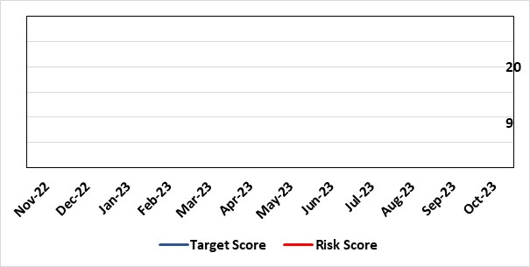 |  | Rationale for current score:  Current performance against the performance measures for CAMHS is poor. This translates into risk for patients as the service is unable to deliver timely access to assessment and interventions.
Level of Control  = % |  |  | Rationale for target score:  The rationale for the target score is linked to successful recruitment and more timely access to services for children and young persons which will reduce risk.
Date added to the risk register
October 2023
Controls (What are we currently doing about the risk?) |  |  | Mitigating actions (What more should we do?)
-Ongoing recruitment into all staff groups  -Use of temporary agency workforce in nursing at premium rates of pay to sustain current levels of performance  -Use of locum medical staff due to high vacancy level on medical workforce.  -Recent appointment into psychological therapies lead posts.  -Exploring fixed term appt of Band 5 psychological therapies support staff to improve performance |  |  | Action | Lead |  | Deadline
 |  |  | Continued efforts at recruitment | Acting Associate Service Director |  | Monthly review
Assurances (How do we know if the things we are doing are having an impact?)  -Monthly CAMHS Directorate meeting in place where performance and workforce are scrutinised  -Reporting into Weekly Business Team and MH & LD management board.  -Reporting into HB Performance and Finance Committee  -Ongoing validation of the waiting list to ensure robust reporting going forward |  |  | Gaps in assurance (What additional assurances should we seek?)
Additional Comments / Progress Notes
-Revised performance trajectories have been developed to reflect the reduced capacity within the service as a result of vacancies.

Datix ID Number: 3566  Health Care Standards: Governance & Accountability; 6.3 Listening & Learning from Feedback |  |  | HBR Ref Number: 95  Risk Target Date: 31/03/2024 |  | Current Risk Rating  4 x 3 = 12
Objective: Demonstrably Improved Quality, Safety & Reduced Harm |  | BAF Ref: 1 | Director Lead: Gareth Howells, Executive Director of Nursing  Assuring Committee: Quality & Safety Committee
Risk: Covid-19 Nosocomial Case Reviews NEW RISK  Failure to (effectively) complete the nationally mandated review of cases of nosocomial COVID-19 by the stipulated end date of the National Nosocomial COVID-19 Programme (NNCP), 31st March 2024, resulting in possible reputational damage and the cessation of funding prior to completion of the work. This risk is caused, in part, by uncertainty in relation to continued availability of appropriate staff capacity to meet the demands of the reviews. |  |  | Date last reviewed: October 2023
Risk Rating  (consequence x likelihood):  Initial: 4 x 5 = 20  Current: 4 x 3 = 12  Target: 4 x 2 = 8 | 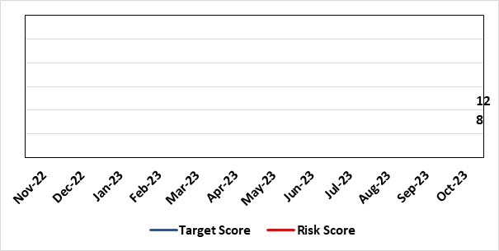 |  | Rationale for current score:  A reduced score from that which would have applied earlier in the Programme is put forward now as two approaches have recently been approved for the rapid and effective review of all cases in which no or low harm has occurred. This has enabled the successful consideration and closure of numerous cases, with particularly good progress reported in data relating to waves 1 and 3 of the pandemic. In turn, this has translated to a positive position against the NHS Executive trajectory for completion of the NNCP.
Level of Control  = % |  |  | Rationale for target score:  Reviews to continue at pace, with new approaches, referred to above, becoming slicker as they become practised. Application of the mitigating actions noted below will aid in proactively controlling activity which might, otherwise, distract from the processes of reviewing and communicating outcomes.
Date added to the risk register
October 2023
Controls (What are we currently doing about the risk?) |  |  | Mitigating actions (What more should we do?)
- Monthly data submission and highlight reports to the NHS Executive NNCP team;  - Workbook Review Process to determine outcomes for cases in which no harm has occurred.  - Triage Review Panels to determine outcomes for cases of no or low harm;  - Peer Review Panels to determine outcomes for cases of medium harm or above;  - Lessons identified reported via the Patient Stakeholder Experience Group;  - Recording progress and outcomes on Datix using set scripts and processes.  - Detailed Programme records kept to track progress, updates and notifications.  - Team processes documented, updated and shared to ensure consistency of approach. Rationale for approaches documented and approved by Executive, as required.  - Team communication channels which enable interim contact with patients/relatives monitored daily.  - Communication methods and content are adapted in response to feedback from the public / monitoring bodies.  - Programme timelines to ensure delivery targets are met at all stages of communication with the public are consistently monitored.  - Schedule of regular learning activity available to the team for development of skills specifically related to Programme.  - Input requested from specialist, multidisciplinary colleagues, as required, including IPC, medics, the patient feedback team and L&RS.  - Clinical Investigators appointed to undertake reviews are senior and experienced, affording a level of assurance across the Programme.  - Given the consistently difficult subject matter is considered by the Nosocomial COVID-19 Review Team, wellbeing is monitored which ensures that all team members remain able to work to an optimal level. |  |  | Action | Lead |  | Deadline
 |  |  | Review communication methods and content in response to feedback from the public | Business Manager (Nosocomial Review Team) |  | 31/12/2023
 |  |  | Develop the Nosocomial COVID-19 Review Team webpage to ensure the most up-to-date progress reports are available to the public | Business Manager (Nosocomial Review Team) |  | 31/12/2023
 |  |  | Develop and implement an action plan for dissemination of lessons identified to operational colleagues of all levels. | Business Manager (Nosocomial Review Team) |  | 31/03/2024
 |  |  | Adopt a process for the subsuming of nosocomial COVID-19 reviews into business as usual activity. This will need to consider all hospital-acquired COVID-19 infections occurring beyond the time remit of the NNCP, 30/04/2022. | Business Manager (Nosocomial Review Team) |  | 31/03/2024
Assurances (How do we know if the things we are doing are having an impact?)  - Consistent progress shown against NHS Executive trajectory for completion of the NNCP.  - Positive feedback from the NHS Executive.  - Positive feedback from patients/relatives.  - No take up of cases for investigation by the Ombudsman / Llais Cymru.  - Processes now in place relating to each of the many aspects of the Programme, including proportionate approaches for the review of varying categories of case.  - Reporting to various fora such as Management Board, Quality & Safety Committee, etc. is well-received. |  |  | Gaps in assurance (What additional assurances should we seek?)  The finite nature of the NNCP presents a risk for potential residual activity to occur following the disbanding of the NRT from end of March 2024. Due to the high number of cases requiring review, the full length of the Programme will be required for completion of the work meaning that Programme activity which instigates interaction with patients and families in the latter stages will pose the biggest risk in this regard. All patients/relatives who receive a review outcome from the Nosocomial COVID-19 Review Team are offered the opportunity to discuss this and to feedback on the process via a satisfaction survey, should they wish. A means of handling this contact from the public will be required beyond the Nosocomial Review Team being in post (31.04.2024)
Additional Comments
The risk is multifaceted in that each of the factors which could cause a delay to the progress of the Programme, thus lead to failure to complete all required reviews by 31st March 2024, carries its own risk, also. The following constitute some examples of this:

- Findings of review report a breach of duty which leads to qualifying liability resulting in reputational damage and/or financial impact.
- Distress caused to patients / relatives by communication of review findings/delayed communication of findings resulting in receipt of additional complaints and/or negative media attention.
- High take-up of offer to discuss cases with the team by patients / relatives resulting in a variety of concerns/queries raised, some of which are out of the scope of the nosocomial COVID-19 review resulting in high volumes of work for other Health Board teams who are already working to capacity.
- Failure to effectively disseminate lessons identified during NNCP reviews resulting in the continuation of practice which causes harm and which might, otherwise, be avoidable.
- Members of the Nosocomial Review Team seeking alternative employment due to the finite nature of the programme resulting in a need to re-recruit, and consequently, retrain.

Risk Score Calculation

For each risk identified, the LIKELIHOOD & CONSEQUENCE mechanism will be utilised. Essentially this examines each of the risks and attempts to assess the likelihood of the event occurring (PROBABLILITY) and the effect it could have on the Health Board (IMPACT). This process ensures that the Health Board will be focusing on those risks which require immediate attention rather than spending time on areas which are, relatively, a lower priority.

