


Meeting Date | 27th February 2024 |  | Agenda Item |  |  | 3.3
Report Title | Deep Dive Review of Suicide Prevention Quality Priority
Report Author | Jayne Whitney, Suicide Prevention Quality Improvement Lead
Report Sponsor | Gareth Howells, Director of Nursing and Patient Experience
Presented by | Jayne Whitney, Suicide Prevention Quality Improvement Lead
Freedom of Information | Open
Purpose of the Report | This report provides an update on progress against the Suicide Prevention quality priority to date, goals for the coming period and outlines how work to reduce the risk of suicide within our workforce will be incorporated into business as usual by 1st April 2025.
Key Issues | - Suicide Prevention became a health board quality priority in 2021.  - Work to reduce the risk of suicide within our population and workforce will be incorporated into business as usual processes from 1st April 2025.  - The final report on the Suicide Prevention quality priority will be brought to Management Board in July 2024.  - All of the Goals, Methods and Outcomes set out for achievement by 2023 have been achieved.  - Agreement needed with Workforce and OD to agree the future model of suicide prevention training within the organisation.  - Future model of Sharing Hope being developed based on an external evaluation of the impact of the programme  - Regional Partnership Board to lead on population health work to reduce the risk of suicide within our communities.
Specific Action Required  (Please choose one only) | Information | Discussion |  | Assurance | Approval
Specific Action Required  (Please choose one only) | ☒ | ☒ |  | ☒ | ☐
Recommendations | - Note management board are to attend a bespoke face to face Sharing HOPE event early 2024 date TBC.  - Note the Sharing HOPE team in revisiting and remodelling the service to create sustainable option by June 2024.  - Note the longevity of React & Suicide Prevention Level 1 Training.  - Note the future training model for Suicide Prevention.  - Note that service groups with a digital dashboard to offer continuity of monitoring of numbers trained & data under the remit of suicide awareness & prevention.

Quality Priority – SUICIDE PREVENTION

- INTRODUCTION

This report outlines progress against the Suicide Prevention Quality Priority, noting achievements and the focus of activity from 2021 – 2023 in order to embed the improvements into business as usual within the organisation. Therefore, all work streams are underpinned by a collaborative approach and will be presented within this report.

- BACKGROUND

Suicide Prevention become a quality priority in 2021 and a lead for supporting this work came into post in January 2022. The main function of the role was to implement a quality improvement approach across the health board. This was achieved by using the ‘Talk to Me 2-strategy’ structure and framework along with appropriate NICE guidelines across Swansea Bay Health Board and focussing on priority care providers, places and people.
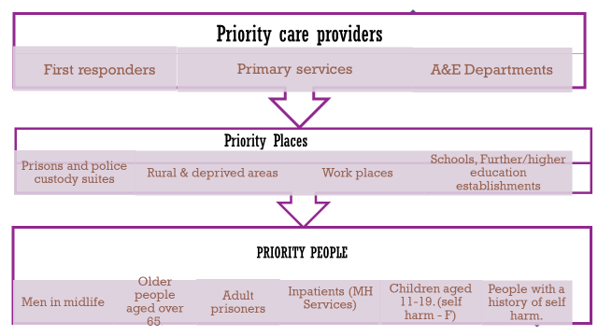
NHS STAFF – SUICIDE AND RISK OF MENTAL HEALTH ISSUES
Evidence on NHS staff post Covid found that an increase of mental health issues such as moral trauma, self-harm, anxiety, depression, burn out and stress leading to the risk of suicide. Research continues to suggest the rise of suicide amongst at risk groups such as female nurses, critical care workers and ethnic minority groups.
Nurse tried to kill himself after stress of Covid and 'daily threats of violence' became too much - Wales Online.
https://www.nursingtimes.net/news/mental-health/charity-shares-concerning-data-on-nurse-suicide-attempts-during-covid-19-21-06-2021/
Ethnic Minority Groups’ Experiences of Suicide Bereavement: A Qualitative Exploratory Study (suicidebereavementuk.com)
Stressed NHS staff in England quit at record 400 a week, fuelling fears over care quality | NHS | The Guardian

The focus of the work has been driven by identification of early signs of mental health issues within all our staff groups and targeting those most at risk. This has involved interventions based on compassion, anti-stigma, trauma informed support and normalising a culture based on open and transparent conversations, whilst encouraging our staff to reach out to each other and the population we serve. Awareness and prevention training has been based on knowing the signs, asking the question/having the conversation and becoming equipped with resources to signpost whilst keeping people safe.

Delivery of Quality Priority

Delivery of the quality priority to date has focussed on the following key areas:

- Reduction of the risk of staff suicide through promoting help-seeking behaviours.
- Increased awareness of the risk of suicide through delivery of training programme for health board staff.
- Contribution to the multi-agency working through the Multi-agency Group (MAG).

This has been led through a health board wide steering group, co-ordinated by the Suicide Prevention Quality Improvement Lead.

Key achievements to date include:

- Delivery of the Arts Council & Baring Foundation funded staff wellbeing project “Sharing HOPE – The Art of Healing Together”. Sharing HOPE has become an award-winning staff wellbeing initiative. Winning the SBUHB LOV award 2023 for improving lives through creativity. Finalists at the HSJ Patient Safety Awards 2023 for Staff wellbeing Initiative of the year. Finalist at the NT Workforce Awards 2023 for Best Employer for staff recognition and engagement and Winner at the NT Workforce Awards 2023 for Best Staff Wellbeing Initiative – commended highly by the judges for its holistic approach to healing and high levels of engagement.
- Collaborative approaches and working with SBUHB wellbeing services and Mental Health Learning and Development training team, in forums focussing on staff wellbeing based on the values of the health board and early identification regarding staff at risk of mental health issues and risk of suicide. Suicide prevention training in the delivery of React & Suicide Prevention & TRiM awareness (trauma response to individual staff and teams) Level 1. Accessible to all staff via face to face and teams. This includes a health board wide approach as well as bespoke sessions within priority places and people such as Emergency Department, Child Health & Primary care. Destigmatising mental health across our staff groups and our population with partnership working to deliver sessions with Time to change Wales. Both TRiM and Time to change Wales reaching the final of the NHS awards 2023. The relaunch of mental health for managers training. Having a wider lens over the referrals to staff wellbeing and data capturing staff having transparent and open discussions regarding suicidal ideation and sign posting for support.
- Engagement with priority places and people – QI project established at HMP Swansea.
- Continued working together with third sector and partnership working – presenting within platforms from a collaborative approach such as offering bespoke awareness and training to South Wales Police (SWP), which was influential in SWP exploring investment for police officers from an external training provider. Continued partnership relationships with Swansea Council transformation teams for community engagement.
- Engagement within public forums such as World Mental Health Day SBUHB community event, presenting at the Swansea PSB Safeguarding partnership event and vulnerable community groups such as Chat & Chai.
- A digital data system allowing for measures and outcomes updated on a monthly basis on all the main themes and projects that fall under the umbrella of suicide prevention.
- A digital resource hub accessible to all staff on Suicide Prevention established with resources from a 3c approach, including governmental information and strategies, cross-sectoral resources and third sector & voluntary organisations highlighting collaborative support networks both locally and nationally.

Table 1: GMOs set 2021/2022
A summary of progress against the individual actions to achieve the goals, methods and outcomes of the priority follows:

Goals | Methods | Outcomes | Progress
Aid suicide prevention | Multi agency approach | - Define governance structures to support quality priority.  - Task group to agree immediate priorities.  - Establish Quality Priority steering group.  - Engage with Multi Agency Group (MAG) regarding work programme. | - Completed 31/10/2021.  - Completed 08/06/2021.  - Completed 28/06/2021.  - Completed 31/10/2021.
Maximise the opportunities for early recognition of anxiety and depression, to prevent escalation to risk of suicide for staff | Early intervention and recognition of mental health issues & early referral to OH and wellbeing – staff wellbeing paramount. | Reduce triggers to staff overall sickness. Likely post Covid rebound with sickness/anxiety/moral trauma and long Covid. | - Base line data on wellbeing started 1/02/2022 & completed 15/06/2022.  - Improved data collection for wellbeing and parameters & methodology completed 1/6/2022.  - Sharing HOPE – the art of healing together commenced 17/02/2022. Official launch with film September 2022. Funding in place until 2024 - several projects underway in high-risk areas such as ITU & mental health in patient wards. Four Health Board wide events agreed during spring/summer.  - Data and methodologies/ outcomes completed for Sharing HOPE 1/06/2022
Educated Workforce to recognise the early signs & symptoms of an acute depressive illness.  Compassionate employer with recognition of suicide risk throughout all tiers of management and clinical staff | Initial baseline scoping exercise to ascertain learning and training needs for all front-line staff throughout Service Groups – this may require development/purchase of a specific educational package.  To source 2nd stage bespoke training that will assess suicidal risk. | Educate a workforce who can recognise early indicators of suicide & self-harm amongst the population we serve and staff groups. | - Mapping of training and outcomes completed 1.6.2022.  - Training proposal completed 16.06.2022 and identified a 3-tier approach to training.  - React and Suicide Awareness merged to create Tier 1 – React & Introduction to Suicide Prevention launched September 2022. 1088 staff members trained to date equating to 8.7% of workforce. Total trained in React & Suicide Prevention since 2021 is 4,914, (39.31% of workforce).
 |  |  | - Tier 2 – Safety planning/safety tools for qualified professionals. Piloted through slippage money £5000 March 2022 for 20 staff throughout Service Groups. Feedback & evaluation completed. Agreement is required on the future model of Tier 2 training within SBUHB.
 |  |  | - Tier 3 – Suicide Prevention/IMV Training - Specialist training for mental health professionals. Pilot study with y Caswell clinic for staff working with female services June 2023. Wider roll out to be agreed with Mental Health division & Q & S group for sign off following pilot study. Kim Liddiard leading on Level 3 training – awaiting timescales to be identified by MH & LD division.
Improve data collection on agreed baselines, parameters, and methodology. | Agreed parameters and data collection for:  - Suicide Awareness Training  - REACT Training  - TRiM  - Wellbeing Data on MH  - Time to Change Wales  - Sharing HOPE  - Bespoke events facilitated across health board for example world suicide prevention week.  - MH for managers training  - REACT & Suicide Prevention Tier 1 training across the health board & on the NQN induction. | Baseline data collection and dashboard to input date and retrieve each month for reporting. | - Completed process and dashboard developed 01/06/2022.
Development of communication and training plan for intranet | Utilising differing means of communication via the Department of Insight Communication and Engagement. | To highlight the priority within Swansea Bay Health Board and public domain. | Campaigns delivered and ongoing:  - React & Suicide Prevention Training  - Sharing HOPE – The art of healing together (SBUHB & public domain)  - Education week for World Suicide Prevention Day symposium.  - Screen saver on suicide prevention over Christmas and new year 2022  - Article published in Bay News Paper in December 2022.  - Time to Change campaign delivered by those with lived experience.  - Lunch & learn events for all Health Board staff.  - Close working with Mental Health Division  - Staff wellbeing, events calendar, and planning.

Table 2: The following GMOs for 2023/24
Goals | Methods | Outcomes | By whom | By When | Progress
Quality, Safety, and Improvement Intranet page for priority – Suicide Prevention | Quality & Safety intranet hub  Quality Priority page for Suicide Prevention | A central point for staff to access vital resources & communication regarding suicide prevention to support patients and staff wellbeing | Suicide Prevention Lead & | 31.03.2023 | Commenced 1/11/2022 and completed by 31/03/2023 with on-going editorial forum to keep resources up to date and relevant.
Business Case for Tier 2 Safety planning/safety tool training  Tier 3 Specialist suicide prevention training for inpatient care for mental health services. | Train the trainer programme of 8 trainers within Learning & development | To deliver level 2 training to enhance safety planning/safety tools for those at risk of suicide | Suicide Prevention Lead  Suicide Steering Group  SBUHB wide training & development teams | March 2023 to move forward during 2024/2025 | Commenced 1/10/2022 – Tier 2, Agreement required on future model of training for tier 2. A business plan for financial year 2024/25 with an aim to complete and recruit trainers. Business case stepped down due to financial pressures and lack of funding opportunities.  Tier 3 – Suicide Prevention/IMV Training - Specialist training for mental health professionals. Pilot study with y Caswell clinic for staff working with female services June 2023. Wider roll out to be agreed with Mental Health division & Q & S group for sign off following pilot study.
Priority People & Places - HMP Swansea Prison, Primary Care & Emergency Department | Identify a QI project at HMP Swansea.  Engagement in training with known priority places & people including ED, Child Service & Primary Care. | To reduce potential suicides within the high risk – people and places and males. | Suicide Prevention Lead  Suicide Prevention Steering group  Appropriate stakeholders within HMP prison | 1/10/2023 | Commenced 1/10/2022 – initial meetings but delayed due to new Governor appointment (in position by end of February 2023). QI project identified communication between transition points as people move within or out of criminal justice systems and continuum of sharing risk within services. This work will continue to progress as a QI project for 2024/25. Marie Phillips & stakeholders within Mental Health – this work will be required to report back into service groups Q & S structures.  Bespoke training has been delivered within ED, Primary Care and Child Health Services.
SBUHB Response Policy following death of staff member by suicide and family support and review of MH managers training | To create a response policy and working group to develop informative pathways of support | A policy that supports and navigates individuals and managers to seek support and help through the bereavement of suicide | Suicide Prevention Lead  Care after Death Team  Occupational Health & Employee Wellbeing Team. | 1/10/2023 | Commenced 1/10/2022 – working group in situ meetings organised with stakeholders February 2023. Meeting completed and outcomes were that existing policies are due for review and response pathways will be included as appendix and populated within documentation. – capturing current processes such as React, TRiM, SOP for Suicide Prevention for Managers. Wellbeing services will lead with input from suicide prevention lead in collaborative approach
Suicide Policy and best practice for SBUHB (Mental Health Division) | To produce a best practice policy for suicide prevention | To direct staff on best practice and evidence interventions. | Consultant Clinical Psychologist  Suicide Prevention Policy Working Group | 1/10/2023 | Dates provided and agreed to sit on steering group along with other stakeholders.  Completed with ratification in PRG 27/04/2023
3rd sector engagement with Neath & Swansea Voluntary services & wider voluntary platforms. | To engage 3rd sector organisations on mental health & suicide prevention | 3rd sector engagement with Mental Health Division & wider public domain within hospital sites for patients & staff | Suicide Prevention Lead  Hafal (Adferiad)  NPTB CVS  Swansea CVS  Quality Audit and Quality Improvement Service MH & LD division. | 2023/2024 | Partnership working and links identified. Suicide Prevention lead continues to participate a plethora of community-based events within the 3rd sector and voluntary organisations. There is currently work in situ from a wider public arena for suicide prevention within public health and DICE

Sharing HOPE: The Art of Healing Together

Sharing HOPE is an arts project across the Health Board available to all staff groups. Its aim is to highlight the power of sharing stories & capturing Covid recovery, moral trauma and destigmatising of mental health. Differing art forms can create an arena for healing from the impact of the Pandemic and can facilitate staff recovery. The project focuses on engaging with high-risk areas of care, which evidence notes as being female staff nurses, those working in high-risk environments and critical care workers.
The use of all kinds of art forms have allowed for a different way of working and engaging staff to tell their story in a way that is different to existing methods of organisational systems. Storytelling and the sharing of experiences within the recovery philosophy and research for those experiencing mental health difficulties is well founded. Hope remains the significant factor in both mental health and suicide prevention, which inspires peer conversations and creates feelings of “you are not alone”.
Sharing HOPE has had £85.800 in strategic funding over 3 years from The Arts Council of Wales and The Baring Foundation, as part of their Arts and Minds programme. This was based on research into the mental health benefits of engaging with the arts. The current costs of Sharing Hope, not including HB staff hours or external evaluators, are approximately £50k per year.

Initially it was hoped to engage with 100 staff through the project, we have surpassed this target to date 985 staff have engaged with Sharing HOPE since its launch in April 2022. There have been 116 engagement events across the health board. These include bespoke session, within high-risk environments, staff wellbeing events and World Suicide Prevention events across hospital sites and staff and community beach sculpture events which involved families of staff.
Bespoke areas for critical high-risk environments to date:
- ITU Morriston
- Mother & Baby Unit Tonna Hospital
- Ward B, C & D Neath Port Talbot Hospital
- Labour Ward
- Ward 12
- Ty Olwen
- Y Rhosyn
- Wellbeing & Occupational Health Team

Drop in events have been held for all staff at Neath Port Talbot Hospital, Morriston Wellbeing week, Morriston Library, and family beach days during the summer of 2023.

Engagement sessions:

The table below shows the number of engagement activities that have taken place, which highlights the range of work that has been undertaken.

The table below shows the number of engagement activities that have taken place, which highlights the range of work that has been undertaken since April 2022.

Month of Event | Number of staff engagements & venues
April 2022 | 50 people engaged with Sharing HOPE recording the poem for the launch cross sites.
June 2022 | 19 people engaged with Sharing HOPE event (NPT Hospital).
Aug 2022 | 21 people engaged across sites (NPT, Morriston, Cefn Coed, Tonna and Singleton Hospital).
Sept 2022 | 25 people attended the Sharing HOPE launch event (Taliesin Swansea Uni).
Sept 2022 | 77 World Suicide Prevention Day (WSPD).
Oct 2022 | 119 people engaged with Sharing HOPE (Patient Safety Congress (PSC) HB Wide on MS Teams.
Oct 2022 | 9 people engaged with Mother & Baby Unit, Tonna.
Oct 2022 | 21 people engaged with NPTSSG Professional Nursing Forum (PNF).
Nov 2022 | 25 people engaged with Sharing HOPE across sites (Morriston, Singleton, Community Services).
Dec 2022 | 27 people HB wide engaged with Sharing HOPE held at the Glyn Vivian Art Gallery. 1 staff member engaged with Sharing HOPE from Morriston Service Group.
Jan 2023 | 10 people engaged with Sharing HOPE (Tonna CMHT).
Feb 2023 | 11 people engaged with Sharing HOPE (ITU Morriston Hospital).
Mar 2023 | 31 people engaged with Sharing HOPE across sites (Morriston, Singleton & NPT Hospital).
April 2023 | 38 people engaged with Sharing HOPE across sites (Morriston, Singleton & NPT Hospital).
May 2023 | 118 people engaged with Sharing HOPE across sites (Morriston, Singleton & NPT Hospital).
June 2023 | 68 people engaged with Sharing HOPE across sites (Morriston, Singleton & NPT Hospital).
July 2023 | 38 people engaged with Sharing HOPE across sites sites (Morriston, Singleton & NPT Hospital).
Aug 2023 | 40 people engaged with Sharing HOPE across sites (Morriston, Singleton & NPT Hospital).
Sep-23 | 134 people engaged with Sharing HOPE across sites (Morriston, Singleton & NPT Hospital).
Oct-23 | 48 people engaged with Sharing HOPE across sites (Morriston, Singleton & NPT Hospital)
Nov- 23 | 56 people engaged with Sharing HOPE across sites (NPT Hospital & Swansea University)
Total amount of people engaged with Sharing HOPE = 985

The sharing HOPE team have identified several areas across the service groups and continue to focus on developing work plans with the teams involved. Discussions regarding health board wide events for the spring/summer 2023 are in situ.

Sharing HOPE HEALTH BOARD WIDE SERVICE GROUP PARTICIPATION

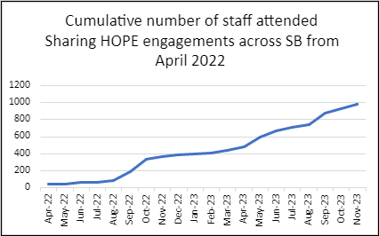

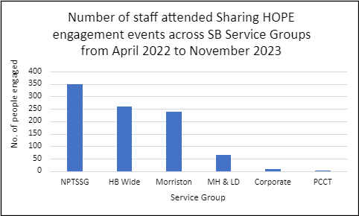

Evaluations
150 evaluations received since April 2022 – largest group is Nursing & Midwifery, which is reflective of the attendance within bespoke groups and captures high-risk areas such as ITU and female staff nurses and BAME.
4.78 out of 5 rating.
93 out of 150 evaluations were completed by Nursing & Midwifery Registered Nurses
135 women and 15 men.
106 of 150 stated they were English, Welsh, Scottish and Northern Ireland/white origin.
36 of 150 stated other ethnicity.
Key learning points
- Patients are our focus but without good wellbeing of our staff we cannot deliver the care and treatment that they need and within our vision of being a high-quality organisation.
- Evidence told us that post Covid, we were likely to see a rise mental health issue such as substance misuse, alcohol, anxiety, and depression. Since January 2022, there have been 1165 staff wellbeing referrals for mental health and 1523 initial assessments undertaken. Sadly, within certain risk groups there is a high risk of suicide. Six percent of all initial assessments showed staff had thought about suicide in the last 7 days and 3% had plans to end their lives. It has been difficult to establish and extract health board data on staff suicides as no one department holds this information. However, we are aware of staff suicides in 2022 and 2023.
- Sharing Hope is groundbreaking and a brilliant example of cross disciplinary and co-production between arts in health and quality improvement.
- Moral trauma and supporting staff is vital.
- Becoming an award-winning staff wellbeing initiative validates our approach and the challenge of staff wellbeing and reaffirms that now is the right time to be innovative in supporting the workforce and invest in Arts in Health.
- Sharing Hope is different from exiting sources of staff support in a way that reaches those that would not otherwise engage with support, in a way that feels accessible and non-threatening and reinforces a compassionate culture towards our staff. Staff have attended drop in events within wellbeing promotional events and bespoke sessions and have disclosed suicidal thoughts – these safe spaces have been imperative in becoming a gateway in navigating staff to the right support at the right time.
- We have found that the main cause of workplace stress is staffing issues, which also appears to be the main barrier to engagement.
- We have found in evaluations the highest percentage of methods to inform staff about engagement events has been via their managers and staff wellbeing services. (92 of 150 people from managers and 33 from staff wellbeing). The lowest percentage and showing the least impact has been through intranet and posters. (Out of the 150 evaluations only 5 staff saw it on the intranet and 2 via posters).

Lead Artist Virginia Hearth commissioned by Sharing HOPE has reflected on the bespoke session, working with high risk and vulnerable staff in the most challenging environments across the health board and has kindly shared a very personal account of her engagements with staff since April 2022.
“How do I help with all of this? I listen, and I respond with empathy. I make a space for people to open up and share how they feel. I help to normalise things by creating a shared experience for staff. Sometimes I come along just at the right time, and I just happen to catch someone before they fall. I enable people to feel seen and heard.
The arts can contain big feelings, and can express them and transform them into something more manageable. Oftentimes, the process of creating can help soothe distress, help reduce anxiety, and give people some breathing space in their busy and stressful days.
"You happened to be here just when I needed you. I did not know I was going to say all of this today. You have probably saved my life" is perhaps the most significant thing anyone attending these sessions has said directly to me.

Sharing HOPE was successful in winning the Best Staff Wellbeing Initiative at the Nursing Times Workforce Summit and Awards in London on 21st November 2023.

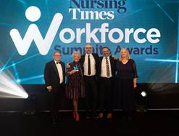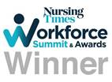
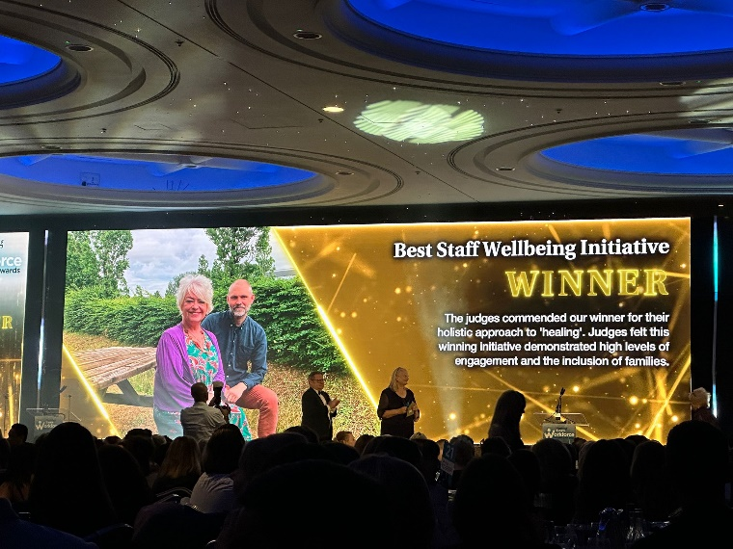
Sharing HOPE was also recognised as a finalist in the Best Employer for Staff Recognition and Engagement Category.
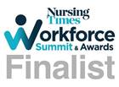
Next steps
- An external evaluation has started which includes a film which commenced in November 2023.
- There is 1 year left for funding, so a scoping exercise is underway to gain sustainable funding for sharing HOPE.
- Continue with three-tier approach including bespoke and open groups.
- Online virtual groups in next phase (this autumn & winter).
- Arrangements are in situ to present Sharing HOPE & activity to the Chair Board in January 2024.
- Sharing HOPE will present as best practice to the All-Wales Mental Health and Learning Disabilities- Quality Safety and Learning Group on 19th December 2023.

LAUNCH OF REACT (HOW TO HAVE A PSYCHOLOGICALLY SAVVY CONVERSATION WITH COLLEAGUES & SUICIDE AWARENESS & PREVENTION TRAINING.
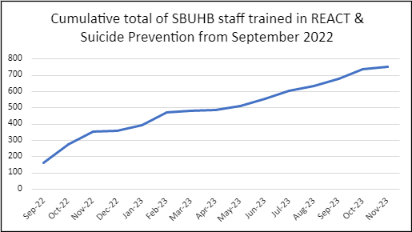

- Plans in situ for a deep dive evaluation of React & Suicide prevention training level 1 in January 2024.
- Recruited 4 new trainers for Suicide Prevention level 1 from Morriston Service group and Mental Health & LD for 2024.
- Bespoke sessions are now underway in Emergency Department as part of training days for the department and child health sessions continue into 2024.
- Primary care – Swansea GP cluster Suicide Prevention training held on November 29th 2023, where 49 Primary care professionals attending a bespoke training event. The organiser reported regarding the session “The feedback was hugely positive with the majority scoring the presentation Very Good and Excellent. We received no negative feedback and a lot of the free text comments said, ‘Thank you’ and that the information was very useful and helpful and will be shared with others who were not able to make it”.
The number of Attended REACT & Suicide Prevention Inductions for newly qualified nurses from October 2022 to November 2023 = 351

The total number of people attended REACT and Suicide Prevention training including inductions for newly qualified nurses from September 2022 to November 2023 = 1088

Total number of staff outcomes by Service groups from September 2022 to November 2023

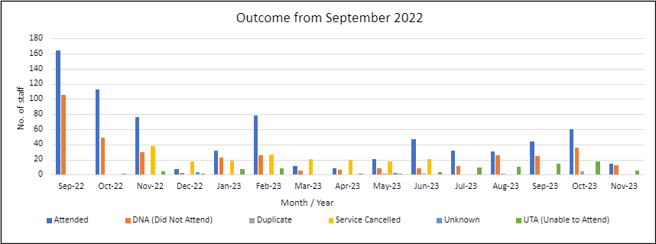

REACT & Suicide Prevention Trajectories
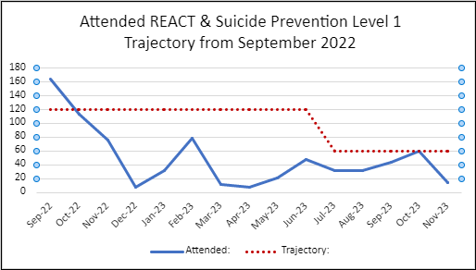

The attended REACT & Suicide Prevention Training trajectory chart from Sept 2022 to November 2023.

- Suicide Awareness and REACT Evaluations is now 71.
- Learning needs met - 4.90 out of 5 report training needs had been met.
- Trainers’ knowledge – rated 4.99 out of 5.
- 70 out of 71 staff evaluations have said that because of the training they are more confident to share knowledge about the support available for people experiencing suicidal thoughts.
- 68 out of 71 people reported they would now know how to support a colleague affected by mental health wellbeing.
- Feedback from asking if there were any improvements that could be made?
- “The training was very interesting and quite emotional at the end. Will remember this training”.
- “No need for any improvement. The training was very informative and had a powerful message”.
- “I think the only improvement would be more venues”.
- “Content was good and nice mix of interaction and presentation. Would be good to have further training tier 2 and 3”.
- “No suggestions as the training was excellent”.
- 35 out of 69 people report that post Covid has affected their mental health.

REACT TRAINING
Total number of staff trained up to Oct 2021 = 874
Training since Nov 2021 onwards is in the below chart = 2502
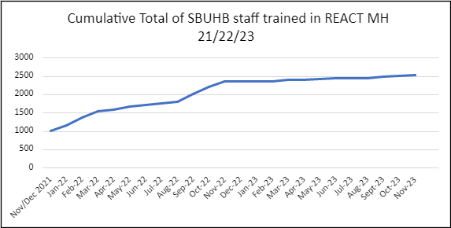

BASIC SUICIDE AWARENESS & PREVENTION TRAINING
Total number of staff trained up to Aug 2021 = 167
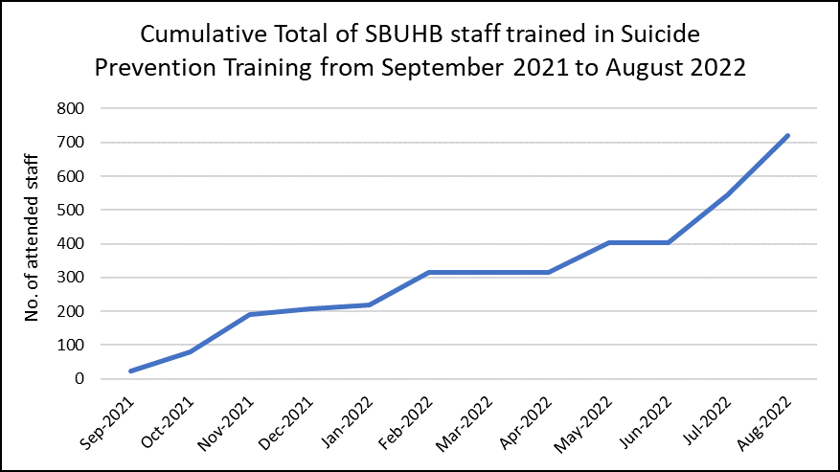
Training since Sept 2021 to Aug 2022 is in the below chart = 720

The React and Suicide Awareness Training combined in September 2022
4,914 of our staff have been trained in the recognition of the risk of suicide
730 staff attended REACT & Suicide Prevention Training from Sep 22 to November 2023
7 staff attended REACT & Suicide Prevention Training (Bespoke) Managers Pathway May 23
887 staff attended Suicide Prevention training including Nurses inductions from Oct 18 to Aug 22
351 newly qualified Nurses induction attended for REACT & Suicide Prevention from Oct 22 to November 23
2541 staff attended Bespoke REACT training from Oct 21 to November 23
263 NPT Primary care staff attended bespoke BT4L (Protective time by learning) Mar 23
49 Swansea Bay Cluster PLTS attended (Protective learning) Nov 23 Suicide Prevention Training
67 attended Child Health Bespoke session since June 2023
19 attended Emergency Department bespoke session since October 2023

The total number of staff attended training including newly qualified staff and bespoke sessions.
The number of Health Board Staff 12,500 this indicates approximately 39.31% of the workforce has received REACT and Suicide Prevention training.
REFERRALS TO WELLBEING
These questions were asked from January 2022
Total number of referrals for MH = 1665
Number of MH Initial Contact sessions delivered - 1523
Total staff reporting suicidal thoughts in past 7 days from March 2022 = 89 (This question was introduced to staff in March 2022).
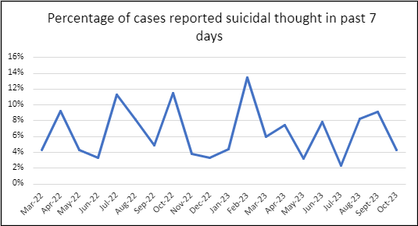
Total staff reporting plans to end life from January 2022 = 46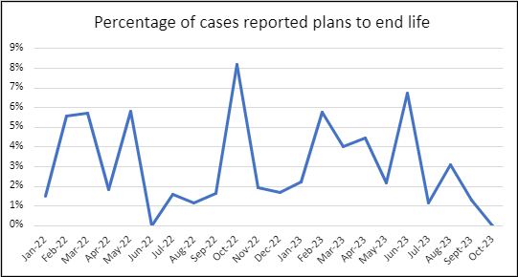
Due to the new Wellbeing & Occupational referral system – data for November is unavailable as there are issues on how to extract this information.
TIME TO CHANGE WALES
Total number of staff trained up to Aug 2022 = 231
Training sessions to commence September through to December 2022 (training sessions are sporadic in nature due to the training programmes available from time to change Wales)
From January 2022 – A total of 846 staff members have attended the Time to Change Wales sessions.
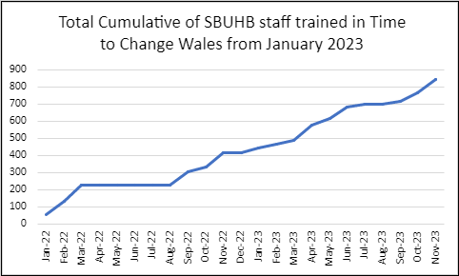
TRiM
70 TRiM supporters to date since July 2021
Since May 2023 there have been 23 TRIM responses. 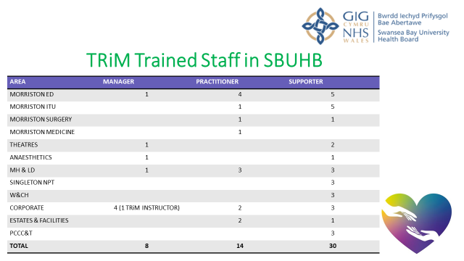

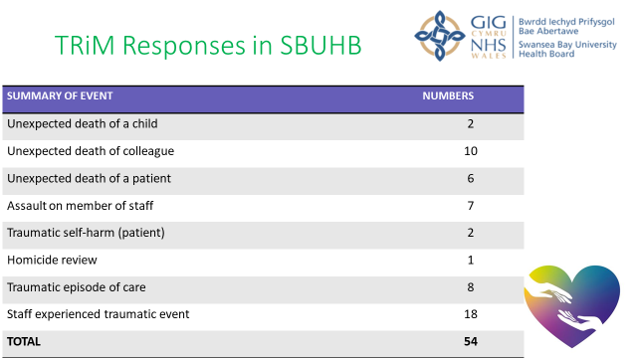

- GOVERNANCE AND RISK ISSUES

There are no specific governance risks noted at present. Risks to embedding & improvements noted within the report.

- FINANCIAL IMPLICATIONS

There is a funding requirement if Tier 2 Suicide Prevention Training is to be delivered externally.
External funding for Sharing HOPE expires in September 2024 and alternative funding will be sought once the final model is developed.

- RECOMMENDATION
- Note management board to attend a bespoke face to face Sharing HOPE event early 2024 date TBC.
- Note the Sharing HOPE team in revisiting and remodelling the service to create sustainable option by June 2024.
- Note the longevity of React & Suicide Prevention Level 1 Training.
- Note the future training model for Suicide Prevention.
- Note that service groups with a digital dashboard to offer continuity of monitoring of numbers trained & data under the remit of suicide awareness & prevention.

Governance and Assurance

Link to Enabling Objectives  (Please choose) | Supporting better health and wellbeing by actively promoting and empowering people to live well in resilient communities
Link to Enabling Objectives  (Please choose) | Partnerships for Improving Health and Wellbeing |  | ☒
Link to Enabling Objectives  (Please choose) | Co-Production and Health Literacy |  | ☒
Link to Enabling Objectives  (Please choose) | Digitally Enabled Health and Wellbeing |  | ☒
Link to Enabling Objectives  (Please choose) | Deliver better care through excellent health and care services achieving the outcomes that matter most to people
Link to Enabling Objectives  (Please choose) | Best Value Outcomes and High-Quality Care |  | ☒
Link to Enabling Objectives  (Please choose) | Partnerships for Care |  | ☒
Link to Enabling Objectives  (Please choose) | Excellent Staff |  | ☒
Link to Enabling Objectives  (Please choose) | Digitally Enabled Care |  | ☒
Link to Enabling Objectives  (Please choose) | Outstanding Research, Innovation, Education and Learning |  | ☒
Health and Care Standards
(Please choose) | Staying Healthy |  | ☒
(Please choose) | Safe Care |  | ☒
(Please choose) | Effective Care |  | ☒
(Please choose) | Dignified Care |  | ☒
(Please choose) | Timely Care |  | ☒
(Please choose) | Individual Care |  | ☒
(Please choose) | Staff and Resources |  | ☒
Quality, Safety and Patient Experience
The aim of the Suicide Quality Project is to aid suicide prevention underpinned by the Welsh Government Strategy Talk to me 2 and appropriate NICE guidelines.
- Educating a workforce to recognise the early signs & symptoms of an acute depressive illness.
- Compassionate employer with recognition of suicide risk throughout all tiers of management and clinical staff
- Educate a workforce who are able to recognise early indicators of suicide & self-harm amongst the population we serve and staff groups.

Financial Implications
As noted above
Legal Implications (including equality and diversity assessment)
None identified.
Staffing Implications
Staff Mental Health, Staff Suicide, Moral Trauma, absenteeism, presentism, and compassionate fatigue.
Long Term Implications (including the impact of the Well-being of Future Generations (Wales) Act 2015)
To continue to educate stakeholders on suicide prevention and awareness underpinned by the Welsh Governments Talk to me 2 Strategy:
- Local Health Boards & Local Authorities working in partnership with the 3rd sector, service users with lived experience, clinicians, and professionals.
- Focus on priority care providers, priority places and priority people.
- Knowing the signs, asking the question, and signposting to timely resources and support.
Report History |  | Management Board January 2024, Quality and Safety Committee February 2024
Appendices |  | None

