Swansea Bay University Health Board

Patient Experience
&
Concerns Report
Quarter 3 2025/26

CONTENTS
Report Summary | Page 2
Complaints | Page 5
Complaint Themes | Page 8
High Risk Areas | Page 13
Morriston Service Group | Page 24
Neath Port Talbot Singleton Service Group | Page 29
Mental Health & Learning Disabilities Service Group | Page 34
Primary and Community Service Group | Page 39
Medical Examiners Compliments | Page 44
Ombudsman Cases & Learning | Page 45

Report Summary and Overview
COMPLAINTS | Oct | Nov | Dec
Total number of complaints received | 255 | 204 | 197
Complaints acknowledged within set timescale | 100% | 100% | 100%
Number of re-opened complaints | 4 | 5 | 5
 | Aug | Sep | Oct
Complaints responded to within agreed timescale - formal | 43% | 45% | 54%
OMBUDSMAN | Oct | Nov | Dec
Number of Ombudsman Investigations received | 1 | 1 | 5
PATIENT EXPERIENCE | Oct | Nov | Dec
No. of Friends & Family surveys received | 6,332 | 5,565 | 5,070
Recommendation score | 91% | 92% | 92%
New Bespoke Surveys | 0 | 0 | 0
NATIONAL REPORTABLE INCIDENTS | Oct | Nov | Dec
Number of National Reportable Incidents reported | 10 | 6 | 13
Number of Never Events | 0 | 0 | 0

Successes | Priorities
Complaints;  - Concerns Redress Assurance Group (CRAG) meetings with Service Groups continue to be held.  - Bespoke training for complaints handling provided to Service Groups and specific areas at their request.  Patient Experience  - The overall satisfaction score for this quarter (Q3) is 92%. Feedback is collected through a variety of methods, including online surveys, paper-based questionnaires, SMS messaging, QR codes, Interactive Voice Responses, and BSL, supporting continuous improvement in the quality of care and patient experience.  - The National Maternity and Neonatal Surveys are now live. These surveys explore the mother's journey across five key phases of pregnancy and postnatal care. Maternity team reviewing the feedback, building action plans aligning learning to the themes identified. Monthly meetings are held to review the data and themes.  The National and Maternity survey results are being incorporated into the Maternity Beacon Dashboard for Wales. This will provide NHS Improvement and Performance with a comprehensive overview of patient experiences across the service.  - Work has been ongoing with digital services to populate the local Q&S dashboard with survey data. This is due to complete by the end of January. This will allow SBU staff to have an overview of patient experience in a quick and timely manner.  - Multi-Factor Authentication (MFA) has been introduced in Civica, our patient experience system, to strengthen overall security. MFA requires users to verify their identity using more than one method—typically a password plus a code sent to a mobile device. This reduces the risk of unauthorised access. All staff with Civica access have been informed of this change and supported with the setup process.  - Internal Audit has issued the final report, and we received a Reasonable assurance rating.  - As part of learning from the internal audit report, Action Manager is now being used to record all negative alerts received by the Patient Experience Department. Each comment is reviewed, and when patients choose to provide their contact details, an action is created and sent to PALS or the relevant department for follow-up. Teams update the action once they have spoken with the patient or family member, ensuring a clear and complete audit trail. If the conversation results in a formal complaint, it is recorded in the Datix Complaints Management System. The corresponding Datix reference number is then added to Action Manager. | Complaints;  - As part of the Listening to People Guidance that will be implemented on the 1st April 2025, ongoing discussions with Service Groups are being held. Test of Change processes being undertaken for Singleton Neath Port Talbot and Morriston Service Groups.  - Attendance continuing at the national implementation group regarding the Listening to People Guidance.  - Complaints within Service Groups currently being managed under the Putting Things Right Guidance are being actively reviewed with the assistance of Corporate Services with the aim of responding to this category of complaints prior to the implementation of the Listening to People Guidance April 2026.  Patient Experience;  - The People’s Experience Framework self-assessment toolkit has been circulated to the Service Group Nurse Directors for completion. Four of the five Service Groups have populated and returned the toolkit. The next step is to work with DICE to develop a master version, which will inform the action plan supporting A Healthier Swansea Bay – Updated Organisational Strategy and bring together all elements of the All Wales People’s Experience Framework.
Opportunities | Risks & Threats
Complaints;  - Workshops held with Service Groups to provide guidance and allow discussion on the implementation of the Listening to People Guidance being implemented 1st April 2026.  - Complex Case Management documents received, presentation provided by The Head of Safety & Learning at Once for Wales at the Patient & Safety Group January 2026.  Patient Experience;  - At present, three national surveys are planned for delivery in Q4, with up to six additional surveys likely to take place in Q1 and Q2 of 2026/27. To support this activity, local Task and Finish groups will be formed. | Complaints;  - The increase in complex complaints being received  - Number of overdue complaints exceeding the 30 day timescale being processed under the current Putting Things Right guidance  - Increase in complaints being received when the new Listening to People guidance is implemented in April 2026.  Patient Experience;  - A new version of the national Beacon dashboard is being developed. Swansea Bay UHB is supporting the process by validating the data to ensure accuracy before the dashboard goes live across Wales.

- COMPLAINTS

1. Complaints performance –
The Health Board is committed to supporting patients, relatives, and carers in resolving their concerns. Our service is visible, accessible, and impartial, with every issue taken seriously. Our aim is to provide compassionate , empathetic , honest and open responses in a way that can be easily understood by the recipient.

1.1 Total complaints received

The Health Board received 656 complaints in quarter 3 (Q3) of 2025/26 (October, November, December). This compares with 639 complaints in quarter 2 (Q2) of 2025/25 (July, August, September). As shown in the graph, fewer complains were received in December which is impacted on the overall total for Q3, this is a reoccurring trait for the month of December due to Christmas. This total includes complaints received and managed via either formal, early resolution and any re-opened complaints. Graph 1 provides a long-term view of complaints received per month.
Graph 1: Total number of complaints per month

Graph 2: Formal v Early resolution complaints per month

Graph 2 (above) shows complaints dealt with via the Formal Putting Things Right (PTR) investigation process compared with those dealt with via the early resolution investigation process, over the same period. We continue to deal with a higher proportion of complaints via the formal process, this is due to the tight timescale of two working days for early resolution complaints. Any early resolution complaint that is not resolved within two working days, will convert to a formal following guidance issued by Welsh Government.
1.2 Complaint responses within agreed timescale
Whenever a complaint is managed through the formal PTR process, the Health Board is required to investigate the complaint and write to the complainant with our findings, within 30 working days. If this target is not achievable, it is essential that the complainant is kept up to date throughout and any delays are explained.

1.2.1 Formal Investigations
The Health Board’s internal target is to respond to at least 85% of formal complaints within the agreed timescale. Welsh Government also issue a target for all Health Board’s to achieve at least 75% each month.

Graph 3 shows the Health Board’s performance in responding to complaints since November 2024. The Health Board performance for October 2025 was 54%.

Graph 3: Percentage of formal complaints responded to within agreed timescale

1.3 Overdue complaints

The Service groups are actively working to reduce the number of complaints that have exceeded the 30-working day timescale which is a recommendation timescale within the ‘Putting Things Right Guidance on dealing with concerns about the NHS 2011.’

The Corporate complaints team monitor the overdue complaints and send out bi-weekly reports to each Service Group requesting updates.

1.4 Re-opened complaints
The Health Board aims to resolve all complaints within the first response however, there are times when the complainant remains dissatisfied or needs further clarification. If the complainant writes back to the Health Board expressing their dissatisfaction, the correspondence will be reviewed by the Corporate Complaints Team and a decision made in conjunction with the appropriate Service Group as to whether the complaint should be re-opened. This may be when the complainant feels not all issues raised in the initial complaint have been addressed or if a meeting is required.

Graph 4 shows the number of re-opened complaints per month since January 2025.

Graph 4: Number of re-opened complaints by Service Group per month

The number of re-opened complaints appears to have decreased. The ethos for any complaint investigation is ‘Investigate once, Investigate well’.

2. Complaints Themes

2.1 – Themes - Health Board overview
Every complaint received by the Health Board is coded in the Datix Once for Wales system against the relevant subject codes. This allows the Health Board to identify any themes in the complaints received.

Table 1 provides a breakdown of complaints received by primary subject code in Q3 2025/26 compared with Q2 for 2025/26.

Table 1: Complaints by primary subject
Subject/Theme |  | Q2 2025/26 | Q3 25/26
Communication Issues |  | 79 | 117
Appointments |  | 75 | 93
Clinical treatment/Assessment |  | 161 | 147
Admissions |  | 46 | 31
Attitude and Behaviour |  | 63 | 51
Medication |  | 30 | 24
Test and Investigation Results |  | 43 | 41
Referral |  | 28 | 28
Discharge Issues |  | 32 | 35
Environment/Facilities |  | 6 | 17
Monitoring/Observation Issues |  | 23 | 21
Equipment |  | 3 | 8
Personal Property/Finance |  | 1 | 3
Assault |  | 1 | 0
Confidentiality |  | 4 | 0
Consent |  | 6 | 1
Record Keeping |  | 1 | 1
Access (to Services) |  | 7 | 11
Accident/Falls |  | 5 | 3
Catering |  | 1 | 5
Cleanliness |  | 1 | 0
Infection Control |  | 4 | 3
Nutrition/Hydration Issues |  | 4 | 2
Other |  | 1 | 2
Patient Care |  | 1 | 0
Resources (lack of staff) |  | 6 | 10
Skin Damage |  | 0 | 0
Privacy and Dignity |  | 0 | 0

Top theme; Clinical Treatment;
During Q3, 214 complaints were received regarding clinical treatment. A breakdown of the sub-subjects are below – please note, some complaints include more than one of these issues.
What we are doing about this?
- Continuous Flow Model to help reduce delays and improve patient and staff experience.
- Emergency Department redesign to improve patient flow
- ‘Your Next Patient’ introduced in Morriston Hospital to improve patient flow and ambulance waiting times
- Welsh Government Insourcing initiative to help reduce waiting times for first appointments
- Emergency Department. Patient Experience feedback for Quarter 3. The wordle below highlights in green mainly positive comments for ‘Professional and Competent’ while the negative red comments are relating to ‘Waiting’.


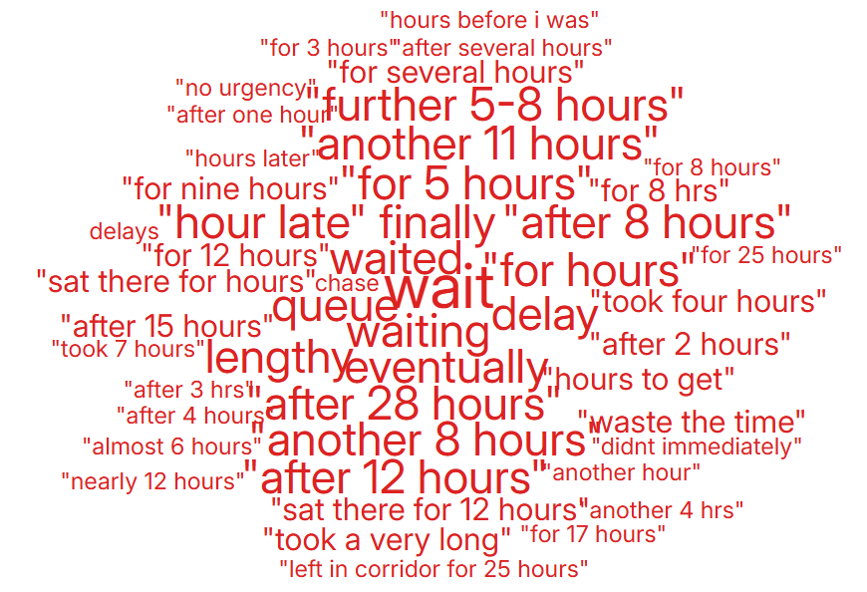
Clinical Treatment;
Delay/Lack of diagnosis | 22
Delay/Lack of treatment or Assessment | 128
Incorrect diagnosis | 20
Incorrect/insufficient treatment or Assessment | 74
Reaction to procedure/ treatment | 32

Theme 2; Communication;
Communication Improvement Plan;
- Training during consultant development programme where the importance of good and clear communication is discussed.
- Complaints/communication training sessions delivered by the Corporate team to Service Groups – this training is ongoing
- Bespoke training provided to Service Groups and specific departments on complaints which includes communication
- Reminders in CRAG meetings of the importance of clear communication and regular meaningful updates to complainants or patients

- Outpatient Department – Quarter 3 – Wordles related to communication were all positive. Please see comments below.
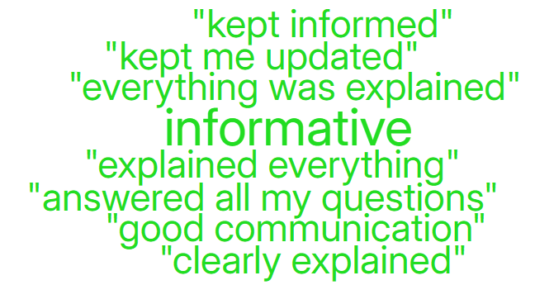
- Morriston hospital were all very helpful and attended to my and other patients’ needs to a very high standard and worked very well as a team.

- The doctor explained everything to me.

- The staff were so helpful, and friendly and the consultant explained everything in detail 10 out of 10.

- Everything went really smooth. from the start to the end. Nurses and staff very helpful and nice. Doctor explained everything really clearly and nice.

During Q3, 183 complaints were received relating to communication. A breakdown of the sub-subjects are below – please note, some complaints include more than one of these issues.
Communication Issues;
Insufficient/Incorrect information | 141
Communication with family | 25
Communication with patient/service user | 24
Communication with External Agencies or Other NHS Organisations | 10
Communication between Services/Departments | 5

Theme 3; Appointments;
What we are doing about this?
- Outsourcing of patients to other Healthcare providers to help reduce waiting times.
- Rapid Diagnostic Centre expansion.
- Expansion of our virtual wards to widen the range of disciplines involved, so increasing the number of patients who can be treated appropriately out of hospital
- Re-location of Phlebotomy clinical area in Singleton Hospital due to the dissatisfaction expressed by users of the services.
All Wales questions do not have ‘appointments’ as a question set. Therefore, as an alternative a search was undertaken on the words delay/delays/appointment.
Below are the Quarter 3 comments we received regarding Phlebotomy appointment arrangements. Many of these relate to the recent move into a smaller space. All feedback has been taken into consideration, and the Phlebotomy service at Singleton has now moved to a more appropriate, improved area.
- The place for blood test is totally unsuitable. No parking, no seating, no privacy, very stressful.
- Relocated blood test facilities are not appropriate for the service. Poor waiting area and not enough space for the staff.
- The department is now in a small room is not fit for purpose and surely not medically safe.
Below are some comments relating to ‘appointments’ for Adult Mental Health in Quarter 3.
- “Orchard centre. Been waiting about a year for my first appt. They said I’d missed an appt, but I did not. Now I must go back through GP. That’s not good. I need to be seen.

- “I’ve heard nothing further from the diagnosis. I am currently having counselling. My GP has heard nothing either. I’m wanting next steps after diagnosis.

- “Clinic was running late”

During Q3, 101 complaints were received regarding appointment issues. Many of these complaints will have more than one sub-subject, see breakdown below;
Appointments;
Delay in appointment/waiting time/transport | 64
Patient lost to follow-up | 19
Appointment cancelled | 10
Location of appointment unsuitable | 4
Capacity of clinics | 3
Cancelled appointment/transport | 2
Continuity of staff | 1
Patient booked into wrong outpatient clinic | 1

- HIGH RISK AREAS

As part of the Health Board’s focus on Urgent Care, Planned Care and Cancer Services the following section highlights complaints received in:
- Orthopaedics
- Emergency Department (ED)
- General Surgery
- Cancer Services
- Mental Health
Graph 1 below shows the number of complaints for each of these areas received per month since January 2025.
Graph 1: Complaints per month
As shown in the graph, there have been no complaints for Cancer Services for the whole of 2025. A breakdown of the issues raised within the other services during Q3 can be found below;

3.1 – Orthopaedic Complaint themes

Patient Experience Feedback: Orthopaedic Services
As Orthopaedics is classed as a ‘High Risk Area’, the Patient Experience Team reviewed the feedback for Orthopaedic Services. In Quarter 3, the service received 1,346 Friends and Family Survey responses and achieved an overall score of 93%. This is a slight increase in ‘very good’ ratings compared to Quarter 2, when the figure was 92%.
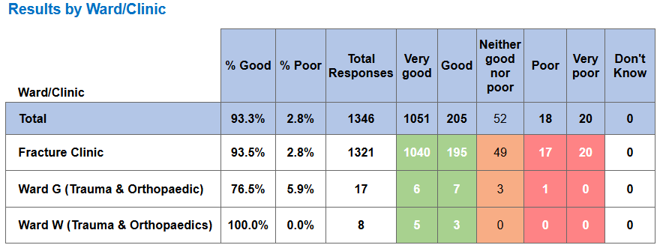

Top themes for Orthopaedic services:
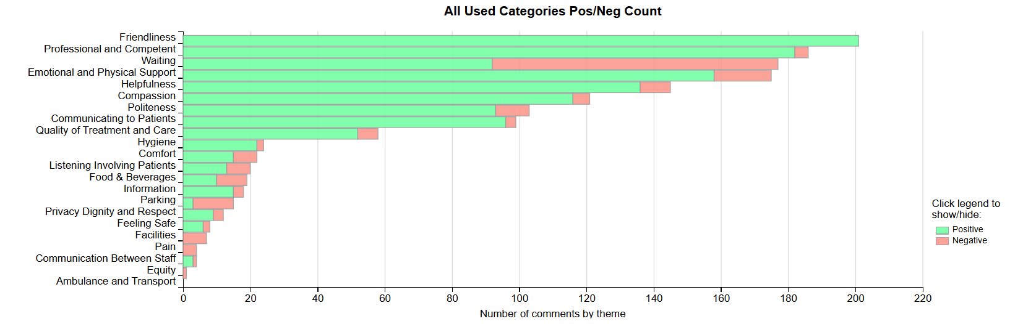
Positive Themes
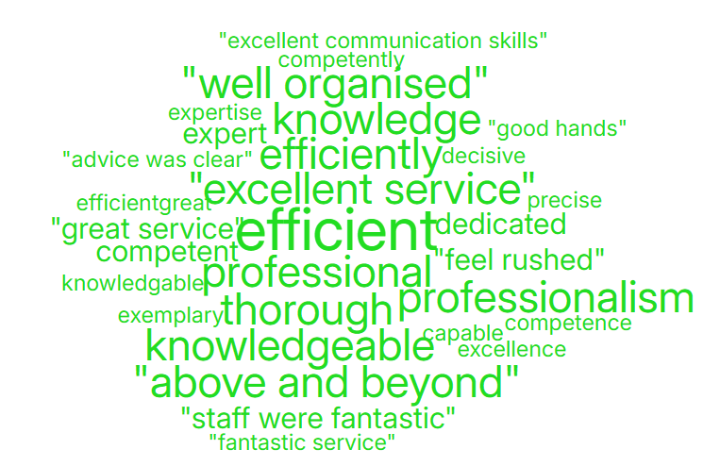
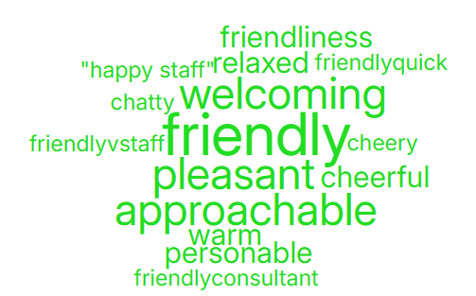
‘Professional & Competent’ ‘Friendliness’

Negative Themes
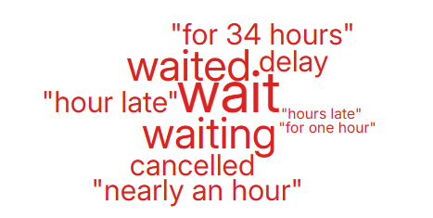
‘Waiting’ ‘Emotional & Physical Support’
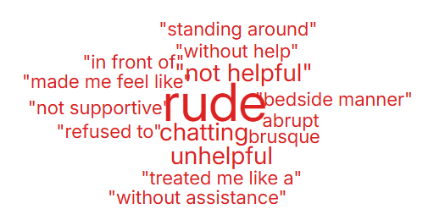

3.2– Emergency Department (ED) Complaints
During Q3 of 2025/26, ED received 41 complaints, this compared with 36 during Q2, a breakdown of the issues raised in Q3 is below;

The 23 ‘clinical treatment/assessment’ complaints mainly relate to delays in treatment or assessment.

Patient Experience Feedback: ED Services
As ED is classed as a ‘High Risk Area’, the Patient Experience Team has reviewed the feedback for ED Services. In Quarter 3, ED received 830 Friends and Family Survey responses, with an overall score of 71%, showing a slight drop in ‘very good’ ratings compared to Quarter 2, when the score was 72%
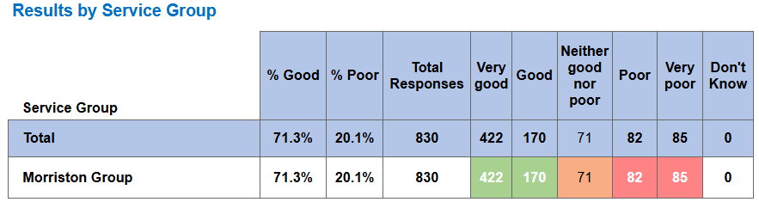

Below are the top themes for ED services:
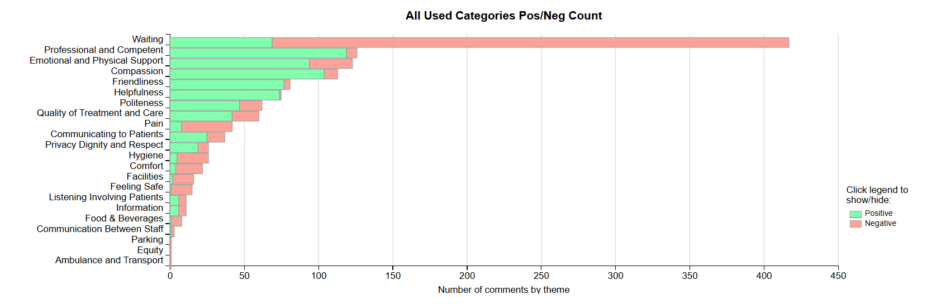
Positive Themes

‘Professional & Competent’ ‘Compassion’
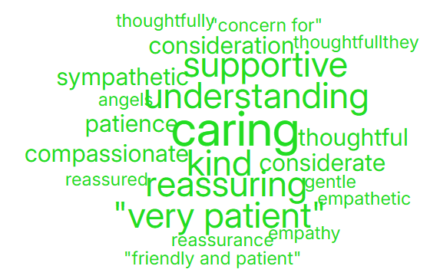
Negative Themes
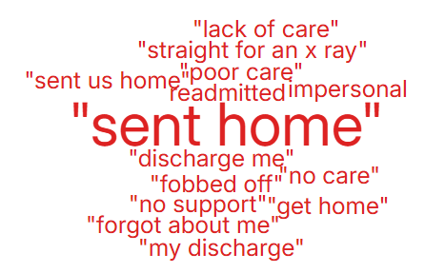
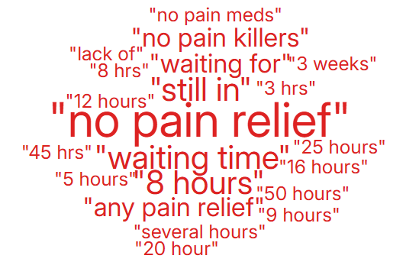
‘Pain’ ‘Quality of Treatment & Care’

  - – General Surgery Complaints
During Q3 of 2025/26, General Surgery received 29 complaints, a breakdown of the issues is below;

Patient Experience Feedback: General Surgery
As General Surgery is classed as a ‘High Risk Area’, the Patient Experience Team have reviewed the feedback for General Surgery. In Quarter 3, the service received 634 Friends and Family Survey responses and achieved an overall score of 98%. This is a slight increase in ‘very good’ ratings compared to Quarter 2, when the figure was 97%.
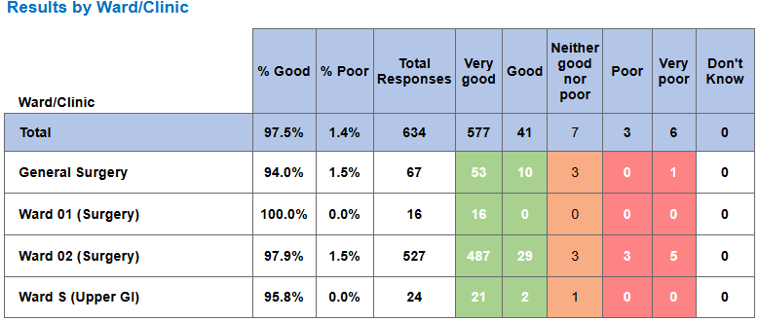
Below are the top themes for General Surgery services:
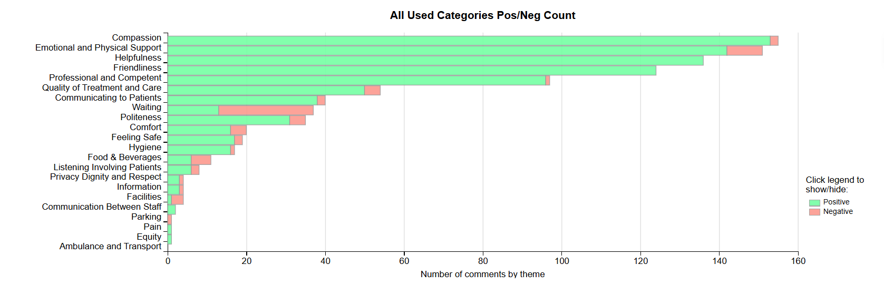
Positive Themes

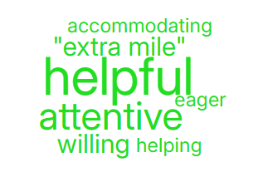
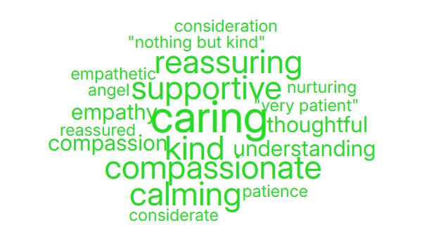
‘Compassion’ ‘Helpfulness’

Negative Themes
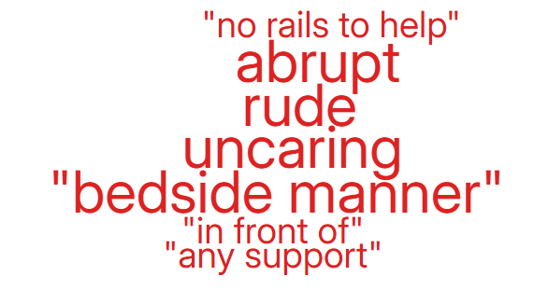
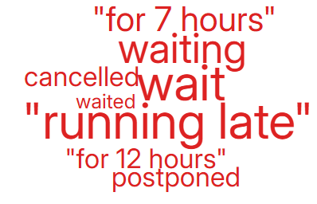
‘Waiting’ ’Emotional & Physical Support’

Cancer Service Complaints
As shown in graph 1 above, there were no complaints relating to cancer services for the whole year of 2025.

Patient Experience Feedback: Cancer Services
As Cancer is classed as a ‘High Risk Area’, the Patient Experience Team reviewed the feedback for Cancer Services. In Quarter 3, the service received 764 Friends and Family Survey responses and achieved an overall score of 95%. This is a slight increase in ‘very good’ ratings compared to Quarter 2, when the figure was 94%.
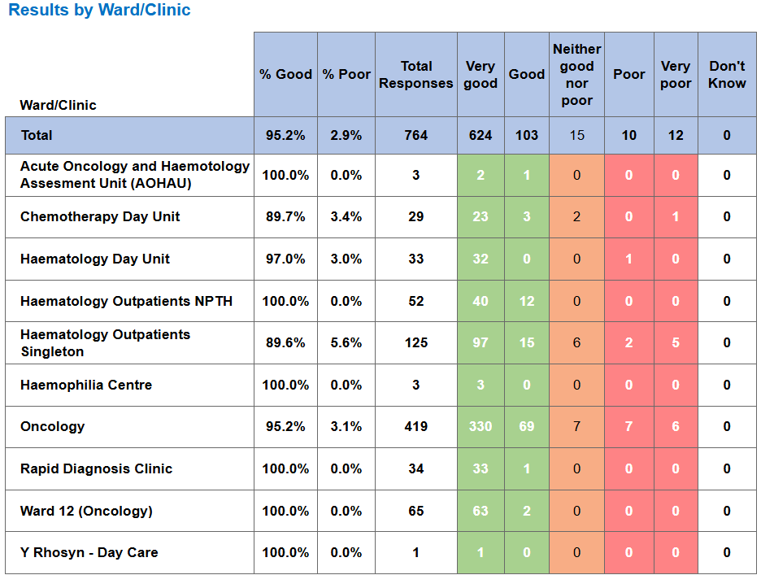
Below are the top themes for Cancer services:
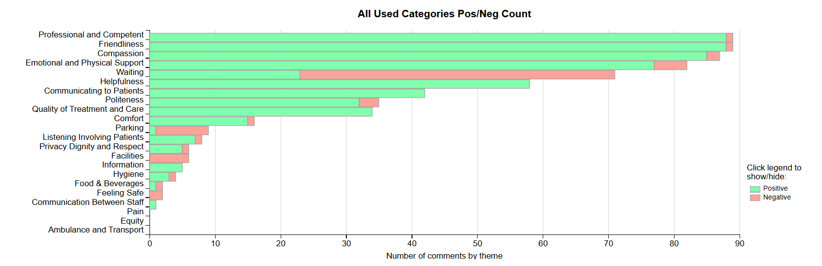

Postive Themes
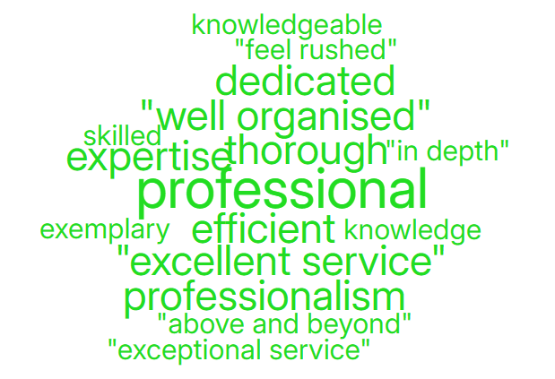
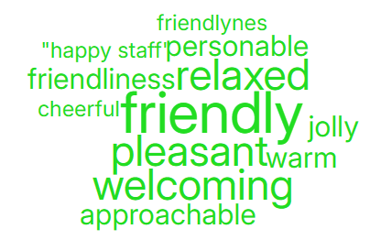
‘Friendly’ ‘Professional & Competent’

Negative Themes
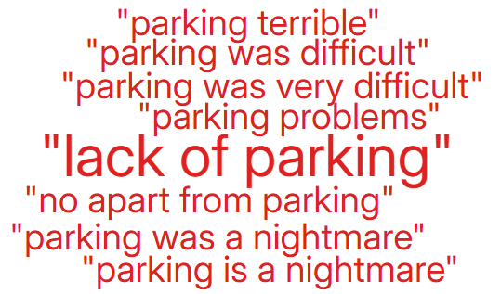
‘Waiting’ ‘Parking’
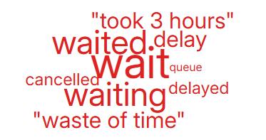

3.4 Mental Health Complaints
During Q3 of 2025/26, Mental Health received 89 complaints, a breakdown of the top 10 areas these relate to is shown below;

Also below is a breakdown of the issues raised within these complaints;
Communication Issues (including Language) | 19
Monitoring/Observation Issues | 18
Appointments | 15
Clinical treatment/Assessment | 10
Attitude and Behaviour | 8
Discharge Issues | 5
Medication | 5
Referral | 3
Patient Care | 2
Record Keeping | 2
Admissions | 1
Nutrition/Hydration Issues | 1

Patient Experience Feedback: Mental Health
For our Mental Health feedback, we primarily utilise a Service/User/Carer survey that is designed to be more user-friendly. In Quarter 3, we received 334 responses, with an overall satisfaction score of 99% for the question, "Overall, how was your experience?"
Additionally, we received 2 Friends and Family responses, resulting in an average score of 50%.
Below are the top themes for Mental Health services:

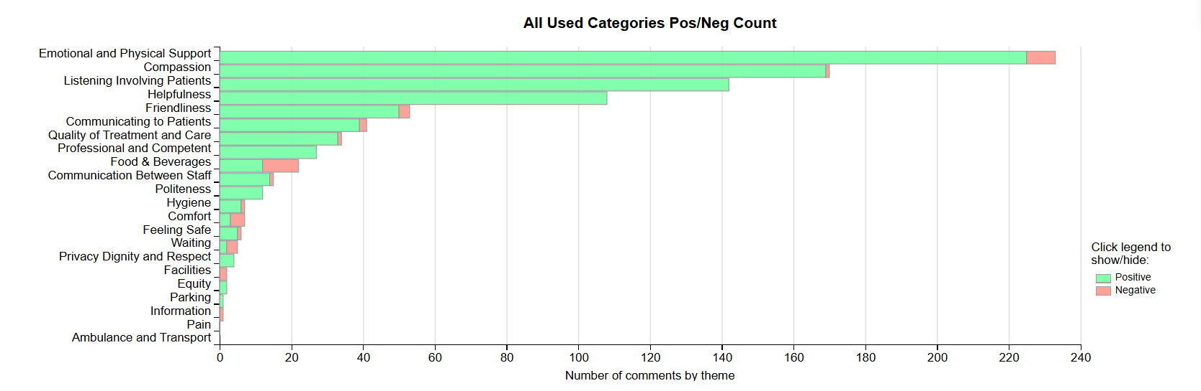

Themes - Positive
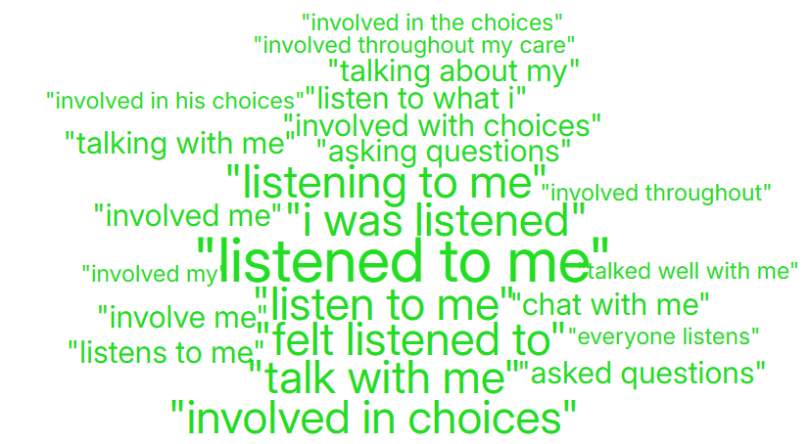
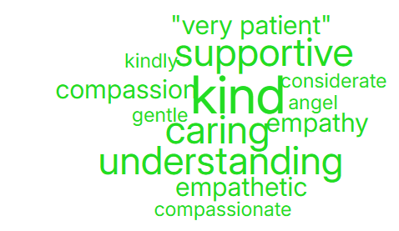
'Compassion' 'Listening & Involving patients'

Negative Themes
‘Emotional & Physical Support’ ‘Food & Beverages’
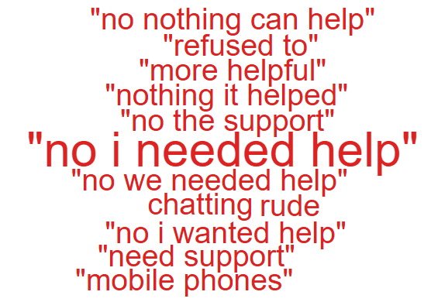
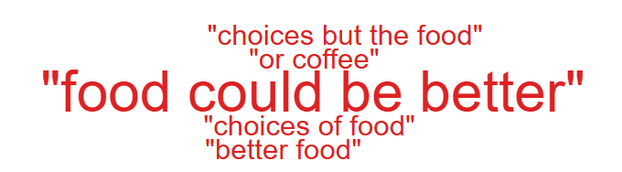

- SERVICE GROUP COMPLAINTS, INCIDENTS, COMPLIMENTS AND PATIENT FEEDBACK HIGHLIGHTS

MORRISTON SERVICE GROUP
4.1 – Morriston Service Group complaints
Morriston Service Group received a total of 293 complaints during Q3 2025/26, this compares with 264 complaints during Q2 2025/26. There appears to have been an increase in September and October compared with previous months which is explained below in Graph 2. Graph 1 below shows the total number of complaints received relating to Morriston Service Group since January 2025. The graph breaks the total number received down by Formal Putting Things Right, Early Resolution and Re-opened complaints.
Graph 1: Morriston Service Group complaints by month and type

Graph 2 shows the top five services that had the most complaints since January 2025.

Graph 2: Top 5 Services by month

As shown in the graph, there appears an increase in Phlebotomy complaints in October which would contribute to the overall increase to Morriston complaints received in Q3. This has been addressed and action has been taken to improve patient experience.
4.2 – Morriston Service Group Incidents
Morriston Service Group reported 2395 incidents in quarter 3 (Q3) of 2025/26 (October, November, December). This compares with 2373 incidents in quarter 2 (Q2) of 2025/26 (July, August, September) Graph 1 shows the number of incidents per month broken down by severity.

Graph 1: Morriston Incidents by Severity and month

Graph 2 shows the top 5 incident types, of all incidents reported by Morriston Service Group since October - December 2025.
Graph 2: Top 5 incidents per month

4.3 – Morriston Service Group National Reportable Incidents
Morriston Service Group reported 15 Nationally Reportable Incidents (NRI’s) during Q3 2025/26, this compared to 3 being reported during Q2 of 2025/26. Of the NRI’s reported, 4 x Pressure Ulcers, 4 x Falls, 1 x Misreported Scan, 1 x Goblet Cell Carcinoma, 1 x Wrong pathway, 1 x Unexpected re-attendance to the emergency department / minor injuries, 1 x Failure to follow up a missed appointment by a patient/service user, 1 x Reports - failure/delay to receive and 1 x Dermatology patient lost to follow up.
Graph 1: Nationally Reportable Incidents reported per month by Morriston Service Group

4.4 – Morriston Service Group Compliments
Morriston received 101 compliments during Q3 of 2025/26. Graph 1 shows the number received per month since January 2025.
Graph 1: Morriston compliments per month

Graph 2: Morriston compliments – Top 5 Services

4.5 Morriston Service Group Patient Experience Feedback
Overall, during quarter 3 there were 112,094 is this number of patients seen under Morriston Service Group (This includes Emergency Department and Minor Injury Unit).

There were 8,815 Friends and Family survey returns which equates to 8% responding to the survey. Out of the 8% who responded, 90% of people stated they would highly recommend the Health Board to Friends and Family.
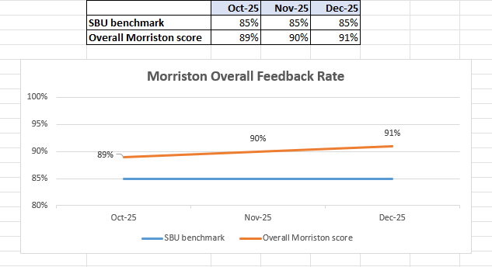

Below are the number of responses in a line graph:

Below are the main themes mentioned for Morriston:
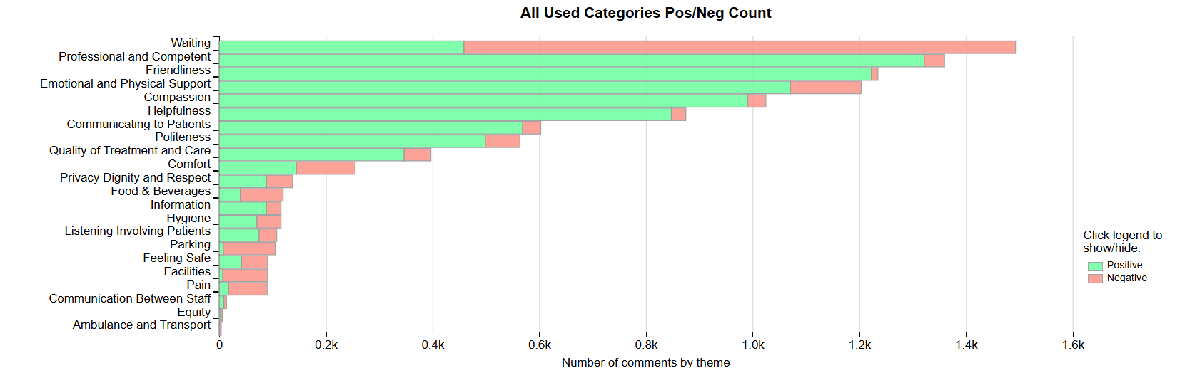

NEATH PORT TALBOT SINGLETON SERVICE GROUP
4.6 – NPTSSG Complaints
NPTSSG received a total of 185 complaints during Q3 2025/26 which compares with 193 complaints during Q2 2025/26. Graph 1 below shows the total number of complaints received relating to NPTSSG since January 2025. The graph breaks the total number received down by Formal Putting Things Right, Early Resolution and Re-opened complaints.

Graph 1: NPTSSG complaints by month and type

Graph 2 shows the top five services that had the most complaints since January 2025.
Graph 2: Top 5 Services by month

4.7 – NPTSSG Incidents
NPTSSG reported 1438 incidents in quarter 3 (Q3) of 2025/26 (October, November, December). This compares with 1392 incidents in quarter 2 (Q2) of 2025/26 (July, August, September). Graph 1 shows the number of incidents per month broken down by severity.

Graph 1: NPTSSG Incidents by Severity and month

Graph 2 shows the top 5 incident types, of all incidents reported by NPTSSG since October – December 2025.
Graph 2: Top 5 incidents per month

4.8 – NPTSSG National Reportable Incidents
NPTSSG reported 8 Nationally Reportable Incidents (NRI’s) during Q3 2025/26, this compares to 6 Nationally Reportable Incidents (NRI’s) during Q2 2025/26. Of the NRI’s reported – 3 x Pressure Ulcers, 1 x Fall, 1 x Infection outbreak, 1 x Stillbirth, 1 x Neonatal death and 1 x Unexpected admission to SCBU.

Graph 1: Nationally Reportable Incidents reported per month by NPTSSG

There appears to have been an increase in December due to retrospective reporting of avoidable pressure damage or avoidable in-patient fall.

4.9 – NPTSSG Compliments
NPTSSG received 49 compliments during Q3 of 2025/26, compared with 42 during Q2. Graph 1 shows the number received per month since January 2025.
Graph 1: NPTSSG compliments per month

Graph 2: NPTSSG compliments – Top 5 Services

4.10 NPTSSG Patient Experience Feedback
Overall, during Quarter 3 there were 107,323 number of patients seen under Neath Port Talbot and Singleton Service Group.

There were 6,232 Friends and Family survey returns which equates to 6% responding to the survey. Out of the 6% who responded, 94% of people stated they would highly recommend the Health Board to Friends and Family during this quarter.

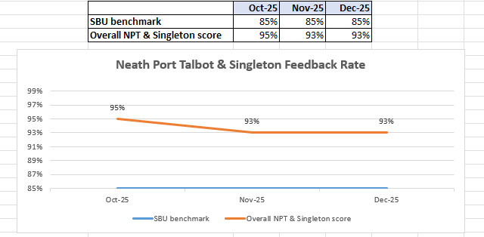
Below are the number of responses in a line graph:

Below are the main themes mentioned for NPT & Singleton:
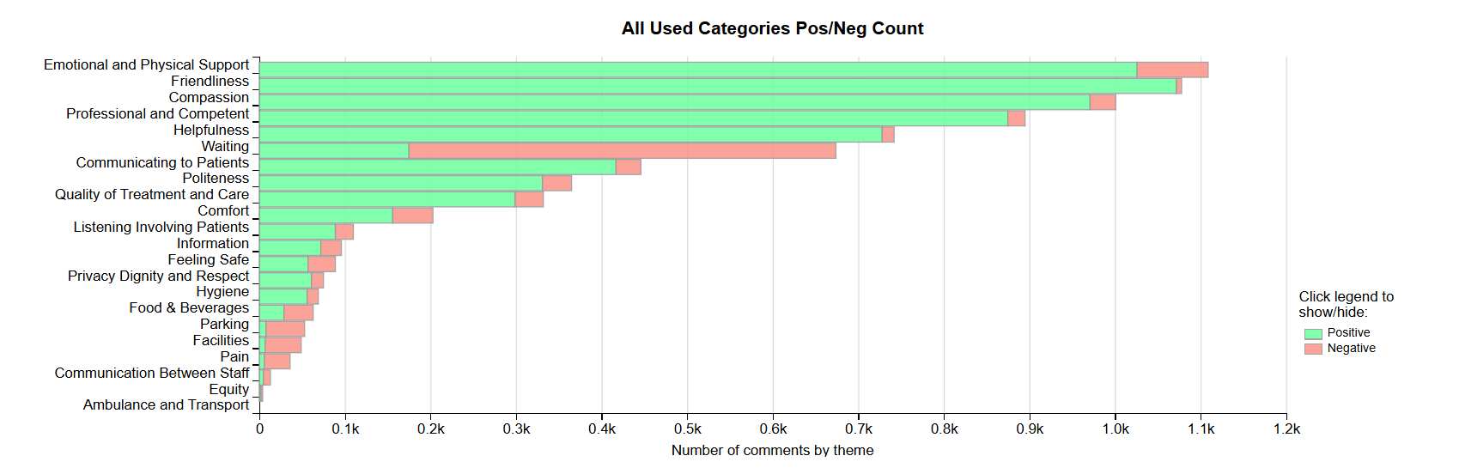
MENTAL HEALTH AND LEARNING DISABILITIES SERVICE GROUP
4.11 – MH&LD Complaints
MH&LD received a total of 89 complaints during Q3 2025/26 (October, November, December) compared with 97 complaints during Q2 2025/26 (July, August, September). Graph 1 below shows the total number of complaints received relating to MH&LD since January 2025. The graph breaks the total number received down by Formal Putting Things Right, Early Resolution and Re-opened complaints.

Graph 1: MH&LD complaints by month and type

As you can see from the graph, MHLD had an increase in complaints during June. This was due to multiple complaints being received from one complainant who is known to the service.
Graph 2 shows the top five areas within MH&LD that had the most complaints since January 2025.
Graph 2: Top 5 Services by month

4.12 – MH&LD Incidents
MH&LD reported 871 incidents in quarter 3 (Q3) of 2025/26 (October, November, December). This compares with 1065 incidents in quarter 2 (Q2) of 2025/26 (July, August, September) Graph 1 shows the number of incidents per month broken down by severity.
Graph 1: MH&LD Incidents by Severity and month
Graph 2 shows the top 5 incident types, of all incidents reported by MH&LD since October - December 2025.
Graph 2: Top 5 incidents per month

4.13 – MH&LD National Reportable Incidents
MH&LD reported 2 NRI’s during Q3 of 2025/26, compared with 1 NRI’s during Q3 of 2025/26.

4.14 – MH&LD Compliments
MH&LD received 3 compliments during Q3 of 2025/26. Graph 1 shows the number received per month since January 2025.
Graph 1: MH&LD compliments per month

4.15 MH&LD Patient Experience Feedback
This data is from Quarter 3.

The Mental Health and Learning Disabilities Service Group are using a different set of survey questions. The role out of the semi structured interview surveys have been managed in stages. Roll out, awareness posters and meetings with managers and teams continues.
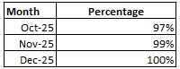

Below are the number of responses in a line graph:
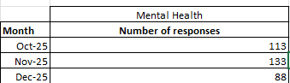

PRIMARY AND COMMUNITY SERVICE GROUP
4.16 – P&C Complaints
P&C received a total of 68 complaints during Q3 2025/26 (October, November, December) compared with 69 complaints during Q2 2025/26 (July, August, September). Graph 1 below shows the total number of complaints received relating to P&C since January 2025. The graph breaks the total number received down by Formal Putting Things Right Early Resolution and Re-opened complaints.
Graph 1: P&C complaints by month and type

Graph 2 shows the top five services that had the most complaints since January 2025.
Graph 2: Top 5 Services by month

From the graph it is evident that the number of Prison complaints has decreased over the last six months. The Prison Service send complaints to the Health Board retrospectively in batches therefore, it is likely there will be an increase again in the coming months.
4.17 – P&C Incidents
P&C reported 1078 incidents in quarter 3 (Q3) of 2025/26 (October, November, December). This compares with 1027 incidents in quarter 2 (Q2) of 2025/26 (July, August, September). Graph 1 shows the number of incidents per month broken down by severity.
Graph 1: P&C Incidents by Severity and month

Graph 2 shows the top 5 incident types, of all incidents reported by P&C since January 2025.
Graph 2: Top 5 incidents per month

4.18 – P&C National Reportable Incidents
P&C reported 3 Nationally Reportable Incidents (NRI’s) during Q3 2025/26, which compared to 5 reported during Q3 of 2025/26. The 3 NRI’s reported in Q3 included 2 x Unexpected deaths and 1 x Prison death.
Graph 1: Nationally Reportable Incidents reported per month by P&C

4.19 – P&C Compliments
P&C received 84 compliments during Q3 of 2025/26, compared with 94 during Q3. Graph 1 shows the number received per month since January 2025.

Graph 1: P&C compliments per month

Graph 2: P&C compliments – Top 5 Services

4.2 P&C Patient Experience Feedback
During Quarter 3, a total of 1,037 patients were seen under the Primary and Community Service Group.

A total of 1,849 Friends and Family survey responses were received during this quarter, with 93% of respondents stating they would highly recommend the Health Board to their friends and family.
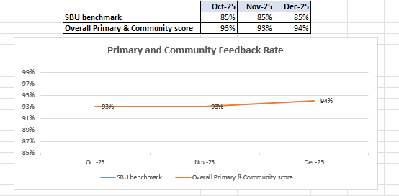

Patient Experience Team are currently working with I.T to automate SMS messages from the PIMS, PIMS+ platform to automate SMS survey messages to Primary Care and Therapies patients. This will increase the number of returns.

Below are the number of responses in a line graph:

Below are the main themes mentioned for Primary & Community:
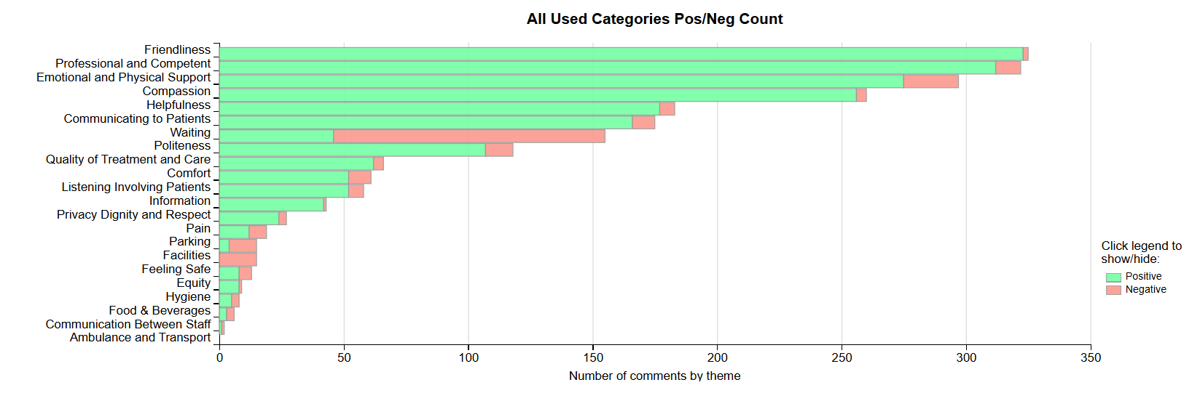

- MEDICAL EXAMINER COMPLIMENTS

5.1 ME Compliments
The Health Board has received a number of compliments from families through the Medical Examiner. This evidences the good work being done when treating these end of life patients. During Q3, approximately 85 compliments were received, 28 for Morriston, 5 for Neath Port Talbot Singleton and 52 for Primary & Community. A few examples are shown below;
“The care she received was exceptional. From the day she was diagnosed to her death everyone has been brilliant. During her admission in Singleton she was treated like a queen. The DN's were lovely 10/10 they gave her the dignity she deserved. Money couldn't have bought her better care. He is very grateful to all involved.”
Ward 10, Singleton

“He was given excellent treatment and as a GP practice they were very attentive. Cannot fault the GPs.”
GP Practice

“Fantastic care in the hospital, amazing, really good. She has no concerns to raise, she is a palliative nurse and is more than happy with the care he received.”
Ward D, NPTH

“As a family they would like to thank the whole ICU team in Morriston Hospital for amazing care. In particular, they wished to thank Dr …….. - who was incredibly kind. He had to deliver a very awkward conversation to a very passionate family and was such a gentleman. He allowed …. to pass with dignity and in peace and they are very grateful to him for this reason. Also, thanks to all the ICU nurses, in particular the nurse who was with him on the evening he passed, she offered great comfort to the family..”
ICU, Morriston

- OMBUDSMAN CASES

6.1 Ombudsman investigations
7 new Ombudsman investigations were received during Q3 2025/26, this compares to 3 in Q2 2025/26. Graph 1 shows the number of investigations received per month;

Graph 1: Number of Ombudsman investigations per month

The Health Board has also received 53 decisions not to investigate from the Ombudsman during Q3. Graph 2 below shows these by month.

Graph 2: Ombudsman decisions not to investigate

There are a number of different reasons why the Ombudsman decided not to investigate these complaints, listed below are the rational from the Ombudsman of their decision not to investigate;

- Health Board response addressed all queries raised.
- Remedy through court available
- Further information not provided by the complainant to the Ombudsman
- Reasonable response from the Health Board
- Ombudsman unable to achieve anything further

Public Interest Report – Orthopaedic Waiting List
Trauma & Orthopaedic waiting times Public Interest:
The investigation related to a delay in a patient receiving total knee replacement surgery from Swansea Bay University Health Board. The investigation considered whether the waiting time for surgery was appropriately managed in line with the Welsh Government’s Rules for Managing Referral to Treatment Waiting Times, specifically when the waiting time clock was re-set in October 2023.
The Ombudsman’s investigation found that although the patient was added to the waiting list for orthopaedic surgery in August 2019, without his knowledge, his waiting time clock was re-set in October 2023. During a pre-operative assessment, in October 2023, it was decided that Mr W required further assessments to determine if he was fit to proceed with surgery. Mr W had previously been deemed fit for surgery but, as pre-operative assessments are only valid for 6 months, due to the length of time Mr W had needed to wait, further assessment was required. The Health Board said that it was appropriate to re-set Mr W’s clock at this time as he was unfit to proceed with the procedure. However, the Health Board did not provide any evidence of a clinician documenting that Mr W was medically unfit to proceed at this point.
The final report was received by the Health Board on 20th November 2025, the recommendations are as follows:
Within 4 weeks (18th December 2026) of the final report being issued, the Health Board should:

- Arrange for the Chief Executive to make an apology to Mr W for the failings identified in the management of his waiting time for surgery.

- Share this report with relevant staff and reflect on the failings identified, in particular the need for there to be a well-documented clinical decision before a patient is deemed unfit for surgery.
Recommendations a) and b) are complete and we are on target to complete the below recommendations within the given timescale;
Within 12 weeks (12th February 2026) of the final report being issued, the Health Board should:

- Appoint an independent person (a suitably qualified individual not employed by the Health Board) to re-audit its orthopaedic waiting list to establish if any other patients have been treated incorrectly in the same way as Mr W, including incorrect waiting time re-set date and/or not being informed of their waiting time clock being re-set. If any are identified, the Health Board should apologise to those patients and ensure the correct waiting list date is recorded. The Health Board should propose a scope for the audit that should be agreed by this office before the audit commences.

- Given that the Health Board remained of the view during the course of my investigation, that it was appropriate to reset the clock in Mr W’s case, it should ensure its training for staff on the application of the RTT guidance includes this type of scenario, to ensure that its approach to waiting list management is in keeping with the RTT guidance.

Share the report with its Board which should nominate a Committee to maintain oversight and monitoring of the Health Board’s compliance with these recommendations

