Meeting Date | 5 February 2026 |  | Agenda Item |  |  | 4.4
Name of Meeting | Quality and Safety Committee
Report Title | A review of the ‘Your Next Patient’ policy in practice
Report Author | Alison Gallagher, Interim Assistant Director of Operations: Urgent & Emergency Care (UEC)
Report Sponsor | Deb Lewis, Chief Operating Officer  Neil Cooper, Interim Service Group Director Morriston Hospital.
Presented by | Deb Lewis, Chief Operating Officer
Freedom of Information | Open
Purpose of the Report | The purpose of the report is to review application of the ‘Your Next Patient’ (YNP) policy in practice.  The policy was aimed at providing more timely patient access to a specialty bed and the care that the specialty ward-based teams can provide.  The report explores how the use of the policy is applied in practice and demonstrates a drift towards the use of this capacity aligned to surge capacity.  The report explores the findings of Mid and West Fire Service and the actions taken to address the fire safety concerns raised.  The report provides insight into the capacity solutions currently employed to manage flow, YNP forming a part of this.  The report describes the risk associated with the cessation of the use of YNP capacity.
Key Issues | - The use of YNP spaces constitutes a core feature of the UEC capacity and contributes to the existing bed gap based on current activity and lengths of stay.  - Patients can spend protracted periods of time in the ‘YNP’ spaces which are not designated bed spaces and can be described as sub-optimal in terms of the offer to patients.  - There is drift in the application of the policy in respect of patient placement, use of the YNP spaces and the dependency that has grown, it can be described as ‘core capacity’ particularly in Medical Specialty wards.  - The fire safety concerns raised have been addressed through a series of adjustments in terms of the YNP allocations and the designated YNP spaces on the ward templates however, there remains unmitigated risks associated with the use of this capacity.  - There is flexing of the policy to respond to surges in Emergency Dept (ED) demand and the requirement to deliver ambulance handover within a maximum of 45 minutes whereby patients move across the specialty boundaries which undermines the original policy intention.
Specific Action Required  (please choose one only) | Information | Discussion |  | Assurance | Approval
Specific Action Required  (please choose one only) | ☐ | ☐ |  | ☐ | ☒
Recommendations | The Committee is asked to:  - ACCEPT the current risk tolerance associated with the use of YNP capacity due the risk of not doing being greater than the risk of continuation with the impact being on the Emergency Department, Assessment services and the wider community as set out in the report.

A review of the ‘Your Next Patient’ policy in practice.

- INTRODUCTION

The paper sets out the current position in relation to the use of ‘Your Next Patient’ (YNP) spaces across the Health Board. The original policy intent is explored, the findings of Fire Safety partners and the actions taken to mitigate risks are discussed and the current status of this capacity is set out in the context of wider UEC capacity.

- BACKGROUND

Continuous Flow in the NHS, often referred to as full capacity protocol was introduced in the NHS in Bristol in 2022. However, there have been variations of the model in practice in Swansea Bay since 2018 in order to respond to challenges in maintaining resuscitation capacity in the Emergency Department. There are numerous descriptors in use across NHS Wales that essentially describe placement of additional patients on wards in non-designated bed spaces, often to referred to as ’pre-emptive patient placement’, ‘boarding’ or ‘surging’. All of these terms describe the same action aimed at reducing ED crowding by sharing the risk across the wider system to reduce patient harm associated with prolonged ED stays and overcrowding.

In June 2025, Swansea Bay launched, ‘Your Next Patient’ a variation on the existing continuous flow approach already in practice. This approach was championed by the Executive Nurse Director who had introduced this model in previous organisations. The emphasis switched to employing the model to enable patients to access specialist care on the specialty-based wards that could best meet their clinical needs earlier in their pathway. The expectation being that ward multi-disciplinary teams would essentially ‘pull’ their patients from ED or other front door assessment areas into the YNP spaces moving them to a designated bed space when capacity available.

- POLICY IN PRACTICE:

The ‘Your Next Patient’ flow model works in areas where there is high demand for specialist care such as respiratory and gastroenterology, with the policy intention being realised and thus providing patients with earlier access to specialist teams. However, in the majority of areas, the Your Next Patient capacity is used as surge capacity and has become a fixed feature of the core capacity solution in Specialist Medicine and to a lesser extent in Surgical and Orthopaedic ward areas.

The following Your Next patient capacity is in use across the Health Board:

Hospital | Specialist ward areas | Number of YNP spaces
Morriston | Assessment areas:  - Acute Medical Unit (AMU)  - Older Persons Assessment Unit (OPAU)  - Surgical Assessment Unit (SAU) | 9
Morriston | Specialist Medicine | 15  (inc 1 stroke/1 renal)
Morriston | Trauma & Orthopaedics | 4
Morriston | Surgical services | 5
Morriston | Cardiac services | 2  (+2 ringfenced emergency use only)
Morriston | Burns & Plastics | 0
Singleton Hospital | Oncology/Haematology | 2
Singleton Hospital | Rehabilitation | 0
Singleton Hospital | Clinically optimised | 0
NPTH | Stroke rehabilitation | 0
NPTH | Orthogeriatric rehabilitation | 1
NPTH | Post acute care recovery | 1
 | Total | 39

The capacity above can be impacted by a number of variables including infection outbreaks, patient acuity, staffing availability. The YNP areas have core risk assessments however there is a dynamic risk assessment process which may impact the number of YNP spaces available at any given time. This is managed on a site basis through the safety huddle process and is subject to challenge driven by other risks across the UEC pathway.

There is also evidence of drift away from the original policy intent by placing patients in YNP spaces outside of their host specialty, this does not feature in the policy.

At the time the ‘Your Next Patient’ model was launched, operational teams with digital partners developed a dashboard view of the ‘Your Next Patients’ in the system to enable Patient Flow and clinical managerial teams to have access to a live state in respect of the YNP spaces, this is set out below:

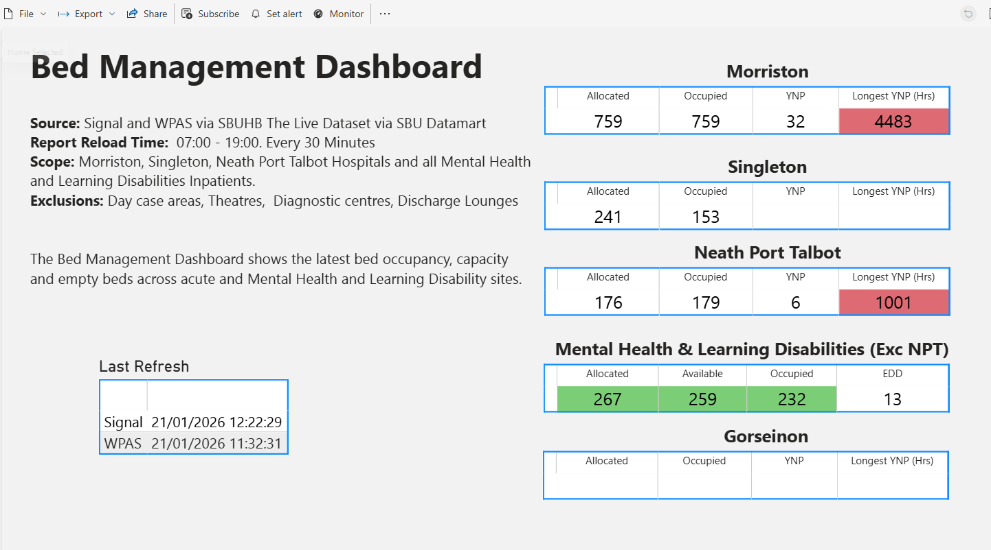
This information can be further drilled down by hospital site and ward. The longest YNP (hrs) reflects the total patient length of stay and not the period of time the patient has spent in a non-designated bed space. It is also important to understand that use of the YNP space should be driven by placement of the lowest risk patient and other parameters such as Oxygen dependency, cognitive state, therefore the YNP space may be occupied by a patient transferring from ED or an acute assessment service or by an existing in patient on a ward who is deemed clinically suitable to vacate their designated bed space and move into a YNP space, thus allowing the acute admission access to a purposed bed space.

- FIRE SAFETY & THE USE OF YNP SPACES:

Following a visit from Mid and West Wales Fire and Rescue Service, (MWWFRS) in July 2025, the Health Board was issued with a letter to address fire safety matters. This was due to the increased number of patients being placed on the ward templates that resulted in fire exit doors and routes being obstructed. The letter outlined the requirements of two specific regulations (8 & 14) within the Regulatory Reform (Fire Safety) Order 2005. Details of the requirements for each of these regulations are set out at Appendix 1.

With a follow up visit on 8th December 2025 by MWWFRS, they acknowledged the slight improvement and agreed to an extension of 90 days to adhere to the letter of fire safety matters, this runs to the 8th March 2026. There is a possibility that, if all actions are not completed, this could escalate to a Fire Safety Enforcement notice and potential for prosecution/fines, if there are continuous breaches to the Regulatory Reform (Fire Safety) Order, 2005. Specifically, in respect of the YNP spaces on the ward areas, the current number of spaces reflects a reduction in the number of available spaces owing to the fire safety notice. However, the ongoing use of the current YNP spaces does not completely meet with regulations and remains a tolerated risk despite several risk reduction actions been undertaken.

- GOVERNANCE AND RISK MANAGEMENT:

All the YNP spaces have documented risk assessments undertaken by senior nursing teams and are dynamically assessed daily in respect of staffing, ward acuity and infection control issues.

However, there have been complaints received in respect of patient placement in non-designated bed spaces which provide a sub-optimal offer to patients who require an in-patient stay in hospital. These spaces do not have call bells, piped gases or indeed a locker and armchair and therefore patient selection is often challenging owing to the complex patient cohorts managed in our hospitals.

There is a correlation between DATIX reports relating to staffing levels on the wards driven by additional patients and increased workload.

During 2025 there were 87 incidents reported in relation to bed availability and patients placed in inappropriate clinical settings, these incidents would include those patients in ‘Your Next Patient’ spaces but do not relate exclusively to the use of the YNP capacity. None of the incidents have triggered Duty of Candour and therefore can be classified as ‘minimal harm’.

Also, during 2025 there were 217 incidents where it was reported that there were insufficient staff (numbers and skills) to manage the patient caseload within a ward/department. Overview of these indicates that the driver for this level of reporting was either additional patients on the ward and/or no 1:1 resource available to maintain individual patient safety.

It is understood that YNP spaces offer a sub-optimal environment of care and does not provide the level of dignity and privacy we would like to offer to all patients, this is emerging in current patient feedback as follows:
- Reduced levels of care provided within busy/crowded locations – especially at front door locations
- Lack of privacy
- In-hospital harm (falls/infection/pressure injury) contributed to by busy ward locations
- Failures in discharge potentially resulting in readmission

Other factors emerging are:
- Delays in diagnostics
- Poor staff attitude
- Communication failures

- SUMMARY: THE BALANCE OF RISK:

It is recognised that the use of YNP spaces has shifted to provide surge capacity in respect of emergency flow pressures. The use of this capacity is managed as core capacity and the UEC pathway and outputs are reliant on this space. It is important to recognise that the YNP spaces does not represent the totality of patients nursed in non-designated trolley, bed or chair spaces. In the front-door assessment services patients continue to experience prolonged waits in the waiting rooms, on hard chairs or in areas that do not meet their clinical need, such as Majors patients managed in the Minors area of the Emergency Department. Furthermore, there are patients who are in designated bed spaces however they are unfunded or have been temporarily repurposed to support urgent and emergency care flow. This is set out below:

A snapshot of the position as at today in respect of patients requiring in patient admission and not in a designated bed space:

Clinical service area | Number of patients in non-designated bed spaces requiring in patient admission (excluding patients in YNP spaces)
Emergency Department | 30
AMU | 24
TOTAL | 54

Current YNP occupancy in addition to the above:

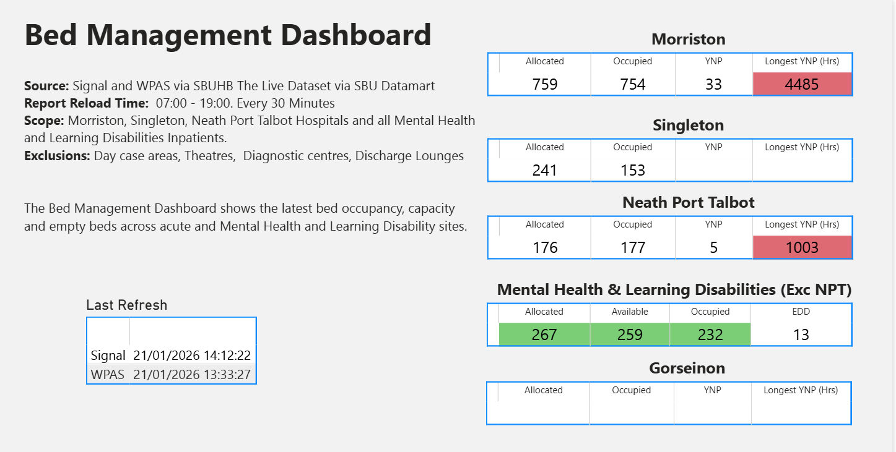

The above demonstrates a live YNP position of 38 patients, however there are currently 36 with 2 being recorded on a closed ward footprint.

Unfunded surge capacity:

In addition to the unplaced patients in ED and AMU Morriston, and the patients occupying Your Next Patient spaces, there are areas of unfunded surge capacity currently in use and in patient elective areas occupied by patients on the UEC pathway as follows:

Hospital | Ward/Service area | Number of unfunded/repurposed beds in use for UEC flow
Morriston | Ward S | 4
Morriston | OPAU Assessment | 6
Morriston | OPAU Purple Bay | 5
Morriston | Theatre Assessment Unit (TAU) | 3 to 5 – flexed daily
Morriston | Anglesey | 25
NPTH& Singleton | Ward A | 16 repurposed
NPTH& Singleton | Neuro Rehab Unit | 6 repurposed
NPTH& Singleton | Oncology | 4
NPTH& Singleton | Ward 4 | 30
TOTAL: |  | 96 (exc TAU)

The above demonstrates a concerning picture in terms of UEC capacity, with the YNP spaces providing just a part of an overall solution to the capacity gap we have in the UEC pathway. In addition to all of the patient numbers set out above, there are currently 48 medical outliers, patients admitted under the care of Specialist Medicine occupying non-medical beds. The total number of patients in the above snapshot who are in non-designated bed spaces or repurposed beds is: 186.

Whilst it is recognised that the use of YNP space is far from optimal, a decision to take down the use of this capacity would result in these patients being held in the Emergency Department or Assessment areas, all of which are over-crowded and running above funded capacity levels. Furthermore, increasing the number of patients in the Emergency Department or in the Assessment areas would result in a worsening ambulance handover position, increased risk to patients requiring urgent care and increased risks to patients in our communities requiring ambulance response.

- RECOMMENDATION:

The Committee is asked to consider the use of YNP spaces in the context of wider flow pressures and whole system risk. It is important to re-emphasise that the use of YNP capacity is part of a wider temporary capacity solution to mitigate risk across the UEC pathway.

It is therefore recommended that taking down the use of YNP capacity would result in greater risk to patients in the Emergency Department, front door assessment services and in the wider community.

Noting the above, the Committee is asked to:
- ACCEPT the current tolerance to the risk associated with the use of YNP capacity as the risk of not doing so is deemed greater than the risk of continuation

APPENDIX 1: Regulatory Reform (Fire Safety) Order 2005.

Regulation 8 of the Regulatory Reform (Fire Safety) Order 2005 (FSO) places a duty on the 'responsible person' for non-domestic premises in England & Wales to take general fire precautions to ensure the safety of employees and other 'relevant persons' (visitors, etc.), covering fire detection, escape routes, firefighting equipment, and emergency plans, based on a fire risk assessment. It requires measures to be "reasonably practicable" for employees and "reasonably required" for others, aligning with broader workplace safety duties.

Key Requirements of Regulation 8
- Applies to "Responsible Person": The duty falls on the person in control of the premises (e.g., owner, employer, landlord).
- For Employees: Take precautions to ensure their safety, as far as is reasonably practicable.
- For Other Relevant Persons (Non-Employees): Take precautions that are reasonably required in the circumstances to keep the premises safe.
- Based on Risk Assessment: These precautions stem from a suitable and sufficient fire risk assessment.
- Examples of Precautions: Includes ensuring appropriate fire alarms, clear escape routes, firefighting equipment, emergency lighting, and staff training.
In essence, Article 8 mandates the implementation of the preventive and protective measures identified as necessary from a fire risk assessment to keep everyone on the premises safe from fire.

Regulation 14 of the Regulatory Reform (Fire Safety) Order 2005 focuses on Emergency Routes and Exits, requiring them to lead directly to safety, be adequate for the number of people, kept clear of obstructions, and equipped with appropriate signage, emergency lighting, and easily openable doors for quick, safe evacuation from non-domestic premises in England and Wales. The "responsible person" must ensure these routes are maintained and suitable for all, including those with disabilities, as identified in the fire risk assessment.

Key Requirements of Regulation 14
- Direct to Safety: Emergency routes and exits must lead as directly as possible to a place of safety.
- Adequate Capacity: The number, distribution, and size of routes and exits must be sufficient for the premises and maximum number of occupants.
- Clear & Unobstructed: Routes must be kept clear at all times, with no obstructions or impediments.
- Signage & Lighting: Clearly marked with signs and have emergency lighting if normal lighting failure would create a hazard.
- Easy Opening: Emergency doors must open easily in the direction of escape and not be locked or fastened in a way that prevents immediate use.
- Special Needs: Arrangements must be made for people with disabilities, as identified in the risk assessment.
- No Sliding/Revolving Doors: These are generally prohibited for emergency exits.

Governance and Assurance

Link to Enabling Objectives  (please choose) | Supporting better health and wellbeing by actively promoting and empowering people to live well in resilient communities
Link to Enabling Objectives  (please choose) | Partnerships for Improving Health and Wellbeing |  | ☐
Link to Enabling Objectives  (please choose) | Co-Production and Health Literacy |  | ☐
Link to Enabling Objectives  (please choose) | Digitally Enabled Health and Wellbeing |  | ☐
Link to Enabling Objectives  (please choose) | Deliver better care through excellent health and care services achieving the outcomes that matter most to people
Link to Enabling Objectives  (please choose) | Best Value Outcomes and High Quality Care |  | ☐
Link to Enabling Objectives  (please choose) | Partnerships for Care |  | ☐
Link to Enabling Objectives  (please choose) | Excellent Staff |  | ☐
Link to Enabling Objectives  (please choose) | Digitally Enabled Care |  | ☐
Link to Enabling Objectives  (please choose) | Outstanding Research, Innovation, Education and Learning |  | ☐
Health and Care Standards
(please choose) | Staying Healthy |  | ☐
(please choose) | Safe Care |  | ☒
(please choose) | Effective Care |  | ☐
(please choose) | Dignified Care |  | ☐
(please choose) | Timely Care |  | ☐
(please choose) | Individual Care |  | ☐
(please choose) | Staff and Resources |  | ☐
Quality, Safety and Patient Experience
The use of the YNP capacity risks and the associated sub-optimal patient experience is offset by the risks held in the Emergency Department and front door services and across the wider UEC pathway.
Financial Implications
There are no direct financial consequences associated with the use of the YNP capacity however, the wider capacity picture does have associated costs that sit outside the scope of this paper.
Legal Implications (including equality and diversity assessment)
The fire safety risks associated with the use of the YNP capacity is well documented in the paper and the ongoing breach of Regulations 8 and 14 of the Regulatory Reform (Fire Safety) Order 2005 could potentially result in prosecution/fines.
Staffing Implications
The staffing implications of the YNP spaces are cost neutral however it is recognised that use of this capacity places additional pressures on ward teams particularly where unavailability is high and staffing levels are reduced.
Long Term Implications (including the impact of the Well-being of Future Generations (Wales) Act 2015)
Report History |  | Nil
Appendices |  | APPENDIX 1: Regulatory Reform (Fire Safety) Order 2005.

