Meeting Date | 28 January 2025 |  | Agenda Item |  |  | 4.5
Name of Meeting | Quality and Safety Committee
Report Title | Tackling Diabetes Together Improvement Plans
Report Author | Julie Morse, Strategic Planning Manager  James Rodaway, Associate Director of Population Health  Alice Puchades, Consultant in Public Health  Dr Anjula Mehta, Deputy Executive Medical Director
Report Sponsor | Dr Richard Evans, Executive Medical Director
Presented by | Dr Anjula Mehta, Deputy Executive Medical Director
Freedom of Information | Open
Purpose of the Report | The purpose of the report is to set out the health board’s position in relation to the Diabetes 8 Care Standards and the national Tackling Diabetes Together programme.
Key Issues | - Whilst Type 1 diabetes affects around 16,000 people in Wales and cannot be prevented, more than 190,000 people have type 2 diabetes, which can be prevented or delayed. Estimates suggest the prevalence of diabetes may rise to 10% of the population by 2035.  - People with diabetes require significant support from NHS services to help manage the condition. Part of the new approach is the roll out of support to people who are at highest risk of diabetes and the introduction of new remission services for newly diagnosed people who may be able to reverse the development of the condition.  - Public Health Wales has implemented the Tackling Diabetes Together [TDT] Programme in collaboration with NHS partners. This programme aims to address health inequalities that contribute to the risk of developing diabetes and ensure better management of the condition.  - SBUHB has signed up to the TDT Programme and formulated a plan to improve the position in relation to the Diabetes 8 Care Standards.  - SBUHB needs to develop preventative approaches to tackle the determinants that affect the prevalence of diabetes in our population.
Specific Action Required  (please choose one only) | Information | Discussion |  | Assurance | Approval
Specific Action Required  (please choose one only) | ☐ | ☐ |  | ☒ | ☐
Recommendations | Members are asked to:  - ACKNOWLEDGE the increase in those with type one and type two diabetes in Swansea Bay;  - ACKNOWLEDGE the implementation of the Public Health Wales Tackling Diabetes Together Programme, to which Swansea Bay has signed up and formulated an improvement plan;  - ACKNOWLEDGE the re-establishment of the Diabetes Planning and Development Group to take forward the work required.
TACKLING DIABETES TOGETHER IMPROVEMENT PLANS

- INTRODUCTION
The purpose of the report is to set out the health board’s position in relation to the Diabetes 8 Care Standards and the national Tackling Diabetes Together programme.

- BACKGROUND
Whilst Type 1 diabetes affects around 16,000 people in Wales and cannot be prevented, more than 190,000 people have type 2 diabetes, which can be prevented or delayed by modifying existing risk factors for this disease. Estimates suggest the prevalence of diabetes may rise to 10% of the population by 2035.

People with diabetes require significant support from NHS services to help manage the condition. Part of the new approach is the roll out of support to people who are at highest risk of diabetes and the introduction of new remission services for newly diagnosed people who may be able to reverse the development of the condition.

Swansea Bay has noted an increase of patients with Type 1 diabetes and a significant increase of patients with Type 2 diabetes (approx. 42,000 more patients now live with Type 2 diabetes).
In addition, the health board is an outlier (UK-wide) for amputation rates – a key adverse outcome of poorly managed diabetes; patients have a 19% mortality rate and SBUHB has the highest number of inpatient spells per 10,000 head of population - inpatient stay costs for diabetics are the highest in Wales.

Although progress is being made in performance against the overall standards for Type 2 diabetes, improvement is required for the standards relating to podiatry/foot surveillance.

Public Health Wales has implemented the Tackling Diabetes Together [TDT] Programme in collaboration with NHS partners. This programme aims to address health inequalities that contribute to the risk of developing diabetes and ensure better management of the condition.

SBUHB has signed up to the TDT Programme and has formulated a plan to improve the Health Board’s position in relation to the Diabetes 8 Care Standards.

- GOVERNANCE AND RISK ISSUES
The TDT programme has 6 work streams:
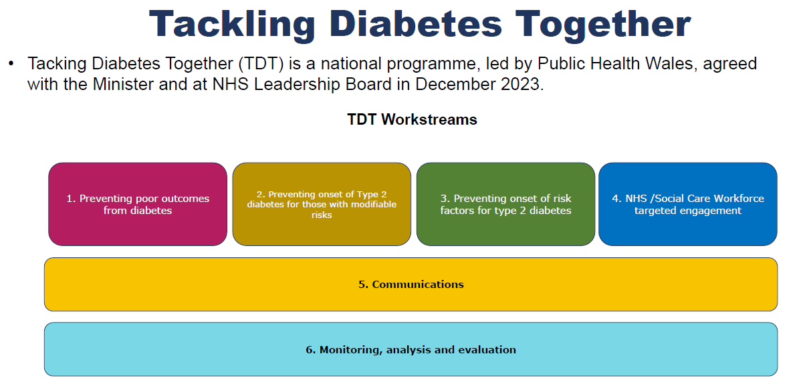

SBUHB has signed up to the TDT Programme and has formulated a plan to improve the Health Board’s position in relation to diabetes management and treatment improvement areas that need to be addressed over the next four years. Our work will align with the two key strategic objectives of the TDT programme

- Having more people live well with diabetes measured through a reduction in complications such as amputations by December 2028
- Stopping the prevalence of type 2 diabetes increasing by Dec 2028

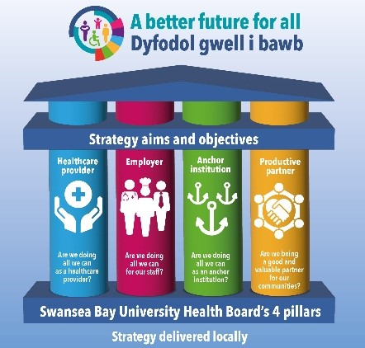
Swansea Bay University Health Boards Population Health Strategy outlines our approach to tackling health inequity and shifting focus on to prevention to improve the health and wellbeing of the population.

The four-pillar framework within the strategy can support us to articulate the impact from TDT through a population health lens:

- Healthcare Provider: how are we considering equity and shifting our focus to a preventative model of diabetes management that supports our population to live well, prevent or delay the onset of diabetes, and enables those living with diabetes to self-manage the condition?
- Employer: what are we doing to support and look after our staff to prevent and manage diabetes?
- Anchor institution: how are we best utilising our footprint to ensure equitable access to reduce risk factors and improve outcomes?
- Productive partner: how as a Health Board are we partnering with our GP clusters and others to reduce the prevalence of diabetes and support those with the condition to live well?

SBUHB CURRENT POSITION

Prevalence of Diabetes in SBUHB
Currently 8.13% of people registered in Swansea Bay have diabetes- meaning that over 26,000 people in Swansea Bay have diabetes. Approximately 10% of the NHS budget is spent on people with diabetes and it is estimated that over the next ten years, one in 11 adults in Wales will have Type 2 diabetes; PHW estimates that by 2035/36 there will be a 56% increase in patients living with diabetes. This rising prevalence will incur significant cost to the NHS.

Hospital Admissions
Over 10% of hospital admissions are attributed to people with diabetes. People with diabetes admitted to hospital, have an 8% chance of mortality within the year. This number rises to 13% if they have had an amputation; SBUHB has the highest rate of amputations, certainly in Wales, and one of the highest in the UK.

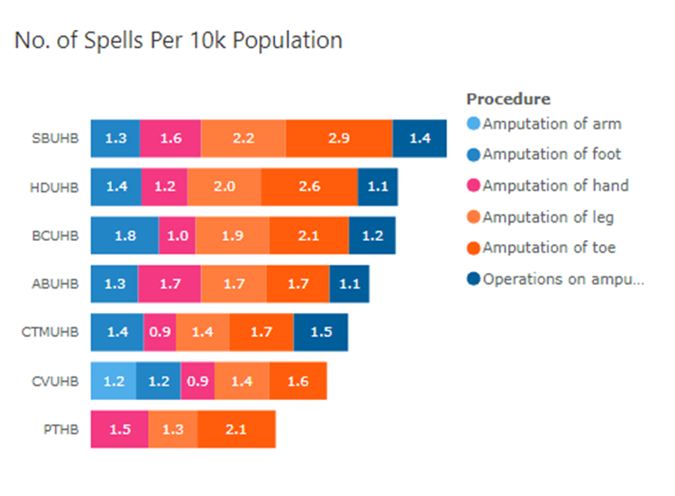
The graph above highlights that Swansea Bay is an outlier for the number of inpatient spells relating to amputations compared to the other Health Board areas in Wales. In 2022/23 over 75% of diabetic inpatients on the amputation pathway in Swansea Bay were classed as Emergency Admissions, with an average length of stay of 25 days and an average cost of £23,000 per inpatient spell.

Diabetes Development & Planning Group
The Health Board has re-established its Diabetes Development & Planning Group [DPDG] to focus on improving compliance with the eight diabetes care standards; action plans will highlight:

- Health inequalities, particularly related to patient engagement in the management of their condition
- Education in self-management, via standardised communications
- Streamlining and improvement of data flows, mapping optimal pathways
- Ensuring robust access points for patients

Following on from the work programme set out by the One Bay Way programme, the goal is to work towards the implementation of a more sustainable community model, rebalancing resources into early intervention and prevention.

The Diabetes Planning and Development Group is taking the lead on planning for improvements, supported by Executive, GP and Consultant leadership. As context in relation to the baseline position for the Health Board, the following can be observed:

- Swansea Bay has noted an increase of patients with Type 1 diabetes and a significant increase of patients with Type 2 diabetes (approx. 42,000 more patients now live with Type 2 diabetes).
- SBUHB is an outlier (UK-wide) for amputation rates – a key outcome of poorly managed diabetes; patients have a 19% mortality rate.
- SBUHB has the highest number of inpatient spells per 10,000 head of population - inpatient stay costs for diabetics are the highest in Wales.
- Although progress is being made in performance against the overall standards for Type 2 diabetes, improvement is required for the standards relating to podiatry/foot surveillance.

8 Care Standards
One of the health board’s key priorities over the next five years as part of the Tackling Diabetes Together programme is improving its position against the eight care standards.

Each Health Board is assessed against eight annual care standards as noted below:

- HbA1c (Blood Tests)
- Blood Pressure.
- Cholesterol Level.
- Kidney Function.
- Urine Albumin.
- Foot Surveillance.
- BMI (Height and Weight)
- Smoking Status

The eight care standards are annual checks that an individual should receive to ensure the risk of complications is minimised. Any complications detected early will allow intervention to reduce progression. The treatment targets are checks to ensure risk factors are effectively addressed, particularly for complications such as kidney disease, cardiovascular disease, amputations or stroke and to address risk factors such as obesity or smoking. Overall the aim is to improve patient outcomes and ensure patients with diabetes live healthier and longer.

NHS Wales has signed up to the National Diabetes Audit (NDA) to collect compliance data relating to the eight care standards. In NHS England, this is delivered in partnership with Diabetes UK. The benefit of the two home nations collating this information is that it provides a comprehensive picture of diabetes care in England and Wales and gives local organisations the opportunity to benchmark and compare data to identify gaps and share best practice. Within Swansea Bay, this data enables us to determine our priorities and targets for improvement. It is important to note that is only pulled from the Audit+ systems across primary care so data quality will depend on the reliability and effectiveness of data transfer from secondary care and other services, such as podiatry, and consistent coding to enable complete extraction into the audit system.

The Health Board’s performance against the standards for Type 1 diabetes is exceptionally low at 8.2%. Compliance against the standards for Type 2 diabetes is better at 44.6%, but performance is low for both when compared to England:

Type 1 Type 2
Wales | 8.2% | 44.6%
England | 44.3% | 62.3%
[data from NHS Wales diabetes insights & variation Atlas as at Q4 23/24]

SBUHB does not currently perform well overall against these eight standards, and in particular, compliance with the foot surveillance and urine albumin checks are amongst the lowest in Wales.

In terms of type two diabetes, performance is set out below:

 | SBUHB | All Wales
BP | 87.13% | 88.44%
BMI | 80.63% | 80.3%
Cholesterol | 80.76% | 81.54%
Foot | 66.54% | 67.51%
HBa1c | 87.05% | 89.57%
Serum Creatinin | 81.75% | 90.31%
Smoking | 78.01% | 75.08%
Urine Albumin | 58.22% | 59.92%
All | 44.72% | 44.59%

Data is made available on the completion of each of the eight care standards and the table above shows a significant difference in completion rates across each one, with the lowest uptake in foot surveillance and urine albumin, not only in the health board but across Wales. The picture is similar within in England.

Delivery of the eight care standards to type two diabetics is managed through primary care, with the exception of the ‘super six’ patient groups (Pregnancy, severe renal disease, children and young people, active severe foot disease, insulin pumps, current hospital inpatients) who would be managed in secondary care along with type one diabetics.

This enables compliance with the standards to be broken down further by primary care cluster:

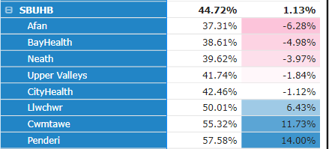

Three of the clusters are achieving significantly better than the Wales and England average however there are three clusters which are falling below. This links with levels of social deprivation, rurality and GP sustainability data.

Availability in practices of services across Swansea Bay is average:

  - Number of practices providing Directed Supplementary Service (DSS) - 42/44
  - Number of practices providing National Supplementary Service (NSS) - 36/44

The difference between the two services is the NSS enables practices to initiate and manage type two patients on GLP1 medication and manage patients stable on insulin treatment.

Just some of the activities undertaken by primary care to provide the eight care standards includes:
- NDA (National Diabetic Audit) engagement
- Data extraction from GP systems and coding
- Annual reviews – call and recall
- Medication reviews
- Feedback and learning
- Co-produced care plans/education
- Management of new and existing diabetes management patients

Practice level data was requested for compliance against the individual standards and there was significant variation linked with levels of deprivation, health literacy, and patient engagement, as well as practice sustainability concerns and lack of administrative standards to ensure consistent and timely data coding.

In terms of type one performance against the eight care standards, which is managed through secondary care, the health board falls significantly below the all-Wales target. However, the individual breakdown shows a better performance against some of the key standards, such as blood pressure, serum creatinine and HBa1C, although foot surveillance and urine albumin remains low.
 | SBUHB | All Wales
BP | 65.20% | 65.2%
BMI | 54.77% | 63.22%
Cholesterol | 45.82% | 55.58%
Foot | 24.91% | 43.10%
HBa1c | 56.1% | 65.71%
Serum Creatinine | 58.40% | 65.12%
Smoking | 44.96% | 53.58%
Urine Albumin | 26.19% | 35.01%
All | 8.84% | 21.9%

Some of the challenges noted within secondary care data entry include patient engagement with high ‘did not attend’ rates, the move to telephone consultations as a result of the pandemic and the availability of podiatry in outpatient clinics to undertake routine and advanced foot care. However the most limiting challenge and gap is inconsistent and ineffective data transfer to primary care. For example, during an outpatient’s appointment, a patient’s bloods and/or urine sample results may not be ready when the clinic letter to primary care is drafted but they become available to the consultant at a later time via the Welsh Clinical Portal and if normal, would not be communicated to primary care.

Whilst there is clarity where the eight care standards are completed for type 1 and stable type 2 diabetics, there is a large group of patients who sit between primary and secondary intermittently requiring secondary care input for insulin treatment escalation and optimisation. This group of patients are often not recalled or do not attend their annual reviews in primary care due to lack of clarity as to who is managing their diabetes. As yet, Swansea Bay has not developed a community diabetes service but this needs to be a priority moving forward for this group of patients.

The health board has taken a number of strategic and operational actions to improved performance against the eight care standards in addition to signing up to the Tackling Diabetes Together programme. As mentioned above, the internal strategic oversight group, the DPDG, is in place and is attended by key stakeholders from the health board, primary care clusters and Diabetes UK.

In addition, the eight care standards will be part of the cluster and health board IMTP prioritisation work and is included in the Population Health Strategy. This includes pathway mapping and a value-based healthcare approach using baseline practice level performance data as a point on which to build.

In addition to the targeted discussions and target setting with practices following receipt of their baseline data, in October 2024, communication was sent to practices reiterating the requirement of the DSS specification, with a follow-up sent the following month. This will take around six months to see an improvement in outcomes and a post payment verification exercise has commenced to review practice claims against clinical aspects of the DSS specification.

Through the Primary Care Academy, Diabetes Training Programme is offered to general practice with scoping/planning training for HCSWs which will support with 8 care standards currently being worked through.

Digital improvements are key, with some of the actions to create better communication and data transfer between primary and secondary care, including podiatry, and coding within GP systems.

In terms of cluster development, the health board’s largest GP practice has enrolled in a pilot for patients to have urine home testing pilot (Urine albumin), with the initial engagement and compliance rates being positive. Each cluster now has a dedicated secondary care consultant from whom advice and expertise can be sought for more complex patients.

Lastly, scoping is underway for a multi-disciplinary diabetes service to deliver specialist care for more complex patients in the community and closer to patients’ homes.

Regional Working
A regional Whole Systems Approach (WSA) to healthy weight team has been established and is working across Swansea Bay and Hywel Dda UHBs to develop system capability & capacity. The team is bringing together organisations and communities in the local area to build a collective understanding of how the local food environment shapes people’s opportunities to maintain a healthy weight, and where best to intervene within the system to achieve long-terms system change - one in which our environment promotes and supports healthy weight.

This approach goes beyond traditional partnership working. It means looking at the complex interaction of all the various parts of the system – from food sourcing and procurement, affordability of food, access to green and blue spaces, plus planning decisions and active travel options.

The team have recently engaged Public Services Boards (PSBs) and wider partners across the region in a series of workshops to agree a single focus for collaboration across the region over the coming years. The analysis of the outputs of the five workshops is being finalised and will be reported in early December 2024. Once agreed, the priority focus will form the basis for preventative, long-term action to halt the rise in excess weight in the population

Approach to Prevention
In prediabetes, weight loss has been shown to delay the onset decrease the risk of Type 2 diabetes, while in established type 2 diabetes weight loss has been shown to improve glycaemic control, with severe calorie restriction even reversing the progression of the disease. Swansea Bay has a range of weight management services available for both adults and children and young people. There are challenges around the limited capacity of the Level 2 adult weight management services compared to demand for the services and Swansea Bay is the only Health Board in Wales without a substantially funded Level 3 adult weight management service. There is work happening across the Health Board on developing the Adult Weight Management Pathway, using a One Bay Way Approach, but there is a lack of substantive funding identified for the development of the adult weight management pathway.

Smoking is also an important risk factor, identification of smoking status is one of the 8 Care Standards. People who smoke have an increased risk of developing Type 2 diabetes. People who have diabetes and who smoke have a higher risk of developing complications including diabetic neuropathy and cardiovascular complications, and have higher morbidity rates. In Swansea Bay nearly 14% of adults are smokers, with smoking known to be more prevalent in people living in deprived areas. People living with diabetes should be offered support to quit smoking through the Help Me Quit smoking cessation service, and work should be done across Swansea Bay to support smoke-free becoming the norm.

GOVERNANCE

The DPDG will set out the plans required to deliver improvement against the 8 Diabetes Care Standards – with particular focus on foot checks and urine test checks. Progress will be reported to the Quality & Safety Committee, with key achievements and issues for escalation to also be reported up to the Management Board.

The DPDG has also applied for funding from the TDT programme to appoint a Health Care Support Worker [HCSW] to out-reach to patients for their diabetes care, focusing on those who either inconsistently, or not at all, respond and attend their review appointments. The HCSW will align with GP clusters to ensure collaboration and robust communication to plan and target interventions. The HCSW will complete routine diabetes reviews including blood tests, blood pressure checks, foot surveillance and urine samples but also provide targeted education on diabetes, self management and lifestyle interventions.

The Group will also put in place plans to improve patient engagement with self-management and treatment plans. One longer term goal is to reduce amputations required as a result of poor management of diabetes.

The proposal is to start in two GP clusters with particularly low eight care standards performance and aim to extend role to the remaining clusters once evaluated and successful. According to recent data (Diabetes Insights & Variation Atlas), the two clusters at Upper Valleys and Neath are particularly poor performers (both Type 1 and Type 2) in line with the 8 Care standards, and so the initial focus will be within these two Cluster groups.

The aim is also to sign up 20 GP practices to support home testing and changes to outpatient clinic letters have enabled patient care standards process status to be noted for easy viewing.

The Group is also actively benchmarking with other Health Boards and linking in with Diabetes UK to gain advice on communication models to ensure improved engagement from patients in the management of their condition.

RISKS

The diabetes pathway is not supported by robust data capture – data is input into differing systems across the Health Board and only GP data is fed into the National Diabetes Audit for onward reporting. It is also difficult for all clinicians to have timely access to patient information for speedy decision making. The Group is working with Digital colleagues to try to work through a local solution.

Although improvements in diabetes services features on the IMTP 2024/25, funding has not materialised. This will need to be of high focus in next years IMTP.

Preventative approaches and system working are not sufficiently mature within the Health Board to develop the partnerships required to effect change.

- FINANCIAL IMPLICATIONS
There is not a financial implication to the improvement programme at this stage, however plans to adopt a new model in the future, to focus the management of diabetes into the community setting, will require investment.

- RECOMMENDATION
Members are asked to:
- ACKNOWLEDGE the progress made in reviewing and improving our current Health Board diabetes pathways
- ACKNOWLEDGE the current and predicted rising prevalence in those with type one and type two diabetes
- ACKNOWLEDGE the implementation of the Public Health Wales Tackling Diabetes Together Programme, to which Swansea Bay has signed up and formulated an improvement plan;
- ACKNOWLEDGE the re-establishment of the Diabetes Planning and Development Group to take forward the work required.
- ACKNOWLEDGE the focus on improving current performance against 8 care processes.

Governance and Assurance

Link to Enabling Objectives  (please choose) | Supporting better health and wellbeing by actively promoting and empowering people to live well in resilient communities
Link to Enabling Objectives  (please choose) | Partnerships for Improving Health and Wellbeing |  | ☒
Link to Enabling Objectives  (please choose) | Co-Production and Health Literacy |  | ☐
Link to Enabling Objectives  (please choose) | Digitally Enabled Health and Wellbeing |  | ☒
Link to Enabling Objectives  (please choose) | Deliver better care through excellent health and care services achieving the outcomes that matter most to people
Link to Enabling Objectives  (please choose) | Best Value Outcomes and High Quality Care |  | ☒
Link to Enabling Objectives  (please choose) | Partnerships for Care |  | ☒
Link to Enabling Objectives  (please choose) | Excellent Staff |  | ☒
Link to Enabling Objectives  (please choose) | Digitally Enabled Care |  | ☒
Link to Enabling Objectives  (please choose) | Outstanding Research, Innovation, Education and Learning |  | ☐
Health and Care Standards
(please choose) | Staying Healthy |  | ☒
(please choose) | Safe Care |  | ☐
(please choose) | Effective Care |  | ☒
(please choose) | Dignified Care |  | ☐
(please choose) | Timely Care |  | ☒
(please choose) | Individual Care |  | ☒
(please choose) | Staff and Resources |  | ☒
Quality, Safety and Patient Experience
The Health Board’s improvement plans relating to diabetes will help to reduce the number of patients developing Type 2 diabetes and to better manage patients living with diabetes. The aim is also to bring more patients on board with their own management of their condition, this relieving pressure on the healthcare system, especially the secondary care system.

Financial Implications
Noted above

Legal Implications (including equality and diversity assessment)
None expected.

Staffing Implications
None expected – apart from the one HCSW role funded by Public Health Wales TDT programme

Long Term Implications (including the impact of the Well-being of Future Generations (Wales) Act 2015)
Collaboration: Delivering a coherent Tacking Diabetes Together programme requires collaboration across secondary and primary care in addition to collaboration with partners from across the region.
Long Term: The programme is a long-term programme that the Health Board is committed to delivering.
Integration: Providing an integrated response across the Health Board and Clusters is integral to delivering Tackling Diabetes Together.
Prevention: Preventing diabetes and preventing people with the condition from worsening are key objectives of the programme.
Involvement: Involving patients in the care of their condition is a key objective of the programme.

Report History |  | Nil.
Appendices |  | Nil.

