

Meeting Date | 28 January 2025 |  | Agenda Item |  |  | 5.2
Name of Meeting | Quality and Safety Committee
Report Title | Quality Priority – Pressure Ulcer Prevention
Report Author | Rachel Govier-Williams, Lead specialist Tissue Viability Nurse
Report Sponsor | Sharron Price, NPSSG GND Pressure Ulcer Prevention Strategic Group (PUPSG) lead
Presented by | Rachel Govier-Williams, Lead specialist Tissue Viability Nurse
Freedom of Information | Open
Purpose of the Report | To provide an update on the Pressure Ulcer Prevention quality priority including the progression and current position.
Key Issues | - On target to meet 10% reduction in Pressure Ulcer incidents (HB wide)  - Governance: 32% of incidents reported are awaiting investigation  - Continued work needed to develop quality improvement plans based on localised data with particular focus on Deep Damage and intervention planning  - Ongoing risks:  - Awaiting executive dashboard development  - Medical illustration access
Specific Action Required  (please choose one only) | Information | Discussion |  | Assurance | Approval
Specific Action Required  (please choose one only) | ☒ | ☐ |  | ☒ | ☒
Recommendations | Members are asked to note the report and endorse the following recommendations:  - Note the reported update on this Quality Priority  - Endorse the Health Board Strategic Quality Improvement Plan.  - Endorse the continued reporting from Service groups via PUPSG ensuring inclusion of lessons learnt to promote shared learning.  - Endorse the Quality Priority aim to reduce the incidents of HB acquired deep damage PU’s by 10% by March 2025.

- INTRODUCTION

Pressure Ulcer Prevention was identified as a Quality Priority by the Health Board (HB) in March 2023.

Whilst the initial aim to reduce HB acquired Pressure ulcers by 10% was not achieved in the first year, a reduction in the rate of increase was noted, slowing annual increases from over 30% (April 2020-March 2021) to just 9% over the 2023/2024 period.
This quality priority received no additional resource for focussed leadership and as result focussed work was unable to commence until September 2023. Despite the challenge of limited additional resource, significant improvement has been noted in the reduction of the pressure ulcer incidents, particularly since April 2024.

This paper provides an update as to the progress of the Pressure Ulcer Prevention Quality Priority since March 2023.

- BACKGROUND
Avoidable pressure ulcers are a key indicator of the quality and experience of patient care; the majority are preventable. The Strategic Priorities for Wales 2024/2025 reinforces need to prevent and report pressure ulcers.
An increase in pressure ulcer incidents has been recognised Nationally and attributed to a number of factors including increase in numbers of patients at end of life being treated at home and more frail patients being discharged from hospital in a proactive measure to manage resources and provide the right care in the right place.
The average cost of pressure Ulcer management is between £2,000 (Category 1) to £20,000 (Category 4) (NHS Improvement, 2018). Using those figures and based on the number of pressure ulcers of each severity treated last year in Swansea Bay UHB, this would equate to an approximate spend of £5m.

- SITUATION
Health Board Total Pressure Ulcer incidents
Total number of incidents are charted from June 2020 (Graph 1). Increasing prevalence of incidents noted over this period until March 2023. This can be attributed to a number of factors including;
- Increased acuity of patients within system
- Pandemic aftermath showing societal deconditioning particularly in older persons
- Improvements in incident reporting
- Increase in numbers of patients supported within HB

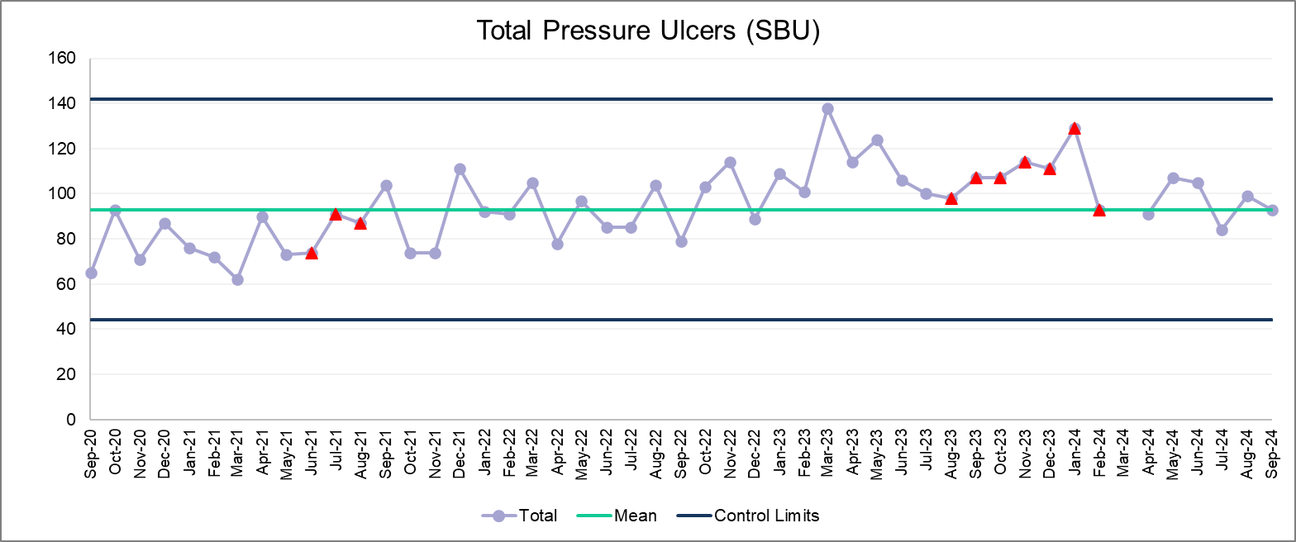

Graph 1: Total HB acquired Pressure ulcer incidents
Since February 2024, the trajectory has changed. Quarter 1 and 2 of 2024/2025 has seen an 11% reduction against the same period in 2023/2024. Data suggests the HB is on target to meet its overarching aim of 10% reduction in HB acquired PU’s in 2024/2025.

This progress has been attributed to the following work streams:

- Strengthening of Governance structures: this includes development of reporting structures and processes plus increased consistency to scrutiny and investigation processes to provide HB wide approach
- Workforce training: Significant existing resource has been utilised to provide intense and targeted training and education across the HB.
- Continued and enhanced quality assurance processes: completion of a number of focussed clinical audits producing local data utilised for focussed quality improvement initiatives
- Development of digital solutions: progress continues on the development of both a Datix (incident reporting) and Quality database. Further development of these digital solutions is predicted to further improve outcomes through real time data access
- Focussed Quality Improvement initiatives: a number of QI projects have provided valuable learning and development. The Corporate Quality Improvement team has been supporting some of these initiatives.

Pressure Ulcer Rates

Using the measure of rate (per 1000 bed days) is helpful in reflecting progress made as it removes the ambiguity of increased system capacity. Graph 2 shows the HB pressure Ulcer rate. There is currently no national average rate available for comparison. Benchmarking of HB incidents or rates with other HB’s is also not currently possible, due to changes in pressure ulcer reporting to Welsh Government.
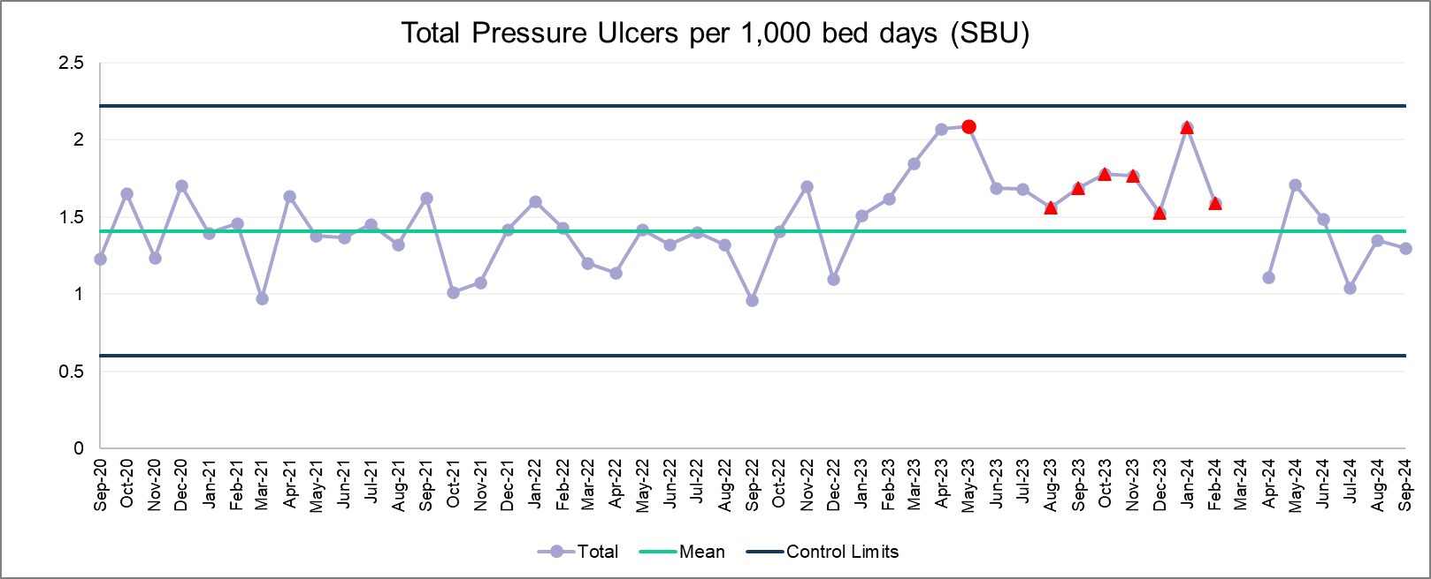

Graph 2: HB pressure Ulcer Rate per 1000 be days

Pressure Ulcer Severity

The majority of incidents (90%) reported are superficial in nature.

The incidents of serious harm through deep damage (including category 3,4 and unstageable) pressure ulcers are increasing. PCTSG has reported a 20% increase in category 3 and above pressure ulcers in Q1 and 2 when compared to the same period last year, highlighting a need for more work on prevention and early identification.

Neath Port Talbot Hospital has seen numbers double in the first half of the year despite a comprehensive and intensive training programme and improvement of early identification at point of transfer. Targeted work is currently being undertaken to understand and reduce these incidents.

Conversely, Morriston has seen a reduction of 30% deep damage incidents, and Singleton have reported no incidents in this financial year to date.

During the Q2 period there was 1 National Reportable Incident in SBUHB. This developed and was deemed avoidable in Primary and Community Care Service Group.

32 Incidents were deemed Deep damage across the HB but deemed unavoidable following scrutiny.

Avoidable Harm

Understanding prevalence of avoidable harm is helpful in understanding the HBs action in prevention. Our data suggests 54% of harm was avoidable.

The percentage of incidents assessed as avoidable varies significantly between service groups. Work is ongoing to agree a Health Board governance approach in order to be able to provide assurance of comparable data.

Graph 3: Avoidability Status Q1 2024

Governance
38%% of incidents await investigation with the majority of outstanding investigations in those service groups with greatest incident numbers (Graph 3). This has improved with 46% awaiting closure in Q1
We acknowledge the need for prompt investigation to ensure accurate learning and timely sharing of lessons learnt. Targeted work is underway to reduce the non-investigated figure with a notable improvement of 40% in Q1 2024/2025 when compared to Q4 of the previous year.

Quality Improvement Initiatives Summary
There are a number of quality Improvement initiatives that are active across the HB. A comprehensive list with status updates can be found in appendix 7. Most notable to date is the progress made with updating all assessment/intervention documentation to reflect all skin tones and the development of a training programme with care homes.

4- RECOMMENDATIONS
- Note the reported update on this Quality Priority
- Endorse the Health Board Strategic Quality Improvement Plan.
- Endorse the continued reporting from Service groups via PUPSG ensuring inclusion of lessons learnt to promote shared learning.
- Endorse the Quality Priority aim to reduce the incidents of HB acquired deep damage PU’s by 10% by March 2025.

Governance and Assurance

Link to Enabling Objectives  (please choose) | Supporting better health and wellbeing by actively promoting and empowering people to live well in resilient communities
Link to Enabling Objectives  (please choose) | Partnerships for Improving Health and Wellbeing |  | ☒
Link to Enabling Objectives  (please choose) | Co-Production and Health Literacy |  | ☐
Link to Enabling Objectives  (please choose) | Digitally Enabled Health and Wellbeing |  | ☐
Link to Enabling Objectives  (please choose) | Deliver better care through excellent health and care services achieving the outcomes that matter most to people
Link to Enabling Objectives  (please choose) | Best Value Outcomes and High Quality Care |  | ☒
Link to Enabling Objectives  (please choose) | Partnerships for Care |  | ☐
Link to Enabling Objectives  (please choose) | Excellent Staff |  | ☐
Link to Enabling Objectives  (please choose) | Digitally Enabled Care |  | ☐
Link to Enabling Objectives  (please choose) | Outstanding Research, Innovation, Education and Learning |  | ☐
Health and Care Standards
(please choose) | Staying Healthy |  | ☐
(please choose) | Safe Care |  | ☒
(please choose) | Effective Care |  | ☐
(please choose) | Dignified Care |  | ☐
(please choose) | Timely Care |  | ☐
(please choose) | Individual Care |  | ☐
(please choose) | Staff and Resources |  | ☐
Quality, Safety and Patient Experience
PU prevention Quality Priority reports directly to Q&S group and Patient safety Group. The overall aim is to reduce Pressure incidence and reduce the harm patients are caused through avoidable pressure ulcers.

Financial Implications
No financial implications noted in this report.

Legal Implications (including equality and diversity assessment)
Each service group have Falls Prevention Meetings/Forums and these feed into a HB wide Overarching PUPSG Group. This report to both the Quality Priority Programme Board and Q&S governance structures.

Staffing Implications
PU prevention champions have been identified across all HB areas; role to be developed through QI programme.

Long Term Implications (including the impact of the Well-being of Future Generations (Wales) Act 2015)
The focus of the pressure QP work is prevention. The Quality Improvement programme led by PUPSG
Report History |  | None
Appendices
Appendix 1 – Quality Improvement Plan
Appendix 2
Updated Terms of Reference
Appendix 3
New reporting template
Appendix 4
Poster
Appendix 5
Education Audit
Appendix 6
Data
*Can be found in the resource section of admin control*

