

HEALTH BOARD RISK REGISTER
December 2024

RISKS ASSIGNED TO THE
QUALITY & SAFETY COMMITTEE

Datix ID Number: 738  Health & Care Standard: |  |  | HBR Ref Number: 1  Risk Target Date: 31/03/2025 |  | Current Risk Rating  5 x 5 = 25
Objective: Urgent & Emergency Care |  | BAF Ref: 2.4 | Director Lead: Deb Lewis, Chief Operating Officer  Assuring Committee: Performance & Finance Committee  For information: Quality & Safety Committee
Risk: Access to Unscheduled Care  If we fail to provide timely access to Unscheduled Care then this will have an impact on quality & safety of patient care as well as patient and family experience and achievement of targets. There are challenges with capacity/staffing across the Health and Social care sectors. (This risk includes ED, AMU and impact in community from ability to release ambulances at both front doors.) |  |  | Date last reviewed: December 2024
Risk Rating  (consequence x likelihood):  Initial: 4 x 5 = 20  Current: 5 x 5 = 25  Target: 3 x 4 =12 | 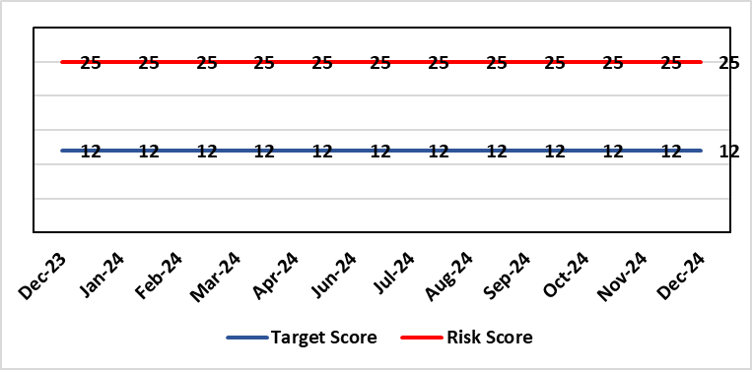 |  | Rationale for current score:  The UEC system continues to see high demand, with ambulance attendances in particular being higher than seen previously. This is coupled with reduced flow out of hospital beds due to an imbalance of acute / community / care service provision. These factors are resulting in unacceptable delays in patients accessing UEC services and therefore the risk score remains high.
Level of Control  = 50% |  |  | Rationale for target score:  The HB is currently under escalating performance monitoring from WG (Targeted Intervention or TI) for delivery of UEC services. The improvement plan developed as a response to TI and that already included in the HB annual plan is to implement models of care that reflect best practice and focus on areas that will benefit patients, staff and the UEC system most. The implementation of this plan will improve patient flow, length of stay and reduce emergency demand.
Date added to the HB risk register
26.01.16
Controls (What are we currently doing about the risk?) |  |  | Mitigating actions (What more should we do?)
Five main areas of work within the plan:  - Frailty strategy – approved via Management Board  - Grip & control operational management  - Senior decision makers at front door services  - Pathway of care delays (PoCD)  - Home First  - ACT  - Interface with local authority  - Reconfiguration of Emergency Dept  In addition to BAU improvement actions:  - Continued focussed roll-out of 6-Goals schemes of work  - D2RA / Trusted assessor model  - SAFER  - Criteria-led discharge  - Continuous Flow Model (CFM)  - Robust SDEC model |  |  | Action | Lead |  | Deadline
 |  |  | Review of senior decision making capacity within SDEC and AMU | GMD Morriston SG |  | 31/12/2024
 |  |  | Implementation of 7-day community services | Interim EMD |  | 31/12/2024
 |  |  | Implementation of UEC Navigation Hub to decrease demand and implement right patient right place process | COO |  | 30/11/2024
 |  |  | Reintroduce D2RA Principles across the Health Board | Corporate Patient Flow team & Assistant Director of Operations |  | 28/02/2025
Assurances (How do we know if the things we are doing are having an impact?)  - Urgent & Emergency Care Board is meeting monthly chaired by the COO.  - Six Goals programme reviews the pan on a monthly basis |  |  | Gaps in assurance (What additional assurances should we seek?)  The need to deliver sustained service.
Additional Comments / Progress Notes
14/10/2024: Actions remain current with the exception of the CFM, which is now on hold pending improvement from other actions. UEC summit held in October to consolidate system approach. This will be repeated in six weeks.
23/10/2024: Actions refreshed. Criteria led discharge was rolled out in Medicine and had been indicated to follow in other areas. The previous action in relation to that action has been closed as previously described and replaced with action to implement D2RA, during which further consideration will be given to criteria-led discharge.
06/11/2024: The Winter Plan is currently in development, along with actions to achieve the 50-day Challenge as laid out by the Care Action Committee. The plans will be submitted to WG and received by the Board at the end of November. There is a significant financial challenge in delivering the additional capacity, both in terms of physical space and 7-day working, required to achieve the progress required over Winter.

Datix ID Number: 739  Health & Care Standard: |  |  | HBR Ref Number: 4  Risk Target Date: 31/03/2025 | Current Risk Rating  4 x 5 = 20
Objective: Care is high quality, safe, efficient, and delivers the best possible outcomes for people |  | BAF Ref: 2.1 | Director Lead: Hazel Powell, Executive Director of Nursing  Assuring Committee: Quality & Safety Committee
Risk: Healthcare Acquired Infection  Risk of patients acquiring infection as a result of contact with the health care system, resulting in avoidable harm, impact on service capacity, and failure to achieve Tier 1 national infection reduction goals. |  |  | Date last reviewed: December 2024
Risk Rating  (consequence x likelihood):  Initial: 4 x 5 = 20  Current: 4 x 5 = 20  Target: 4 x 3 =12 | 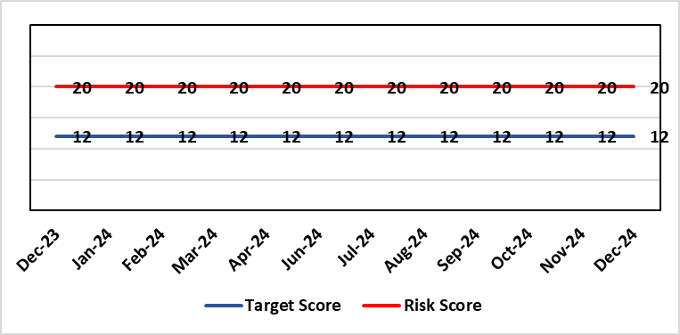 |  | Rationale for current score:  Health Board incidence of key Tier 1 infections per 100,000 population above All Wales rates, indicating Health Board’s population at greater risk of infection. High occupancy rates & frequent ward moves associated with increased risk of infection transmission. Lack of decant facilities compromises environment deep cleaning & decontamination, and planned preventative maintenance programmes.
Level of Control
= 40%
Date added to the HB risk register
January 2016
Date added to the HB risk register  January 2016 |  |  | Rationale for target score:  Improved governance structures for IPC and antimicrobial stewardship will drive improved local ownership and embed responsibility for these priorities for all levels of staff. Adequately maintained & clean environments facilitate good IPC & minimise infection risks. Reduced occupancy & frequency of patient moves mitigate against infection transmission. Compliant ventilation systems and water safety minimise infection risks. Access to timely data on infections, training, antimicrobial stewardship, cleaning at ward/unit/practice level enables Service Groups to identify areas for focused QI programmes, drive improvement, & effectively measure outcomes.
Controls (What are we currently doing about the risk?) |  |  | Mitigating actions (What more should we do?)
- Policies, procedures, protocols and guidelines supplement the National Infection Control Manual.  - Infection Prevention & Control related training provided programmes.  - Surveillance of infections, with early identification of increased incidence, and instigation of controls.  - Antimicrobial stewardship programmes and systems of monitoring and feedback.  - Provision of cleaning service to meet National Standards of Cleanliness.  - Engineering controls for water safety, ventilation, and decontamination.  - Infection Prevention Improvement Plans 2024/25 for HB and Service Groups were approved by the Health Board's Infection Prevention & Control Strategic Group on 30/04/24 and 31/07/24 respectively. Progress is reported at SG Infection Control Committees, HB Infection Prevention & Control Group, Quality & Safety Group, Quality & Safety Committee, and Management Board. These include trajectories to meet national targets and report performance against them.  - The Health Board has been escalated to Targeted Intervention for its position relating to healthcare associated infection (HCAI). Governance processes for HCAI have been revised to provide strengthened scrutiny and assurance. |  |  | Action |  | Lead | Deadline
 |  |  | Achieve 85% compliance with IPC mandatory training (Levels 1 & 2) |  | Service Group Directors | 31/12/2024
 |  |  | Undertake a programme of decant, deep clean and disinfection with hydrogen peroxide vapour (HPV) in Morriston Hospital. |  | Morriston Service Group Directors | 31/12/2024
 |  |  | Achieve reduction in Tier 1 infections to meet de-escalation criteria for intervention targets |  | Service Group Directors | 31/03/2025
Assurances (How do we know if the things we are doing are having an impact?)  - Clear Corporate and Service Group IPC Assurance Framework in place.  - Infection Prevention Improvement Plans for HB and Service Groups with progress reported at SG Infection Control Committees, HB Infection Prevention & Control Group, Quality & Safety Group and at Management Board. These include trajectories to meet national targets and report performance against them. This is also reported to Quality & Safety Committee.  - Ongoing monitoring of infection control rates.  - IPC, antimicrobial, decontamination and cleaning audit programmes.  - Annual completion of IPC Level 2 mandatory training for all HB staff.  - Compliance and validation systems for water safety, ventilation systems and decontamination.  - Revised and strengthened governance structure for HCAI, including monthly meetings of Executive HCAI Scrutiny Group. |  |  | Gaps in assurance (What additional assurances should we seek?)  - High occupancy rates & frequent ward moves associated with increased risk of infection transmission.  - Lack of single room availability, leading to delays in isolating patients with infections and increasing risks to patient contacts.  - Increased numbers of clinically optimised patients remaining in hospital leads to increased length of stay, increased risk of over-occupancy and over-crowding, with consequence of increasing risks of acquisition of infection.  - General infrastructure of the aging hospital estate compromises ability to clean and decontaminate effectively.  - Antimicrobial prescribing, relating particularly to total volume of antibiotics, with the SBUHB having second highest total volume of antibiotics prescribed in primary care in Wales.  - Lack of decant facilities compromises environment deep cleaning & decontamination, and planned preventative maintenance programmes.  - Varying levels of IPC responsibility embedded across all disciplines and groups, with variable medical engagement at all levels in infection prevention-related Quality Improvements programmes.
Additional Comments / Progress Notes
28/11/2024: The health board continues to experience an increase in the number of C. difficile cases and currently has the highest incidence of C. difficile in Wales (85.98/100,000).
Whole genome sequencing indicates that the majority of the cases are not linked, however, there have been a small number of genomically linked transmissions identified during October.
Gold Cdiff high incidence meetings are taking place every two weeks, with the Morriston and Singleton service groups also holding Silver Incident Management Team meetings every two weeks.
Mandatory IPC training compliance position at the end of Oct 24:
> Level 2 IPC training compliance = 83.75%
> Level 1 IPC training compliance = 91.53%
Tier 1 position against the Targeted Intervention de-escalation hospital onset (HO) criteria in October 2024:
> C.difficile: (HO target - 6) = 19 cases. Combined cumulative position - Community (CO) and hospital onset (HO) cases = 161.
> Staph aureus: (HO target - 3) - 4 cases. Combined, cumulative position - Community (CO) and hospital onset (HO) = 74 cases.
> E coli: (HO target - 4) - 7 cases. Combined, cumulative position - Community (CO) and hospital onset (HO) = 139 cases.
> Klebsiella Spp: (HO target - 4) - 5 cases. Combined, cumulative position of Community (CO) and hospital onset (HO) = 72 cases.
> Pseudomonas aeruginosa (not included in targeted intervention monitoring). Combined, cumulative total - 8 cases.

Datix ID Number: 840  Health & Care Standard: |  |  | HBR Ref Number: 16  Risk Target Date: 31/03/2025 | Current Risk Rating  5 x 4 = 20
Objective: Planned Care |  | BAF Ref: 2.5 | Director Lead: Deb Lewis, Chief Operating Officer  Assuring Committee: Performance & Finance Committee  For information: Quality & Safety Committee
Risk: Access and Planned Care  There is a risk of harm to patients if we fail to diagnose and treat them in a timely way. |  |  | Date last reviewed: December 2024
Risk Rating  (consequence x likelihood):  Initial: 4 x 4 = 16  Current: 5 x 4 = 20  Target: 4 x 2 = 8 | 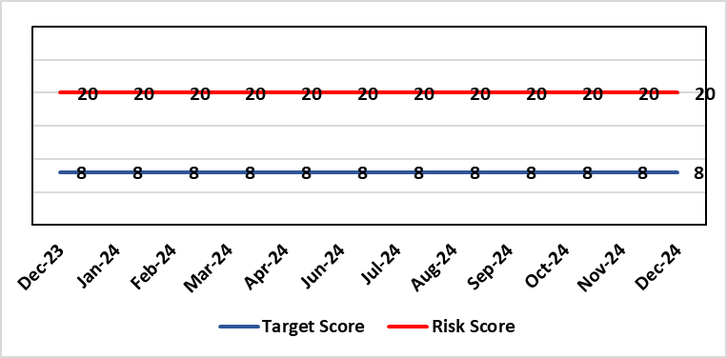 |  | Rationale for current score:  Whilst the HB has eradicated very long waits for surgery, patients are still waiting in excess of 104 weeks for surgical intervention, which is outside of national policy on RTT. The HB is currently under escalating performance monitoring from WG (Targeted Intervention or TI) for delivery of Planned Care services. The improvement plan developed as a response to TI mirrors that already included in the HB
Level of Control
= 90%
Level of Control  = 90% |  |  | Rationale for target score:  There is scope to reduce the likelihood score to reduce the overall risk to an acceptable level. The Risk target date indicates when we expect to see some reduction in waiting lists – albeit the overall risk level may remain as work continues.
Date added to the HB risk register
January 2013
Controls (What are we currently doing about the risk?) |  |  | Mitigating actions (What more should we do?)
- There is a bi-weekly Targeted Intervention (TI) meeting specifically for assurance on the recovery of our elective programme.  - Specialty level capacity and demand models set out the baseline capacity and identify solutions to bridge the gap this financial year.  - A focused intervention is in train to support to the 10 specialties with the longest waits.  - Long waiting patients are being outsourced to the Independent Sector, where appropriate  - Additional internal activity is being delivered on weekends (via insourcing), although this is currently at risk due to changes in policy pertaining to the payment of enhanced rates to A4C staff.  - Planned care trajectories are being developed and submitted to WG as part of the annual plan by the end of May 2024.  - Governance process put in place to monitor performance against trajectories internally, and with Welsh Government as part of Targeted Intervention.  - External & internal validation continues.  - All long waiting patients are receiving clinical reviews to ascertain continued need for surgery. |  |  | Action |  | Lead | Deadline
 |  |  | Theatre Optimisation Programme now in place to maximise efficient use of theatre capacity |  | NPTSSG SGD | 31/03/2025
Assurances (How do we know if the things we are doing are having an impact?)  - TI dashboard developed to monitor performance in a live state  - Weekly TI monitoring meetings chaired by the COO  - Bi-weekly planned care meetings chaired by the COO  - Monthly TI monitoring meetings with WG |  |  | Gaps in assurance (What additional assurances should we seek?)
Additional Comments / Progress Notes
14/10/2024: Progress against the Planned Care agenda continues with 52 weeks maintained and 156 weeks now removed.
31/10/2024: Action complete – Recovery plan to meet 104 target by March 2025 submitted to Welsh Government to secure additional funding.

Datix ID Number: 1043  Health & Care Standard: |  |  | HBR Ref Number: 36  Risk Target Date: 31/07/2025 | Current Risk Rating  4 x 4 = 16
Objective: The delivery of care is supported by innovative digital solutions |  | BAF Ref: 4 | Director Lead: Matt John, Director of Digital  Assuring Committee: Digital, Research & Innovation Committee  For information: Quality & Safety Committee
Risk: Paper Record Storage  Lack of a single electronic record means there is greater reliance on the provision of the paper record. If we fail to provide adequate storage facilities for paper records, then this will impact on the availability of patient records at the point of care. Quality of the paper record may also be reduced if there is poor records management in some wards. There is an increased fire risk where medical records are stored outside of the medical record libraries. |  |  | Date last reviewed: December 2024
Risk Rating  (consequence x likelihood):  Initial: 4 x 5 = 20  Current: 4 x 4 = 16  Target: 3 x 3 =9 | 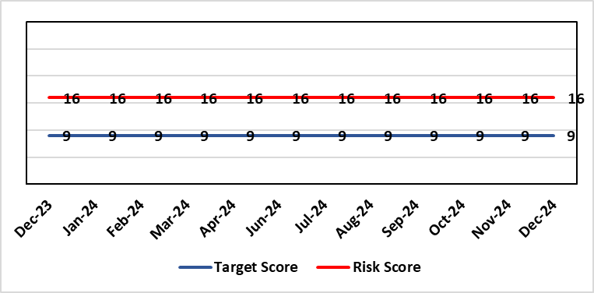 |  | Rationale for current score:  C - Inability to find records for patients could delay care/increase length of stay over 15 days. Could also mean patients receive incorrect treatment. Increased risk of fire where records are stored outside of the medical record libraries.  L - we know this happens from incidents raised
Level of Control  = 70% |  |  | Rationale for target score:  C - The increased development and adoption of the digital record will reduce the need for the paper health record being available at the point of care.  L - The increased development and adoption of the digital record, the introduction of RFID and the approach to management of the paper record identified in the Business case process should reduce the amount of paper required to be stored and managed.
Date added to the HB risk register
June 2016
Controls (What are we currently doing about the risk?) |  |  | Mitigating actions (What more should we do?)
- There is a plan in place to increase the functionality of the electronic record to document patient care. The delivery of the plan is overseen by the Digital Leadership Group and progress provided to Management Board. (Supported by individual project boards as appropriate).  - Records managed by the Medical Records libraries are RFID tagged and location tracked.  - Medical Record libraries are regularly risk assessed for fire by health and safety.  - Alternative offsite storage arrangements have been identified.  - All records must be documented on the Information Asset Register (IAR). |  |  | Action |  | Lead | Deadline
 |  |  | Movement of records and staff into new centralised unit |  | Head of Health Records & Clinical Coding | 31/03/2025
 |  |  | Allow for new process to stabilise and evaluate benefits of new centralised unit. |  | Head of Health Records & Clinical Coding | 30/05/2025
Assurances (How do we know if the things we are doing are having an impact?)  - RFID has been implemented for the acute record improving the management and storage of records  - Health Records performance reports developed in line with RFID technology  - Attainment of the Tier 1 Health Board target for clinical coding completeness which relies on the timely availability and quality of the Paper record and electronic sources  - Monitoring complaints and incident reporting.  - Electronic record is being implemented in accordance with the plan eg implementation of WNCR, ETR, HEPMA etc. |  |  | Gaps in assurance (What additional assurances should we seek?)  Investment required supporting the delivery and operational costs of the Digital strategy.  Reliance on DHCW for delivery of the solution for a fully electronic patient record.  Impact of the Infected Blood Enquiry on the Health Boards ability to destroy notes.  Process for ensuring clinical adoption of electronic ways of working and cessation of adding information to the paper record that is already available electronically needs to be agreed and enforced by the Health Board.  Impact of the infected Blood Inquiry on the health boards ability to destroy notes and the change in the records code of practice is being reviewed by the Director of Digital.
Additional Notes
11/09/2024 (Revised 27/09/2024) – Two previous actions completed: WG approval for Health Records Business Case; legal agreement with landlord.
Actions & targets revised: Two actions now included within the risk. Action 1 – All necessary work in progress and milestones agreed with contractor. Action 2 – Allowing time for new staff and processes to settle within the new unit, evaluate impact and consider further actions if required.

Datix ID Number: 1514  Health & Care Standard: |  |  | HBR Ref Number: 43  Risk Target Date: 31/03/2025 |  | Current Risk Rating  4 x 4 = 16
Objective: Mental Health & Learning Disability Services |  | BAF Ref: 2.3 | Director Lead: Hazel Powell, Executive Director of Nursing  Assuring Committee: Quality & Safety Committee  For Information: Mental Health Legislation Committee
Risk: Deprivation of Liberty Safeguards  Due to a limited resources within the MCA/DoLS service (lack of Best Interest Assessor resource and signatory approval) there is a risk of failure to complete and authorise the assessments associated with Deprivation of Liberty within the legally required timescales, exposing the health board to potential legal challenge and reputational damage. |  |  | Date last reviewed: December 2024
Risk Rating  (consequence x likelihood):  Initial: 4 x 4 = 16  Current: 4 x 4 = 16  Target: 3 x 2 = 6 | 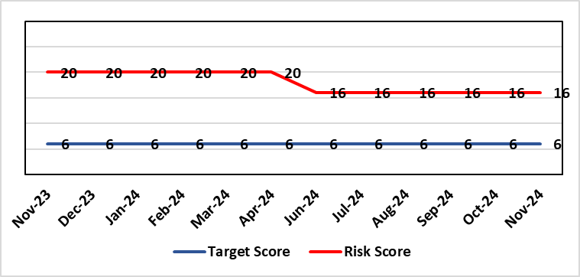 |  | Rationale for current score:  Multiple breaches in statutory duty  (Breaches expected at least as frequently as weekly, but not daily)  No claims received to date.
Level of Control  = 40% |  |  | Rationale for target score:  Consequences of DoLS breaches for the Health Board will not change. With controls in place, over time likelihood should decrease.  Risk target date indicates date of review following mitigating actions
Date added to the HB risk register
July 2017
Controls (What are we currently doing about the risk?) |  |  | Mitigating actions (What more should we do?)
- Duty system in place. Duty BIA scrutinise referrals and liaise with managing authority to ensure safeguards are in place to mitigate risks.  - Four signatory authorisers in place.  - Monthly Performance & Assurance Meeting  - Monthly Legislative Assurance Meeting with Group Nurse Director and Finance.  - Quarterly reports to Mental Health & Legislative Committee on MCA/DoLS compliance. |  |  | Action | Lead |  | Deadline
 |  |  | Workforce Plan to be submitted for additional resources (2 wte BIA) to mitigate risks. | Deputy Head of Nursing for Long Term Care |  | 31/03/2025
 |  |  | Workforce Plan to be submitted to request additional signatory resources to reduce breach risk. | Deputy Head of Nursing for Long Term Care |  | 31/03/2025
Assurances (How do we know if the things we are doing are having an impact?)  Monthly Legislative Assurance Meeting with Group Nurse Director and Finance.  Quarterly reports to Mental Health & Legislative Committee on MCA/DoLS compliance. |  |  | Gaps in assurance (What additional assurances should we seek?)  Current resources  - 3 substantive BIA (3 wte)  - 6 external BIA (£250 per assessment)  - 4 (band 8) signatories  Additional 2 WTE BIAs required to meet service demands.  Substantive BIA’s role includes additional duties compared to external BIA whose only role is to complete form 3a of the DoLS process. In addition to form 3a completion, substantive BIA also undertake the following to meet service demand (Daily Duty Rota to scrutinise referrals; Facilitate Level 3 MCA/DoLS Training; Capacity Assessments; Advice and support to Managing Bodies; Support during Best Interest Meetings)
Additional Comments / Progress Notes
05/09/2024: Breaches for Q1 are reported at 7. All substantive BIA’s have returned from sick leave. Risk remains unchanged at 16.
19/12/2024: Breaches for Q2 are reported at 17. This is due to
- An increase in DoLS referrals following wider HB staff awareness of MCA/DoLS following implementation of Level 3 training
- Additional support to Managing Authorities for wider MCA/DoLS awareness
- Breaches due to insufficient signatory resource

Datix ID Number: 1761  Health & Care Standard: |  |  | HBR Ref Number: 50  Risk Target Date: 31/03/2025 | Current Risk Rating  5 x 5 = 25
Objective: Cancer Care |  | BAF Ref: 2.6 | Director Lead: Deb Lewis, Chief Operating Officer  Assuring Committee: Performance & Finance Committee  For information: Quality & Safety Committee
Risk: Access to Cancer Services  There is a risk of delay in diagnosing patients with cancer, and consequent delay in commencement of treatment, which could lead to poor patient outcomes and failure to achieve targets.  The HB remains unable to deliver on the target of 75% of patients being treated within 62 days and is currently under targeted intervention by WG to improve performance. The HB has been given an initial target of 60% to be delivered by the end of Dec-24, increasing to 70% by the end of March 2025. |  |  | Date last reviewed: December 2024
Risk Rating  (consequence x likelihood):  Initial: 4 x 5 = 20  Current: 5 x 5 = 25  Target: 4 x 3 = 12 |  |  | Rationale for current score:  Risk score based on being off trajectory for SCP.
Level of Control  = 70% |  |  | Rationale for target score:  Target score reflects the challenge this area of work present the Board and where small numbers of patients impact on the potential to breach target.
Date added to the HB risk register: April 2014
Controls (What are we currently doing about the risk?) |  |  | Mitigating actions (What more should we do?)
- Tight management processes to manage each individual case on the Single Cancer Pathway (SCP). Enhanced monitoring & weekly monitoring of action plans for top 6 tumour sites.  - Initiatives to protect surgical capacity to support SCPs have been put in place  - Tumour sites have been given additional targets to achieve by the end of Qtr1:  - Achieve the 10-day 1st Outpatient target  - Deliver a decision to treat (DTT) by day 31  - A specific plan is being delivered to support Pathology services and ensure SCP tests are turned around within 5 days. |  |  | Action |  | Lead | Deadline
 |  |  | Cancer Performance & Information Group to monitor improvement trajectories for both cancer backlog and SCP performance on a monthly basis |  | COO / Deputy MD | 31/03/2025
 |  |  | Full review of gynaecology / gynae-oncology pathway given service constraints to be done. Additional theatre capacity for gynaecological cancer to be agreed to reduce current backlog |  | Deputy COO | Completed
 |  |  | Specific focus on improvement in skin cancer performance |  | COO / Deputy MD | 31/01/2025
Assurances (How do we know if the things we are doing are having an impact?)  - TI dashboard developed to monitor performance in a live state  - Weekly TI monitoring meetings chaired by the COO  - Bi-weekly Cancer meetings chaired by the Dep COO  - Monthly TI monitoring meetings with WG |  |  | Gaps in assurance (What additional assurances should we seek?)  Performance and activity data monitored, but delays to treatment continue while sustainable solutions found.
Additional Comments / Progress Notes
14/10/2024: August performance reduced against the trajectory (56% v 59%). The target of 60% for end of Sept remains in place.
31/10/2024: Retrospective performance for April to June (following review of outstanding pathology report) – 60% achieved for each month in the first quarter
02/12/2024 September 2024 performance – 57%. Action completed: Full review of gynaecology / gynae-oncology pathway given service constraint; Additional theatre capacity for gynaecological cancer to reduce current backlog.

Datix ID Number: 1587  Health & Care Standard: |  |  | HBR Ref Number: 61  Risk Target Date: TBC |  | Current Risk Rating  4 X 4 = 16
Objective: Planned Care |  | BAF Ref: 2.5 | Director Lead: Deb Lewis, Chief Operating Officer  Assuring Committee: Quality & Safety Committee
Risk: Paediatric dental GA (General Anaesthetics)/Sedation services provided under contract from Parkway Clinic, Swansea. Medical Safety risk as GA are performed on children outside of an acute hospital setting. Repatriation of service to acute site delayed due to theatre capacity which means the health board continues to commission services for delivery outside of national guidance (WHC 2018-09) attracting reputational risk. There is also an associated risk in that the diagnosing clinician does not deliver the care to the patient resulting in increased risk of need for multiple GAs. |  |  | Date last reviewed: December 2024
Risk Rating  (consequence x likelihood):  Initial: 5 x 3 = 15  Current: 4 x 4 = 16  Target: 4 x 2 = 8 | 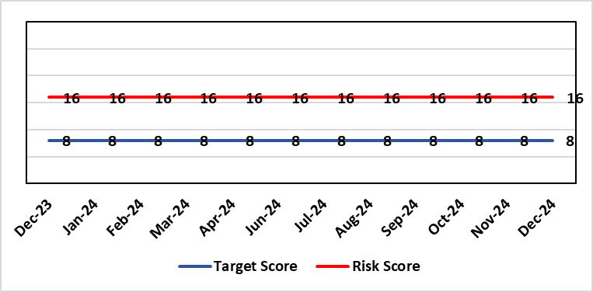 |  | Rationale for current score:  There is no immediate access to crash team/ICU facilities in in Parkway Clinic – the client group are undergoing G/A/sedation. Paediatric GA/Sedation services provided under contract from Parkway Clinic, Swansea continue due to lack of capacity for these patients to be accommodated in Secondary Care.
Level of Control  = 60% |  |  | Rationale for target score:  Relocation of the paediatric GA service [provided by Parkway Clinic] to a hospital site being treated as a priority.
Date added to the HB risk register
4th July 2018
Controls (What are we currently doing about the risk?) |  |  | Mitigating actions (What more should we do?)
Consultant Anaesthetist present for every General Anaesthetic clinic.  Assurance Documentation supplied by Parkway Clinic including confirmation of arrangements in place with WAST and Morriston Hospital for transfer and treatment of patients  New care pathway implemented - no direct referrals to provider for GA.  Multi-drug sedation ceased from Sep 2018 in line with WHC 2018 009  Revised SLA/Service Specification  HIW Inspection Visit Documentation provided to HB  All extended GA cases require approval from paediatric specialist prior to treatment |  |  | Action | Lead |  | Deadline
 |  |  | Include transfer of services from Parkway on new theatre programme. Options to be considered by Theatre Planning Group | Associate Service Group Director (Surgery) |  | 31/01/2025
Assurances (How do we know if the things we are doing are having an impact?)  RMC (Referral Management Centre) collate referral and treatment outcome data for review by Paediatric Specialist  Regular clinical meeting arranged with Parkway to discuss individual cases/concerns  Regular clinical/ management meeting for CDS/primary care management team to discuss service pathway /concerns/issues arising |  |  | Gaps in assurance (What additional assurances should we seek?)  Deputy COO led Task & Finish Group is no longer in place – it will need to be re-established to progress transfer when theatre capacity is agreed.  Pressures on the POW special care dental GA list and this service is considered alongside any plans for the Parkway contract.
Additional Comments / Progress Notes
05/12/2024: Action updated.

Datix ID Number: 1605  Health & Care Standard: |  |  | HBR Ref Number: 63  Risk Target Date: 31/01/2025 | Current Risk Rating  3 X 4 = 12
Objective: Maternity Services |  | BAF Ref: 2.8 | Director Lead: Hazel Powell, Executive Director of Nursing and Christine Morrell, Director of Therapies & Health Sciences  Assuring Committee: Quality & Safety Committee
Risk: Screening for Fetal Growth Assessment in line with Gap-Grow (G&G).  There is not enough Ultrasound scanning & clinic capacity within Swansea Bay UHB to offer all women serial ultrasound scan screening in the third trimester in line with the UK perinatal Institute Growth Assessment Programme (GAP). Welsh Government mandate fetal growth screening in line with the GAP programme, which states serial ultrasound growth scans should be performed at three weekly intervals. There is significant evidence of the increased risk for stillbirth or neonatal mortality/morbidity (hypoxic ischaemic encephalopathy) HIE, where a fetus is growth restricted (Intrauterine Growth Restriction - IUGR) and/or small for gestational age fetus (SGA). |  |  | Date last reviewed: December 2024
Rationale for current score:
Previous score of 20 was 4 (consequence) x 5 (likelihood). Consequence score of 4 calculated due to the governance and assurance – non-compliance with national standards with significant risk if unresolved and likelihood of 5 as expected to happen daily/>50%.
The service group has reviewed the score as 3(consequence) x 4 (likelihood) due to the current progress of actions. The service group are going to monitor the implementation of three weekly scanning in the third trimester. On review in January if three weekly scanning has been achieved for a three-month period the service will consider closing this risk.
Risk Rating  (consequence x likelihood):  Initial: 4 x 3 = 12  Current: 3 x 4 = 12  Target: 3 x 4 = 12 | 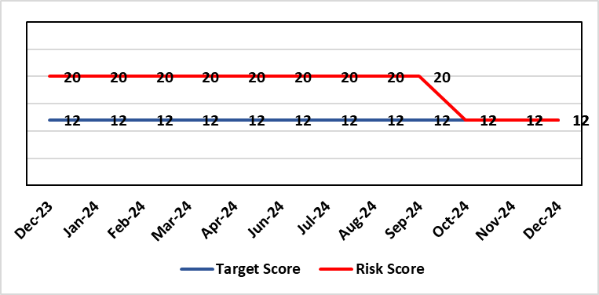
Level of Control  = 60% |  |  | Rationale for target score:  When the service is able to provide third trimester ultrasound scan in line with GAP recommendations, we will be providing care in line with evidence based best national practice as mandated by Welsh Government. Risk Target Date indicates when outcome of potential scanning/review capacity solutions anticipated and sustained implementation is confirmed.
Date added to the HB risk register
1st August 2019
Controls (What are we currently doing about the risk?) |  |  | Mitigating actions (What more should we do?)
All staff are required to complete the GAP GROW eLearning on an annual basis. Compliance is monitored via the Training & Education forum.  A local policy to scan women three weekly is in place.  Four qualified midwifery sonographers and a midwifery sonography lead who provides training are in place.  Lead sonographers have created a governance process for the review of scan images of babies born with a birth weight centile under 10th centile to identify themes and trends within the department and areas for quality improvement. |  |  | Action |  | Lead | Deadline
 |  |  | See Progress Notes
Assurances (How do we know if the things we are doing are having an impact?)  GAP grow training compliance >95% for Midwives and Obstetricians (Dec 2024)  Serial ultrasound scans are now being performed on a three-weekly schedule in accordance with the recommendations from the Perinatal Institute.  The detection rate of IUGR/SGA is anticipated to increase as a result of the above leading to improved antenatal management plans and intrapartum planning. We will monitor the rate of stillbirth and/or neonatal mortality/morbidity in anticipation of a reduction.  Administrative support is in place.  Lead Sonographers for Singleton and Neath and Lead Midwife sonographer have developed a governance review group which meets monthly to review all ultrasound scan images where there was a baby born under the 10th centile to identify themes and learning for quality improvement. |  |  | Gaps in assurance (What additional assurances should we seek?)
Additional Comments / Progress Notes
10/10/2024 GAP/GROW target compliance reached September 2024 – actual 96% Midwives, 100% Obstetric Team
25/10/2024 – The service are going live with three weekly scanning appointments for all women undergoing serial scans in pregnancy on the 28/10/24. All new bookings have been booked for three weekly scans. Midwifery sonography service to provide clinic in NPT site.
28/11/2024 Bronze Command Working Group to monitor ongoing capacity needs follow a period of implementation of three weekly scanning to describe the impact and consider the change in line with guidance to deliver capacity requirements in Maternity scanning.
09/01/2025: Action completed & Current position: Midwifery sonography service is in place in Singleton; Midwifery sonography service has been implemented in NPT; All women with low PAPP-A receive serial scans; Serial scans are performed 3-weekly in line with GAP Grow; GAP grow training compliance >95% for Midwives and Obstetricians. In view of this the service is reviewing this risk for potential de-escalation, in discussion with Executive Directors.

Datix ID Number: 2159  Health & Care Standard: |  |  | HBR Ref Number: 64  Risk Target Date: 31/03/2026 | Current Risk Rating  4 X 4 = 16
Objective: Care is delivered in safe and appropriate settings |  | BAF Ref: 3 | Director Lead: Darren Griffiths, Director of Finance & Performance  Assuring Committee: Quality & Safety Committee
Risk: Health & Safety Infrastructure  Insufficient resource and capacity of the health, safety and fire function within SBUHB to maintain legal and regulatory compliance for the workforce and for the sites across SBUHB. |  |  | Date last reviewed: December 2024
Risk Rating  (consequence x likelihood):  Initial: 5 x 4 = 20  Current: 4 x 4 = 16  Target: 4 x 3 = 12 | 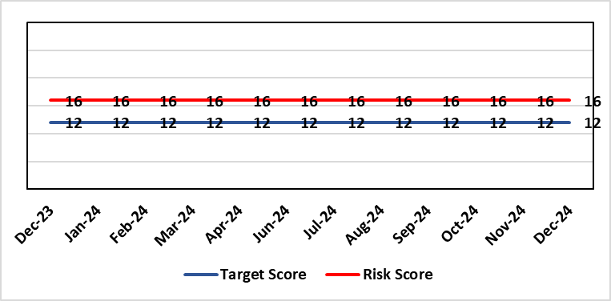 |  | Rationale for current score:  The Health Board received 12 Health & Safety Executive (HSE) improvement notices during 2019-20 covering various Health & Safety legal breaches covering a range of areas. There is the potential for future multiple notices for not meeting legal requirements.
Rationale for target score:
Compliance with the notices and to have sufficient resources to implement a sustainable health and safety provision to support the legal requirements of the Health Board and demonstrate that suitable resources are in place to undertake the roles and responsibilities of the department, also to undertake suitable and sufficient training, provide corporate overview/audit to ensure practices are being employed in the workplace.
Level of Control
= 70%
Date added to the HB risk register
September 2019
Controls (What are we currently doing about the risk?) |  |  | Mitigating actions (What more should we do?)
- Assistant Director of Health and Safety in post to support strengthening and develop the H&S function to support the organisation. Business case submitted for additional resources.  - Health and Safety Operational Group and the Health and Safety Committee monitor compliance. Refreshed the Fire Safety Group with additional controls in place.  - Fire risk assessments are being prioritised with temporary additional resources put in place in March 2021 to reduce the number of FRA overdue, and brought up to date. However, due to leavers and recruitment, resource levels have fluctuated along with compliance levels that are continually monitored.  - Fire training in place and fire wardens in place  - Fire risk assessment schedule in place for the next 12 months to maintain 100% compliance of completion and is regularly reviewed |  |  | Action |  | Lead | Deadline
 |  |  | Review the staffing structure within the Health & Safety function |  | Assistant Director of H&S | 31/03/2025
Assurances (How do we know if the things we are doing are having an impact?)  - Monitoring through the appropriate group/committees (H&S committee) to receive assurance and or identify gaps for key compliance and adherence to applicable legislation.  - Site visits/tours to identify compliance and gaps in compliances. |  |  | Gaps in assurance (What additional assurances should we seek?)  Health and safety, capital and estates now sit under the umbrella of Finance and is currently going through a restructure, with the H&S structure also included in this and will be phased in, with a target date of 31/03/2026.
Additional Comments / Progress Notes
25/10/2024: There has been a senior structure review, with some portfolio changes. The next stage is to review the portfolio structure and provide a structure that will be recommended to the Health Board for implementation, this will likely be on a phased approach.

Datix ID Number: 1834  Health & Care Standard: |  |  | HBR Ref Number: 66  Risk Target Date: TBC | Current Risk Rating  5 X 5 = 25
Objective: Cancer Care |  | BAF Ref: 2.6 | Director Lead: Richard Evans, Executive Medical Director  Assuring Committee: Quality & Safety Committee
Risk: Access to SACT (Cancer Services)  The demand & complexity of planned treatment regime for cancer patients requiring chemotherapy currently exceed the available chair capacity, risking unacceptable delays in access to SACT treatment in Chemotherapy Day Unit with impact on targets and patient outcomes. |  |  | Date last reviewed: December 2024
Risk Rating  (consequence x likelihood):  Initial: 5 x 5 = 25  Current: 5 x 5 = 25  Target: 2 x 2 = 4 | 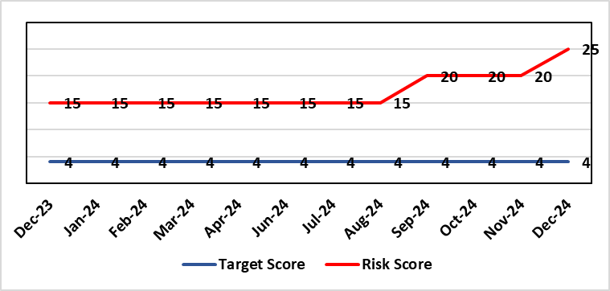 |  | Rationale for current score:  Due to staff sickness across the Multi-Disciplinary Team, the demands for SACT outstripping capacity and the three bank holidays in December, the risk has increased to 25.  There are continuing workforce challenges in CDU and PTS. Patient waiting times and the number of patients breaching SACT targets are increasing due to increased demand, therefore increasing the risk 25 (December 2024).
Level of Control
=
Date added to the HB risk register  30/11/2019 |  |  | Rationale for target score:  Reduced delays in treatment will reduce risk of harm.
Controls (What are we currently doing about the risk?) |  |  | Mitigating actions (What more should we do?)
Review of scheduling by staff to ensure all chairs used appropriately.  Previous business case endorsed by CEO for shift of capacity to home care.  A Daily scrutinizing process in progress to micro manage individual cases, deferrals etc.  Changes made to prescribing & authorising processes to improve workflow for PTS reducing potential delays to supply and administration of treatment.  Responsibility for checking bisphosphonate prescriptions in CDU moved to nursing staff to free up Pharmacy capacity allowing them to focus on key clinical tasks within Pharmacy.  Joint project with Nuclear Medicine to streamline pathways and prioritise SACT patients appropriately halved the average time waiting for MUGA/EDTA tests required before starting SACT.  Increased homecare capacity  Adopted principles from UK SACT board publication: General Principles to Support Systemic anti-Cancer Therapy Aseptic Pressures September 2023 |  |  | Action | Lead | Deadline
 |  |  | A demand and capacity options paper has now been shared with the Service Group SLT and agreed in principle. Paper going to CPIG and Exec Board in January 2025 meetings for approval. | Divisional Manager (Cancer) | 24/01/2025
Assurances (How do we know if the things we are doing are having an impact?)  Additional funding agreed to support increase in nurse establishment to appropriately staff the unit during its main opening hours. Additional scheduling staff also agreed. This funding has been utilised but with further increase demand further funding for Pharmacy and Nursing would be required  Pre-Assessment process has been separated from start date in an attempt to fill deferral slots at short notice where possible. Improved communication between MDT to streamline booking and deferral process.  Continue to monitor patient experience via friends and family in conjunction with the Welsh Cancer Patient Experience Survey results under our PTR procedures. Monitoring our waiting times against new SACT metrics, which is a measure based on treatment intent and is no longer reported as average waiting time so is more linked to expected outcomes etc. This performance metric is included in our Cancer Performance report we send to WG and Management Board and internally via governance arrangements with NPTSSG where Oncology services sit.  SBU Capacity Task and Finish group meeting monthly to analysis demand and capacity gap.  Common themes for delays will continue to be identified and analysed each month. A quarterly report will be provided to the SACT, Consultant meeting and Division Business meeting to inform of the outcome  Main breach causes are due to CDU capacity and SACT booking delays. Quarterly reports demonstrate this trend. Further work being done on new ways of working and possible increase in chair capacity & workforce.  April: 64% patients breached P2 (average number of days over is 4)  56% patients breached P3 (average number of days over is 3)  …  Sep: 94% patients breached P2 (average number of days over is 13)  92 % patients breached P3 (average number of days over is 8)  Nov: 86% patients breached P2 (average number of days over is 15)  61% patients breched P3 (average number of days over is 3)  Welsh SACT performance metrics – P2 to start within 14 days. P3 to start within 21 days |  |  | Gaps in assurance (What additional assurances should we seek?)  Workforce requirements are to be mapped to demonstrate additional capacity required to meet current and future predicted SACT Demand.
Additional Comments / Progress Notes
December 2024:
- Deterioration in waiting time to SACT which has now increased to 6-8 weeks, dependent on regimen. The current increase from 30 to 42 days from DTT is due to the sustained and increasing demand but has been exacerbated by losing 3 normal working days for Christmas Day, Boxing Day and New Year’s Day.
- The Service Group SLT approved the increase in Risk Rating from 20 to 25 and the options for increasing immediate chair capacity to reduce waiting times
- Increased scrutiny and escalation of chemotherapy booking diary implemented with daily scrutiny by lead consultants.
- Clinical priority reviews being undertaken of patients on the cancellation list to ensure that they are being booked in clinical priority
- Approached Velindre and Hywel Dda to establish whether they can provide short term support. Appropriate patients are being identified for treatment in Hywel Dda on a case by case basis.
- Approval in principle from Service Group SLT for submission of the paper to Execs to support the medium term plan to increase Oncology SACT by 2 chairs with investment into Cancer Services and Pharmacy Services which will now be shared with Executive Directors for consideration.

Datix ID Number: 1418  Health & Care Standard: |  |  | HBR Ref Number: 69  Risk Target Date: See Target Rationale |  | Current Risk Rating  5 X 4 = 20
Objective: Children & Young People Services |  | BAF Ref: 2.7 | Director Lead: Deb Lewis, Chief Operating Officer  Supporting Director: Hazel Powell, Executive Director of Nursing  Assuring Committee: Quality & Safety Committee
Risk: Risk of issues related to adolescent patients being admitted to Adult MH inpatient wards- Inappropriate settings resulting in 'Safeguarding Issues' The WG has requested that HBs identify Secondary Care in -patient facilities for the care of adolescents- in Swansea Bay University Health Board Ward F NPT hospital is the dedicated receiving facility with one bed identified. |  |  | Date last reviewed: December 2024
Risk Rating  (consequence x likelihood):  Initial: 2 x 3 = 6  Current:5 x 4 = 20  Target: 2 x 3 = 6 | 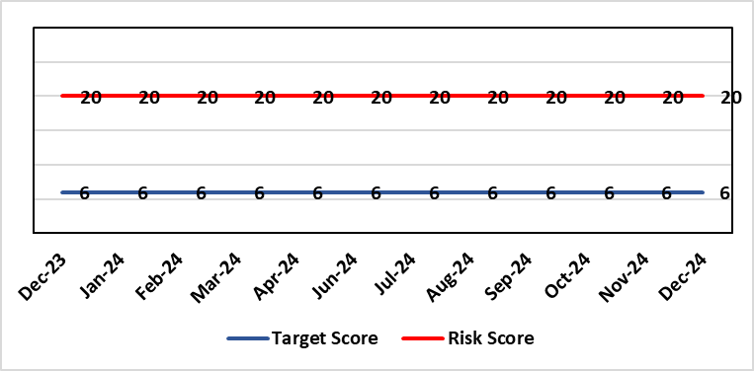 |  | Rationale for current score:  Every health board is required to have an admission facility for adolescent Mental Health patients. Whilst ward F has been identified as the single point of access in SBU and provides access to a bed for adolescent admissions if available at the time of request it is a mixed sex adult ward. Therefore the facilities are less than ideal for young patients in crisis.
Level of Control
=
Date added to the HB risk register  27/02/2020 |  |  | Rationale for target score:  The longer term aim for the Health Board remains to create an admission facility for adolescent Mental Health patients but this will not be possible until the new Adult Inpatient Unit is built.
Controls (What are we currently doing about the risk?) |  |  | Mitigating actions (What more should we do?)
Safeguarding Training for Staff, Joint protocol with Cwm Taf LHB [CAMHS] currently subject to review, Local SBUHB policy on providing care to young people in this environment. This includes the requirement for all such patients on admission to be subject to Level 3 Safe and Supportive observations.  Only Adolescents within 16-18 age range are admitted to the adult ward.  The health board works with CAMHS to make sure that the length of stay is as short as possible. |  |  | Action | Lead |  | Deadline
 |  |  | Next service group review of effectiveness of current controls. | MH&LD Head of Operations & Clinical Directors |  | 31/12/2024
Assurances (How do we know if the things we are doing are having an impact?)  Individual Rooms with en Suite Facilities, Joint working with CAMHS, monitoring of staff training, Monitoring of admissions by the MH&LD SG Legislation Committee of the Health Board. The ongoing issues with the risks presented by the use of this has recently been raised at an all Wales level with Welsh Government and a formal review is anticipated. The Service Group continues to flag the risk particularly in light of Ward F being identified as the SPOA for AMH in the Health Board which has resulted in an increase in acuity and a greater concentration of individuals who are experiencing the early crisis of admission - this has served to increase the already identified risks for young people in the environment. |  |  | Gaps in assurance (What additional assurances should we seek?)
Additional Comments / Progress Notes
15/09/2024: Joint Service Director review indicates nothing has changed in relation to service provision and the controls mentioned are still in place with no changes.
25/10/2024 No change to the current arrangements and controls. The Health Board is still awaiting the outcome of its capital prioritisation requests to Welsh Government of which the Adult Inpatient new build case is a part.

Datix ID Number: 1832  Health & Care Standard: |  |  | HBR Ref Number: 80  Risk Target Date: 31/12/2024 | Current Risk Rating  4 x 5 = 20
Objective: Urgent & Emergency Care |  | BAF Ref: 2.4 | Director Lead: Deb Lewis, Chief Operating Officer  Assuring Committee: Quality & Safety Committee
Risk: Transfer of Clinical Optimised Patients  A deficit in the availability of appropriate community / domiciliary care results in unacceptable delays in discharging patients from acute hospital beds. As a result, patients can decompensate and never gain the independence that could have been available from an early discharge. |  |  | Date last reviewed: December 2024
Risk Rating  (consequence x likelihood):  Initial: 4 x 5 = 20  Current: 4 x 5 = 20  Target: 4 x 2 = 8 |  |  | Rationale for current score:  - Sustained levels of clinically optimised patients (COPs) leading to overcrowding within ED, use of inappropriate or overuse of decant capacity in ED and delays in accessing medical bed capacity, clearly emerged as themes.  - Constraints in relation to all patient flows out of Morriston to a more appropriate clinical setting, identified and included in an expanded risk.  - Delay in discharge for clinically optimised patients can result in deterioration of their condition.
Level of Control
= 25%
Level of Control  = 25% |  |  | Rationale for target score:  Targeted reduction of Clinically Optimised patients remains a priority for the HB in order to minimise risk of avoidable harm to patients within the HB and in the wider community.
Date added to the risk register
May 2021
Controls (What are we currently doing about the risk?) |  |  | Mitigating actions (What more should we do?)
- One of the measures under targeted intervention is to see a reduction in pathway of care delays, which specifically supports the reduction in the number of clinically optimised patients.  - Review is undertaken on a patient by patient basis – with explicit action agreed in order to progress transfer to appropriate clinical setting.  - Critical constricts in relation to access/time delays for social workers and assessment for package of care and social placement  - The health board continues to procure 63 additional care home and hospital beds to provide additional discharge capacity.  - Clinically optimised patients (COP) have been cohorted into the available capacity at Singleton Hospital to ensure that their needs can be met more appropriately. This has reduced the number of COPs at Morriston Hospital. Weekly escalation meetings are held with health and social service colleagues to ensure the requirements of the patients are reviewed and patients are pulled through the system where possible. |  |  | Action |  | Lead | Deadline
 |  |  | The Care Action Committee (CAC) is focussing on reducing the impact of COPs within acute hospitals. The HB is actively engaging with the work from the CAC and currently developing the Winter Plan for 24/25, of which reducing COPs will be a key focus. This work is being taken forward by the Interim Head of Integrated Services in PCT to ensure cross-boundary support. |  | Interim Head of Integrated Services – PCT | 30/11/2024
Assurances (How do we know if the things we are doing are having an impact?)  - Patient level dashboard allows breakdown by delay type  - Close management of utilization of additional care home beds. |  |  | Gaps in assurance (What additional assurances should we seek?)
Additional Comments
14/10/2024: Action refreshed. This remains a current risk. It will be the main focus of the Winter Plan currently being developed and is also a key focus of the Care Action Committee.

Datix ID Number: 2561  Health & Care Standard: |  |  | HBR Ref Number: 85  Risk Target Date: 30/04/2025 | Current Risk Rating  4 x 5 = 20
Objective: Children & Young People Services |  | BAF Ref: 2.7 | Director Lead: Christine Morrell, Director of Therapies & Health Sciences  Assuring Committee: Quality & Safety Committee
Risk: Non-Compliance with ALNET Act There are risks to the Health Board’s ability to meet its statutory duties and establish the effective collaborative arrangements required by the ALN Act, which is being implemented through a phased approach. This risk is caused by:  - Lack of staff resource needed to carry out the additional work needed to comply with the ALN Act for operational services, especially those in the PCST Service Group.  - Implementation of the Act for those of above compulsory school age (post-16) commenced in September 2023. This presents risks because of gaps in service provision.  - Multiple pressures for operational services are impacting on capacity / engagement of leads within impacted services to progress tasks that need to be undertaken to mitigate the risks and current vacancy in ALN Project Manager post.  - Issues with Data Quality due to pressure on ALN and Service administration teams, process issues and absence of a robust system to enable data capture and analysis. This means that accurate and up-to-date data regarding the Health Board’s compliance is not available.  Potential consequences of this risk are: non-compliance with statutory duties, parent / carer and young peoples' dissatisfaction leading to complaints. Educational Tribunals and Judicial Reviews (this is new legislation with many points of ambiguity and is highly likely to be legally ‘tested’); reputational impact; and children failing to access the multi-agency support that they need with their learning needs, leading to poor outcomes. |  |  | Date last reviewed: December 2024
Rationale for current score:
Risk score reflects that while controls are in place, there are multiple areas of risks (relating to compliance with legislation; governance and assurance; workforce and OD; and sustainable services); and high probability (especially given multiple risk areas) of at least one of these areas of risk being realised. Caused by implementation timetable for the ALN Act, slippage against plan and need for strengthened governance (as described in ‘Risk’ section).

Risk Rating  (consequence x likelihood):  Initial: 5 x 5 = 25  Current: 4 x 5 = 20  Target: 2 x 3 = 6 |  |  | Rationale for target score:  As the ALN Act is new legislation, there remains some ongoing likelihood of risk events during the initial phases of implementation, though with lessened consequences as a result of mitigating actions.
Level of Control
=
Date added to the HB risk register
14/05/2022

Controls (What are we currently doing about the risk?) | Mitigating actions (What more should we do?)
- Progressing the necessary work within an appropriate structure (see under ‘ACTIONS’) are constrained by financial and/or service delivery pressures.  - DECLO (Designated Educational Clinical Lead Officer) is in post - this is a statutory requirement.  - Health Board ALN Steering Group has been established, with governance structure in place involving the ALN Operational Group working under the governance of this  - Operational processes through which the Health Board fulfils its statutory duties under the ALN Act are in place.  - Ongoing collaboration between the DECLOs at a national level ensures a broadly consistent approach across Wales to how Health Boards fulfil their requirements under the ALN Act. Some ongoing differences remain because of different Local Authority approaches, through Welsh Government have formed a national group to support improved consistency around Health-Education collaboration through the ALN Act.  - Regarding demand / capacity and staffing resource challenges, WG has a phased implementation timetable that has recently been extended from summer 2024 to summer 2025. From summer 2025, the Act will be fully in ‘delivery as usual’. The phased implementation offers partial short-term mitigation of the risks.  - Awareness has been raised at Board level through Development session and bi-monthly updates are provided to the Patient Safety & Compliance Group.  - Welsh Government have been engaging with the Designated Education Clinical Lead Officers on a national basis regarding ALN key performance indicators and compliance. A Welsh Health Circular requiring regular reporting against statutory key performance indicators is anticipated in the coming months.  - Audit and Assurance Services have conducted an audit of the Health Board in relation to the ALN Act, which provided an overall ‘limited assurance’ rating. Management responses have been developed and a work plan is in place, monitored through the ALN Steering Group, to address issues identified in the audit. | Action | Lead | Deadline
 | Securing longer-term administrative and project management support needed to mitigate risks | DoTHS | 31/01/2025
 | Progress action plan in relation to ALN audit | DECLO | 31/03/2025
 | Review the Health Board’s compliance with its legal requirements under the ALN Act based on data collected through the new ALN App for January – March 2025, and reassess the level of risk for noncompliance with the ALN Act based on this | DECLO | 30/04/2025
Assurances (How do we know if the things we are doing are having an impact?)  - There is regular reporting in respect of the ALN Act through the Patient Safety and Compliance Group.  - ALN Steering Board has been established, ensuring oversight at a senior level within all impacted operational and corporate areas.  - DECLO meets regularly with ADOTHS / DoTHS of the 3 health boards of South-West and Mid Wales for update and assurance.  - National ALN Reform Steering Group has been formed and will include Health representation (SBU Deputy DOTHS). This will provide a national forum for consideration of risks. | Gaps in assurance (What additional assurances should we seek?  - Extent of gap in staffing resource (gap between work required and capacity available) has been provisionally quantified, but data is imperfect and there remains some uncertainty. This is in a context where demands will increase significantly over the next year.
Additional Comments / Progress Notes
02/01/2025: The action ‘Effective, realistic operational processes’ has now been completed. Due to activity that has been progressed to mitigate the Health Board’s risk for noncompliance with duties under the ALN Act, it is anticipated that from now on the Health Board will be producing accurate and reliable data regarding its compliance with the statutory requirements of the ALN Act. Based on data from January – March 2025 it will be possible by 30th April 2025 to re-assess the level of the Health Board’s risk for non-compliance with its legal duties under the ALN Act and hopefully to reduce the current level of reported risk. Work to progress the action plan developed in response to the ALN Audit is on track for completion by 30/03/2025. There is likely to be slippage against the action to bring in project management capacity by 31/01/2025; an update will be provided next month.

Datix ID Number: 3071  Health Care Standards: |  |  | HBR Ref Number: 89  Target Risk Date: TBC | Current Risk Rating  4 x 5 = 20
Objective: Primary & Community Care |  | BAF Ref: 2.2 | Director Lead: Hazel Powell, Executive Director of Nursing  Supporting Director: Deb Lewis, Chief Operating Officer  Assuring Committee: Quality & Safety Committee
Risk: Healthcare Nursing Staff Levels at HMP Swansea  There is a risk that the men in HMP Swansea will not receive the appropriate standard of care. This is due to the fact that the nursing establishment within the prison no longer fully meets the changed demographics and numbers of men being detained. The maximum operational capacity of the Prison can reach circa 480 men. The Health Board investment into the Prison is based on delivering services to 250 men. This was also highlighted as a risk in the June 2022 HIW governance review. In addition there is no head room built into the Prison nursing establishment so periods of sickness, leave and study renders the roster short. |  |  | Date last reviewed: December 2024
Risk Rating  (consequence x likelihood):  Initial: 4 x 5 = 20  Current: 4 x 5 = 20  Target: 2 x 2 = 4 | 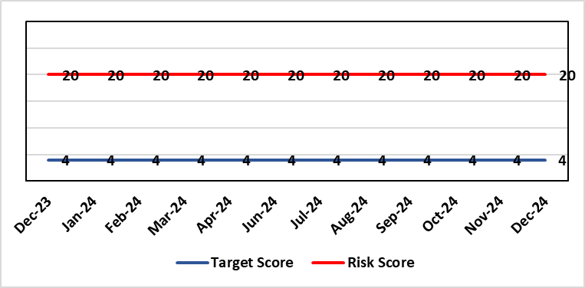 |  | Rationale for current score:  Consequence major – unable to fully deliver on the recommendations of HIW due to low healthcare staffing numbers, further impacted during periods of sickness or absence as no headroom. Recommendations also raised in Prison & Probation Ombudsman reports. Likelihood expected – suboptimal care provided on a daily basis.
Level of Control  = % |  |  | Rationale for target score:  Consequence minor – With sufficient staffing numbers the prison will be able to deliver on HIW recommendations and fully implement the actions in the Health Delivery Plan. Likelihood unlikely – With full establishment and headroom, suboptimal care is less likely.
Date added to the risk register
30/11/2022
Controls (What are we currently doing about the risk?) |  |  | Mitigating actions (What more should we do?)
Daily communication with the Governor about the availability and priority of healthcare nursing staff.  Pharmacy technician role established – can administer drugs to support nursing establishment.  Agreed that Health Care Support Workers to be 2nd checkers for CD drugs and to support substance withdrawal monitoring (awaiting accreditation).  Bank and agency staff are used in a limited way, when skillset allows.  E-roster implemented and scrutinised with regular reporting to Service Group Patient Safety & Compliance Group.  Escalation for overtime and additional hours to fill shortfalls. |  |  | Action | Lead | Deadline
 |  |  | Review of staffing in prison | Deputy Head of Nursing | 31/01/2025
Assurances (How do we know if the things we are doing are having an impact?)  Prison feedback and complaint process  Progress reporting on action plans through Service Group PS&C Group, and Health Board Q&S structures (via Patient Safety & Compliance Group). |  |  | Gaps in assurance (What additional assurances should we seek?)  Implementation and reporting of clinical audits. Audit framework for HMP Swansea in development - Clinical Pathways/Audits and Health Promotion groups taking forward.
Additional Comments
23/10/2024: Action complete – The base line assessment was completed by the proposed timeframe and we have received a draft report – management are in the process of responding to that report.
A Deputy Head of Nursing (DHoN) has been appointed and is to support review of staffing within the prison – expected completion December 2024. The findings of the baseline assessment will support the staffing review that the DHoN is undertaking.
A service specification for health protection works has been submitted to Public Health it is expected there will be investment from public protection team to support with vaccination and health protection screening work it is expected that £74,439 recurrent funding will be available for health protection works within the prison. Once funding has been confirmed and allocated there is an expectation of improved health protection health outcomes.
23/12/2024: Review of staffing is ongoing. We await the current health needs assessment (HNA) report on prisoner health to align resource & skill mix required to meet needs. Action target adjusted reflecting wait for receipt of HNA.

Datix ID Number: 3516  Health Care Standards: |  |  | HBR Ref Number: 94  Risk Target Date: TBC |  | Current Risk Rating  4 x 3 = 12
Objective: Mental Health & Learning Disability Services |  | BAF Ref: 2.3 | Director Lead: Deb Lewis, Chief Operating Officer  Assuring Committee: Performance & Finance Committee  For information: Quality & Safety Committee
Risk: CAMHS failure to meet required standards of performance  The CAMHS service is unable to meet the required level of performance due to workforce deficits in the team across all staff groups including medics, psychological therapies and nursing.  Links to other CAMHS risk register entries: (Ref: 3410/3373/3351/3346/3349/3350) |  |  | Date last reviewed: December 2024
Risk Rating  (consequence x likelihood):  Initial: 4 x 5 = 20  Current: 4 x 3 = 12  Target: 3 x 3 = 9 | 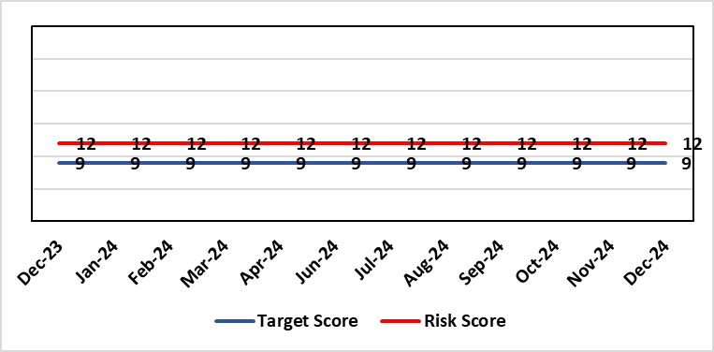 |  | Rationale for current score:  Marked improvement in the performance against the Mental health Measure for CAMHS. Data validation for new patients complete. Current risk score reduced to 12 in view of improved performance however this reflects the fragility in the workforce to deliver sustained performance.
Level of Control  = % |  |  | Rationale for target score:  The rationale for the target score is linked to successful recruitment and more timely access to services for children and young persons which will reduce risk.
Date added to the risk register
October 2023
Controls (What are we currently doing about the risk?) |  |  | Mitigating actions (What more should we do?)
-Ongoing recruitment into all staff groups  -Temporary agency workforce in nursing at premium pay rates to sustain current levels of performance  -Use of locum medical staff due to high vacancy level on medical workforce.  -Recent appointment into psychological therapies lead posts. |  |  | Action | Lead |  | Deadline
 |  |  | Continued efforts at recruitment | Acting Associate Service Director |  | Monthly review
Assurances (How do we know if the things we are doing are having an impact?)  -Monthly CAMHS Directorate meeting in place where performance and workforce are scrutinised  -Reporting into Weekly Business Team and MH & LD management board.  -Reporting into SBU Performance & Finance Committee and IQPD (Integrated Quality & Performance Delivery) meeting with Welsh Government  -Ongoing validation of the waiting list to ensure robust reporting going forward |  |  | Gaps in assurance (What additional assurances should we seek?)
Additional Comments / Progress Notes
25/10/24: Sept 2024 compliance is 92% so now within the national required target for the past two months. Recruitment is still proving difficult which the service is continuing to manage so the risk will need to remain the same until we secure the required substantive workforce.

Datix ID Number: TBC  Health Care Standards: |  |  | HBR Ref Number: 102  Risk Target Date: 31/01/2025 |  | Current Risk Rating  4 x 4 = 16
Objective: Maternity Services |  | BAF Ref: 2.8 | Director Lead: Hazel Powell, Executive Director of Nursing  Assuring Committee: Quality & Safety Committee  For Information: Workforce & OD Committee
Risk: Inability for maintaining Birthrate Plus® compliant rosters  Birthrate Plus® enables health boards to calculate their midwifery staffing requirements based on their specific activity, case mix, demographics and skill mix.  There is a risk non-compliance with roster templates due to increased acuity, unplanned staff absence and vacancies. The potential impact of this may be reduced staffing levels against the agreed Birthrate Plus ®, staffing template resulting in poor patient outcomes and experience, and potential suspension of services. |  |  | Date last reviewed: December 2024
Rationale for current score:
The vacancy position has improved for Band 5 & 6 registered staff – there are no vacancies. The risk was reduced from 25 to 20 initially and on further assessment is being reduced to 16. Whilst the service is now over-established with registered midwives, the score will be moderate (16) due to unregistered vacancies (which will concluded in September following job evaluation and new JD’s to support the unregistered workforce) and unavailability (due to parenting leave, mandated study leave and sickness). There are improved numbers of registered midwives per shift with most shifts achieving the required 14 midwives. Additional staff in AAU have been put in place to ensure two on duty at all times in line with the RCOG Good Practice Guidelines for Maternity Triage.
Risk Rating  (consequence x likelihood):  Initial: 4 x 5 = 20  Current: 4 x 4 = 16  Target: 4 x 4 = 12 | 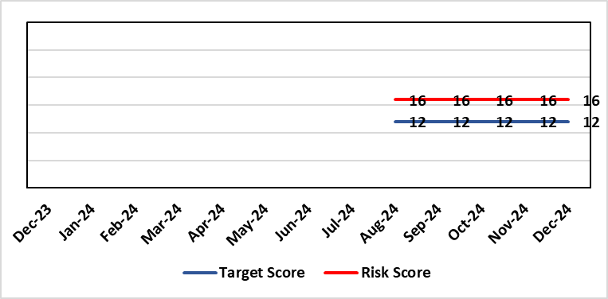
Level of Control  = |  |  | Rationale for target score:  It is intended through resolution of the unregistered job evaluation process and the recruitment of new unregistered workforce that the unavailability position will improve. Further, on review of the community Intrapartum pathways being re-established that the acuity on the Singleton site will lessen as women have all options for birth open to them and that via risk assessment women will be enabled to birth in the right settings.  Projected decrease in unregistered vacancies by end of 2024.
Date added to the risk register
11/09/2024
Controls (What are we currently doing about the risk?) |  |  | Mitigating actions (What more should we do?)
- The Health board has put the following controls in place:  - Service Group Nurse Director chairs fortnightly roster scrutiny meetings to ensure effective deployment of staff.  - All midwives are working at the hours they require up to full time.  - Specialist midwives and management redeployed to support clinical care as required  - Birth rate plus Intrapartum acuity tool completed 4 hourly to guide safe service provision and escalation  - Escalation meeting held daily during the week to review rotas and reallocate staff as required chaired by Head of Midwifery  - Escalation guidelines in place to support actions during periods of increased acuity  - Morning safety huddle for community midwifery teams  - Morning safety huddle for obstetric unit generates RAG-rated daily acuity and shares this with the Service Group for its daily meeting.  - Additional shifts offered via Bank, additional hours and overtime at enhanced rates  - Utilisation of off-contract midwifery agency authorised by Executive Director of Nursing  - Open advert for recruitment on TRAC (recruitment system)  - On-Call Manager Rota in place.  - International recruitment campaign initiated with MEDACS.  - Offer of additional support worker shifts particularly in the postnatal area for additional support for women  - Maternity Care Assistance (MCA) role in place to support Midwives in providing care in women and their families.  - Regular communication with stakeholders includes: Early warnings to Welsh Government; Verbal and formal communication with Llais; Internal communications on home births, RCM updates; weekly staff briefings and bulletins.  - Maternity Services Improvement & Assurance Board continue, meeting fortnightly, chaired by NPTS Nurse Director. This is reported into the Midwifery & Neonatal Service Performance Board in place chaired by EDON |  |  | Action | Lead |  | Deadline
 |  |  | Recruitment of 6.27 WTE (whole time equivalent) Band 2 HCA (health care assistant) positions at Singleton: will commence on completion of job matching of current workforce into band 3 posts following job evaluation implementation plan expected end of September | HOM |  | 31/03/2025  New date for completion to be advised on completion of band 3 competency assessment
 |  |  | Work is being undertaken to complete job planning at middle grades to support BSOTS. | Directorate Manager |  | 31/07/2025
Assurances (How do we know if the things we are doing are having an impact?)  The following assurance mechanisms in place currently:  Birth-rate Plus Intrapartum acuity tool completed 4 hourly  X3 weekly look ahead of rosters to alert and mitigate against unexpected staff absence  Daily staff safety briefings chaired by Head of Midwifery which considers sickness & other absences and daily review of safety and quality outcomes.  The Group Head of Quality Safety & Risk is supporting daily oversight of Datix incidents. The following red flag events are monitored:  • Delayed or cancelled elective caesarean sections;  • Missed or delayed care incidents;  • Delayed or cancelled induction of labour;  • Delay of 2 hours or more between admission for induction of labour and beginning of process;  • Delay of 30 minute or more between presentation and triage. |  |  | Gaps in assurance (What additional assurances should we seek?)
Additional Comments / Progress Notes
10/10/2024: Implementation of BSOT to commence in October 2024 following completion of a complex implementation framework which includes Job Planning for Obstetric cover and the arrangement of appropriate safe waiting areas for women on the three escalation pathways for review.
09/01/2025: Actions completed: (i) Seventeen newly qualified midwives through streamlining to commence employment from October 2024 onwards. All to be in post from December 2024; (ii) Business case for implementation of BSOTS (Birmingham Symptom Specific Obstetric Triage System) in the Ante Natal Assessment Unit developed and a new AAU pathway and documentation process is in place. Consultant job planning to support BSOTS is complete. Work to complete job planning at middle grades is ongoing currently. Current position is: the establishment has no registered staff vacancies. Birthrate plus compliance has been achieved. Turnover is reviewed monthly as part of enhanced monitoring – this has identified minimal turnover in the department. Bank and agency usage only for short term sickness. We are waiting for the Band 2 and 3 progression to complete so we are able to reassess what vacancy we will have at this level. The current risk level is being reviewed with Executive Directors with a view to possible reduction & de-escalation of the risk.

Datix ID Number: TBC  Health Care Standards: |  |  | HBR Ref Number: 103  Risk Target Date: 31/01/2025 |  | Current Risk Rating  4 x 4 = 16
Objective: Maternity Services |  | BAF Ref: 2.8 | Director Lead: Hazel Powell, Executive Director of Nursing  Assuring Committee: Quality & Safety Committee  For Information: Workforce & OD Committee
Risk: High Quality Choices in Place of Birth  There is a risk of not being able to provide high quality choices in place of birth (via appropriately staffed and resourced community midwifery teams, the freestanding midwifery unit at Neath Port Talbot Hospital, the alongside midwifery unit and obstetric unit at Singleton Hospital). The potential impact of this is poor patient experience and birth outcomes, poor staff morale and increased attrition of community midwives, increased acuity within obstetric services at Singleton Hospital, and the reduction of services could impact on organisational reputation. |  |  | Date last reviewed: December 2024
Rationale for current score:
Womens birth choices had been limited resulting in women choosing to freebirth, employ private midwives or transfer their care to neighbouring Health Boards to support their birth choice.
The service had experienced increased complaints and enquiries from women seeking support for intrapartum community pathways of care
Risk Rating  (consequence x likelihood):  Initial: 4 x 4 = 16  Current: 4 x 4 = 16  Target: 4 x 3 = 12 |  |  | Rationale for target score:  Re-instatement of community Intrapartum pathways of care.  Increased positivity of women’s experience and choice for birth
Level of Control
=
Date added to the risk register
11/09/2024
Controls (What are we currently doing about the risk?) |  |  | Mitigating actions (What more should we do?)
The Health board has put the following controls in place:  - Maternity and Neonatal Assurance Boards Chaired by the NPTSSG Group Nurse Director  - Senior Leadership Team Weekly Meeting  - Morning safety huddle for community midwifery teams  - Ongoing assurance and monitoring of complaints or concerns identified by the women  - ‘Transfer Meeting’ to review cases of women transferring from the NPT Birth Centre or Home into the Obstetric Unit at Singleton Hospital to assess any learning or improvements to be made  - Maternity Services Improvement & Assurance Board continue, meeting fortnightly, chaired by NPTS Nurse Director. This is reported into the Midwifery & Neonatal Service Performance Board in place chaired by EDON |  |  | Action | Lead |  | Deadline
 |  |  | See progress notes
Assurances (How do we know if the things we are doing are having an impact?)  The Group Head of Quality Safety & Risk is supporting daily oversight of Datix incidents. The following red flag events are monitored:  - Inability to provide choice for place of birth  - Delayed transfer to the Obstetric Unit  - Adverse outcomes as a result of place of birth outside of the Obstetric Unit |  |  | Gaps in assurance (What additional assurances should we seek?)
Additional Comments / Progress Notes
10/10/2024 Birth Centre re-opened on 16th September. Community Home Birth pathways due to commence on the 21st October 2024.
18/11/2024: Community home birth pathways recommenced 21/10/2024.
09/01/2025: Birth place options have been in place for a period of 3-4 months respectively for NPT Birth Centre and Home Birth options. This has been a sustained service without interruption or impact on staffing, acuity and safety of the Obstetric Unit in Singleton. The Escalation Policy business continuity options have been used in line with guidance intermittently and not for sustained periods. The on-boarding of the Newly Qualified Midwives, no longer supernumerary since December 2024, has further supported staffing and acuity on the Singleton Hospital site. Noting this the risk level is being reviewed with Executive Directors with a view to reduction & possible de-escalation of the risk..

Risk Score Calculation

For each risk identified, the LIKELIHOOD & CONSEQUENCE mechanism will be utilised. Essentially this examines each of the risks and attempts to assess the likelihood of the event occurring (PROBABILITY) and the effect it could have on the Health Board (IMPACT). This process ensures that the Health Board will be focusing on those risks which require immediate attention rather than spending time on areas which are, relatively, a lower priority.

