


Clostridioides difficile
(C. difficile) Standards:
Risk Assessment and Governance Framework
(Version 1.0)

Infection Prevention & Control

Responsible Author: Head of Nursing, Infection Prevention & Control
Approved by: Gold C. difficile High Incidence Management Group,
Sub-Group of Infection Prevention & Control Strategic Group
Approval date: 20 May 2025
Issue Date: June 2025
Review Date: May 2028

Clostridioides difficile (C. difficile) Standards:

Risk Assessment and Governance Framework

(Version 1.0)

Contents

Section | Title | Page
 | Table of Contents | 1
 | Version Control | 2
1 | Introduction | 3
2 | Standards for C. difficile - summary | 5
3 | Swansea Bay University Health Board (SBUHB) Standards for C. difficile (detailed) | 7
Standard 1 | Roles and Responsibilities | 7
Standard 2 | Testing | 8
Standard 3 | Isolation | 9
Standard 4 | Infection Prevention & Control Practice | 10
Standard 5 | Environment of Care | 10
Standard 6 | Antimicrobial Stewardship | 12
Standard 7 | Assessment and Management of multiple cases of C. difficile on a ward | 12
Standard 8 | Surge Capacity IP&C Risk Assessment | 13
Standard 9 | Risk Assessment and Governance Standards | 13
Standard 10 | Communication | 14
Annex 1 | Diarrhoea - Assessment of risk | 15
Annex 2 | Isolation of Patient with Suspected or Confirmed C. difficile – Assessment of Risk & Escalation | 16
Annex 3 | Cleaning – Assessment of Risk & Escalation | 17
Annex 4 | Multiple cases of C. difficile on a ward - Period of Increased Incidence/Outbreak – Risk Assessment & Escalation | 18

Version Control

Version | Date of Issue | Revisions
1.0 | tbc | First version

Clostridioides difficile (C. difficile) Standards:

Risk Assessment and Governance Framework

Introduction

Clostridioides difficile (C. difficile) is a bacterium found in the gut of humans (and animals). It can be found in people with no symptoms (colonisation) but can cause disease when there is an imbalance of the normal gut bacteria, usually because of antibiotic use. When this imbalance of the normal gut bacteria occurs, C. difficile bacteria can multiply to high numbers in the gut and, where there is a toxigenic strain of C. difficile, the toxins produced can cause inflammation and damage to the colon (colitis). Symptoms may occur within days of starting antibiotics or symptoms may occur up to 3 months later.

Clostridioides difficile infection is very unpleasant for patients. It can cause serious illness and can lead to death, particularly in elderly patients with other health conditions. It causes diarrhoeal illness, which can be mild, moderate, severe, and life-threatening. It may cause mucosal damage and inflammation of the large bowel; occasionally, patients may develop a severe, life-threatening form of the disease called ‘Pseudomembranous colitis’ resulting in severe damage to the colon.

Patients who have C. difficile infection, or those that are carriers (colonised) of C. difficile, may pose a risk to other patients nursed in the same area by being a source of C. difficile spores that, if passed onto other patients, may cause C. difficile infection in those patients. Therefore, in Swansea Bay University Health Board (SBUHB) all patients who have diarrhoea, including those whose diarrhoea is not thought be infectious in origin should be managed in a way that reduces the risks to other patients; they should have a stool sample sent to the laboratory and preventative measures should be in place including isolation of the patient until C. difficile carriage has been excluded.

Swansea Bay University Health Board has had the highest incidence of C. difficile infection in NHS Wales since its establishment in 2019. The annual number of cases has continued to increase annually since 2019/20 FY. The number of cases of C. difficile infection has exactly doubled over the 6 years from FY2019/20 to FY 2024/25 (138 cases and 276 cases respectively).
There is an increasing burden and risk of Clostridioides difficile (C. difficile) infection in the Swansea Bay University Health Board (SBUHB) population despite improvement initiatives to date. Risks for hospital patients are increasing, and this paper discusses existing Health Board protocols and guidance for the prevention and control of C. difficile, and the risks associated with inequitable cleaning hours across inpatient areas, the inability to adequately deep clean and disinfect environments contaminated with C. difficile, and the risk of exposure to, and transmission of, C. difficile to patients admitted to our hospitals.

Prevention, early diagnosis, correct treatment, and optimal and effective management is critical.

Swansea Bay University Health Board’s Quality Ambition 1¹ is to be a high quality organisation, which delivers safe and reliable care high quality care. Safe care meaning that no avoidable arm should come to patients whilst they are in our care, and reliable meaning that we deliver consistent care to a standard that patients can rely upon. However, for our patients receiving care in our hospitals in 2024/25, 73% of all C. difficile infections were categorised as hospital acquired. This was a 10.6% increase compared with the previous year.
The number of periods of increased incidence of C. difficile (PCR positive cases) reported in Datix in 2024/25 rose by 52% compared with the previous year. Outbreaks of C. difficile are those that are linked in time and place (epidemiologically linked) and linked by Whole Genomic Sequencing which confirm that transmission has occurred in hospital. The number of C. difficile outbreaks reported in Datix in 2024/25 has increased by 63% compared with 2023/24.
To improve how the health board manages C. difficile, the health board must create and promote clear standards, along with a risk assessment and governance framework. These standards will communicate clearly to all staff, patients and the public that preventing this infection is a high priority.
The standards in this framework document are based on evidence-based national guidance, best-practice guidance, and lessons learned within the health board from the robust scrutiny of healthcare associated C. difficile infection that has been established over the previous two years.
Whilst the health board may not be able to always achieve all the standards for C. difficile due to service and system pressures, it remains important that the standards are set, accepted, and promoted. It is essential that there is robust governance supporting that include escalation, reporting, and monitoring achievement of, or derogation from, the standards.
This is the right thing to do for the patients and population served by Swansea Bay University Health Board. These standards will inform future direction, developments, priorities, and plans for achieving the goal of being a high-quality organisation, which aims to reduce the incidence of C. difficile infection to be the lowest in Wales and amongst the lowest in the UK.

¹ Swansea Bay University Health Board 5 year Quality Strategy, 2023.

Standards for C. difficile - summary

Standard 1 | Roles and Responsibilities:  SBUHB has clear lines of accountability to ensure these C. difficile standards are implemented and monitored
Standard 2 | Testing:  SBUHB has established arrangements for prompt laboratory testing and reporting of C. difficile in line with national best practice standards.
Standard 3 | Isolation:  Patients with unexplained, potentially infective diarrhoea will be promptly isolated to minimise risk of transmission of infection (which will be within 2 hours of symptom onset for patients where there is a high suspicion, or a confirmed positive result, of C. difficile).
Standard 4 | Infection Prevention & Control Practice:  Infection prevention & control (IP&C) practices will be applied consistently always, by all staff, in all care settings, for all patients whether infection is known to be present or not to ensure the safety of those being cared for, staff and visitors in the care environment.
Standard 5 | Environment of Care:  SBUHB will provide a safe, clean environment that prevents and minimises the transmission of infection.  SBUHB will provide patient care equipment and furniture that has been cleaned and decontaminated between patients.  SBUHB will work towards the provision of dedicated decant facilities on acute sites to enable the thorough deep clean and high level decontamination of rooms where there has been C. difficile.  SBUHB will make every effort to ensure that patients are not admitted to an area where C. difficile was present until the area has been thoroughly cleaned using the 4D decontamination process.

Standard 6 | Antimicrobial Stewardship:  There are robust antimicrobial stewardship polices and processes in place that minimise the risk of development of C. difficile.
Standard 7 | Assessment and Management of multiple cases of C. difficile on a ward:  Minimise transmission of infection, and minimise impact on patients and services, through the effective management of:  Multiple community onset or hospital onset cases of C. difficile on a ward.  Number of confirmed C. difficile cases over a given period which prompts investigation by IPC team.  Confirmed outbreaks of C. difficile.
Standard 8 | Surge Capacity IP&C Risk Assessment:  Operational Services will review the potential IP&C impact when undertaking a risk assessment of proposed surge capacity.
Standard 9 | Risk Assessment and Governance Standards:  To ensure patient safety and minimise the risk of C. difficile infection, SBUHB has a robust risk assessment and governance framework for decisions relating to C. difficile.
Standard 10 | Communication:  Clear, accessible IP&C advice must always be available, including out-of-hours. A governance process must support escalation, justify and review any deviations, and evaluate outcomes to support learning and improvement.  The Health Board will uphold a culture of openness and transparency in accordance with the Duty of Candour.

Swansea Bay University Health Board (SBUHB) Standards for C. difficile (detailed)
Standard | Expectation
Standard 1: Roles and Responsibilities  SBUHB has clear lines of accountability to ensure these C. difficile standards are implemented and monitored | This includes:  Board agreement on the standards that will be applicable in the health board for the oversight and management of healthcare-associated C. difficile, minimising risks of infection transmission, and ensuring optimal outcomes.  Appropriate governance structures and processed at board, service group, division, and ward levels.  A health board protocol for the management of C. difficile, which is reviewed every three years as a minimum, and which is accessible to staff.  The Infection Prevention & Control Team (IP&CT) undertakes surveillance of C. difficile to identify cases and provide advice on the infection prevention & control management of cases, incidents, and outbreaks.  The clinician in charge of the patient, ward and department managers are responsible for ensuring patients with known or suspected C. difficile infections are identified, reported, and managed promptly in line with health bard protocols.  Robust processes are in place to report, escalate and address non-compliance with the standards.  Robust processes are in place to investigate and report cases, incidents, and outbreaks.  Robust reporting systems both internally and externally, including Datix, for reporting hospital onset and community onset healthcare associated cases of C. difficile.  Robust systems for testing for C. difficile and the prompt reporting of results from PHW laboratory services.

Standard 2: Testing  SBUHB has established arrangements for prompt laboratory testing and reporting of C. difficile in line with national best practice standards.  Refer to Annex 1 | This includes:  - SBUHB has a Service Level Agreement with Public Health Wales for the provision of testing for and reporting on C. difficile.  - Robust reporting mechanisms to ensure IP&C, clinicians and care staff can act upon positive results in a timely manner including verbal reporting and via IP&C electronic patient management system (ICNet).  - Staff following the SIGHT mnemonic (Suspect-Isolate-Gloves-Hand Hygiene-Test) and send a sample as soon as possible when a patient has unexplained diarrhoea (Bristol Stool Type 5 – 7).  - Where a patient has, or has had, a C. difficile PCR positive result, electronically flagging the patient record to alert staff to the history of C. difficile. If the patient is an inpatient, updating the patient’s SIGNAL record to identify current or previous C. difficile infection.  - Adding a ‘Sensitivity’ note on a patient’s HEPMA record when there is a C. difficile PCR positive result, alerting prescribers to the risk of C. difficile infection or recurrent infection, which may inform decisions on prescribing or reviewing antibiotics or acid suppression therapy.  - Reporting a delay or a failure to collect and send a sample as an incident in Datix.

Standard 3: Isolation  Patients with unexplained, potentially infective diarrhoea will be promptly isolated to minimise risk of transmission of infection (which will be within 2 hours of symptom onset for patients where there is a high suspicion, or a confirmed positive result, of C. difficile).  Refer to Annex 2 | This includes:  - A written protocol for single room prioritisation for any patients with suspected or known infective diarrhoea, especially with a known/suspected C. difficile.  - Promptly isolating patients with unexplained, potentially infective diarrhoea whilst awaiting test result, and reviewing the result to determine whether isolation may be discontinued and to inform the need for further investigations of the cause. Undertaking a risk assessment of likelihood of C. difficile, based on known risk factors, and using the outcome of the risk assessment for the prioritisation of available single rooms.  - Promptly isolating known or suspected cases of C. difficile to reduce exposure of other patients and reduce transmission risks. Recognising that the standard for time to isolation of confirmed cases of C. difficile is within 2 hours.  - Escalating to Site Managers and IP&CT an inability to isolate cases of unexplained diarrhoea, or suspected or confirmed cases of C. difficile, and reporting this as an incident in Datix.  - Reporting a failure or delay in isolating a suspected or known case of C. difficile as an incident in Datix and escalating to the Matron, Head of Nursing, and IP&CT.  - Where there are more known or suspected cases of C. difficile, or diarrhoea with other infective cause (e.g. Norovirus), than there are single rooms, ensuring that the IP&CT participate in the risk assessment of case isolation. Cohorting is only to be done after consultation with, and advice from the IP&CT, and the on-call Microbiologist (if out-of-hours) via Consultant Connect.

Standard 4: Infection Prevention and Control Practice  Infection prevention & control (IP&C) practices will be applied consistently by all staff, in all care settings, always, for all patients whether infection is known to be present or not to ensure the safety of those being cared for, staff and visitors in the care environment. | This includes:  - The consistent implementation of standard infection control precautions (SICP’s) and transmission-based precautions to reduce the spread of C. difficile (National Infection Prevention & Control Manual).  - Consistent compliance with Hand Hygiene, Bare Below Elbow (BBE), uniform and dress code. These are monitored with lapses/failures escalated to the senior clinical team.  - Audit of IPC -Standard Precautions in the Care Environment and IPC – Standard Precautions Practice is included in Ward and IP&C audit programmes, and as part of outbreak management.
Standard 5: Environment of Care  SBUHB will provide a safe, clean environment that prevents and minimises the transmission of infection.  SBUHB will provide patient care equipment and furniture that has been cleaned and decontaminated between patients.  SBUHB will work towards the provision of dedicated decant facilities on acute sites to enable the thorough deep clean and high level decontamination of rooms where there has been C. difficile.  SBUHB will make every effort to ensure that patients are not admitted to an area where C. difficile was present until the area has been thoroughly cleaned using the 4D decontamination process.  Refer to Annex 3 | This includes:  Adhering to the All-Wales National standards for cleanliness and undertaking audit to monitor compliance against the standards. Ensuring there is ward, divisional, service group, and board oversight of audit outcomes.  Ensuring that any concerns regarding the domestic cleaning provision are escalated to the Domestic Services Manager, the relevant Matron, Head of Nursing, and the IP&CT, and that, if appropriate, this is reported in Datix.  Ensuring that all patient care equipment and furniture is in a good state of repair, and that it is cleaned and decontaminated between patients in line with manufacturer and local guidance, and in line with the National Infection Prevention & Control Manual.  Ensuring that wards and departments undertake audit of standards of cleanliness of the care environment (including care equipment) and that there is a process for monitoring and tracking audit results.  Ensuring that the multi-bedded patient room, in which a patient with diarrhoea was situated at the time of onset, is cleaned to a 3D cleaning level as a minimum. If C. difficile is confirmed, the room is to be cleaned to a higher 4D cleaning level to mitigate against the risk of C. difficile spores remaining within that environment as an ongoing source of infection to other patients.  Where a decision is made to admit a new patient into an area that has not been decontaminated to the correct health board standard, ensuring that:  Staff will undertake and document a risk assessment.  If it is considered that the risk of not admitting the patient would be greater than the risk of potential exposure to C. difficile, ensuring that the patient is informed and understands the risk, and this is documented in patient notes.  Ensuring that this decision to admit is reported as a patient safety incident in Datix, noting the risks, and that the patient has been informed of the risk. Ensuring that a copy of the risk assessment is uploaded as a document in the corresponding Datix incident report.  Providing enhanced cleaning and disinfection of frequent touch points when C. difficile positive patients are detected.  Provision of decant facilities on all acute sites to allow the deep clean and high level disinfection (UV-C or HPV) of rooms where there have been C. difficile cases.  Ensuring that there are robust processes in place to ensure the physical environment is maintained in a good state of repair.  Ensuring that defects and faults identified as a risk for infection transmission are rapidly reported and dealt with by estates teams, especially in the management of incidents and outbreaks of infection.  Investigation of C. difficile transmission routes includes the role of the physical environment e.g. water outlets, ventilation, built environment.

Standard 6: Antimicrobial Stewardship  There are robust antimicrobial stewardship polices and processes in place that minimise the risk of development of C. difficile. | This includes:  Antimicrobial Guidelines readily available and accessible for health board staff.  There is an Antimicrobial Stewardship Group which sets a clear antimicrobial stewardship protocol for all health board staff that highlights the roles and responsibility of individuals to ensure best practice when prescribing antimicrobials.  Utilising Start Smart Then Focus (SSTF) across health board as part of the stewardship protocol.  Review of organisational antimicrobial usage and prescribing with audit of data at regular intervals by Antimicrobial Stewardship Group.  Taking specific actions where there are early signals of increasing antimicrobial resistance or antimicrobial consumption trends, particularly broad-spectrum agents.  Providing education, training and support for all prescribers and to all staff involved in delivering antimicrobial stewardship.
Standard 7: Assessment and Management of multiple cases of C. difficile on a ward:  Minimise transmission of infection, and minimise impact on patients and services, through the effective management of:  Multiple community onset or hospital onset cases of C. difficile on a ward.  Number of confirmed C. difficile cases over a given period which prompts investigation by IPC team.  Confirmed outbreaks of C. difficile.  Refer to Annex 4 | This includes:  - A robust programme of surveillance of C. difficile to monitor trends to enable early detection and investigation of potential outbreaks.  - Following the Protocol for Infection Outbreak/Incident Management (‘Health Board Outbreak/Incident Plan’), undertaking an incident impact assessment and categorisation, and establishing an Incident Management Team or Outbreak Control Group as appropriate.  - Multi-disciplinary assessment of IPC practices, environment of care, and antimicrobial prescribing, that potentially increases patient risk for C. difficile infection or cross-transmission.  - Assessing the risk and impact of C. difficile infections in relation to bay or ward closure and communicating the outcome of the assessment to Site Teams, Clinical Executive Directors and On-call managers.  - Following a robust assurance process during these incidents or outbreaks and escalating and de-escalating appropriately until incident/outbreak concluded.  - Auditing of IPC -Standard Precautions in the Care Environment and IPC – Standard Precautions Practice is included in Ward and IP&C audit programmes, and as part of incident/outbreak management.  - Timely reporting mechanisms both internally and externally.
Standard 8: Surge Capacity IP&C Risk Assessment  Operational Services will review the potential IP&C impact when undertaking a risk assessment of proposed surge capacity. | This includes:  Ensuring that infection risks are included in assessing and identifying areas that can be used for surge capacity and that these risks will inform final decisions.
Standard 9: Risk Assessment and Governance Standards  To ensure patient safety and minimise the risk of C. difficile infection, SBUHB has a robust risk assessment and governance framework for decisions relating to C. difficile. | This includes:  Ensuring a comprehensive and documented risk assessment precedes any of the following decisions:  Not isolating a suspected or confirmed C. difficile case.  Derogating from the standard 4D clean and instead performing a 3D clean.  Admitting patients into a bay prior to completion of the required 4D or derogated 3D clean.  Placing additional patients (pre-emptively) into a ward under investigation or confirmed to have a C. difficile outbreak.  Cohorting patients with suspected or confirmed C. difficile infection.  Re-opening a bay or ward earlier than the date agreed by the Bronze or Silver C. difficile Incident/Outbreak Control Group.  Ensuring the outcomes of any risk assessments and decisions made which lead to a derogation from the standards in this document are escalated to the following:  Silver and Gold On-Call.  Service Directors.  The Infection Prevention and Control Team.  Executive Lead for Infection Prevention and Control.  Ensuring there is oversight, learning and continuous improvement through the formal review of all decisions that derogate from these C. difficile standards at:  Service Group Infection Prevention and Control Groups.  Health Board Infection Prevention & Control Strategic Group.
Standard 10: Communication  Clear, accessible IP&C advice must always be available, including out-of-hours. A governance process must support escalation, justify and review any deviations, and evaluate outcomes to support learning and improvement.  The Health Board will uphold a culture of openness and transparency in accordance with the Duty of Candour. | This includes:  Clearly communicating IP&C advice in relation to Periods of Increased Incidence and Outbreaks, bay or ward closures, and any additional restriction available to staff and managers out of hours.  Reviewing derogation, or deviation from IP&C advice, or from the health board’s Standards for C. difficile with site teams, and reporting in Datix where appropriate, and escalating to Service Group Directors, Executive Director of Nursing & Patient Experience and the Executive Medical Director.  Communicating with NHS Executive and Welsh Government in line with the National Policy on Patient Safety Incident Reporting and Supporting Section 3 – Guidance on nationally reporting specific incident types.  Being open and candid with our patients, in line with Duty of Candour, when a C. difficile infection results in moderate or severe harm, or death as a consequence of C. difficile.  Additionally, being open and transparent with our patients when there is an epidemiologically linked outbreak of C. difficile confirmed by Whole Genome Sequencing.

Annex 1: Diarrhoea - Assessment of risk

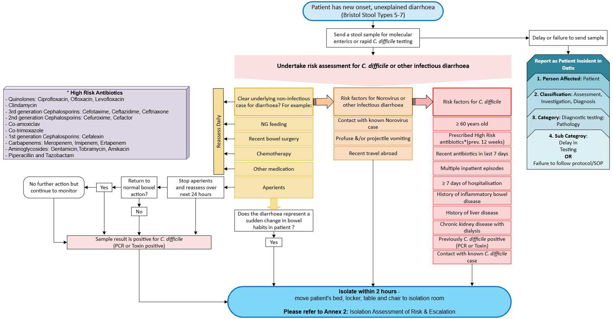

Annex 2: Isolation of Patient with Suspected or Confirmed C. difficile

– Assessment of Risk & Escalation

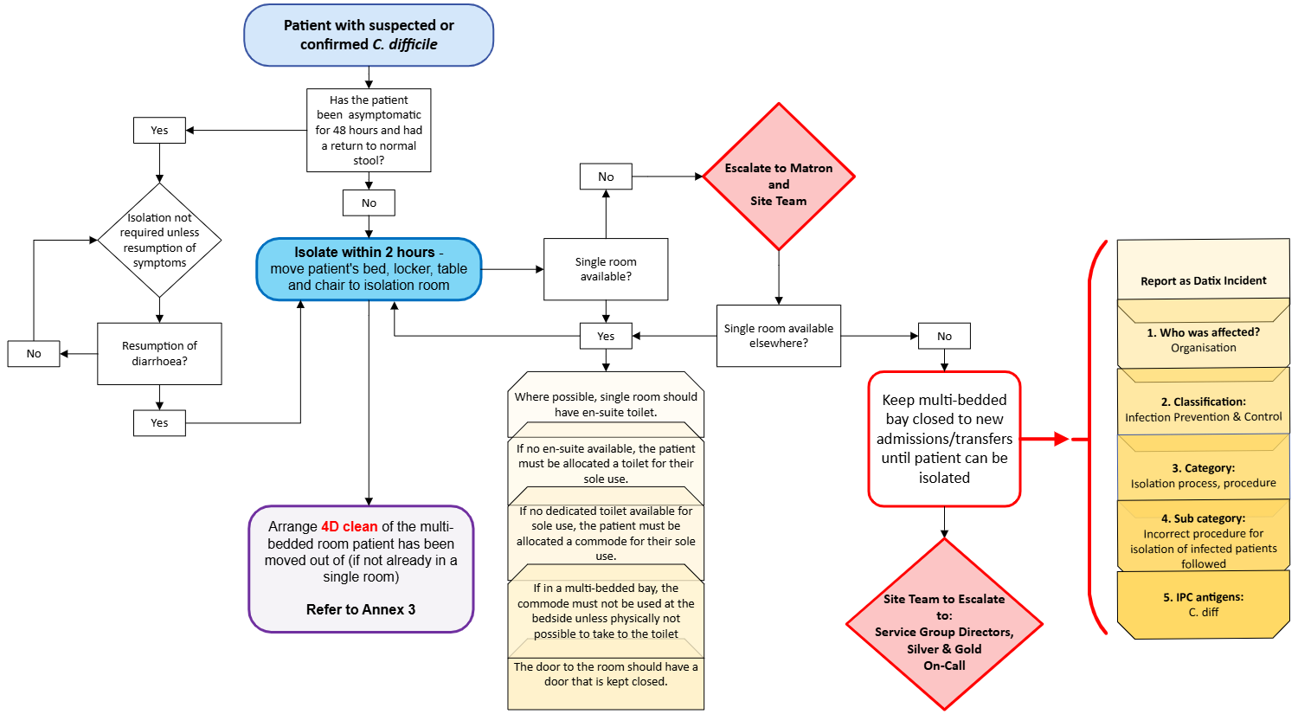

Annex 3: Cleaning – Assessment of Risk & Escalation

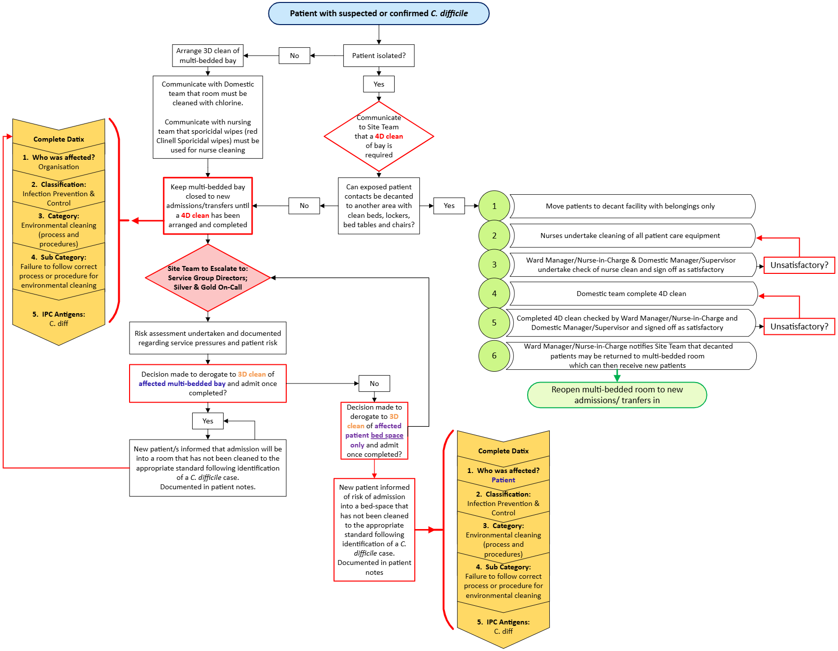

Annex 4: Risk Assessment and Management of multiple cases of C. difficile on a ward

