Meeting Date | 3 July 2025 |  | Agenda Item |  |  | 3.3
Meeting Title | Quality and Safety Committee
Report Title | Close Down Report for Maternity and Neonatal Gold Command
Report Author | Liz Wonnacott, Head of Service – Medical Director
Report Sponsor | Liz Rix, Executive Director of Nursing  Dr Richard Evans, Executive Medical Director
Presented by | Dr Richard Evans, Executive Medical Director  Liz Rix, Executive Director of Nursing
Freedom of Information | Open
Purpose of the Report | The purpose of the report is to set out the seek endorsement of the standing down of the gold command arrangements for maternity and neonatal services.
Key Issues | - In December 2023, the health board’s maternity and neonatal services were placed by Welsh Government into enhanced monitoring;  - To scrutinise and seek assurance that the work required is being undertaken, a gold command structure has been established;  - Significant progress has been made against all areas of focus and as such, the health board is in a position to recommend the standing down of the gold command arrangements.
Specific Action Required  (please choose one only) | Information | Discussion |  | Assurance | Approval
Specific Action Required  (please choose one only) | ☐ | ☐ |  | ☒ | ☐
Recommendations | Members are asked to:  - BE ASSURED that additional actions set by Welsh Government during enhanced monitoring meetings are being closed within required timescales;  - BE ASSURED that focus is being given to de-escalating from enhanced monitoring through the presentations to Welsh Government;  - BE ASSURED that the maternity and neonatal dashboard is now live and providing oversight of key indicators to support reporting into relevant fora;  - BE ASSURED the 2019, 2023 and 2024 HIW improvement plans are all closed and are subject to an internal governance check prior to sign-off;  - BE ASSURED that no significant or immediate concerns were raised in the HIW unannounced inspection of the free-standing midwifery unit at Neath Port Talbot Hospital and ACKNOWLEDGE an improvement plan has been submitted to HIW;  - BE ASSURED by the reduction in the risk score by HEIW for the obstetrics and gynaecology service from 12 to eight;  - BE ASSURED that the services are closing more incidents each month than are opened and the backlog has significantly reduced;  - BE ASSURED that national and external reports have been considered in detail and any action required has been taken;  - BE ASSURED that the Perinatal Committee, chaired by the Executive Director of Nursing, has been established;  - AGREE the standing down of the gold command structure based on the progress made by the maternity and neonatal services to address concerns identified.

CLOSE DOWN REPORT FOR MATERNITY AND NEONATAL GOLD COMMAND

- INTRODUCTION
The purpose of the report is to set out the seek endorsement of the standing down of the gold command arrangements for maternity and neonatal services.

- BACKGROUND
In December 2023, the health board’s maternity and neonatal services were placed into enhanced monitoring by Welsh Government. This was because of concerns as to the quality and safety of the care provided raised by members of the Senedd and families who have accessed the services.

The escalation status followed an unannounced inspection by Healthcare Inspectorate Wales (HIW) in September 2023 during which seven areas of immediate action were identified. In addition, the formal report for the visit set out a number of recommendations for improvement, and an action plan was shared with HIW. HIW undertook a follow-up unannounced visit in undertaken in April 2024 to review progress and while some of work had been completed, there were still improvements required.

Alongside this were two Health Education and Improvement Wales (HEIW) targeted inspections of obstetrics and gynaecology in February and July 2024 as part of HEIW’s quality framework to identify areas working well or in need of improvement, as well as national reports which identify areas of improvement for maternity and neonatal services across the UK.

To scrutinise and seek assurance that the work required is being undertaken, a gold command structure was been established, led by the Deputy Medical Director as the senior responsible officer, supported by the Chief Operating Officer and Executive Director of Nursing and Patient Experience. Meetings are attended by members of the Singleton/Neath Port Talbot Service Group’s senior team under which sit maternity and neonatal services.

Significant progress has been made against all areas of focus and as such, the health board is in a position to recommend the standing down of the gold command arrangements.

- GOVERNANCE AND RISK ISSUES
The main areas of focus for the group are enhanced monitoring, inspection action plans, open incidents, national reports and horizon scanning:

- Enhanced Monitoring
Senior members of the service group along with key members of the executive team meet with Welsh Government on a monthly basis to share progress to achieve de-escalation. During these meetings, actions additional to the criteria already set by Welsh Government can be allocated and these are reviewed within the gold command meetings to ensure completion.

While the majority of the actions set by Welsh Government during these meetings are closed by the next one, there had been one outstanding action, the establishment of a maternity dashboard. The dashboard went live on 1st April 2025. This will now be used for regular reporting in the service group’s Quality, Safety and Risk Group meetings, and form the basis of assurance reports to the Quality and Safety Committee and Board.

Attention is now turned to de-escalation from enhanced monitoring. In addition to the criteria set by Welsh Government for the health board to include in its presentations, each month the health board incorporates a different element of the de-escalation framework:

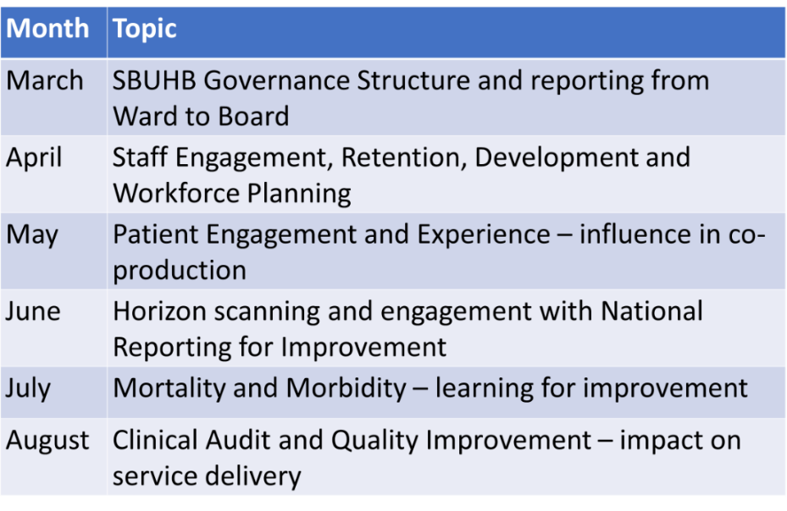
This has been well received so far, providing assurance to Welsh Government as to the progress being made. In addition, NHS Wales Performance and Improvement Divison attends the service’s monthly meeting at which progress is discussed.

- Inspection Action Plans
- HIW Inspections
The improvement plans for the 2019, 2023 and 2024 HIW inspections have now been completed in full. A sample check of the actions undertaken in response to the recommendations is now underway by the corporate assurance team to test if the work completed is robust enough to close the recommendations. In addition, as the location of the bereavement room is not ideal, options for a longer-term solution are being revisited.

It is anticipated HIW will return to review the services, but no formal arrangements have been made to date. However, an unannounced visit was made by HIW to the free-standing midwife unit at Neath Port Talbot Hospital in February 2025. This in general was a positive report but did identify areas for improvement, none of which related to patient care or safety. The majority were process, document or policy-based, while some were in relation to support available to the workforce. An improvement plan has been agreed with the HIW and will be monitored for progress through the service group’s internal governance structure and the Perinatal Committee. Eight recommendations were made, four of which have already been actioned, two partially completed and two are in progress and within set timescales.

- Health Education and Improvement Wales (HEIW)
HEIW undertook a follow-up visit to obstetrics and gynaecology in April 2025. It was a positive visit which saw the risk score reduce from 12 (high) to eight (medium) following the actions undertaken in response to two visits in 2024. A further visit will be scheduled in six months. The GMC (General Medical Council) was updated by HEIW about the significant progress made by the obstetrics and gynaecology department at Singleton Hospital and as a result, the GMC has de-escalated the department from entering into an enhanced monitoring process.

There were three main areas which HEIW highlighted in April 2025, and the service has already agreed the action to address these:

- Handover of gynae-oncology/waiting list initiative patients – the IT option on SIGNAL (the patient information system) is current being explored to identify how it can support with the handover patients. In the meantime, a template is being developed to support comprehensive handovers, along with protected time given to trainees to provide/receive handover.

- Evidence of positive change following professional concerns management – HEIW appreciates that this will be a challenging area to demonstrate improvement as confidentiality will need to be ensured. However, a meeting will be arranged with trainees to share the management and governance of professional concerns within Swansea Bay. This will provide assurance to the trainees that there are processes in place and also to encourage them to continue raising concerns if needed.

- Theatre training opportunities – going forward, trainees will only be in theatre if it is a training opportunity. In addition, a review of theatre sessions will be undertaken to ensure they add value and offer training opportunities.

An action plan has been agreed with HEIW to address all the recommendations from the visit and progress against this will be reported through the service group’s internal governance structure, the Perinatal Committee and the Workforce and OD Committee. All actions will be completed in advance of HEIW’s visit in six months.

- Open Incidents
The service is now in a position where it is closing more incidents each month than are opened and the table below sets out the position reported in May 2025:

 | Maternity |  | Neonatal
 | Open | Overdue | Open | Overdue
Incidents | 93 | 33 | 14 | 3
Duty of Candour | 2 |  | 0
Concerns | 16 | 6 | 0 | 0
Redress | 29 |  | 2
Claims | 57 |  | 6

There has a been a significant improvement in the number of open incidents as there were 230 open reported when the gold command group was first established in August 2024 and the majority of those which are overdue are from this period onwards. However, a small number remain from 2023 and 2024, and responses are now in the final stages and requiring senior sign-off.

The majority of incidents reported are under the category of maternity adverse outcomes. These could include stillbirths, cord prolapse or birth trauma, the numbers for these are small. The most common low or no harm incidents such as post-partum haemorrhage, born under 10th centile (meaning the baby is smaller than expected for its gestational age) and unexpected admissions to the neonatal intensive care unit. In order to better understand and learn from each incident, the option of ‘other’ under this category has been removed so a specific description now has to be given.

- National Reports
Since the establishment of the gold command meeting, a number of national or external reports have been received and considered, with actions taken forward as necessary:

- MBRRACE-UK (Mothers and Babies: Reducing Risk through Audits and Confidential Enquiries across the UK) 2023
The national MBRRACE-UK report for 2023, published in March 2025, identified the health board as an outlier for stabilised and adjusted extended perinatal mortality (the number of stillbirths and neonatal deaths which meet the MBRRACE criteria as opposed to all stillbirths and neonatal deaths in that period). Thematic analysis and learning have been identified from the cases, and include improvements around CTG (cardiotocography), which is the monitoring of a baby or (babies) heartrate before and during labour, as well earlier identification of very sick babies. A number of actions were agreed to address the issues highlighted in the report, all of which have been completed ahead of the gold command deadline of September 2025.

- MBRRACE-UK: ‘State of the Nation Report Saving Lives, Improving Mothers’ Care October 2024 Surveillance findings and lessons learned to inform maternity care from the UK and Ireland Confidential Enquiries into Maternal Deaths from thrombosis and thromboembolism, malignancy and ectopic pregnancy 2020-2022, and morbidity findings for recent migrants with language difficulties’
The service has benchmarked itself against the findings and there were no immediate causes for concern or significant issues to note.

- Maternity and Neonatal Safety Support Programme MatNeoSSP
The action plan for the MatNeoSSP report was updated to ensure that any outstanding actions for Swansea Bay are being progressed and monitored.
- Audit Wales Review of Operational Governance
The service group reviewed the report more widely across all of its services and developed an action plan to address the recommendations but there were no concerns directly related to maternity or neonatal services. It had recently undergone an organisational change process, resulting in a new leadership and governance structure, which address the findings of the report. These have been shared with the members of the gold command for assurance.

- Care Quality Commission (CQC) Review
The findings of the CQC review have been considered by the service and nothing different from that of other reports has been identified. Therefore, any actions required were taken as part of the work already ongoing.

- NNAP (National Neonatal Audit Programme)
NNAP identified the neonatal intensive care unit at Singleton Hospital as an outlier for late onset sepsis in 2023. A quality improvement programme was put in place to deliver the actions required and no further issues have been identified. This has been reported to NNAP and the report taken through the service group’s Quality, Safety and Risk Group, as well as reported to the Clinical Outcomes and Effectiveness Group.

- VON (International Vermont Oxford Network)
The VON report, which is a neonatal quality improvement review and is similar to NNAP, identified the health board as within the national average with no concerns raised.

- Llais
Llais, an independent statutory body set up by Welsh Government for people to have their say in relation to health and social services, undertook an assurance visit to the maternity services towards the end of 2024 and a report on its findings was published in May 2025. In addition to some traumatic accounts, the Llais report also includes comments praising staff, especially with regards the respect and compassion shown to many mums-to-be, their partners and families. The report will be considered alongside that of the external independent review, referenced below.

- Horizon Scanning
As part of the gold command’s role, it looks ahead to any potential reviews or reports relating to maternity or neonatal services. These could be regular national reports which are issued as standard or external reviews being undertaken either of the health board itself or other maternity and neonatal services from which there could be learning.

The main report expected by the health board is the external independent review. This will be considered by the board in the first instance and responsibility delegated within its governance structure as appropriate. Llais shared its findings with the external independent review panel and these findings will be taken into account, alongside a range of other inputs. These include feedback from service users via the review’s own engagement activities but also as a result of detailed clinical reviews undertaken by independent clinicians and the review of a raft of data on the services.

The health board will consider the external independent review’s findings in July 2025 and will respond fully with an action plan that addresses all of its findings and recommendations in the autumn.

In addition, the service will be undertaking a six-month review following the reopening of the free-standing midwifery unit in September 2024 to identify successes and lessons learned. This will be received by the health board in due course.

- Conclusion
Discussions are now commencing around the direction of travel to support the governance and assurance of the improvements for maternity and neonatal services. The gold command structure was formed to ensure the timely
implementation of actions in response to identified areas of concern. As demonstrated above, significant progress has been made in each of the areas.

This is emphasised further by the risk scores relating to maternity and neonatal services reducing to 12, with approval from the Risk Scrutiny Panel for these to be removed from the health board risk register as they are below the risk appetite. They will continue to be monitored by the service group and will be escalated if required.

As such it is proposed that the gold command structure be stood-down. Governance and assurance going forward will be supported by the establishment of the Perinatal Committee, chaired by the Executive Director of Nursing.

- FINANCIAL IMPLICATIONS
There are no financial implications associated with this report.

- RECOMMENDATION
Members are asked to:
- BE ASSURED that additional actions set by Welsh Government during enhanced monitoring meetings are being closed within required timescales;
- BE ASSURED that focus is being given to de-escalating from enhanced monitoring through the presentations to Welsh Government;
- BE ASSURED that the maternity and neonatal dashboard is now live and providing oversight of key indicators to support reporting into relevant fora;
- BE ASSURED the 2019, 2023 and 2024 HIW improvement plans are all closed and are subject to an internal governance check prior to sign-off;
- BE ASSURED that no significant or immediate concerns were raised in the HIW unannounced inspection of the free-standing midwifery unit at Neath Port Talbot Hospital and ACKNOWLEDGE an improvement plan has been submitted to HIW;
- BE ASSURED by the reduction in the risk score by HEIW for the obstetrics and gynaecology service from 12 to eight;
- BE ASSURED that the services are closing more incidents each month than are opened and the backlog has significantly reduced;
- BE ASSURED that national and external reports have been considered in detail and any action required has been taken;
- BE ASSURED that the Perinatal Committee, chaired by the Executive Director of Nursing, has been established;
- AGREE the standing down of the gold command structure based on the progress made by the maternity and neonatal services to address concerns identified.

Governance and Assurance

Link to Enabling Objectives  (please choose) | Supporting better health and wellbeing by actively promoting and empowering people to live well in resilient communities
Link to Enabling Objectives  (please choose) | Partnerships for Improving Health and Wellbeing |  | ☒
Link to Enabling Objectives  (please choose) | Co-Production and Health Literacy |  | ☐
Link to Enabling Objectives  (please choose) | Digitally Enabled Health and Wellbeing |  | ☐
Link to Enabling Objectives  (please choose) | Deliver better care through excellent health and care services achieving the outcomes that matter most to people
Link to Enabling Objectives  (please choose) | Best Value Outcomes and High Quality Care |  | ☒
Link to Enabling Objectives  (please choose) | Partnerships for Care |  | ☐
Link to Enabling Objectives  (please choose) | Excellent Staff |  | ☐
Link to Enabling Objectives  (please choose) | Digitally Enabled Care |  | ☐
Link to Enabling Objectives  (please choose) | Outstanding Research, Innovation, Education and Learning |  | ☐
Health and Care Standards
(please choose) | Staying Healthy |  | ☐
(please choose) | Safe Care |  | ☒
(please choose) | Effective Care |  | ☒
(please choose) | Dignified Care |  | ☒
(please choose) | Timely Care |  | ☒
(please choose) | Individual Care |  | ☒
(please choose) | Staff and Resources |  | ☐
Quality, Safety and Patient Experience
The health board is dedicated to ensuring that pregnancy and childbirth is a safe and positive experience for all service users in order to support healthy life choices and to give children the best start in life. This requires safe and effective maternity and neonatal services. The actions identified by the reviews and external bodies will support the improvements needed to achieve this.
Financial Implications
There are no financial implications associated with the report.
Legal Implications (including equality and diversity assessment)
There are no legal implications associated with the report.
Staffing Implications
There are no staffing implications associated with the report.
Long Term Implications (including the impact of the Well-being of Future Generations (Wales) Act 2015)
The health board has a 10-year vision to be a high-quality organisation. Work being undertaken to address the concerns raised and to de-escalate from enhanced monitoring will not only support that vision but develop maternity and neonatal services which are safe and sustainable in the longer-term.
Report History |  | Standing agenda item to the Quality and Safety Committee
Appendices |  | No appendices.

