

HEALTH BOARD RISK REGISTER
Risks assigned to the Quality & Safety Committee
May 2025

Datix ID Number: 738  Health & Care Standard: |  |  | HBR Ref Number: 1  Risk Target Date: 31/12/2025 |  | Current Risk Rating  5 x 5 = 25
Objective: Urgent & Emergency Care (UEC) |  | BAF Ref: 2.4 | Director Lead: Deb Lewis, Chief Operating Officer  Assuring Committee: Performance & Finance Committee  For information: Quality & Safety Committee
Risk: Access to Unscheduled Care  If we fail to provide timely access to Unscheduled Care then this will have an impact on quality & safety of patient care as well as patient and family experience and achievement of targets. There are challenges with capacity/staffing across the Health and Social care sectors. (This risk includes ED, AMU and impact in community from ability to release ambulances at both front doors.) |  |  | Date last reviewed: May 2025
Risk Rating  (consequence x likelihood):  Initial: 4 x 5 = 20  Current: 5 x 5 = 25  Target: 3 x 4 =12 | 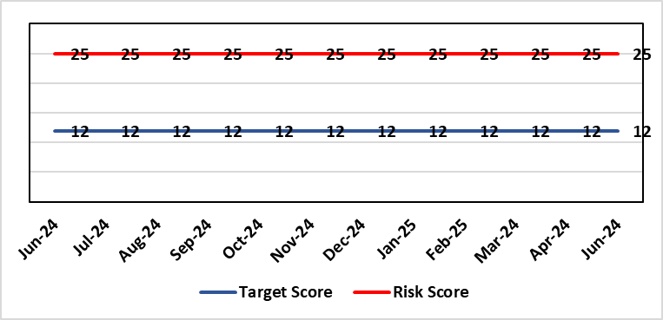 |  | Rationale for current score:  The UEC system continues to see high demand, with ambulance attendances in particular being higher than seen previously. This is coupled with reduced flow out of hospital beds due to an imbalance of acute / community / care service provision. These factors are resulting in unacceptable delays in patients accessing UEC services and therefore the risk score remains high.
Level of Control  = 50% |  |  | Rationale for target score:  The HB is currently under escalating performance monitoring from WG (Targeted Intervention or TI) for delivery of UEC services. The improvement plan developed as a response to TI and that already included in the HB annual plan is to implement models of care that reflect best practice and focus on areas that will benefit patients, staff and the UEC system most. The implementation of this plan will improve patient flow, length of stay and reduce emergency demand.
Date added to the HB risk register
26.01.16
Controls (What are we currently doing about the risk?) |  |  | Mitigating actions (What more should we do?)
Five main areas of work within the plan:  - Frailty strategy (already achieved: Older Persons Assessment & Short Stay Unit stood up; Hub stood up to triage/stream/capture outcomes from incoming calls; standard operating procedures developed for Short Stay, Assessment Unit, Neck of Femur Pathways/beds, and Hub; Phase 1 capital works completed)  - Grip & control operational management and centralisation of patient flow resources  - Senior decision makers at front door services  - Pathway of care delays (PoCD) Implementation of Discharge-To-Reassess (D2RA)  - Home First  - Acute Care Team (ACT)  - Interface with local authority  - Urgent & Emergency Care redesign programme linked to capital expansion scheme.  - Development of a UEC Care Co-ordination Hub to promote pre-hospital triage redirection and streaming.  In addition to (Business As Usual) BAU improvement actions:  - Continued focussed roll-out of 6-Goals schemes of work  - D2RA / Trusted assessor model  - SAFER  - Criteria-led discharge  - Continuous Flow Model (CFM)  - Robust SDEC model |  |  | Action | Lead |  | Deadline
 |  |  | Implementation of revised senior decision-making capacity within SDEC (Same Day Emergency Care) and AMU (Acute Medical Unit) | Group Medical Director, Morriston |  | 31/10/2025
 |  |  | Amended action: Review of community services being undertaken by Group Nurse Directors for PCT / Morriston to ensure return of investment ahead of expansion. | Group Nurse Directors (Morriston & PCT) |  | 31/06/2025
 |  |  | Implementation of UEC (Urgent & Emergency Care) Navigation Hub to decrease demand and implement right patient right place process | Chief Operating Officer |  | 31/09/2025  Pending WG funding-Six Goals
 |  |  | Focus on reducing pathway of care delays (PoCDs) as per the Care Action Committee 50-day Challenge | Associate Service Group Director, PCTS |  | 30/09/2025 (reduce to 100 Clinically Optimised Patients)
 |  |  | Further develop admission avoidance pathways with Welsh Ambulance Services Trust, focussing on Falls prevention and Respiratory conditions | Assistant Director Operations UEC |  | 30/09/2025 (linked to 6 Goals reporting & funding)
 |  |  | Reintroduce D2RA Principles across the Health Board with external consultancy support | Assistant Director of Operations UEC,  Associate Service Group Director PCTS |  | 28/06/2025
Assurances (How do we know if the things we are doing are having an impact?)  - Urgent & Emergency Care Board is meeting monthly chaired by the COO.  - Six Goals programme reviews the plan on a monthly basis  - UEC Redesign held 2-weekly to update on work streams  - UEC Summit meetings held x 2 with Executive Management Board – 3rd summit planned March 25.  - D2RA Executive meeting held Feb 25 – Memorandum of Understanding (MOU) re D2RA agreed. Operational workshop held Mar 25 with a plan to test D2RA principles pre-Easter weekend  - Ongoing delivery of the Integrated Discharge Hub with both front and back door focus – programme of work in progress to design sustainable solution |  |  | Gaps in assurance (What additional assurances should we seek?)  Affordability of the UEC Care Co-ordination Hub pending approval of WG Six Goals funding.  Affordability of a sustainable D2RA model and right sizing of the community services and bedded facilities to support timely discharge.
Additional Comments / Progress Notes
01/04/2025: UEC Plan developed based on Six Goals. UEC Annual Plan agreed. Revised structure proposal being presented to UEC Programme Board 01/04/25.
16/05/2025: Progress made with admission avoidance pathways with WAST, focussing on Falls prevention and Respiratory conditions. Further work to be considered in 2025/26.

Datix ID Number: 739  Health & Care Standard: |  |  | HBR Ref Number: 4  Risk Target Date: 31/03/2026 | Current Risk Rating  4 x 5 = 20
Objective: Care is high quality, safe, efficient, and delivers the best possible outcomes for people |  | BAF Ref: 2.1 | Director Lead: Elizabeth Rix, Executive Director of Nursing  Assuring Committee: Quality & Safety Committee
Risk: Healthcare Acquired Infection (HCAI)  Risk of patients acquiring infection as a result of contact with the health care system, resulting in avoidable harm, impact on service capacity, and failure to achieve Tier 1 national infection reduction goals. |  |  | Date last reviewed: May 2025
Risk Rating  (consequence x likelihood):  Initial: 4 x 5 = 20  Current: 4 x 5 = 20  Target: 4 x 3 =12 | 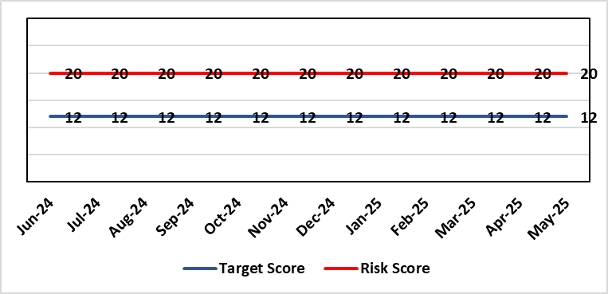 |  | Rationale for current score:  Health Board incidence of key Tier 1 infections per 100,000 population above All Wales rates, indicating Health Board’s population at greater risk of infection. High occupancy rates & frequent ward moves associated with increased risk of infection transmission. Lack of decant facilities compromises environment deep cleaning & decontamination and planned preventative maintenance programmes.
Level of Control
= 40%
Date added to the HB risk register
January 2016
Date added to the HB risk register  January 2016 |  |  | Rationale for target score:  Improved governance structures for IPC and antimicrobial stewardship will drive improved local ownership and embed responsibility for these priorities for all levels of staff. Adequately maintained & clean environments facilitate good IPC & minimise infection risks. Reduced occupancy & frequency of patient moves mitigate against infection transmission. Compliant ventilation systems and water safety minimise infection risks. Access to timely data on infections, training, antimicrobial stewardship, cleaning at ward/unit/practice level enables Service Groups to identify areas for focused QI programmes, drive improvement, & effectively measure outcomes.
Controls (What are we currently doing about the risk?) |  |  | Mitigating actions (What more should we do?)
- Policies, procedures, protocols and guidelines supplement the National Infection Control Manual.  - Infection Prevention & Control (IPC) related training provided programmes.  - Surveillance of infections, with early identification of increased incidence, and instigation of controls.  - Antimicrobial stewardship programmes and systems of monitoring and feedback.  - Provision of cleaning service to meet National Standards of Cleanliness.  - Engineering controls for water safety, ventilation, and decontamination.  - Infection Prevention Improvement Plans 2024/25 for HB and Service Groups were approved by the Health Board's Infection Prevention & Control Strategic Group on 30/04/24 and 31/07/24 respectively. Progress is reported at SG Infection Control Committees, HB Infection Prevention & Control Group, Quality & Safety Group, Quality & Safety Committee, and Management Board. These include trajectories to meet national targets and report performance against them.  - The Health Board has been escalated to Targeted Intervention for its position relating to healthcare associated infection (HCAI). Governance processes for HCAI have been revised to provide strengthened scrutiny and assurance. |  |  | Action |  | Lead | Deadline
 |  |  | Achieve 85% compliance with IPC mandatory training (Levels 1 & 2) |  | Service Group Directors | 31/03/2026
 |  |  | Achieve reduction in Tier 1 infections to meet de-escalation criteria for intervention targets |  | Service Group Directors | 31/03/2026
Assurances (How do we know if the things we are doing are having an impact?)  - Clear Corporate and Service Group IPC Assurance Framework in place.  - Infection Prevention Improvement Plans for HB and Service Groups with progress reported at SG Infection Control Committees, HB Infection Prevention & Control Group, Quality & Safety Group and at Management Board. These include trajectories to meet national targets and report performance against them. This is also reported to Quality & Safety Committee.  - Ongoing monitoring of infection control rates.  - IPC, antimicrobial, decontamination and cleaning audit programmes.  - Annual completion of IPC Level 2 mandatory training for all HB staff.  - Compliance and validation systems for water safety, ventilation systems and decontamination.  - Revised and strengthened governance structure for HCAI, including monthly meetings of Executive HCAI Scrutiny Group. |  |  | Gaps in assurance (What additional assurances should we seek?)  - High occupancy rates & frequent ward moves associated with increased risk of infection transmission.  - Lack of single room availability, leading to delays in isolating patients with infections and increasing risks to patient contacts.  - Increased numbers of clinically optimised patients remaining in hospital leads to increased length of stay, increased risk of over-occupancy and over-crowding, with consequence of increasing risks of acquisition of infection.  - General infrastructure of the aging hospital estate compromises the ability to clean and decontaminate effectively.  - Antimicrobial prescribing, relating particularly to total volume of antibiotics, with the SBUHB having second highest total volume of antibiotics prescribed in primary care in Wales.  - Lack of decant facilities compromises environment deep cleaning & decontamination and planned preventative maintenance programmes.  - Varying levels of IPC responsibility embedded across all disciplines and groups, with variable medical engagement at all levels in infection prevention-related Quality Improvements programmes.
Additional Comments / Progress Notes
13/06/2025: SBUHB continues to have the highest incidence rate per 100,000 population for C. difficile infections SBUHB 46.07/100,000 (Wales = 39.14).
Staph aureus bacteraemia – second highest rate; SBUHB = 33.78/100,000 (Wales = 28.55). E coli Bacteraemia – third lowest rate; SBUHB 61.43/100,000 (Wales = 65.8).
Klebsiella spp bacteraemia – second highest rate; SBUHB 32.25/100,000 (Wales 21.93). Pseudomonas aeruginosa bacteraemia – highest incidence rate; SBUHB 9.21/100,000 (Wales = 4.54).

Tier 1 position against the Targeted Intervention de-escalation hospital onset (HO) criteria in May 2025 and, also the cumulative position Apr-May 2025
> C. difficile: (HO target - 6) = 5 cases. Combined cumulative position - Community (CO) and hospital onset (HO) = 31 cases
> Staph aureus: (HO target - 3) = 6 cases. Combined, cumulative position - Community (CO) and hospital onset (HO) = 23 cases.
> E coli: (HO target - 4) =5 cases. Combined, cumulative position - Community (CO) and hospital onset (HO) = 40 cases.
> Klebsiella Spp: (HO target - 4) = 7 cases. Combined, cumulative position of Community (CO) and hospital onset (HO) = 18 cases.
> Pseudomonas aeruginosa (not included in targeted intervention monitoring). Combined, cumulative total = 6 cases.

IPC training compliance: level 1 - 90.14% (increase), Level 2 - 81.44% (increase).

Datix ID Number: 840  Health & Care Standard: |  |  | HBR Ref Number: 16  Risk Target Date: 31/03/2026 | Current Risk Rating  4 x 4 = 16
Objective: Planned Care |  | BAF Ref: 2.5 | Director Lead: Deb Lewis, Chief Operating Officer  Assuring Committee: Performance & Finance Committee  For information: Quality & Safety Committee
Risk: Access and Planned Care  There is a risk of harm to patients if we fail to diagnose and treat them in a timely way. |  |  | Date last reviewed: May 2025
Risk Rating  (consequence x likelihood):  Initial: 4 x 4 = 16  Current: 4 x 4 = 16  Target: 4 x 2 = 8 | 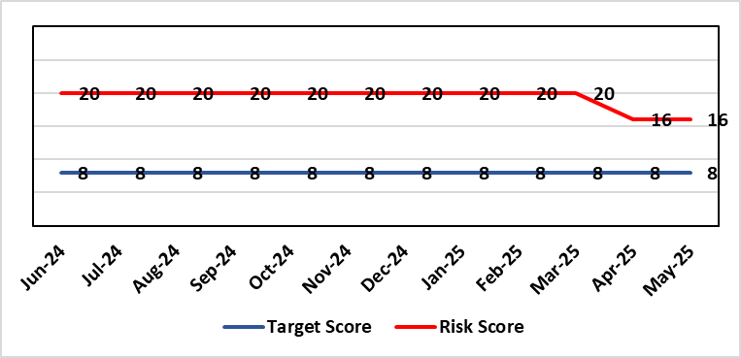 |  | Rationale for current score:  Patients are still waiting in excess of 104 weeks for surgical intervention, which is outside of national policy on RTT. However, the position is improving: targets set for 2024/25 were met and the Health Board de-escalated by Welsh Government from Targeted Intervention (TI) for delivery of Planned Care services, to Enhanced Monitoring. Current risk score reflects that improved position.
Level of Control
= 90%
Level of Control  = 90% |  |  | Rationale for target score:  There is scope to reduce the likelihood score to reduce the overall risk to an acceptable level. The risk target date indicates when we expect to see some reduction in waiting lists – albeit the overall risk level may remain as work continues.
Date added to the HB risk register
January 2013
Controls (What are we currently doing about the risk?) |  |  | Mitigating actions (What more should we do?)
- There is a bi-weekly Targeted Intervention (TI) meeting specifically for assurance on the recovery of our elective programme.  - Specialty level capacity and demand models set out the baseline capacity and identify solutions to bridge the gap this financial year.  - A focused intervention is in train to support to the 10 specialties with the longest waits.  - Long waiting patients are being outsourced to the Independent Sector, where appropriate  - Additional internal activity is being delivered on weekends (via insourcing), although this is currently at risk due to changes in policy pertaining to the payment of enhanced rates to A4C staff.  - Planned care trajectories were developed and submitted to Welsh Government.  - Governance process put in place to monitor performance against trajectories internally, and with Welsh Government as part of Targeted Intervention.  - External & internal validation continues.  - All long waiting patients are receiving clinical reviews to ascertain continued need for surgery. |  |  | Action |  | Lead | Deadline
Assurances (How do we know if the things we are doing are having an impact?)  - TI dashboard developed to monitor performance in a live state  - Weekly TI monitoring meetings chaired by the Chief Operating Officer  - Bi-weekly planned care meetings chaired by the Chief Operating Officer  - Monthly TI monitoring meetings with Welsh Government |  |  | Gaps in assurance (What additional assurances should we seek?)
Additional Comments / Progress Notes
16/05/2025: Action complete: Theatre Optimisation Programme now in place to maximise efficient use of theatre capacity. Risk assessment revised to reflect improved performance and de-escalation by Welsh Government to Enhanced Monitoring status. Monitoring of continued delivery is ongoing.

Datix ID Number: 1043  Health & Care Standard: |  |  | HBR Ref Number: 36  Risk Target Date: 31/07/2025 | Current Risk Rating  4 x 4 = 16
Objective: The delivery of care is supported by innovative digital solutions |  | BAF Ref: 4 | Director Lead: Matt John, Director of Digital  Assuring Committee: Digital, Research & Innovation Committee  For information: Quality & Safety Committee
Risk: Paper Record Storage  Lack of a single electronic record means there is greater reliance on the provision of the paper record. If we fail to provide adequate storage facilities for paper records, then this will impact on the availability of patient records at the point of care. Quality of the paper record may also be reduced if there is poor records management in some wards. There is an increased fire risk where medical records are stored outside of the medical record libraries. |  |  | Date last reviewed: May 2025
Risk Rating  (consequence x likelihood):  Initial: 4 x 5 = 20  Current: 4 x 4 = 16  Target: 3 x 3 =9 | 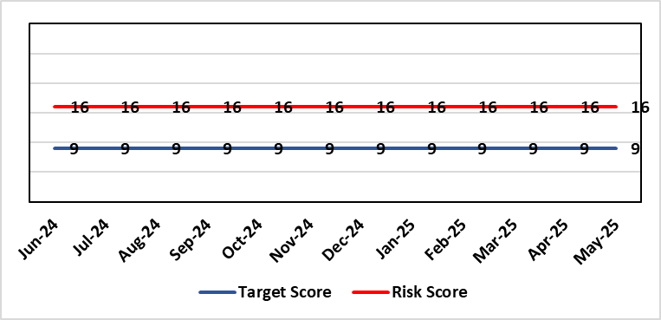 |  | Rationale for current score:  C - Inability to find records for patients could delay care/increase length of stay over 15 days. Could also mean patients receive incorrect treatment. Increased risk of fire where records are stored outside of the medical record libraries.  L - we know this happens from incidents raised
Level of Control  = 70% |  |  | Rationale for target score:  C - The increased development and adoption of the digital record will reduce the need for the paper health record being available at the point of care.  L - The increased development and adoption of the digital record, the introduction of RFID and the approach to management of the paper record identified in the Business case process should reduce the amount of paper required to be stored and managed.
Date added to the HB risk register
June 2016
Controls (What are we currently doing about the risk?) |  |  | Mitigating actions (What more should we do?)
- There is a plan in place to increase the functionality of the electronic record to document patient care. The delivery of the plan is overseen by the Digital Leadership Group and progress provided to Management Board. (Supported by individual project boards as appropriate).  - Records managed by the Medical Records libraries are RFID-tagged (Radio Frequency Identification) and location tracked.  - Medical Record libraries are regularly risk assessed for fire by health and safety.  - Alternative offsite storage arrangements have been identified.  - All records must be documented on the Information Asset Register (IAR). |  |  | Action |  | Lead | Deadline
 |  |  | Allow for new process to stabilise and evaluate benefits of new centralised unit. |  | Head of Health Records & Clinical Coding | 01/08/2025
Assurances (How do we know if the things we are doing are having an impact?)  - RFID has been implemented for the acute record improving the management and storage of records  - Health Records performance reports developed in line with RFID technology  - Attainment of the Tier 1 Health Board target for clinical coding completeness which relies on the timely availability and quality of the Paper record and electronic sources  - Monitoring complaints and incident reporting.  - Electronic record is being implemented in accordance with the plan eg implementation of WNCR (Welsh Nursing Care Record), ETR (Electronic Test Requesting), HEPMA (Hospital Electronic Prescribing and Medicines Administration) |  |  | Gaps in assurance (What additional assurances should we seek?)  Investment required supporting the delivery and operational costs of the Digital strategy.  Reliance on DHCW (Digital Health & Care Wales) for delivery of the solution for a fully electronic patient record.  Impact of the Infected Blood Enquiry on the Health Boards ability to destroy notes.  Process for ensuring clinical adoption of electronic ways of working and cessation of adding information to the paper record that is already available electronically needs to be agreed and enforced by the Health Board.  Impact of the infected Blood Inquiry on the health board’s ability to destroy notes and the change in the records code of practice is being reviewed by the Director of Digital.
Additional Notes
11/03/2025: Movement of staff and records continue but coming to an end – on target for completion by current deadline.
07/04/2025: All relevant records and all staff now moved across to Ty Samlet. Action 1 therefore completed.
08/05/2025 - Reviewed with ADI – some progress being made with wider non-acute records, therefore will be waiting for updates on the wider records workstream before considering a re-wording of this risk or whether to close it down (reference whether this risk is relating to the paper storage issue, or the wider digital record workstream).
12/06/2025 – Reviewed – no notable progress to report

Datix ID Number: 1514 Risk reduced from 20 to 16  Health & Care Standard: |  |  | HBR Ref Number: 43  Risk Target Date: TBC |  | Current Risk Rating  4 x 4 = 16
Objective: Mental Health & Learning Disability Services |  | BAF Ref: 2.3 | Director Lead: Elizabeth Rix, Executive Director of Nursing  Assuring Committee: Quality & Safety Committee  For Information: Mental Health Legislation Committee
Risk: Deprivation of Liberty Safeguards  Due to a limited resources within the MCA/DoLS (Mental Capacity Act/Deprivation of Liberty Safeguards) service (lack of Best Interest Assessor resource and signatory approval) there is a risk of failure to complete and authorise the assessments associated with Deprivation of Liberty within the legally required timescales, exposing the health board to potential legal challenge and reputational damage. |  |  | Date last reviewed: May 2025
Risk Rating  (consequence x likelihood):  Initial: 4 x 4 = 16  Current: 4 x 4 = 16  Target: 3 x 2 = 6 | 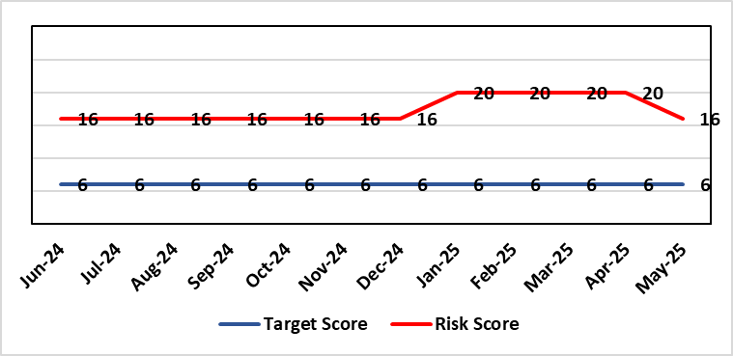 |  | Rationale for current score:  Multiple breaches in statutory duty  Breaches confirmed as expected at least as frequently as weekly, but not daily.  No claims received to date.
Level of Control  = 40% |  |  | Rationale for target score:  Consequences of DoLS breaches for the Health Board will not change. With controls in place, over time likelihood should decrease.  Risk target date indicates date of review following mitigating actions
Date added to the HB risk register
July 2017
Controls (What are we currently doing about the risk?) |  |  | Mitigating actions (What more should we do?)
- Duty system in place. Duty BIA (Best Interest Assessors) scrutinise referrals and liaise with managing authority to ensure safeguards are in place to mitigate risks.  - Four signatory authorisers in place.  - Monthly Performance & Assurance Meeting  - Monthly Legislative Assurance Meeting with Group Nurse Director and Finance.  - Quarterly reports to Mental Health & Legislative Committee on MCA/DoLS compliance. |  |  | Action | Lead |  | Deadline
 |  |  | Amended: Board Paper to be completed and submitted to PCT Service Group Management Board to identify risks and mitigation of an additional 4 WTE (Whole Time Equivalent) BIA | Deputy Head of Nursing for Long Term Care |  | 31/07/2025
 |  |  | Amended: Signatory Process reviewed to reduce the breach risk. Workforce Plan to be discussed with Director of Nursing PCT | Deputy Head of Nursing for Long Term Care |  | 31/07/2025
Assurances (How do we know if the things we are doing are having an impact?)  Monthly Legislative Assurance Meeting with Group Nurse Director and Finance.  Quarterly reports to Mental Health & Legislative Committee on MCA/DoLS compliance. |  |  | Gaps in assurance (What additional assurances should we seek?)  Current resources  - 3 substantive BIA (3 wte)  - 6 external BIA (£250 per assessment)  - 4 (band 8) signatories  Additional 4 WTE BIAs required to meet service demands.  Substantive BIA’s role includes additional duties compared to external BIA whose only role is to complete form 3a of the DoLS process. In addition to form 3a completion, substantive BIA also undertake the following to meet service demand (Daily Duty Rota to scrutinise referrals; Facilitate Level 3 MCA/DoLS Training; Capacity Assessments; Advice and support to Managing Bodies; Support during Best Interest Meetings)
Additional Comments / Progress Notes
19/12/2024: Breaches for Q2 are reported at 17. This is due to
- An increase in DoLS referrals following wider HB staff awareness of MCA/DoLS following implementation of Level 3 training
- Additional support to Managing Authorities for wider MCA/DoLS awareness
- Breaches due to insufficient signatory resource
28/01/2025: Breaches for Q3 58. Increase of 35% of referrals. 1 wte BIA long term sick. Increased risk noted as HB professionals are requesting additional bespoke mental capacity assessment training which is having an impact on BIA and Band 7 capacity to undertake core work (DoLS assessments). Risk score increased to 20. To be discussed in Mental Health Legislation Committee 06/02/2025.
06/05/2025: Breaches for Q4 have reduced to 26. This is likely to be due to a review of signatory process and BIA return from long term sick leave. DoLS referrals have reduced by 30% for February and March 2025. To continue to monitor during Q1 to ascertain if continue to stabilise. Risks and compliance discussed in MHLC 06/05/2025. Risk Score remains at 20. To be reviewed if breaches continue to reduce.
17/06/2025: Risk reviewed. Breaches confirmed as remaining at reduced level therefore risk score reduced in line to 16.

Datix ID Number: 1761  Health & Care Standard: |  |  | HBR Ref Number: 50  Risk Target Date: TBC | Current Risk Rating  5 x 5 = 25
Objective: Cancer Care |  | BAF Ref: 2.6 | Director Lead: Deb Lewis, Chief Operating Officer  Assuring Committee: Performance & Finance Committee  For information: Quality & Safety Committee
Risk: Access to Cancer Services  There is a risk of delay in diagnosing patients with cancer, and consequent delay in commencement of treatment, which could lead to poor patient outcomes and failure to achieve targets.  The health Board remains unable to deliver on the target of 75% of patients being treated within 62 days and is currently under targeted intervention by Welsh Government to improve performance. |  |  | Date last reviewed: May 2025
Risk Rating  (consequence x likelihood):  Initial: 4 x 5 = 20  Current: 5 x 5 = 25  Target: 4 x 3 = 12 | 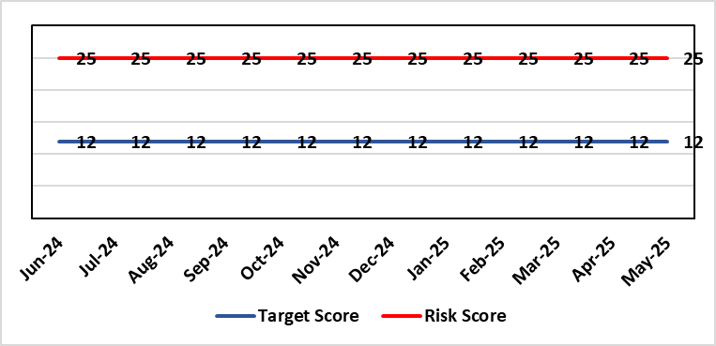 |  | Rationale for current score:  Risk score is based on being off trajectory for SCP.
Level of Control  = 70% |  |  | Rationale for target score:  Target score reflects the challenge this area of work presents the Board and where small numbers of patients impact on the potential to breach target.
Date added to the HB risk register: April 2014
Controls (What are we currently doing about the risk?) |  |  | Mitigating actions (What more should we do?)
- Tight management processes to manage each individual case on the Single Cancer Pathway (SCP). Enhanced monitoring & weekly monitoring of action plans for top 6 tumour sites.  - Initiatives to protect surgical capacity to support SCPs have been put in place  - Tumour sites have been given additional targets to achieve by the end of Qtr1:  - Achieve the 10-day 1st Outpatient target  - Deliver a decision to treat (DTT) by day 31  - A specific plan is being delivered to support Pathology services and ensure SCP tests are turned around within 5 days. |  |  | Action |  | Lead | Deadline
 |  |  | Following a review of governance processes for our Annual plan, Cancer monitoring will now be included in the Planned Care Board |  | Chief Operating Officer / Director of Planning Partnerships | 30/09/2025
Assurances (How do we know if the things we are doing are having an impact?)  - TI dashboard developed to monitor performance in a live state  - Weekly TI monitoring meetings chaired by the Chief Operating Officer  - Bi-weekly Cancer meetings chaired by the Deputy Chief Operating Officer  - Monthly TI monitoring meetings with Welsh Government |  |  | Gaps in assurance (What additional assurances should we seek?)  Performance and activity data monitored, but delays to treatment continue while sustainable solutions found.
Additional Comments / Progress Notes
16/05/2025: Action complete: Cancer Performance & Information Group to monitor improvement trajectories for both cancer backlog and SCP performance on a monthly basis. The Health Board missed the target of 70% for the end of March and delivered 62%. This will increase at the 3-month refresh point. Actions noted above will continue during 2025/26 to deliver sustainable improvements.

Datix ID Number: 1587  Health & Care Standard: |  |  | HBR Ref Number: 61  Risk Target Date: TBC |  | Current Risk Rating  4 X 4 = 16
Objective: Planned Care |  | BAF Ref: 2.5 | Director Lead: Deb Lewis, Chief Operating Officer  Assuring Committee: Quality & Safety Committee
Risk: Paediatric dental GA (General Anaesthetics)/Sedation services provided under contract from Parkway Clinic, Swansea. Medical Safety risk as general anaesthetics are performed on children outside of an acute hospital setting. Repatriation of service to acute site delayed due to theatre capacity which means the health board continues to commission services for delivery outside of national guidance (WHC 2018-09) attracting reputational risk. There is also an associated risk in that the diagnosing clinician does not deliver the care to the patient resulting in increased risk of need for multiple General Anaesthetics. |  |  | Date last reviewed: May 2025
Risk Rating  (consequence x likelihood):  Initial: 5 x 3 = 15  Current: 4 x 4 = 16  Target: 4 x 2 = 8 | 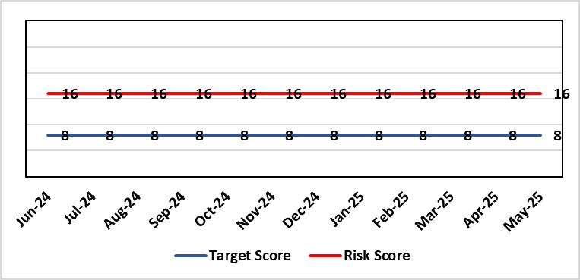 |  | Rationale for current score:  There is no immediate access to crash team/ICU facilities in in Parkway Clinic – the client group are undergoing GA (general anaesthetic)/sedation. Paediatric GA/Sedation services provided under contract from Parkway Clinic, Swansea continue due to lack of capacity for these patients to be accommodated in Secondary Care.
Level of Control  = 60% |  |  | Rationale for target score:  Relocation of the paediatric general anaesthetics service [provided by Parkway Clinic] to a hospital site being treated as a priority.
Date added to the HB risk register
4th July 2018
Controls (What are we currently doing about the risk?) |  |  | Mitigating actions (What more should we do?)
Consultant Anaesthetist present for every general anaesthetic clinic.  Assurance Documentation supplied by Parkway Clinic including confirmation of arrangements in place with WAST and Morriston Hospital for transfer and treatment of patients  New care pathway implemented - no direct referrals to provider for general anaesthetics.  Multi-drug sedation ceased from Sep 2018 in line with WHC 2018 009  Revised SLA (Service Level Agreement)/Service Specification  HIW (Healthcare Inspectorate Wales) Inspection Visit Documentation provided to Health Board  All extended general anaesthetics cases require approval from paediatric specialist prior to treatment |  |  | Action | Lead |  | Deadline
 |  |  | Include transfer of services from Parkway on new theatre programme. Options to be considered by Theatre Planning Group | Associate Service Group Director (Surgery) |  | Closed (See Comments below)
Assurances (How do we know if the things we are doing are having an impact?)  RMC (Referral Management Centre) collate referral and treatment outcome data for review by Paediatric Specialist  Regular clinical meeting arranged with Parkway to discuss individual cases/concerns  Regular clinical/ management meeting for CDS/primary care management team to discuss service pathway /concerns/issues arising |  |  | Gaps in assurance (What additional assurances should we seek?)  Deputy Chief Operating Officer-led Task & Finish Group is no longer in place – it will need to be re-established to progress transfer when theatre capacity is agreed.  Pressures on the Princess of Wales special care dental general anaesthetics list and this service is considered alongside any plans for the Parkway contract.
Additional Comments / Progress Notes
11/03/2025: A paper is going to Management Board in March 2025 to consider extension of Parkway Contract to 31/03/2026.
06/05/2025: Health Board Management Board agreed that current contract with provider will be extended for 2+1 years whilst the Health Board explores capital bid for regional service as part of wider Paediatrics Day Case Unit

Datix ID Number: 2159  Health & Care Standard: |  |  | HBR Ref Number: 64  Risk Target Date: 31/03/2026 | Current Risk Rating  4 X 5 = 20
Objective: Care is delivered in safe and appropriate settings |  | BAF Ref: 3 | Director Lead: Darren Griffiths, Director of Finance & Performance  Assuring Committee: Quality & Safety Committee
Risk: Health & Safety (H&S) Infrastructure  Insufficient resource and capacity of the health, safety and fire function within SBUHB to maintain legal and regulatory compliance for the workforce and for the sites across SBUHB. |  |  | Date last reviewed: May 2025
Risk Rating  (consequence x likelihood):  Initial: 5 x 4 = 20  Current: 4 x 5 = 20  Target: 4 x 3 = 12 | 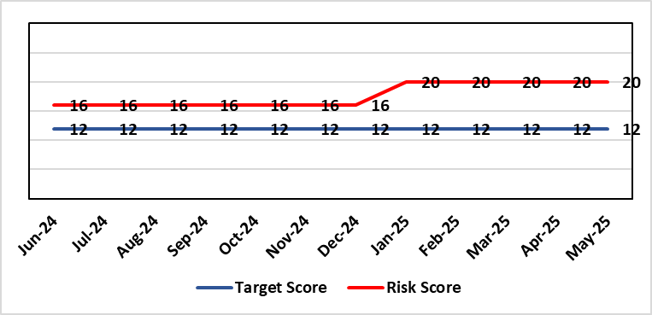 |  | Rationale for current score:  The Health Board received 12 Health & Safety Executive (HSE) improvement notices during 2019-20 covering various Health & Safety legal breaches covering a range of areas. There is the potential for future multiple notices for not meeting legal requirements based on current available resources. Due to retirement resources in the team has reduced and the risk level increased to 20.
Rationale for target score:
Compliance with the notices and to have sufficient resources to implement a sustainable health and safety provision to support the legal requirements of the Health Board and demonstrate that suitable resources are in place to undertake the roles and responsibilities of the department, also to undertake suitable and sufficient training, provide corporate overview/audit to ensure practices are being employed in the workplace.
Level of Control
= 70%
Date added to the HB risk register
September 2019
Controls (What are we currently doing about the risk?) |  |  | Mitigating actions (What more should we do?)
- Assistant Director of Health and Safety in post to support strengthening and develop the H&S function to support the organisation. Business case submitted for additional resources.  - Health and Safety Operational Group and the Health and Safety Committee monitor compliance. Refreshed the Fire Safety Group with additional controls in place.  - Fire risk assessments (FRA) are being prioritised with temporary additional resources put in place in March 2021 to reduce the number of FRA overdue and brought up to date. However, due to leavers and recruitment, resource levels have fluctuated along with compliance levels that are continually monitored.  - Fire training in place and fire wardens in place  - Fire risk assessment schedule in place for the next 12 months to maintain 100% compliance of completion and is regularly reviewed |  |  | Action |  | Lead | Deadline
 |  |  | Having completed staffing structure review, next action is to work through Health Board governance processes to ensure affordability and to agree a risk-based, phased approach to implement any agreed structure going forward. |  | Assistant Director of Capital and H&S | 31/03/2026
Assurances (How do we know if the things we are doing are having an impact?)  - Monitoring through the appropriate group/committees (H&S committee) to receive assurance and or identify gaps for key compliance and adherence to applicable legislation.  - Site visits/tours to identify compliance and gaps in compliances. |  |  | Gaps in assurance (What additional assurances should we seek?)  Health and safety, capital and estates now sit under the umbrella of Finance and is currently going through a restructure, with the H&S structure also included in this and will be phased in, with a target date of 31/03/2026 for the proposed new structure to be in place.
Additional Comments / Progress Notes
07/05/25: Vacancy panel approved new head of health and safety post which will oversee the modernisation of the function. Resource remains limited so key risks will be prioritised and matched to the next phase of recruitment that the head of health and safety will oversee.
15/06/2026: Head of H&S post out to advert, risks monitored and prioritised within resources.

Datix ID Number: 1834  Health & Care Standard: |  |  | HBR Ref Number: 66  Risk Target Date: TBC | Current Risk Rating  5 X 5 = 25
Objective: Cancer Care |  | BAF Ref: 2.6 | Director Lead: Richard Evans, Executive Medical Director  Assuring Committee: Quality & Safety Committee
Risk: Access to SACT (Systemic Anti-Cancer Therapy)  The demand & complexity of planned treatment regime for cancer patients requiring chemotherapy currently exceed the available chair capacity, risking unacceptable delays in access to SACT treatment in Chemotherapy Day Unit with impact on targets and patient outcomes. |  |  | Date last reviewed: May 2025
Risk Rating  (consequence x likelihood):  Initial: 5 x 5 = 25  Current: 5 x 5 = 25  Target: 2 x 2 = 4 | 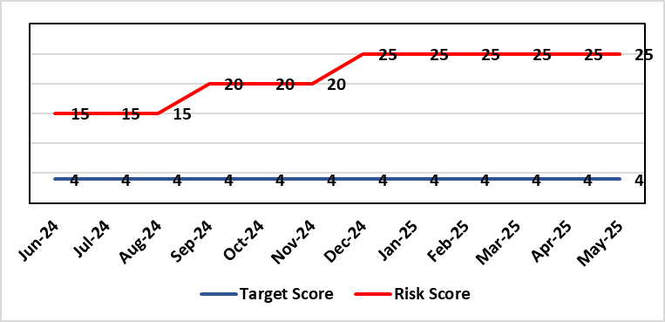 |  | Rationale for current score:  Due to staff sickness across the Multi-Disciplinary Team, the demands for SACT continues to outstrip capacity.  There are continuing workforce challenges in CDU and PTS. Patient waiting times and number of patients breaching SACT KPIs remain. New diagnoses and NICE approvals continue to require implementation of additional SACT adding further pressure.  Two Chairs have been verbally agreed however staff recruitment and training are now needed before this increase can be implemented.
Level of Control
=
Date added to the HB risk register  30/11/2019 |  |  | Rationale for target score:  Reduced delays in treatment will reduce risk of harm.
Controls (What are we currently doing about the risk?) |  |  | Mitigating actions (What more should we do?)
Review of scheduling by staff to ensure all chairs used appropriately.  Previous business case endorsed by CEO for shift of capacity to home care.  A daily scrutinizing process in progress to micro-manage individual cases, deferrals etc.  Changes made to prescribing & authorising processes to improve workflow for PTS reducing potential delays to supply and administration of treatment.  Responsibility for checking bisphosphonate prescriptions in CDU moved to nursing staff to free up Pharmacy capacity allowing them to focus on key clinical tasks within Pharmacy.  Joint project with Nuclear Medicine to streamline pathways and prioritise SACT patients appropriately halved the average time waiting for MUGA/EDTA tests required before starting SACT.  Increased homecare capacity  Adopted principles from UK SACT board publication: General Principles to Support Systemic anti-Cancer Therapy Aseptic Pressures September 2023 |  |  | Action | Lead | Deadline
 |  |  | A demand and capacity options paper has now been shared with the Service Group Senior Leadership Team and agreed in principle. Paper went to CPIG in January 2025. Verbal approval from Director of Finance for two chairs in Feb 2025 and request for resubmission of 3-year business case plan. Three-year plan approved for Year 1 by the Business Case Assurance Group (BCAG) (additional 2 chairs 24/25 6 chairs per year for years 2 and 3 to run at 80%) on 22nd April 2025. | Divisional Manager (Cancer) | Complete (3-year Plan paper agreed)
 |  |  | Recruiting to posts | Divisional Manager (Cancer) | 31/08/2025
 |  |  | Training of new staff (full competency) | SACT Training Team / Pharmacy | 28/02/2026
Assurances (How do we know if the things we are doing are having an impact?)  Additional funding agreed to support increase in nurse establishment to appropriately staff the unit during its main opening hours. Additional scheduling staff also agreed. This funding has been utilised but with further increase demand further funding for Pharmacy and Nursing would be required  Pre-Assessment process has been separated from start date in an attempt to fill deferral slots at short notice where possible. Improved communication between MDT (Multi-Disciplinary teams) to streamline booking and deferral process.  Continue to monitor patient experience via friends and family in conjunction with the Welsh Cancer Patient Experience Survey results under our PTR procedures. Monitoring our waiting times against new SACT metrics, which is a measure based on treatment intent and is no longer reported as average waiting time so is more linked to expected outcomes etc. This performance metric is included in our Cancer Performance report we send to WG and Management Board and internally via governance arrangements with NPTSSG where Oncology services sit.  SBU Capacity Task and Finish group meeting monthly to analysis demand and capacity gap.  Common themes for delays will continue to be identified and analysed each month. A quarterly report will be provided to the SACT, Consultant meeting and Division Business meeting to inform of the outcome  Main breach causes are due to CDU capacity and SACT booking delays. Quarterly reports demonstrate this trend. Further work being done on new ways of working and possible increase in chair capacity & workforce.  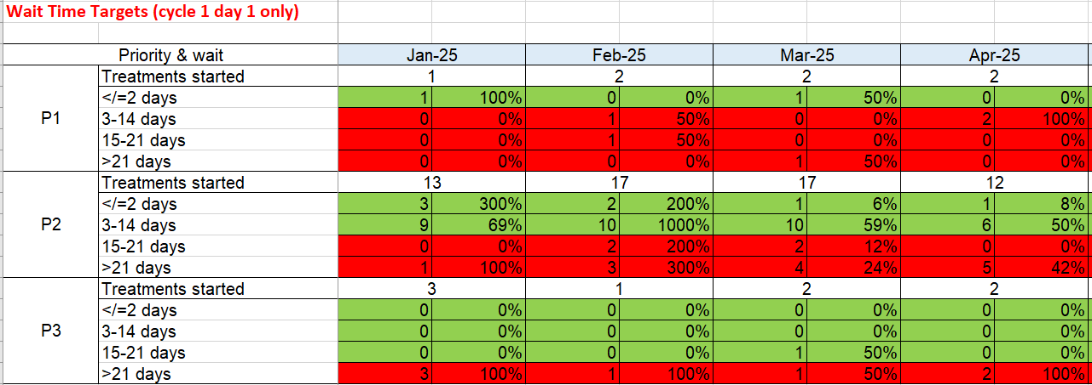  Welsh SACT performance metrics – P2 to start within 14 days. P3 to start within 21 days |  |  | Gaps in assurance (What additional assurances should we seek?)  Workforce requirements are to be mapped to demonstrate additional capacity required to meet current and future predicted SACT Demand.
Additional Comments / Progress Notes
March 2025:
- Recruitment for pharmacy and nursing workforce in progress
- Three-year plan business case developed ready for submission
April 2025:
- Action complete: 3-year plan approved at Business Case Assurance Group 22/04/2025
- Recruiting to posts and training additional SACT staff
May 2025
- SACT competency increased CDU (chemotherapy day unit) 100%, BMT (bone marrow transplant) 93.5%, Ward12 79%
- 29 CNS (clinical nurse specialists) going through refresher framework to provide resilience
- Recruitment process underway

Datix ID Number: 1418  Health & Care Standard: |  |  | HBR Ref Number: 69  Risk Target Date: See Target Rationale |  | Current Risk Rating  5 X 4 = 20
Objective: Children & Young People Services |  | BAF Ref: 2.7 | Director Lead: Deb Lewis, Chief Operating Officer  Supporting Director: Elizabeth Rix, Executive Director of Nursing  Assuring Committee: Quality & Safety Committee
Risk: Risk of issues related to adolescent patient admission to adult mental health inpatient wards. Risk of inappropriate settings resulting in 'Safeguarding Issues'. The Welsh Government has requested that Health Boards identify Secondary Care in -patient facilities for the care of adolescents- in Swansea Bay University Health Board Ward F NPT hospital is the dedicated receiving facility with one bed identified. |  |  | Date last reviewed: May 2025
Risk Rating  (consequence x likelihood):  Initial: 2 x 3 = 6  Current:5 x 4 = 20  Target: 2 x 3 = 6 | 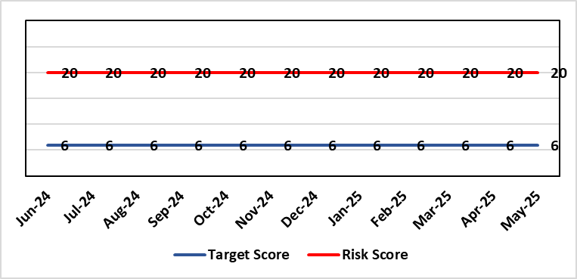 |  | Rationale for current score:  Every health board is required to have an admission facility for adolescent Mental Health patients. Whilst ward F has been identified as the single point of access in SBU and provides access to a bed for adolescent admissions if available at the time of request it is a mixed sex adult ward. Therefore the facilities are less than ideal for young patients in crisis.
Level of Control
=
Date added to the HB risk register  27/02/2020 |  |  | Rationale for target score:  The longer-term aim for the Health Board remains to create an admission facility for adolescent Mental Health patients but this will not be possible until the new Adult Inpatient Unit is built.
Controls (What are we currently doing about the risk?) |  |  | Mitigating actions (What more should we do?)
Safeguarding Training for Staff, Joint protocol with Cwm Taf LHB [CAMHS] currently subject to review, Local SBUHB policy on providing care to young people in this environment. This includes the requirement for all such patients on admission to be subject to Level 3 Safe and Supportive observations.  Only Adolescents within 16-18 age range are admitted to the adult ward.  The health board works with CAMHS to make sure that the length of stay is as short as possible. |  |  | Action | Lead |  | Deadline
 |  |  | Next service group review of effectiveness of current controls. | MH&LD Head of Operations & Clinical Directors |  | 30/06/2025.
Assurances (How do we know if the things we are doing are having an impact?)  Individual Rooms with en Suite Facilities, Joint working with CAMHS, monitoring of staff training, Monitoring of admissions by the MH&LD SG Legislation Committee of the Health Board. The ongoing issues with the risks presented by the use of this has recently been raised at an all Wales level with Welsh Government and a formal review is anticipated. The Service Group continues to flag the risk particularly in light of Ward F being identified as the SPOA for AMH in the Health Board which has resulted in an increase in acuity and a greater concentration of individuals who are experiencing the early crisis of admission - this has served to increase the already identified risks for young people in the environment. |  |  | Gaps in assurance (What additional assurances should we seek?)
Additional Comments / Progress Notes
01/04/2025: No change currently to detail.

Datix ID Number: 1832  Health & Care Standard: |  |  | HBR Ref Number: 80  Risk Target Date: 31/12/2025 | Current Risk Rating  4 x 5 = 20
Objective: Urgent & Emergency Care |  | BAF Ref: 2.4 | Director Lead: Deb Lewis, Chief Operating Officer  Assuring Committee: Quality & Safety Committee
Risk: Transfer of Clinically Optimised Patients  Risk that we fail to significantly reduce the number of Clinically Optimised Patients in hospital beds. A deficit in the availability of appropriate community / domiciliary care results in unacceptable delays in discharging patients from acute hospital beds. As a result, patients can decompensate and never gain the independence that could have been available from an early discharge.  Lack of access to same day domiciliary care/emergency placements in the community hinders ability to avoid admission and associated harms. |  |  | Date last reviewed: May 2025
Risk Rating  (consequence x likelihood):  Initial: 4 x 5 = 20  Current: 4 x 5 = 20  Target: 4 x 2 = 8 | 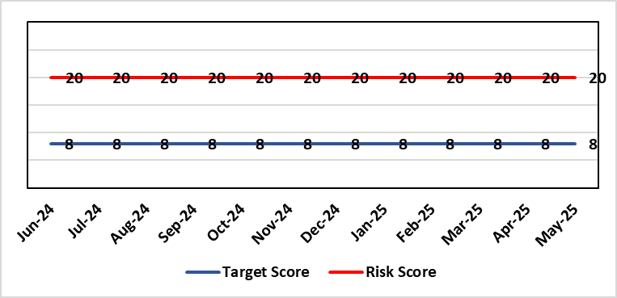 |  | Rationale for current score:  - Sustained levels of clinically optimised patients (COPs) leading to overcrowding within ED, use of inappropriate or overuse of decant capacity in ED and delays in accessing medical bed capacity, clearly emerged as themes.  - Constraints in relation to all patient flows out of Morriston to a more appropriate clinical setting, identified and included in an expanded risk.  - Delay in discharge for clinically optimised patients can result in deterioration of their condition.
Level of Control
= 25%
Level of Control  = 25% |  |  | Rationale for target score:  Targeted reduction of Clinically Optimised patients remains a priority for the HB in order to minimise risk of avoidable harm to patients within the HB and in the wider community.
Date added to the risk register
May 2021
Controls (What are we currently doing about the risk?) |  |  | Mitigating actions (What more should we do?)
- One of the measures under targeted intervention is to see a reduction in pathway of care delays, which specifically supports the reduction in the number of clinically optimised patients.  - Review is undertaken on a patient-by-patient basis – with explicit action agreed in order to progress transfer to appropriate clinical setting.  - Critical constricts in relation to access/time delays for social workers and assessment for package of care and social placement  - Weekly escalation meetings are held with health and social service colleagues to ensure the requirements of the patients are reviewed and patients are pulled through the system where possible. |  |  | Action |  | Lead | Deadline
 |  |  | Reintroduce D2RA (Discharge to Recover & Assess) Principles across the Health Board with external consultancy support |  | Assistant Director of Operations UEC  Associate SGD PCTS | 28/06/2025
 |  |  | Work programme and governance structure agreed by local partnership (health board & local authorities) to work up sustainable D2RA model. |  | Associate Director UEC | 31/03/2026
Assurances (How do we know if the things we are doing are having an impact?)  - Patient level dashboard allows breakdown by delay type  - Regular (weekly) COP reviews and escalations  - Shared vision with NPT & Swansea LA CEOs agreed and governance structure with Executive Directors for sign off |  |  | Gaps in assurance (What additional assurances should we seek?)  Capacity and demand exercise required to inform reshaping of community services
Additional Comments / Progress Notes
12/05/2025: Action previously completed: The Care Action Committee (CAC) focus on reducing the impact of clinically optimised patients within acute hospitals. The Health Board engaged with the work from the CAC and currently developing the Winter Plan for 24/25, of which reducing COPs will be a key focus. This work is being taken forward by the Associate SGD PCTS to ensure cross-boundary support.
Integrated Discharge hub now established from within existing resources following a successful test of change. Positive turnaround of patients from front door services reducing admission demand and long-term care demand. Roll-out of true Discharge to Recover then Assess (D2RA) principles/ activity planned in conjunction with Local Authority partners to improve timeliness of all discharges (which will positively impact COP position)

Datix ID Number: 2561  Health & Care Standard: |  |  | HBR Ref Number: 85  Risk Target Date: 30/05/2025 |  | Current Risk Rating  4 x 5 = 20
Objective: Children & Young People Services |  | BAF Ref: 2.7 | Director Lead: Christine Morrell, Director of Therapies & Health Sciences  Assuring Committee: Quality & Safety Committee
Risk: Non-Compliance with ALNET Act There are risks to the Health Board’s ability to meet its statutory duties and establish the effective collaborative arrangements required by the ALN Act, which is being implemented through a phased approach. This risk is caused by:  - Lack of staff resource needed to carry out the additional work needed to comply with the ALN Act for operational services, especially those in the PCST Service Group.  - Implementation of the Act for those of above compulsory school age (post-16) commenced in September 2023. This presents risks because of gaps in service provision.  - Multiple pressures for operational services are impacting on capacity / engagement of leads within impacted services to progress tasks that need to be undertaken to mitigate the risks and current vacancy in ALN Project Manager post.  - There have been long-standing issues with Data Quality due to pressure on ALN and Service administration teams, process issues and absence of a robust system to enable data capture and analysis. While these have now been addressed, meaning that the Health Board should be producing accurate and reliable data moving forwards, until April 2025 there will not be a meaningful body of compliance data available. This means that accurate and up-to-date data regarding the Health Board’s compliance remains currently unavailable, but such data will be available by April 2025, at which point a thorough review of the Health Board’s risk of ALN non-compliance will be carried out.  Potential consequences of this risk are: non-compliance with statutory duties, parent / carer and young peoples' dissatisfaction leading to complaints. Educational Tribunals and Judicial Reviews (this is new legislation with many points of ambiguity and is highly likely to be legally ‘tested’); reputational impact; and children failing to access the multi-agency support that they need with their learning needs, leading to poor outcomes. |  |  | Date last reviewed: May 2025
Rationale for current score:
Risk score reflects that while controls are in place, there are multiple areas of risks (relating to compliance with legislation; governance and assurance; workforce and OD; and sustainable services); and high probability (especially given multiple risk areas) of at least one of these areas of risk being realised. Caused by implementation timetable for the ALN Act, slippage against plan and need for strengthened governance (as described in ‘Risk’ section).

Risk Rating  (consequence x likelihood):  Initial: 5 x 5 = 25  Current: 4 x 5 = 20  Target: 2 x 3 = 6 |  |  | Rationale for target score:  As the ALN Act is new legislation, there remains some ongoing likelihood of risk events during the initial phases of implementation, though with lessened consequences as a result of mitigating actions.
Level of Control
=
Date added to the HB risk register
14/05/2022
Controls (What are we currently doing about the risk?) |  |  |  | Mitigating actions (What more should we do?)
- Progressing the necessary work within an appropriate structure (see under ‘ACTIONS’) are constrained by financial and/or service delivery pressures.  - DECLO (Designated Educational Clinical Lead Officer) is in post - this is a statutory requirement.  - Health Board ALN Steering Group has been established, with governance structure in place involving the ALN Operational Group working under the governance of this  - Operational processes through which the Health Board fulfils its statutory duties under the ALN Act are in place.  - Ongoing collaboration between the DECLOs at a national level ensures a broadly consistent approach across Wales to how Health Boards fulfil their requirements under the ALN Act. Some ongoing differences remain because of different Local Authority approaches, through Welsh Government have formed a national group to support improved consistency around Health-Education collaboration through the ALN Act.  - Regarding demand / capacity and staffing resource challenges, WG has a phased implementation timetable that has recently been extended from summer 2024 to summer 2025. From summer 2025, the Act will be fully in ‘delivery as usual’. The phased implementation offers partial short-term mitigation of the risks.  - Awareness has been raised at Board level through Development session and bi-monthly updates are provided to the Patient Safety & Compliance Group.  - Welsh Government have been engaging with the Designated Education Clinical Lead Officers on a national basis regarding ALN key performance indicators and compliance. A Welsh Health Circular requiring regular reporting against statutory key performance indicators is anticipated in the coming months.  - Audit and Assurance Services have conducted an audit of the Health Board in relation to the ALN Act, which provided an overall ‘limited assurance’ rating. Management responses have been developed and a work plan is in place, monitored through the ALN Steering Group, to address issues identified in the audit. |  |  |  | Action | Lead | Deadline
 |  |  |  | Securing longer-term administrative and project management support needed to mitigate risks | Executive Director of Allied Health Professions & Health Science | 30/06/2025
 |  |  |  | Review the Health Board’s compliance with its legal requirements under the ALN Act based on data collected through the new ALN App for January – March 2025, and reassess the level of risk for noncompliance with the ALN Act based on this | DECLO | 30/05/2025
Assurances (How do we know if the things we are doing are having an impact?)  - There is regular reporting in respect of the ALN Act through the Patient Safety and Compliance Group.  - ALN Steering Board has been established, ensuring oversight at a senior level within all impacted operational and corporate areas.  - DECLO meets regularly with ADOTHS / DoTHS of the 3 health boards of South-West and Mid Wales for update and assurance.  - National ALN Reform Steering Group has been formed and will include Health representation (SBU Deputy DOTHS). This will provide a national forum for consideration of risks. |  |  |  | Gaps in assurance (What additional assurances should we seek?  - Extent of gap in staffing resource (gap between work required and capacity available) has been provisionally quantified, but data is imperfect and there remains some uncertainty. This is in a context where demands will increase significantly over the next year.
Additional Comments / Progress Notes
09/05/2025 – Analysis of compliance data for the first full quarter for which data is available (Jan- March 2025) is being carried out. This will be brought to the ALN Steering Group, 20/05/2025. ALN risk will be reviewed and reassessed based on this.
Action closed: A report on progress with management actions associated with the ALN audit has been provided to the Mental Health Legislation Committee, with the majority of actions now fully closed down.

Datix ID Number: 3071  Health Care Standards: |  |  | HBR Ref Number: 89  Target Risk Date: TBC | Current Risk Rating  4 x 5 = 20
Objective: Primary & Community Care |  | BAF Ref: 2.2 | Director Lead: Elizabeth Rix, Executive Director of Nursing  Supporting Director: Deb Lewis, Chief Operating Officer  Assuring Committee: Quality & Safety Committee
Risk: Healthcare Nursing Staff Levels at HMP Swansea  There is a risk that the men in HMP Swansea will not receive the appropriate standard of care. This is due to the fact that the nursing establishment within the prison no longer fully meets the changed demographics and numbers of men being detained. The maximum operational capacity of the Prison can reach circa 480 men. The Health Board investment into the Prison is based on delivering services to 250 men. This was also highlighted as a risk in the June 2022 HIW governance review. In addition there is no head room built into the Prison nursing establishment so periods of sickness, leave and study renders the roster short. |  |  | Date last reviewed: May 2025
Risk Rating  (consequence x likelihood):  Initial: 4 x 5 = 20  Current: 4 x 5 = 20  Target: 2 x 2 = 4 | 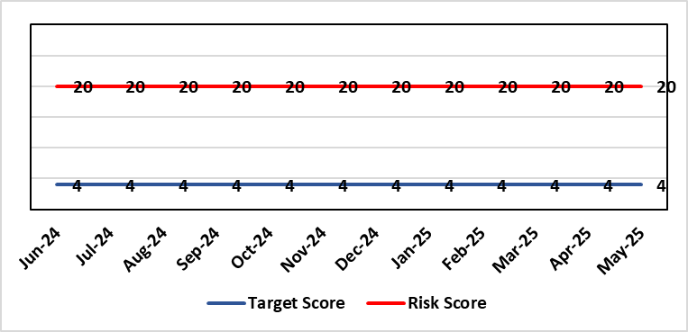 |  | Rationale for current score:  Consequence major – unable to fully deliver on the recommendations of HIW due to low healthcare staffing numbers, further impacted during periods of sickness or absence as no headroom. Recommendations also raised in Prison & Probation Ombudsman reports. Likelihood expected – suboptimal care provided on a daily basis.
Level of Control  = % |  |  | Rationale for target score:  Consequence minor – With sufficient staffing numbers the prison will be able to deliver on HIW recommendations and fully implement the actions in the Health Delivery Plan. Likelihood unlikely – With full establishment and headroom, suboptimal care is less likely.
Date added to the risk register
30/11/2022
Controls (What are we currently doing about the risk?) |  |  | Mitigating actions (What more should we do?)
Daily communication with the Governor about the availability and priority of healthcare nursing staff.  Pharmacy technician role established – can administer drugs to support nursing establishment.  Agreed that Health Care Support Workers to be 2nd checkers for CD drugs and to support substance withdrawal monitoring (awaiting accreditation).  Bank and agency staff are used in a limited way, when skillset allows.  E-roster implemented and scrutinised with regular reporting to Service Group Patient Safety & Compliance Group.  Escalation for overtime and additional hours to fill shortfalls. |  |  | Action | Lead | Deadline
 |  |  | Review of staffing in prison. Royal College of Psychiatrists Substance Misuse and Mental Health Baseline assessment completed – analysis of outcome and agreement of further action next. (Following financial deep dives) | Deputy Head of Nursing | 31/09/2025
Assurances (How do we know if the things we are doing are having an impact?)  Prison feedback and complaint process  Progress reporting on action plans through Service Group PS&C Group, and Health Board Q&S structures (via Patient Safety & Compliance Group). |  |  | Gaps in assurance (What additional assurances should we seek?)  Implementation and reporting of clinical audits. Audit framework for HMP Swansea in development - Clinical Pathways/Audits and Health Promotion groups taking forward.
Additional Comments / Progress Notes
23/12/2024: Review of staffing is ongoing. We await the current health needs assessment (HNA) report on prisoner health to align resource & skill mix required to meet needs. Action target adjusted reflecting wait for receipt of HNA.
11/03/2025: Action target refreshed
06/05/2025: Presentation to PCT Operational Board on 22/04/2025. Internal Health Board meeting to be re-established. Desktop review of Royal college of Psychiatrists Baseline assessment for mental health and substance misuse, needs assessment and internal workforce review – Action plan to be developed by DHOH Prison lead nurse (June 2025).
Risk score to be reviewed in line with action plan. No current change to risk score.
16/06/2025: Reviewed – no change

Datix ID Number: 3516  Health Care Standards: |  |  | HBR Ref Number: 94  Risk Target Date: TBC |  | Current Risk Rating  4 x 3 = 12
Objective: Mental Health & Learning Disability Services |  | BAF Ref: 2.3 | Director Lead: Deb Lewis, Chief Operating Officer  Assuring Committee: Performance & Finance Committee  For information: Quality & Safety Committee
Risk: CAMHS failure to meet required standards of performance  The CAMHS service is unable to meet the required level of performance due to workforce deficits in the team across all staff groups including medics, psychological therapies and nursing.  Links to other CAMHS risk register entries: (Ref: 3410/3373/3351/3346/3349/3350) |  |  | Date last reviewed: May 2025
Risk Rating  (consequence x likelihood):  Initial: 4 x 5 = 20  Current: 4 x 3 = 12  Target: 3 x 3 = 9 | 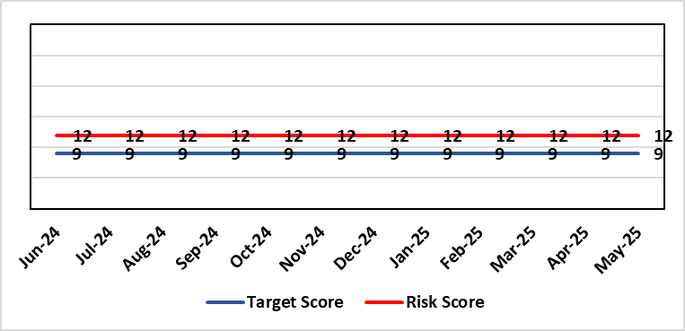 |  | Rationale for current score:  Marked improvement in the performance against the Mental health Measure for CAMHS. Data validation for new patients complete. Current risk score reduced to 12 in view of improved performance however this reflects the fragility in the workforce to deliver sustained performance.
Level of Control  = % |  |  | Rationale for target score:  The rationale for the target score is linked to successful recruitment and more timely access to services for children and young persons which will reduce risk.
Date added to the risk register
October 2023
Controls (What are we currently doing about the risk?) |  |  | Mitigating actions (What more should we do?)
-Ongoing recruitment into all staff groups  -Temporary agency workforce in nursing at premium pay rates to sustain current levels of performance  -Use of locum medical staff due to high vacancy level on medical workforce.  -Recent appointment into psychological therapies lead posts. |  |  | Action | Lead |  | Deadline
 |  |  | Continued efforts at recruitment | Acting Associate Service Director |  | 31/05/2025
Assurances (How do we know if the things we are doing are having an impact?)  -Monthly CAMHS Directorate meeting in place where performance and workforce are scrutinised  -Reporting into Weekly Business Team and MH & LD management board.  -Reporting into SBU Performance & Finance Committee and IQPD (Integrated Quality & Performance Delivery) meeting with Welsh Government  -Ongoing validation of the waiting list to ensure robust reporting going forward |  |  | Gaps in assurance (What additional assurances should we seek?)
Additional Comments / Progress Notes
28/01/25: Compliance against Part 1a (national target 80%) of the measure has continued to improve Aug 84%, Sept 91%, Oct 89%, Nov 80% and while Dec is 77%, Jan prediction is back in target. This demonstrates ongoing improvement from when CAMHs transferred across to SBUHB from last April (23%).
We have recruited to some of the workforce for part 1a of the service awaiting start dates, which will also allow ceasing of agency staff that we inherited. There is wider recruitment continuing in relation to medical and psychology workforce which is also improving. With all this detail the risk score remains appropriate at 12 currently.
01/04/25 Welsh Government have now removed this part of CAMHs services out of targeted intervention. There was a dip in compliance in January 2025 which recovered in February - but this still demonstrates the fragility of the available workforce is this area which is still being addressed, so risk rating remains the same. Two nursing posts and a new consultant psychiatrist have been appointed – awaiting start dates. There is some further discussion regarding requirement to make the service provision sustainable so will review further in two months.

Datix ID Number: 443 New Risk  Health & Care Standard: Effective Care 3.1 Clinically Effective Care |  |  | HBR Ref Number: 104  Risk Target Date: 31/03/2027 |  | Current Risk Rating  4 x 5 = 20
Objective: Care is delivered in safe and appropriate settings supported by innovative digital solutions |  | BAF ref: | Director Lead: Matt John, Director of Digital  Assuring Committee: Digital Data & Innovation Committee  For information: Quality & Safety Committee
Risk: Failure to meet Tier 1 targets in Clinical Coding Completeness  Because: The volume of new inpatient episodes exceeds the available clinical coding staff capacity; There are difficulties recruiting and retaining a sufficient number of trained clinical coding staff to address the gap, and; Clinical information is not always of sufficient quality or completeness electronically (such as DALs) to support swift coding.  There is a risk that: Clinical notes for inpatient episodes will not be coded in a timely way.  Resulting in: The non-achievement of the Tier 1 Welsh Government target (which is that 95% of inpatient activity should be coded within 30-days of discharge); Insufficient coded data to support effective service planning for population health needs; Inadequate data being available for mortality review/quality and safety purposes, with increased risk of failure to spot variance that are negatively impacting levels of patient care and potentially causing avoidable deaths; Negative impact on accuracy of analysis to understand how resources are being allocated and used at Health Board level and national level (programme budgeting); Delays in claiming casemix sensitive contract lines with JCC, Hywel Da and Cwm Taff (circa 70m per annum value in total) due to lack of coding data. |  |  | Date last reviewed: May 2025
Risk Rating  (consequence x likelihood):  Initial: 3 x 4 = 12  Current: 4 x 5 = 20  Target: 4 x 3 =12 | 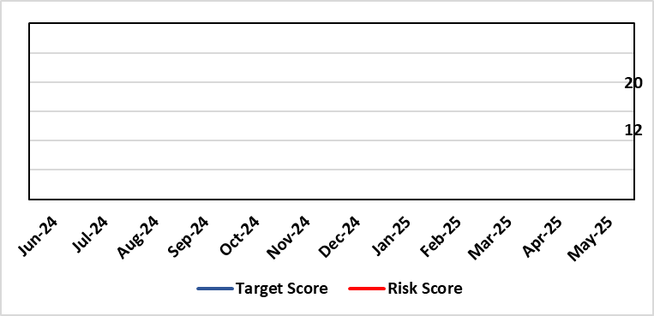 |  | Rationale for current score:  C - Insufficient coding data will negatively impact service planning for population health needs and inadequate data being available for mortality review/quality and safety purposes. This could result in failures at spotting patterns of variance that are negatively impacting levels of patient care and potentially causing avoidable deaths.  Clinically coded activity is also used to understand how resources are being allocated and used at Health Board level and national level (programme budgeting), and therefore a reduction in coding completeness will impact on the accuracy of this analysis. It is also used to claim casemix sensitive contract lines with JCC, Hywel Da and Cwm Taff of circa 70m per annum with lack of coding data impacting on the timeliness in making these claims.  L - Tier 1 target is currently not being met on a regular basis.
Level of Control  = |  |  | Rationale for target score:  C - Insufficient coding data will negatively impact service planning for population health needs and inadequate data being available for mortality review/quality and safety purposes. This could result in failures at spotting patterns of variance that are negatively impacting levels of patient care and potentially causing avoidable deaths.  Clinically coded activity is also used to understand how resources are being allocated and used at Health Board level and national level (programme budgeting), and therefore a reduction in coding completeness will impact on the accuracy of this analysis. It is also used to claim casemix sensitive contract lines with JCC, Hywel Da and Cwm Taff of circa 70m per annum with lack of coding data impacting on the timeliness in making these claims.  L – Increase in what can be coded electronically, unit centralisation, greater staff retention and the development of an auto-coding model will lead to increased capacity and a reduction in likelihood for targets not being met.
Date added to the HB risk register

Controls (What are we currently doing about the risk?) |  |  | Mitigating actions (What more should we do?)
- A three-year coding modernisation plan has been approved by executive board on 26th February 2025. This plan will see the implementation of an auto-coding solution and a re-banding of the clinical coding department within existing budgets to attain Tier 1 targets by 27/28.  - The coding management team assess the staffing complement on a daily basis to ensure resources are deployed in the most efficient and effective manner, in line with demand and clinical coding priorities.  - There is a comprehensive training programme in place for new Trainee Coders.  - The Clinical Coding Departments raise incidents when clinical information is missing from the patient’s health records and prevents the activity being coded in a timely manner. These incidents are highlighted at the Directorate Business Meetings held on a monthly basis as part of the Clinical Coding Key Performance Indicators.  - Clinical coding staff performance continues to be monitored and discussed during the monthly Clinical Coding Managers Meetings, which are chaired by the Head of Health Records & Clinical Coding and an update is also reported and presented on the Health Board Performance Scorecard.  - An App has been developed by Digital Intelligence that shows any relevant data relating to a patient episode from different systems including Signal, TOMs, EPOA and DAL in one place. This will reduce the number of systems a clinical coder needs to log into. |  |  | Action | Lead |  | Deadline
 |  |  | Electronic coding increased by circa 20% increasing Home Working | Coding Manager |  | Complete
 |  |  | Completion of all Actions on Audit Action Plan | Head of Digital Intelligence Programmes |  | 30/06/2025
 |  |  | Auto-coding model in production for two specialties | Head of Digital Intelligence Programmes |  | 30/09/2025
 |  |  | Organisational Change Process for re-banding of clinical coding department completed | Head of Health Records & Clinical Coding |  | 30/09/2025
 |  |  | Centralising of coding department leading to efficiencies | Head of Health Records & Clinical Coding |  | 31/10/2025
Assurances (How do we know if the things we are doing are having an impact?)  - Attainment of the Tier 1 Health Board target for clinical coding completeness which relies on the timely availability and quality of the paper record and electronic sources. Coding 95% of in-patient activity within 30 days of discharge is a tier 1 Welsh Government target that is currently not being achieved regularly within SBU – with an average of circa 74% for 24/25. Performance is reported to Digital Business Meeting every 3 months, and to Digital, Data, Research & Innovations Committee via a Coding Paper.  - Episodes are coded from paper and electronic sources; the ability to code from electronic sources improves the timeliness & accuracy; approximately 52,000 episodes of 150,000 episodes are coded from electronic sources currently. This is reported to Digital Business Meeting every 3 months, and to Digital, Data, Research & Innovations Committee via a Coding Paper.  - An Audit has been carried out by NHS Wales Assurance and Audit Services of the Coding Department was completed in June 2024 with a result of limited assurance. In response a twelve-point action plan was developed of which one action remains which is the escalation of the coding risk to the Health Board Risk register. |  |  | Gaps in assurance (What additional assurances should we seek?)  Investment required supporting the delivery and operational costs of the Digital strategy.  Replacing qualified coders who have left the department with trainees reduces productivity - the only mitigation against this is an auto-coding product to increase productivity and re-banding across coding department to put staff at same bandings as NHS England and help staff retention – the investment required for this is yet to be funded.  The Quality of Discharge Summary provision and standard of clinical information available at the point of coding requires improvement to assist with prompt and accurate coding.  There continues to be missing clinical information at the point of coding, preventing accurate and timely coding.
Additional Comments / Progress Notes
Supplementary Notes:
- Coding 95% of in-patient activity within 30 days of discharge is a tier 1 Welsh Government target that is currently not being achieved regularly within SBU – with an average of circa 74% for 24/25.
- Contract coders and overtime have been used to achieve that 75% average which has stopped due to the current financial situation of the Health Board.
- Retaining and recruiting qualified coding staff is a big challenge due to higher bandings in England and the availability of digitised record to allow home working.
- 6 WTE qualified coders have been lost to English Health Boards or DHCW in the last 3 years due to higher bandings with a further 2WTE retiring. This has resulted in circa 44% of the current coding WTE being trainees/unqualified. Currently, there are 5 qualified coder vacancies (June 2025).

Datix ID Number: 3114 New Risk  Health & Care Standard: 3.4 Information Governance and Communications Technology |  |  | HBR Ref Number: 105  Target Date: TBC |  | Current Risk Rating:  5 x 4 = 20
Objective: Care is delivered in safe and appropriate settings supported by innovative digital solutions |  | BAF Ref: | Director Lead: Chris Morrell, EDAHPHS  Supporting Director: Matt John, Director of Digital  Assuring Committee: Quality & Safety  For information: Digital, Data & Innovation
Risk: Loss of pathology services  If the new Laboratory Information Management (LIMS) system is not live before 15th December 2025 then pathology will lose access to the current LIMS system resulting in the inability of pathology to deliver diagnostic results and blood transfusion services across all Health Board services including emergency, acute, primary and community services. |  |  | Date last reviewed: May 2025
Risk Rating  (consequence x likelihood):  Initial: 5 x 5 = 25  Current: 5 x 4 = 20  Target: 5 x 1 = 5 | 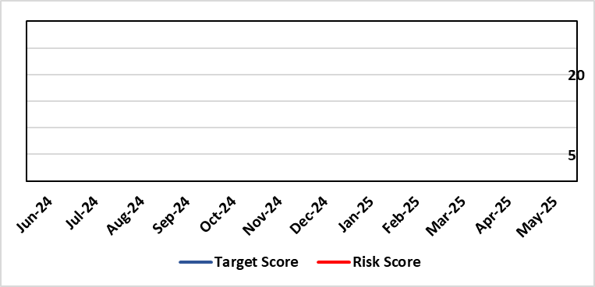 |  | Rationale for current score:  Consequence – catastrophic – due to loss of ability to support clinical services and manage blood transfusion services  Likelihood – probable (10-50% chance currently) – due to being off-track on project and lack of confirmed back-up plan.
Level of Control  = |  |  | Rationale for target score:  Consequence as above  Likelihood will be negligible if effective system / mitigations put in place in time
Date added to the HB risk register
18/06/2025
Controls (What are we currently doing about the risk?) |  |  | Mitigating actions (What more should we do?)
Working with Digital Health and Care Wales to explore how access to the current LIMS system could be extended beyond 15th December 2025  The current LIMS system is accessed through remote access software. Licenses for the remote access software end on 14th December 2025. This means from 15th December 2025 SBUHB Pathology services will not be able to access the current LIMS system. Digital Health and Care Wales are underway with a procurement exercise that could either extended licenses for, or replace, the current remote access software.  Configuring and testing the new LIMS system with the aim of go-live before 15th December 2025  The new LIMS system does not require remote access software. If the Health Board can go live on the new LIMS system before 15th December 2025 the risk will not be realised. SBUHB Pathology services are working in collaboration with other Health Boards and Trusts to share configuration and testing as part of a national programme. However, there is low confidence in achieving go-lives in September (Cellular Pathology), Blood Sciences (October) and Blood Transfusion (November) given the number of issues in the system. Testing has been already extended from two months to twelve months.  Pursuing only a ‘Minimal Viable Product’ to avoid scope-creep  SBUHB Pathology Services are only seeking to pursue a safe replacement system, known as a ‘Minimal Viable Product’. This is to eliminate the possibility of testing timescales being extended. Other Health Boards and Trusts report they are following the same approach.  Challenging the supplier and Digital Health and Care Wales for their technical delivery  The supplier is responsible for addressing any defects identified during testing. Digital Health and Care Wales (DHCW) are responsible for delivering some of the technical integrations (in addition to co-ordinating the national programme). The SBUHB Project Team, through the programme governance, challenge the supplier and DHCW to deliver on their commitments. |  |  | Action | Lead |  | Deadline
 |  |  | Blood Transfusion is the last pathology discipline to go live (November) and is consequently most at risk from access being lost from 15th December 2025. Explore how the Blood Transfusion Module of the current LIMS could potentially be accessed without the need for remote access software. | Head of Laboratory Medicine |  | TBC
Assurances (How do we know if the things we are doing are having an impact?)  National Programme Board  SBUHB, together with all Health Boards, Trusts and the supplier belong to the national LIMS Programme Board.  The Programme Board receives updates on Digital Health and Care Wales progress towards procuring extended licenses, or a replacement of, the current remote access software.  The Programme Board receives updates on testing activities, including metrics showing the number of outstanding system issues. It is chaired by the Executive Director of Allied Health Professions and Health Science for Aneurin Bevan University Health Board.  SBUHB Project Team  A Project Manager is in place to manage the SBUHB Project Team on daily basis.  Operational Delivery Network LIMS 2.0 Sub-Group  SBUHB work in regional partnership with Hywel Dda University Health Board (HDUHB) and hold a joint, monthly Operational Delivery Network LIMS 2.0 Sub-Group, which receives reports from the SBUHB and HDUHB Project Managers, along with Programme Managers from the supplier and Digital Health and Care Wales.  This group is jointly chaired by the SBUHB Clinical Lead for Laboratory Medicine and HDUHB Head of Pathology Service, who are also Senior Responsible Officers for the SBUHB and HDUHB projects.  Morriston Management Board  The SBUHB project regularly reports progress to the Morriston Management Board.  Digital, Data, Research and Innovation Committee  The SBUHB project regularly reports progress to the Digital, Data, Research and Innovation Committee. |  |  | Gaps in assurance (What additional assurances should we seek?)  The national programme team have stated that engagement on costs will initiated with Directors of Finance by the DHCW Director of Finance. SBUHB should seek assurance on minimising and meeting the costs of the proposed mitigation and backup plans:  Meeting the costs of mitigation  The SBUHB go-live date had been planned for June 2025, but a proposed ‘mitigation plan’ put forward by the national programme team seeks both to extend testing timescales and extend licensing for the current LIMS (otherwise due to expire in June 2025) while still achieving go-live before 15th December 2025. It also re-profiles non-SBUHB Blood Transfusion activities into Q1 2025/26. The national programme estimate the cost across Wales at £1.6m.  Meeting the costs of the backup plan  If a go-live before 15th December 2025 is not achieved, a backup plan has been proposed by the national programme team which would extend both access to the current LIMS system and the programme to implement the new LIMS system.  The national programme estimate the cost across Wales between £7.2m (for 3 months) and £12.3m (for 12 months).  A significant proportion of these costs are associated with the remote access software. If the procurement exercise by Digital Health and Care Wales to source an extension or replacement of the remote access software is unsuccessful, then the current supplier is only willing to extending licenses for a minimum of 3 years at a cost of around £5m.
Additional Comments / Progress Notes
User Acceptance Testing sign-off
User Acceptance Testing across Wales was originally expected to take place across the two months of September and October 2024. However, a significant number of issues in the system, coupled with partial delivery of integrations between the LIMS and national systems managed by Digital Health and Care Wales, were identified early in the process. Maintaining the availability of Pathology staff to undertake testing across an extended duration, alongside maintaining service delivery, has also been challenging.

User Acceptance Testing has been extended to, depending on the pathology discipline, around twelve months. Go-lives have not been delayed by the same amount and the decreased duration between the end of User Acceptance Testing and go-live puts additional pressure on the project:
 | Previously | Currently
Duration of User Acceptance Testing | 2 months | 12 months
Duration between User Acceptance Testing sign-off and go-live | 3 months | 1 month

Business Continuity
The Health Board’s current Business Continuity Plan to address a failure in digital pathology systems is to revert back to paper based reporting, which is unsustainable and would only be effective over a very short-term period (days).

Blood Transfusion services in other part of Wales
SBUHB Blood Transfusion are the only Blood Transfusion service in Wales that have successfully migrated onto the current LIMS system. Other Blood Transfusion services use other legacy systems and will potentially be impacted after the 15th December 2025 in other ways (e.g. by having to extend support for their existing legacy systems).

Pathology resource for testing
Testing is reliant on the knowledge and skills of Health Board staff whose availability is limited, having to manage testing alongside normal service delivery. With a national shortage of Biomedical Scientists, there is no readily available external resource to support this process.

Risk Score Calculation

For each risk identified, the LIKELIHOOD & CONSEQUENCE mechanism will be utilised. Essentially this examines each of the risks and attempts to assess the likelihood of the event occurring (PROBABILITY) and the effect it could have on the Health Board (IMPACT). This process ensures that the Health Board will be focusing on those risks which require immediate attention rather than spending time on areas which are, relatively, a lower priority.

