

Meeting Date | 26th March 2024 |  | Agenda Item |  | 3.2
Report Title | Pressure Ulcer – Quality Priority Update
Report Author | Rachel Govier-Williams, Lead Specialist Tissue Viability Nurse
Sponsored by | Sharron Price, Group Nurse Director
Presented by | Gareth Howells, Executive Director of Nursing & Patient Experience
Freedom of Information | Open
Purpose of the Report | The purpose of this report is to provide Quality and Safety Committee with an update regarding current performance relating to pressure ulcer prevention and the ongoing actions of the PUPSG.
Key Issues | - Align Swansea Bay UHB Tissue Viability Nurses into one team and service, under the line management of the Lead Tissue Viability Nurse. This will require an Organisational Change Process  - Lack of Medical Photography across sites  - All-Wales issue re problems with the interface between ward metrics and DATIX
Specific Action Required  (please one only) | Information | Discussion |  | Assurance |  | Approval
Recommendations | Members are asked to:  - Note the content of this report.

Priority areas for feedback in meeting
Exception  achievement, risk | Outcome:  progress / planned mitigation
Health Board Audit and Investigation Closures | SG to outline in QI plans for Assurance
Current HB increase in pressure ulcers | PUPSG QI mapping
Quality Priorities | Report structure change

Risk register update
Current / New Risk | Status | Update | Updated Risk level | Target risk
No TVN Morriston Hospital | 2446  (3 1/2 years vacant) | Band 7 FTE interviews undertaken  Band 6 – pending VCF | 20

Learning and Improvements
Identified Learning, Improvement or Development | Lead
Current HB Figures -Training mapped to Themes | RGW- Lead TVN / SG Reps
QI plans | SG Reps
PUPSG and QP | SP/ RGW/ ED

- INTRODUCTION

This paper will provide Quality and Safety Committee with a summary of Swansea Bay Health Boards (SBUHB) Quarter 3 pressure ulcer position, and updates on the ongoing Quality Improvement work and key risks to the Health Board target of zero tolerance of pressure ulcers.
- BACKGROUND

This report will detail the Pressure Ulcer Performance for Quarter 3 period 2023/24. This is based data sourced 15/2/2024 may differ as per live changes that have since occurred, such as closures and reallocation. Quality improvement programmes and initiatives led by the Pressure Ulcer Prevention Strategy Group (PUPSG) have resulted in significant success over previous years in reducing the number of patients suffering this ‘mostly avoidable harm’. SBUHB has seen challenges in sustaining improvement post Covid-19 despite ongoing QI projects.

- GOVERNANCE AND RISK ISSUES
3.1 Current Situation

Table 1.
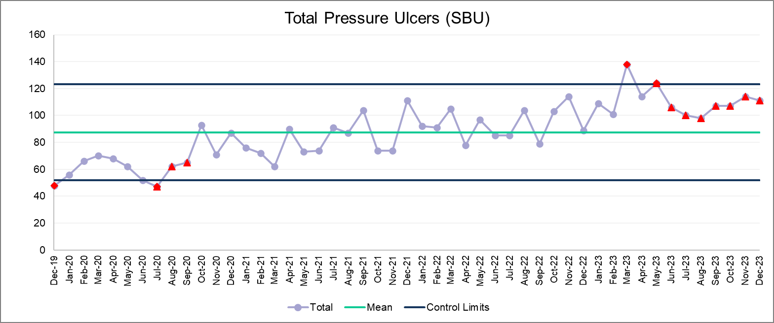
Covid
AMSR
Astronomical point
Table 1 above illustrates the performance of SBUHB as a whole; hospital, community, MH&LD combined. Direct comparison of Q3 2023/24 to Q3 2022/23 shows the same number of incidents being reported, however, there has been an overall increase over the previous year with a decrease in performance; an 8.5% increase in incidents compared to Q2 2023/24.
The three main hospitals (Morriston, Neath Port Talbot and Singleton Hospital) has seen a 15.1% percentage change and Primary, Community & Therapies Service Group (PCT) 11.3% since Q2. Over the last 3 quarters there is a clear run and an upward trajectory in incidents. Service changes and operational factors may have influenced this special cause. The current incident rate (per 1000 bed days) is 1.67 for Q3 for the main hospital sites. This must be viewed in context, as it reflects that some of this data may be questionable in relation to reliability of the Datix reports. If the incidents have not yet been investigated, images uploaded or reviewed by a TVN then they may in fact be incorrect.
The above table indicates the true magnitude of the increase incidents since December 2019 and the context of the position post Covid-19. As a Health Board control measures have changed to reflect the new normal. The below chart (table 2) reflects percentage changes comparing to the previous quarter.

Quarterly Percentage changes
Table 2
  - Pressure Ulcer Severity
Table 3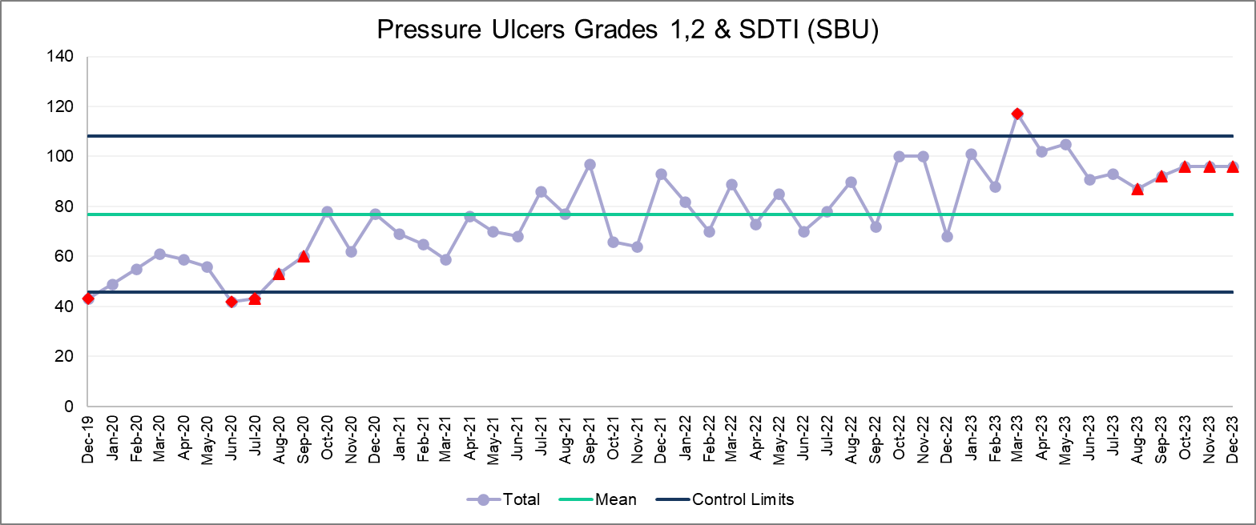 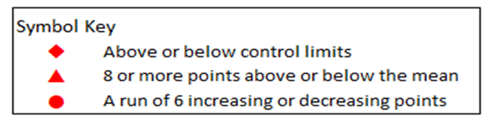
During Q3 2024 the severity of most pressure ulcers developing in the acute hospital and community settings continued to be superficial in nature with 90% of the incidents comprised of pressure ulcers with unbroken skin or category 2 superficial epidermis loss or Suspected Deep Tissue injury (SDTI). This data suggests that when pressure ulcers do occur, staff implement the interventions required to prevent further damage. However, the evolving damage of SDTI may not be accounted for, and identifying the actual number of these that have been reported and then evolved is not reflected in these figures and highlights prevention is key.

Table 4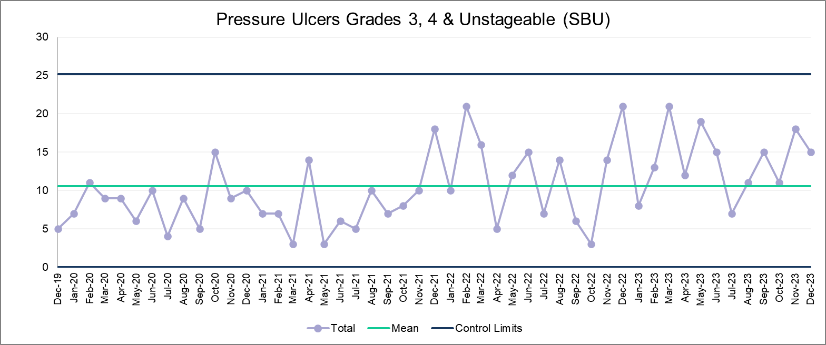
Table 4 above indicates the levels of ‘Deep’ damage developing in the Health Board, the position has decreased with 44 incidents of ‘deep damage’ (grade 3, 4 and unstageable) reported in Q3 in comparison to the 33 in Q2.

The numbers that are Welsh Government reportable are based on the investigations and identifying avoid ability so not all yet identified due data investigation delays. The Health Board continues to have ongoing issues in relation to delayed data input on Datix Cymru reporting system, similar to previous quarters.

3.3 Service Group Delivery of targets and hot spot areas

The table below (5) demonstrate the specific Service Groups. PCT has seen over increase of 7.7% in the period but remain predictable and stable. This has been correlated to ongoing District Nurse case load acuity and long-term care issues and increase in EOL care at home. Themes remain related to unscheduled care, increased vulnerability, and a diluted skill mix of staff. Operational factors such as workforce skills has been identified as one of the indirect factors influencing numbers of patients developing damage.

Table 5
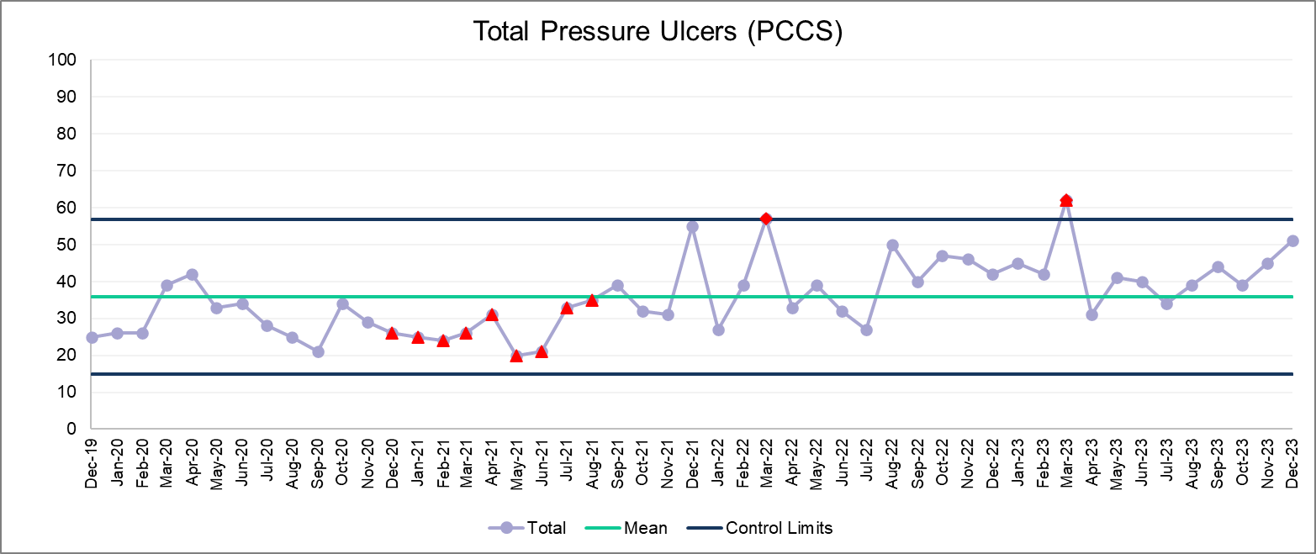

Tables 6 - 9 correlate service and operation changes across the NPT, Singleton & Morriston sites. Morriston has had an increase of incidents with 8 points above the mean average for the Health Board and numbers that are out of are expected control limits. There has been a 3.7% increase from Q2, however December reporting shows a decrease in trajectory which may continue into Q4.
The increase in Morriston Service Group has been correlated to service acuity, throughput and operational changes, and pressures of unscheduled care and changes since AMSR. Reflective of less inpatients, Singleton site are seeing very low numbers. Neath Port Talbot Site has experienced an increase in incidents reporting 16 in Q3 in comparasion to 14 in Q2. Deep dives have been undertaken to address service changes, skill of the staff and investigate what is an anolmolgy for the site, % change is a poor marker and not used for lower numbers. Mental Health & Learning Disabilities Service Group incidents remain stable.

Table 6 Table 7
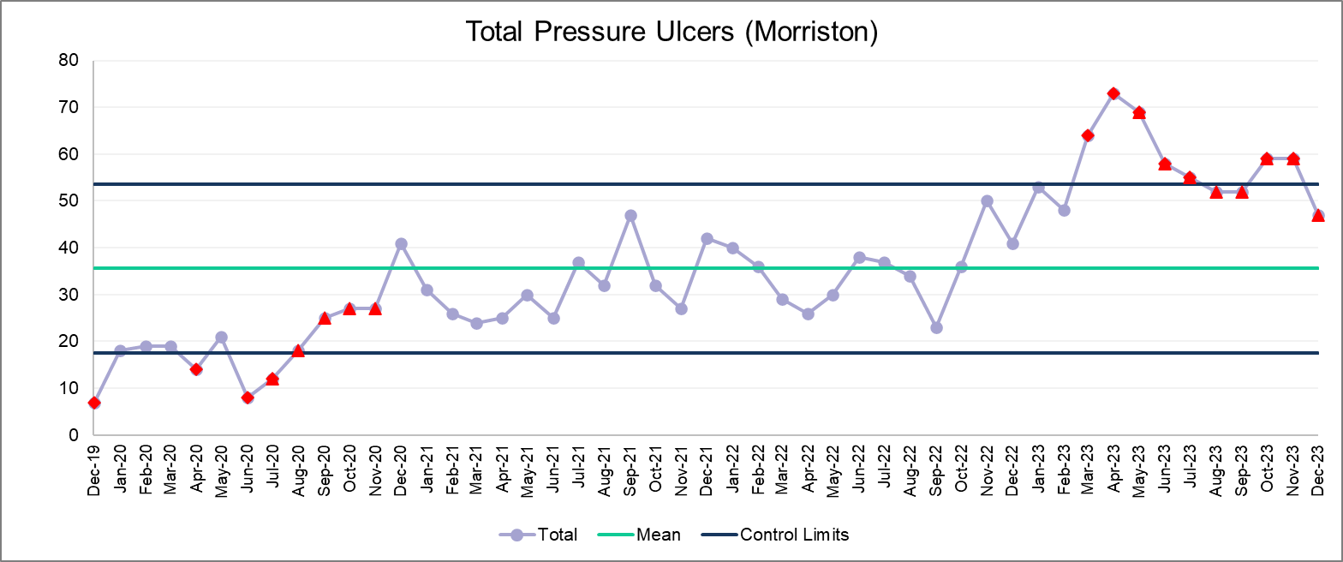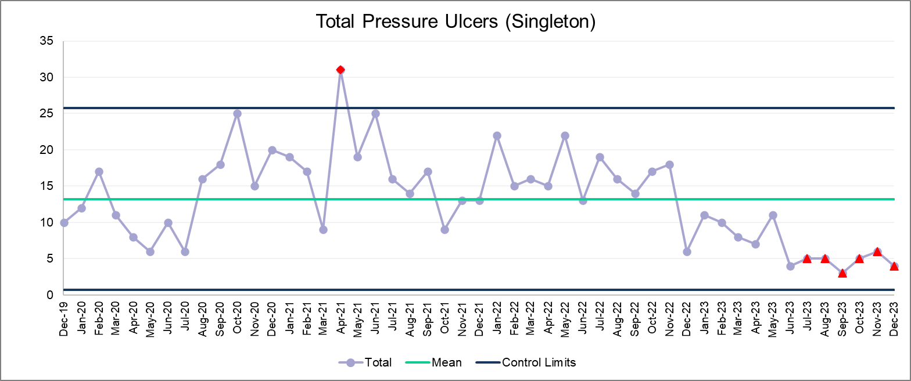

Table 8 Table 9
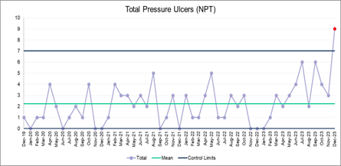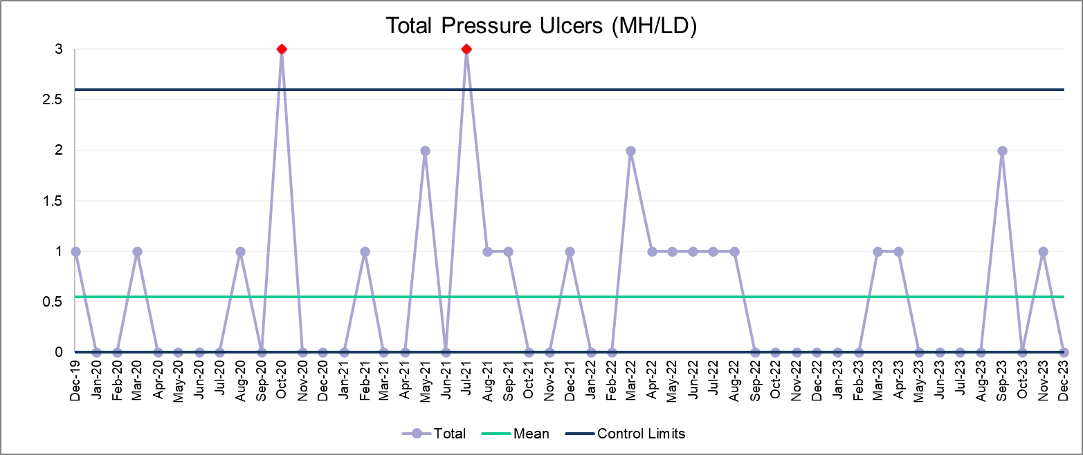

The pareto chart (table 10) below illustrates the current HB ‘hot spots’. The patient’s home remains’ the location where the highest numbers of Health Board Acquired (HBA) incidents occur, followed by Morriston Service Group. We can see the top hot spot area remain mostly unchanged in terms of unscheduled care and emergency admission areas.

Table 10

3.4 Pressure Ulcer Investigation and Scrutiny
Identification of causal factors and learning from pressure ulcer incidents relies on timely investigation and scrutiny of Individual cases. Of 320 incidents reported in Q3 only 211 have been closed, the remaining 35 % are currently under investigation as of 15/02/24. 12 incidents were closed without investigation.

With numbers still awaiting investigation and those that have not yet gone to panel to share the hot debrief or investigation, the opportunity for learning has been potentially missed. The process for early and ‘live ‘learning is imperative to prevent patient avoidable harm. As Pressure Ulcers are a Quality Indicator, assurance will be driven from PUPSG and individual Service Group QI improvement plans to address this.
In terms of avoidability table 11 illustrates the status of incidents for Q3 and the outcome of the investigations whether they were deemed avoidable or unavoidable in scrutiny panel.

Table 11

19 incidents have been deemed avoidable, this is not a true reflection due to the fact there are 89 of the 174 incidents investigated or scrutinised that have not had an aviodability status prior to closure. Pressure ulcers in the larger number are avoidable and in addition to lessons learnt, the governance around these needs addressing to ensure Duty of Candour and redress is considered.

3.5 Audits

TVN/ Pressure Ulcer Prevention Intervention Service (PUPIS) undertake Pressure Ulcer audits Health Board-wide every 6 months. These provide key information and themes regarding patient care, skills of staff and quality of data to identify areas of good practice or Quality improvement.

During Q3 to provide more key information regarding skills assessment and reporting, a reporting audit is also undertaken. This gives a snapshot of the reliability of the incidents reported as pressure ulcers and the staff assessment skills and knowledge.

Results
62% - Overall that were a pressure ulcer and categorised correctly (this is a snapshot of 4-day period and does not include delayed reporting or unvalidated reviews)
72% of incidents reported were a Pressure Ulcer
85% of those that were a pressure ulcer were staged correctly.

Table 12

3.6 Quality Improvement
Pressure Ulcer Prevention Strategic Group (PUPSG)
There has been on going work led by the PUPSG and the Strategic Quality Improvement Plan. This work continues to be based on the learning from investigations and identification of causal factors to reduce the number of avoidable pressure ulcers. The causal factors and thematics have proven challenging to ‘map’ since the changeover to Datix Cymru. A new reporting template has been developed with the objective of getting more concise and accurate data, themes and learning that is governed by the pressure ulcer quality priorities.
Service Groups are requested to submit progress reports quarterly in advance of the PUPSG meetings. The reports detail progress made in achieving targets on priority improvement areas; ‘hot spots’. The reports also provide an opportunity for Service Groups to share their quality improvement objectives that are more specific to challenges individual to the Group and share learning.
Pressure Ulcer Prevention Education
Education on the prevention of Pressure Ulcers has been delivered by practice educators, TVN’s, and PUPIS. Training to prevent pressure ulcers was made available to staff and disseminated via the Group Nurse Directors and posted on the intranet. Further resources for pressure ulcer prevention have been developed by the TVN and PUPIS teams and are being made available on the Share Point page. This incorporates live updates and access to webinars and electronic training.
‘Face to face’ training has been delivered this includes Fundamental’s training days for a mix of community and hospital staff. These has been a very successful implementation of Tissue Viability Skills days in PCT incorporating pressure ulcer prevention, staging, management, and reporting with excellent attendance. Wound interest groups have been implemented for long term care homes has been well attended. Successful pressure ulcer champion’s conferences were provided by the team in November and December with 200 staff in attendance. In addition to this, Pressure ulcer training is also now taught on the oversees programme as well as induction.
Hot spot training has been delivered in NPTSSG after a deep dive approach. This is not achievable in Morriston Service Group due to lack of TVN on site. The Lead TVN has supported with the Health Board training and Scrutiny Panels.
QI plans are in place related to Pressure Ulcer Education for the Q4 period to triangulate an accessible approach to education that does not require a limited resource of Tissue Viability.

Governance
There has been SOP and guidance updates to support Pressure ulcer reporting and investigating.
The scrutiny panel terms of reference were signed off by PUPSG and the guidance for reallocation of incidents from admission to A&E and AMAU areas to PCT.
There are plans for more informative Pressure Ulcer performance dashboards which will enable quality and performance reviews per location. Also, the Datix Cymru amendments required are underway.
In addition, the All-Wales Reporting and Investigating pressure ulcer guidelines have been updated and reviewed by WG, these will also incorporate Skin assessment in darker skin tones aligning with skin bias.

Equality & Diversity
The Lead TVN has been working with digital teams across Wales to develop amendments to the repositioning skin chart and the purpose T risk assessment to incorporate darker skin tones, this is in final stages.
There has been the development of pressure ulcer categorisation tool for Micronates of gestation 22- 26 weeks (Neonates and lead TVN).
There has been a review of the management of bariatric patients whilst undergoing surgery addressing new ways to prevent damage in long theatre cases that are high risk are developing avoidable harm.
The pressure ulcer leaflet has been published in Bangladeshi and Chinese.

Audits
The TVN team have continued to undertake Quality Assurance and Pressure Ulcer Prevalence audits 6 Monthly, which provides key themes. Previous Health Board data suggests areas are not achieving above 80% in most risk assessment, prevention and care planning, repositioning processes and interventions that are required to ensure they are reducing the risk of patients developing pressure damage. In terms of Health Board Policy and Compliance there is much room for improvement to reduce risk of Health Board Acquired avoidable harm.

Quality priorities
Quality priorities have been outlined by the lead TVN and QP lead, and QI tools will be used to drive forward QP improvement project in Feb PUPSG led by Group Nurse Director for Neath Port Talbot and Singleton.

3.7 Key Issue and QI improvements required
Key issues:
- TVN report outlines service-related MSG remains a patient safety risk – score of 20 on the risk register
- Medical Illustration for Neath, Learning Disabilities and Mental health and out of hours Morriston is required.
- TVN service is not resourced enough or sustainable enough to support.
- Hot spot areas identified in all inpatient areas remain – unplanned admission areas with no significant improvements.
- Governance and Datix reporting make data questionable due to accuracy.
- PU incidents require investigation and closure more promptly.

Qi improvement required:
- Information and patient Education
- Dashboards Service group specific with governance status including per 1000 bed days.
- WNCR and digital issues being addressed from AW level.
- MDT approach and discharge planning requires addressing.
- Training compliance and accountability

- FINANCIAL IMPLICATIONS
Avoidable harm has significant impact to our patient’s quality of life, length of stay and will also have a significant financial impact to the Health Board.
- SUMMARY
Ongoing quality improvement is imperative for pressure ulcer prevention, improved patient outcomes and to ensure the sustainability of practice change. The challenges staff are still facing for the prevention of pressure ulcers are reflected in the performance data and coincide with the continued pressures since and the organisational factors. There has been an increased demand for care of the more vulnerable patient and increased acuity in unscheduled care.
The challenges are also amplified by continued staffing issues in the TVN team. The Objective for the end of 2024 and moving forward to 2025 for PUPSG to set mutually agreed targets for the year. The targets will be to set to reduce the incidence of the most common measurable contributory factors implicated in avoidable pressure ulcers. The PUPSGs key focus will continue to focus on Quality Improvement for the HB and support the Service groups to manage their specific challenges.

Risks to Delivery
- No Tissue Viability Service on site in Morriston Service Group. This has been vacant for 3 ½ years. This is due to funding. Risk Register score 20 – ID 6225, Band 7 FTE interviews undertaken, pending VCF for band 6. SBAR for aligning tissue viability services completed,
- There is a high risk to delivery of this priority due to the problems with the interface between ward metrics and DATIX, meaning that Pressure Ulcer incident data thematic is not readily available. This is an all-Wales issues, which is also affecting other areas of patient safety. Progress has been made with informatics to build a local work around for short term use – this remains in progress.
- Lack of Medical Photography

To mitigate the risks described above, a part time (0.66wte) band 7 is being funded from NPTSSG to support the ongoing work regarding the hot spot areas in NPTH, there is an agreement that this will provide interim support into Morriston Service Group for 2 days a week.
The Lead Tissue Viability Nurse will also be undertaking a Health Board-wide review of the Tissue Viability services, to outline our current position, benchmark against other organisations and make recommendations around the future direction of Tissue Viability Services across the Health Board. This work is supported by the Executive Director of Nursing and Patient Experience and all Group Nurse Directors.

- RECOMMENDATIONS

Quality and Safety Committee are asked to:
- Note the contents of the report

