Meeting Date | 25 March 2025 |  | Agenda Item |  |  | 3.7
Meeting Title | Quality and Safety Committee
Report Title | Perinatal SBUHB MBRRACE 2023 Summary Report
Report Author | Kathryn Greaves – Clinical Director of Midwifery  Sujoy Banerjee - Associate Service Group Medical Director
Report Sponsor | Richard Evans - Executive Medical Director & Deputy Chief Executive  Hazel Powell – Interim Executive Director of Nursing
Presented by | Kathryn Greaves – Clinical Director of Midwifery
Freedom of Information | Open
Purpose of the Report | The paper sets out the findings from the MBRRACE 2023 Repot for Stillbirths and Neonatal Deaths within Swansea Bay University Health Board. The paper offers both quantitative and qualitative discussion about the findings from the reviews and the limitations of MBRRACE data reporting in representing the complexities surrounding the death of a baby.
Key Issues | MBRRACE-UK is a national collaboration dedicated to improving maternal and perinatal health outcomes.  The data set concentrates on perinatal services and report all late fetal losses, stillbirths and neonatal deaths within 28 days to MBRRACE. All women who birthed a baby who was stillborn or whose baby died within SBUHB were reported to MBRRACE.
Specific Action Required  (please choose one only) | Information | Discussion |  | Assurance | Approval
Specific Action Required  (please choose one only) | ☐ | ☐ |  | ☒ | ☐
Recommendations | Members are asked to:  - Acknowledge the ongoing Improvement work that is in progress to address the learning from case reviews  - Acknowledge the paper with explanation of the SBUHB MBRRACE 2023 Report findings  - Be Assured with the content of the report and the explanation of the MBRACE 2023 Report to support organisational understanding.

Perinatal SBUHB MBRRACE 2023 Summary Report

- INTRODUCTION

MBRRACE-UK (Mother and Babies: Reducing Risk through Audits and Confidential Enquiries across the UK) 2023 data has been published for Swansea Bay Health Board. Reports are published two years in arrears by MBRRACE-UK which is why the 2023 data is the focus of this report. The findings of the report for this year did identify Swansea Bay as an outlier. However, variation in perinatal mortality outcomes on MBRRACE reports should be expected year on year due to the small denominator size. This does not indicate poor quality of care. MBRRACE methodology acknowledges the same and their grading is simply a flag for qualitative review.

- BACKGROUND

MBRRACE-UK is a national collaboration dedicated to improving maternal and perinatal health outcomes.
The data set concentrates on perinatal services and report all late fetal losses, stillbirths and neonatal deaths within 28 days to MBRRACE. All women who birthed a baby who was stillborn or whose baby died within SBUHB were reported to MBRRACE by the service.
The data looks through the stabilised and adjusted still birth and neonatal mortality rate within the Health Board and compares the data with unit of similar sizes. Stabilised and adjusted rates are the number of stillbirths and neonatal deaths which meet the MBRRACE criteria as opposed to all stillbirths and neonatal deaths in that period, which is the crude data).

The stabilised and adjusted stillbirth and neonatal deaths is 3.73 per 1000 total births and this lies within the average for similar Trust and HBs, while the latter stabilised and adjusted neonatal deaths is 2.10 per 1000 live births which is 5% higher than the average for similar trusts and health boards.

The extended perinatal mortality (stabilised and adjusted still births plus neonatal mortality) is 5.87 per 1000 total births and 5.26 per 1000 total births. This is 5% higher than the average for similar trusts and health boards organisations.

Figure 1 Stillbirth rate excluding congenital abnormalities

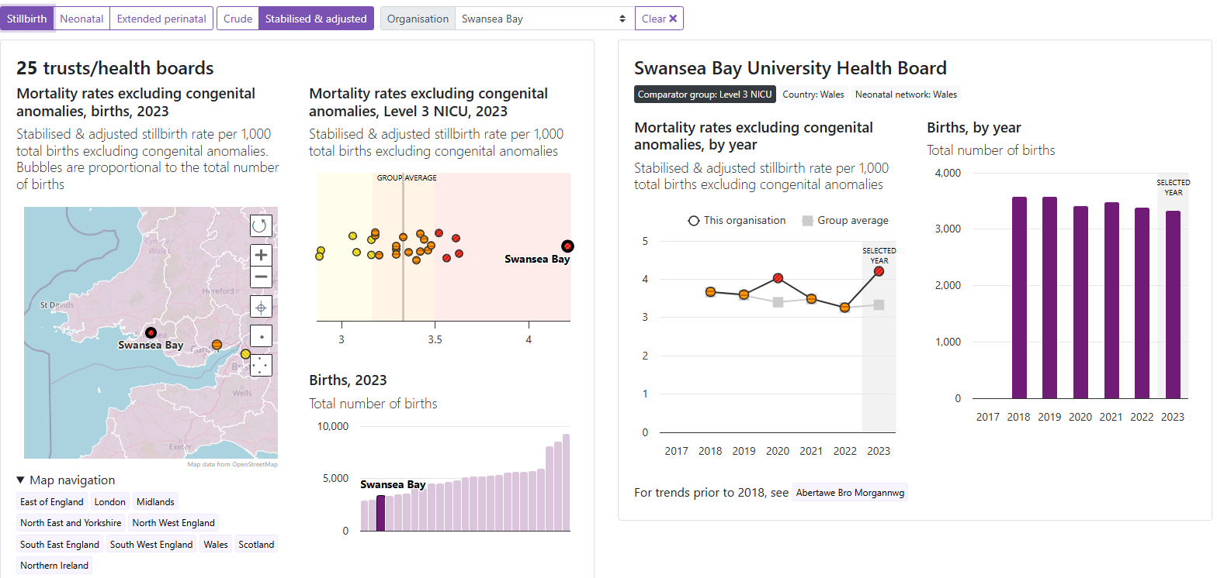
Figure 2: Neonatal Deaths excluding congenital abnormalities
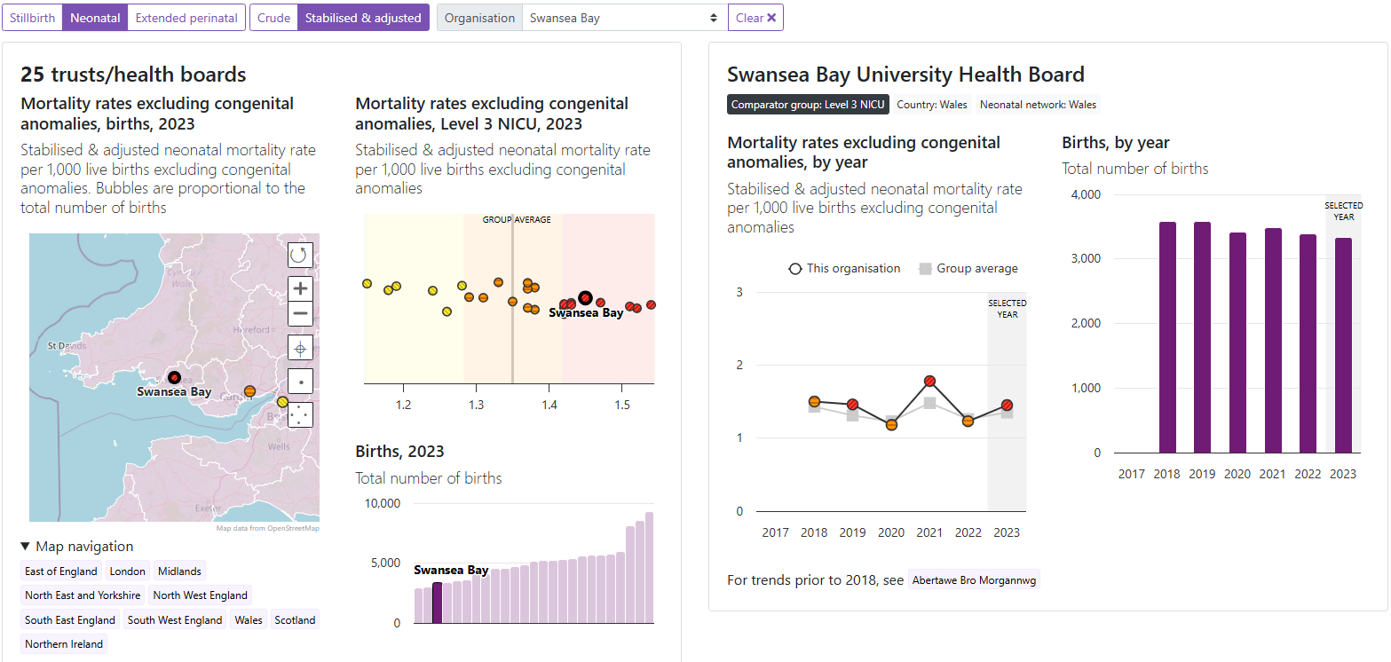

Figure 3 Extended perinatal excluding congenital abnormalities

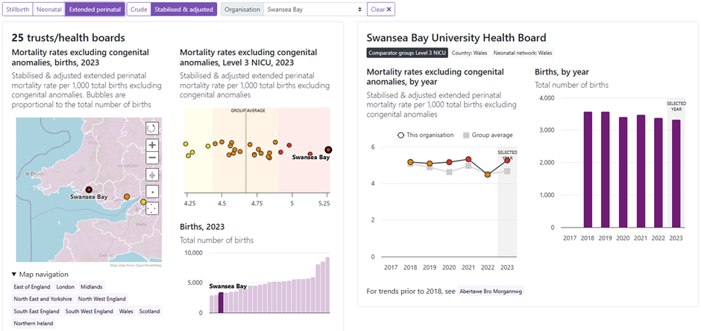
- GOVERNANCE AND RISK ISSUES

3.1 Benchmarking

The adjusted perinatal mortality, stillbirths, and neonatal mortality calculations are subject to wide variation year on year, affected by the reduction in live births (denominator) in SBUHB following separation with Princess of Wales. This means that since 2019, fewer women have birthed within Swansea Bay as it had one less birth centre. However, the number of high-risk pregnancies and/or extremely sick babies has not changed, as the health board continues to patients from referral centres (numerators) as it is a level three service, as it has a neonatal intensive care unit (NICU) which not all neighbouring health boards have.

MBRRACE reports by HB and only adjusts Swansea Bay data by comparing it with other level 3 NICUs, which is based on. case mix (numerator) rather than birth rate (denominator). SBUHB has the third lowest in-house birth rate among tertiary centres in the UK and a large proportion of high-risk infants and mothers are referred in from other Health Boards. Therefore, small variation in deaths (even 1-2 cases) can result in very significant change in mortality rates.

Figure 4
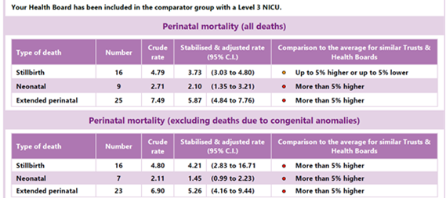
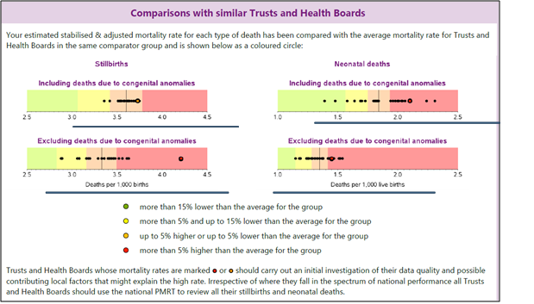

3.2 Other Benchmarking reports – Vermont Oxford Network

The Vermont Oxford Network, the world’s largest neonatal benchmarking organisation uses alternative methodology of variation and have not reported SBUHB Neonatal KPIs (key performance indicators) as outliers in any field in 2023 (graph below). While accepting the population is slightly different (500-1500 gms), this is the highest risk subjects cared for in NICU and accounts for over 90% mortality and is not restricted to the gestational age or the age of the neonate. MBRRACE-UK collects data on neonates who are born after 24 weeks of gestation and those who are less than 28 days of age.

Figure 5 VON data on deaths and morbidity – 2007-2023 (Not outlier in any year)

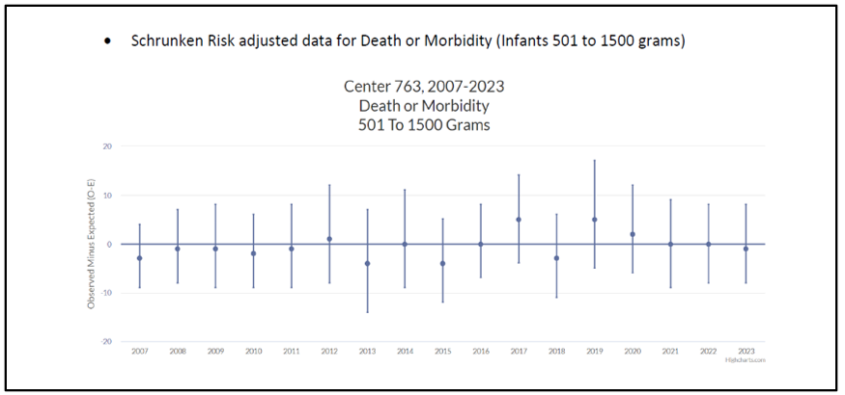

Therefore, to understand the significance of these reports, a qualitative analysis of care is required as undertaken through mortality reviews and recently through peer external review within the Perinatal Mortality Review Tool (PMRT) and uses the following grading:
- Grade A (no issues identified)
- Grade B (care issues identified, no impact on outcome)
- Grade C (care issues identified, which may have affected the outcome)
- Grade D (care issues identified that definitely affected the outcome)

The internal and external reviews (Maternity and Neonatal Network) of mortality from 2023 were largely favourable. The majority of stillbirths and neonatal deaths were graded either ‘A’ or ‘B’ using the PMRT. Completion of the PMRT should include an external peer review member and administration support

It should be noted that the proportion of mothers under 25 years of age who suffered a stillbirth or neonatal death was higher in Swansea Bay than that of the UK as a whole: 17.3% versus 14.0%. However, this is also reflective of the health board’s birth rates in general with a higher-than-average proportion being under 25. In the national MBRRACE-UK Perinatal Mortality Surveillance Report it was shown that mortality rates were higher for babies born to mothers under 25 and over 34 years of age compared to mothers aged from 25 to 34 years old.

The mothers giving birth in SBUHB were considerably less likely to live in areas of highest deprivation (level 5) than those giving birth across the UK as a whole. However, mothers living in areas with level 4 deprivation was almost twice as high as national average (38.5% vs 20%).

The proportion of babies of non-White ethnicity was considerably lower than that of the UK as a whole: 1.3% versus 28.0%. However, this data was unreliable due to poor reporting of ethnicity in 89% cases.

In SBUHB, 30 babies (0.9%) were born at 24 to 27 weeks gestational age, more than 2-fold higher than the 0.4% seen in the UK as a whole. The highest mortality in neonatal care is seen in the lowest gestation babies. However, the percentage of babies born at 28 to 31 weeks was similar to the national average: 1.1% versus 0.8%. In addition, 90 babies (2.7%) were born post-term (42 weeks or greater), a similar percentage to the UK average of 1.2%.

Some of the outcomes can be explained by more than twice the number of extreme pre-term babies cared for in SBUHB than national average. These lower gestation preterm babies are the biggest contributors to neonatal mortality. Mothers residing in Grade 4 deprivation were twice that of national average and this could also be contributory.

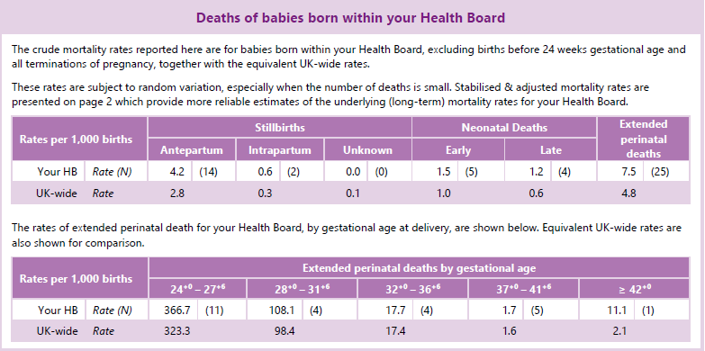

  - Learning from Stillbirths and Neonatal Deaths

SBUHB Maternity services reported 16 stillbirths and nine neonatal deaths in 2023. As set put above, each one was reviewed internally and scored using the PMRT, with the majority in the ‘A’ or ‘B’ category, which shows that care did not affect the outcome.

Thematic analysis and learning have been identified from the cases graded ‘C’ or ‘D’, and include improvements around CTG (cardiotocography), which is the monitoring of a baby or (babies) heartrate before and during labour, as well earlier identification of sepsis.

3.3 MBRRACE-UK 2022 and 2024 Reports

In 2022, the HB was within the average limits for stabilised and adjusted extended perinatal mortality rates. However, it was still important to learn from the cases reported to MBRRACE-UK and some of the improvements made include:

- Implementation of a smoking cessation team for Maternity services
- Carbon monoxide monitoring re-introduced following the COVID pandemic
- Superintendent Sonographers and Lead Midwife Sonographer developed a governance meeting for reviewing ultrasound images of babies born under the 10th centile and not identified antenatally for learning and education for teams.
- The delay in receiving post-mortem results (beyond the recommended standard of 12 weeks) to be discussed at the All-Wales Perinatal Network and escalated to Welsh Government. Waiting times have now been reduced and results are being received within 4 months.
- All late fetal losses from 22+0 to 23+6 to be Datix reported to ensure robust MDT review is undertaken excluding TOP and those with a birth weight < 500g.
- Ensure all perinatal deaths from 22 weeks gestation until 28 days after births to have a robust MDT review undertaken
- All women who declare smoking at booking are offered serial ultrasound scans
- Serial scans for all woman who are identified as a low PAAP-A have been implemented
- Implementation of GAP Grow 2
- Serial scans performed three weekly in line with GAP Grow
- Ongoing audit being undertaken on babies under the 10th centile as calculated by Gap/Grow (Fetal assessment tool) on babies that were not highlighted as small for gestational age pre-birth and audit findings to be shared where any themes, trends or lessons learnt.
- Parental concern is now included in ITU chart as a flag for clinician review
- Learning events and simulation has taken place on early identification of sepsis
- Parents are informed on their rights to a second opinion, and contact details for senior clinicians are displayed on NICU.

In addition, the reporting of cases to MBRRACE has improved since 2022. In 2022 the percentage of deaths notified by SBUHB within 7 days was 40% for stillbirths and late fetal losses and 67% for neonatal deaths, in 2023 this rose slightly to 53% for stillbirths and late fetal losses and 75% for neonatal deaths. The governance around reporting to MBRRACE was reviewed following the 2022 report (which was published late 2023 and targeted processes were changed for 2024, reviewing the live database our reporting as per MBRRACE timeframes (within 7 working days of event) has improved and will be confirmed in the 2024 report which will be published later this year.

Figure 6 Percentage of deaths notified by your Health Board within 7 working days
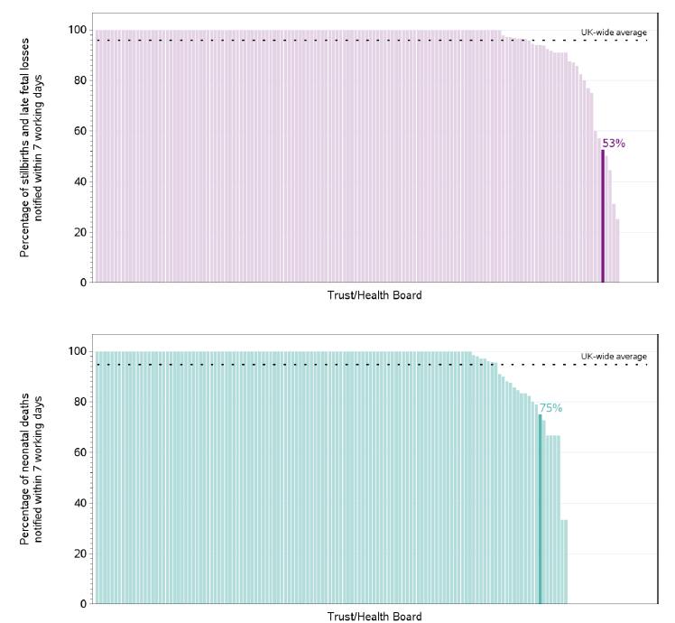

The 2024 data is yet to be published; however, an internal review of 2024 stillbirths and neonatal deaths shows the health board could be within the average for similar sized organisations if similar parameters to that of the 2023 dataset are to be applied. This will be confirmed when the final report is published towards the end of this year. However, the health board will continue to have variation in RAG rating of our mortality by case mix and natural variation due to our low denominator of birth as evidenced by wide confidence interval unless MBRRACE adjusts our outcome by both Level 3 NICU and births under 4000. In the absence of that, qualitative analysis is the best way to assess our care.

These metrics will be monitored regularly via the Quality Indicators established as part of the Quality Management System and will serve to implement monitoring and learning as part of the continuous learning environment which the health board strives to achieve.

  - Local Perinatal Dashboard

A local maternity and neonatal dashboard and indicator set have been developed with the Business Intelligence Team and Clinical service for service, divisional, service group, board and corporate use. This will enable the organisation to monitor maternity and neonatal services continuously, including trends helping to detect deviations and implement improvement measures wherever necessary. This will be live from 1st April 2025 and will support the service to identify trends, themes and potential concerns, and take action, in real time, enabling issues to be addressed at an earlier stage and potentially preventing escalation into something more serious.

- FINANCIAL IMPLICATIONS

The implementation of digital CTG will have cost implications of circa £15k and a bid has been submitted to charitable funds for the funding. The risks of not implementing a software package to support identification of babies at risk is evident through our learning from case reviews. The societal burden of avoidable deaths of babies is vast in the long-term implications for women, families and society and these are tools which would support optimal care and interpretation of antenatal fetal heart patterns. Cost implications associated with the implementation of Antenatal Computerised CTG to support identification of babies at risk are minimal in comparison to the harm to women, babies, families and societal costs.

- RECOMMENDATION
Members are asked to:
- Acknowledge the ongoing Improvement work that is in progress to address the learning from case reviews
- Acknowledge the paper with explanation of the SBUHB MBRRACE 2023 Report findings
- Be Assured with the content of the report and the explanation of the MBRACE 2023 Report to support organisational understanding.
Governance and Assurance

Link to Enabling Objectives  (please choose) | Supporting better health and wellbeing by actively promoting and empowering people to live well in resilient communities
Link to Enabling Objectives  (please choose) | Partnerships for Improving Health and Wellbeing |  | ☐
Link to Enabling Objectives  (please choose) | Co-Production and Health Literacy |  | ☐
Link to Enabling Objectives  (please choose) | Digitally Enabled Health and Wellbeing |  | ☐
Link to Enabling Objectives  (please choose) | Deliver better care through excellent health and care services achieving the outcomes that matter most to people
Link to Enabling Objectives  (please choose) | Best Value Outcomes and High-Quality Care |  | ☒
Link to Enabling Objectives  (please choose) | Partnerships for Care |  | ☒
Link to Enabling Objectives  (please choose) | Excellent Staff |  | ☒
Link to Enabling Objectives  (please choose) | Digitally Enabled Care |  | ☒
Link to Enabling Objectives  (please choose) | Outstanding Research, Innovation, Education and Learning |  | ☒
Health and Care Standards
(please choose) | Staying Healthy |  | ☐
(please choose) | Safe Care |  | ☒
(please choose) | Effective Care |  | ☒
(please choose) | Dignified Care |  | ☒
(please choose) | Timely Care |  | ☒
(please choose) | Individual Care |  | ☒
(please choose) | Staff and Resources |  | ☒
Quality, Safety and Patient Experience
The health board is dedicated to ensuring that pregnancy and childbirth is a safe and positive experience for all service users in order to support healthy life choices and to give children the best start in life. In addition to achieving the Health Board quality priorities, maternity services must also achieve the priorities identified by Welsh Governments Quality Statement for Maternity and Neonatal Services 2025. The Quality Statement has embedded within its core principles, person-centred, high-quality care for mothers and babies throughout pregnancy, birth and following birth.
Financial Implications
Financial implications are set out in the report.
Legal Implications (including equality and diversity assessment)
There are no legal implications.
Staffing Implications
There are no staffing implications of the report.
Long Term Implications (including the impact of the Well-being of Future Generations (Wales) Act 2015)
The Paper is reflective of the Well-being and Future Generations Act in addressing the social, economic, environmental and cultural wellbeing of the population of Swansea Bay University Health Board.

Report History |  | New Report taken through Service Group Governance for approval
Appendices |  | Nil

