Meeting Date | 25 March 2025 |  | Agenda Item |  |  | 4.2
Meeting name | Quality & Safety Committee
Report Title | Infection Prevention and Control
Report Author | Joanne Walters, Deputy Head of Nursing, Infection Prevention & Control
Report Sponsor | Hazel Powell, Interim Executive Director of Nursing, Midwifery & Patient Experience
Presented by | Delyth Davies, Head of Nursing, Infection Prevention & Control
Freedom of Information | Open
Purpose of the Report | This is an assurance report that provides an update on incidence, progress and actions relating to healthcare associated infections (HCAIs) within Swansea Bay University Health Board for the reporting period Quarter 3, to the end of December 2024.
Key Issues | - Hospital onset case numbers for the four infections exceeded the Targeted Intervention de-escalation criteria during the quarter.  - C. difficile cases continue to increase. The Health Board has the high incidence of C. difficile in Wales.  - The number of C. difficile Periods of Increased Incidence (PII) and genomically linked transmission events (outbreaks) is increasing.  - A lack of decant facility is impacting on the ability to appropriately 4-D clean rooms where cases of C. difficile are identified.  - Additional pre-empt patients on wards currently is a common occurrence; this over-crowding increases the risk of transmission.  - High incidence of Influenza in the community impacted on an increase of Influenza incidents in hospitals during Quarter 3, which has compounded existing service pressures and demand for single rooms.  - The health board continues to face significant challenges relating to healthcare associated infection risks, which are recorded in the health board’s Risk Register.
Specific Action Required (please choose one only) | Information | Discussion |  | Assurance | Approval
Specific Action Required (please choose one only) | ☐ | ☐ |  | ☒ | ☐
Recommendations | The Quality & Safety Committee is asked to:  - NOTE: the health board’s Quarter 3 position in relation healthcare associated infections.  - NOTE: the performance of the health board to Targeted Intervention for performance in relation to HCAIs.  - NOTE: the health board continues to have the highest incidence of C. difficile infection and Klebsiella spp. bacteraemia in Wales.  - NOTE: the continued increase in numbers of cases, and the increased numbers of periods of increased incidence, and outbreaks of C. difficile cases seen in Quarter 3, and the continuation of the Gold C. difficile High Incidence Management Group.  - NOTE: progress on Infection Prevention & Control Improvement Plan to 31st December 2024.  - NOTE: the significant challenges and increased service pressures caused by Influenza in community and hospital settings and the current decision to move to universal mask wearing in hospital settings.  - NOTE: the improvement in IPC Level 2 training to 84.85% compliance reported at 31st December 2024.  - NOTE: the challenges and risks within the health board currently and mitigations recorded in the risks recorded in the health board’s Risk Register.

INFECTION PREVENTION AND CONTROL

- INTRODUCTION
This report provides an overview of progress against Welsh Government Targeted Intervention de-escalation criteria. The health board additionally has internal reduction goals for healthcare-associated infections (HCAIs), and the report provides a summary of progress against these internal goals also. The reporting period is 1st April 2024 – 31st December 2024.

The key HCAIs are:
- Clostridioides difficile infection
- Staphylococcus aureus bacteraemia
- Gram negative bacteraemia (Escherichia coli, Klebsiella spp., Pseudomonas aeruginosa)
An update in relation to respiratory viruses and other key infection-related incidents and outbreaks to 31st December 2024 is provided also.
The report provides a summary of the activities carried out across the health board in relation to the prevention, control and management of infection. The report also identifies key risks, and makes recommendations to address areas requiring action or improvement.

- Progress on key healthcare associated infections (HCAI)
2.1 Progress against Targeted Intervention
The health board’s monthly progress against the Targeted Intervention de-escalation criteria for hospital onset, healthcare associated infections (HCAI) is presented in Table 1. Hospital Onset (HO) infections are defined as a positive microbiology result for a sample collected on day 3 or more of a hospital admission (day 1 being the first day of the admission to an in-patient location).
Table 1.
During Quarter 3, the health board exceeded the set targets for all organisms, for each month, with the exception of November, when the targets for E. coli and Klebsiella spp. were achieved. In October, the number of C. difficile hospital onset cases recorded was the highest number since the health board was placed under targeted interventions. Quality Improvement initiatives continue across primary and secondary care settings including:
- IPC care home nurse is continuing to support care homes with infection prevention education and collaborating with the healthy bladder and bowel team to reduce catheter associated urinary tract infections.
- Improving sampling: reducing inappropriate use of dipstick tests to diagnose or exclude urinary tract infections in the older person (age category >65 years), and in catheterised patients.
- Denture Daisy sessions being delivered across care settings to improve in-patient and care home resident’s oral hygiene.
- A review of cleaning standards for C. difficile, using a risk-based approach has commenced.
- Hospital-acquired pneumonia (HAP) audit in Morriston, using the Audit Management and Tracking (AMaT) system, is due for completion at the end of January;
- Risk stratification review for C. difficile.
- Continued education around 72-hour antimicrobial therapy review;
- Mattress Storage Task & Finish group has been established with representation from all Service groups.
- Implementation of a history of previous C. difficile alert flag in Hospital Electronic Prescribing and Medicines Administration System (HEPMA) to alert prescribers to patients at risk.
- The development of a digital application that will support standardising the process for HCAI case reviews and enable learning to be shared widely is progressing.
Each of the service group’s HCAI Improvement Plans continues to be monitored centrally through the monthly Executive HCAI Scrutiny Group meetings, co-chaired by the Acting Executive Medical Director and Acting Executive Director of Nursing and Patient Experience.
2.2 Progress against internal health board reduction goals for key Healthcare Associated Infections (HCAIs): 1st April 2024 – 31st December 2024
Progress against the internal health board HCAI reduction goals (based on the Welsh Government 2023/24 improvement goals) is shown in Table 2. These continue to be monitored and reported within the health board, to maintain a focus on infection reduction for patients in primary care, community, and hospital settings.

Table 2: Internal health board HCAI reduction goals. Cumulative cases to end of December 2024
Infection | Cumulative Cases to end of  December 2024 | Internal improvement goal trajectory to end of December 2024 | Actual cases versus internal reduction goal (+/-)
C. difficile (CDI) | 206 | 74 | +132
Staph. aureus bacteraemia (SABSI) | 98 | 56 | +42
E. coli bacteraemia (EcBSi) | 170 | 178 | -8
Klebsiella spp. bacteraemia  (Kl BSI) | 90 | 57 | +33
Ps. aeruginosa bacteraemia (PAERBSI) | 13 | 15 | -2

A summary position for service groups is shown in Table 3. This identifies the cumulative number of cases up to the end of December 2024, with the annual increase or reduction shown in brackets.

Table 3: Service Group Annual Comparison to end of December 2024
 | CDI | SaBSI | EcBSI | KlBSI | PAER BSI
SBUHB - Total | 206 (↑12%) | 98 (↓15%) | 170 (↓16%) | 90 (↑30%) | 13 (↓32%)
PCTSG - CAI | 54 (↓17%) | 39 (↓28%) | 92 (↓2%) | 27 (↓18%) | 3 (↓25%)
PCTSG - HAI | 5 (↑ 3 cases) | 2 (↑2 cases) | 0 (↓33%) | 0 cases | 0 cases
MH&LD – HAI | 1 (↑1 case) | 0 cases | 2 (↑2 cases) | 1 (↑1 case) | 0 cases
MORR – HAI | 107 (↑16%) | 39 (↑15%) | 44 (↓36%) | 39 (↑50%) | 5 (↓44%)
NPTH - HAI | 11 (↑6 cases) | 0 (↓1 case) | 8 (↑33%) | 4 (↑2 cases) | 1 (↑1 case)
SH - HAI | 25 (↑47%) | 17 (↓26%) | 17 (↓37%) | 15 (↑88%) | 2 (↓3 cases)
Other HB Cases Identified in SBUHB | 3 cases | 1 case | 7 cases | 4 cases | 0 cases

Charts showing the position of the health board and service group progress against the infection improvement trajectories, up to 31st December 2024, are detailed in Appendix 1.
Appendix 2 provides a comparison with other acute health boards in Wales in relation to incidence of these infections per 100,000 population and per 1,000 admissions. Compared with other health boards in Wales, Swansea Bay has the highest incidence/100,000 population for C. difficile infections and Klebsiella spp. bacteraemia.
Improvement goals for 2024/25 were circulated from Welsh Government in a Welsh Health Circular published in September 2024 (WHC (2024) 038), and these outlined the goals for antimicrobial resistance and healthcare associated infection. Progress against these goals is monitored and is shown in Table 4. However, as the original internal goals had been used for the development of the Health Board’s, and Service Group, Infection Improvement Plans, it was agreed to continue to report progress against these original internal goals for the remainder of the financial year.
Table 4: Progress against WHC (2024)038 Improvement Goals, by acute Health Board, April 2024 – December 2024.
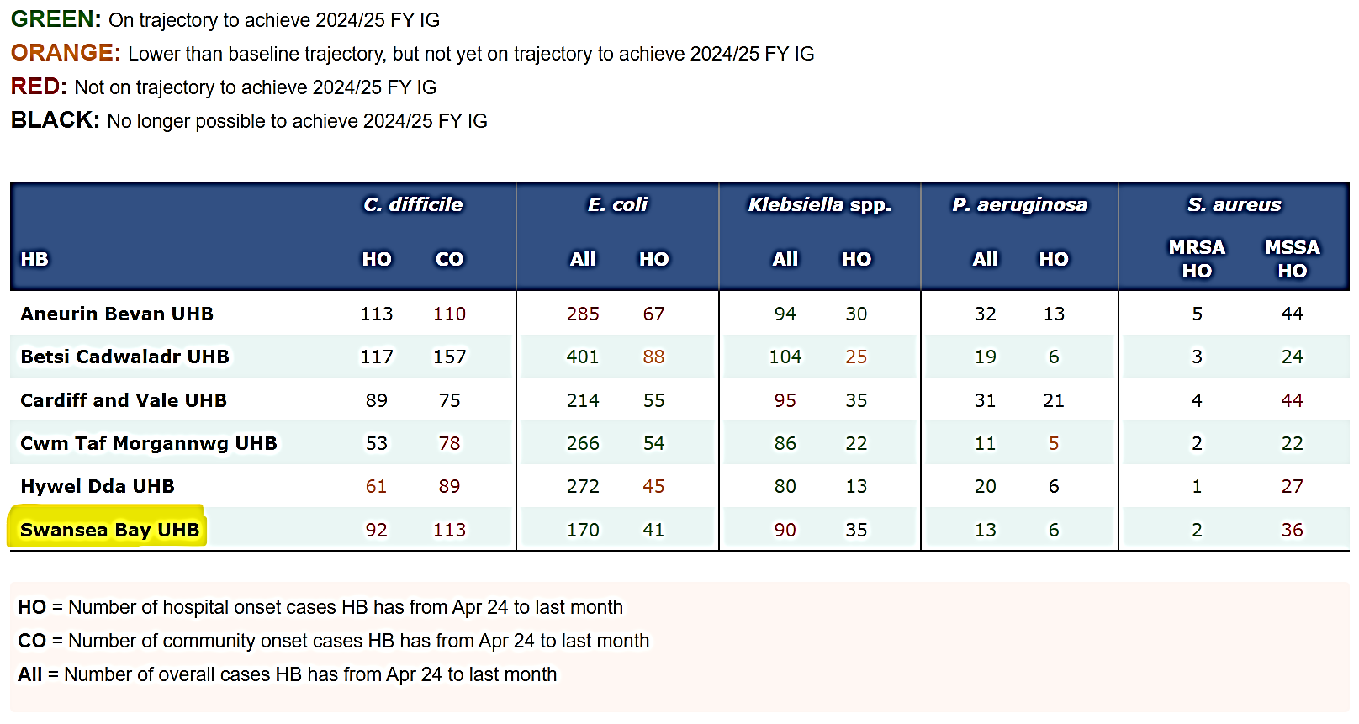
- Clostridioides difficile
At the end of Quarter 3, the annual internal infection reduction goal has been exceeded by 132 cases. There has been an 12% increase in case numbers when compared with the number of cases in the same period in 2023/24. Numbers of C. difficile infection have increased year-on-year, with an almost doubling of patients affected in the 6 years from 2019.
Of the 206 positive cases to date, 72% were categorised as hospital-acquired infections (HAI). The majority of the HAI cases were attributed to Morriston Hospital where a 16 % increase in case numbers has been recorded compared with the equivalent time period of the previous year.
The number of cases attributed to Neath Port Talbot Hospital has more than doubled when compared to the same time period in 2023/24 and Singleton Hospital case rates increased by 47% compared with the previous year. Three cases of C. difficile identified in Swansea Bay hospitals were from patients who reside within the boundaries of other health boards and who were found to be positive on, or soon after, admission.
The health board continues to have the highest incidence of C. difficile infection compared with other Welsh acute health boards (70.96/100,000 population). This is significantly higher than the Wales average of 49.63/100,000 population. All acute health boards in Wales have seen an overall increase in case numbers compared with the previous financial year, however, the rate of increase for the health board is the second lowest (12%) when compared with the other health boards in Wales, with percentage increases ranging from 8%-107%.
All healthcare associated C. difficile toxin positive cases in Service Groups are reviewed by Director-led HCAI scrutiny panels to establish if patient infection episodes were managed appropriately, and to determine if the infection episode could have been prevented. It is important that themes from the case reviews are analysed, and that all learning is shared with care providers and those who make decisions on patient care planning.
Morriston Hospital is nearing the conclusion of the site-wide disinfection programme, which was in response to the outbreak of C. difficile WGS Cluster Code WG22-00159_73. The programme has involved ward decant, deep clean and disinfection with hydrogen peroxide vapour (HPV) technology. This programme has seen:
- 20 Wards deep cleaned & HPV decontaminated.
- 6 Wards UV cleaned.
- 34 Whole Ward moves.
The programme has been successful in relation to further transmission of the outbreak strain. There has been an additional case identified retrospectively, who had been an inpatient in contact with other outbreak cases during December 2023 and, as such, is considered to be part of the 2023/24 outbreak.

- Staph. aureus bacteraemia

Although the internal improvement goal target has already been exceeded by 42 cases, there has been an overall reduction in case numbers by 15% across the health board when compared with the same period in the previous financial year. All service groups, with the exception of Morriston, have less cases reported than the equivalent time period in 2023_24. Fifty-nine percent of the cases were Hospital Acquired Infections (HAI). The most common source for these infections was considered to be line-associated infections (34%). There have been 21 line-associated infections reported to date, with 62% of them attributed to Morriston. Of the remaining cases that were attributed to Singleton, the majority have been identified in the patient population receiving care via Cancer Services. Community acquired infections (CAI) accounted for 41% of all reported cases. The most common source (35%) was recorded as skin and soft tissue infections (SSTIs), followed by bone and joint infections (22%).
- Gram negative bacteraemia (E. coli, Klebsiella spp., Pseudomonas aeruginosa),
The maximum number of E. coli bacteraemia cases required to meet the internal reduction target should not exceed 234 cases. The health board is currently maintaining a trajectory below the internal infection reduction goal. To the end of Quarter 3, there have been 170 cases, which represents a 16% reduction when compared with the same time period in the previous financial year. Seven cases were recorded for patients residing outside the boundaries of the health board, but who had an E. coli bacteraemia within the first two days of admission to Morriston.
Fifty-eight percent of the cases were categorised as community-acquired infections. The urinary tract was considered to be the most common source recorded for all of the bacteraemia cases (54%). The urinary tract was recorded as the primary source for 44% of hospital-acquired infections and 60% of the community-acquired cases. The health board-wide quality priority campaign continues to focus on the importance of hydration & nutrition to prevent dehydration and the associated complications such as infections, constipation, and other life-threatening conditions.
E. coli bacteraemia rates have reduced within the health board compared with the same reporting period in 2023/24, with the exception of Neath Hospital, where there has been a 33% increase, and Mental Health and Learning Disabilities, where there have been two cases (zero in 2023/24). Singleton and Morriston are both maintaining a trajectory required to achieve the internal annual reduction goal.
The annual total number of Klebsiella spp. bacteraemia cases (71) has been exceeded; there have been 90 cases to the end of December 2024. This total includes 4 cases identified in patients who reside outside the boundaries of the health board, but who had a Klebsiella spp. bacteraemia within the first two days of admission to Morriston. There has been an overall 30% increase in case numbers when compared with the same period in the previous financial year. The distribution of hospital and community acquisition are recorded as 66% and 34% respectively. The urinary tract continues to be the most common primary source of infection for all Klebsiella bacteraemia (40%) followed by hepatobiliary associated disease (21%). In the hospital setting, 34% of the cases have the urinary tract reported as the primary source, followed by hepatobiliary disease (17%).

In order to achieve the internal infection reduction goal for Pseudomonas aeruginosa bacteraemia, the maximum annual number of cases should not exceed 21. The cumulative total for Quarter 3 is currently 13 cases. This demonstrates a 32% reduction compared with the same time period in the previous financial year. The health board is maintaining trajectory to achieve the internal annual reduction goal. The majority of the infections are considered to be hospital-acquired infections (77%). The most common primary source for all of the infections is the urinary tract (46%), with respiratory infection reported as the second most common source (23%).

- Infection Prevention & Control Improvement Plan
  - Overarching 2024/25 Infection Prevention Improvement Plan
The infection prevention improvement plan focuses on core themes to reduce episodes of harm caused by healthcare associated infections (HCAI).
Progress to the end of Quarter 3 is presented in Appendix 3 (separate document).

- Outbreaks and clusters, untoward incidents, Periods of Increased Incidence (PII), and ward/bay closures from diarrhoea and vomiting
  - Periods of Increased Incidence (PII)
A period of increased incidence (PII) is triggered when two hospital-acquired cases of C. difficile are attributed to the same ward location within a 28-day time period. For reporting PII in Swansea Bay, this includes both toxin positive and toxin negative cases.
Table 5 in Appendix 4 includes the details of the thirty-three PIIs that occurred in twenty-nine wards during Quarter 3 of this year. The number of PIIs, and the number of patients affected, is increasing:
• Quarter 1 23 PIIs, involving 64 patients;
• Quarter 2 27 PIIs, involving 94 patients;
• Quarter 3 33 PIIs, involving 105 patients.
Whole Genome Sequencing (WGS) is performed by the anaerobic reference lab in Cardiff on all C. difficile positive samples. If cases have the same genomic cluster code, they are considered to be genetically related and may indicate that a transmission event has occurred. When the WGS cluster code is shared by two or more cases, and epidemiological links are established (linked in time and place), these are reported as probable outbreaks.
WGS results take approximately two weeks to be reported to the health board, this means that linked cases are identified and reported retrospectively. In some instances, the WGS results may identify cases with the same cluster code that are not associated to a PII. In these instances, a further review of the patient pathway is undertaken to establish if there are epidemiological links in time or place.
For the 33 PIIs reported in Quarter 3, WGS results available at the time of reporting indicate that the majority of these cases were not genomically linked. Whilst there is a level of reassurance that transmission in hospital does not account for the majority of cases, the increasing numbers of cases of C. difficile seen within the health board, along with the increasing number of PII and genomically-linked transmission events, is concerning.
Four probable transmission events (outbreaks) were identified for wards in PII during Quarter 3. By reviewing the patients’ timelines and pathways it has been possible to establish epidemiological links i.e., the patients have been on the same ward, either at the same time, or within a specific period of time. These transmission events were all associated to Morriston and include Cardigan Ward, Gowers Ward, Ward T, and Ward J.
Results of genomic sequencing suggests that there could be various sources for exposure to C. difficile within hospital and community settings. As such, there must be a greater focus on maintaining the balance of the gut microbiome and improvements in the prescribing of antimicrobials, proton pump inhibitors, and laxatives.

  - Genomically linked C. difficile clusters:
The WGS results received during Quarter 3 have been reviewed to identify any epidemiological links between individual cases previously reported which might outbreaks retrospectively.
One hundred and eighty-three laboratory identified C. difficile PCR positive test results were reviewed (October – December 2024). Of the 183, there were 106 distinct genomic cluster results.
Table 6 in Appendix 4 provides the details of fourteen WGS genomic cluster codes where there were two or more patients identified to have the same WGS cluster code. Seven of the fourteen clusters have been found to be epidemiologically linked in time and place, and are categorised as outbreaks of limited extent, involving hospital transmission events. There have been 16 patients affected these outbreaks of limited extent. The locations of these outbreaks are identified within Table 7.
  - Incidents and outbreaks

There have been 84 separate ward infection incidents in health board hospitals between October and December 2024. Forty of these ward incidents involved single cases only and resulted in bay closure (range 0-4 days). Table 8 in Appendix 5 provides a summary of the infection-related incidents and outbreaks (not associated to C. difficile), where two or more confirmed cases were identified. This is shown by service group during the reporting period, and includes the causative organism where it has been confirmed, and the number of patients affected. The majority of the incidents during this Quarter were as a result of Influenza.

The increased prevalence of Influenza circulating in the community during December resulted in additional pressure across many services, particularly on unscheduled care and acute inpatient locations, where many patients were presenting to hospital due to complications secondary to community-acquired Influenza. The insufficient single room accommodation across acute inpatient settings resulted in an inability to isolate all patients with infectious symptoms (suspected and confirmed cases). This potentially led to exposure of other patients, closure of bays, and in some instances outbreaks occurring. Daily Infection Control huddle meetings continue to be held to manage these situations, and the Infection Prevention & Control team provides clinical teams with support to assess the incident, and advice on the appropriate control measures. At these Infection Control Safety Huddles, those present undertake risk assessments of isolation capacity and use, to support the prioritisation of single room utilisation, and to determine where it would be appropriate to cohort suitable patients to improve capacity to maintain safe patient flow.

In response to the high incidence of Influenza in community and hospital settings, a decision was made to introduce universal masking in all clinical areas, and to close wards to visiting, with the exception of “visiting with a purpose”, by agreement with the ward manager.

- Education & Training
Training compliance
The IPCT, along with local training practice leads, continues to deliver IPC training and updates to both clinical and non-clinical staff employed by the health board. This is in addition to any online training undertaken by staff.
The tables in Appendix 6 identify the numbers of staff (with percentage compliance where available) that have undertaken IPC-related training to 30th December 2024.
Level 1 and Level 2 Infection Prevention & Control Training (Table 9 and Table 10):
- Compliance to 30th December 2024 for Level 1 training was 91.57% and for Level 2 training was 84.85%.
Hand Hygiene Practice Assessment and Hand Hygiene Assessors (Table 11)
- Over the last 12-month rolling period (1st January 2024 to 30th December 2024), 2,685 staff have had a hand hygiene practice assessment, with the assessment undertaken by the IPC nurses or by the department-based Hand Hygiene Assessors.
- ESR reports Hand Hygiene Competence compliance within the health board as 31.97%. This information in ESR is considered unreliable and service groups may wish to consider alternative methods of recording practice assessments (Table 12).
- Over the last three years (1st January 2022 to 30th December 2024), the IPCT has trained 576 Hand Hygiene Assessors within the service groups. Detailed information regarding Hand Hygiene Assessors is available for each service group.

Aseptic Non-Touch Technique (ANTT) (Table 13)
- Compliance with ANTT training to 30th December 2024 is recorded in ESR as 29.74% for the ANTT e-learning course, and competence assessment compliance as 16.39%.
- Training reports from ESR uses all health board staff as the denominator for compliance. Not all health board staff are required to undertake ANTT e-learning or competency assessment, therefore the compliance percentage is not a true representation of compliance. Service groups may wish to consider alternative methods of recording compliance.

- Assurance
Reporting
- The Quality & Safety Group receives quarterly assurance reports relating to infection prevention and control. In addition, any issues for escalation would be taken to the Quality & Safety Group outside of the quarterly reporting schedule.
- The assurance reports are formally presented to the Quality & Safety Committee quarterly.
- The performance tracker, showing performance against the Tier 1 infection reduction expectations, is circulated weekly to the Executive Team and Service Group Directors and is available on the IPC SharePoint site.
- The Targeted Intervention performance tracker is circulated to the Executive Leads for HCAI, and performance is reported formally at monthly Targeted Intervention and Integrated Quality, Planning and Delivery meetings with Welsh Government.
- Senior IP&C staff attend each Service Group Infection Control Group. The IP&C Matrons and the Matron, Decontamination Operational Lead, together with Band 7 Infection Control Nurses, ensure support is provided to the Service Group Triumvirates.
- The IPC team actively participates in healthcare associated infection review panels within Service Groups, liaising closely with service group IP&C leads and clinical staff from each ward/department.
- The senior members of the IPCN team, along with other Corporate Nurses, participate in Quality & Safety assurance visits across the health board to review Safe & Effective Care provision.

- Infection Prevention Team Audit Programme
The IPC team continues to collaborate with the Audit Management and Tracking (AMaT) project team to design new audits for use across the health board. This includes development of an audit to support monitoring outbreak control measures, and audits for use in community settings. The IPC team continues to support the project team and clinical staff during the phased introduction of the IPC environment audits in AMaT across clinical areas. Acute inpatient settings are now undertaking monthly audits using the IPC standard precautions audit tool. During November, the IP&C environment audits were introduced into outpatient settings.
Since the implementation of AMaT, the IPCT has undertaken 24 annual audits, with a compliance score range of between 66.7 to 100%. Additionally, 74 quarterly validation audits have been completed, with compliance scores ranging from 40 to 100%. An additional 71 audits have been undertaken by the IPC team using the manual systems when infection incidents, outbreaks and PIIs are detected.
Verbal feedback is provided to the nurse-in-charge at the time of the audit. This is followed up with the senior nursing team ahead of the final report being available in AMaT. The action plans in response to areas of non-compliance are developed by the clinical areas and monitored by the service groups. These are reported through their agreed governance meetings.

- Infection-related Incidents and Risks in DATIX
Risk Register
On the 15th January 2025, there was one new infection-related risk reported (4067); there were 15 open and accepted infection-related risks on the Risk Register.

Table 14: Open and Accepted infection-related risks on the Risk Register
Infection-related risks on the Risk Register | Total
Executive Director of Nursing | 7
Morriston Hospital Service Delivery Unit | 4
Singelton Hospital, Neath Port Talbot Hospital Service Group | 4
Total | 15

Of the 15 open and accepted infection-related risks on the Risk Register, four had passed the review date. There has been email communication with all relevant Risk Handlers to request a review and update of overdue risks, the detail of which can be found in Table 15.

Table 15: Overdue review of infection-related risks, by Service Group | Overdue Review | Risk Register ID
Singleton Hospital Delivery Unit | 2 | 3011, 3778
Morriston Hospital Service Delivery Unit | 2 | 3012, 3515

Infection-related incidents
At 15th January 2025, RLDatix system identified the following infection-related incidents:

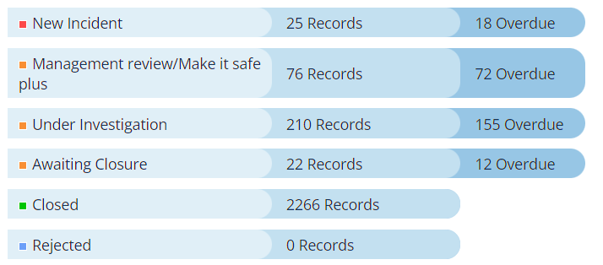

CHALLENGES, RISKS AND MITIGATION
HCAI
- Lack of a dedicated decant facility (Datix Risk ID 2210). There are still no permanent decant facilities available across the health board, this impacts on being able to decant bays and wards to undertake deep cleaning maintenance and refurbishment.
- Increased risk to patients for acquisition of C. difficile infection (Datix Risk ID 2286). Morriston has completed HPV disinfection of 20 wards across the hospital. A Gold C. difficile High Incidence Management Group has been established, meeting twice a month, with representation from each service group and support services. A review to determine if existing systems could support a risk stratification identification process for acquisition of C. difficile is underway. A digital application is under further development for HCAI case reviews; this should be available to pilot during in the next quarter. A paper on the C. difficile position and risk, with recommendations, will be submitted to the Management Board in January.
- Service pressures across the acute sites preclude the ability to undertake a regular pro-active programme of 4D cleaning, and compromise the ability to undertake reactive 4D cleaning following episodes of infection such as C. difficile.
- The limited availability of single room isolation facilities continues to present a challenge to the appropriate management of patients with suspected or confirmed infections, resulting in a risk of extended exposure of other patient contacts to the risk of transmissible infections, such as MRSA and other multi-drug resistant organisms. Additionally, due to the competing demands for single rooms, there can be a delay in isolating patients while staff await confirmation of an infection prior to moving patients, which may add to the exposure risk for other patients and an extended period where organisms continue to contaminate the environment – HBR 4 (Datix Risk ID – 739).
- The high numbers of clinically optimised patients awaiting packages of care continues to put increased pressure on bed capacity in the acute sites. The additional patients “boarding” on most wards throughout Morriston continues. Surge beds are also in use in Gorseinon, staffed by bank and agency staff. Additional beds in existing multi-bedded rooms further reduces space between beds. These factors increase the risk of infection transmission due to non-compliance with bed spacing guidance (Datix Risk ID – 2488).
- Bed spacing and ventilation within the majority of inpatient wards poses an ongoing risk in relation to transmission of infections, including COVID-19 and other seasonal viral infections, including influenza, Respiratory Syncytial Virus, parainfluenza, and Norovirus (Datix Risk ID 2488).

- GOVERNANCE AND RISK ISSUES
Healthcare associated infections are associated with poor patient outcomes, and are significant quality and safety issues. Continuing failure to achieve the infection reduction improvements is an unacceptable position for our patients (HBR 4), and has resulted in an escalation from Enhanced Monitoring to Targeted Intervention.

- FINANCIAL IMPLICATIONS
A Department of Health impact assessment report (IA No. 5014, 20/12/2010) stated that the best estimate of costs to the NHS associated with a case of Clostridioides difficile infection is approximately £10,000. The estimated cost to the NHS of treating an individual cost of MRSA bacteraemia is £7,000 (the cost of MSSA bacteraemia could be less due to the availability of a wider choice of antibiotics). In an NHS Improvement indicative tool, the estimated cost of an E. coli bacteraemia is between £1,100 and £1,400, depending on whether the E. coli is antimicrobial resistant. Estimated costs related to healthcare associated infections, from 01 April 2024 to the end of December 2024 is as follows: C. difficile - £2,060,000; Staph. aureus bacteraemia - £686,000; E. coli bacteraemia - £194,800; therefore, a total cost of £2,940,800.

- RECOMMENDATION
The Quality & Safety Committee is asked to:
- NOTE: the health board’s Quarter 3 position in relation healthcare associated infections.
- NOTE: the performance of the health board to Targeted Intervention for performance in relation to HCAIs.
- NOTE: the health board continues to have the highest incidence of C. difficile infection and Klebsiella spp. bacteraemia in Wales.
- NOTE: the continued increase in numbers of cases, and the increased numbers of periods of increased incidence, and outbreaks of C. difficile cases seen in Quarter 3, and the continuation of the Gold C. difficile High Incidence Management Group.
- NOTE: progress on Infection Prevention & Control Improvement Plan to 31st December 2024.
- NOTE: the significant challenges and increased service pressures caused by Influenza in community and hospital settings and the current decision to move to universal mask wearing in hospital settings.
- NOTE: the improvement in IPC Level 2 training to 84.85% compliance reported at 31st December 2024.
- NOTE: the challenges and risks within the health board currently and mitigations recorded in the risks recorded in the health board’s Risk Register.
Governance and Assurance

Link to Enabling Objectives  (please choose) | Supporting better health and wellbeing by actively promoting and empowering people to live well in resilient communities
Link to Enabling Objectives  (please choose) | Partnerships for Improving Health and Wellbeing | ☐
Link to Enabling Objectives  (please choose) | Co-Production and Health Literacy | ☐
Link to Enabling Objectives  (please choose) | Digitally Enabled Health and Wellbeing | ☐
Link to Enabling Objectives  (please choose) | Deliver better care through excellent health and care services achieving the outcomes that matter most to people
Link to Enabling Objectives  (please choose) | Best Value Outcomes and High Quality Care | ☒
Link to Enabling Objectives  (please choose) | Partnerships for Care | ☐
Link to Enabling Objectives  (please choose) | Excellent Staff | ☐
Link to Enabling Objectives  (please choose) | Digitally Enabled Care | ☐
Link to Enabling Objectives  (please choose) | Outstanding Research, Innovation, Education and Learning | ☐
Health and Care Standards
(please choose) | Staying Healthy | ☐
(please choose) | Safe Care | ☒
(please choose) | Effective Care | ☐
(please choose) | Dignified Care | ☐
(please choose) | Timely Care | ☐
(please choose) | Individual Care | ☐
(please choose) | Staff and Resources | ☐
Quality, Safety and Patient Experience
Effective infection prevention and control needs to be everybody’s business and must be part of everyday healthcare practice and be based on the best available evidence so that people are protected from preventable healthcare associated infections.
Financial Implications
A Department of Health impact assessment report (IA No. 5014, 20/12/2010) stated that the best estimate of costs to the NHS associated with a case of Clostridioides difficile infection is approximately £10,000. The estimated cost to the NHS of treating an individual cost of MRSA bacteraemia is £7,000 (the cost of MSSA bacteraemia could be less due to the availability of a wider choice of antibiotics). In an NHS Improvement indicative tool, the estimated cost of an E. coli bacteraemia is between £1,100 and £1,400, depending on whether the E. coli is antimicrobial resistant. (Trust and CCG level impact of E. coli BSIs accessed online at:
https://improvement.nhs.uk/resources/preventing-gram-negative-bloodstream-infections/ ).
Estimated costs related to healthcare associated infections, from 01 April 2024 to the end of December 2024 is as follows: C. difficile - £2,060,000; Staph. aureus bacteraemia - £686,000; E. coli bacteraemia - £194,800; therefore, a total cost of £2,940,800.
Legal Implications (including equality and diversity assessment)
Potential litigation in relation to avoidable healthcare associated infection.
Staffing Implications
None identified.

Long Term Implications (including the impact of the Well-being of Future Generations (Wales) Act 2015)
A healthier Wales: preventing infections
Report History | Quality & Safety Committee meeting 26th November 2024
Appendices | Appendix 1. HB & SG Infection reduction trajectory charts.  Appendix 2. All Wales comparison - Incidence of Tier One infections – December 2024.  Appendix 3. HB Improvement Plan 2024_25 to end Q3, 2024/25 (separate document).  Appendix 4. PII and WGS clusters for Quarter 3, 2024/25.  Appendix 5. Incidents and outbreaks of infection, Quarter 3, 2024/25.  Appendix 6. Infection Prevention & Control-related Education.

C. difficile
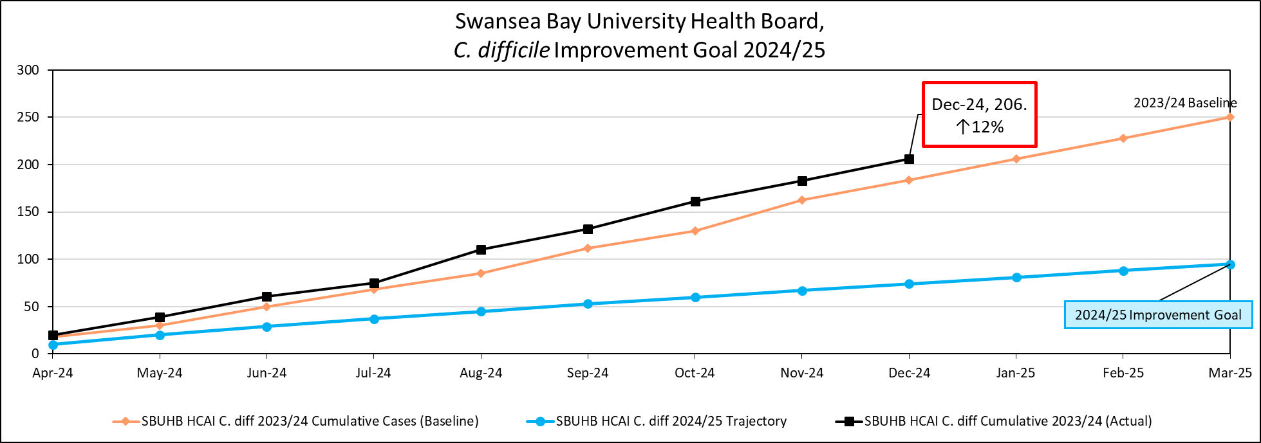
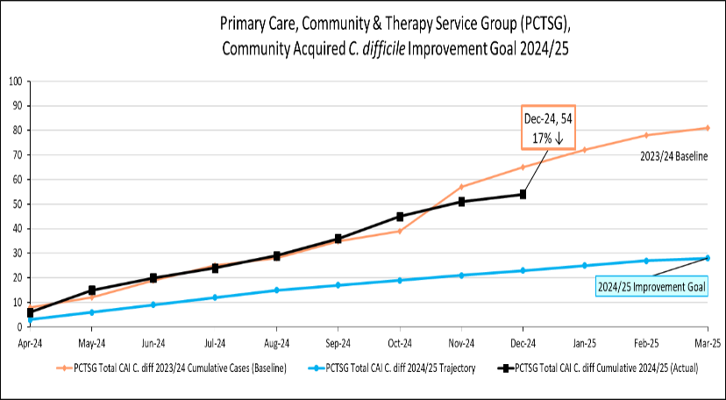

Staph. aureus bacteraemia
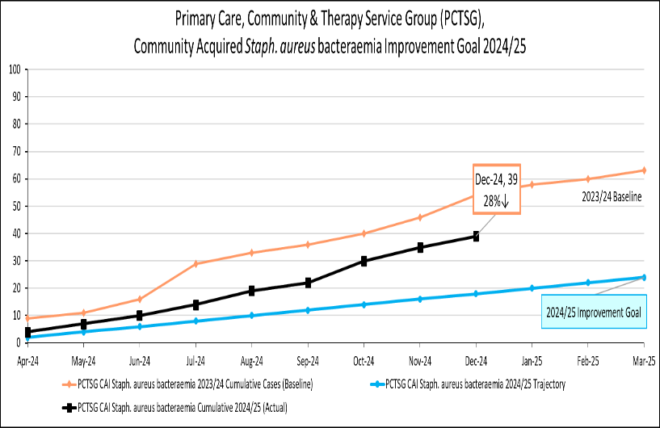

E. coli bacteraemia

Klebsiella spp. Bacteraemia

Pseudomonas aeruginosa bacteraemia

Incidence/100,000 population | Incidence/1,000 admissions
C. difficile infection
 | 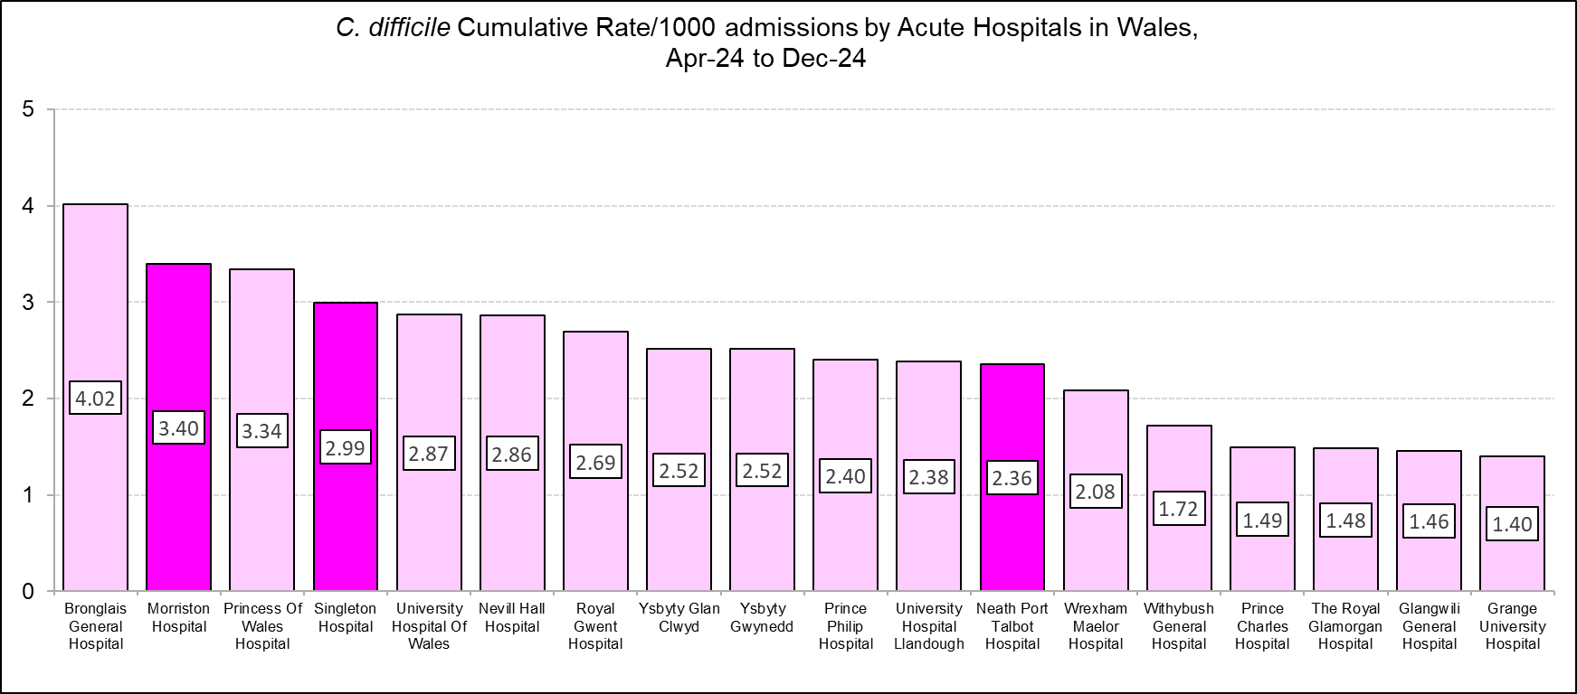
Staph. aureus bacteraemia
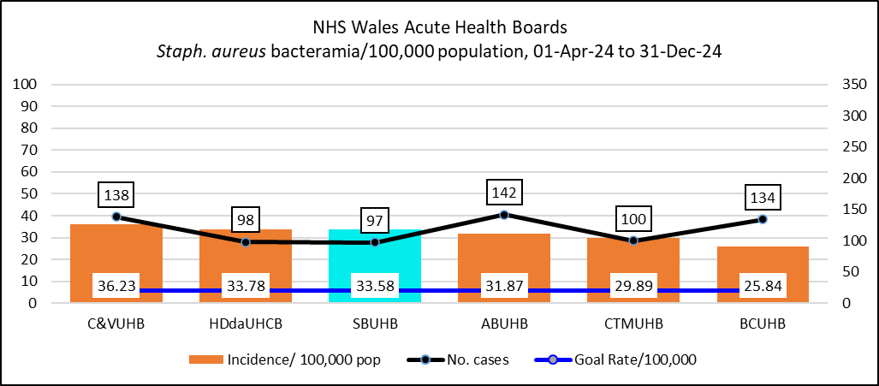 | 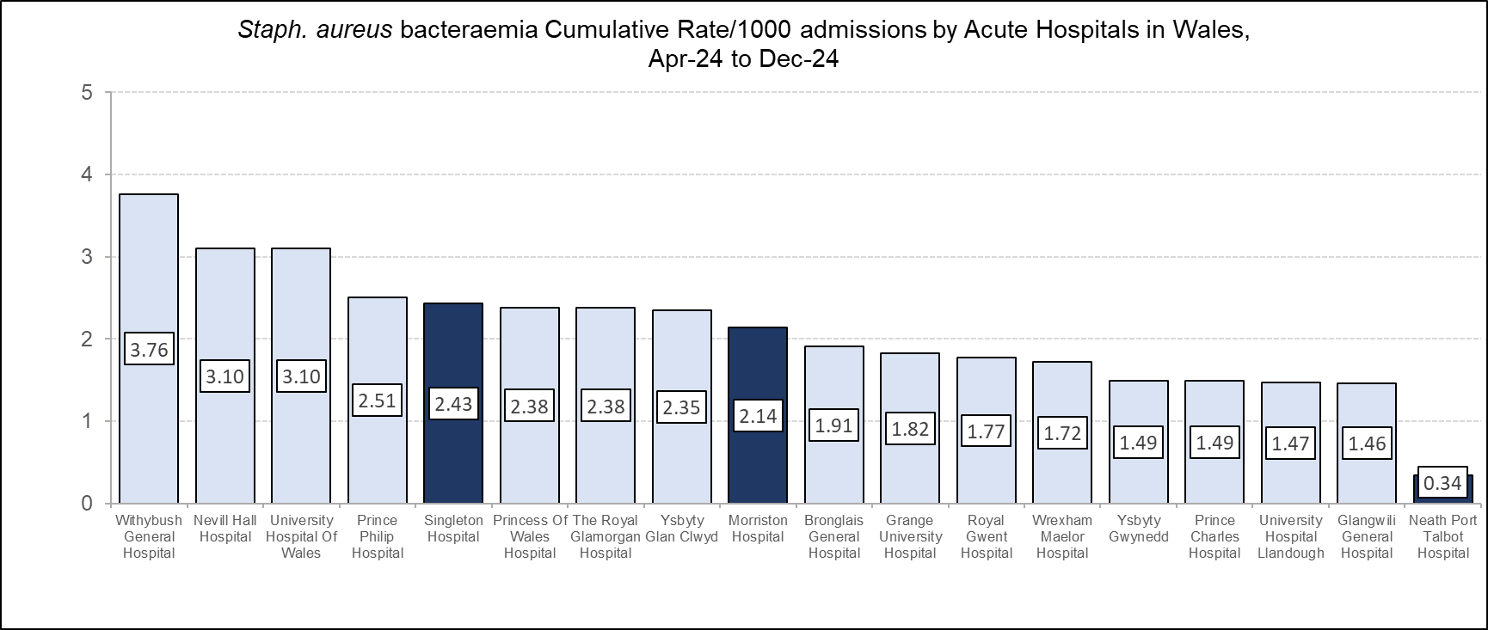
Incidence/100,000 population | Incidence/1,000 admissions
E. coli bacteraemia
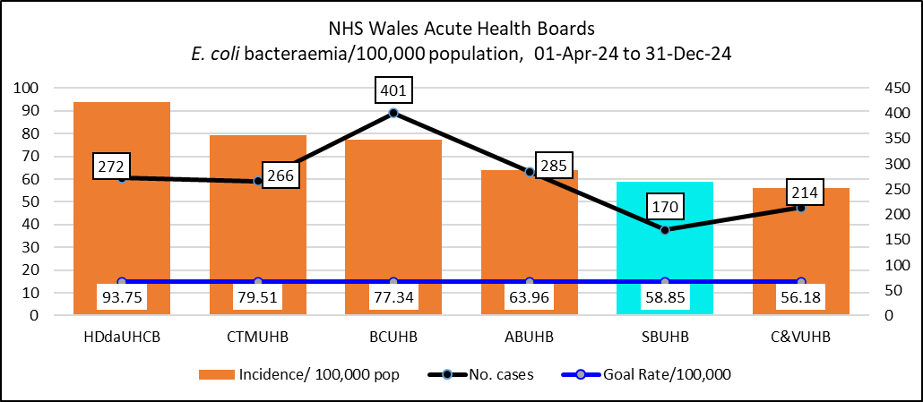 | 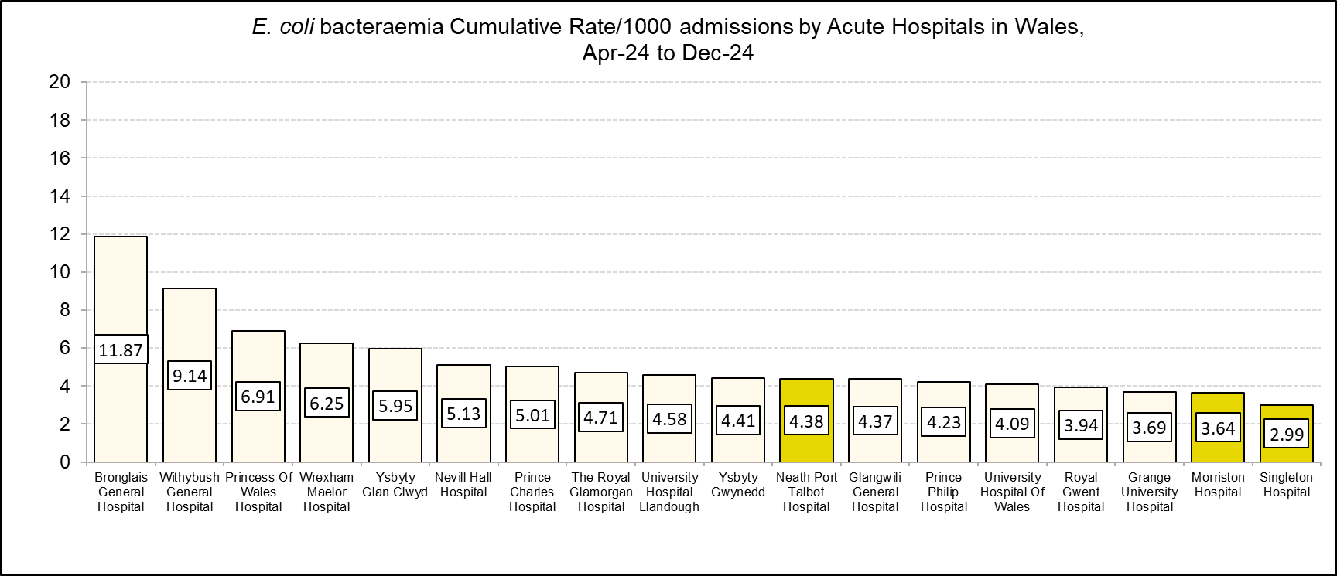
Klebsiella spp. bacteraemia
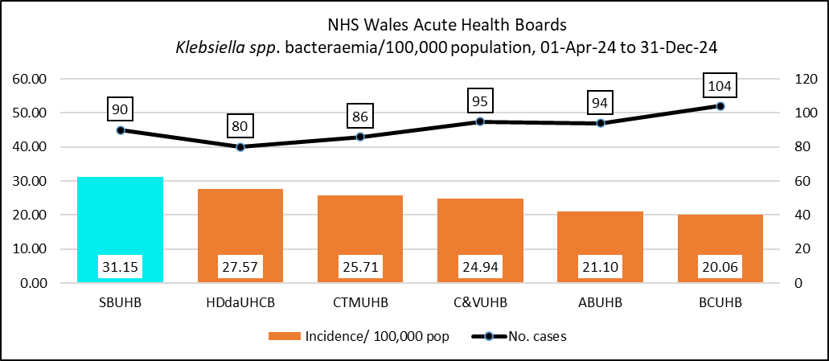 | 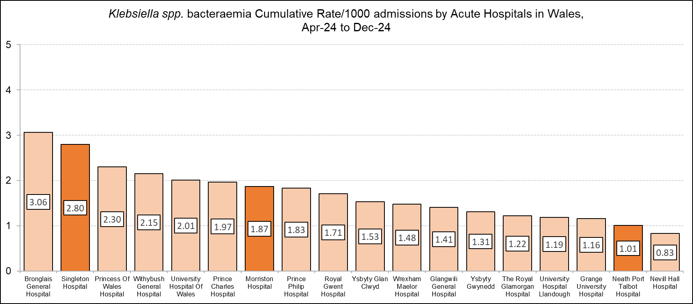

Incidence/100,000 population | Incidence/1,000 admissions
Pseudomonas aeruginosa bacteraemia
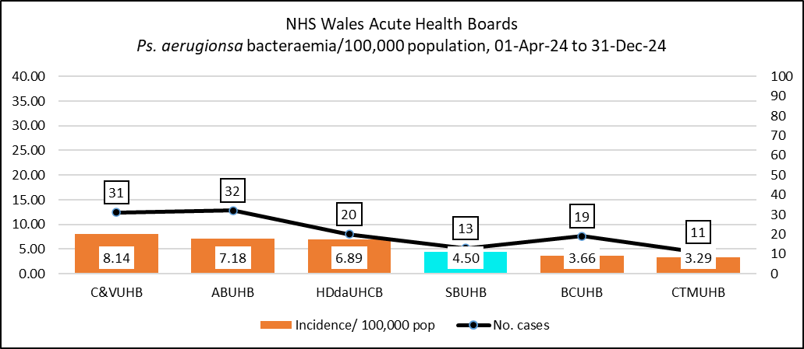 | 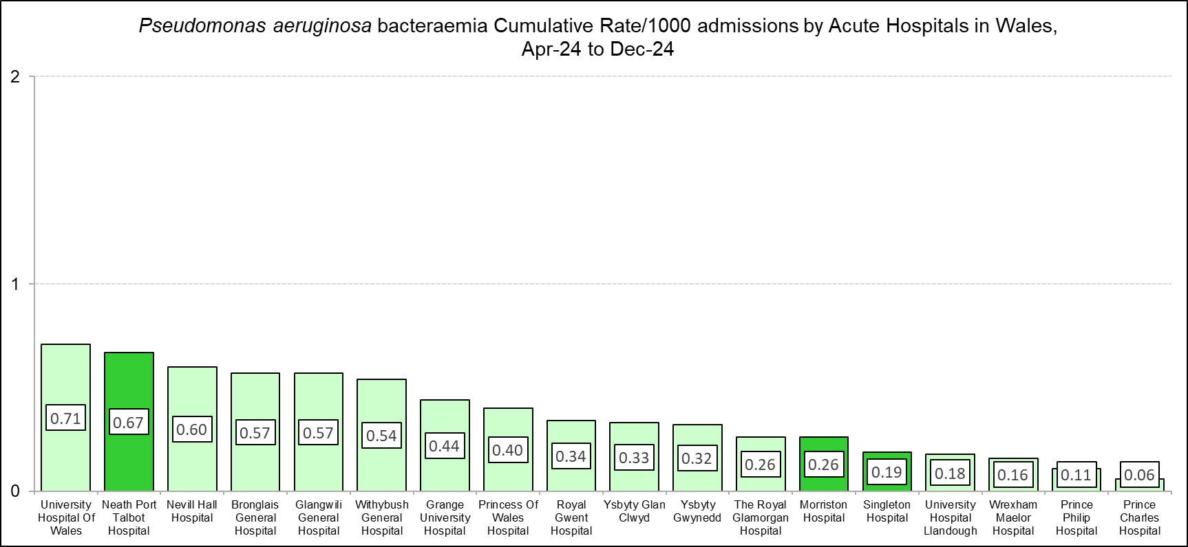

Table 5: Periods of increased Incidence (PII) of Clostridioides difficile Quarter 3 2024/25
Ward | Pt. Cases  Oct-24 | Pt. cases Nov-24 | Pt. cases Dec-24 | No. of patients affected in PII | No. PII in Q3 | WGS Links established
MH Anglesey | 4 | 0 | 0 | 4 | 1 | 4 distinct WGS
MH Cardigan | 2 | 4 | 3 | 9 | 1 | 3 patients with linked WGS; 6 distinct.
MH Cyril Evans | 0 | 0 | 2 | 2 | 1 | 2 distinct WGS
MH Gowers | 0 | 3 | 0 | 3 | 1 | 2 patients with linked WGS; 1 distinct.
MH ITU | 3 | 2 | 1 | 6 | 2 | 6 distinct WGS
MH Liz Baker Renal Unit | 0 | 1 | 2 | 3 | 1 | 3 distinct WGS
MH OPAU | 2 | 4* | 3* | 8* | 2 | 8 distinct WGS.
MH Pembroke | 2 | 0 | 1‡ | 2 | 1 | 3 distinct WGS
MH Powys Ward | 2 | 0 | 0 | 2 | 1 | 1 WGS result not available.
MH Ward C | 2 | 0 | 0 | 2 | 1 | 2 distinct WGS
MH Ward E | 2 | 1 | 1 | 4 | 2 | 4 distinct WGS
MH Ward F | 1 | 2* | 0 | 2* | 1 | 2 distinct WGS.
MH Ward G | 0 | 2 | 1 | 3 | 1 | 2 distinct WGS; 1 unavailable
MH Ward H | 2 | 0 | 0 | 2 | 1 | 2 distinct WGS
MH Ward J | 1 | 3 | 1‡ | 4 | 1 | 2 patients with linked WGS; 3with distinct WGS
MH Ward K | 0 | 2 | 3 | 5 | 1 | 4 distinct WGS to date; 1 C. diff not cultured.
MH Ward L | 2 | 0 | 2 | 4 | 2 | 4 distinct WGS
MH Ward R | 1‡ | 1 | 4 | 5 | 1 | 5 distinct WGS to date. 1WGS result awaited.
MH Ward T | 6 | 2 | 0 | 8 | 1 | 2 patients with linked WGS (Oct).  6 distinct WGS.
MH Ward V | 1‡ | 0 | 2 | 2 | 1 | 3 distinct WGS
MH Ward W | 2 | 0 | 0 | 2 | 1 | 2 distinct WGS.
West Renal Unit | 1 | 2 | 0 | 3 | 1 | 3 distinct WGS
Gorseinon | 0 | 0 | 2 | 2 | 1 | 1 WGS unavailable.
NPTH Ward D | 0 | 1 | 2* | 2* | 1 | 2 distinct WGS
NPTH Ward C | 2 | 0 | 0 | 2 | 1 | 2 distinct WGS
Singleton Chemotherapy Day Unit | 1 | 3* | 2 | 5* | 1 | 5 distinct WGS
Singleton Ward 4 | 2 | 1‡ | 0 | 2 | 1 | 3 distinct WGS
Singleton Ward 8 | 2 | 2 | 1 | 5 | 1 | 5 distinct WGS
Suite 2 Tonna | 0 | 2 | 0 | 2 | 1 | 2 distinct WGS
Number of PII/ Outbreaks |  |  |  |  | 33 | 4 epidemiologically linked WGS clusters
Total number of patients in PII | 43 | 38 | 33 | 105
* Same patient positive on two occasions.
‡ Patient positive outside the 28-day PII.
Table 6: Genomically-linked Clusters reported in Quarter 3, 2024/24
WGS cluster code | No. of samples | No. of patients | Epidemiological link established
Cluster Code WG19-00301_869 | 4 | 2 | No  Both patients sampled twice.
Cluster Code WG24-00724_1924 | 3 | 3 | Yes
Cluster Code WG24-00706_1936 | 3 | 3 | Yes
Cluster Code WG24-00708_250 | 3 | 2 | Yes  One patient sampled twice.
Cluster Code WG23-00431_1160 | 3 | 2 | No  1 patient sampled twice.
Cluster Code WG22-00629_841 | 3 | 2 | Yes  One patient sampled twice
Cluster Code WG24-00485_1049 | 2 | 2 | Yes
Cluster Code WG24-00730_1382 | 2 | 2 | No
Cluster Code WG24-00721_2719 | 2 | 2 | Yes
Cluster Code WG24-00608_1122 | 2 | 2 | No
Cluster Code WG24-00709_246 | 2 | 2 | Yes
Cluster Code WG20-00309_1126 | 2 | 2 | Yes
Cluster Code WG19-00070_350 | 2 | 2 | No
Cluster Code WG19-00595_683 | 2 | 2 | No
Notes:
- 183 laboratory confirmed C. difficile PCR positive tests reported.
- 14 genomically linked clusters, associated to more than one patient with the same Cluster Code (to 2 SNPs).
- 7 genomically linked clusters, with 2 or more patients epidemiologically linked in time & place.
- 7 genomically linked clusters, with no epidemiological link in time or place.
- 47 reported as Cluster Code Single Case.
- WSG results are still outstanding for 4 positive samples.
- WGS results are not available for 5 positive samples.
- “C. difficile Culture not isolated” was reported for 4 positive samples sent for analysis.

Table 7: Whole Genome Sequencing Results – SBU Clusters Quarter 3, 2024/25
 | No. clusters > 1 patient | Clusters linked in time & place.  Transmission event - Outbreak | Clusters linked in place NOT time.  Possible Transmission Event - Possible Outbreak | Clusters NOT linked in time or place.
Clusters of 2 patients | 11 | 5  Anglesey, Gowers, Ward J, Ward T,  Ward W |  | 7
Clusters of 3 patients | 2 | 2  AMU,  Cardigan | - | -

Table 8: No of infection incidents across the health board during Quarter 3 involving two or more patients.
Service Group | Incident / outbreak type | No. of incidents | No. of patients involved
MH & LD | Covid_19 | 1 | 2
PCTG (Gorseinon) | Covid_19 | 2 | 4
PCTG (Gorseinon) | Other Respiratory Virus | 2 | 6
PCTG (Gorseinon) | Norovirus | 1 | 15
Morriston Hospital | Covid-19 | 4 | 10
Morriston Hospital | Influenza A | 19 | 64
Morriston Hospital | Norovirus or D&V | 2 | 13
Singleton Hospital | Influenza | 1 | 6
Singleton Hospital | MRSA PII | 1 | 3
Neath Hospital | Covid-19 | 1 | 4

Table 9: Level 1 – Infection Prevention and Control Training
Staff Group  Infection Prevention & Control –  Level 1 – 3-yearly | % Compliance  to 30th December 2024 | Increase () or decrease () in compliance from previous quarterly report
Add Prof Scientific and Technic | 96.13% | (94.28%)
Additional Clinical Services | 92.27% | (92.15%)
Administrative and Clerical | 93.74% | (93.50%)
Allied Health Professionals | 94.39% | (94.52%)
Estates and Ancillary | 85.39% | (86.65%)
Healthcare Scientists | 93.28% | (91.33%)
Medical and Dental | 71.81% | (67.69%)
Nursing & Midwifery Registered | 94.32% | (93.97%)
OVERALL COMPLIANCE | 91.57% | (91.10%)
Table 10: Level 2 - Infection Prevention and Control Training
Staff Group  NHS|CSTF| Infection Prevention and Control - Level 2 – Annual | % Compliance  to 30th December 2024 | Increase () or decrease () in compliance from previous report
Add Prof Scientific and Technic | 93.89% | (89.19%)
Additional Clinical Services | 86.62% | (84.57%)
Administrative and Clerical | 86.32% | (83.29%)
Allied Health Professionals | 89.64% | (88.25%)
Estates and Ancillary | 70.52% | (68.20%)
Healthcare Scientists | 88.31% | (82.40%)
Medical and Dental | 59.63% | (52.23%)
Nursing & Midwifery Registered | 89.39% | (87.66%)
OVERALL COMPLIANCE | 84.85% | (82.16%)
Table 11: Hand Hygiene Practice Assessments and Hand Hygiene Assessors
Service Groups | Number of staff received hand hygiene practice assessment  (Between 1st January 2024 – 30th December 2024)
Morriston | 810
NPT & Singleton | 692
Primary Care & Community | 554
Mental Health & Learning Disabilities | 491
Support Services | 118
Corporate | 20
GRAND TOTAL | 2685
Service Groups | Number of trained Hand Hygiene Assessors  (Between 1st January 2022 – 30th December 2024)
Morriston | 215
NPT & Singleton | 166
Primary Care & Community | 81
Mental Health & Learning Disabilities | 75
Support Services | 33
Corporate | 6
GRAND TOTAL | 576

Table 12: Hand Hygiene Practice Assessments in ESR
Staff Group  Hand Hygiene Competence – Annual | % Compliance  to 30th December 2024 | Increase () or decrease () in compliance from previous report
Add Prof Scientific and Technic | 26.27% | 21.40%
Additional Clinical Services | 33.36% | 34.80%
Administrative and Clerical | 7.06% | 7.83%
Allied Health Professionals | 41.54% | 42.31%
Estates and Ancillary | 13.18% | 14.46%
Healthcare Scientists | 9.95% | 12.76%
Medical and Dental | 4.91% | 6.64%
Nursing & Midwifery Registered | 31.97% | 32.61%
OVERALL COMPLIANCE | 24.24% | 25.00%

Table 13: Aseptic non-touch Technique (ANTT)
Staff Group  Aseptic Non-Touch Technique  Assessment - 3 Yearly  e-Learning - once only | % Compliance to  30th December 2024 |  | Increase () or decrease () in compliance compared to previous report
 | Competence Assessment  (3 yearly) | e-Learning  (once only) | Competence Assessment  (3 yearly) | e-Learning  (once only)
Add Prof Scientific and Technic | 2.04% | 9.37% | (1.48%) | (6.78%)
Additional Clinical Services | 19.88% | 36.03% | (19.17%) | (35.53%)
Allied Health Professionals | 10.54% | 23.06% | (10.07%) | (22.35%)
Healthcare Scientists | 4.23% | 10.70% | (4.34%) | (10.97%)
Medical & Dental | 3.05% | 10.31% | (2.97%) | (9.32%)
Nursing & Midwifery Registered | 33.63% | 57.84% | (33.61%) | (57.04%)
OVERALL COMPLIANCE | 16.39% | 29.74% | (16.10%) | (29.02%)

