

Meeting Date | 06 March 2024 |  | Agenda Item |  |  | 3.1
Report Title | Healthcare Associated Infection (HCAI): SBUHB Position, and feedback from the C. difficile Round Table Event with Public Health Wales and the Delivery Unit
Report Author | Delyth Davies, Head of Nursing, Infection Prevention & Control
Report Sponsor | Gareth Howells, Executive Director of Nursing & Patient Experience
Presented by | Gareth Howells, Executive Director of Nursing & Patient Experience
Freedom of Information | Open
Purpose of the Report | To inform Management Board of the health board’s position against HCAI, with a particular focus on the worsening C. difficile position. The report also provides feedback on the outcome of C. difficile Round Table event that took place on 8th February. A core Infection Prevention Improvement Plan for 2024/25 is included for consideration and approval by Management Board.
Key Issues | All NHS organisations must ensure that they have effective organisational structures and management systems in place for the control of healthcare associated infections in accordance with the Code of Practice for the Prevention and Control of Healthcare Associated Infections (Welsh Government, 2015). The Health & Care Quality Standards 2023 require all NHS Organisations to deliver high quality, safe care that avoids preventable harm, such as that caused by healthcare associated infections, and that organisations deliver effective care that achieves optimal outcomes for our population.  The health board will not meet the Infection Reduction Goals set by Welsh Government for C. difficile, Staph. aureus bacteraemia, or Klebsiella species bacteraemia. The Health Board is likely to narrowly miss achieving the E. coli bacteraemia reduction goal but is on trajectory to achieve the reduction in Pseudomonas aeruginosa bacteraemia.  The health board’s C. difficile position is worsening, with the risk of a C. difficile infection being three times higher for patients in SBUHB than it is in the best performing health board. There has been a statistically significant increase in C. difficile cases across the health board, and in Morriston Hospital. There appears to be a correlation with the transfer of all acute medicine to Morriston. There are increasing clusters of genomically linked cases of C. difficile, and more patients included in these clusters. Additionally, there has been a hospital-wide outbreak of C. difficile identified retrospectively in Morriston.  Feedback from the C. difficile Round Table Discussion event held on 8th February is presented. Discussions were helpful, but there was strong challenge also, with a strong emphasis on the need for the health board to address the current worrying C. difficile case numbers.  The risk relating to C. difficile on the health board’s Risk Register has been reviewed and the associated risks reassessed. The risk score has been revised and increased from 15 to 20, to reflect the gravity of the current situation and the priority focus required to address and reverse this position as a matter of urgency.  Approximately 47% of the key targeted Tier 1 infections occur in community settings, yet there is little IPC specialist resource funded for community. This is a risk for the health board and a redesign of the specialist IPC resource has been proposed, in response to equity of service provision across the health board, to respond to fragility within the current team, and to develop leadership and excellence in infection prevention & control.  The core Infection Prevention Improvement Plan for 2024/25 is presented for approval, which includes the following core themes:  The core themes include:  - Improving the Culture  - Leadership  - Clean & Safe Healthcare Environment  - Antimicrobial Stewardship
Specific Action Required | Information | Discussion |  | Assurance | Approval
Specific Action Required | ☒ | ☐ |  | ☐ | ☒
Recommendations | Management Board is asked to:  NOTE the Quarter 3 position in relation to the tier 1 infections;  NOTE the significantly worsening C. difficile position in the health board, the increasing number of transmission events, the ongoing hospital-wide outbreak of C. difficile in Morriston;  NOTE the feedback from the multi-agency C. difficile Round Table Discussion event held on 8th February 2024.  NOTE the risks that appear on the Risk Register relating to healthcare associated infections, availability of single rooms, overcrowding and lack of space between beds.  AGREE in principle the need to increase the IPC resource within primary care and community, and to strengthen leadership in IPC across the organisation.  AGREE the core Infection Prevention Improvement Plan for 2024/25.  AGREE that Service Groups will develop Infection Prevention Improvement Plans, monitored locally, with progress reported to Management Board and Quality & Safety Committee.
Healthcare Associated Infection (HCAI): SBUHB Position, and feedback from the C. difficile Round Table Event with Public Health Wales

- INTRODUCTION

The purpose of this report is to inform Management Board of health board’s position against HCAI, with a particular focus on the worsening C. difficile position. The report also provides feedback on the outcome of C. difficile Round Table event that took place on 8th February with the Delivery Unit, the UK Anaerobic Reference Unit, and the Healthcare Associated Infection and Antimicrobial Resistance Programme Team of Public Health Wales. The core Infection Prevention Improvement Plan for 2024/25, together with recommendations for the specialist infection prevention and control (IPC) resource to meet current and future challenges, is presented for consideration by the Management Board.

- BACKGROUND
  - How are we doing?
Cases of the key Tier 1 infections to January 2024:
The Health Board will not meet the Infection Reduction Goals set by Welsh Government for C. difficile, Staph. aureus bacteraemia, or Klebsiella species bacteraemia. The Health Board is likely to narrowly miss achieving the E. coli bacteraemia reduction goal but is on trajectory to achieve the reduction in Pseudomonas aeruginosa bacteraemia. Swansea Bay University Health Board (SBUHB) and Service Group progress is shown in Appendix 1, along with how these infections are distributed across secondary care, community and mental health & learning disability settings.
Swansea Bay University Health Board (SBUHB) has the highest incidence of C. difficile infection and Staph. aureus bacteraemia (this has been the case for a number of years), the second highest incidence of Pseudomonas aeruginosa bacteraemia, but the second lowest incidence of E. coli bacteraemia in Wales (see Charts 1-5 in Appendix 2).
  - C. difficile infections within Swansea Bay UHB
The greatest concern for the health board is the position in relation to C. difficile. There been a 24% increase and the incidence of C. difficile per 100,000 population is deteriorating month-on-month. SBUHB is an extreme outlier compared to other health boards, as shown in the Chart 1 in Appendix 2. This incidence means that for every one person in CVUHB with a C. difficile infection, there will be three people in SBUHB with C. difficile infection. This position is unacceptable.
The distribution of all C. difficile (PCR positive), as well as those with C. difficile infection (toxin positives) is shown in Charts 6 and 7 in Appendix 3. The average ratio for the quarterly distribution of all C. difficile in secondary care settings to community settings is 60:40. For C. difficile toxin cases the average quarterly distribution ratio is 66:34. However, the majority of cases are found in community settings and in Morriston Hospital.
Trend analysis of C. difficile, for SBUHB and Service Groups, is shown in Charts in Appendix 4. For SBUHB as a whole, and in Morriston in particular, there has been a statistically significant change in the number of cases of those colonised with C. difficile (and those with infection). This step change appears to correlate to the transfer of all acute medicine to Morriston Hospital (second phase of AMSR concluded 5th February 2023).
It should be noted that this position of sustained increase has not occurred previously across SBUHB nor in Morriston Hospital.
    - Hospital-wide outbreak of C. difficile
A hospital-wide outbreak of genomically linked C. difficile (Cluster Code WGS22-00159_737) has been identified retrospectively. The outbreak appears to have taken place during November to December 2023, and may be ongoing. It is important to note that this outbreak is not the cause of the health board’s increased incidence of infection (at the end of Quarter 2, already there was a 24% annual increase).
This is the first genomically confirmed hospital-wide outbreak of C. difficile that has occurred in Swansea Bay. To date, there are fourteen healthcare associated cases linked with Morriston Hospital. The outbreak is being managed by a Service Group Outbreak Control Group.
Factors contributing to the outbreak:
- Increased service pressures leading to over-crowding, over-occupancy and increased length of stay for clinically optimised patients (see charts in Appendix 5);
- Lack of available single room capacity for patient isolation, with demand exceeding capacity.
- Antimicrobial stewardship is critical - additional patients are becoming colonised with C. difficile, antibiotic prescribing can lead to risk of toxin production and infection.
- An increased use of commodes at the patient’s bed in multi-bedded rooms, exposing more patients to risk.
- Patient movement, including non-clinical transfers, with some patients receiving episodes of care on multiple wards during their episode of hospitalisation. Examples of this can be seen in Figure 1 in Appendix 6.
- Pressure for rapid bed turn-around times potentially inhibiting effective cleaning.
- Lack of decant facilities, with risk of ongoing transmission and outbreak extension.
    - Feedback from the C. difficile Round Table Discussion
Detailed feedback is provided in Appendix 7, but key points are:
- The C. difficile figures in SBUHB are worrying and the health board must find a way to address issues identified. A multi-disciplinary approach is needed to tackle the issues.
- Increased movement of patients around the hospital was leading to spread of infection.
- The number of linked clusters (transmission events) almost doubled in the second half of 2023, and the number of patients involved in these transmission events has increased. The majority of the transmission events. In the second half of the year, there had been 63 patients involved in 25 cluster transmission events. Twenty-nine of the 38 cluster transmission events occurred in Morriston.
- SBUHB undertakes more inpatient testing than other health boards. SBUHB has amongst the lowest rate of C. difficile positivity (PCR positives), but has the highest rate of toxin positivity, particularly in GP samples.

- GOVERNANCE AND RISK ISSUES
The population served by SBUHB should expect to receive safe and high quality services. Service Groups infection improvement plans focus on reducing episodes of harm caused by preventable healthcare associated infections.
  - Risk Register relating to availability of single rooms:
Recorded on the Corporate Risk Register HBR 4/ID 739 and in the following recorded risks 35, 478, 797, 535, 1750, and 2286.
  - Risk Register relating to overcrowding and lack of space between beds:
Recorded on the Corporate Risk Register HBR 4/ID 739 and in the following recorded risks 2286, 2488, and 3515.
  - Risk Register relating to C. difficile
In particular, Risk Reference 2286 has been reviewed in light of the continuing increase in C. difficile, the outcome of the genomic analysis of C. difficile in SBUHB, and the current unprecedented genomically linked outbreak of C. difficile in Morriston Hospital. The risk score has been revised and increased from 15 to 20, to reflect the gravity of the current situation and the priority focus required to address and reverse this position as a matter of urgency.
  - Leadership, excellence and equality in infection prevention & control (IPC)
The burden of healthcare associated infections across the health board is such that approximately 47% of these infections occur in community settings, yet there is little IPC specialist resource funded for community. In November 2023, an IMTP briefing paper was developed to propose a redesign of the specialist IPC resource within the health board, in response to equity of service provision across the health board, to respond to fragility within the current team, and to develop leadership and excellence in infection prevention & control. A summary of the proposals for a whole system approach for IPC can be seen in Appendix 8.

- 2024/25 Infection Prevention Improvement Plan
The infection prevention improvement plan for 2024/25 is attached in Appendix 9, and this focuses on core themes to reduce episodes of harm caused by healthcare associated infections (HCAI).
The core themes include:
- Improving the Culture
- Leadership
- Clean & Safe Healthcare Environment
- Antimicrobial Stewardship
Service Groups are asked to review their challenges relating to HCAI and develop Service Group specific improvement plans, monitored locally, with progress reported to Management Board and Quality & Safety Committee.

- FINANCIAL IMPLICATIONS
The financial implications of the key recommendations for action have not been scoped in full. The cost associated with the IPC IMTP bid for 2024/25 has been estimated as £328,971. Costs associated with safe systems for the management, decontamination and safe storage of mattresses, and with the extension of the enhanced cleaner role will need to be established. However, the potential cost benefits are substantial.
Notwithstanding the harm caused to our patients and service users, the overall financial impact of healthcare associated infections for the health board is significant and success will also support a reduction in bed occupancy, reduced harm, reduced medication spend, increased patient satisfaction and a reduced mortality for the people we look after. The following provides an overview of these benefits.
Bed-days lost and costs associated with HCAI
Appendix 10 provides examples of average excess length of stay (LOS) and bed-days lost in relation to the targeted Tier 1 blood stream infections and by total blood stream infections (all organisms), from April 2023 to January 2024, using NHS Scotland estimates.
An example is provided also of excess LOS and bed-days lost by C. difficile infection (CDI) in SBUHB, by acute hospital site, April 2023 – January 2024

- RECOMMENDATION
Management Board is asked to:
- NOTE the Quarter 3 position in relation to the tier 1 infections;
- NOTE the significantly worsening C. difficile position in the health board, the increasing number of transmission events, the ongoing hospital-wide outbreak of C. difficile in Morriston;
- NOTE the feedback from the multi-agency C. difficile Round Table Discussion event held on 8th February 2024.
- NOTE the risks that appear on the Risk Register relating to healthcare associated infections, availability of single rooms, overcrowding and lack of space between beds.
- AGREE in principle the need to increase the IPC resource within primary care and community, and to strengthen leadership in IPC across the organisation.
- AGREE the core Infection Prevention Improvement Plan for 2024/25.
- AGREE that Service Groups will develop Infection Prevention Improvement Plans, monitored locally, with progress reported to Management Board and Quality & Safety Committee.

Governance and Assurance

Link to Enabling Objectives  (please choose) | Supporting better health and wellbeing by actively promoting and empowering people to live well in resilient communities
Link to Enabling Objectives  (please choose) | Partnerships for Improving Health and Wellbeing | ☐
Link to Enabling Objectives  (please choose) | Co-Production and Health Literacy | ☐
Link to Enabling Objectives  (please choose) | Digitally Enabled Health and Wellbeing | ☐
Link to Enabling Objectives  (please choose) | Deliver better care through excellent health and care services achieving the outcomes that matter most to people
Link to Enabling Objectives  (please choose) | Best Value Outcomes and High Quality Care | ☒
Link to Enabling Objectives  (please choose) | Partnerships for Care | ☐
Link to Enabling Objectives  (please choose) | Excellent Staff | ☐
Link to Enabling Objectives  (please choose) | Digitally Enabled Care | ☐
Link to Enabling Objectives  (please choose) | Outstanding Research, Innovation, Education and Learning | ☐
Health and Care Standards
(please choose) | Staying Healthy | ☐
(please choose) | Safe Care | ☒
(please choose) | Effective Care | ☐
(please choose) | Dignified Care | ☐
(please choose) | Timely Care | ☐
(please choose) | Individual Care | ☐
(please choose) | Staff and Resources | ☐
Quality, Safety and Patient Experience
Effective infection prevention and control needs to be everybody’s business and must be part of everyday healthcare practice and be based on the best available evidence so that people are protected from preventable healthcare associated infections.
Financial Implications
A Department of Health impact assessment report (IA No. 5014, 20/12/2010) stated that the best estimate of costs to the NHS associated with a case of Clostridioides difficile infection is approximately £10,000. The estimated cost to the NHS of treating an individual cost of MRSA bacteraemia is £7,000 (the cost of MSSA bacteraemia could be less due to the availability of a wider choice of antibiotics). In an NHS Improvement indicative tool, the estimated cost of an E. coli bacteraemia is between £1,100 and £1,400, depending on whether the E. coli is antimicrobial resistant. Estimated costs related to healthcare associated infections, from 01 April 2023 to 31 January 2024 is as follows: C. difficile - £2,080,000; Staph. aureus bacteraemia - £875,000; E. coli bacteraemia - £240,800; therefore, a total cost of £3,195,800.
Legal Implications (including equality and diversity assessment)
Potential litigation in relation to avoidable healthcare associated infection.
Staffing Implications
Additional resource for bed and mattress management, for enhanced cleaner role, and for specialist infection prevention and control resource for primary care and community.

Long Term Implications (including the impact of the Well-being of Future Generations (Wales) Act 2015)
A healthier Wales: preventing infections
Report History | Infection Prevention Improvement Plan update paper on 14th December 2022
Appendices | Appendix 1 – Health Board and Service Group progress against the Tier 1 infection reduction goals, with quarterly distribution.  Appendix 2 – Comparison of the incidence of Tier 1 infections per 100,000 population in acute NHS Wales Health Boards  Appendix 3 – Distribution of C. difficile cases (colonised and infection) across SBUHB.  Appendix 4 - Statistical process control trend analysis of C. difficile in Swansea Bay University Health Board.  Appendix 5 – Service pressures at Morriston, including occupancy and length of stay.  Appendix 6 - Hospital-wide outbreak of C. difficile.  Appendix 7 – Feedback from C. difficile Round Table Discussion event on 8th February 2024.  Appendix 8 – Infection Prevention & Control IMTP 2024/25: “The One Bay Infection Prevention & Protection Way”.  Appendix 9 – Core Infection Prevention Improvement Plan 2024/253  Appendix 10 - Bed-days lost and costs associated with HCAI

C. difficile
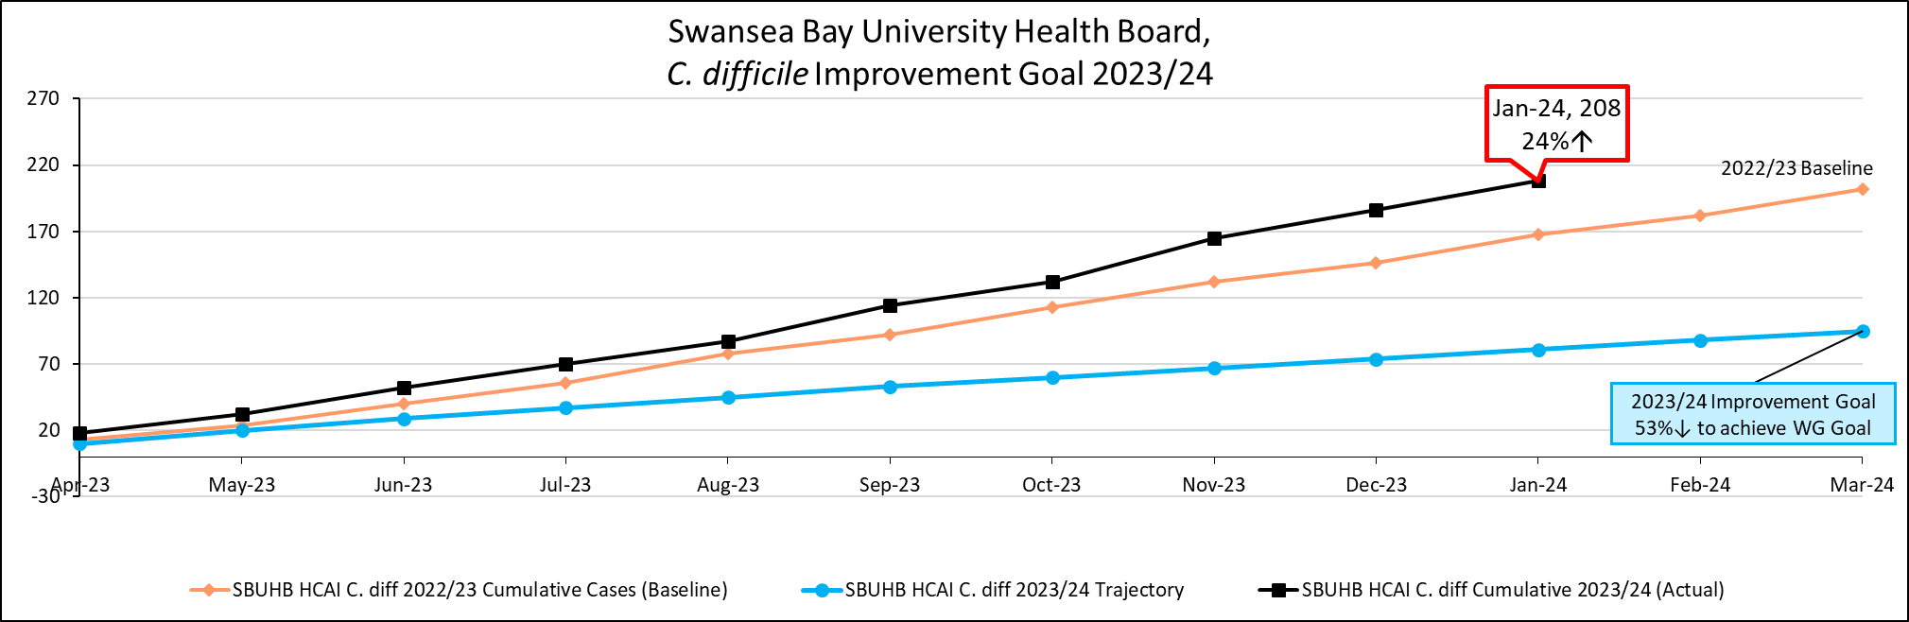
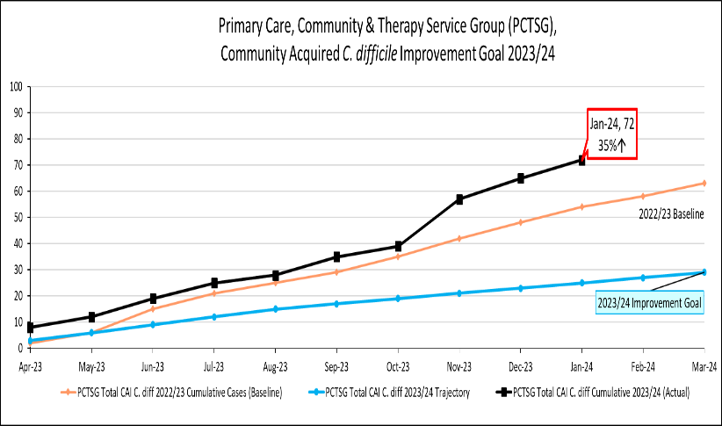 | 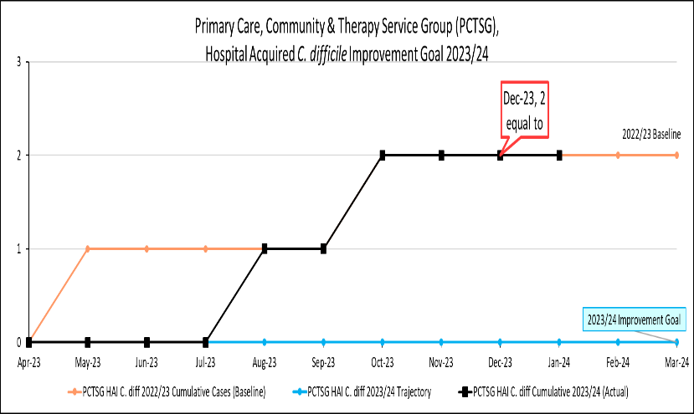
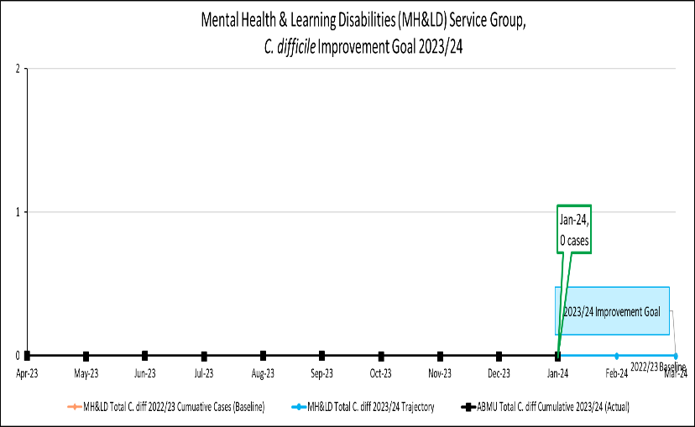 | 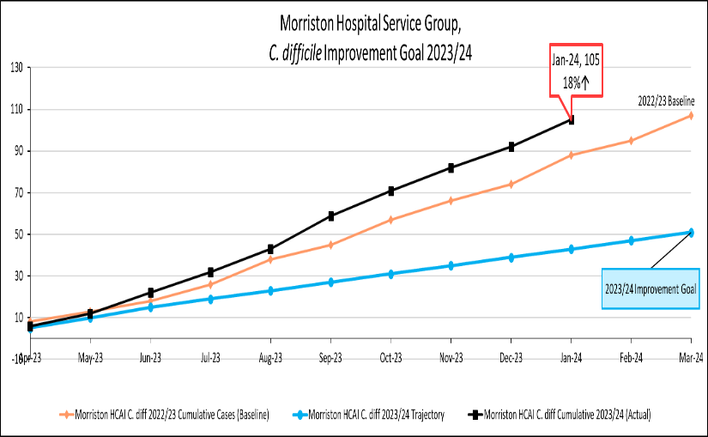
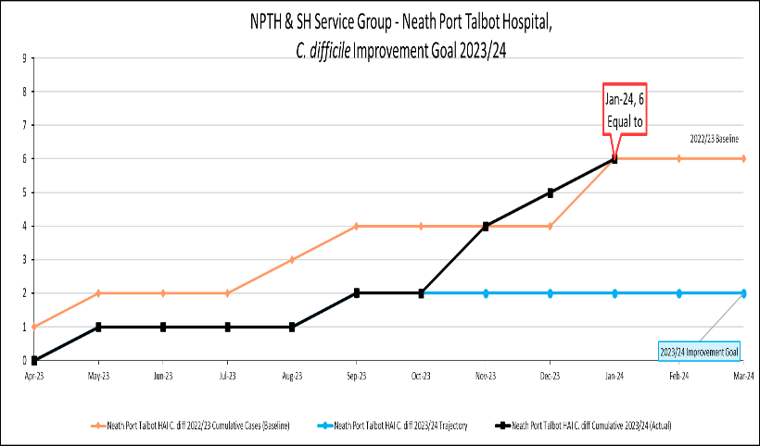 | 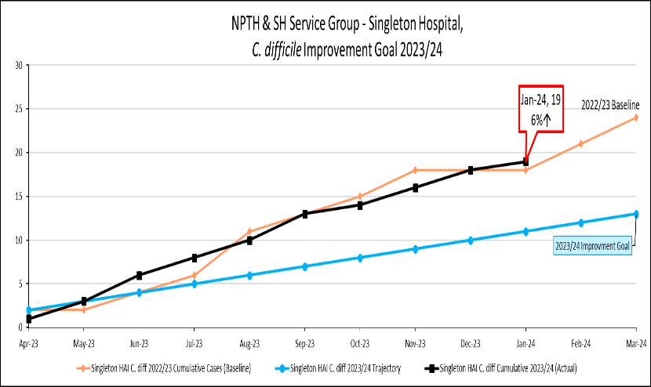

Staph. aureus bacteraemia
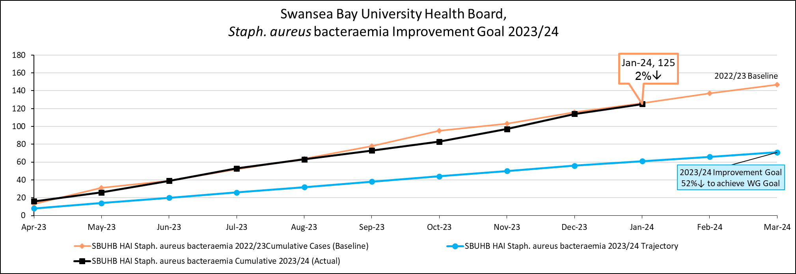
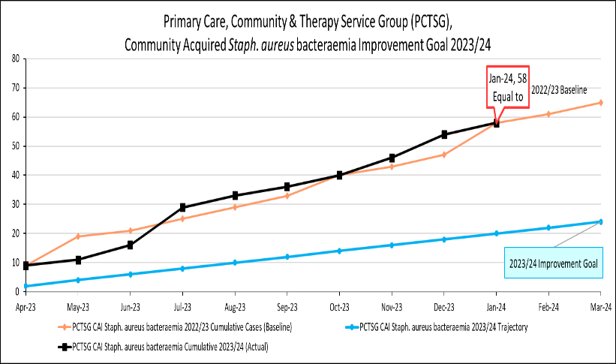 | 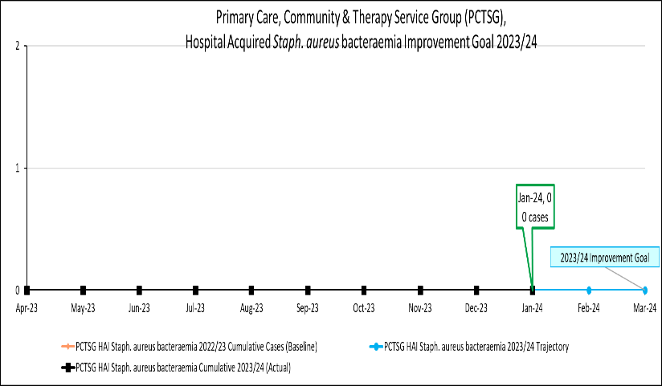
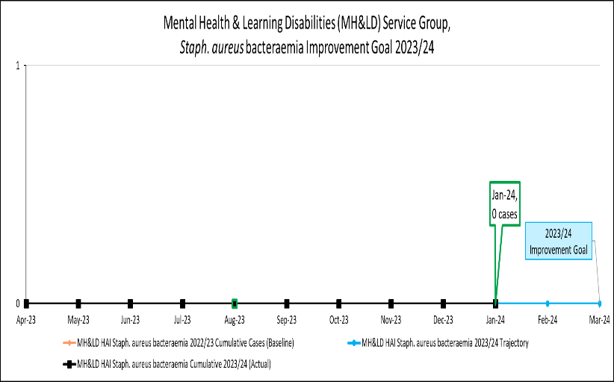 | 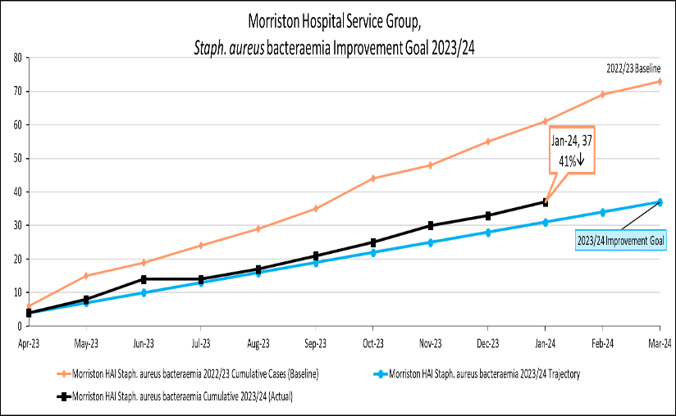
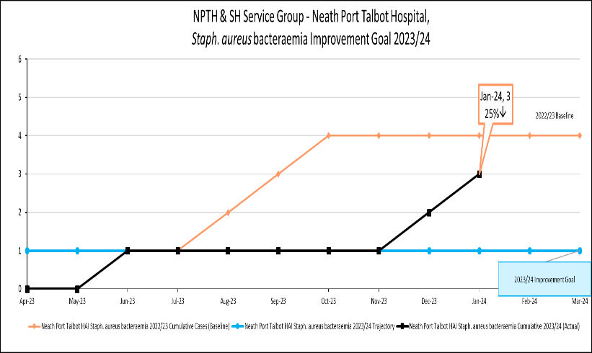 | 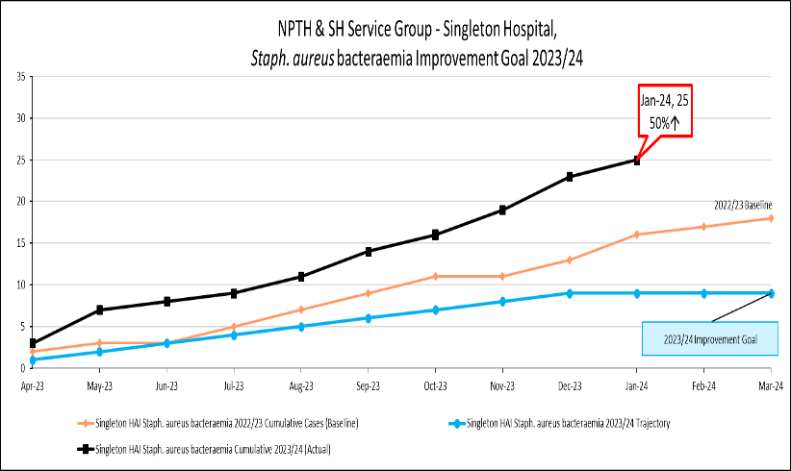

E. coli bacteraemia
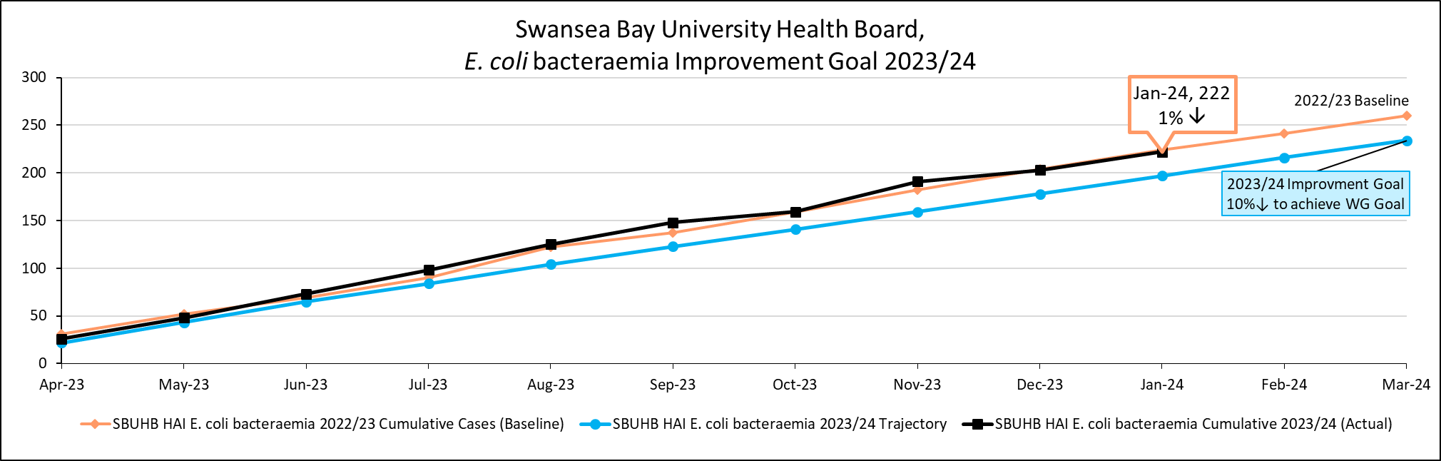
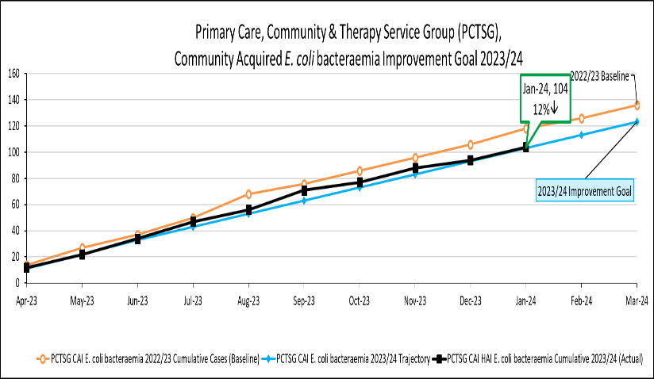 | 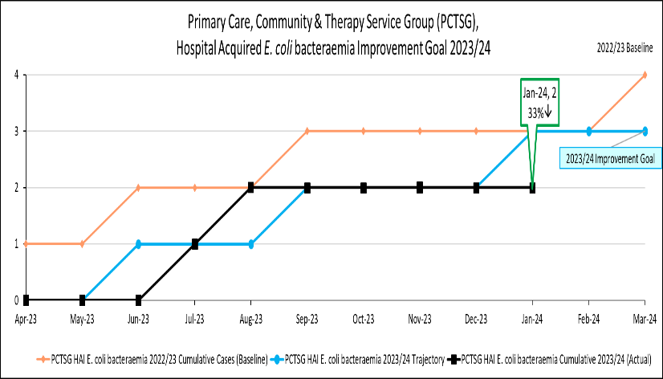
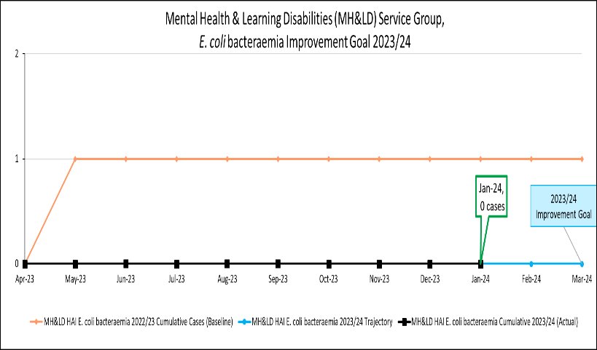 | 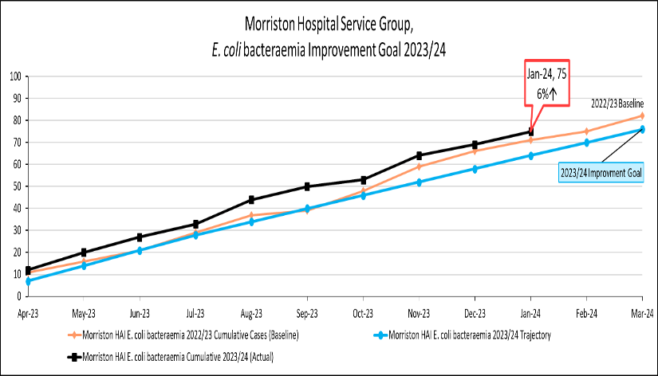
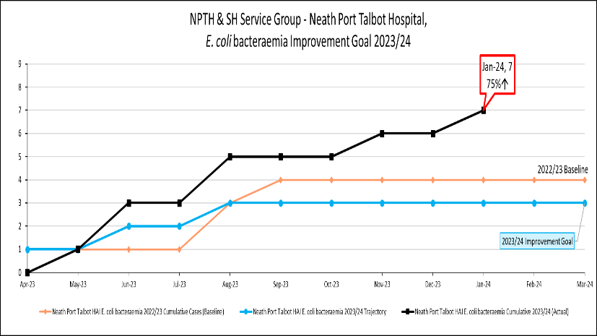 | 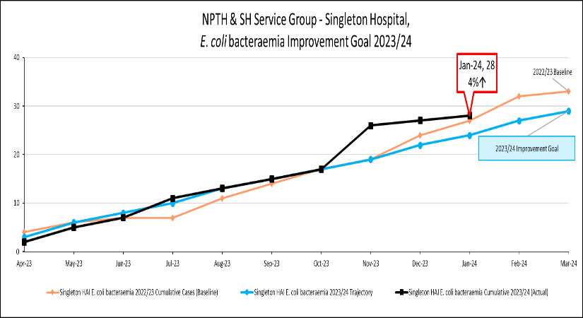

Klebsiella spp. bacteraemia
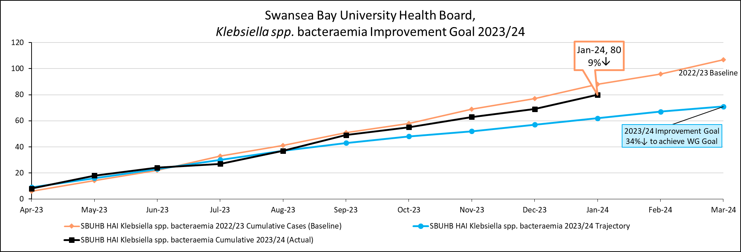
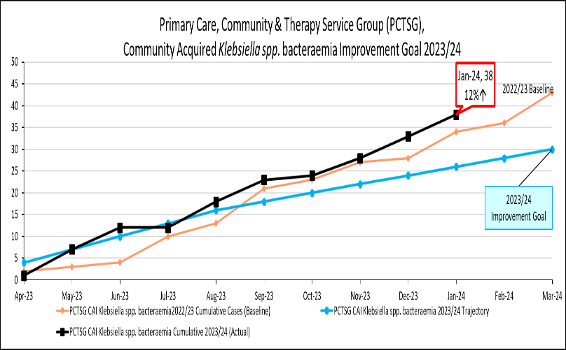 | 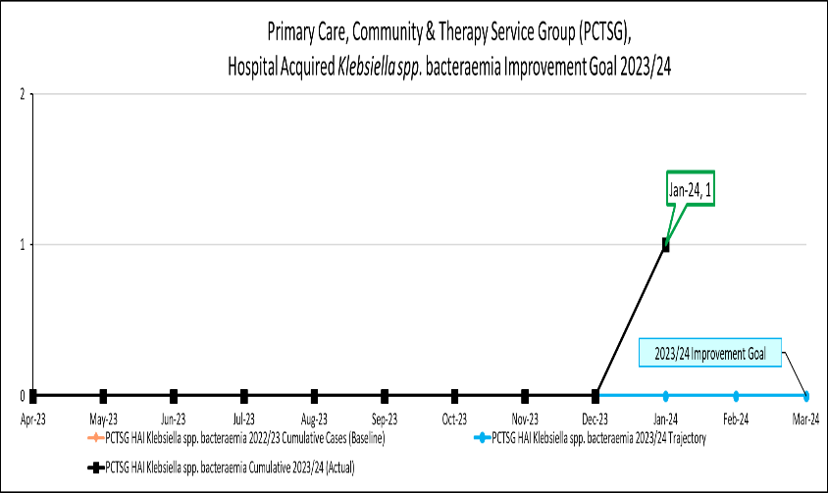
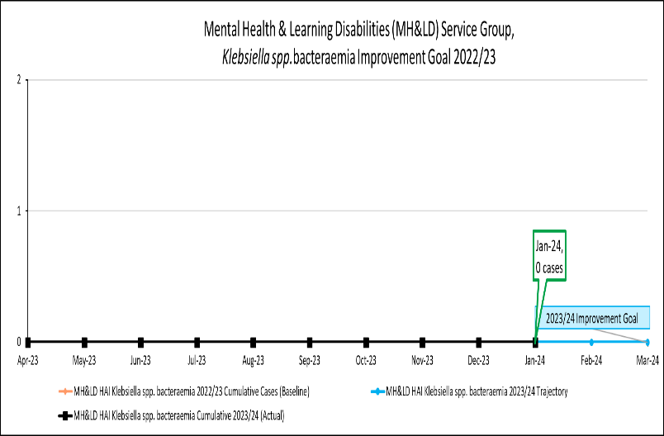 | 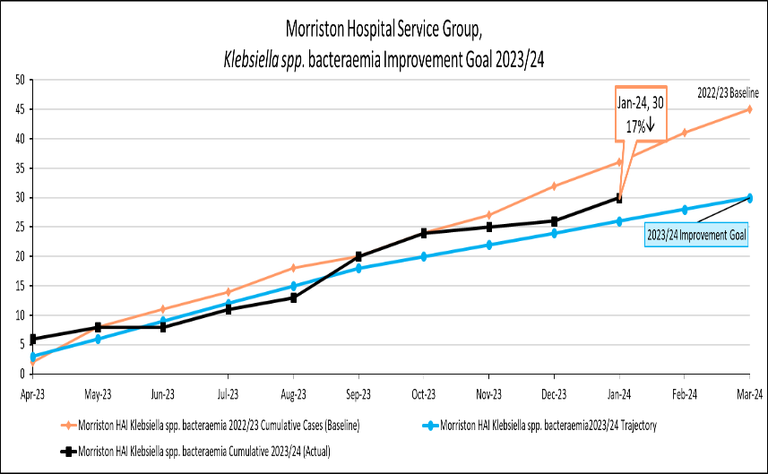
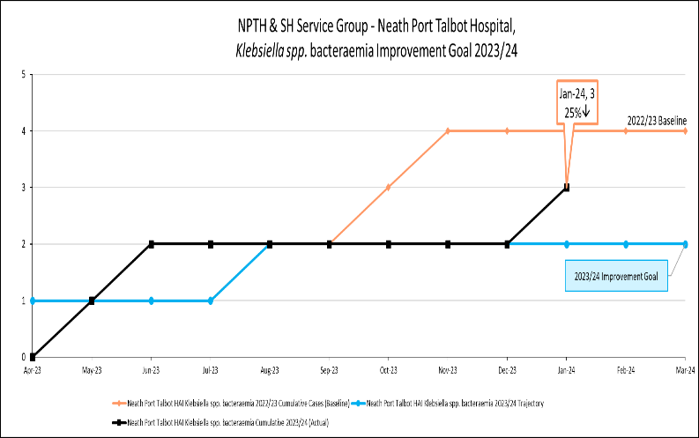 | 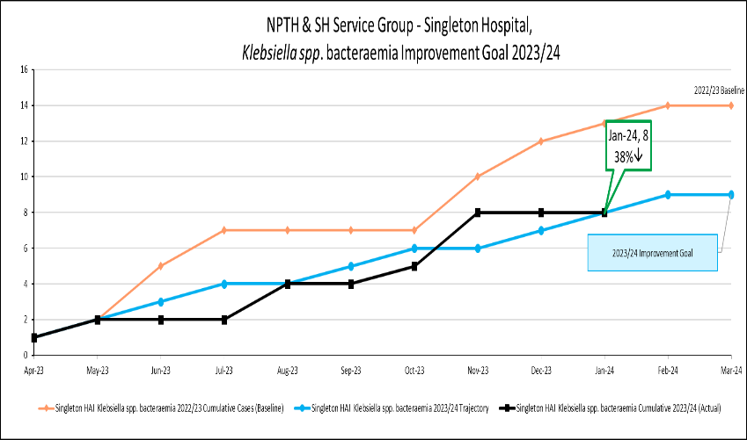

Pseudomonas aeruginosa bacteraemia
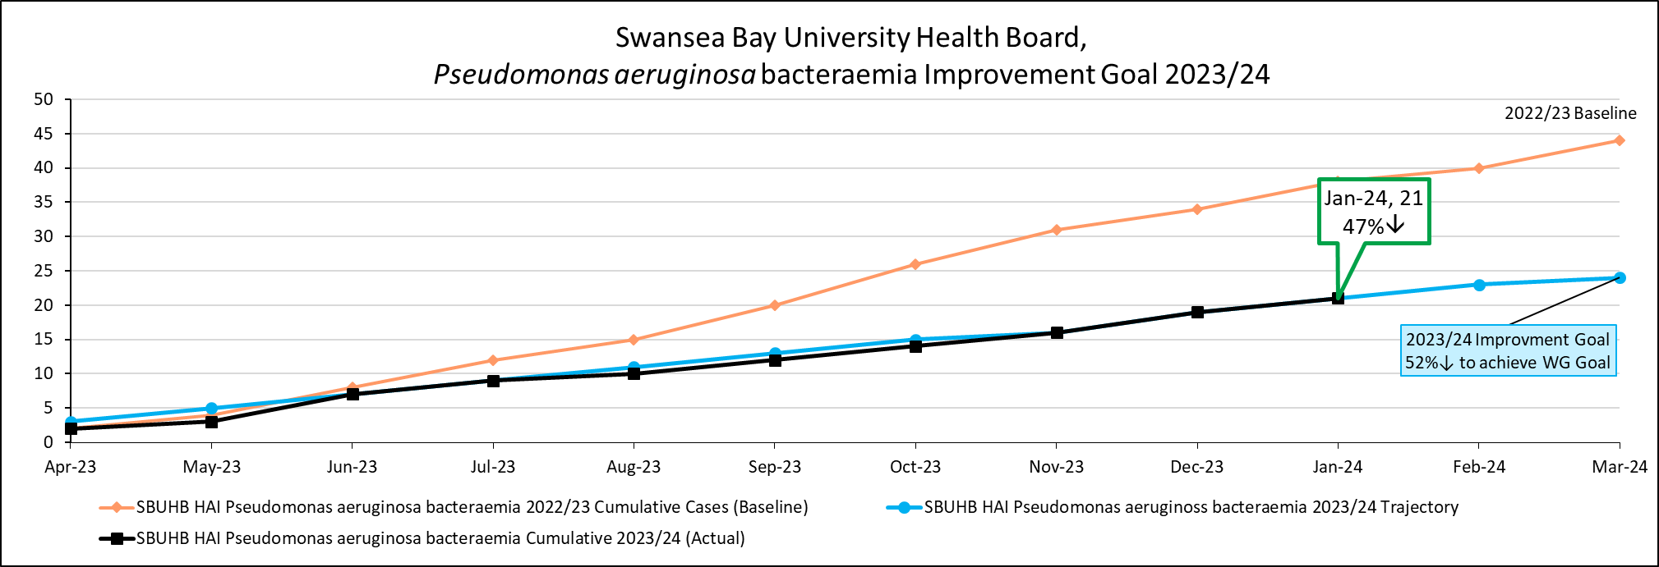
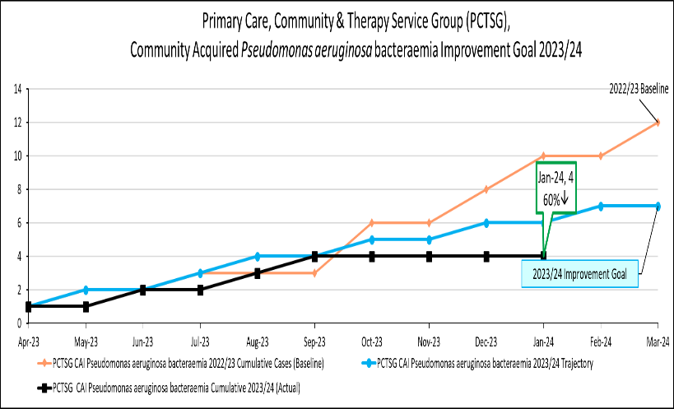 | 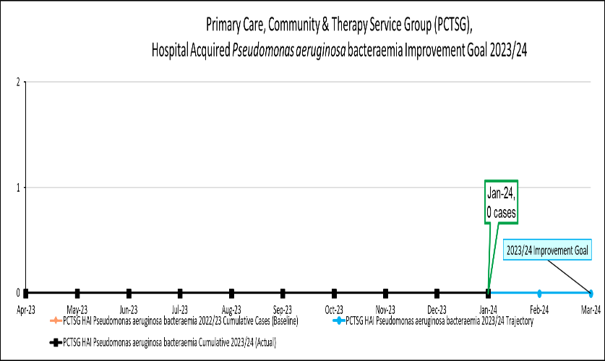
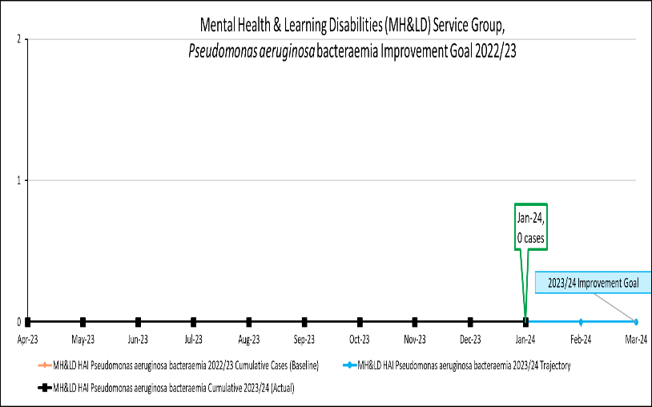 | 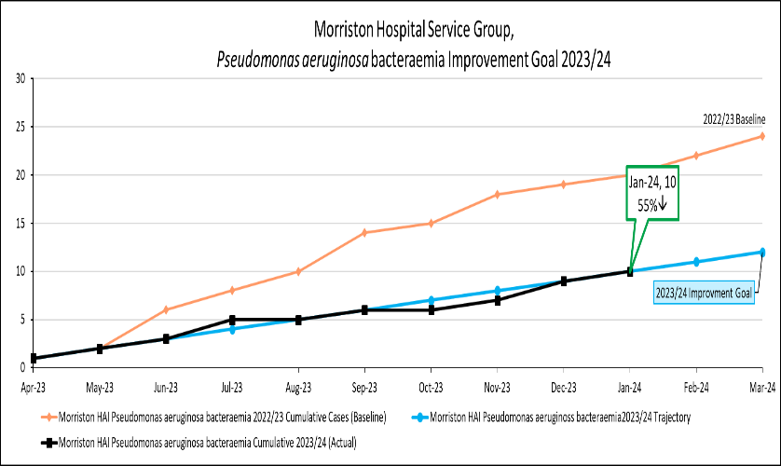
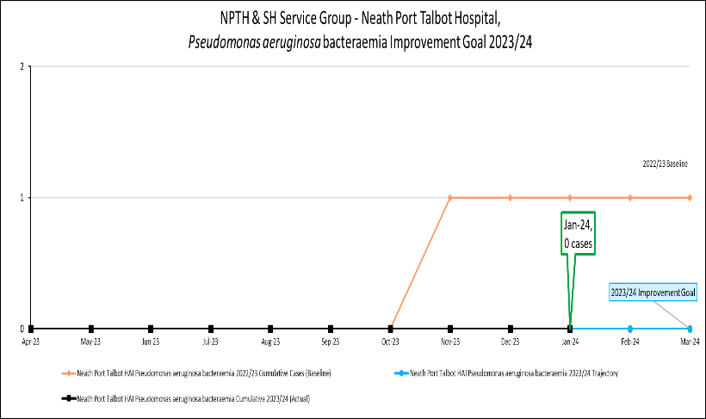 | 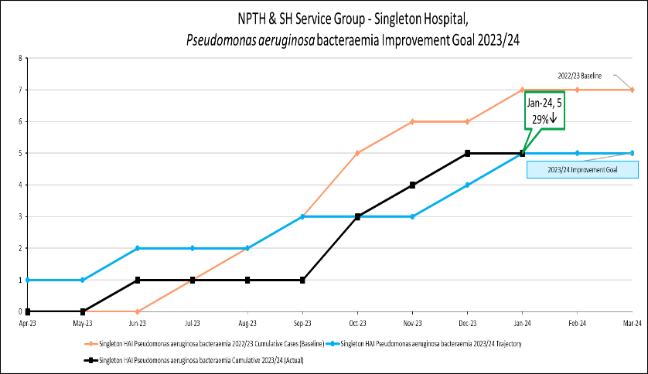

Distribution of Tier 1 infections by secondary care, community and mental health & learning disability settings

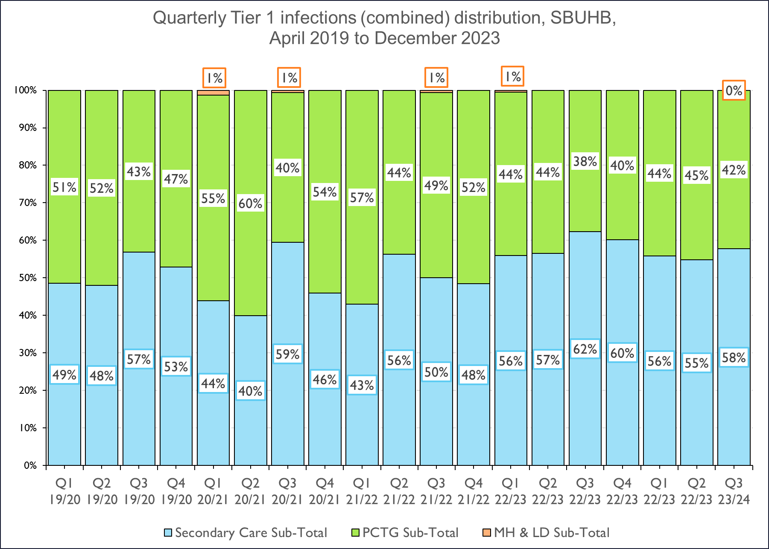

Distribution of Tier 1 infections by Service Groups

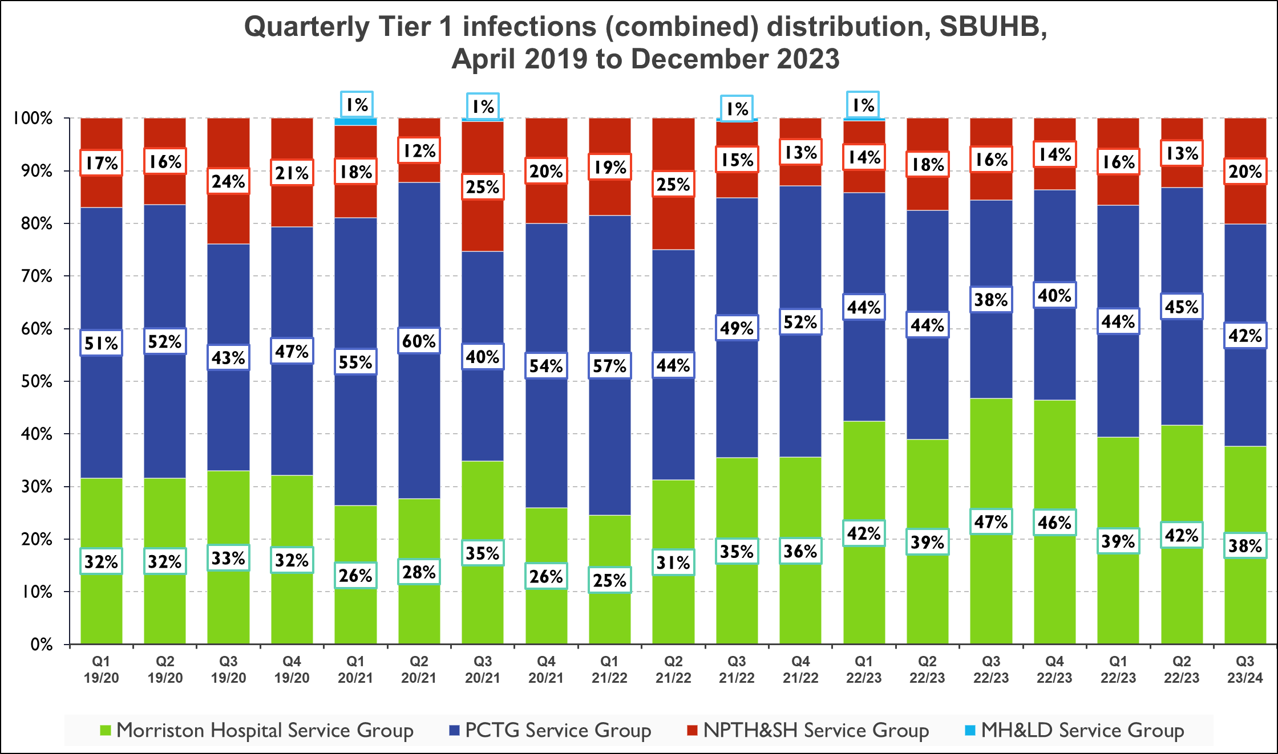

Chart 1: C. difficile | Chart 2: Staph. aureus bacteraemia
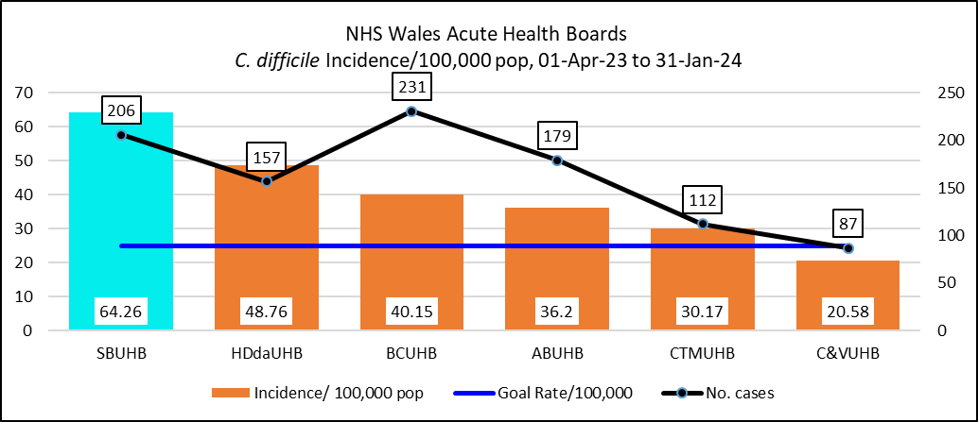 | 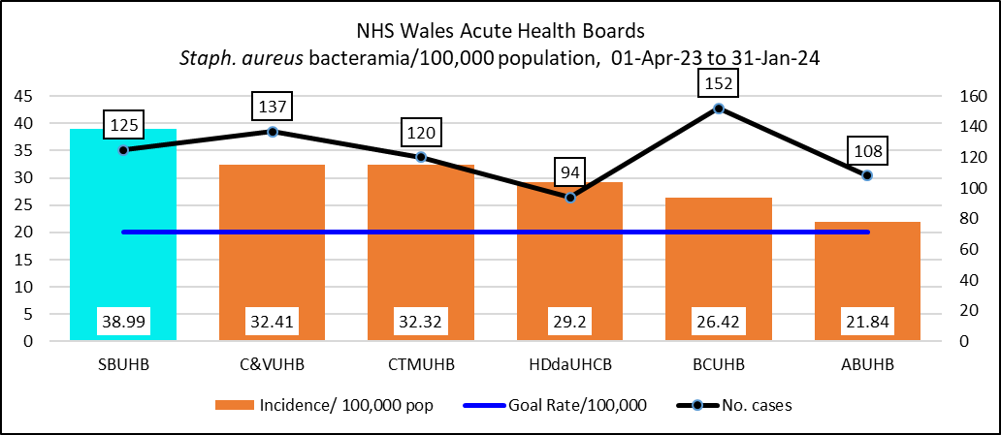
Chart 3: E. coli bacteraemia | Chart 4: Klebsiella species bacteraemia
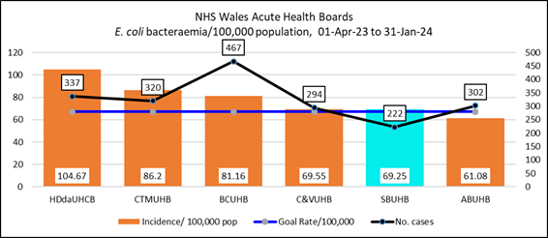 | 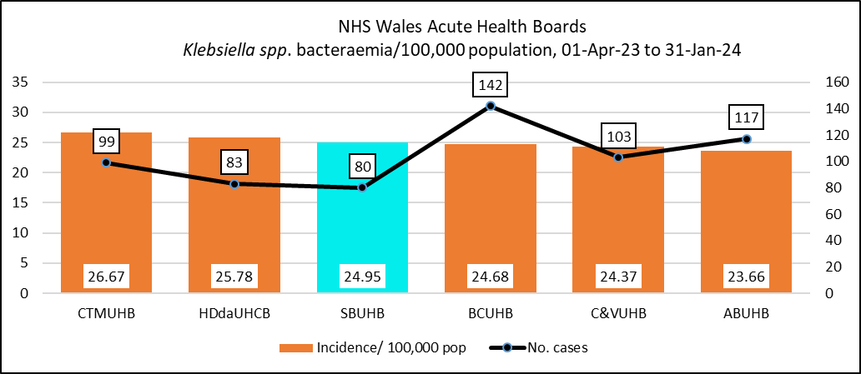
Chart 5: Pseudomonas aeruginosa bacteraemia
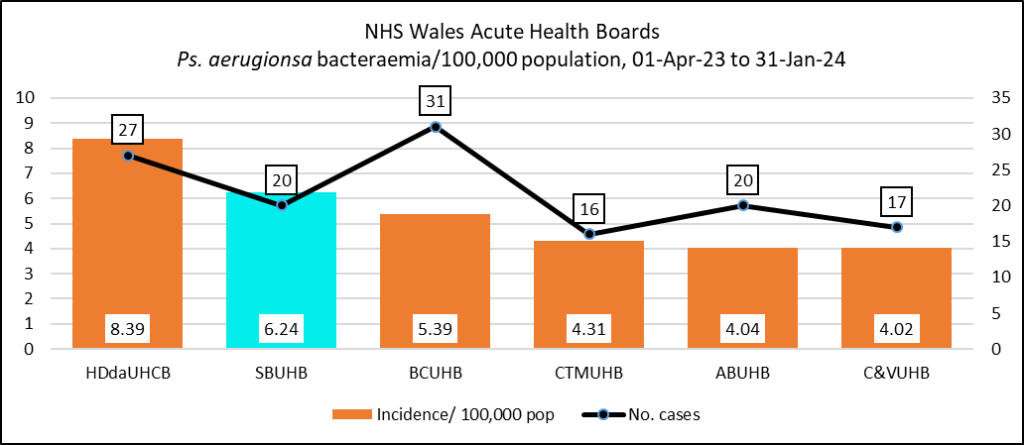

Chart 6:
Quarterly distribution of all C. difficile (PCR positives) across the Service Delivery Groups, April 2019 to December 2023
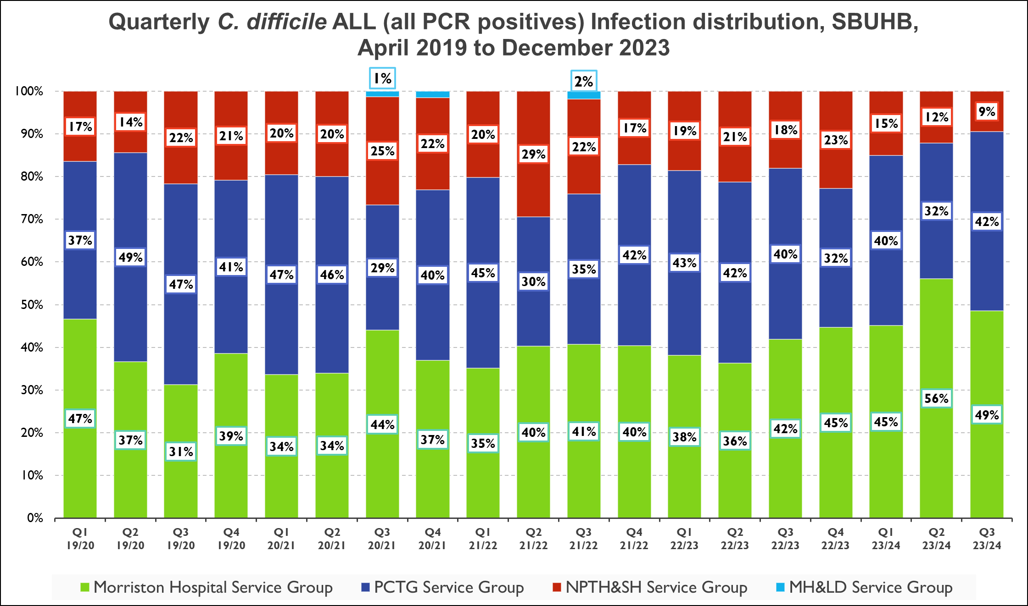
Chart 7:
Quarterly distribution of C. difficile Infection (toxin positives) across the Service Delivery Groups, April 2019 to December 2023
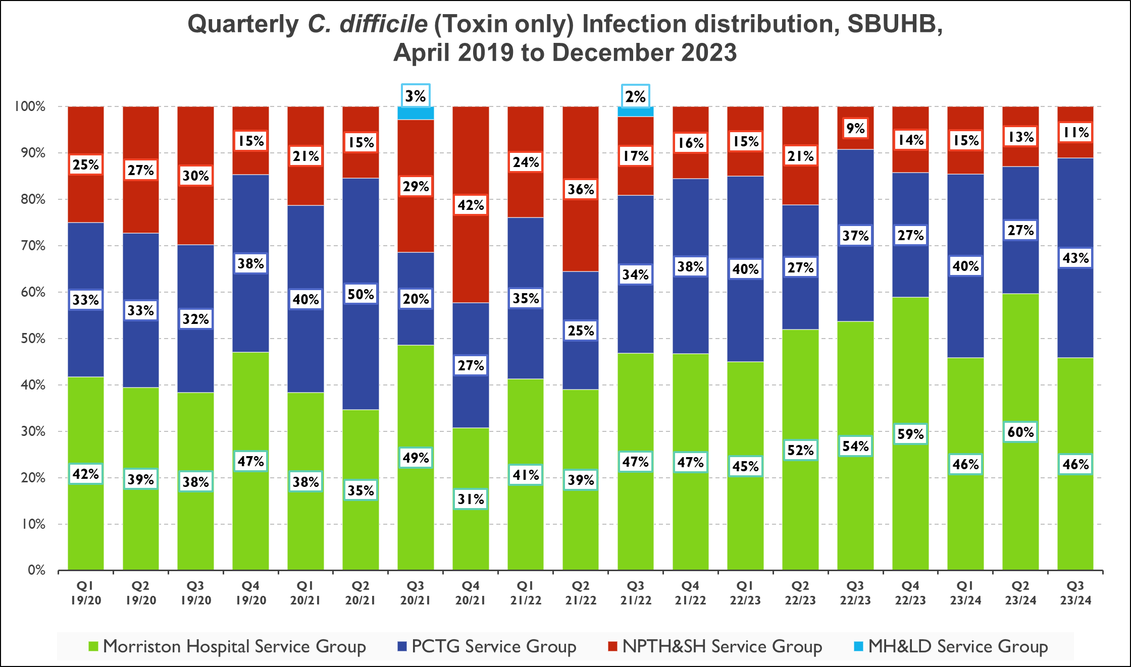

Health Board and Service Group C. difficile Trends
Health Board Trend analysis of C. difficile
Chart 8: All C. difficile (all PCR positives – colonisation and infection)
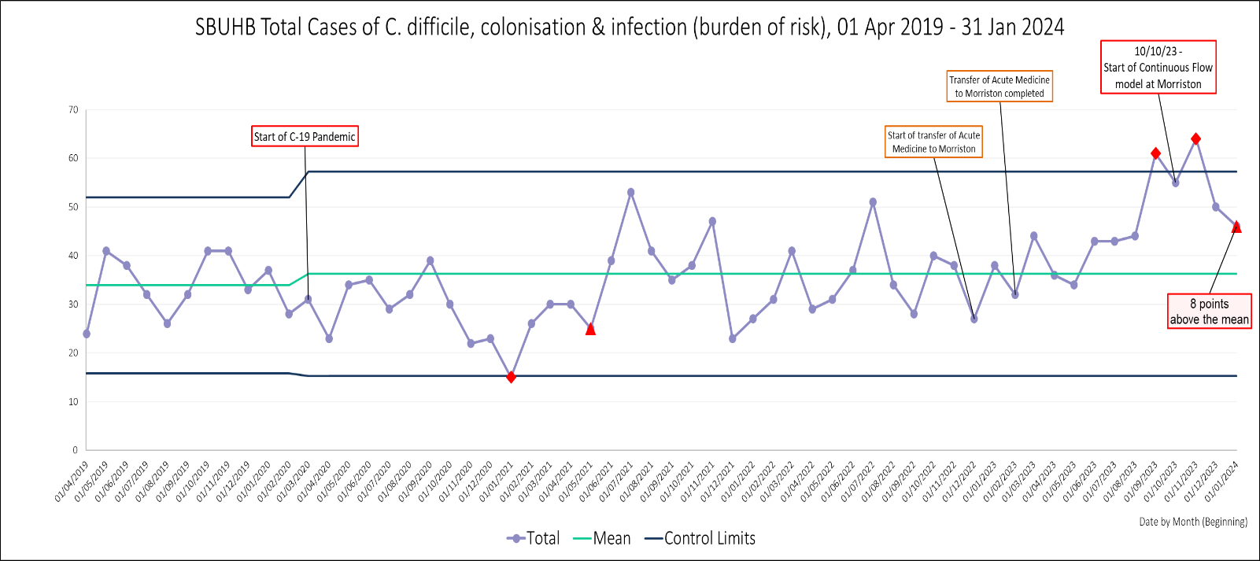
Chart 9: C. difficile infection (toxin positives only)
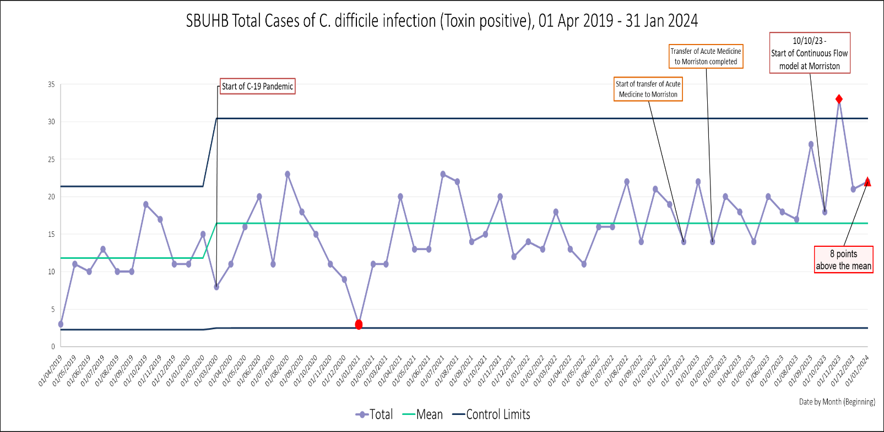

Charts 10 & 11: Primary Care, Community and Therapies
All C. difficile (all PCR positives – colonisation and infection) | C. difficile infection (toxin positives only)
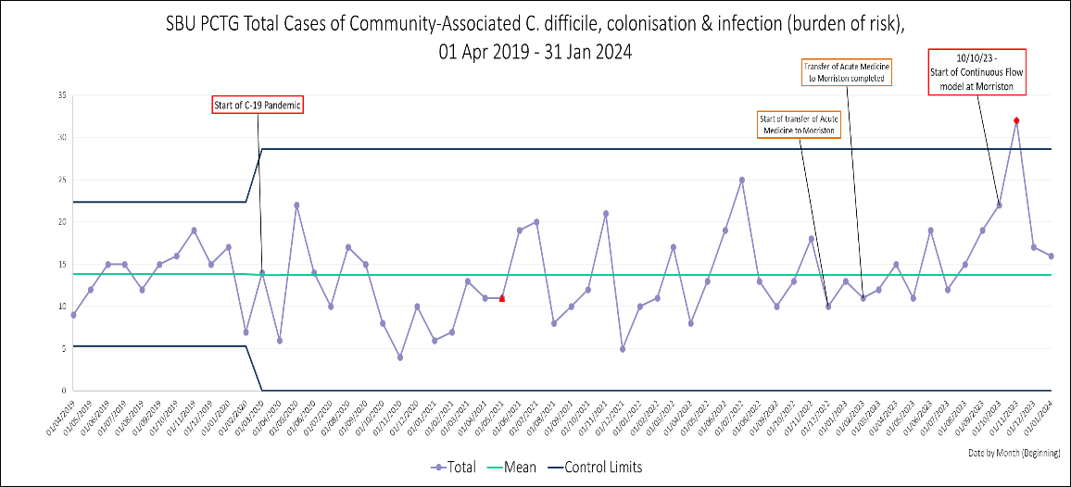 | 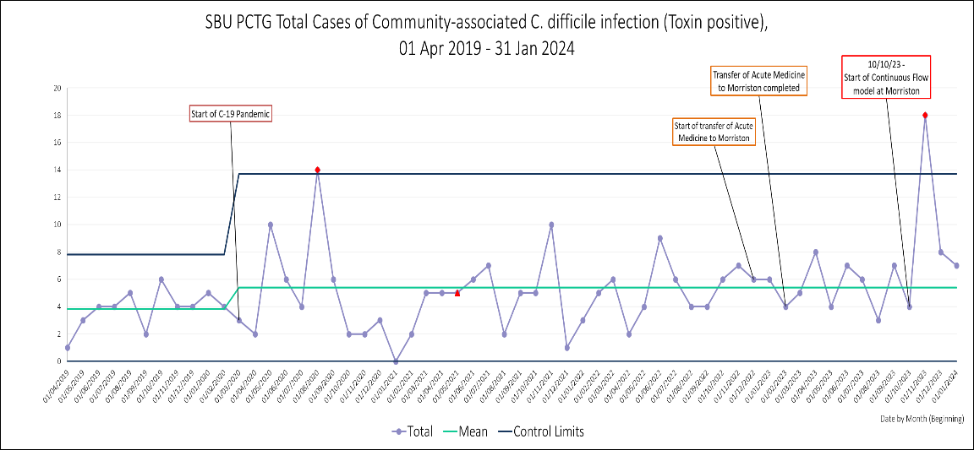
Charts 12 & 13: Neath Port Talbot
All C. difficile (all PCR positives – colonisation and infection) | C. difficile infection (toxin positives only)
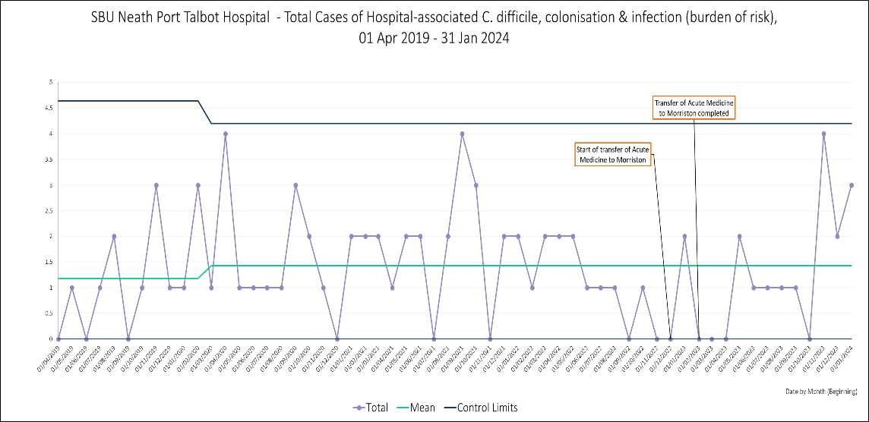 | 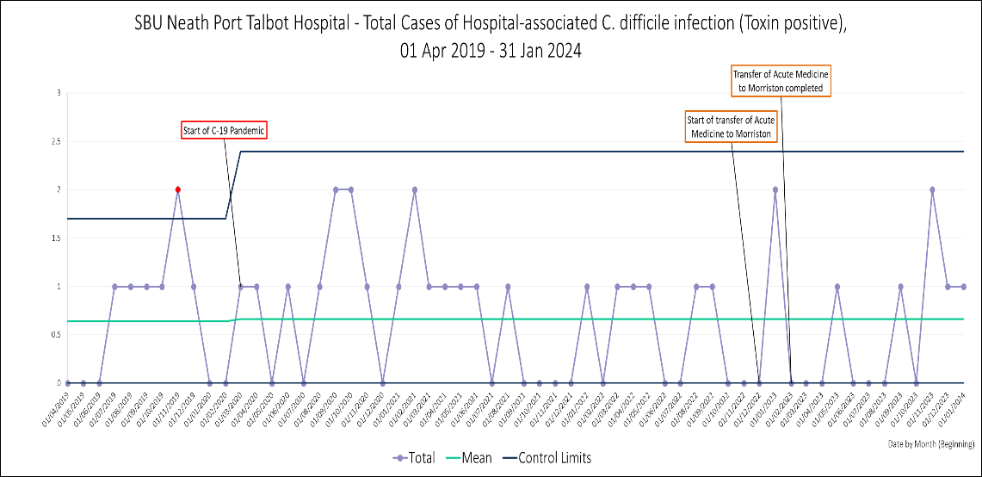

Charts 14 & 15: Singleton
All C. difficile (all PCR positives – colonisation and infection) | C. difficile infection (toxin positives only)
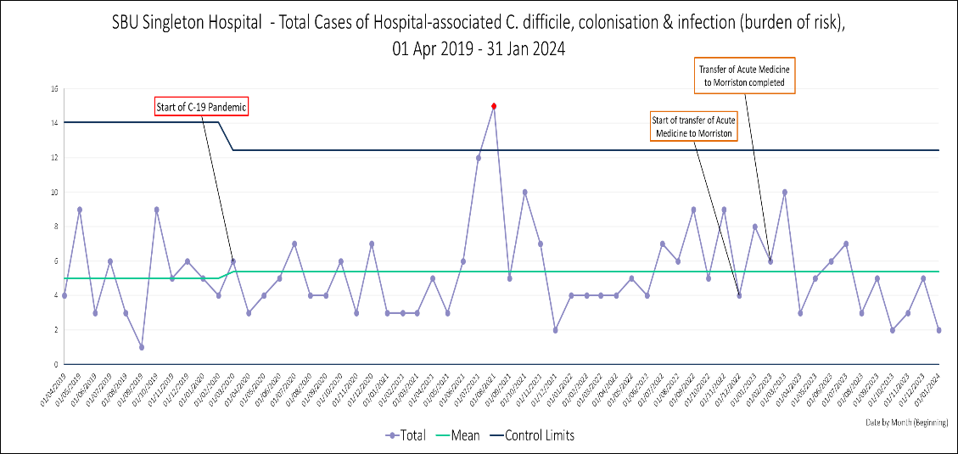 | 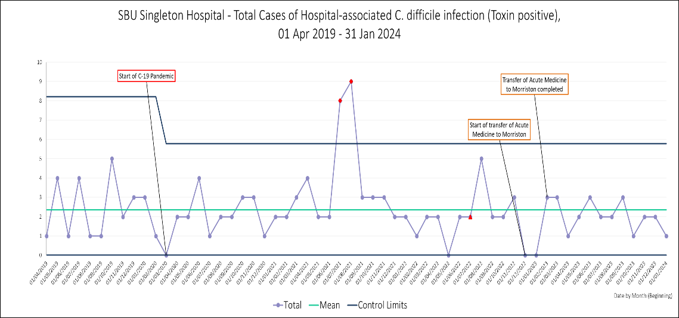
Charts 16 & 17: Morriston
All C. difficile (all PCR positives – colonisation and infection) | C. difficile infection (toxin positives only)
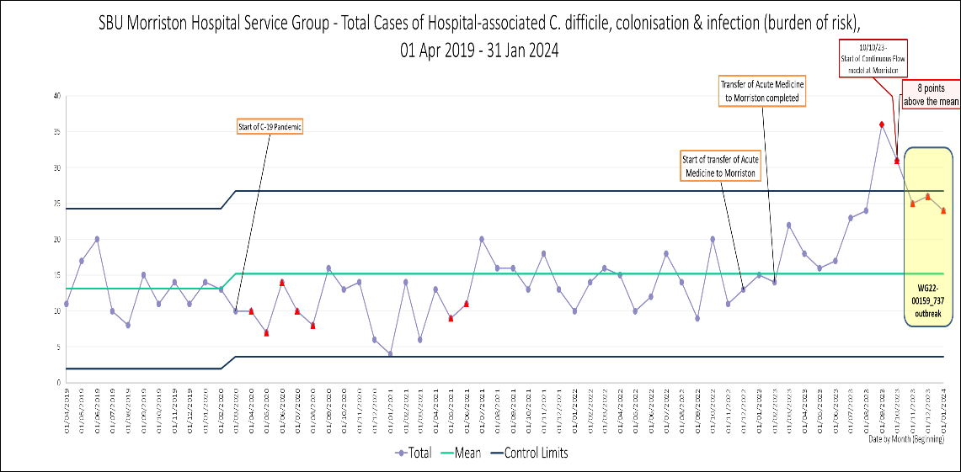 | 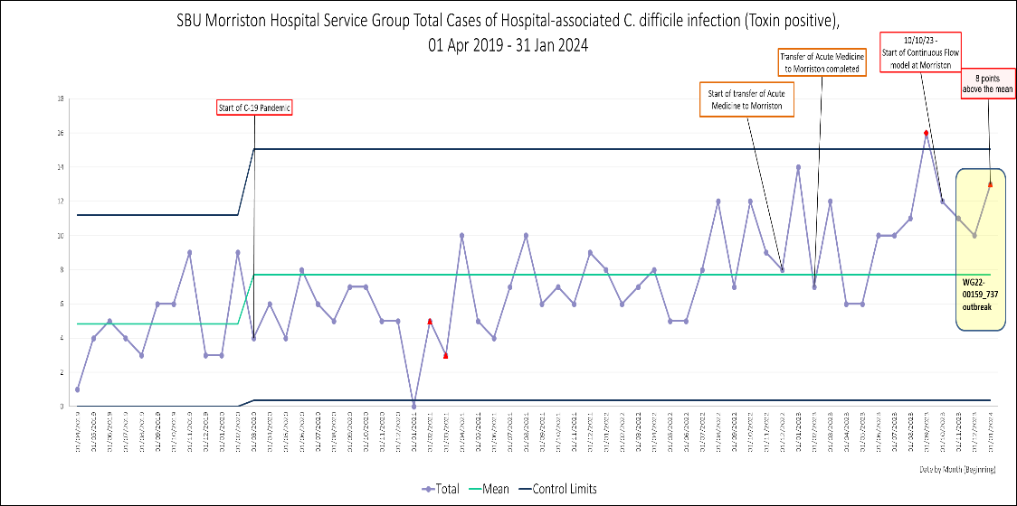

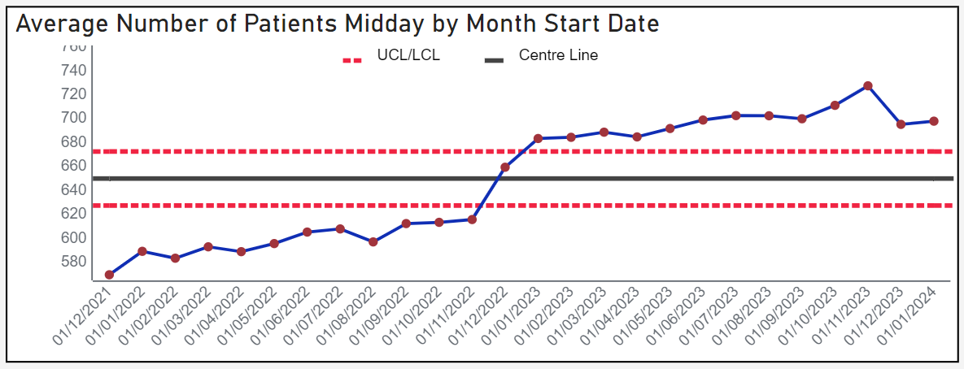 | 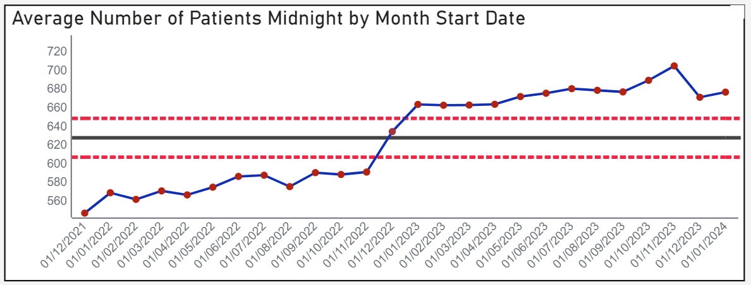
Clinically Optimised Patients & Patients Over 21 days in a bed (of which >95% are COP)
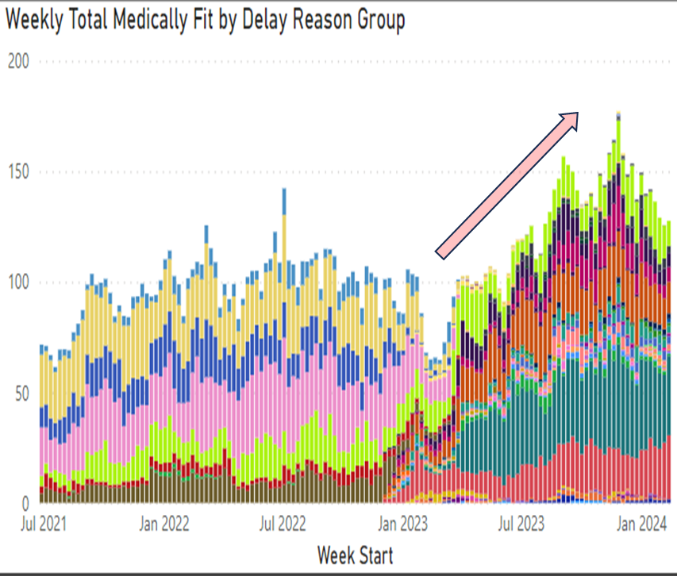 | 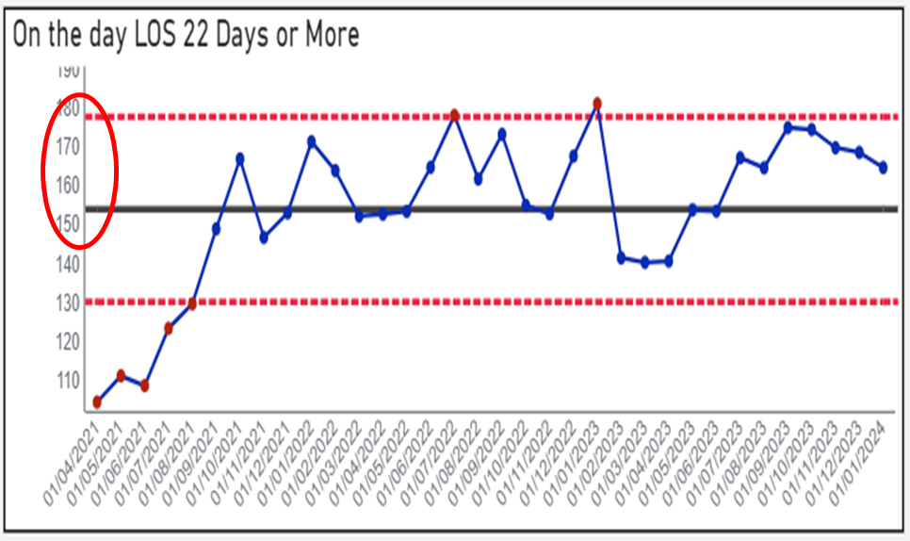

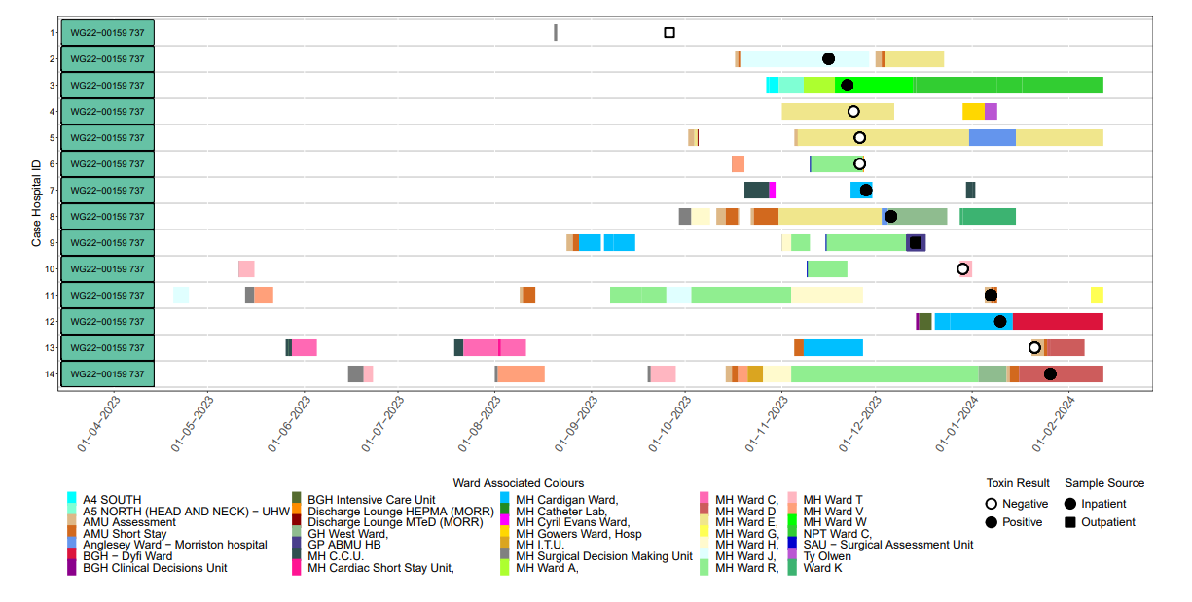

Graph Number | Specimen Date | Specimen Number | WGS Cluster | T5 | T2 | T0
1 | 26/09/2023 | F23S****41A | WG22−00159 | 652 | 737 | 1468
2 | 16/11/2023 | F23S****15A | WG22−00159 | 652 | 737 | 1478
3 | 22/11/2023 | F23S****20A | WG22−00159 | 652 | 737 | 1510
4 | 24/11/2023 | F23S****40A | WG22−00159 | 652 | 737 | 1478
5 | 26/11/2023 | F23S****12A | WG22−00159 | 652 | 737 | 1478
6 | 26/11/2023 | F23S****33A | WG22−00159 | 652 | 737 | 1478
7 | 28/11/2023 | F23S****45A | WG22−00159 | 652 | 737 | 1478
8 | 06/12/2023 | F23S****42A | WG22−00159 | 652 | 737 | 1478
9 | 14/12/2023 | F23S****08A | WG22−00159 | 652 | 737 | 1478
10 | 29/12/2023 | F23S****42A | WG22−00159 | 652 | 737 | 1541
11 | 07/01/2024 | F24S****11A | WG22−00159 | 652 | 737 | 1478
12 | 10/01/2024 | F24S****93A | WG22−00159 | 652 | 737 | 1478
13 | 21/01/2024 | F24S****19A | WG22−00159 | 652 | 737 | 1563
14 | 26/01/2024 | F24S****81A | WG22−00159 | 652 | 737 | 1478

A retrospective case-control study published in the British Medical Journal Quality & Safety in 2021, using multivariable analysis, identified a robust association between intrahospital transfers and the development of a hospital-associated infection (HAI), with each additional transfer increasing the odds of developing an HAI by 9% in elderly patient (study accessed at: https://doi.org/10.1136/bmjqs-2020-012124).

On 8th February, a C. difficile Round Table Discussion event was held, with participation from the Deputy Executive Director of Nursing, Service Group Nurse Director for Morriston, Service Group Senior Leadership team representatives, Infection Prevention & Control Senior Managers, Infection Control Doctor lead, Healthcare Epidemiologist, Consultant Medical Microbiologists, Estates and Facilities Leads, the Deputy Medical Director and Head of HARP Programme, the Head of Nursing HARP, Deputy Lead Clinical Scientist for the UK Anaerobic Reference Unit, and the Deputy Director of Quality and Safety, Performance & Assurance at NHS Executive Delivery Unit.
The discussions were helpful, and there was tough challenge. This can be summarised as:
- Prevention & Management Strategy – the health board follows national guidance, although early isolation presents a greater challenge at Morriston, which has the lowest proportion of single rooms per ward than other hospitals within the health Bboard. The lack of available single room capacity was on the health board’s Risk Register, and on Morriston’s Risk Register prior to AMSR. The centralisation of all unscheduled care on the Morriston site has compounded the position, with higher numbers of patients requiring single rooms, for many reasons, including infections.
- Antimicrobial Stewardship programmes and successes – significantly restricted the use of high risk broad-spectrum antibiotics and are now the best performer in Wales and amongst the best in England and Wales. However, the second highest prescriber of total antibiotics in Primary Care in Wales and third highest in England and Wales.
- C. difficile position, as outlined in 2.3 to 2.6 above.
- A genomic analysis of C. difficile in SBUHB in 2023 was presented by Dr Michael Perry of the UK Anaerobic Reference Unit. This analysis for SBUHB in 2023 showed that the number of clusters of infection had almost doubled over the second part of the calendar year. There had been 38 linked clusters within the health board in 2023. Thirteen of these occurred between January and June 2023; 25 occurred between July and December 2023. Not only had the number of linked clusters (transmission events) almost doubled, but the number of patients involved in the transmission event had increased also. In the first half of the year, there had been 31 patients involved in 13 cluster transmission events. In the second half of the year, there had been 63 patients involved in 25 cluster transmission events. Twenty-nine of the 38 cluster transmission events occurred in Morriston.
- A review of C. difficile testing in Wales from April to November 2023, with an analysis of positivity rates, was presented by Dr Mari Morgan, Senior Scientist, HARP (Appendix 6). This analysis showed that:
  - Testing. SBUHB had the highest overall testing rate per 100,000 population in NHS Wales, and the highest rate of inpatient testing per 1,000 admissions (almost three times more than Aneurin Bevan UHB), which may be linked to higher numbers of symptomatic patients, or a lower threshold for sending a sample. However, SBUHB is mid-range for the number of tests sent by GP.
  - Overall C. difficile positivity rate. Although SBUHB sent the most samples, it had the lowest PCR positivity rate of all major Welsh Health Boards, but the second highest toxin positivity rate (second to Aneurin Bevan UHB). The inpatient positivity rate reflected this position also. However, for GP tests, SBUHB had the second highest PCR positivity rate, but the highest toxin positivity rate of all health boards.
  - This may be linked to the SBUHB Primary Care being the second highest prescriber of all antibacterial items Wales and the third highest in England and Wales.

- The Head of Nursing for the HARP team provided feedback from her site visit to Morriston Hospital on 25th January 2024.
  - Morriston had been exceptionally transparent and had been looking at themes and trends across the site.
  - There had been strong nursing leadership at the Outbreak Control Group she’d attended but her observation was that this was a nurse-led model and that a multi-disciplinary approach would be needed to tackle the issues.
  - The acute medical reconfiguration that had taken place had promoted transmission of C. difficile across the site.
  - Multiple beds moves would exacerbate the risk of infection transmission.
  - She recognised that there were real pressures across the site but the placement of additional patients on wards led to an inability to carry out 4D cleans and was likely to affect the effectiveness of the cleans undertaken.
  - The health board should give consideration to the rationalisation of bed cleans (which currently is shared between cleaning staff and nursing staff). The model of a dedicated enhanced cleaner that had been shown to be effective on the pilot ward should be considered as a workforce redesign for roll-out across the health board.
  - The health board should consider Health Building Notes guidance on spaces between beds and on ward layout. Derogation from the guidance in favour of increasing capacity could lead to increased risks of healthcare associated infections.
- Summary of feedback from Dr Eleri Davies, Deputy Medical Director and Head of HARP Programme:
  - High incidence of C. difficile in Morriston Hospital in 2017/18 had been brought under control by strict approaches in terms of managing patient pathways and managing patient flow, and by decanting areas and undertaking deep cleans and high level disinfection with hydrogen peroxide to break the cycle of increased incidence.
  - It was considered that the increased movement of patients around the hospital was definitely leading to spread of infection. Whilst there was appreciation of the service pressures, the Health Board was strongly advised that a discussion on patient pathways and patient moves must take place. Strict protocols must be in place to ensure that, even at times of extreme pressures, patients are not admitted into beds unless the bed spaces, beds, mattresses and surrounding items are effectively decontaminated.
  - Consideration should be given to investment in additional temporary buildings to expand capacity, with more single rooms, rather than putting additional patients in wards. Whilst there is a cost associated with these proposals, there is a cost (morbidity and mortality) if C. difficile infection cannot be brought under control in the Health Board.
  - The C. difficile figures in SBUHB are worrying. Although there was good work being done, this was not turning the tide. The health board must find a way to address issues identified.
- Summary of feedback from Cathy Dowling, Deputy Director, Quality and Safety, Performance & Assurance, NHS Executive:
  - It was evident from the discussions that there were high level controls in place. However, she considered that the health board should drill down on the themes of this outbreak and consider what the implications of these would be on a site basis but also on a health board-wide basis.

4C Antibiotics in Primary Care – Welsh comparison
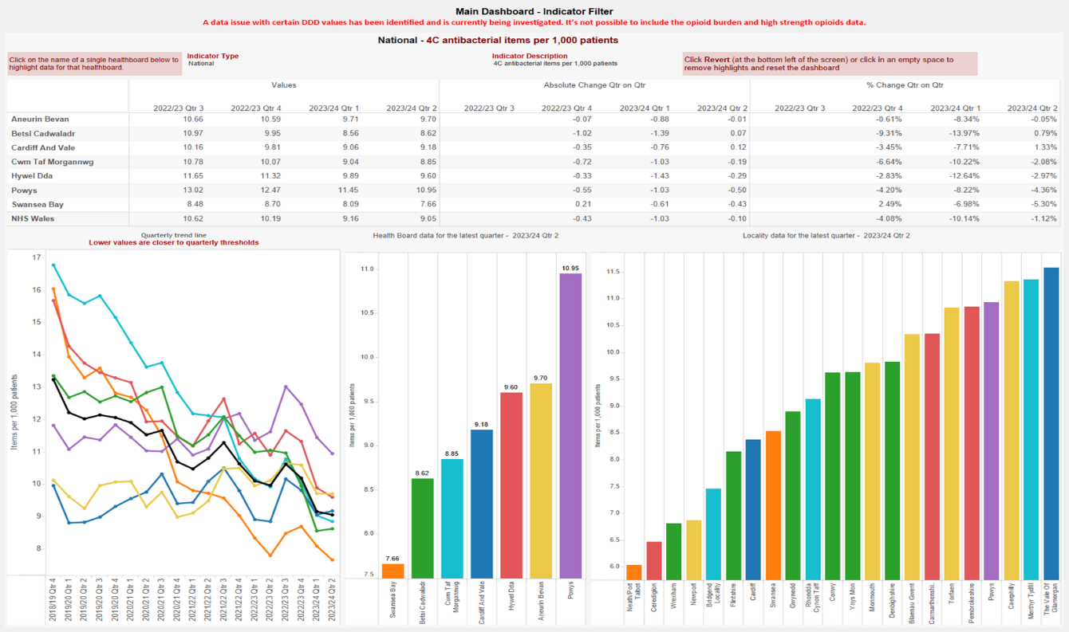
4C Antibiotics in Primary Care – English and Welsh comparison
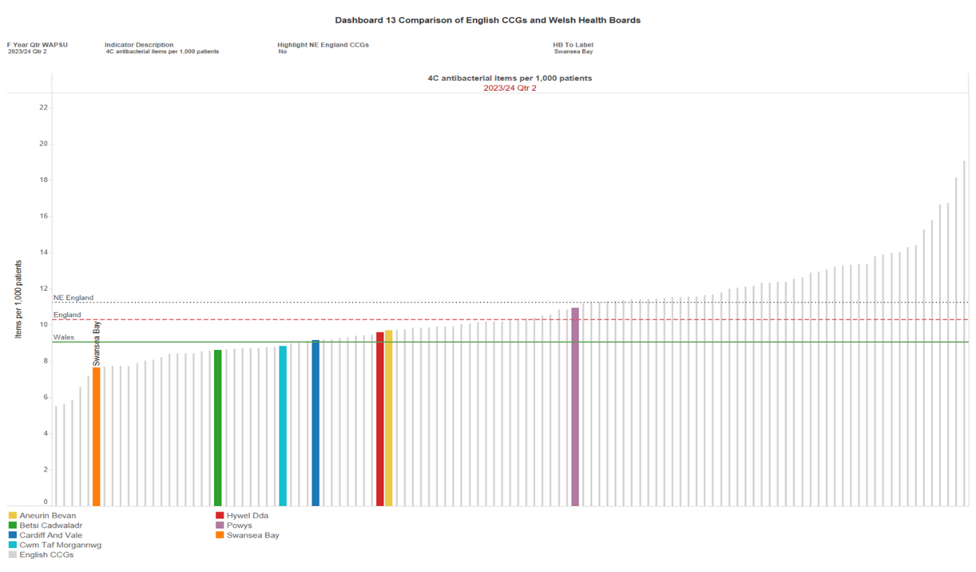

Total volume antibiotic prescribing in Primary Care – Welsh comparison

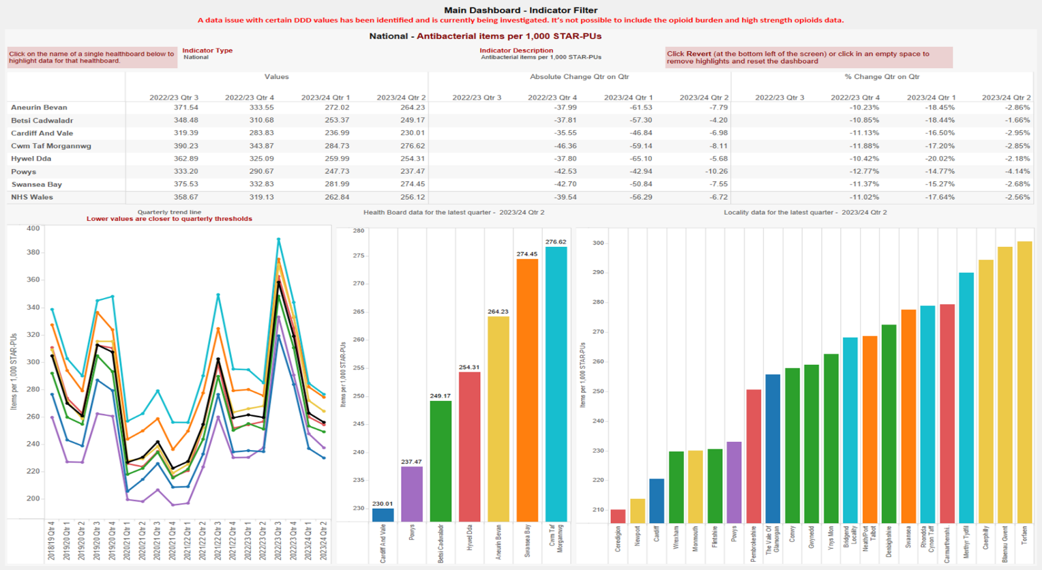

Total volume antibiotic prescribing in Primary Care – English and Welsh comparison
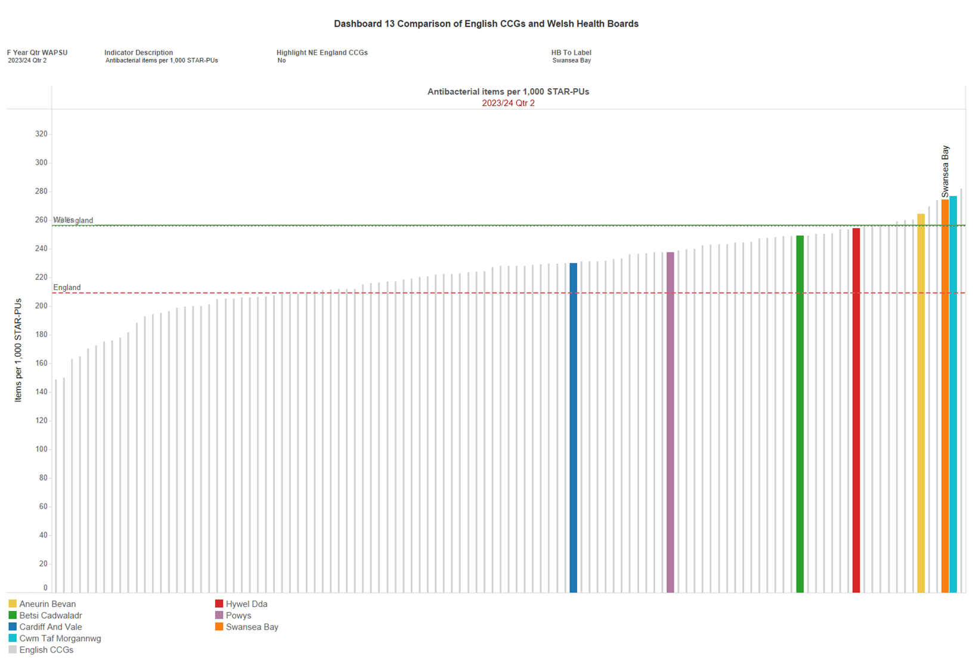

Genomic Analysis of C. difficile in SBUHB in 2023
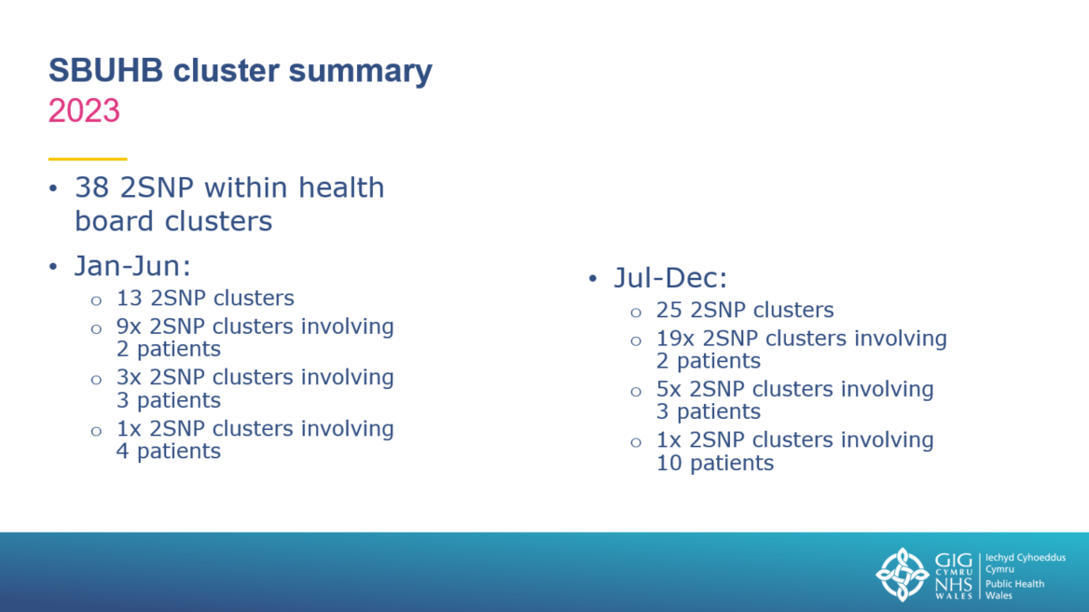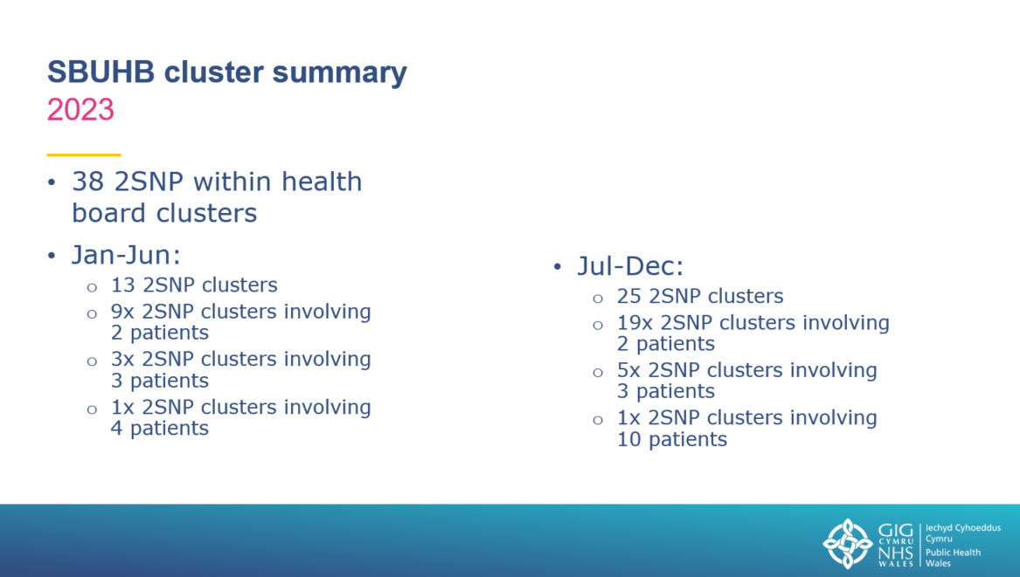

Review of C. difficile testing in Wales from April to November 2023
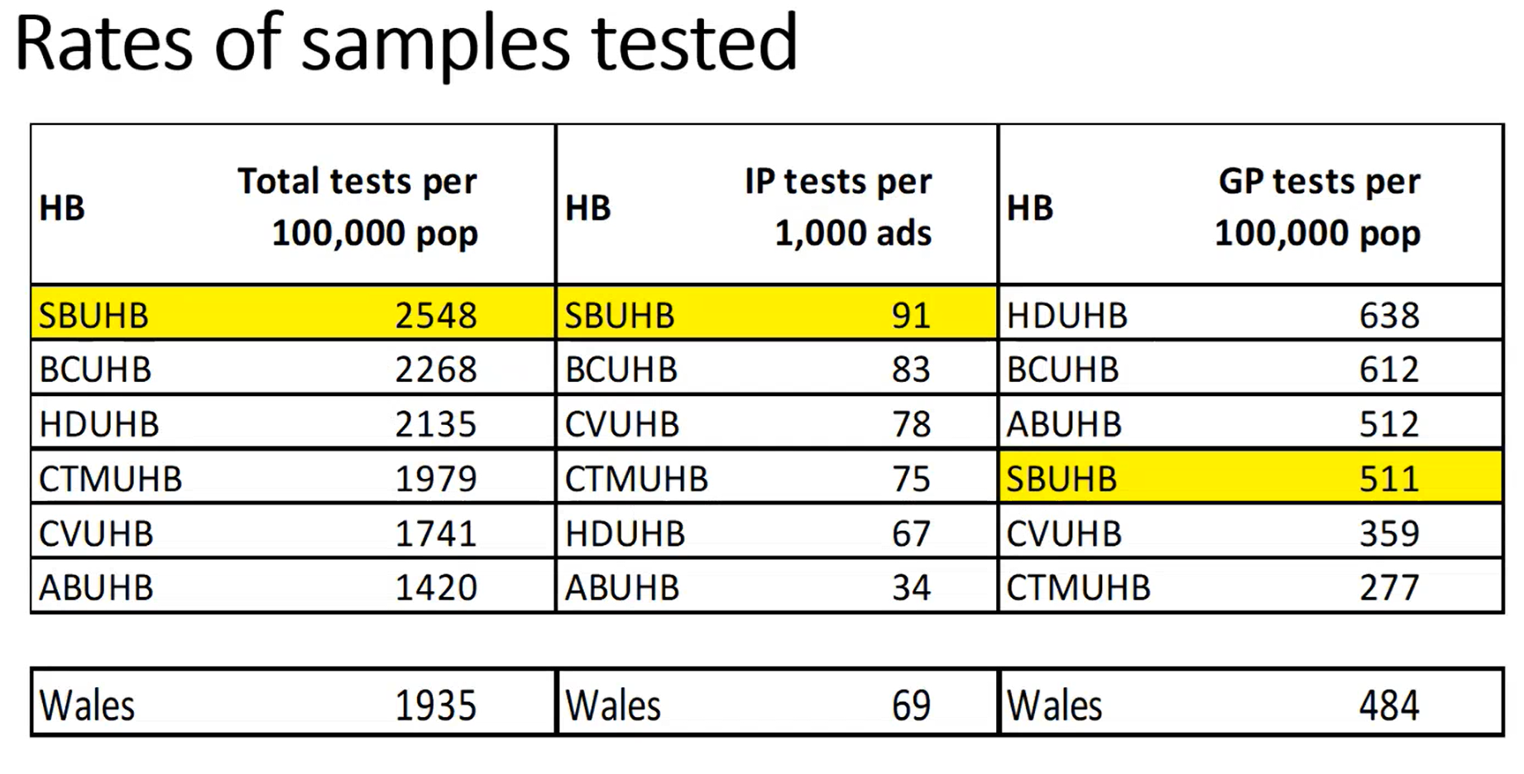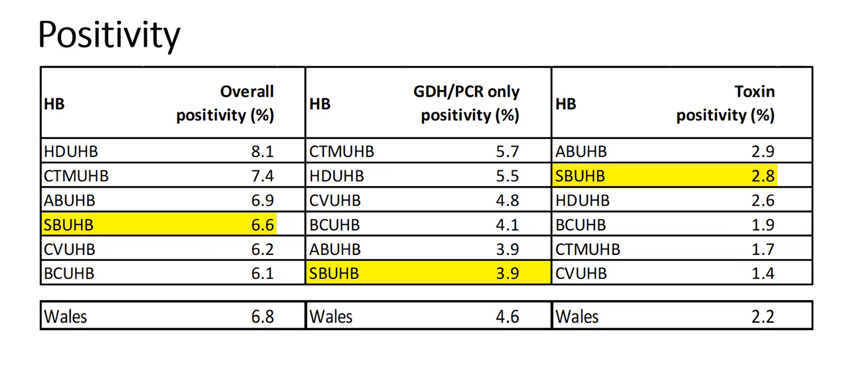
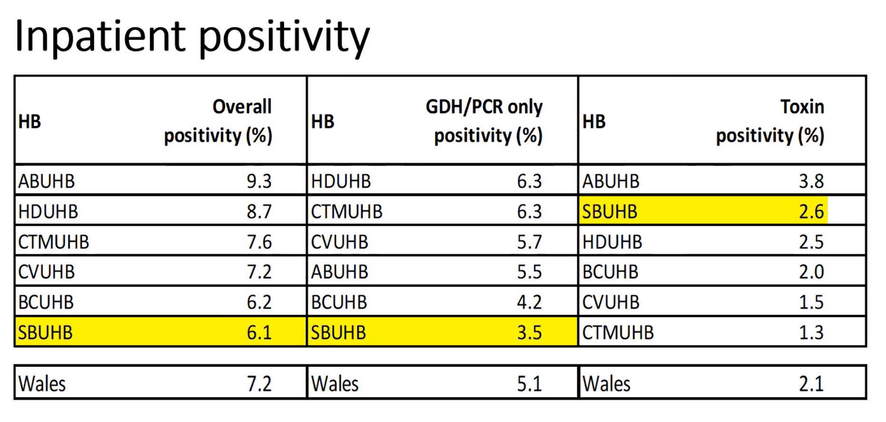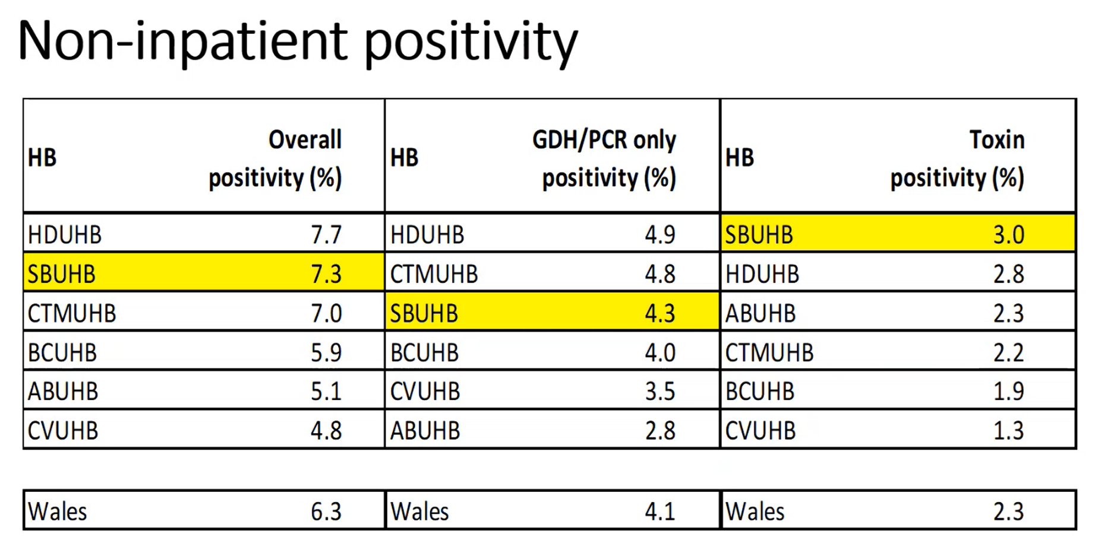
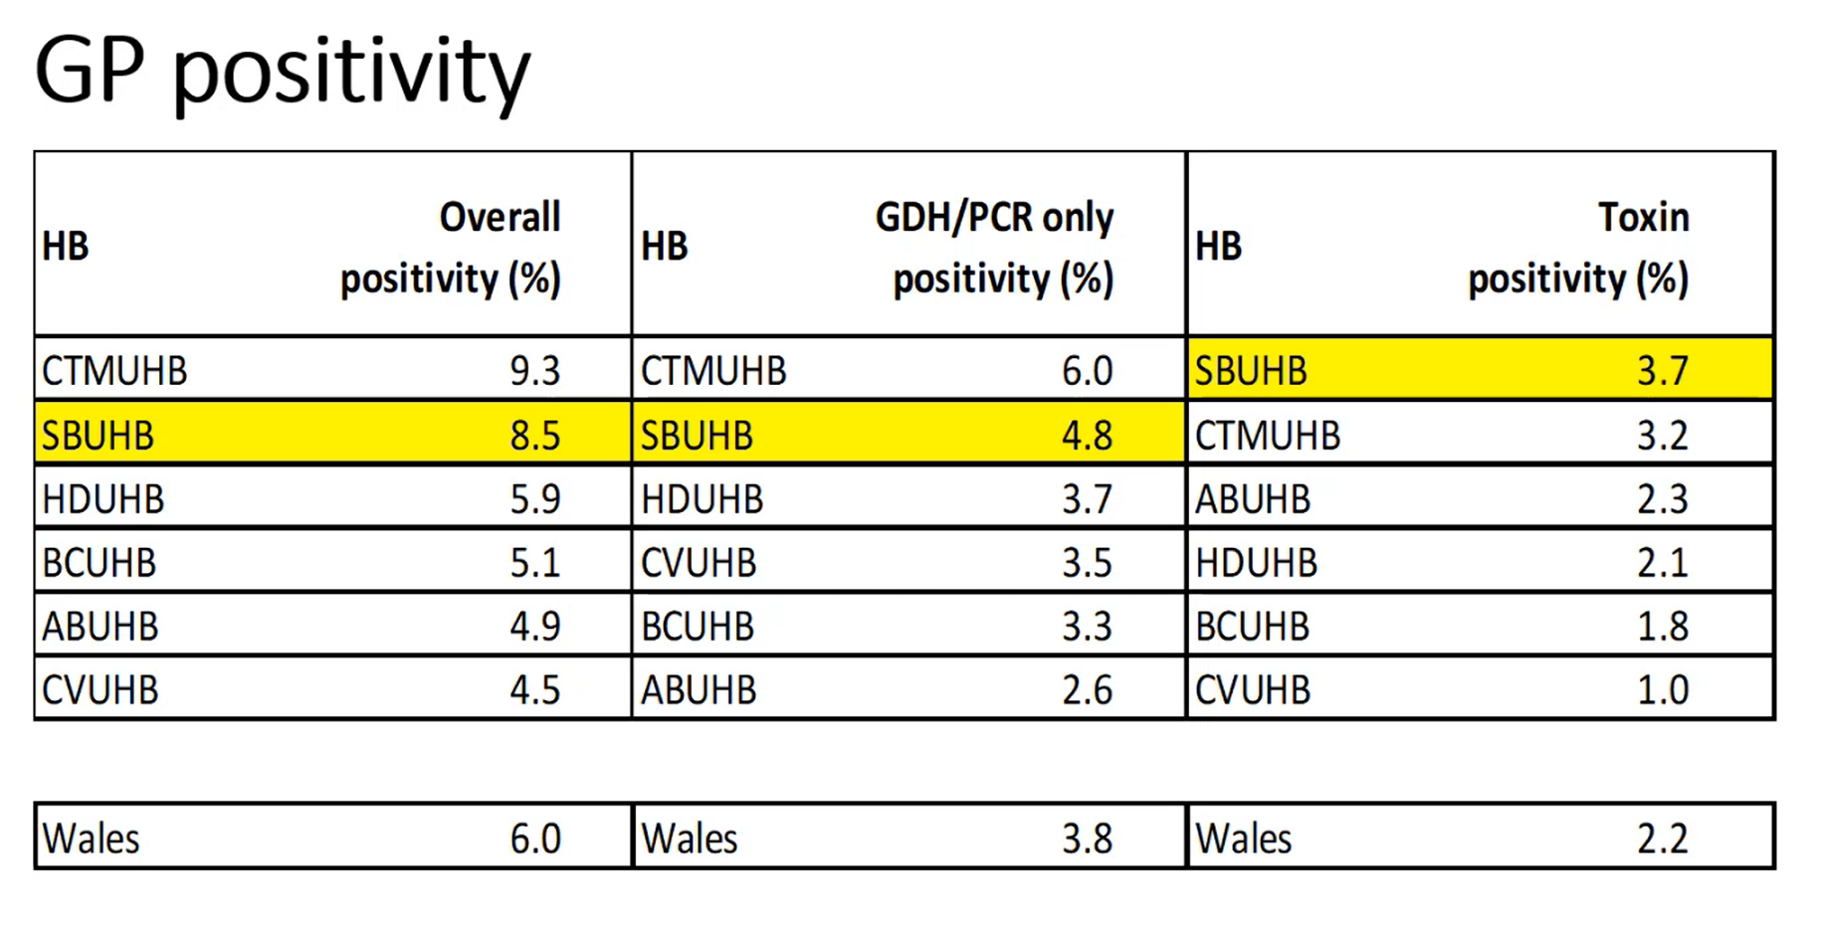

Integrated Infection Prevention & Health Protection Service Redesign.
Goal: Develop the One Bay Infection Prevention & Protection Way to support the 10 Year Vision of being a High Quality Organisation with a focus on improvement and performance to deliver high quality care and patient experience.
Purpose | Post | Band | WTE | Cost
LEADERSHIP AND EXCELLENCE: to become a centre of excellence for research and innovation in the field of infection prevention & control, which will inform and evaluate infection reduction improvement programmes
Strengthen leadership in IPC within Service Groups and across the organisation, empowering leaders and all staff to apply best practice in infection prevention, to develop targeted improvement strategies aimed at reducing avoidable healthcare associated infections, and to promote immunisation to protect our workforce and our patients against vaccine-preventable diseases. Strengthening leadership also through collaboration with partner organisations, local authorities and with contractors. | Consultant Nurse/ Practitioner for IPC | 8c | 1 | £81,138
Delivering the best outcomes for our population, preventing illness and harm caused by communicable infections and healthcare associated infections.
Work towards an equitable Infection Prevention service across Primary Care and Community
Rationale: FY 2022/23: Primary Care & Community key Tier 1 indicator infections accounted for 44% of the HB total; Q1-Q3 2023/24:
Primary Care & Community key Tier 1 indicator infections accounted for 46% of the HB total. (Currently only 10% of IPC resource dedicated to Primary, Community, Mental Health and Learning Disabilities).
Strengthen operational leadership within IPC to establish a senior IPC Quality Improvement Partner for Service Group Senior Leadership Teams, equitable across Primary Care & Community, Mental Health & Learning Disabilities, and Secondary Care, reflecting the distribution of infection across the Health Board.  This will supplement the existing 8a Quality Improvement IPC post that is secondary care-centric. | IPC Matron, Quality Improvement | 8a | 1 | £57,349
To maintain and sustain a substantive role for an IPC specialist providing support to Care Homes.  To continue to fund beyond March 2025 (currently funded jointly by LA and HB), approve substantive funding for this temporary seconded post. | Senior IPC Specialist Nurse for Care Homes | 7 | 1 | £50,056*
Development of an augmented infection prevention and control service in the community, which will facilitate the IPC service organising itself around our patients, enabling both a proactive and reactive service, getting it right first time, preventing infections and avoiding admissions to hospital as a result of infections.  These posts would reflect a Cluster model approach, with one Band 6 and one Band 4 covering the West Clusters (City Health, Bay Health, Penderi and Llwchwr Clusters) and the other Band 6 and Band 4 staff covering the East Clusters (Afan, Neath, Upper Valleys and Cwmtawe Clusters). This also reflects the Virtual Ward model approach. | IPC Nurse/ Practitioner | 6 | 2 | £85,236  (2x £42,618)
 | IPC Training & Audit Support Worker | 4 | 2 | £55,192  (2 x £27,596)
Supporting this would be requirement for appropriate IT equipment (laptop, dock, monitor, keyboard and mouse), mobile phones, and traveling expenses.
TOTAL COST |  |  |  | £328,971
*Currently funded via COVID funding and LA/HB agreement to March 2025.

A study was undertaken in NHS Scotland to estimate the costs associated with HCAI, including excess length of stay. This study, published in August 2021, used Scottish NHS reference costs to estimate unit costs for bed-days. This study is the first in the UK to report whole-hospital incidence associated infection for approximately 20 years.
Full details of methods and findings are published in Bed-days and costs associated with the inpatient burden of healthcare-associated infection in the UK, in the Journal of Hospital Infection 114 (2021) 43 – 50: https://doi.org/10.1016/j.jhin.2020.12.027
Excess length of stay and bed-days lost due to healthcare associated infection, by type – SBUHB to 31/01/24
Table 1: Average excess LOS and bed-days lost by Tier 1 blood stream infection (BSI) in SBUHB, April 2023 – January 2024
 | Tier 1 BSI in SBU  Apr-23 to Jan-24 | Average excess LOS per HAI | Total bed-days lost to Tier 1 BSI  Apr-23 to Jan-24
Staph. aureus BSI | 125 | 11.4 | 1,425
E. coli BSI | 222 | 11.4 | 2,530.8
Klebsiella spp. BSI | 80 | 11.4 | 912
Ps. aeruginosa BSI | 21 | 11.4 | 239.4
All Tier 1 BSI | 448 | 11.4 | 5,107.2
Table 2: Average excess LOS and bed-days lost by all blood stream infection (BSI) in SBUHB, by acute hospital site, April 2023 – January 2024
Hospital | All BSI SBUHB | Average excess LOS per BSI | Total bed-days lost to Tier 1 BSI  Apr-23 to Jan-24
Morriston Hospital | 1,189 | 11.4 | 13,554.6
Neath Port Talbot Hospital | 37 | 11.4 | 421.8
Singleton Hospital | 198 | 11.4 | 2,257.2
Total | 1,424 | 11.4 | 16,233.6
Table 3: Cost per case for each healthcare associated bloodstream infection in SBUHB, April 2023 – January 2024
HCAI | Cases  (01/04/23 – 31/01/24) | Cost per case for each HCAI type and overall (£) |  | Total cost in SBUHB  (Apr-23 to Jan-24)  (£ million)
HCAI | Cases  (01/04/23 – 31/01/24) | Total cost per case (£) | Direct cost per case (£) | Total cost (£m) | Direct cost (£m)
Tier 1 BSI | 448 | 9,109 | 5,917 | 4,080,832 | 2,650,816
All BSI  (incl. Tier 1 BSI) | 1,424 | 9,109 | 5,917 | 12,971,216 | 8,425,808
A systematic review and meta-analysis published in 2020 stated that the CDI-associated mean difference in length of stay (LOS) varied from 3.0 days to 21.6 days (Marra AR, Perencevich EN, Nelson RE, et al. Incidence and Outcomes Associated with Clostridium difficile Infections: A Systematic Review and Meta-analysis. JAMA Netw Open. 2020;3(1):e1917597. doi:10.1001/jamanetworkopen.2019.17597, accessed at: https://jamanetwork.com/journals/jamanetworkopen/fullarticle/2758401 ). Using Health Board-specific data, the calculations relating to excess length of stay might range from 390 to 2808 additional bed days.
Table 4: Excess LOS and bed-days lost by C. difficile infection (CDI) in SBUHB, by acute hospital site, April 2023 – January 2024
Hospital | C. difficile SBUHB | Excess LOS per CDI | Total bed-days lost to C. difficile  Apr-23 to Jan-24  (range)
Morriston | 105 | 3.0 - 21.6 | 315 - 2268
Neath Port Talbot | 6 | 3.0 - 21.6 | 18 - 129.6
Singleton | 19 | 3.0 - 21.6 | 57 - 410.4
Total |  |  | 390 – 2,808

