

Meeting Date | 28 November 2023 |  | Agenda Item |  |  | 4.4
Report Title | Progress update on the review of cases of COVID-19 contracted in a healthcare setting
Report Author | Andrea Folland, Nosocomial Review Team Business Manager
Report Sponsor | Raj Krishnan, Acting Executive Medical Director  Gareth Howells, Executive Director of Nursing and Patient Experience
Presented by | To be confirmed
Freedom of Information | Open
Purpose of the Report | To provide the Quality & Safety Committee with a progress update on the review of cases of COVID-19 contracted in healthcare settings (nosocomial) and communication with families of deceased patients.
Key Issues | In line with national requirements on NHS organisations in Wales, reviews into nosocomial transmission of COVID-19, and related work to communicate review outcomes, continues within the Health Board.  As the Nosocomial COVID-19 Review Programme nears its end, the need to manage trajectory of activity towards deadline and the risks presented by this, and the finite nature of the Programme, remain prevalent.
Specific Action Required  (please choose one only) | Information | Discussion |  | Assurance | Approval
Specific Action Required  (please choose one only) | ☒ | ☐ |  | ☐ | ☐
Recommendations | Members are asked to:  - NOTE the progress made in reviewing nosocomial COVID-19 cases, including an update on communicating this work to patient families  - NOTE the drive to ensure a legacy of learning from the Health Board Nosocomial COVID-19 Review Programme  - NOTE the continuing risk for residual activity to occur following the disbanding of the Review Team in March 2024, and some action taken in mitigation of this since submission of the last report to the Committee.
Progress update on the review of cases of COVID-19 contracted in a healthcare setting
- INTRODUCTION

Health Boards in Wales are continuing to review cases of patients who contracted COVID-19 in healthcare settings (nosocomial cases.) As reported to the Quality & Safety Committee in June this year, at SBUHB, this work focussed initially on patients who definitely or probably contracted nosocomial COVID-19, and subsequently, died. More recently, the Nosocomial Review Team (NRT) has been considering cases of indeterminate acquisition in patients who died, as well as cases of nosocomial COVID-19 in patients who are living, ensuring wider progress across the Programme.

The National Nosocomial COVID-19 Programme (NNCP), led by the NHS Wales Executive, continues to monitor the work of Nosocomial Review Teams (NRTs). The NNCP enables practice-sharing and provides update reports to Welsh Government on behalf of Health Boards. In line with national requirements, engagement with families of patients who have died having contracted nosocomial COVID-19, continues.

- BACKGROUND
Two appendices, referenced throughout the paper, are included as a means of providing supplementary information on current activity:
Appendix 1: The NHS Wales Executive Proportionality Decision Tool which provides a guide for Health Boards on the level of investigation required for different categories of nosocomial COVID-19 patient safety incident. The Nosocomial Review Team references this guide to ensure the proportionality of its own processes.

Appendix 2: The Ombudsman Information Sheet which outlines the process the official will follow in investigating complaints received about COVID-19 acquired in hospital, including those which are subject to review by the National Nosocomial COVID-19 Programme. The Health Board has formally acknowledged receipt of this information, providing assurance of its sharing and discussion with relevant colleagues and a commitment to working collaboratively with the Ombudsman, within the framework outlined, to facilitate robust and timely outcomes.

- KEY UPDATES

  - Reviewing progress:

As depicted in Figure 1, work is currently progressing at a rate which has met and will follow the trajectory required to complete the programme by its stipulated end-date, March 2024. This forecast, however, is predicated on the continued availability of the current workforce:

Figure 1: SBUHB Review Progress against Trajectory (NNCP Data Dashboard)

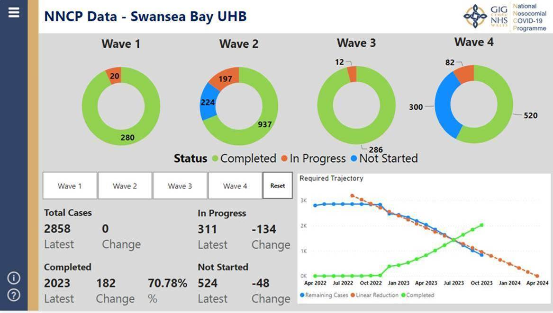

Table 2 provides a further breakdown of the progress depicted in Figure 1. A description of the data, by row, can be found in Table 3, which follows:

Table 2: Data as at 05.10.2023

 |  | Wave 1  (27.02.2020 – 26.07.2020) | Wave 2 (27.07.2020 – 16.05.2021) | Wave 3  (17.05.2021 – 19.12.2021) | Wave 4  (20.12.2021 – 30.04.2022) | Total:
1. | Total COVID-19 nosocomial incidents | 300 | 1358 | 298 | 902 | 2858
2. | Incidents under review | 0 | 168 | 0 | 57 | 225
3. | Downgraded / Recategorised | 4 | 146 | 4 | 139 | 293
4. | Referred to Scrutiny Panel | 20 | 29 | 12 | 25 | 86
5. | Completed Investigations | 276 | 791 | 282 | 381 | 1730

The balance of cases which remain unaccounted for in Table 2 comprises cases on which investigations have not yet commenced.

2. | The 225 cases under review all relate to definite, probable and indeterminate nosocomial COVID-19 acquisitions, some cases in which patients have died, and some in which patients are alive.
3. | Waves 1 & 3: Cases in which a review has commenced and found a non-nosocomial acquisition of COVID-19. Waves 2 & 4: Cases in which patients acquired nosocomial COVID-19 and died, however, COVID-19 is not on their death certificates.
4. | The number of cases referred to forthcoming Scrutiny Panels; deaths in which COVID-19 was definitely, probably and indeterminately nosocomially acquired;
5. | The number of cases considered by Scrutiny Panels for which outcomes have been determined. These relate to deaths in which COVID-19 was definitely, probably and indeterminately nosocomially acquired and patients who definitely, probably and indeterminately acquired nosocomial COVID-19 and are alive.

The cases of living patients who definitely, probably or indeterminately acquired nosocomial COVID-19, referred to above, continue to be subject to a desktop review. Where it is found that no referral to the Long COVID-19 Service has been made for these patients, cases have been deemed to be of no / low harm. In line with the NNCP Proportionality Tool (Appendix 1), these cases have, subsequently, been closed and are being logged on Datix, in accordance with healthcare acquired infection reporting requirements.

  - Communicating with patient families

On last reporting to the Quality & Safety Committee, 81 reviews had been conducted relating to patients who died having definitely or probably contracted nosocomial COVID-19 during wave 1. In relation to these reviews, 6 outcome letters remained outstanding. These have, since, been completed and sent to families, incorporating the satisfaction survey, approval for the use of which was received from Management Board and reported to the Quality & Safety Committee during June.
Of the wave 1 review outcome letters issued, the NRT had received contact on two cases, one from each of the Ombudsman and Llais. Having compiled further information in response to initial queries about both cases, the Ombudsman has requested a reissuing of the review it has considered. The NRT is working on compiling this in line with the Ombudsman’s information sheet regarding complaints about healthcare acquired COVID-19 (Appendix 2). Feedback on the response issued to Llais is awaited.
In line with observations collated during contact with the Ombudsman, Llais and the tens of families who have received communication via the Programme, to date, the Health Board has updated its review outcome letter template for definite, probable and indeterminate cases of healthcare acquired COVID-19 in which no breach of duty has been identified. The Ombudsman has noted and welcomed the revisions, acknowledging an improvement in the way in which they will enable communication of key messaging to the public. Llais, the NHS Executive, Legal and Risk Services and the Health Board executive leads for the Programme have all been sighted on the template, with approval for use received.

Since June, a further 107 families have been contacted in relation to reviews commenced on cases of patients who died having definitely, probably or indeterminately contracted nosocomial COVID-19 during wave 2. In relation to this cohort:
- 33 families returned contact to the NRT to contribute to the reviews of their relatives;
- 1 family does not wish further communication beyond notification of review;
- 3 outcome letters, in revised format, and satisfaction surveys have been issued;
- Contact has not, yet, been possible with an additional 24 families despite thorough attempts to trace them via e-systems, GP surgeries and the Care After Death Service;
- Calls continue to notify more families of review of their relatives’ cases.

3.3 Assurance of compliance with national programme requirements

Health Board alignment with NNCP requirements continues as follows:

- Monthly data submission and highlight reports to the programme team;
- Scrutiny Panels to determine outcomes for cases of medium harm or above;
- Updates to Health Board NRT webpage, documenting NNCP position (Nosocomial COVID-19 reviews - Swansea Bay University Health Board (nhs.wales));
- NRT attendance at Duty of Candour and Quality Strategy training to ensure up-to-date knowledge of principles underpinning the review framework;
- Full and thorough participation in an NHS Executive visit to the Health Board to demonstrate Health Board progress and position against the Programme framework;
- Lessons identified reported, monthly, via the Patient Stakeholder Experience Group.

As a means of expanding on the delivery of lessons identified during reviews to staff, the NRT has recently presented key themes to the Quality & Safety Group. This presentation is to be repeated at forthcoming meetings of the Infection Prevention & Control Group and the Professional & Governance Group for Therapies. Visits to all operational Health Board sites are also to occur, commencing during the week of 23.10.2023, in a bid to reach operational staff of all levels and professions with appropriate messaging.

- GOVERNANCE AND RISK ISSUES

  - Update to continuing risks previously reported to Quality & Safety Committee:

Risk: | Risk score: | Mitigation:
Distress caused to families resulting in receipt of additional complaints and/or negative media attention following commencement of the communication phase of the programme. | 16 | Briefing key stakeholders, including those providing family support. Regular debriefs with relevant parties, such as the CHC and the Care After Death Service ensure alignment of priorities.
Failure to provide outcome responses to families within 6-months from initial contact, in line with the NHS (Concerns, Complaints and Redress Arrangements) (Wales) Regulations 2011. | 12 | The high volume of cases for review is monitored and the communications process balanced against reviewing progress. Regular appraisal of both determines whether modification of either is required.
Potential loss of staff as they seek more permanent work than can be offered by the Programme. | 12 | The score has decreased from a risk rating of 15 due to successful rounds of recruitment resulting in a full complement of Reviewers.  Contact with recruitment agencies is underway to replace NRT admin staff who have sought permanent employment elsewhere within the Health Board.

4.2 Future risks requiring mitigation planning:

As previously reported, the finite nature of the Programme presents a risk for potential residual activity to occur following the disbanding of the NRT from March 2024, as set out below:

Likelihood of occurrence: | Risk:
Certain | National expectation that from 01.04.2023, healthcare acquired COVID-19 infections, occurring beyond 01.05.2022 (the end of wave 4), and which meet the definition of a Patient Safety Incident (PSI), will be considered within business as usual processes.
Likely | In line with Ombudsman guidance (Appendix 2), patients / families may raise issues with cases within one year of first becoming aware of them. Continuing initial contact with families over coming months would put such potential contacts well beyond Programme end, March 2024.
Possible | National expectation that the aforementioned satisfaction survey be conducted with those contacted via the Programme. Should this be implemented during every phase of communication, responses may be received post-Programme.

As a means of ensuring consistency in addressing some of the healthcare acquired COVID-19 caseload which has arisen since 01.05.2023 with work conducted by the NRT, Programme reviewing approaches have been shared with the Clinical Audit and Effectiveness Facilitator for use in relation to cases which are for consideration by the Mortality Review Board.

A nosocomial COVID-19-specific entry has been compiled for inclusion on the Health Board Risk Register. This has been taken before the Risk Scrutiny Panel for review and will ensure that the need for consideration of a Programme exit strategy remains on the Health Board agenda.

- FINANCIAL IMPLICATIONS

For nosocomial COVID-19 cases, qualifying liability is considered with reference to a four stage test:
- It must be established the Health Board owed the individual a duty of care.
- Whether the Health Board has breached its duty of care in the context of the pandemic.
- Whether the COVID-19 was caused by that breach of duty.
- Whether the COVID-19 caused the patient to suffer harm, injury or death.
Where all tests outlined above are satisfied and it is accepted in a case that there is a qualifying liability, the Health Board must, under the Regulations, consider making an offer of Redress. Redress can include financial compensation.
Under the Regulations, where financial redress is offered, this would be below £25,000. It is for Health Bodies to decide, at the outset, whether the likely value of any financial redress would exceed £25,000, were liability to be established. If yes, qualifying liability should not be investigated and a Regulation 24 response should be sent (factual account with no conclusion as to Breach of Duty or Qualifying liability). A clinical negligence case would, subsequently, be pursued.
In relation to nosocomial COVID-19 cases, the Welsh Risk Pool has a mandatory requirement that Health Bodies seek advice from NWSSP Legal & Risk Services before any admission of breach of duty or qualifying liability is made.

- RECOMMENDATIONS

Members are asked to:
- NOTE the progress made in reviewing nosocomial COVID-19 cases, including an update on communicating this work to patient families
- NOTE the drive to ensure a legacy of learning from the Health Board Nosocomial COVID-19 Review Programme
- NOTE the continuing risk for residual activity to occur following the disbanding of the Review Team in March 2024, and some action taken in mitigation of this since submission of the last report to Quality & Safety Committee.

Governance and Assurance

Link to Enabling Objectives  (please choose) | Supporting better health and wellbeing by actively promoting and empowering people to live well in resilient communities
Link to Enabling Objectives  (please choose) | Partnerships for Improving Health and Wellbeing |  | ☒
Link to Enabling Objectives  (please choose) | Co-Production and Health Literacy |  | ☒
Link to Enabling Objectives  (please choose) | Digitally Enabled Health and Wellbeing |  | ☐
Link to Enabling Objectives  (please choose) | Deliver better care through excellent health and care services achieving the outcomes that matter most to people
Link to Enabling Objectives  (please choose) | Best Value Outcomes and High Quality Care |  | ☒
Link to Enabling Objectives  (please choose) | Partnerships for Care |  | ☒
Link to Enabling Objectives  (please choose) | Excellent Staff |  | ☒
Link to Enabling Objectives  (please choose) | Digitally Enabled Care |  | ☒
Link to Enabling Objectives  (please choose) | Outstanding Research, Innovation, Education and Learning |  | ☒
Health and Care Standards
(please choose) | Staying Healthy |  | ☒
(please choose) | Safe Care |  | ☒
(please choose) | Effective Care |  | ☒
(please choose) | Dignified Care |  | ☒
(please choose) | Timely Care |  | ☒
(please choose) | Individual Care |  | ☒
(please choose) | Staff and Resources |  | ☒
Quality, Safety and Patient Experience
Cases of complaint and concern continue to be prioritised for full review. Methods by which to circulate lessons identified have been updated, including monthly reports to the Patient Stakeholder Experience Group.
Financial Implications
Limited financial implications are anticipated, in terms of the NRT, given the allocation of WG funding to cover the next two years’ work. Redress / legal action could result in financial implications over the next phases.
Legal Implications (including equality and diversity assessment)
Following review, cases may progress to redress or clinical negligence. Further information will be provided to the Quality & Safety Committee should this become pertinent.
Staffing Implications
There may be an ongoing requirement to recruit a small number of staff to continue with the work of the programme as those currently involved defect from the NRT due to the fixed-term nature of the work.
Long Term Implications (including the impact of the Well-being of Future Generations (Wales) Act 2015)
To be considered following completion of reviews.
Report History |  | Quality & Safety Committee, 27th June 2023
Appendices |  | - NNCP Proportionality Decision Tool  - Ombudsman Information Sheet Regarding Complaints about COVID-19 Acquired in Hospital

