Meeting Date | 23rd April 2026 |  | Agenda Item |  |  | 2.4
Name of Meeting | Quality and Safety Committee
Report Title | Quality and Safety in Mental Health
Report Author | Melanie Walker, External Expert Advisor,  Lucy Hunt, Senior Project Manager
Report Sponsor | Dr Raj Krishnan, Interim Executive Medical Director
Presented by | Melanie Walker, External Expert Advisor
Freedom of Information | Open
Purpose of the Report | To provide an overview of the key issues to consider ensuring the prevention and reduction of harm and the delivery of safe, high quality mental health care in order to provide advice and support to the Swansea Bay University Health Board (SBUHB) Quality and Safety Committee in its role in the governance, scrutiny and assurance of SBUHB services.
Key Issues | - National frameworks emphasise rights-based, trauma-informed, and least-restrictive practice, with a strong focus on co-production, early intervention, and parity between mental and physical health.  - Key elements of safe, high-quality care.  - Risks in Mental Health & Learning Disabilities services and an overview of Service Group’s highest scoring identified risks and the relevant risks currently identified in the Strategic and Corporate Risk Registers  - Progress of workstreams that is contributing to addressing the actions needed to mitigate the current risks to delivery of a high quality, safe and responsive standard of care.  - Planned next steps for the Quality and Safety Workstream.  - Development of key quality and safety metrics and a dashboard, with draft Key Lines of Enquiry (KLOE).  - Despite significant work being undertaken within the Transformation Programme, risks and challenges will remain in the SBUHB Mental Health arena once the immediate actions to improve the quality and safety of services have been delivered.
Specific Action Required  (please choose one only) | Information | Discussion |  | Assurance | Approval
Specific Action Required  (please choose one only) | ☐ | ☐ |  | ☒ | ☒
Recommendations | Members are asked to:  - ACKNOWLEDGE and CONSIDER the risks of harm outlined, including those related to equality, diversity and inclusion, environmental safety, workforce fragility, access and flow, clinical variation and data limitations.  - RECEIVE the update on the Transformation Programme and APPROVE the update on the Quality and Safety Workstream  - REVIEW the developing Mental Health Quality and Safety Dashboard and CONSIDER whether additional measures or areas of focus are required to strengthen visibility of harm.  - APPROVE the forward plan and the commitment that the Q&S workstream report will provide regular updates to this Committee.  - REVIEW the Key Lines of Enquiry (KLOE) to guide scrutiny and ensure discussion remains focused on areas of highest risk.

QUALIY AND SAFETY IN MENTAL HEALTH

- INTRODUCTION

The purpose of this paper is to provide an overview of the key issues that require consideration to ensure the prevention and reduction of harm and the delivery of safe, high‑quality mental health care. It aims to support and advise the Swansea Bay University Health Board (SBUHB) Quality and Safety Committee in fulfilling its governance, scrutiny, and assurance responsibilities in relation to the safety, effectiveness, and reliability of SBUHB Mental Health Services.

The SBUHB provides a wide range of mental health and learning disability services from multiple sites across a range of specialities. In addition, people with mental health conditions or learning disabilities will utilise many other Health Board services and people presenting with physical health care needs may also require support or treatment for their mental health. The paper cannot cover all elements of such a complex system and so should be read as a broad briefing, and the committee may wish to receive additional information on specific issues at a later date. Of particular note is the specific issues for learning disability services. It should be noted that the author, although experienced in mental health and learning disability services management, is not a mental health professional.

The paper describes the elements needed to facilitate safe, high-quality care and describes some of the risks of harm specific to mental health patients and services. It provides a summary of relevant national policy and guidance. It then provides an update on the Mental Health and Learning Disability Service Group’s highest scoring identified risks and the relevant risks currently identified in the Strategic and Corporate Risk Registers.

This is followed by a summary update of the Mental Health Transformation Programme to demonstrate how the programmes workstreams are contributing to the addressing the actions needed to mitigate the current risks to delivery of a high quality, safe and responsive standard of care. The paper includes an update on progress by the Quality and Safety Workstream and its planned next actions. This update replaces the regular report to the Committee on this occasion.

The paper then provides the Committee with an update on the developing Q&S metrics and dashboard with a draft set of Key Lines of Enquiry to support the Committee is seeking assurance. Finally, it identifies remains outstanding gaps, sets out further actions and makes recommendations to the Committee.

- BACKGROUND

  - National Policy and Regulation Context: Safety and Quality for Mental Health
The All-Wales Mental Health Strategy, the Suicide and Self-Harm Prevention Strategy for Wales, and the Mental Health Quality Statements provide a direction of travel for mental health services. These national frameworks emphasise rights-based, trauma-informed, and least-restrictive practice, with a strong focus on co-production, early intervention, and parity between mental and physical health. Risk assessment and management are embedded within statutory Care and Treatment Plans (CTPs) under the Mental Health (Wales) Measure, supported by shared decision-making and the “Once for Wales” approach to learning, safety, and quality improvement. This ensures that risk management is consistent, person-centred, and aligned with national expectations for high-quality mental health care across Wales.

In March 2026, Welsh Government published two new Quality Statements for mental health and self-harm services, which define the outcomes and standards which services must deliver with the goal to move towards open access services in Wales, to help people access support at an earlier stage before reaching crisis point. These standards support the delivery of the actions in the All-Wales Mental Health and Wellbeing Strategy and the Suicide Prevention and Self-Harm Strategy. Both document statements are available in the online reading room for this meeting.

The table below summarises the Mental Health Quality Statement core components for redesigning services around the goal to deliver same day, open access care which are set out in the table below.

Table 1: All-Wales Core Quality Statements for Service Redesign
Focus: System Design and Improvement (core components 1-5) | Focus: Care Experience (Core components 6-9)
- Systems are co-designed with people who bring diverse perspectives and experiences | - People have same day access to multiple levels of care
- Systems reflect a variety of diverse options and include both formal and informal services | - Resources and services are guided by a One-at-a-Time approach
- The promotion of safety is distributed across the system | - Services are flexible, data-informed and collaborative
- System and service improvement is achieved through continuous monitoring and quality improvement cycles | - Care is person-centred
- Recovery orientated and trauma informed approaches are clearly and consistently integrated at all levels of the system of care

The Self-Harm Quality Statement emphasises compassionate, patient-centred care that is made available to anyone who self-harms, regardless of their intent; the statement identifies six pillars of high-quality care:

- Immediate treatment
- Trauma-informed support
- Continuity of care
- Safety planning
- Holistic signposting
- Skilled responders.

These Strategies and Quality Statements are considered within the Transformation Programme, described later in this document, however, they also have impact for the wider SBUHB culture, strategy, planning, resources and services.

  - The Key Elements of High Quality, Safe Care

Patient safety is the prevention of unintended or unexpected harm to people whilst they receive physical or mental health treatment and care. It is achieved when the culture, environment, workforce, service model and governance of an organisation work together to minimise the risk of harm, promote recovery and to support the continuous improvement of the quality and safety of care.

Whilst the principles of safe care are the same for physical or mental health services there are specific factors, risks and requirements for mental health and learning disability patients and services. Mental Health and Learning Disability Services operate within a multi-agency system, supporting people across all age groups with diverse presentations and needs. Ensuring safety in this context requires a holistic approach that integrates relational, emotional and procedural dimensions of safety with strong leadership, evidence-based practice, safe environments and robust governance. Diagram 1 describes the key elements of high quality, safe care.

Diagram 1: Key Elements of Care

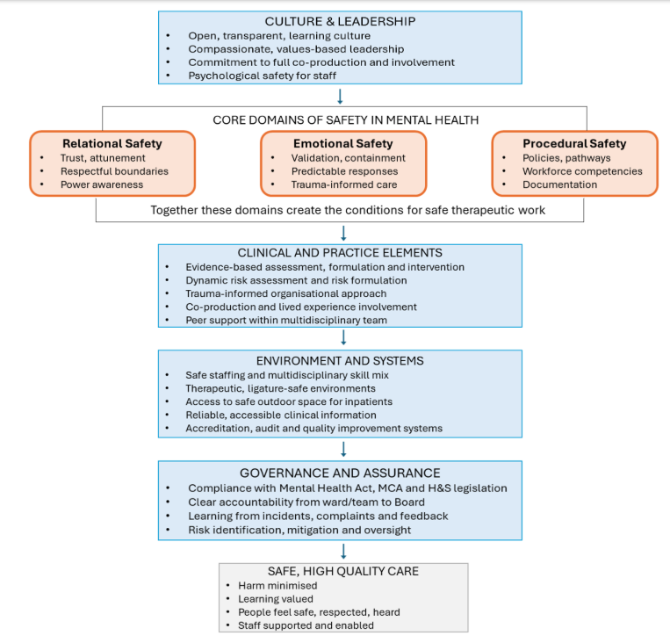

High quality, safe care depends on the wider organisational elements that shape daily practice. A safe culture is one in which staff feel supported, able to speak up, and confident that concerns will be heard without fear of blame. Compassionate, values-based leadership at all levels—from frontline teams to the Board—is essential in modelling openness, listening to diverse perspectives, and ensuring that learning informs decision-making.

The three safety domains; relational, emotional and procedural are interdependent and fundamental to how mental health care and services should be considered:

- relational safety provides the connection that enables engagement;
- emotional safety provides the capacity for therapeutic work;
- procedural safety provides the framework within which care is delivered.

Weakness in any domain compromises overall safety and increases the risk of harm, disengagement and poor outcomes. For the Committee, assurance must therefore extend beyond compliance with procedures to include culture, practice and lived experience.

Relational safety is the extent to which service users, carers and staff feel safe with one another. This form of safety is created through the quality of interpersonal connection. Trust, communication, clear boundaries, and awareness of power imbalances all contribute to a therapeutic environment in which people feel respected and able to engage. Relational safety is fundamental to engagement, therapeutic alliance and recovery; without it, procedural measures alone cannot create a safe environment.

Emotional safety refers to the internal sense that one’s feelings can be expressed, explored and regulated without fear of judgement, dismissal or escalation. Emotional safety is strengthened when staff respond predictably and calmly to distress, provide containment for strong emotions, and respect individual coping strategies. This is central to trauma-informed care, which recognises the prevalence and impact of trauma and seeks to avoid re-traumatisation. Emotional safety is essential for therapeutic progress and for staff wellbeing, enabling openness and reducing the likelihood of escalation.

Procedural safety underpins these relational and emotional dimensions and encompasses the formal systems, policies and processes that protect people from harm and ensure consistent, lawful and evidence-based practice. Clear safeguarding pathways, competent and supervised staff, transparent decision-making, reliable application of standards and effective mechanisms for reporting and learning all contribute to a safe and accountable system. Procedural safety provides the structural assurance required for safe care delivery and organisational governance.

Safe clinical practice is grounded in evidence-based assessment, formulation, treatment and intervention. Dynamic assessment recognises that risk fluctuates and must be reviewed frequently, while risk formulation provides a shared understanding of why risks exist and how it can be mitigated. Trauma-informed approaches ensure that services promote psychological, emotional and physical safety. Central to all of this is the involvement of people receiving care and those who support them. Co-production and peer support strengthen safety by ensuring that services reflect what people need to feel safe, respected and involved.

Safe staffing requires the right number of staff with the right skills, values and supervision, supported by a multidisciplinary skill mix that reflects the complexity of mental health care. Psychologists, Allied Health Professionals and Social Care Practitioners each contribute essential expertise.

Safe, therapeutic environments—whether inpatient wards, clinics or community spaces—must minimise environmental and psychological risks, including ligature risks, observation challenges and access to safe outdoor space for detained patients. Regular environmental risk assessments and adherence to therapeutic design principles are essential.

Reliable, accessible information underpins safe care at every level. Clinicians require accurate, up-to-date individual information to support assessment and decision-making, while aggregated data is essential for quality improvement, service planning, performance management and Board assurance. Accreditation frameworks, such as those provided by the Royal College of Psychiatrists, support consistent standards and external validation.

Strong governance and assurance processes underpins all these elements. Governance ensures compliance with legislation—including the Mental Health Act, Mental Capacity Act, Safeguarding of Children and Adults and Health and Safety requirements—and provides clear lines of accountability from frontline services to the Board. It also ensures that learning from incidents, complaints, audits and patient feedback is embedded and used to drive continuous improvement.

Together, these components create a system in which harm is minimised, learning is valued, people receive safe, high-quality care, and staff are supported and enabled.

It is important to recognise the constant challenge that services, teams and individual clinicians face balancing the management of risks, least restrictive practice and the wider society views, whilst impacting people’s rights and dignity to a certain extent whilst trying to eliminate harm and risk.

  - Co-production, Lived Experience, and the Reduction of Harm in Mental Health Care
High-quality, safe mental health care is built on partnership. Involving people who use services—and, where appropriate, their families and other carers—as active participants in their own care is essential to achieving safe, effective, and meaningful support.

Engagement transforms care, making it more personalised and responsive. Individuals bring insight into what helps, what harms, and what matters most to them. They can identify early warning signs, articulate triggers, and describe strategies that support their wellbeing. When these insights are integrated into assessment, care planning, and decision-making, care becomes more effective. Evidence consistently shows that meaningful involvement improves understanding, acceptance, and adherence to treatment plans. A sense of ownership and clarity strengthens engagement, reduces crises, and leads to better clinical and personal outcomes. Involvement is therefore not only a matter of rights and respect; it is a proven contributor to safer, more effective care.

Including families and other carers adds further depth and continuity. Families often hold contextual knowledge about patterns, routines, and relational dynamics that can support recovery. Their involvement can strengthen safety planning, reinforce protective factors, and help bridge transitions between inpatient, community, and home settings. When included appropriately, families become partners in creating stability and reducing the likelihood of crisis or harm.

In this way, involving people who use services and their families is not simply good practice; it is a core component of safe, high-quality mental health care. It strengthens protective factors, improves adherence to treatment, and supports better outcomes across the whole care journey.

Co-production at a system level further reduces harm by recognising that people who use services—and those who support them—are essential partners in planning, monitoring, and assuring safe, high-quality care. Their insights must be central to designing, delivering, and reviewing services. People who use services often identify risks long before they appear in formal systems. They notice subtle cultural shifts, communication gaps, environmental triggers, and practices that feel unsafe or coercive. When these perspectives inform planning and day-to-day decision-making, services become more attuned to what people need to feel safe, respected, and supported. This grounds safety in real-world experience rather than professional assumptions, directly reducing the likelihood of harm.

Co-production also enhances the overall safety, quality, and reliability of services. When people with lived experience contribute to designing care models, reviewing incidents, shaping training and setting priorities, they challenge assumptions that can become embedded in professional and organisational cultures.

For these reasons, co-production is not simply an optional enhancement to harm-reduction efforts; it is a core requirement. It ensures that mental health care and services are shaped by those who understand their risks and possibilities directly. Delivering this consistently requires organisations to act as accountable, learning-oriented systems, responsive to feedback and committed to improvement.

Patient Risk of Harm in Mental Health
Mental health professionals and services are trained to recognise and respond to a broad range of risks that are specific to mental health care which extend beyond traditional clinical or physical-health risk domains. These risks arise from the complex interaction between a person’s mental state, environment, social circumstances, and the care context, and they require a dynamic, formulation-led approach to ensure safe, least-restrictive, and recovery-focused practice.

The key mental health-specific risks include:
- Self-harm and suicide
- Self-neglect and vulnerability
- Violence and aggression
- Risks associated with restraint and other restrictive practices
- Medication-related risks and physical health deterioration
- Substance use and dual diagnosis
- Safeguarding concerns (adults and children)
- Absconding or going missing
- Environmental and ligature risks
- Exploitation by others
- Disengagement or non-engagement with services
- Risks associated with transitions between services.

Mental Health professionals are skilled in relational, emotional and procedural safety and in working in multi‑disciplinary teams in partnership with people who need services, the people who care for them and other partners, to create recovery‑focused care and treatment plans which identify and mitigate these risks. They have expertise in risk and safety management.

Table 2 outlines the core Mental Health risk domains and harm-prevention actions.

Table 2
Risk Domain | Key Actions to Reduce and Prevent Harm
Self-harm and suicide | Robust risk-formulation and safety planning; early identification of distress; compassionate engagement; timely escalation; safe environments; multidisciplinary review of concerns; involvement of the person and carers in what helps them feel safe.
Self-neglect and vulnerability | Regular assessment of ability to meet basic needs; proactive outreach; coordinated multi-agency support; clear care plans addressing nutrition, hydration, medication, and daily living; monitoring of deterioration.
Violence and aggression | Trauma-informed de-escalation training; early recognition of triggers; structured care planning; safe staffing levels; post-incident learning; environments that reduce overstimulation and frustration.
Risks associated with restraint and restrictive practices | Prioritising prevention and de-escalation; ensuring restrictive interventions are last-resort, proportionate, and time-limited; staff competency training; continuous monitoring; governance oversight of incidents and themes.
Medication-related risks and physical-health deterioration | Regular medication review; monitoring for side-effects; physical-health screening; clear communication of changes; ensuring access to physical-health interventions; multidisciplinary oversight.
Substance use and dual diagnosis | Integrated mental-health and substance-use care; harm-reduction approaches; relapse-prevention planning; coordinated multi-agency working; early identification of withdrawal or intoxication risks.
Safeguarding concerns (adults and children) | Routine enquiry; clear referral pathways; staff training; timely multi-agency information-sharing; safeguarding supervision; involvement of carers and statutory partners.
Absconding or going missing | Individualised risk assessment; supportive engagement; meaningful activities; safe observation practice; clear protocols for missing-person response; learning from patterns and triggers.
Environmental and ligature risks | Regular environmental audits; timely mitigation of identified risks; capital planning for high-risk areas; staff awareness of environmental hazards; independent validation through walkarounds.
Exploitation by others | Routine screening for coercion or exploitation; multi-agency safeguarding; support to build protective networks; trauma-informed engagement; monitoring of financial or social vulnerability.
Disengagement or non-engagement with services | Proactive follow-up; flexible appointment options; assertive outreach; relational continuity; early identification of barriers to engagement; collaborative care planning.

As part of its ongoing work to improve safety, implement the evidence base and to embed learning from untoward incidents, the MHLD Service Group implemented a new Safety Planning Framework in August 2025. The Framework details the safety and risk management pathway for the delivery of care to patients in services within the Service Group. It details screening, assessment and management of risk and safety and is in line with the current evidence base and NICE recommended guidance as well as good practice in NHS England and other Health Boards in Wales and that are recommended by NHS Performance and Improvement.

The Framework is applicable to all divisions within MHLD and they are in the process of embedding it and seeking to ensure that all registrants are trained in the model. The policy is a more away from the traditional stratification and scoring of risk to a more formulation driven approach including the Wales Applied Risk Research Network (WARRN) formulation tool at its heart.

WARRN is a trauma‑informed, formulation‑driven approach to risk. It moves away from outdated “predictive” risk tools and instead supports:

- Understanding of a person’s context
- Collaborative planning
- Reduced re‑traumatisation
- More consistent practice across services

The Safety Planning Framework is due for review by MHLD Policy group in June 2026 and as such, the current Head of Psychology and adult mental health partners are in the process of gleaning feedback on its utility to hone the framework over time.

  - Equality, Diversity and Inclusion (EDI) Risks of Harm
There are significant risks of harm arising from inequity, discrimination and bias within Mental Health and Learning Disability services. These risks affect both patients and staff and must be explicitly recognised, as they directly influence safety, access, experience and outcomes. EDI‑related risks are not peripheral; they are core determinants of harm and consideration of risk.

Risks of Harm for Patients
- Inequitable access to services
Patients from minority ethnic backgrounds, women, LGBTQ+ communities, people with disabilities and those experiencing socioeconomic disadvantage may face barriers to timely assessment, treatment and crisis support. Delays increase the risk of deterioration and avoidable harm.

- Discrimination and inequity experienced by people with mental health diagnoses
People with mental health conditions frequently experience stigma, reduced parity of esteem and discriminatory attitudes across the wider health and care system. This can result in their concerns being minimised, their symptoms being dismissed, and their needs not being taken seriously — all of which increase the risk of harm.

- Diagnostic overshadowing and bias impacting physical health
Patients with serious mental health problems are at high risk of diagnostic overshadowing, where physical symptoms are misattributed to their mental health condition. This can lead to delayed or missed diagnosis of serious physical illness, inadequate investigation, and reduced access to appropriate treatment. Given the significantly reduced life expectancy for people with SMI, largely driven by preventable physical health conditions, this represents a major and ongoing risk of harm that requires explicit Committee attention.

- Disproportionate use of restrictive practices
National evidence shows higher rates of restraint, seclusion and compulsory detention among some ethnic minority groups. Without active monitoring and mitigation, these patterns may persist locally and contribute to trauma, mistrust and harm. Of particular note is the risk of prone restraint which, if not managed safely, carries a risk of fatality.

- Cultural and communication barriers
Lack of culturally competent care, limited access to interpreters and insufficient understanding of cultural norms can lead to misinterpretation of risk, inappropriate care plans and missed opportunities for early intervention.

- Bias affecting people with learning disabilities and autism
Patients with learning disabilities, autism or physical health conditions may have their mental health symptoms misattributed to learning disability or neurodiversity, increasing the risk of unrecognised deterioration and poorer outcomes.

Why These Risks Matter for the Committee
EDI‑related risks are safety risks. They influence:
- who receives care
- how care is delivered
- how safe patients feel
- how safe staff feel
- whether harm is recognised and prevented
- whether learning is shared and acted upon

These risks require clear visibility, active monitoring and informed scrutiny. They will also need to be reflected in the developing Quality and Safety Dashboard discussed later in this paper to ensure inequity is identified early and addressed systematically.

  - Other Organisational Access and Capacity Risks of Harm
There are a number of organisational risks of harm caused by delay or inadequate care pathways, including:

Delays in treatment and care – Waiting for mental health care increases the risk of clinical deterioration, crisis presentations and use of emergency services. Waiting times should be treated as safety and quality metrics.

Inappropriate out-of-area placements – Out-of-area placements disrupt continuity of care and break the relational safety that comes from being treated by teams who know the patient well. They isolate people from family, carers, and local support networks, which can worsen distress and delay recovery. There is strong evidence that this has a detrimental effect on patient outcomes.

Fractured care pathways – Historically, across Wales, services have been designed and funded in a piecemeal way. The consequence is that care pathways are fractured, leading to gaps in care and multiple hand-offs.

- GOVERNANCE AND RISK ISSUES

3.1 Mental Health and Learning Disability Service Group Risks
The SBUHB Mental Health and Learning Disability Service Group inevitably carries the most potential for mental health risks and harm in SBUHB. The Service Group risk register identifies risks to delivery of safe care. The Service Group Nurse Director has led the review of the risk register and it is regularly updated.

A summary of the current highest scoring risks within the Service Group is provided in the tables below. There are a total of 40 risks at a score of 16 and above, of which 15 hold a score of 20. These high-scoring risks are reviewed in the Service Group Senior Management Team monthly meeting and then presented in the Executive-led performance meetings.

Table 3: MHLD Service Group Risk Score of 20 at March 2026

Theme | Number
Environment, Estates and Infrastructure | 5
Workforce & OD | 3
Sustainable Services | 3
Governance & Assurance | 3
Patient Safety | 1
Total | 15

Table 4: MHLD Service Group Risk Score of 16 at March 2026

Theme | Number
Environment, Estates and Infrastructure | 7
Workforce & OD | 6
Sustainable Services | 5
Governance & Assurance | 3
Financial Management | 2
Patient Safety | 1
Compliance with legislation and Statutory/regulatory inspections | 1
Total | 25

Quality and Clinical Governance Capacity
The overview in this paper demonstrates the significant work needed to provide adequate governance and assurance. The Quality, Governance and Improvement capacity for the MHLD Service Group is limited and less than other service groups. In addition, historically, the corporate quality and governance teams have not been able to provide the equivalent support as they do other service groups. This creates a significant additional risk for the Health Board.

Gaps in this capacity were flagged to the Health Board in the reports from the External Examiner. They have also been flagged by the Service Group Triumvirate. The interim Medical Director, as Chair of the Quality and Safety Workstream of the Transformation Programme, has flagged this risk through the Programme Board and in Executive Team. The Executive of Nursing and Patient Experience has also identified this risk and asked her corporate team to provide additional temporary support. The current work programme, Organising for Success, is an opportunity to redress this capacity as a matter of urgency.

3.2 Strategic and Corporate Risk Registers
Review of the Corporate and Strategic Risk Registers indicates that there are several significant risks related to MH&LD services materially contribute to risks impacting the Health Board’s ability to deliver the following strategic objectives:

- Care is high quality, safe, efficient and delivers the best possible outcomes for people in partnerships.
- The Health Board is a great place to work where staff feel valued and work together towards a common goal.
- The delivery of care is supported by innovative digital solutions.

The four risks pertaining to MH&LD within the Corporate Risk Register include:
- Difficulties in recruitment of medical staff.
- Provision of an integrated health record and effective information sharing.
- CAMHS performance standards due to workforce deficits.
- Adolescent admissions to adult mental health wards (national issue).

The two risks pertaining to MH&LD within the Strategic Risk Register include:
- Organisation and resource to deliver the required transformation within Mental Health and Learning Disabilities Services.
- Maintenance of Estates across the Health Board, with specific reference to Adult Mental Health, Forensic Services and Learning Disabilities, with limited controls in place to manage the risks within MH&LD.

In addition to the above, following the review of all Service Group operational risk registers, the Director of Workforce and OD has proposed risks be escalated to the Corporate Risk Register around administrative and nursing staffing levels and the health and safety of staff due to estates issues or old equipment.

The importance of the Transformation Programme as a mitigation tool for the risks identified in Mental Health is contained in the Strategic Risk Register, but other issues are not as clearly stated. The Corporate and Strategic Risk Registers are currently being reviewed and updated by the Health Board and so there is an opportunity for the Committee to consider whether the level of risk of harm and other risks in Mental Health and Learning Disabilities Services are appropriately represented.

3.3 SBUHB Mental Health Transformation Programme
In early 2025, SBUHB commissioned an independent external review that identified a range of significant concerns and risks that compromised the quality and safety of services. To address these concerns and mitigate some of the risks, an organisation-wide Mental Health Transformation Programme was established, with five workstreams. Each of the workstreams addresses specific concerns and any aligned risks identified in the MHLD Service Group’s risk register.

The workstreams and concerns are summarised as follows:

- Quality and Safety – concerns about systems and processes for good quality governance and learning from events, particularly actions identified in coroners’ reports and Prevention of Future Death notices.
- Workforce – inadequate staffing establishments, over-reliance on temporary staffing, and insufficient multi-disciplinary input into treatment and care.
- Estates – inadequate and unsafe estate.
- Informatics – no adequate information system for record sharing or information collation and analysis.
- Service Redesign – a fractured service model not aligned with the evidence base or current guidance, exceptionally long waits for assessment and treatment, long lengths of stay, and high numbers of out-of-area inpatient placements.

The review identified that there was not a consistent culture of co-production and engagement, so an expectation was set that the workstreams should be underpinned by engagement, co-production and partnership working. Accountabilities were identified to ensure connection to the Regional Partnership Board (RPB).

The purpose of the Mental Health Transformation Programme is to mobilise SBUHB resources to enable safe, effective and modernised services that are supported by strong quality and safety processes to reduce harm, improve patient outcomes and provide a high-quality, evidence-based approach to care. The work is primarily focused on Adult Mental Health Services but, where appropriate, incorporates other Mental Health and Learning Disability services.

In January 2026, a Programme Board, chaired by the Chief Executive, was established to strengthen oversight and organisational leadership and ensure alignment with national strategies, regional programmes and organisational priorities. In addition, a formal communications, engagement and co-production programme was created to accelerate this area of work.

To ensure good governance, the Transformation workstreams report on progress against their agreed objectives to the Programme Board, which in turn formally reports to the Executive Team. It is an addition to the SBUHB ‘business as usual’ performance, finance and governance processes. Where appropriate, the groups also report through the executive operational and performance meetings and Health Board sub committees. These structures are currently being reviewed by the Director of Corporate Governance.

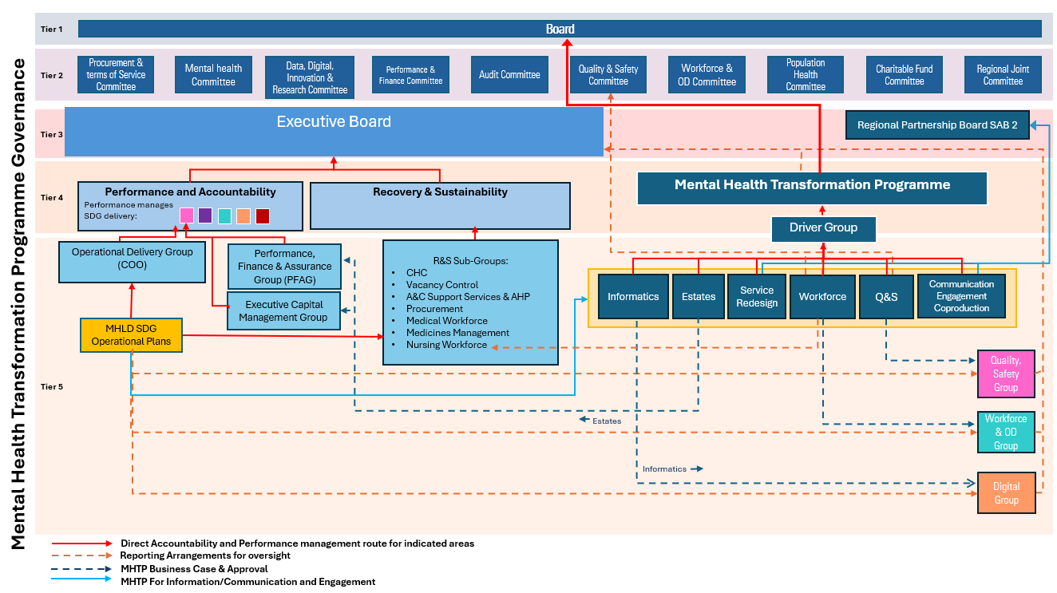

3.3.1 Transformation Workstreams Progress

Quality and Safety Workstream
The Quality and Safety Workstream has worked closely with the MHLD Service Group. The joint work focused on improving learning from incidents. This includes strengthening systems for reviewing adverse events, patient concerns, incidents, and mortality and morbidity reviews. This continues to ensure that resulting insights inform improvement actions and contribute to the reduction of harm and the provision of safe, effective and high-quality services.

A key area of work has been the need to enhance access to, and analysis of, data to deepen understanding of patient experience and clinical outcomes within Mental Health Services. The Service Group Medical Director, with other senior clinical and Q&S leads, has developed a suite of key metrics; these have then been reviewed and agreed by the Q&S workstream. The list now been passed to the Informatics team to facilitate the development of Quality and Safety Dashboard for Mental Health and Learning Disabilities. Appendix 1, included at the end of this document, contains a high-level summary of the dashboard.

The Quality and Safety Workstream has now completed most of the work against its first set of priorities. Its next set will include:

- Review of outcomes of implementation of MH Q&S dashboard.
- Physical Healthcare for people with serious mental health problems.
- Improvement in response times for serious incident and complaints responses and learning opportunities.
- Provide reports to the Committee on the forward plan set out at section 3.7.

Workforce Workstream
The Workforce Workstream has progressed the review of nurse staffing establishment and is continuing with reviews of other professions. This work is aimed at ensuring safe staffing levels, improving skill mix, strengthening multi-disciplinary input, and reducing reliance on temporary staffing.

Service Redesign Workstream
The Service Redesign Workstream is developing a new model of care aligned with the All-Wales Mental Health Strategy, including the Stepped Care Model. This includes redesigning pathways to facilitate open access, reduce waits, improving flow, reducing long lengths of stay, and addressing the high number of out-of-area placements.

Informatics Workstream
The Informatics Workstream is progressing the implementation of RIO, an Electronic Patient Record (EPR), and improving the availability of information and metrics to be utilised in a new Quality and Safety dashboard. This will support improved assurance, better data-driven decision-making, and enhanced visibility of clinical outcomes.

Estates Workstream
The Estates Workstream is addressing concerns relating to inadequate and unsafe estate, ligature risks, and poor therapeutic environments. Key areas of focus include immediate safety actions at Tawe Clinic, Cefn Coed Hospital, ligature risk reduction, options appraisal for interim ward moves, and planning for appropriate therapeutic environments aligned with national Quality Statements.

3.3.2 Mapping of Risks to Workstreams and Mitigations
To support the Committee in understanding how the Transformation Programme directly addresses the risks within Mental Health and Learning Disability care, the table below summarises the alignment between key risks, the relevant workstream, and the mitigations currently underway.

Table 5
Risk / Harm Area | Aligned Workstream | Mitigations Underway
Delays in assessment, treatment and care | Service Redesign | Developing a new model of care aligned with the All-Wales MH Strategy; redesigning pathways to reduce waits; improving flow; reducing long lengths of stay; reducing Out-of-Area placements
Fractured care pathways and multiple hand-offs | Service Redesign | Creating integrated, evidence-based pathways; strengthening MDT working; embedding co-production; aligning services with national Quality Statements.
Out-of-Area placements (OOA) | Service Redesign & Estates | Redesigning community and inpatient pathways; increasing local capacity; progressing estates options appraisal for interim ward moves; improving flow to reduce OOA reliance.
Unsafe or inadequate estate | Estates | Immediate safety actions at Tawe Clinic and Cefn Coed; ligature risk reduction; options appraisal for interim ward moves; planning for modernised therapeutic environments.
Inadequate staffing levels and skill mix | Workforce | Nurse staffing review completed; reviews of other professions underway; strengthening MDT input; reducing reliance on temporary staffing.
Weaknesses in governance, learning and quality systems | Quality & Safety | Development of core Q&S metrics; creation of a Q&S dashboard; strengthened incident and concerns processes; peer review for complex cases; improved mortality review processes; new SOP for PFDs; development of QMS using NHS Wales P&I maturity matrix.
Backlogs in incidents, complaints and concerns | Quality & Safety | Process review by Director of Nursing; peer review for complex cases; temporary additional capacity allocated by Executive Director of Nursing & Patient Experience; oversight through Programme Board.
Gaps in risk register processes and risk management | Quality & Safety | Review of SG risk register; strengthened processes; oversight through Q&S workstream; alignment with Corporate and Strategic Risk Register review.
Inconsistent co-production and engagement | All Workstreams (cross-cutting) | New communications, engagement and co-production programme; expectation set for all workstreams; links to Regional Partnership Board.
Lack of reliable information systems and data for assurance | Informatics | Implementation of EPR; development of Q&S dashboard; improved data collation and analysis; alignment with Q&S metrics.

  - Development of the Mental Health Quality and Safety Dashboard
As described briefly earlier, in order for the Committee, services, clinical teams and individual staff to record, share, collate and utilise patient information, draft Mental Health Quality and Safety (Q&S) Dashboard has been developed, and the final version will be available for the next Committee meeting. The dashboard brings together the core metrics agreed by clinicians, the Quality and Safety Workstream and the Mental Health and Learning Disability Service Group. These metrics have been informed by best practice and national requirements, ensuring alignment with regulatory expectations and the wider quality framework for mental health services. Each metric is supported by a clear description, the clinical or operational rationale for inclusion, and the agreed data source.

The dashboard is intended to strengthen visibility of quality and safety performance across key domains, including patient safety, access and flow, workforce, environment and estate, clinical effectiveness, and patient and carer experience. It will support improved triangulation of data, earlier identification of deterioration, and more consistent reporting to the Programme Board, Executive Team and Quality and Safety Committee.

As data flows mature and reporting becomes more automated, further refinement of the dashboard is expected. Committee members are, therefore, asked to review the draft dashboard and consider whether there are additional measures, indicators or areas of focus they wish to see included to enhance oversight of risk, quality and patient outcomes. Feedback will inform the next iteration of the dashboard and ensure it reflects the Committee’s assurance needs.

3.5 Key Lines of Enquiry (KLOE) to Support Committee Scrutiny
To strengthen the Committee’s ability to interpret the information presented in this report and in the developing Mental Health Quality and Safety Dashboard, a set of Key Lines of Enquiry (KLOE) are included for consideration at Appendix 2, at the end of this document. These KLOE provide a structured framework to support focused, consistent and proportionate scrutiny of quality and safety across Mental Health and Learning Disability services.

They are intended to help Committee members triangulate data, narrative and lived experience, and to identify areas where assurance is improving, limited or requires further attention.

The KLOE are grouped into the following domains:

Patient Safety
- What do incident trends indicate about emerging risks or deterioration
- Is there evidence of learning from incidents, concerns and mortality reviews
- Are restrictive practices reducing and aligned with national guidance
- Are there areas where harm is increasing or not reducing as expected

Access, Flow and Capacity
- Are waiting times improving, stable or deteriorating
- What is driving long lengths of stay, and are actions having impact
- Are out-of-area placements reducing, and what barriers remain

Workforce
- Are staffing levels safe and sustainable
- Is reliance on temporary staffing reducing
- Is MDT input improving across pathways
- Are there hotspots where workforce risk remains high

Environment and Estate
- Are ligature risks being assessed and addressed at pace
- Are environmental and care safety actions on track
- Are there areas where estate constraints continue to compromise safety

Clinical Effectiveness
- Are care plans, risk formulations and physical health checks being completed reliably
- Is there evidence of improved consistency and audit in clinical practice
- Are outcomes improving in line with the new model of care

Patient and Carer Experience
- What themes are emerging from concerns, compliments and feedback
- Are there signals of deteriorating experience or unmet need
- How is lived experience informing improvement

Governance and Assurance
- Does the dashboard provide sufficient visibility of risk
- Are data quality and reporting improving
- Are risks being escalated and mitigated appropriately
- Is the Transformation Programme delivering measurable impact

These KLOE will be used to support Committee discussion and ensure that scrutiny remains focused on the areas of greatest risk, impact and opportunity for improvement. They will also guide the interpretation of the dashboard when it is presented at the next meeting.

3.6 Remaining Risks, Gaps and Dependencies
Although significant work is underway across the Mental Health and Learning Disability (MHLD) services and Transformation Programme, several risks of harm cannot yet be fully mitigated. These areas require continued visibility and informed scrutiny, as they represent ongoing vulnerabilities for patients, carers and staff.

Risks of Harm Not Yet Fully Addressed

- Environmental safety constraints
Ligature risks, blind spots and outdated ward layouts continue to pose safety challenges. Some improvements are dependent on capital investment and cannot be resolved at pace.

- Workforce fragility
High vacancy rates in some professions, reliance on temporary staffing and gaps in MDT skill‑mix continue to increase the risk of inconsistent care, delayed recognition of deterioration and reduced therapeutic engagement.

- Access and flow pressures
Long waits, delayed discharges and out‑of‑area placements remain significant contributors to avoidable harm, particularly for people in crisis or with complex needs.

- Variation in clinical practice
Inconsistent approaches to risk formulation, care planning, physical health monitoring and therapeutic intervention continue to create variation in safety and outcomes.

- Data quality and insight limitations
Several key metrics rely on manual data collection or incomplete data flows, limiting the ability to identify emerging risks early or to triangulate information reliably.

- System‑Level Dependencies
Some risks cannot be mitigated by the Service Group alone and require wider organisational or system action:

  - Capital funding for essential estate improvements.
  - Digital infrastructure to support automated, reliable reporting.
  - National workforce shortages affecting recruitment and retention.
  - Interdependencies with local authority and third‑sector partners. for crisis response and discharge pathways.

Why These Gaps Matter
These gaps represent areas where the risk of harm remains elevated. They also shape the Committee’s ability to interpret the dashboard and narrative reports. Continued oversight is required to ensure that mitigations progress, barriers are escalated, and risks are not normalised.

3.7 Next Steps and Forward Plan
The following actions will be taken forward to strengthen visibility of harm, improve safety, and support the Committee’s ongoing scrutiny.

- Dashboard Development
  - Finalise the draft Mental Health Quality and Safety Dashboard for presentation at the next Committee meeting.
  - Improve data flows and automate reporting where possible to enhance reliability and reduce manual burden.

- Strengthening Risk Insight
  - Continue to refine the risk landscape, ensuring that risks of harm — not performance indicators — remain the primary organising principle.
  - Develop clearer triangulation between incidents, complaints, workforce data, physical health outcomes and lived experience feedback.
  - Enhance visibility of diagnostic overshadowing and physical health inequalities within routine reporting.

- Embedding Consistent Clinical Practice
  - Support teams to embed consistent approaches to risk formulation, care planning and physical health monitoring.
  - Strengthen MDT functioning and supervision structures to reduce variation and improve decision‑making.

- Workforce and Environment
  - Progress business case to address nurse staffing, retention and skill‑mix initiatives.
  - Continue to prioritise environmental safety actions and escalate capital requirements where risks cannot be mitigated locally.

- Committee Engagement
  - Use the KLOE to structure Committee discussion and ensure scrutiny is focused on areas of greatest risk.
  - Provide updates on progress against the risks and dependencies outlined in Section 3.

- FINANCIAL IMPLICATIONS
There are no immediate financial implications associated with this report although the degree of improvements and transformation required will inevitably require capital and revenue investment and repurposing of existing resources.

- RECOMMENDATIONS
Members are asked to:

- ACKNOWLEDGE and CONSIDER the risks of harm outlined, including those related to equality, diversity and inclusion, environmental safety, workforce fragility, access and flow, clinical variation and data limitations.

- RECEIVE the update on the Transformation Programme and APPROVE the update on the Quality and Safety Workstream

- REVIEW the developing Mental Health Quality and Safety Dashboard and CONSIDER whether additional measures or areas of focus are required to strengthen visibility of harm.

- APPROVE the forward plan and the commitment that the Q&S workstream report will provide regular updates to this Committee.

- REVIEW the Key Lines of Enquiry (KLOE) to guide scrutiny and ensure discussion remains focused on areas of highest risk.

Appendix 1: High Level Summary of Quality and Safety Dashboard

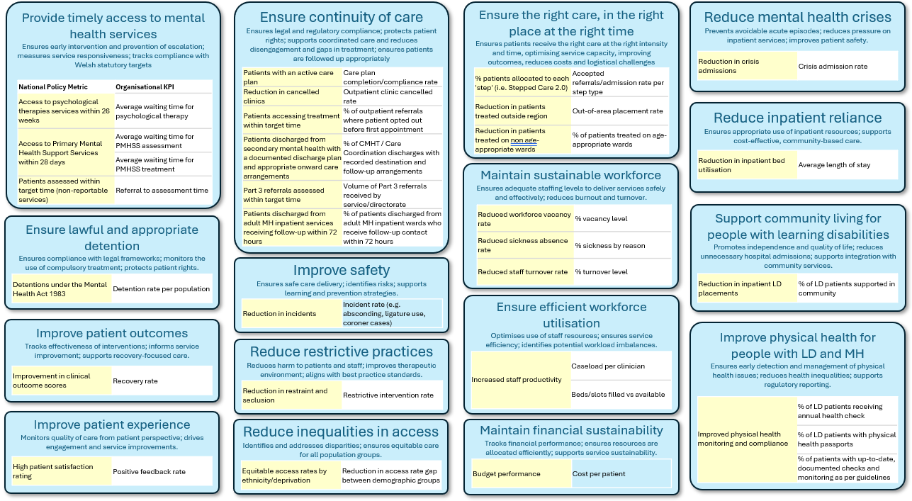

Appendix 2: KLOE

Suggested Key Lines of Enquiry
These Key Lines of Enquiry could support Independent Members to provide effective scrutiny, challenge, and assurance across the key domains of mental health quality, safety, performance, and compliance. They reflect the governance expectations of the NHS Wales Strategy, HIW, the Mental Health (Wales) Measure, the Mental Health Quality Statement and broader regulatory standards. It is not an exhaustive list rather it is intended as a prompt to aide scrutiny and assurance.

1. Strategic Alignment and Purpose
- Is there a clear mental health strategy aligned to population need, Welsh Government policy, and Board priorities?
- Are service models consistent with recovery-oriented, trauma-informed, and least restrictive principles?
- Does the Board/Committee receive regular updates on progress against the mental health strategy and the Mental Health Measure?
- Are investment decisions aligned with long-term transformation rather than short-term operational pressure?

2. Quality and Safety of Care

2.1 Clinical Quality
- Are clinical outcomes (PROMs, HoNOS, recovery measures) routinely reported and understood?
- Is there evidence of learning from incidents, complaints, mortality reviews, and national learning frameworks?
- Are risk assessments and care plans consistently high quality, person-centred, and compliant with the Mental Health Measure?
- Are transitions of care (admission, discharge, crisis pathways) safe and well-coordinated?

2.2 Safety
- Are restrictive practices monitored, reduced, and benchmarked across NHS Wales?
- Are safeguarding responsibilities (adult and child) clearly discharged?
- Are medication safety, rapid tranquillisation, and physical health monitoring robust?
- Are there clear themes emerging from serious incidents, and are actions demonstrably completed?

3. Patient Experience and Rights
- Do patient and carer voices influence service design, governance, and improvement?
- Are advocacy services accessible and effective, including IMHA/IMCA?
- Are complaints themes understood and acted upon?
- Are equality and inclusion metrics (e.g., disproportionate detention) monitored and addressed?
- Are MHA/MCA duties fulfilled, including consent, capacity, and least restrictive practice?
- Is the Board/Committee assured that the Mental Health Measure Part 1 and Part 2 duties are being met?

4. Workforce and Culture
- Are staffing levels safe, sustainable, and aligned with safer staffing models?
- Is there a clear understanding of vacancy rates, turnover, sickness, and agency use?
- Are staff trained in essential competencies (MHA/MCA, PMVA, safeguarding, physical health)?
- Does the Board/Committee receive assurance on staff wellbeing, psychological safety, and culture?
- Are Freedom to Speak Up / Raising Concerns themes acted upon and fed back to staff?

5. Physical Environment and Estate
- Are ligature risk assessments current, with clear mitigation and action plans?
- Are wards and community bases safe, with clear lines of sight, therapeutic and compliant with national standards?
- Is there adequate access to outdoor space, activity rooms, and private areas?
- Are gender-appropriate facilities and reasonable adjustments in place?
- Is capital planning aligned with clinical need and backlog maintenance addressed?

6. Demand, Capacity, Flow, and Access
- Are waiting times for community services, psychological therapies, CAMHS, and crisis care monitored and improving?
- Is bed occupancy safe, and are out-of-area placements minimised?
- Are delayed discharges and length of stay understood and addressed?
- Is there a clear plan for managing surges in demand?
- Are community alternatives to admission (crisis teams, home treatment, crisis cafés) effective?

7. Governance, Compliance, and Assurance
- Are statutory duties under the Mental Health Act, Mental Capacity Act, Mental Health (Wales) Measure, safeguarding, and Duty of Candour met?
- Are HIW inspection findings acted upon with clear trajectories?
- Are quality impact assessments (QIAs) used for cost improvement plans?
- Is there a clear line of sight from Board to ward, including triangulated data?
- Are internal audit findings on mental health acted upon?

8. Digital, Data, and Information Governance
- Are clinical records accurate, timely, and complete?
- Are digital tools supporting care rather than creating burden?
- Is cybersecurity robust and regularly tested?
- Are data quality issues identified and resolved promptly?
- Is data analysis and information used to improve care and inform decisions?
- Is interoperability with partners (primary care, social care, voluntary sector) improving?

9. Financial Sustainability
- Are mental health budgets protected and aligned with strategic priorities?
- Are cost improvement plans safe, deliverable, and quality-assured?
- Is investment in workforce, estate, and digital infrastructure adequate?
- Are financial pressures impacting quality or safety?

10. Partnership Working and System Integration
- Are relationships with local authorities, third sector partners, and Regional Partnership Boards effective?
- Are joint priorities (housing, crisis alternatives, safeguarding, transitions) progressing?
- Is there evidence of shared learning and integrated planning?
- Are inequalities addressed through system-wide action?

Independent Member Assurance Questions (Quick Reference)
An Independent Member should be able to ask and receive clear answers to:
- How do we know people are safe today?
- What are the top three risks in mental health services, and what is being done about them?
- What does the patient voice tell us, and how has it changed our practice?
- Where are we non-compliant with statutory duties, and what is the plan?
- What keeps the clinical leaders awake at night?
- How do we triangulate data to assure ourselves of quality?
- How do we know our culture supports safe, compassionate care?

Governance and Assurance
Link to Enabling Objectives  (please choose) | Supporting better health and wellbeing by actively promoting and empowering people to live well in resilient communities
Link to Enabling Objectives  (please choose) | Partnerships for Improving Health and Wellbeing |  | ☒
Link to Enabling Objectives  (please choose) | Co-Production and Health Literacy |  | ☒
Link to Enabling Objectives  (please choose) | Digitally Enabled Health and Wellbeing |  | ☒
Link to Enabling Objectives  (please choose) | Deliver better care through excellent health and care services achieving the outcomes that matter most to people
Link to Enabling Objectives  (please choose) | Best Value Outcomes and High Quality Care |  | ☒
Link to Enabling Objectives  (please choose) | Partnerships for Care |  | ☒
Link to Enabling Objectives  (please choose) | Excellent Staff |  | ☒
Link to Enabling Objectives  (please choose) | Digitally Enabled Care |  | ☒
Link to Enabling Objectives  (please choose) | Outstanding Research, Innovation, Education and Learning |  | ☒
Health and Care Standards
(please choose) | Staying Healthy |  | ☒
(please choose) | Safe Care |  | ☒
(please choose) | Effective Care |  | ☒
(please choose) | Dignified Care |  | ☒
(please choose) | Timely Care |  | ☒
(please choose) | Individual Care |  | ☒
(please choose) | Staff and Resources |  | ☒
Quality, Safety and Patient Experience
The quality and safety workstream forms part of an overarching delivery plan to address the identified issues in mental health services and align to best practice to provide patients and service users with high quality care.
Financial Implications
There are no immediate financial implications associated with this report although the degree of improvements and transformation required will inevitably require capital and revenue investment and repurposing of existing resources.
Legal Implications (including equality and diversity assessment)
There are no legal implications associated with this report.
Staffing Implications
There are no staffing implications associated with this report.
Long Term Implications (including the impact of the Well-being of Future Generations (Wales) Act 2015)
The quality and safety workstream will support the implementation of the mental health transformation programme to develop sustainable and fit for purpose mental health services for the longer-term.
Report History |  | Standing agenda item
Appendices |  | Appendix 1: High Level Summary of Quality and Safety Dashboard  Appendix 2: KLOE  - A resource section can be found on admin control.

