Meeting Date | 23 April 2026 |  | Agenda Item |  |  | 4.3
Name of Meeting | Quality and Safety Committee
Report Title | Update on Stroke Performance
Report Author | Abi Landeg – Directorate Manager Medicine Specialties  Adel Davies-Pugh Associate Service Group Director
Report Sponsor | Neil Cooper – Assistant Director of Operations  Deb Lewis – Chief Operating Officer
Presented by | Peter Slade – Stroke Clinical Lead
Freedom of Information | Open
Purpose of the Report | This report provides the Committee with an update on the actions undertaken within the Morriston Medicine Specialities Division to enhance the quality and safety of care for stroke patients across Swansea Bay. It also outlines current performance against key indicators and updates the Board on several significant service developments that are currently in progress.
Key Issues | - Sustained 4-day reduction in Length of Stay on the Acute Stroke Unit (ASU), achieved despite continued growth in admission numbers.  - Ongoing increase in admissions and timely discharges from the ASU, reducing the need to outlie stroke patients to other wards  - Improved transfer processes, enabling more timely access to stroke-specific therapy.  - Consistent ability to maintain one ring-fenced bed on the Acute Stroke Unit, supporting timely flow and improved patient experience.  - Performance against Key Performance Indicator (KPI) metrics remains challenging and below expected targets; however, steady and positive progress continues to be made.  - Funding has not yet been secured to implement a 24/7 stroke consultant rota.  - High compliance maintained in key areas including thrombolysis rates, swallow assessments, and therapeutic assessments.  - Increasing Mechanical Thrombectomy access remains a key priority.  - CT Perfusion and MRI Perfusion pathways are now embedded, supporting improved diagnostic accuracy and patient selection for advanced stroke treatments
Specific Action Required  (please choose one only) | Information | Discussion |  | Assurance | Approval
Specific Action Required  (please choose one only) | ☒ | ☐ |  | ☒ | ☐
Recommendations | The committee is asked to:  - CONSIDER the content of the report and its continued improvement to the quality and safety of patients accessing the stroke pathway.

STROKE PERFORMANCE: QUALITY AND SAFETY IMPACT

- INTRODUCTION

The drive to deliver more timely, effective stroke care led to a significant enhancement of key performance indicators in October 2024. Since this time continued year-round pressures across acute hospitals, including Morriston, have made it challenging to deliver sustained improvements against these increased access targets. Despite these pressures, several successful stroke-specific service changes have led to measurable improvements in performance. These improvements have, in turn, strengthened the quality and safety of care provided to stroke patients within Swansea Bay.

- BACKGROUND

  - Improvements to the Stroke pathway

To strengthen the quality and safety of care provided to stroke patients within Swansea Bay several stroke specific changes were implemented by the Medicine Specialities Division in June 2025 that saw the introduction of:

- Twice weekly joint Multidisciplinary Team (MDT) board rounds between Morriston and Neath Port Talbot Hospital (NPTH).
- Introduction of 1 ring-fenced bed on the Acute Stroke Unit (ASU)
- The development of a joint stroke bed requirement list for Morriston and NPTH.
- Patients who require a bed in NPTH (Stroke specific or any medical bed) are now immediately listed daily during board round as ‘green’ or ‘amber’. Any patients listed as green are immediately ready for transfer and those patients who are amber will be ready following medical intervention. Identifying patients early on allows NPTH colleagues the ability to forward plan bed requirements.
- During board round, patients are listed against NPTH criteria reducing the requirement of each patient needing a TOCAL’s review before being listed.
As a result of the above 8 months post introduction, we have seen the below successful outcomes:
Successful Outcome 1 – Sustained 4-day reduction in Length of Stay on the Acute Stroke Unit (ASU), achieved despite continued growth in admission numbers
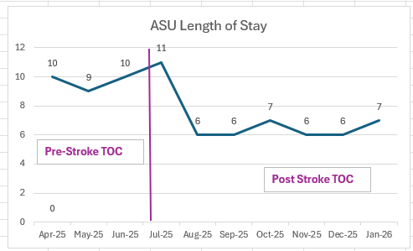

Successful Outcome 2 – Ongoing increase in admissions and timely discharges from the ASU, reducing the need to outlie stroke patients to other wards
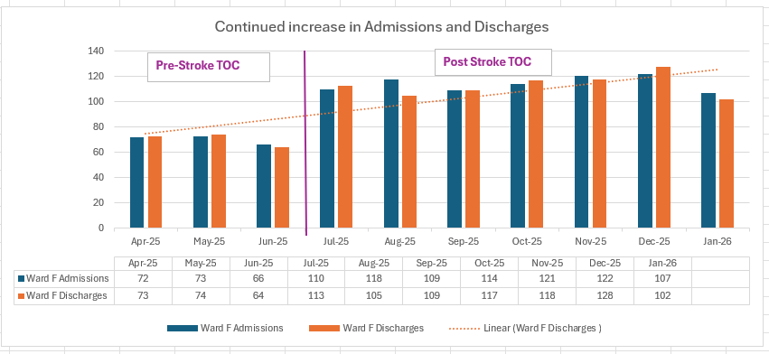

Successful Outcome 3 – Improved transfer processes, enabling more timely access to stroke-specific therapy
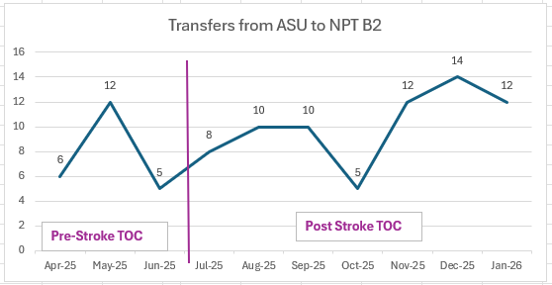

The above has improved quality and safety for Swansea Bay patients and provided:

- Faster, safer patient flow through the stroke pathway

- Less reliance on outlying patients on no-stroke wards which can increase safety risk
- Greater use of Early Supported Discharge who provide specialist stroke physiotherapy, Occupational Therapy support, Speech and language and nursing oversight

- Efficient movement to rehabilitation at NPTH
- Adherence to national timing standards
- Better use of the acute stroke unit and the skills of the workforce
- Reduced inpatient harm

  - Stroke Performance

The next section will outline the progress of each Stroke KPI at Swansea Bay UHB and will identify any immediate actions being put in place to improve compliance.

2.2.1 Key Performance Indicator 1: 4 Hour Admission to ASU (National Target 95%)
Performance against this KPI continues to improve month on month. In February, performance against the 4-hour admission target to the Acute Stroke Unit (ASU) was recorded at 34.4% compared with 13.4% in January 2025 (Appendix 1). Although this is still below the national target of 95% significant progress is being made and work continues to improve this further.

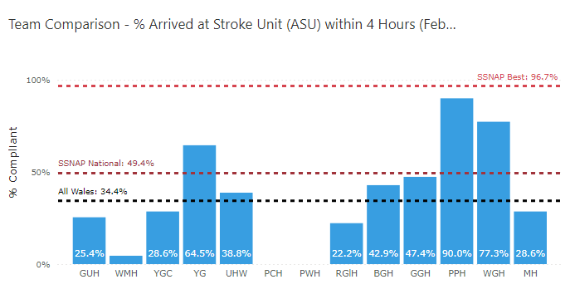

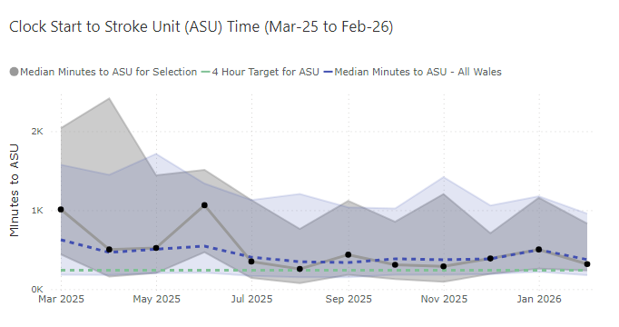

2.2.2 Key Performance Indicator 2: Thrombolysis rates – (National Target 20%)
Thrombolysis rates as of February 2026 was 16.3% against a national target of 20%. This is an area where Swansea Bay performs well in comparison with other centres.

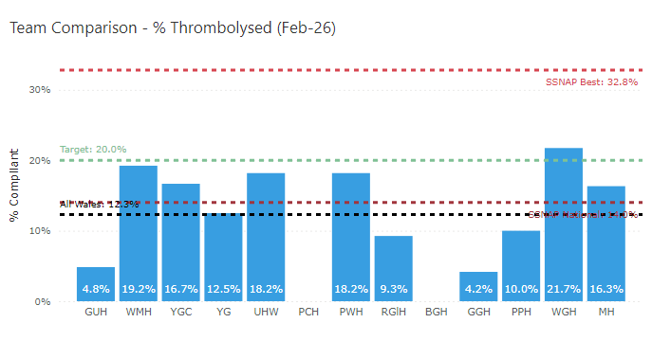

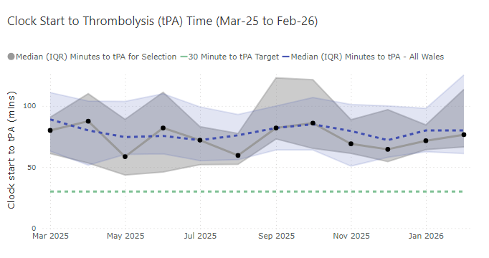

The expansion of the CT Perfusion service which now runs Monday – Friday, 09:00 – 17:00 has had a positive impact upon our Thrombolysis rate as seen above. However, we would like to further improve this by extending this provision out of hours (OOH) by implementing an OOH consultant stroke rota which would enable a stroke specialist consultant to interpret the clinical and radiological situation and determine eligibility for treatment. This would increase access to thrombolysis and thrombectomy for some patients who may benefit from these interventions and suffer less severe disability because of their stroke. We are unable to progress this further given the health board’s financial situation and the pull back of the consultant recruitment monies.

2.2.3 Key Performance Indicator 3: Thrombolysis door to needle time <30 minutes (National Target 95% of eligible patients)

0% of patients eligible for Thrombolysis received this within 30 minutes in February 2026. However, the median time from arrival to thrombolysis was 71 minutes which is comparable with other centres across Wales and is below the All Wales Median.
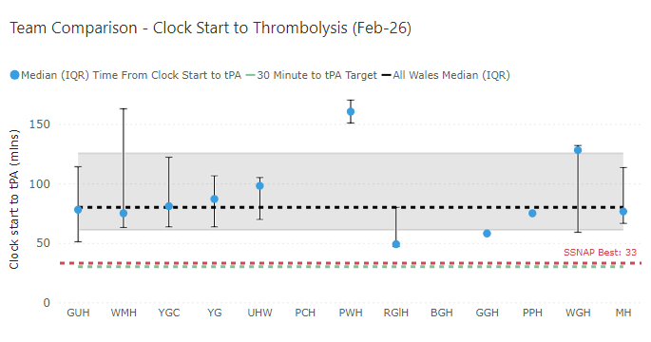

2.2.4 Key Performance Indicator 4: CT head 20 minutes (National Target - 95%)
Performance for CT head within 20 minutes for February 2026 was 24.5% compared with 4.8% in January 2025, a significant improvement. Compliance against this new KPI has positively increased and continues to increase. We now have the ability to hold 1 ring fenced bed on the ASU which has supported the increase in compliance of this KPI.

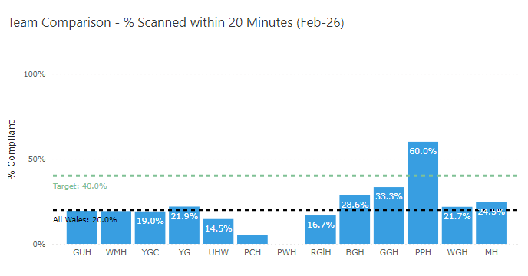
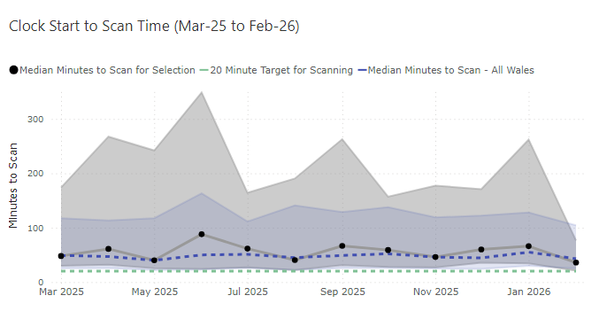

Overall median clock time to CT is reducing which should aid in increasing compliance against this target. One measure put in place is a Direct to CT pilot in conjunction with WAST. A successful direct to CT pilot took place back in 2024 and was very successful however this pilot relies upon the ability to ring-fence a number of beds on Ward F so that appropriate patients can be directly taken to the CT scanner and then on to the acute stroke unit, bypassing the Emergency Department, improving access to specialist care whilst reducing the impact on other acute areas.

2.2.5 Key Performance Indicator 5: Mechanical Thrombectomy – (National Target 10%)

Thrombectomy for February 2026 was 10.6% meeting the National Target of 10%, a first for Swansea Bay since 2024. This is significantly higher than the rate for other sites in Wales.

Thrombectomy is offered to SBUHB patients by an agreement in place with North Bristol NHS Trust and since July 2025 some patients are treated in Cardiff and Vale UHB. Although services have expanded hours, accepting patients from 6am to 10pm 7 days a week, centres in Wales still do not have access to 24/7 thrombectomy services.

All stroke admissions are reviewed at a weekly performance meeting so that it is ensured that all potential thrombectomy candidates are appropriately identified and referred for consideration of intervention, as well as identifying potential delays in treatment pathways.

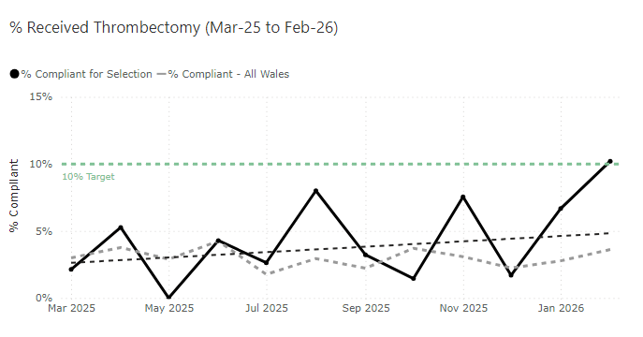
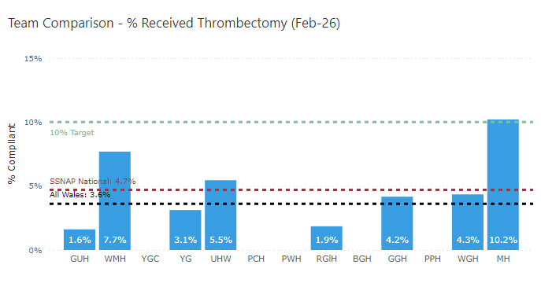

2.2.6 Key Performance Indicator 6: Swallow Test within 4 hours – (National
Target 95%)

89.8 % of patients received a swallow test within 4 hours in February 2026 against a national target of 95%. This is generally an area where we perform consistently well.

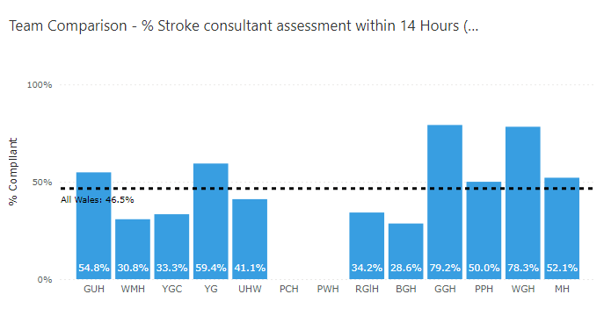

2.2.7 Key Performance Indicator 7: Consultant assessment within 14 hour – (National Target 95%)

Reporting against the new KPI, 52.10% of patients were reviewed in February 2026 by a consultant within 14 hours which remains average for us as a health board. As there is currently no out of hours stroke rota at present, this is unlikely to change significantly until this can be implemented.

4.8 Key Performance Indicator 8: Therapeutic Assessment - (National Target 95%).

Data highlights the current performance of therapy services for stroke patients against the national target:

- Physiotherapy (PT): 77.5% of patients were assessed within 24 hours.
- Occupational Therapy (OT): 75.6 % of patients were assessed within 24 hours
- Speech and Language Therapy (SLT): 89.7% of patients were assessed within 72 hours

* The national database does not include community data, therefore the below only includes acute data.

  - Service Developments

Pre-Hospital Triage Screening Pilot
A pilot commenced on 10th March 2025 which allows WAST crew members to contact the consultant stroke physician on call via Microsoft Teams to help confirm whether the patient being reviewed is having a suspected stroke and direct them to an appropriate pathway. This means that the stroke team will be available and waiting at the front door when the patient arrives via ambulance, enabling access to prompt, specialist care. This is an All-Wales pilot, being initiated by NHS Executive teams.

- Up to 26th March 2026, there have been 39 calls received within the current operating time of 9am to 5pm, Monday to Friday.
- 15 of these calls resulted in an eventual diagnosis of stroke, the other 24 assessments resulted in alternative final diagnoses.
- 23 patients were conveyed with an initial triage diagnosis of possible stroke. 15 patients were directed to the traditional ED pathway. 1 call resulted in an admission avoidance.
- There were no video triage calls that were initially triaged as an alternative diagnosis that received a final diagnosis of stroke.
- Of the 15 stroke patients, 5 received thrombolysis, 3 patients were transferred for thrombectomy and 1 patient received rapid blood pressure lowering for their intracerebral haemorrhage.
- Video triage calls lasted for a mean time of 4:26

CT Perfusion
To maximise the potential benefit from revascularisation treatments and the acute management of intracerebral haemorrhage, a corresponding increase in the availability of advanced imaging techniques is required, and all hyperacute stroke services should have timely access to brain imaging including CT or MR angiography and perfusion. This is featured in the 2023 National Stroke Guidelines.

Work has already taken place to improve the access to CT Perfusion however further conversations are taking place between Radiology and our Clinical Lead to look at improving access to this provision.

The use of advanced imaging such as CT perfusion and MRI in the acute setting, although limited to current specialist staffing availability (Monday to Friday, 9am to 5pm), has resulted in a high proportion of potentially eligible patients receiving appropriate imaging and subsequent treatments. The current percentage of wake up stroke receiving advanced imaging on first imaging visit is 22.5% (national average 22.6%). The current percentage of stroke patients with extended indications for thrombolysis receiving thrombolysis is 23.2% (national average 15.7%). Once specialist staffing levels have been appropriately increased there could be expansion of the hours of availability of these investigations. Based on a clinical audit of patients who would benefit from perfusion imaging, it is estimated that 24/7 access to this would lead to an additional 39 patients per year having access to thrombolysis which could significantly improve their outcome following a stroke.

Comprehensive Regional Stroke Centre (Crsc) Development

The South West Wales region covers the areas served by Swansea Bay University Health Board (SBUHB) and Hywel Dda University Health Board (HDUHB), which is the largest geographic region in Wales with currently 5 Acute Stroke Service admitting sites.
In March 2023, a Business Case was developed for Morriston Hospital to become a Comprehensive Regional Stroke Centre (CRSC) with an intake of patients from SBUHB and Carmarthenshire residents. However, the cost of establishing a CRSC were determined to be prohibitive at time and it was also acknowledged that both health boards needed to focus on and improve their services first before a regional model could be established. It was agreed that the health boards would meet periodically to maintain relationships, keep each other informed of developments within the service and share best practice. The South West Wales Regional Stroke Programme Managers has also been working with the National Stroke Programme to develop the programme to all worked to be completed Once for Wales.
Following the recent appointment of SBUHB Regional Stroke Programme Manager update below:

Stroke Standards:
The updated national Stroke Standards have been released and agreed, it is planned that they will be published and released in conjunction with updated Stroke quality statement towards end of the year. A comprehensive baseline and gap analysis is being undertaken across all Health Boards to assess current compliance and identify areas requiring targeted improvement. This work will inform regional priorities and support consistency in service delivery across the pathway.

Regional Stroke Service Implications:
Following the Hywel Dda University Health Board Clinical Services Plan consultation, the Regional Stroke Programme will consider the wider implications for acute stroke service configuration and access across Southwest Wales. This will form part of ongoing regional planning discussions.

Next Steps
- Quality Improvement Project - Following attendance at the Stroke Association Leadership Residential, there is an opportunity to work with the Stroke Association to undertake a quality improvement project. I would like to propose submitting a project on behalf of our region to support system-wide learning and improvement.

- PROMs and PREMs - Exploration of implementing Patient Reported Outcome Measures (PROMs) and Patient Reported Experience Measures (PREMs) to better understand the impact and quality of stroke care from the patient perspective.

- Regional MDT Network - Development of a regional multidisciplinary (MDT) network with regular touchpoints to facilitate shared learning, case discussions, and alignment of best practice across all sites.

- Identifying Service Pinch Points - Continued engagement with clinical teams to identify and address service pinch points, ensuring that emerging challenges are captured and inform regional planning and improvement activity.

Recruitment into Acute Stroke Services.

Recruitment into 2 consultants posts and several therapy posts were due to go to advert are currently on hold due to finances. Integrated Community Stroke Service development is in Health Board GMO’s for 2025/26 and this will result in a host of additional community posts If the business case being developed is agreed.

- GOVERNANCE AND RISK ISSUES

Progress has been made in the last 6 months in terms of addressing and improving our stroke related risks with the closure of several risks. Following the consistent positive work following the stroke specific tests of change, risk 4418 has been reduced to a risk score of 12 however still posing as a significant risk. The remaining risks below are being reviewed on weekly basis by the Directorate Manager and in partnership with the clinical lead where appropriate. Updates are provided at monthly divisional Quality and Safety meetings to ensure progress.

Risk ID | Title | Risk Level | Risk Handler
4418 (Previously 2901) | Inability to consistently maintain admission to the Acute Stroke Unit within the 4-hour KPI Target. | Significant Risk  Risk score - 12 | Abi Landeg
2147  (Previously 4415) | Potential significant harm due to lack of senior stroke medicine on-call rota | Significant Risk  Risk score - 12 | Abi Landeg

- FINANCIAL IMPLICATIONS

£1.5m expenditure plan over the next few years approved at management board in 2023. Funding previously agreed to and minuted in management board has not been forthcoming in 2024/25 which has hindered progress in this speciality.

- RECOMMENDATION

The committee is asked CONSIDER the content of the report and its continued improvement to the quality and safety of patients accessing the stroke pathway.

Governance and Assurance
Link to Enabling Objectives  (please choose) | Supporting better health and wellbeing by actively promoting and empowering people to live well in resilient communities
Link to Enabling Objectives  (please choose) | Partnerships for Improving Health and Wellbeing |  | ☐
Link to Enabling Objectives  (please choose) | Co-Production and Health Literacy |  | ☐
Link to Enabling Objectives  (please choose) | Digitally Enabled Health and Wellbeing |  | ☐
Link to Enabling Objectives  (please choose) | Deliver better care through excellent health and care services achieving the outcomes that matter most to people
Link to Enabling Objectives  (please choose) | Best Value Outcomes and High Quality Care |  | ☒
Link to Enabling Objectives  (please choose) | Partnerships for Care |  | ☐
Link to Enabling Objectives  (please choose) | Excellent Staff |  | ☐
Link to Enabling Objectives  (please choose) | Digitally Enabled Care |  | ☐
Link to Enabling Objectives  (please choose) | Outstanding Research, Innovation, Education and Learning |  | ☐
Health and Care Standards
(please choose) | Staying Healthy |  | ☒
(please choose) | Safe Care |  | ☒
(please choose) | Effective Care |  | ☒
(please choose) | Dignified Care |  | ☒
(please choose) | Timely Care |  | ☒
(please choose) | Individual Care |  | ☒
(please choose) | Staff and Resources |  | ☒
Quality, Safety and Patient Experience
To strengthen the quality and safety of care provided to stroke patients within Swansea Bay several stroke specific changes were implemented by the Medicine Specialities Division in June 2025 and has improved Quality, Safety and Patient experience:
- Faster, safer patient flow through the stroke pathway
- Less reliance on outlying patients on no-stroke wards which can increase safety risk
- Greater use of Early Supported Discharge who provide specialist stroke physiotherapy, Occupational Therapy support, Speech and language and nursing oversight
- Efficient movement to rehabilitation at NPTH
- Adherence to national timing standards
- Better use of the acute stroke unit and the skills of the workforce
- Reduced inpatient harm

There is further work to be done, and the division will continue to make improvements to the stroke pathway.
Financial Implications
£1.5m expenditure plan over the next few years approved at management board in 2023. Funding previously agreed to and minuted in management board has not been forthcoming in 2024/25 therefore the two further consultant posts that need to be recruited to may not be able to proceed.
Legal Implications (including equality and diversity assessment)
None to Note.

Staffing Implications
The inability to introduce a core service requirement (stroke consultant on call rota)

Long Term Implications (including the impact of the Well-being of Future Generations (Wales) Act 2015)
Briefly identify how the paper will have an impact of the “The Well-being of Future Generations (Wales) Act 2015, 5 ways of working.
- Long Term – Providing enhanced Stroke Services for the SBUHB region.
- Prevention – Enabling timely intervention in patient’s pathways resulting in better outcomes for Stroke survivors.
- Integration – Integrating with other hospital sites to ensure rehabilitation pathways are utilised.
- Collaboration - Acting in collaboration with any other areas such as other hospital sites and tertiary organisations such as the Stroke Association.
Involvement – Stroke performance is monitored weekly by a range of staff from different backgrounds as well as being scrutinised before a regular executive board.
Report History |  | May 2025  September 2025
Appendices |  | Appendix 1 – Stroke Data

Appendix 1
