Meeting Date | 23rd April 2026 |  | Agenda Item |  |  | 4.4
Name of Meeting | Quality and Safety Committee
Report Title | Deep dive: Clinically Optimised Patients
Report Author | Alison Gallagher, Interim Assistant Director of Operations: Urgent Emergency Care (UEC).
Report Sponsor | Deb Lewis, Chief Operating Officer / Executive Director of Primary Care & Mental Health
Presented by | Deb Lewis, Chief Operating Officer / Executive Director of Primary Care & Mental Health
Freedom of Information | Open
Purpose of the Report | The purpose of this report is to present a deep dive into the clinically optimised patient cohort.  The report explores the clinically optimised patient cohort in respect of service impact, patient safety and finance.
Key Issues | - Clinically optimised patients continue to occupy hospital beds for prolonged periods of time waiting for available next steps within their pathway.  - The number of clinically optimised patients and the bed days consumed by this patient group drive the use of temporary surge and workforce solutions, which is unaffordable and often results in patients being cared for in non-clinical environments.  - The harms associated with prolonged lengths of non-value-added hospital stay include deconditioning, falls, hospital acquired infections and can prevent persons returning to a level of independence they may have met pre-hospitalisation.  - The extended lengths of stay for this patient group can drive up the long-term care burden and costs as a result of irreversible deconditioning, thus increasing dependency.  - There is no current assessment of delay related harms associated with prolonged hospital stay, including deconditioning, hospital acquired infection or in patient falls.  - Consideration should be given to this patient group in respect of safeguarding and deprivation in view of the evidence available in relation to patient harm.
Specific Action Required  (please choose one only) | Information | Discussion |  | Assurance | Approval
Specific Action Required  (please choose one only) | ☐ | ☐ |  | ☐ | ☒
Recommendations | The Quality and Safety Committee are asked to RECEIVE the content of the report and CONSIDER:  - How we drive the Clinically Optimised challenge into the Quality and Safety arena based on the evidence base associated with delay related harms.  - Adoption of the Deconditioning Early Warning Indicator tool as part of the ward quality metrics and consider how this fits with the Health Board Duty of Candor and Quality.  - How the clinically optimised patient cohort may be differentiated within the AMAT & DATIX system to enable identification of harm.

Deep dive: Clinically Optimised Patients

- INTRODUCTION

This report aims to provide the Quality & Safety Committee members with an overview of the clinically optimised patient position within Swansea Bay University Health Board. The report explores the following:

- The number of clinically optimised patients by hospital site.
- The bed days consumed by the clinically optimised patient cohort.
- The challenges in reducing the number of clinically optimised patients stranded in hospital beds.
- The harms associated with the extended lengths of stay of this patient cohort.
- How we change the narrative in respect of this patient group to focus on the harms and deprivation associated with unnecessary hospitalisation.

- BACKGROUND

The Health Board has experienced significant challenge in respect of expediting the flow of the clinically optimised patient cohort in partnership with Local Authority colleagues. There are a high number of patients who no longer require hospital services occupying beds on the acute and non-acute hospital sites. This presents the Health Board with challenges in terms of patient flow and impacts urgent and emergency care service delivery.

The Welsh Government Hospital Discharge Policy indicates that Health and Social Care partners should adopt a ‘Discharge to Recover & Assess’, (D2RA) model enabling discharge of this patient group within 48 hours of being deemed clinically optimised. The aim of the D2RA pathways is to enable assessment of care needs in an appropriate environment outside of the hospital setting.

The D2RA model describes discharge to assess in four pathways as follows:

Pathway 0: is for those individuals who do not require any further community care support to leave hospital than when they arrived, whether at an emergency department, assessment areas or as an inpatient.

Pathway 1: People can return home with new or additional care packages of support from health and/or social care and be promptly assessed in their own environment to then inform any additional care package of support from health and/or social care. This includes people requiring intensive support or care at home that can be safely implemented.

Pathway 2: People are supported in a short-term facility to enable recovery, rehabilitation, reablement, assessment, care planning or short-term intensive support in a 24-hour bed-based setting, before returning home.

Pathway 3: People who require complex 24-hour support includes people discharged to their usual place of residency, a care home for the first time, existing care home residents returning to their care setting with an increased change in needs.

The pathway for each patient is determined against the care needs described by the ward based multi-disciplinary teams. This determines whether the patient’s need can be met within the community or in hospital/bedded settings. The current pathways for these patients are complicated and prolonged due to assessment processes being undertaken in hospital and limited capacity to meet the needs of the patients.

Snapshot of current longest waits (excluding MH & LD) as at 9th April 26:

Pathway | Current longest wait post clinically optimised date
1 | 149 days (family dispute)
2 | 10 days
3 | 101 days

Currently the Health and Social Care partners in Swansea Bay operate an ‘Assess to Discharge’ model, which is evidenced by the prolonged lengths of stay for this patient group whose assessments are carried out in hospital prior to discharge.

The financial position of the Health Board is such that supporting an ‘Assess to Discharge’ model is no longer affordable as this drives the use of surge capacity at premium rates of pay to fund temporary workforce solutions. Releasing the beds currently occupied by the clinically optimised patient cohort would produce both patient and organisational benefits as follows:

Patient benefits:

- Avoidance of delay related harm and deconditioning from prolonged and non-value-added hospitalisation will reduce if the D2RA model is adopted across the Health and Social Care system.
- More patients will get home or to their next destination earlier in their pathway.
- The patient’s likelihood of maintaining pre-hospital functionality /independence is increased if they can leave hospital when their acute care episode is completed.

Organisational benefits:

- Improved patient flow and safety through a de-escalation of the over-crowding in the Emergency Department and front door assessment areas – evidence that overcrowding causes delay related patient harm and increases mortality.
- Financial benefits associated with a reduction in the use of surge and the associated temporary workforce pay bill.
- Opportunity to rationalise the organisations bed stock and support delivery of the financial deficit.

- MEASURING THE IMPACT OF THE CLINICALLY OPTIMISED PATIENT COHORT

- The number of clinically optimised patients by hospital site:

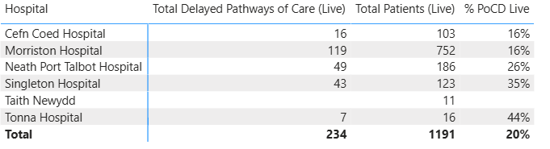

The table above is a live view of the clinically optimised patient cohort as at 09:53 hrs on 24th March 26, extracted from the Power BI Pathway of Care delays dashboard.

The table indicates a current position of 234 clinically optimised patients across 6 hospital sites (including Mental Health & Learning Disability services), occupying 20% of the bed pool. 119 clinically optimised patients are reported in the Morriston site occupying acute beds, with 92 across the Singleton and NPT Hospital sites, all of which impact urgent and emergency care flow.

- The bed days consumed by the clinically optimised patient cohort.

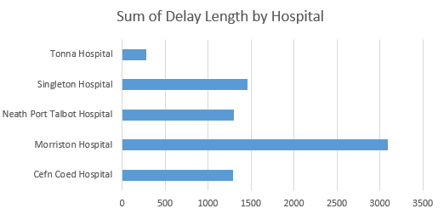
The bed days consumed by the clinically optimised patient cohort vary across the hospital sites with Morriston absorbing the greatest loss of bed days (over 3000 bed days).

Total COP Days at start of the Week
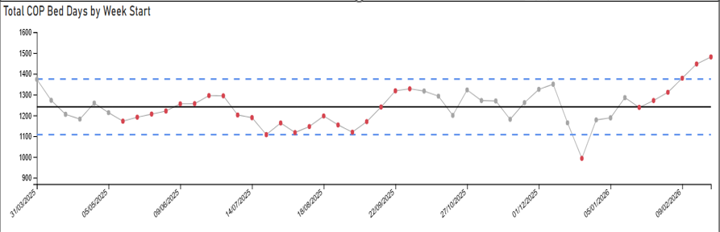

The graph above indicates growing bed day utilisation by the clinically optimised patient cohort Health Board wide exceeding the upper control limits. This is a concerning picture for both patients and the Health Board at a time when demand for urgent and emergency care has increased.

This position impacts considerable on the clinically optimised patients who spend extended periods of time in hospital beds being exposed to the harms well evidenced in relation to deconditioning and prolonged non-value-added hospitalisation, including infection, falls and cognitive decline. Furthermore, a high number of this patient groups are in their last 1000 days of life stranded in hospital which limits the quality of their life and their opportunity of independence.

The other patient group impacted by the bed days consumed by the clinically optimised patient cohort are those requiring urgent and emergency care. The inability to move COP patients through their pathway results in overcrowding of the Emergency Department and front door assessment areas, increasing delays for care which result in delays-related harms and increased mortality. The impact also extends to ambulance handover as over-crowded front door services do not have the capacity to handover ambulances in a timely manner. The unseen consequence of this are those patients waiting in their homes or in the community for an ambulance response, this is often delayed and results in patient harm and sometimes death.

- The challenges in reducing the number of clinically optimised patients stranded in hospital beds.

There are multiple factors that impact the Health and Social Care systems ability to expedite timely flow of the clinically optimised patient cohort. The WG Hospital Discharge Guidance 2026, advocates the D2RA model with an emphasis on a ‘Home first’ approach. It sets out an expectation that patients will be discharged within 48 hours of being deemed clinically optimised following a proportionate assessment of need to identify the safest destination for the patient to meet that need and to continue the assessment process. The current model of operating is very much based on ‘assess to discharge’ whereby all of the comprehensive assessment processes take place in a hospital bed, reflected in the extended lengths of stay of patients.

In order to deliver the D2RA model, there needs to be an understanding of demand and capacity. Pathway 1 is reliant on having the domicialliry care and community services capacity to realise discharge within 48 hours. Pathways 2 and 3 are reliant on appropriate bed pools to meet demand, ideally outside of the hospital setting with minimal specialist in patient reablement taking place in hospital. The current Health and Social Care system is not configured or resourced to deliver the outputs of the D2RA model.

The greatest delays for this patient group sit in the joint assessment reason code which includes multiple reason codes set out by the WG in terms of Pathway of Care delays reporting.

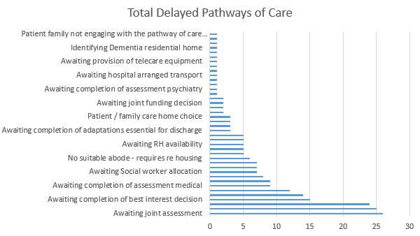

It is reported by Health and Social Care operational teams that the complexity and needs of patients is increasing with a correlating growth in the number of COP patients and the bed days utilised.

Decreasing the number of COP patients in hospital is a key priority for the Health Board in respect of patient safety and the harms that are well understood. Furthermore, managing COP patients in hospital beds with a pressurised urgent and emergency care system does not serve any patients well and is poor use of the taxpayer’s money.

- GOVERNANCE & PATIENT SAFETY

The impact of prolonged hospitalisation on elderly patients is well understood.

If you are 80 years old and in hospital for just one week you will experience a 20% loss of muscle power, 1.5Kg loss of muscle mass and 10% decrease in aerobic capacity. If this is combined with inactivity associated with non-value-added long stays then there is additional accelerated bone loss, respiratory and swallowing issues, incontinence in 50%, muscle weakness that persists for 3-5 years with a 48% increase in disability. These changes result in postural hypotension, falls, delirium, pneumonia, delayed recovery, poor nutrition and hydration and increased infections and result a 5-fold increase in the need for institutional care on discharge as well as an increased risk of death.

National figures show that 1:6 older people who normally walk independently need help with walking on discharge from hospital, 1:3 are discharged with a significant disability that was not present on admission and only 30% are back to their usual level of function within a year.

An audit within Wales of the longest length of stay showed that for the 88 patients the cumulative length of stay was 48.8 years. If we had discharged at the point of being initially declared clinically optimised, we would have saved 28.9 years of bed days. Of these patients 5 were admitted from a care home, but 38 were waiting to be discharged to a care home.

As part of the national work on deconditioning an early warning indicator (DEWI) has been developed which allows the assessment of the aspects of deconditioning (cognition, continence, hydration, nutrition, mobility, sleep, social engagement) at admission and during hospital stay to enable us to accurately monitor the impact and harm our discharge delays are having on our most vulnerable patients, and when to escalate their deterioration. Alongside this there is an action bundle to enable staff to undertake actions to minimise deconditioning, however, the ability to do these within an acute hospital site struggling with acuity and flow is limited.

- FINANCIAL IMPLICATIONS

The cost of failure associated with managing clinically optimised patients in hospital beds with no clinical benefit is estimated at circa £14.7m per annum. Patients are effectively stranded in hospital beds, the majority based on the Morriston site where the staffing infrastructure of the wards is tailored for delivery of acute clinical care and is an expensive resource.
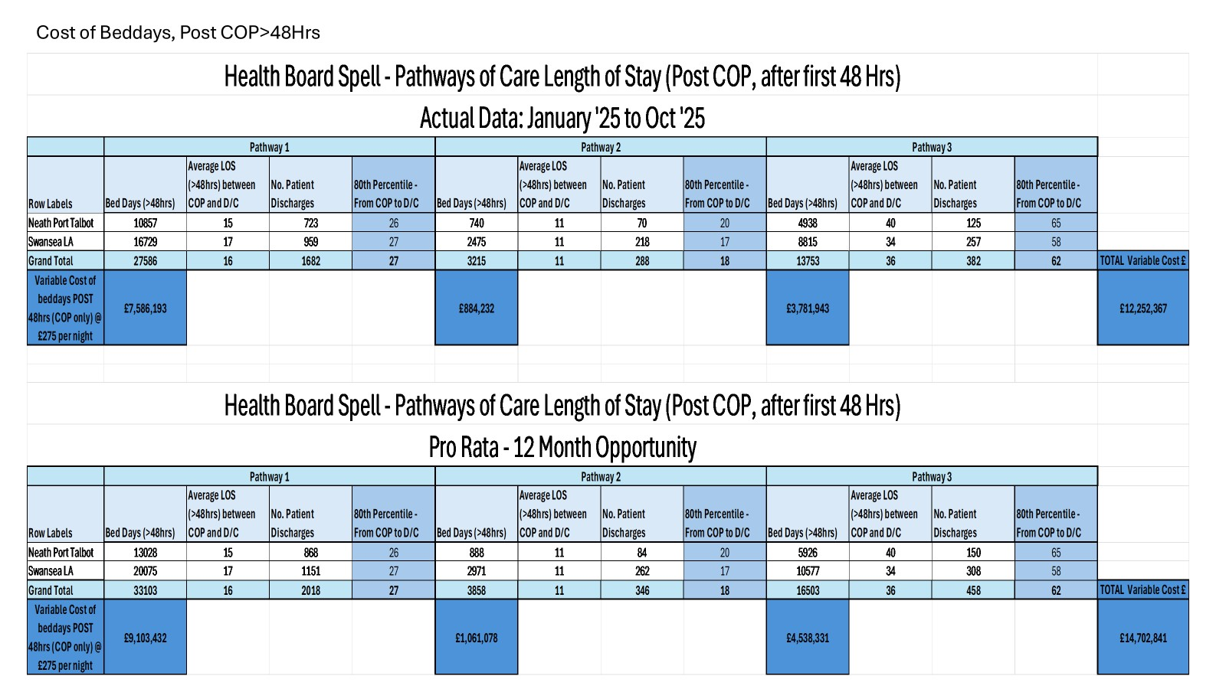

In addition to the above costs, this ‘loss’ of acute capacity results in overcrowding of the Emergency Department and front door assessment services.
Overcrowding of the Emergency Department was reported as a key risk in the ‘Getting it Right First Time’, GIRFT review undertaken in June 2024. The report referenced the impact of delay related harm in Morriston Emergency Department and relevant SEDIT data (Summary Emergency Department Indicator Table) indicated, 113 annual deaths could be associated with delay related harm which can indicate a 10-fold rise in mortality and morbidity.
The report also described a state of urgency in the Emergency Department documented as, ‘The ED at Morriston Hospital is currently causing increased clinical risk for patients and is unpleasant as a place of work for staff. This was the view of both the GIRFT UEC team and the senior ex-members of NHSE’s Emergency Care Intensive Support Team (ECIST), who accompanied us on this visit. It was one of the two EDs in Wales which caused the most concern to the GIRFT team’.
In order to mitigate the well documented risks of crowded Emergency Departments which is a symptom of poor system flow, the use of surge capacity becomes part of the operational footprint. This capacity is often sub-optimal in terms of clinical service delivery, is expensive as it is often staffed by temporary workforce at premium rates of pay and offers poor value for money. In 24/25, cost of surge capacity in Morriston was in excess of £3 million, the breakdown of the costs is set out below:

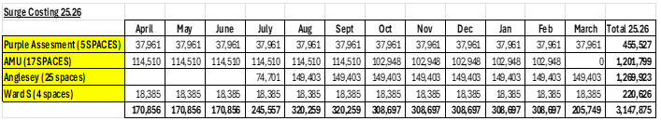

Furthermore, Singleton Hospital has incurred costs as part of the opening of Ward 4 in January 26, aimed to reduce the number of clinically optimised patients on the Morriston site, these costs are set out below:

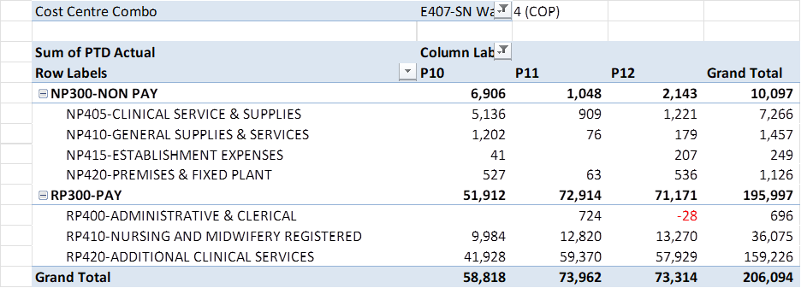

The total costs associated with the clinically optimised patients remaining in hospital beds and the failure response to open surge is circa £18.1m. In terms of the financial challenge of the Health Board, the reduction of the clinically optimised patient cohort is a key enabler of patient flow and therefore patient safety and would serve to enable a reduction in in-patient capacity thus releasing money to contribute to the significant financial deficit.

- RECOMMENDATION

The Quality and Safety Committee is asked to RECEIVE the content of the report and CONSIDER:

- How we drive the Clinically Optimised challenge into the Quality and Safety arena based on the evidence base associated with delay related harms.
- Adoption of the Deconditioning Early Warning Indicator tool as part of the ward quality metrics and consider how this fits with the Health Board Duty of Candor and Quality.
- How the clinically optimised patient cohort may be differentiated within the AMAT & DATIX system to enable identification of harm.

Governance and Assurance
Link to Enabling Objectives  (please choose) | Supporting better health and wellbeing by actively promoting and empowering people to live well in resilient communities
Link to Enabling Objectives  (please choose) | Partnerships for Improving Health and Wellbeing |  | ☒
Link to Enabling Objectives  (please choose) | Co-Production and Health Literacy |  | ☐
Link to Enabling Objectives  (please choose) | Digitally Enabled Health and Wellbeing |  | ☐
Link to Enabling Objectives  (please choose) | Deliver better care through excellent health and care services achieving the outcomes that matter most to people
Link to Enabling Objectives  (please choose) | Best Value Outcomes and High Quality Care |  | ☒
Link to Enabling Objectives  (please choose) | Partnerships for Care |  | ☐
Link to Enabling Objectives  (please choose) | Excellent Staff |  | ☐
Link to Enabling Objectives  (please choose) | Digitally Enabled Care |  | ☐
Link to Enabling Objectives  (please choose) | Outstanding Research, Innovation, Education and Learning |  | ☐
Health and Care Standards
(please choose) | Staying Healthy |  | ☐
(please choose) | Safe Care |  | ☒
(please choose) | Effective Care |  | ☐
(please choose) | Dignified Care |  | ☐
(please choose) | Timely Care |  | ☐
(please choose) | Individual Care |  | ☐
(please choose) | Staff and Resources |  | ☐
Quality, Safety and Patient Experience
The paper clearly demonstrates the quality, safety and poor patient experience associated with the extended hospitalisation of the clinically optimised patient cohort. The Q&S Committee are asked to consider how we move this patient safety issue into the Q&S arena in addition to the current focus through the performance lens.
Financial Implications
The financial implications associated with the failure to deliver D2RA as a discharge transfer model are set out in the paper. The response to this failure is compensated through the use of unfunded capacity solutions that are often staffed at premium rates of pay through temporary workforce solutions.

The financial costs associated with this patient group cannot be overlooked as the money is essentially buying delay related patient harm at a cost or circa £18m. Reducing the COP cohort has significant patient benefits, system benefits and benefits in terms of the long-term care bill associated with deconditioning.

Legal Implications (including equality and diversity assessment)
The Health Board has explored how the pathway of this patient group may be accelerated and have engaged with LA partners to set out the challenge and agree to joint working initiatives that may reduce the number and length of stay of the COP cohort. It is the statutory responsibility of Local Authorities to provide social care whilst the Health Board has a statutory responsibility to provide Health Care. Failure of timely discharge results in the Health Board absorbing the statutory responsibility of the Local Authority to the detriment of providing patients with timely access to health care.
Staffing Implications
The staffing implications are included in the financial costs associated with the clinically optimised patient cohort.
Long Term Implications (including the impact of the Well-being of Future Generations (Wales) Act 2015)
Report History |  | Nil
Appendices |  | Nil

