Meeting Date | 08 October 2026 | Agenda Item | 3.1
Name of Meeting | Quality & Safety Committee
Report Title | Pressure Ulcer Performance
Report Author | Rachel Govier-Williams, Lead Specialist Tissue Viability Nurse
Report Sponsor | Executive Director of Nursing and Patient Experience
Presented by | Elizabeth Rix, Executive Director of Nursing and Patient Experience
Freedom of Information | Open
FoI Closed detail | If closed, choose detail
Impact Assessment Summary Outcome |  | IA Completion date
 |  | Click or tap to enter a date.
Purpose of the Report | For Assurance
Report Summary, detailing any action required
The purpose of this report is to provide an overview of Health Board performance relating to Health Board Acquired Pressure Ulcers (HBAPUs) during the reporting period 2025-2026. It summarises organisational performance, governance, quality improvement activity, education, audit findings and current risks requiring Committee oversight.
Key Issues
The report highlights the key performance measures related to pressure ulcer incidents, including
- Total Number of Health Board–Acquired Pressure Ulcers (HBA PU) (rate per 1000 beds) and organisational performance
- Governance and Assurance
- Patient safety
- Progress and Quality Improvement
- Risks

Decision / Action required | Choose requirement
Recommendations
Members are asked to:
RECEIVE the report and note the current pressure ulcer performance position, including the increase in reported Health Board-acquired pressure ulcers during 2025/26 and the emerging improvement shown in June 2026 live data.
CONSIDER the key risks impacting delivery of sustained improvement, particularly data reliability, incomplete avoidability status recording, delays in incident closure, access to pressure-relieving equipment, medical photography limitations and Tissue Viability Service capacity.
SEEK ASSURANCE that Service Groups have completed and submitted local pressure ulcer improvement plans to the Pressure Ulcer Prevention Strategic Group, with clear actions, ownership, timescales and monitoring arrangements.
SUPPORT the continued implementation of the Health Board Pressure Ulcer Quality Improvement Plan, with particular focus on reducing avoidable harm, improving assessment and categorisation, strengthening governance processes and targeting hotspot areas.
AGREE that a further update is provided in Quarter 3 2026/27 to demonstrate progress against the improvement plan, the reliability of avoidability data and delivery against the agreed harm reduction ambitions.

- INTRODUCTION
1.1 This report provides the Committee with the Health Board's acquired pressure ulcer performance for Swansea Bay University Health Board (SBUHB) for the reporting period 2025/26 and to date. The report will provide assurance of progress to date by SBUHB in implementing change and improving patient safety. It summarises organisational performance, governance, quality improvement activity, education, audit findings and current risks requiring Committee oversight.

2. BACKGROUND
2.1 The 2025/26 Performance Review identified concerns regarding the increasing incidence of reported pressure ulcers across the Health Board (HB). While improvements in reporting culture, scrutiny processes, and incident identification may have contributed to the rise in reported numbers, the trend highlighted the need for stronger assurance and targeted improvement activity to reduce avoidable harm by 30% by March 2027.
In response, a range of measures have been implemented, including enhanced scrutiny arrangements, strengthened governance and reporting processes, focused quality assurance activity, and targeted interventions within high-risk clinical areas. Emphasis has been placed on improving compliance with key preventative care measures, including risk assessment, repositioning, provision of pressure-relieving equipment, and individualised care planning.
Ongoing monitoring through audit, incident review, and performance reporting will be essential to assess the effectiveness of these interventions and ensure improvements translate into better patient outcomes and fewer avoidable pressure ulcers across hospital and community settings. The report highlights the key performance measures related to Health Board Acquired Pressure Ulcers when comparing the 2024/2025 and 2025/2026 periods. It also reflects the live data. The committee is asked to note that live data is subject to change, as validation, investigation and scrutiny may not have been undertaken.
3. ASSESSMENT
3.1 In 2026/2027, the Health Board's performance data indicates;
- Total Health Board Acquired Pressure Ulcers: has seen a 7% increase (Graph 1) comparing 1st July to 31st June 2024-2025 to 1st July to 31st June 2025-2026 – Quarter 2 data not validated or cleansed
- When comparing the 2024/2025 period with 2025/2026, Health Board inpatient sites have seen a 27% overall increase in hospital-acquired pressure ulcer incidents, equating to 198 additional reported incidents annually.
- Acute Hospital, Rate per 100 occupied beds: Annual mean rate 2.7 (no national average).
- 13% rate per 1000 beds increase
- Q1 - Rate per 1,000 beds: 3.2
- December / January Q4 peaks
- Hospital Sites, SPC Run Chart Summary (Graph 2)
- Avoidability status- inaccurate

Graph 1 Health Board Acquired Pressure Ulcers (cleansed to quarter 1)

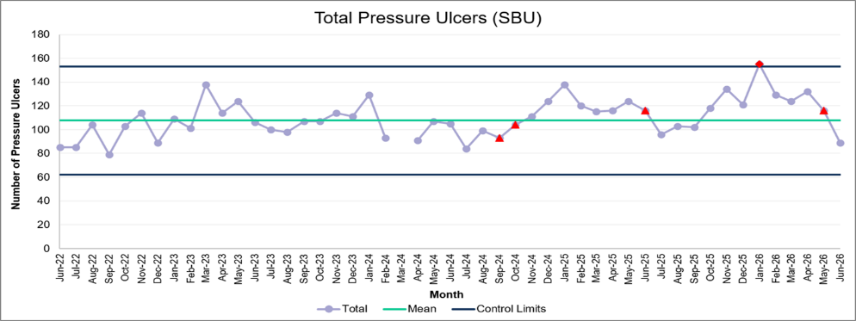
Graph 2 Hospital Acquired Pressure Ulcers (cleansed to quarter 1)
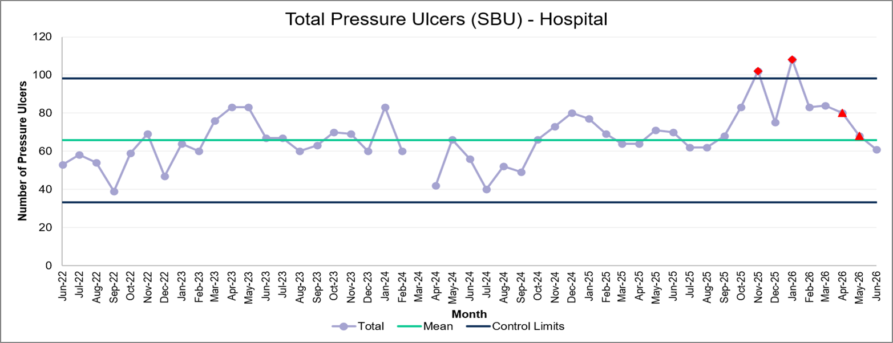
In the annual comparison, a steady upward trend of Health Board Acquired (HBA) incidents has been seen over the past three years. Incident numbers have increased from 1,286 in 2023/24 to 1,377 in 2025/26, alongside a rise in the monthly mean from 74 to 120.
The annual rate per 1,000 bed days has also increased from 1.8 to 2.7. Quarter 1: rate 3.2, indicating that this is not just a rise in activity, but a real increase in harm.
The most recent year shows a 7% upward trajectory, compared to relatively stable performance the previous year, suggesting that improvement has not been sustained and that variation is now increasing

3.2 Monthly Live Reports
Monthly live reports should be interpreted with caution. They include all reported incidents at the point of extraction and therefore contain cases that remain subject to validation, investigation, categorisation and multidisciplinary scrutiny.
As governance processes are completed, cases may subsequently be reclassified, amended or closed. Consequently, live monthly reports should not be used as a measure of final organisational performance. Final reported performance is based upon validated data following completion of governance processes.

3.3 Live data
In August, 104 HBA incidents were reported, a 13% decrease from July, 34 fewer than our peak in January (Graph 3). Figures remain changeable due to Datix amendments and investigations. The data presented last month will have changed
Inpatient rate: R 2.5 per 1,000 bed days. There is no national benchmark, with the highest inpatient rate recorded in Q3 25 (R 2.84).
Primary Care Services rates remain unreliable due to caseload dashboard inaccuracies. We have seen an increase in reporting numbers in 28% from quarter 2 2025 – quarter 2 2026.
Hotspots continue to be highest in patients' own homes and Unscheduled Care and front door services.
Graph 3: Number of HB-acquired incidents – Live data

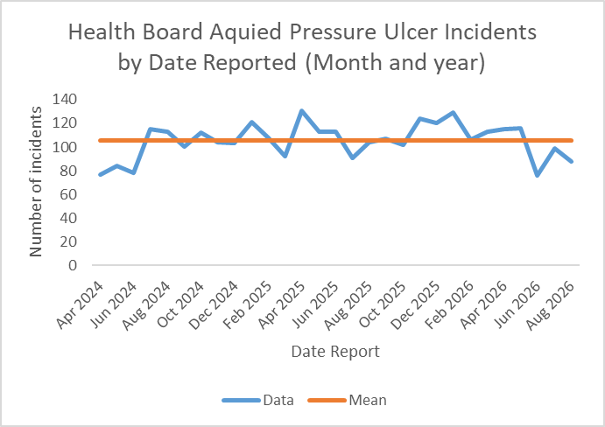

3.4 Primary & Community Services
Quarter-on-quarter performance has typically fluctuated, with periods of both increase and decrease in pressure ulcer incidence (Graph 5). Planned Care Services (PCS) indicate that the overall patient population at risk of pressure ulcers is increasing.
As patient acuity, frailty, and complexity increase, a corresponding rise in the total number of pressure ulcers may be expected, and avoidability and severity of harm are therefore a focus. Therefore, consideration should be given not only to the number of reported pressure ulcers, but also to the underlying risk profile of the population being cared for. This is particularly important when assessing performance trends and the impact of improvement initiatives.
Whilst the Health Board remains focused on reducing avoidable harm.

Graph 5 Primary & Community Services acquired incidence
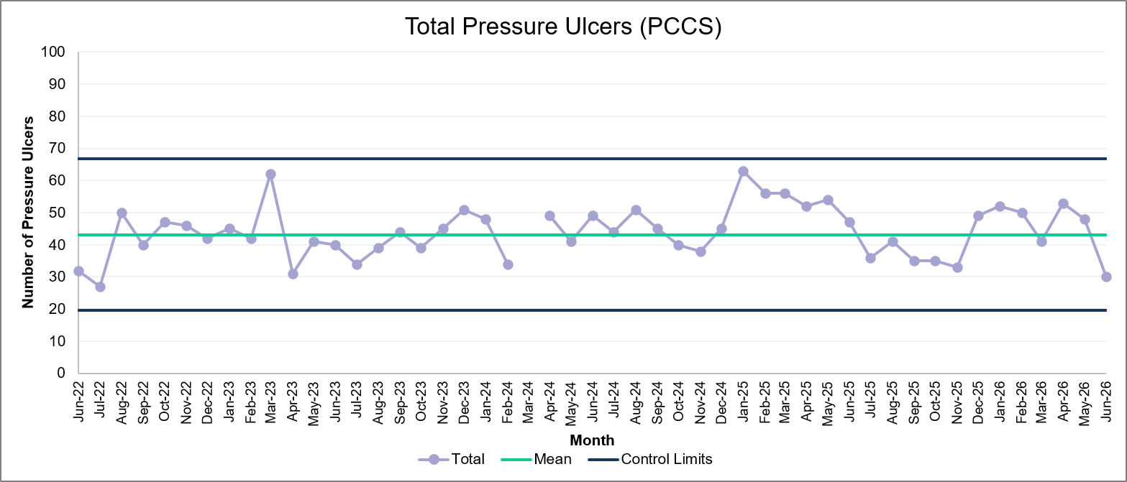

3.5 Severity of Harm 2025/2026
The majority of pressure ulcers developing in both hospital and community settings continues to be predominantly superficial. 88 % of reported incidents were either:
- Category 1 (intact skin with signs of pressure), seen decreased reports 14%
- Category 2 (superficial epidermis loss), or
- Suspected Deep Tissue Injury (SDTI). We have seen an increase in SDTI as opposed to cat 2
- Deep damage represents 12% of incidents. (Graph 6)
SDTI can evolve into more severe damage over time, and this progression is not always captured in these figures. Focus, led by Pressure Ulcer Prevention Strategic Group (PUPSG), is preventing all pressure ulcers, but particularly on reducing deep tissue damage by 20% and addressing avoidability across all service groups with a reduction aim of 30%.
Key focus has been on addressing patterns, learning from themes and targeted interventions to reduce harm effectively.

Graph 6 Pressure ulcer severity
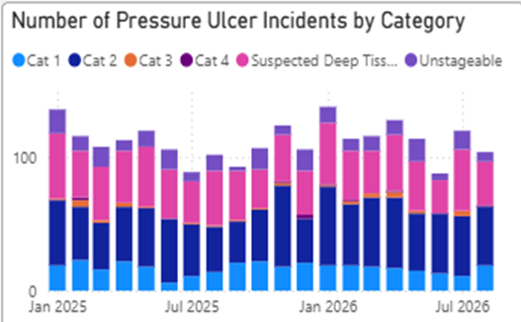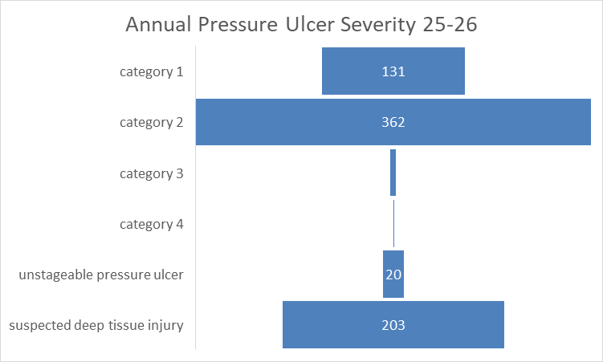
Deep Damage incidents
Our target was also to reduce for Avoidable deep damage by 20% as we can see, we have had over double the number of deep-damage incidents.
186 HBA deep-damage ulcers developed in SBU in 2025-2026
167 HBA 2024-2025
11% increase
Avoidable deep damage
- National Reportable Incidents (NRIs) reported for PU 2025/26 –17 (increase in deep damage avoidability)
- NRIs reported for PU 2024/25 - 7
- 14- 2023/24.
4 NRIs were reported (incidents from Feb –June; delayed reporting).
Harm Profile – August 2026 live data
94% superficial harm; 6 deep/severe harm.
17% decrease in deep damage incidents (not validated on some SG)
3.6 Governance reviews and case closures
Annual Governance indicates 81% of incidents have been closed; this is a 15% improvement on the 2024/2025 period, and reflective of the drive from PUPSG to improve investigations, closures and scrutiny panels.
Graph 7 Incident closure status
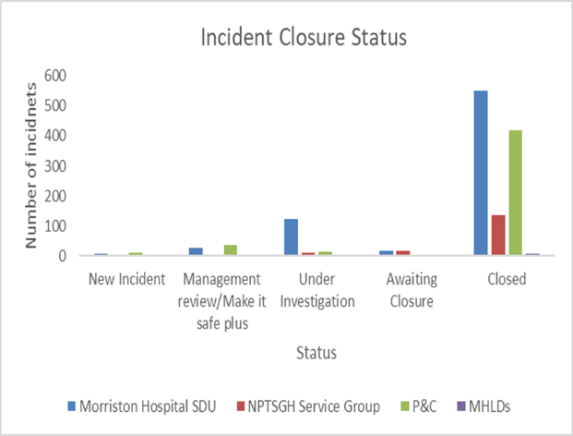
The current level of missing data significantly limits our ability to accurately measure improvement and benchmark performance.

3.7 Avoidability Status Following Scrutiny
Of the incidents closed following scrutiny, 47% were recorded as unavoidable and 11% as avoidable. However, 42% of incidents were closed without an avoidability status being assigned. As a result, the data used to benchmark the Health Board's performance and assess whether the target of a 30% reduction in avoidable harm has been achieved is currently unreliable.
Avoidability status and level of harm are now assigned during the scrutiny process and confirmed at the point of closure. Where omissions are identified, records will be amended before closure wherever possible. A detailed review indicates that a significant number of incidents were closed after scrutiny without an avoidability status being recorded. (Appendix 1)
PUPSG has requested assurance that these incidents will be reopened, reviewed, and updated accordingly to ensure the accuracy of benchmarking data and to enable meaningful measurement of improvement against the 2025/26 baseline. (Graph 8)
Graph 8 Avoidability Status
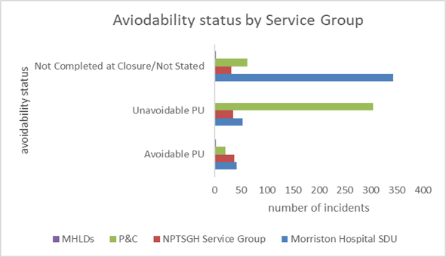
Recognising these issues, targeted improvement work has been undertaken, including the reformatting of some of the scrutiny panels, strengthened governance processes, and enhanced oversight arrangements during Quarter 4 and since. To provide greater assurance regarding the consistency and quality of avoidability investigations. The impact of these changes will continue to be monitored to ensure data accuracy, improve organisational learning, and support reliable reporting of avoidable pressure ulcer reduction across both hospital and community services. A detailed cleanse has been undertaken; 30% of incidents were inaccurately coded. These have been amended. 100% of the remaining incidents have been reopened and are under investigation.

3.8 Identified hotspot high reporting wards/services.
Analysis of incident distribution demonstrates that the highest reporting areas remain patients' own homes and front door services. These areas manage a greater throughput of patients with higher levels of frailty, dependency, and clinical complexity, often within environments where operational pressures are significant. The increased reporting seen within these settings is therefore consistent with the underlying risk profile of the population served. Targeted improvement work continues to focus on these high-risk areas to support early identification of pressure damage, strengthen preventative interventions, and reduce the incidence of avoidable harm. (Graph 9)
Graph 9: Highest reporters of HB acquired Pressure Ulcers.
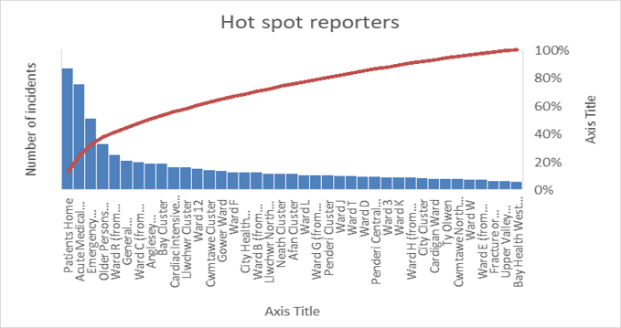
3.9 Health Board Quality Assurance Audits
Biannual quality assurance, reporting, and Investigation audits continue to be undertaken by the Tissue Viability Team; however, this is being delivered by a very small team resource. In addition, hotspot audits are undertaken within Service Groups where additional local resource is available, supported by Matron-led and ward/community-based assurance audits. The graph below presents the findings from the June 2026 audit, which has enabled both the PUPSG and Tissue Viability Team to target improvement activity based on identified themes and areas of unevidenced compliance
Due to reduced community Tissue Viability Nurse capacity during this period, it was not possible to undertake the full programme of community audits on this occasion. The lower level of compliance relating to the documentation of patient information provision is considered to reflect the movement of patients across care settings and limitations in the availability of digital evidence, rather than an absence of information being provided. This has been identified as a key area for improvement, and discussions are ongoing with digital teams to explore solutions that will strengthen the recording and visibility of patient information and education across the patient pathway. Key areas requiring improvement relate to the implementation and documentation of core preventative care interventions, specifically repositioning, the timely provision and use of pressure-relieving equipment, and individualised care planning. These findings are consistent with themes identified through incident reviews and scrutiny processes and represent areas where targeted improvement work is most likely to reduce the risk of pressure ulcers. (Graph 9)
Audit findings continue to inform targeted quality improvement activity, enabling resources to be focused on areas of greatest risk and supporting the delivery of harm reduction and pressure ulcer prevention initiatives across hospital and community settings.

Graph 9: Acute hospital quality assurance audit.

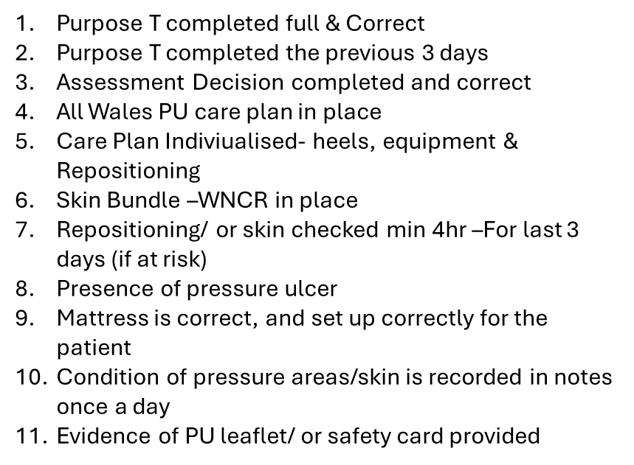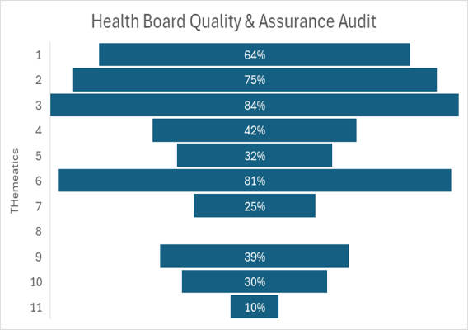

The audit identified concerns regarding the consistency of quality assurance and validation processes in some areas. An improvement plan has been requested to strengthen assurance. Validation, improved consistency of reporting and enhanced governance assurance.
- Quality improvement work continues through targeted interventions within hotspot areas, thematic learning, strengthened governance oversight, implementation of preventative initiatives and delivery of the Health Board Pressure Ulcer education and competency programme.
- Risks remain in relation to operational pressures, workforce capacity, delays in governance processes, data validation, delays in bed contract, reduced TVN support, all impacting increased risk to patient safety and organisational assurance.
Performance continues to be monitored through the Health Board Pressure Ulcer Strategic Group, with routine review of trends, themes and organisational learning.
3.10 Validation Audit
The Tissue Viability Team undertakes validation audits within the highest-reporting inpatient areas to provide additional assurance regarding the accuracy of pressure ulcer reporting and categorisation. Due to current service capacity and workforce constraints, this level of validation cannot be undertaken consistently across all sites, and the lack of medical photography access prevents validation at the point of scrutiny.
The audits have identified concerns relating to assessment skills and the accurate classification of pressure ulcers, including difficulties distinguishing pressure ulcers from wounds of other aetiologies and instances of miscategorisation. These findings have implications for both patient care and organisational reporting.
Accurate assessment and categorisation are critical to ensuring patients receive the most appropriate treatment and preventative interventions. Misclassification may result in delays to the implementation of suitable care plans, inappropriate use of resources, and missed opportunities for targeted intervention. Furthermore, inaccuracies in categorisation impact the reliability of organisational performance data, reducing confidence in trend analysis, benchmarking, and the measurement of improvement over time. (Graph 10)

Graph 10 Validation of pressure ulcers reported in acute Hotspots
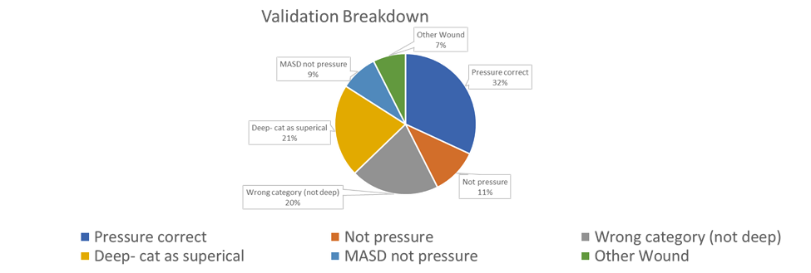

In response, the Tissue Viability Team is targeting education, clinical support, and quality assurance activity towards those areas where validation audits have identified the greatest need. This work aims to strengthen clinician confidence and competence in wound assessment, improve the accuracy of incident reporting, and enhance the quality of data used to inform performance monitoring and patient safety improvement initiatives.

4 Governance and Risks
4.1 Key Risks to the Health Board
The following risks continue to impact the Health Board's ability to deliver optimal pressure ulcer prevention and management arrangements and remain key areas of focus for the Pressure Ulcer Prevention Strategic Group:
Key risks summary: The principal risks relate to the timely availability of pressure-relieving equipment, limited access to medical photography to support validation and clinical review, Tissue Viability Service capacity, incomplete avoidability status recording, delays in incident investigation and closure, and variation in assessment and categorisation practice. These risks collectively impact patient safety, the reliability of performance reporting, the Health Board's ability to evidence progress against harm reduction ambitions, and the delivery of sustained improvement across hospital and community services.

4.2 Equipment Provision and Delayed Bed Contract
The continued delay in the implementation of the new bed contract has presented challenges in ensuring the timely availability of appropriate pressure-relieving equipment. This risk is currently being mitigated through interim bed-hire arrangements with an alternative supplier and by reinforcing guidance to clinical areas regarding minimum stock levels of pressure-relieving overlays and equipment. The implementation of the new contract remains a key priority to support equitable and timely access to equipment across all care settings. Risk register 4422-15
4.3 Medical Photography Access
Limited access to medical photography continues to present challenges in supporting pressure ulcer validation, clinical review, and monitoring. This risk remains recorded on the Risk Register. Work is ongoing with Digital Services to develop an electronic photography solution that will enable secure image capture and storage, improve accessibility of photographic evidence, and support both clinical decision-making and assurance processes. Risk register 3701-15
4.4 Tissue Viability Service Capacity and Access
The capacity of the Tissue Viability Service continues to present challenges in meeting increasing demand, particularly in relation to pressure ulcer validation activities, complex case reviews, and specialist clinical support. An Organisational Change Proposal (OCP) has been submitted to support service development and strengthen resilience within the service. In parallel, work continues to reinforce accountability for senior clinical review and oversight of pressure ulcer assessment, categorisation, and management.

4.5 Data Reliability and Avoidability Status
The reliability of avoidability data remains a significant concern. A substantial proportion of incidents have been closed without the completion of avoidability status, limiting the Health Board's ability to benchmark performance accurately and demonstrate progress against improvement targets. Ongoing work is being undertaken with the Datix team to facilitate the review of these monthly, and amendment of incidents where avoidability status has not been recorded, thereby improving the quality and reliability of performance reporting and assurance data.
Collectively, these risks are being actively monitored through established governance arrangements, with mitigating actions in place to minimise their impact on patient safety, service delivery, and the Health Board's ability to achieve its pressure ulcer reduction objectives for 2026/27. Scrutiny Terms of reference (appendix 1)

5. QUALITY IMPROVEMENT ACTIVITY AND PRIORITIES FOR 2026/27
It is requested that assurance be provided that an improvement plan has now been completed for the Health Board, and the individual service groups have been requested to submit to PUPSG, and any further actions will be added subject to the advice of the oversight committee. Governance structures have been established for the improvement of services. Mitigations are in place or in development for the critical safety issues identified by the PUPSG in the review. Further work is needed to implement the plan, respond to any recommendations, fully develop engagement and ensure a sustainable approach to managing safety and quality in the prevention of avoidable harm from pressure ulcers within SBUHB. It is recommended that Quality & Safety continues to support implementation and provide assurance that improvements are delivered. A key review point will be in the following quarter, 2 2026 (undertaken Nov 2026)
5.1 Improvement Activity
Quality improvement activity continues across the Health Board and includes:
- Targeted improvement support within identified hotspot areas.
- Thematic review of recurring incidents.
- Enhanced governance oversight.
- Shared organisational learning.
- Monitoring compliance with pressure ulcer prevention bundles.
- Review of equipment provision and availability where appropriate.
- Ongoing collaboration with clinical teams to reduce unwarranted variation in practice.
- Delivery and monitoring of the Pressure Ulcer Quality Improvement Plan
Ongoing quality improvement remains essential to reducing pressure ulcer incidence, improving patient outcomes, and ensuring that practice improvements are sustained over time. The challenges staff continue to face in relation to pressure ulcer prevention are reflected within the current performance data and coincide with the significant operational pressures being experienced across the Health Board.
There has been an increasing demand associated with caring for more vulnerable patients, alongside rising patient acuity, particularly within unscheduled care settings. These challenges are further compounded by ongoing workforce pressures, increasing staff incident reporting, and the need to implement business continuity arrangements in some services.
For 2026/27, the PUPSG have established a series of mutually agreed improvement targets. The primary objective will be to achieve a 30% reduction in the incidence of the most common measurable contributory factors associated with avoidable pressure ulcers. The group will continue to provide strategic oversight of pressure ulcer prevention and quality improvement activity, while supporting Service Groups to address their specific operational and clinical challenges.
5.2 Key Areas of Focus for 2026/27
The PUPSG Health Board work programme will focus on:
- Strengthening patient information and education.
- Expanding validation activity to improve the accuracy of pressure ulcer identification and categorisation.
- Improving incident closure processes, ensuring avoidability status and harm categorisation are completed correctly and promptly.
- Development of pressure ulcer dashboards using rates per 1,000 bed days to support meaningful benchmarking across the Health Board.
- Targeted action plans for identified hotspot areas bespoke to their challenges.
- Reducing delays in incident investigation, scrutiny, and Datix closure.
- Development of digital solutions, including collaboration with Medical Illustration and Digital Services to explore an application supporting photography and wound assessment.
- Delivery of planned Tissue Viability Service improvements.
- Implementation of the revised repositioning and sitting regime pathway.
- Addressing gaps within digital documentation and evidence recording.
- Supporting Service Groups to address workforce and staffing challenges.
- Working collaboratively with unscheduled care services to address pressure ulcer risks associated with patient flow and prolonged waiting times.
- Improving access to and utilisation of pressure-relieving equipment, subject to the implementation of the new bed contract.
- Strengthening accountability and clinical assessment skills relating to pressure ulcer prevention and categorisation.
- Development and implementation of digital wound management guidance.
- Continued delivery of the Pressure Ulcer Prevention Superhero League initiative to promote awareness, education, engagement, and shared learning across clinical teams. Launch September 2026 (Appendix 2)
Collectively, these priorities will support the Health Board's ambition to reduce avoidable pressure ulcers, improve the quality and reliability of performance data, strengthen assurance processes, and ensure patients receive safe, effective, and evidence-based pressure ulcer prevention and management interventions
6. Education and Training
The Health Board continues to deliver a comprehensive Pressure Ulcer education programme with its capacity including:
- Pressure ulcer Prevention, Assessment & Management training.
- Targeted education for clinical teams ‘hotspots'.
- Champions digital and full-day training sessions
- Bespoke group support for hotspot areas.
- Learning following incident review.
- Drop-in training
- Training videos.
Primary and Community services currently have reduced education access due to resources.
A centralised resourced tissue viability team is required to support this; an operational change plan has been submitted.
7. OPEN AUDIT RECOMMENDATIONS
There are no open audit recommendations related to this.

8. RECOMMENDATIONS
Members are asked to:
- RECEIVE the report and note the current pressure ulcer performance position, including the increase in reported Health Board-acquired pressure ulcers during 2025/26 and the emerging improvement shown in June 2026 live data.
- CONSIDER the key risks impacting delivery of sustained improvement, particularly data reliability, incomplete avoidability status recording, delays in incident closure, access to pressure-relieving equipment, medical photography limitations and Tissue Viability Service capacity.
- SEEK ASSURANCE that Service Groups have completed and submitted local pressure ulcer improvement plans to the Pressure Ulcer Prevention Strategic Group, with clear actions, ownership, timescales and monitoring arrangements.
- SUPPORT the continued implementation of the Health Board Pressure Ulcer Quality Improvement Plan, with particular focus on reducing avoidable harm, improving assessment and categorisation, strengthening governance processes and targeting hotspot areas.
- AGREE that a further update is provided in Quarter 3 2026/27 to demonstrate progress against the improvement plan, the reliability of avoidability data and delivery against the agreed harm reduction ambitions.
Governance and Assurance
Strategic Objectives
Strategic Objectives  (please choose which is impacted) | People of Swansea Bay live healthier, fairer and more prosperous lives | ☐
Strategic Objectives  (please choose which is impacted) | Care is high quality, safe, efficient and delivers the best possible outcomes for people in partnerships | ☐
Strategic Objectives  (please choose which is impacted) | Care is delivered in partnership with our communities in safe and appropriate setting, supported by innovation | ☐
Strategic Objectives  (please choose which is impacted) | The health board is a great place to work where staff feel valued and work together towards a common goal | ☐
Strategic Objectives  (please choose which is impacted) | The health board is a resilient, sustainable and responsible organisation | ☐
Health and Care Standards
Standards (please choose which applies) | Safe Care | ☒
Standards (please choose which applies) | Timely Care | ☐
Standards (please choose which applies) | Effective Care | ☒
Standards (please choose which applies) | Efficient Care | ☐
Standards (please choose which applies) | Equitable care | ☐
Standards (please choose which applies) | Person-centred Care | ☐
Standards (please choose which applies) | Staff and Resources | ☐
Enablers (please choose which applies) | Whole Systems Approach | ☒
Enablers (please choose which applies) | Leadership | ☒
Enablers (please choose which applies) | Workforce | ☐
Enablers (please choose which applies) | Culture | ☐
Enablers (please choose which applies) | Information | ☐
Enablers (please choose which applies) | Learning, Improvement and Research | ☐
Quality, Safety and Patient Experience
Pressure ulcer prevention remains a significant patient safety priority, with increasing patient acuity, workforce pressures and inconsistencies in assessment, categorisation and incident closure impacting performance. Targeted quality improvement activity, enhanced governance, validation audits and strengthened scrutiny processes are supporting improvements in care delivery and data quality.
Financial Implications
No explicit implications but potential interim hire costs for pressure-relieving beds/equipment because of delays implementing the new bed contract.
Possible investment required to improve equipment availability and stock levels across care settings.
Legal Implications (including equality and diversity assessment)
No specific legal proceedings are identified; however, failure to prevent, appropriately manage, investigate and learn from avoidable pressure ulcers may create clinical negligence, Duty of Candour, regulatory, information-governance and equality risks

Staffing Implications
Current workforce and capacity constraints within the Tissue Viability Service and wider clinical teams are affecting the delivery of audits, validation, specialist support, education and timely governance processes. The proposed organisational change and development of a centralised, appropriately resourced Tissue Viability Service will have staffing implications, which require further assessment and implementation through the relevant workforce processes
Long Term Implications (including the impact of the Well-being of Future Generations (Wales) Act 2015)
Not applicable
Report History
Q&S Committee – January 2025
Appendices
Appendix 1 - Terms of Reference
Appendix 2 - Pressure Ulcer Prevention League- Education

