Meeting Date | 08 October 2026 | Agenda Item | 4.2
Name of Meeting | Quality & Safety Committee
Report Title | Patient Safety and Experience
Report Author | Angharad Higgins, Head of Quality and Safety
Report Sponsor | Executive Director of Nursing and Patient Experience
Presented by | Elizabeth Rix, Executive Director of Nursing and Patient Experience
Freedom of Information | Open
FoI Closed detail | If closed, choose detail
Impact Assessment Summary Outcome |  | IA Completion date
Not required |  | Click or tap to enter a date.
Purpose of the Report | For Assurance
Report Summary; detailing any action required
To provide the Committee with assurance on patient safety, patient experience, and quality of care, including key risks, trends, and improvement actions for the 1.4.26-30.6.26.
Key Issues
- Healthcare-acquired pressure damage remains a patient safety risk requiring sustained improvement.
- Complaints performance remains below target, with a high number of overdue concerns and associated reputational risks.
- Delays in assessment, diagnosis and treatment continue to affect patient outcomes and experience.
- Waiting times, access to care and emergency care pressures remain recurring themes across multiple intelligence sources.
- Workforce capacity and the effective implementation of organisational learning require oversight and assurance.
Decision / Action required | No
Recommendations
Members are asked to:
- Consider the key patient safety, patient experience and quality risks highlighted within the report.
- Maintain oversight of targeted improvement actions are in place for pressure damage, complaints performance and access to care.
- Monitor and receive assurance for delivery of the Ombudsman recommendations, Duty of Candour compliance and incident management timescales.
- Support continued organisational learning and oversight of actions arising from incidents, complaints and patient feedback.
Patient Safety and Experience Report - April- June 2026

- INTRODUCTION

This report provides an integrated overview of patient safety, patient experience and quality performance across the Health Board. It brings together intelligence from incidents, complaints, concerns, patient feedback, Duty of Candour, Ombudsman activity and assurance processes to identify emerging risks, areas of good practice and opportunities for improvement. The report supports the Quality and Safety Committee in discharging its governance responsibilities by providing assurance on the effectiveness of quality and safety systems, highlighting key risks, and monitoring progress against improvement actions intended to enhance outcomes and experiences for patients.

The report covers the period April- June 2026 (Quarter 1), but future reporting periods will be amended to provide bi-monthly reporting to the committee.

- OVERVIEW OF ASSURANCE

Area | RAG | Trend | Level of Assurance | Rationale
Breakthrough objective: Pressure Damage | • | Stable | Limited | Integrity and contemporaneity of data requires improvement
Quality Metrics: Falls | • | Stable | Substantial | Continued performance below national average for falls
Quality Metrics:  Medication incidents | • | Stable | Substantial | Slightly improved position and no systemic risks identified.
Patient safety incidents | • | Stable | Moderate | Timeliness of incident and investigation and closure requires improvement.
Complaints performance | • | Deteriorating | Limited | Reduction in overdue concerns under Putting Things Right, however increasing numbers of overdue concerns under Listening to People.
Ombudsman activity | • | Deteriorating | Moderate | Special report issued, however actions in place to address all recommendations.
Duty of Candour | • | Stable | Moderate | Process embedded.
Patient Experience | • | Stable | Substantial | Triangulated experience across services, including in focus areas.
Ward assurance | • | Stable | Moderate | Robust corporate process in place, limitations on arrangements within service groups.

- Pressure Damage
We are working towards a breakthrough objective of 30% reduction in healthcare-acquired pressure damage incidents by the end of Quarter 4, 2026/27. To achieve this documentation standards, including care plans, wound assessment, and photographic evidence, require improvement. Equipment challenges and limited access to medical photography continue to present risks. Enhanced training, validation processes, and Tissue Viability support have been introduced, with improvement work focused on documentation, training compliance, and equipment provision.
There is a challenge in relation to accurate reporting of the avoidability of harm due to pressure damage, which is dependent on timely review and investigation. Service groups are strengthening their scrutiny panel arrangements to improve oversight, learning, and consistency of review; this will also support more accurate data reporting.
- Falls
Our inpatient falls rate is 3.7 per 1000 occupied bed days, remaining consistently below the national average of 6.6 as shown in the following chart.
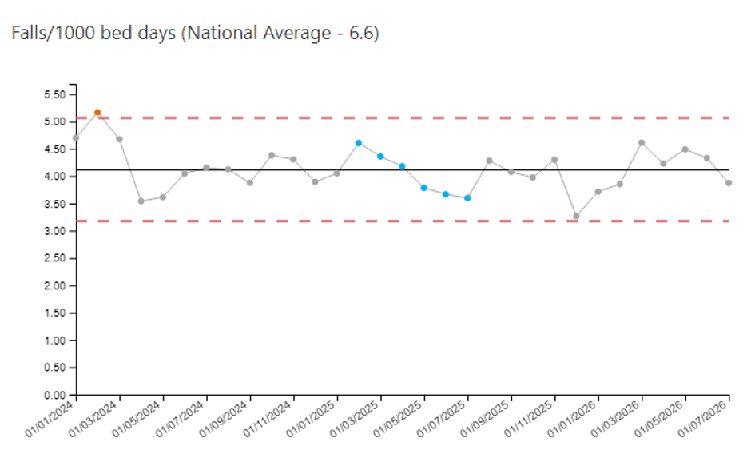A revised In-Hospital Falls Policy, incorporating an updated risk assessment process and associated staff training programme, has been implemented. The impact of these changes is expected to contribute to improved falls prevention and reporting during the coming period.
- Medication errors
Medication errors accounted for 246 patient safety incidents in Quarter 1, a reduction from the previous quarter. The most common themes were administration, prescribing, supply and documentation errors, together with previously unknown allergic or adverse reactions.
The Acute Medical Unit and Emergency Department at Morriston Hospital reported the highest numbers of incidents. Along with the Neonatal Unit, Chemotherapy Day Unit and Ward 12 at Singleton Hospital, these areas accounted for almost 25% of medication-related incidents.
A serious incident investigation identified distraction and workload pressures as contributory factors in a case where incorrect medication was administered due to inadequate patient checks. In response, services have reinforced the importance of patient identification checks regardless of familiarity and introduced protected medication administration practices to minimise distractions.
- Patient Safety Incidents
During Quarter 1, the Health Board reported 6,033 incidents, of which 4,942 (82%) were patient safety incidents.
The most common incident themes resulting in patient harm were pressure/moisture damage, accidents and injuries, behaviour-related incidents, treatment/procedure issues, and medication/IV fluid errors.
The locations reporting the highest numbers of harm incidents were the Acute Medical Unit, Ward R, Clyne Ward, Older Persons Assessment Service, and Ward D (Neath Port Talbot Hospital). The predominant themes were pressure damage, behavioural incidents, and accidents/injuries

- Nationally Reportable Incidents
During Quarter 1, the Health Board reported 23 Nationally Reportable Incidents (NRIs) to NHS Performance and Improvement. These comprised: avoidable healthcare-acquired pressure damage (10), stillbirths and neonatal deaths ('Must Reports') (4), unexpected deaths (3), medication incidents (2), delayed or missed diagnosis (2), avoidable inpatient falls (1), and a healthcare-acquired infection (1).
All NRIs are subject to established reporting, review and governance processes to identify contributory factors, learning and required improvement actions. Progress is monitored through relevant quality and safety governance structures to support organisational learning and risk reduction.
It should be noted that healthcare-acquired pressure damage and avoidable inpatient falls are reported retrospectively following scrutiny panel review. As these incidents are only classified as avoidable after detailed assessment, a proportion of those reported during Quarter 1 occurred in previous reporting periods
The rate of Nationally Reportable Incidents reported per 100,000 population shows no evidence of sustained deterioration and remains below the All-Wales comparator in the majority of months (higher rates are seen during December 2025, January 2026 and May 2026).
During Quarter 1, 45% of the 22 nationally reportable incidents due for closure forms were closed on time.
- Never Events
There have been no new Never Events reported to NHS Performance and Improvement since May 2025.
- Complaints performance

During Quarter 1, the Health Board received 633 complaints, a reduction from 742 in Quarter 4, reflecting implementation of the Listening to People (LTP) process in April 2026. The new approach emphasises early engagement, listening discussions and local resolution. While complaint acknowledgement performance remained strong at 100%, only 47% of formal complaints were responded to within agreed timescales, and 303 complaints remained overdue, including 80 LTP concerns, highlighting ongoing performance challenges.
The graph below shows an improving trend in relation to the management of concerns through Early Resolution, putting us on track to achieve the Welsh Government target of 40% of concerns managed though this route by April 2027.
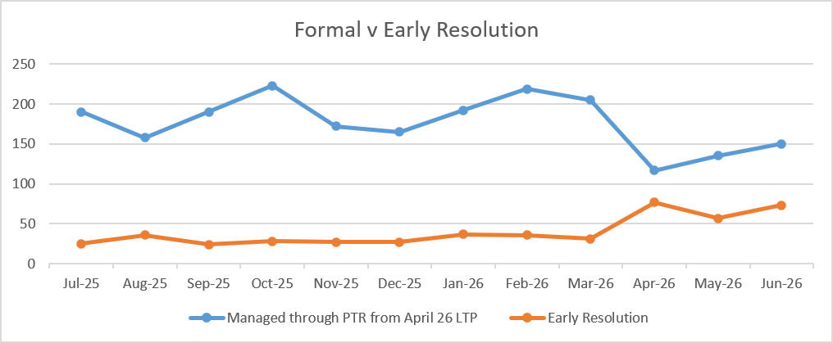
Learning from complaints continues to identify recurring themes of communication, waiting times, access to care, delayed diagnosis and follow-up arrangements, particularly within Emergency Department, Orthopaedic and Gynaecology services. The introduction of Listening Discussions has enhanced opportunities for patients to share their experiences directly, supporting a more person-centred approach to resolution. Increased contact with Patient Advice and Liaison Services (PALS) also indicates improved accessibility and engagement.
Improvement actions to reduce the number of overdue concerns have included additional Corporate Nursing support for high-volume service groups, daily concerns huddles, focused management of overdue complaints and exploring improved signposting for patients awaiting treatment through the Waiting Well service.
Early outcomes include reduced complaint volumes, greater use of early resolution approaches, improved access to advice and support, and a reduction in overdue Putting Things Right complaints. Although overdue LTP concerns remain a challenge, performance continues to be closely monitored through the monthly Listening to People Programme Board.

- Patient Advice and Liaison Service (PALS)
During Quarter 1, PALS continued to provide an important early resolution route for patient concerns based from Morriston, Neath Port Talbot and Singleton Service hospitals. Following implementation of the Listening to People process, PALS contacts increased, demonstrating greater awareness and use of early resolution pathways.
The most common reasons for contact were communication issues (145), appointments (87) and test results (85). Lower levels of contact related to clinical treatment, admissions, discharge, referrals, staff attitude and personal property concerns.
Recognising the significant number of contacts through the PALS service and their important role within Listening to People. Process mapping has commenced for both concerns and PALS teams to identify areas of duplication that can be addressed. Learning from this we are reviewing our approach to triage of concerns and PALS contacts to ensure consistency.
- Public Service Ombudsman
During Quarter 1, the Health Board received five new Ombudsman investigations and continued to manage actions arising from previous cases.
A Special Report was issued by the Public Services Ombudsman for Wales, which concluded that we had not fully implemented recommendations relating to an independent audit of the orthopaedic waiting list and staff training on Referral to Treatment (RTT) guidance. The Ombudsman determined that delays in implementing these actions posed an ongoing risk to patients and exercised powers under the Public Services Ombudsman (Wales) Act 2019 to issue a Special Report. The report will be shared with the Minister for Health and Social Care and Healthcare Inspectorate Wales. The Health Board has provided comments on the report and has now received the final version. Improvement plans are in place to deliver the outstanding recommendations and address identified risks and these are overseen through the Quality and Safety Group.
- Duty of Candour
The Duty of Candour was triggered in 40 patient safety incidents during Quarter 1.
The highest levels of reporting were from the Acute Medical Unit, Emergency Department and Ward B, Neath Port Talbot Hospital. The most common Duty of Candour theme related to inpatient falls, followed by healthcare-acquired pressure damage.
Of the five Duty of Candour cases closed during Quarter 1, compliance was:
- In-person notification: 80%
- Written notification: 100%
- Final response issued: 80%
Duty of Candour incidents continue to be monitored through established governance processes within service groups. Compliance levels for closed cases indicate effective implementation of the Duty.

Patient Experience

Patient experience remained positive during Quarter 1, with 94% satisfaction from over 20,000 Friends and Family responses, demonstrating that most patients continue to report good experiences of care. Feedback consistently highlighted staff compassion, professionalism, kindness, communication and quality of care. High satisfaction levels were reported across Mental Health and Learning Disabilities (99%), General Surgery (97%) and Cancer Services (96%), while Emergency Department satisfaction improved from 64% to 71%.

Patient comments reflected positive experiences of compassionate care, clear communication and staff responsiveness. However, feedback relating to the Active Offer of Welsh-language services indicated inconsistency across some areas. Improvement work is underway to increase Welsh-medium clinical consultations in key services, including Mental Health, Children and Young People’s Services, Speech and Language Therapy and Care of the Elderly.

Analysis of respondent demographics indicates that feedback is predominantly received from older, English-speaking women, highlighting the need to strengthen engagement with a broader range of communities.
More than 1,000 compliments were received through the Medical Examiner service, mainly relating to end-of-life care delivered by District Nursing teams.
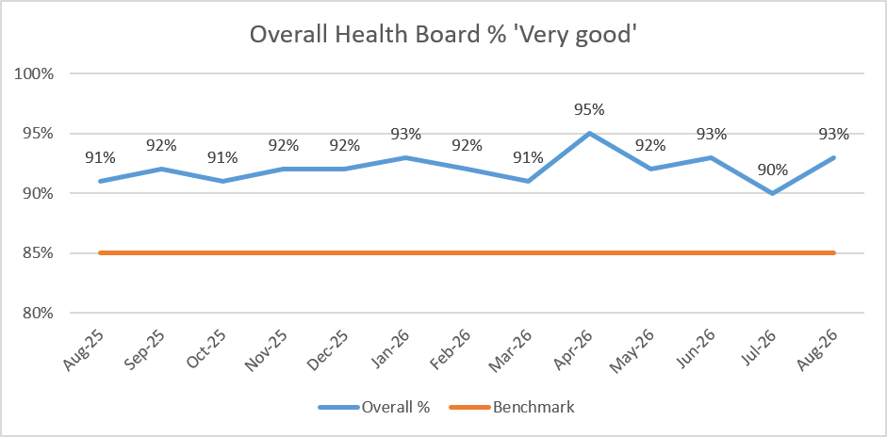
Examples of positive comments received within the feedback include:
- I got to be honest this is the first time I have ever had to go through this and the staff was absolutely amazing well welcomed and explained everything that was going to happen fair play.
- Everything explained efficiently with timelines highlighted for follow up appointments and hearing aid provided. Seen by audiologist and student who were both attentive and understood my needs.

Focus area: Unscheduled care
During Quarter 1, the Emergency Department and Unscheduled Care services continued to face pressures associated with high demand, waiting times and communication. These themes were reflected in patient feedback, complaints and PALS contacts. Despite these challenges, patient experience improved, with Emergency Department satisfaction increasing from 64% in Quarter 4 to 71% in Quarter 1.
Patients identified waiting times, communication, comfort while waiting and emotional support as the main areas for improvement. In response, changes were made to triage and ECG pathways to help reduce delays and improve patient flow.
Focus area: Cancer services
Cancer Services achieved a 96% patient satisfaction rate from Friends and Family feedback during Quarter 1. Patients particularly praised staff compassion, professionalism, support and communication. The service received no formal complaints during the quarter, providing assurance regarding the quality of patient experience. Areas identified for improvement related mainly to waiting times and parking. Cancer Services also continue to monitor and learn from reported treatment and radiotherapy incidents.
Focus area: Mental Health services
Mental Health and Learning Disabilities services reported the highest patient satisfaction rate in the Health Board at 99% during Quarter 1, providing assurance regarding patient experience. Feedback consistently highlighted compassionate, supportive and professional care from staff. The service received very positive Friends and Family feedback, with patients valuing the quality of interactions, involvement in care and the support provided.
Focus area: Orthopaedic services
Orthopaedic Services achieved a 92% patient satisfaction rate during Quarter 1, indicating that most patients reported a positive experience of care. However, Orthopaedics continued to feature within complaints and concerns data, particularly in relation to communication, waiting times and access to treatment. The service was also referenced in Ombudsman activity, reflecting ongoing challenges associated with waiting list management.
Focus area: General surgery
General Surgery reported a 97% patient satisfaction rate during Quarter 1, one of the highest across the Health Board. Patient feedback was overwhelmingly positive, with patients frequently highlighting the professionalism, kindness and compassion of staff, alongside the quality of care received. The high satisfaction score provides strong assurance regarding patient experience within the service. No significant concerns were identified within the patient experience data.

Ward and clinical environment assurance visits

Quality assurance visits were undertaken by the Corporate Quality and Safety Team to Ward 10 (Singleton), Gynaecology Outpatients, Early Pregnancy Unit, Cyril Evans Ward, Ward H (Morriston), Wales Fertility Institute and the Surgical Assessment Unit (Morriston). Follow-up reviews were also completed for Derwen Ward and Fendrod Ward.
These visits provide an additional layer of assurance alongside Service Group quality monitoring arrangements. Actions arising from visits are recorded on the AMaT system and monitored through the Patient Safety and Compliance Group.
Key themes identified included:
Patient experience: Patients consistently reported care from friendly and welcoming staff. Opportunities were identified to improve the quality and choice of food and drink available.
Staff experience: Staff described a strong team ethos and feeling well supported by senior leaders.
Safe care: Improvements were required in patient identification checks, ensuring pull cords meet anti-ligature requirements, and maintaining compliance with safeguarding training. Well-organised ward information boards were observed, supporting effective communication with patients and staff.
A programme of quality assurance visits is planned for the remainder of 2026, targeted according to risk, executive request and routine assurance requirements. This provides ongoing oversight of care quality and supports timely improvement where issues are identified.
- Quality insight
Quality data has been analysed to identify recurring themes across sources. The most frequently occurring issues are listed in the following table.
Communication remains a key theme across all intelligence sources. The introduction of the Listening Discussion will strengthen how we communicate with patients and their families, however work remains to be done in terms of communication between teams and with our colleagues in Primary Care.
Waiting times and access are a major driver for patient dissatisfaction. We are promoting the Waiting Well Service for patients waiting for planned care, however workforce challenges within the Booking Office are currently limiting people's ability to contact a member of health board staff to confirm whether they have been placed onto a waiting list. Work will continue between the concerns and booking office team in order to address this.
Building on our quarterly patient safety congress events, we are now issuing information briefs to support staff in learning from events. We have also established a monthly learning forum and are revising our Learning Framework to put support teams in sharing and developing their knowledge.

Theme | Incidents | Complaints | PALS | Patient Experience | QA Visits | Ombudsman. | What is this telling us?
Communication | ✓ | ✓ | ✓ | ✓ | ✓ | ✓ | Most consistent theme.
Waiting Times & Access to Care | ✓ | ✓ | ✓ | ✓ |  | ✓ | Major organisational challenge driving dissatisfaction and scrutiny.
Delayed Assessment / Diagnosis | ✓ | ✓ |  |  |  | ✓ | Ongoing patient safety and quality risk.
Emergency & Unscheduled Care Pressures | ✓ | ✓ | ✓ | ✓ |  |  | Demand pressures affecting patient experience, though improvement emerging.
Workforce Capability, Training & Compliance | ✓ | ✓ |  |  | ✓ | ✓ | Recurring contributory factor across quality issues.

- GOVERNANCE AND RISK ISSUES

Quality and Safety Committee should be assured by the steps taken to ensure that learning from concerns and patient feedback is being translated into improvement in some areas, however risks remain in the following areas:
- Healthcare-acquired pressure damage remains a significant patient safety concern requiring continued improvement.
- Complaints performance is below target, with a substantial backlog of overdue concerns.
- Delays in assessment, diagnosis and treatment continue to be reported across services.
- Waiting times and access to care remain key drivers of patient dissatisfaction.
- Orthopaedic services continue to face scrutiny following Ombudsman findings.
- Emergency and unscheduled care pressures present ongoing quality and safety risks.
- Workforce capacity and training compliance issues remain contributory factors.
- Incident investigations and closure times require further improvement.
- Duty of Candour compliance is improving but is not yet fully consistent.

- OPEN AUDIT RECOMMENDATIONS

There are open audit recommendations in relation to Learning from Concerns and the Management of Nationally Reportable Incidents which are being addressed through the Quality and Safety Group.

- FINANCIAL IMPLICATIONS
There are no direct financial risks associated with this paper, however, Committee should be cognisant of the financial implications related to concerns management, namely redress and Welsh Risk Pool reimbursal requirements and Ombudsman penalties.

- RECOMMENDATION
Members are asked to:
- Note the key patient safety, patient experience and quality risks highlighted within the report.
- Seek assurance that targeted improvement actions are in place for pressure damage, complaints performance and access to care.
- Monitor progress against Ombudsman recommendations, Duty of Candour compliance and incident management timescales.
- Support continued organisational learning and oversight of actions arising from incidents, complaints and patient feedback.

Governance and Assurance
Strategic Objectives
Strategic Objectives  (please choose which is impacted) | People of Swansea Bay live healthier, fairer and more prosperous lives | ☒
Strategic Objectives  (please choose which is impacted) | Care is high quality, safe, efficient and delivers the best possible outcomes for people in partnerships | ☒
Strategic Objectives  (please choose which is impacted) | Care is delivered in partnership with our communities in safe and appropriate setting, supported by innovation | ☒
Strategic Objectives  (please choose which is impacted) | The health board is a great place to work where staff feel valued and work together towards a common goal | ☒
Strategic Objectives  (please choose which is impacted) | The health board is a resilient, sustainable and responsible organisation | ☐
Health and Care Standards
Standards (please choose which applies) | Safe Care | ☒
Standards (please choose which applies) | Timely Care | ☒
Standards (please choose which applies) | Effective Care | ☒
Standards (please choose which applies) | Efficient Care | ☒
Standards (please choose which applies) | Equitable care | ☒
Standards (please choose which applies) | Person-centred Care | ☒
Standards (please choose which applies) | Staff and Resources | ☒
Enablers (please choose which applies) | Whole Systems Approach | ☒
Enablers (please choose which applies) | Leadership | ☒
Enablers (please choose which applies) | Workforce | ☒
Enablers (please choose which applies) | Culture | ☒
Enablers (please choose which applies) | Information | ☒
Enablers (please choose which applies) | Learning, Improvement and Research | ☒
Quality, Safety and Patient Experience
The report provides oversight of key patient safety risks, including pressure damage, incident management, delayed diagnosis and Duty of Candour compliance.
It highlights patient experience concerns relating to communication, waiting times, access to services and complaints performance.
The report offers assurance on quality governance while identifying areas requiring improvement to enhance patient outcomes, experience and organisational learning.
Financial Implications
There are no direct financial implications associated with this paper.
Legal Implications (including equality and diversity assessment)
The report provides assurance regarding compliance with statutory duties relating to patient safety, quality governance, complaints management and the Duty of Candour.
Staffing Implications
There are no direct staffing implications related to this paper, however the risk in terms of capacity should be acknowledged.

Long Term Implications (including the impact of the Well-being of Future Generations (Wales) Act 2015)
The report supports the Act by promoting prevention, continuous improvement, involvement and long-term service sustainability through the identification of quality, safety and patient experience risks and the implementation of actions to improve outcomes for current and future populations.

Report History
This is the first presentation of this report.

Appendices
None.

