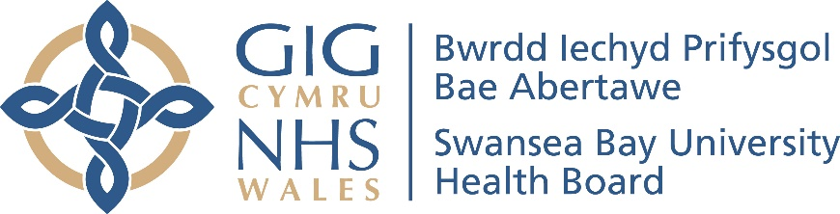
Swansea Bay University Health Board
Health and Safety Annual Report 2022/23

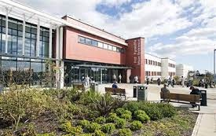
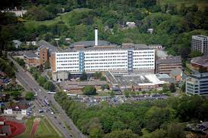

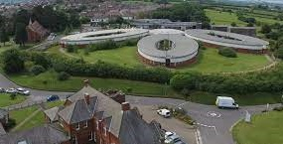
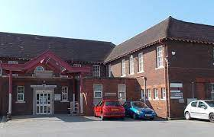

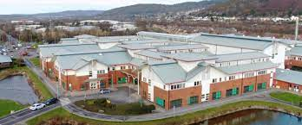

CONTENT

1 - Introduction 3

2 - Background 3

3 - Key Achievements 6
Could include deep dives here or in 4.2
Electric training adopted by all Wales
RIDDOR Training
PBM

4 – Health & Safety Governance Structure 7
4.1 – Health & Safety Arrangements 7
4.2 – Health & Safety Committee/Group Structure 8

5 – Training Compliance 8
5.1 – Health & Safety Training 8
5.2 – Manual Handling Training 10
Other mandatory training based on KPI’s
PBM

6 – Fire Management 11
Fire compartmentation
Fire risk assessments
Fire actions
Fire Warden Training
Fire Audit submission (Could be in key achievements)

7 - NWSSP Audits 12
Add in any information on audits 13

8 – Enforcement Authorities Audits/Inspections 13
Add any information

9 – Incidents – RIDDOR’s 14
10.1 – Case Management 17
DATIX

10 – Health & Safety Risk Register 18
HBRR
SG RR’s

11 – Policies & Procedures 19

12 – Estates & Other Groups Monitoring Compliance 19
12.1 – Electrical (Low & High Voltage) 19
12.2 – Ventilation 20
12.3 – Piped Medical Gases & Operational 20
12.4 – Asbestos Management 20
12.5 – Water Safety 20
12.6 – Estates Fire safety 21
6 FACET Survey
Security
Clinical Waste

13 – Conclusion 21

14 – Recommendations 22

- INTRODUCTION

Swansea Bay University Health Board provide many services across Swansea, Neath and Port Talbot geographical locations, these cover a range of services and settings; tertiary, acute, mental health and learning disabilities and primary care. There are several regional services provided from SBUHB with Morriston Hospital being the Welsh Centre for Burns and Plastic Surgery for Wales and the South of England as part of the UK Burns Network. Our services span across other Health Board areas and host the Welsh Air Ambulance service. SBUHB currently employs circa 13,000 staff.

The Health and Safety annual report covers the period 1st April 2022 – 31st March 2023. The report outlines the journey the Health Board has taken throughout the year, covering key issues:

- Health & safety team resources
- Fire risk assessment compliance
- Training compliance
- Policy & procedure development
- Health & Safety governance
- Enforcing authority actions/site visits (HSE & Fire)
- Health and Safety risk register
- NWSSP internal audits/inspections and actions
- Health and Safety Committee meetings
- Health & Safety Operational Group meetings
- Fire Safety Group meetings
- Supporting/input – implementation of the One for Wales (OfW) DATIX system – commencement date 1st April 2022 with on-going development and feedback
- Collaborative working with Occupational Health Services (Development of a single COSHH database) & site inspections/audits
- Development of internal health & Safety training for managers/supervisors
- RIDDOR training
- Review and enhancement of fit test training packs for the continued rollout of fit testing.

This year has seen the continuation COVID-19 that is now incorporated into respiratory infections, all of which provide challenges for the Health Board, consequently the health & safety implications remain. The Health Board continue to introduce and update control measures based on national and devolved government guidance in response respiratory infections.

- Background

During 2022/23 there has been significant changes within the Health Board, with ‘Changing for the Future’ and the development and introduction of the centres of excellence:
- Morriston Hospital – Centre of excellence of urgent and emergency care, complex care, specialist care and regional surgery.
- Singleton Hospital – Centre of excellence for planned healthcare, women’s health, cancer care and diagnostic tests.
- Neath Port Talbot Hospital – Centre of excellence for orthopaedic and spinal care, rehabilitation and rheumatology, outpatients, day surgery and minor injuries.

There is good governance structures in place for the effective management of health, safety and fire, with regular scrutiny through the Fire Safety group, Health and Safety Operational group and the Health and Safety committee. SBUHB continues its journey to improve and maintain compliance. Continually reviewing and developing policies/procedures and training.

- COVID – Respiratory Infections

With the successful vaccination programme and peoples immune systems being more resilient against COVID-19. There has been a focus on respiratory infections overall, this includes COVID-19, with appropriate assessments undertaken and suitable controls put in place.

Throughout 2022/23 the health and safety team through its respiratory protection coordinator have provided support throughout the health board facilities to ensure our staff receive information, instruction, training and supervision in the correct use of respiratory protection equipment (RPE) to protect the staff member where this is identified by risk assessment and/or safe operating procedures. The health board have developed a network of fit test trainers to assist in the fit testing of our staff and are essential to maintain compliance in this area.

The health board purchased Quantitative testing equipment, this type of test gives an objective assessment of facial fit and provide a direct numerical result called a Fit Factor and can be used for all types of tight-fitting masks including FFP’3 (disposable), half and full face masks. Staff have been upskilled to fit test using this equipment, with a rolling programme in place.

Worked with other health boards/trusts, agencies and stakeholders covering high consequence infectious diseases (HCID). Undertaken joint reviews of training programmes and teaching with accreditation bodies RPA – BSIF.

- Key Achievements 2022-23

Given the challenges over the period it is important to outline some of our key achievements, these are listed in table1. The Health Board response to COVID-19 and respiratory infections, with all staff, management and trade unions working together to implement national guidance, putting in appropriate control measures to minimise and/or remove the risk. Two additional staff appointed to the health and safety team, one health and safety advisor and one manual handling trainer/advisor, providing support to all service groups.

The fire safety advisors have maintained 100% compliance in completing fire risk assessments (FRA) and have improved the information recorded on the FRA, providing more in depth responses for greater understanding to those who receive the FRA’s to follow up actions identified.

Positive work with the service groups, reviewing health and safety governance agendas, putting in firm foundations for health, safety and fire. New groups have been set up as part of the overall reviews, sharing good practice and identifying learning.

In April 2022, Health Boards and Trusts in Wales implemented the new incident module on the DATIX system. This system updated the current incident module and provides a consistent approach across Wales. Swansea Bay was heavily involved in reviewing the existing incident coding structure and developing new codes across the breath of the health, safety and fire agenda.

Table 1.
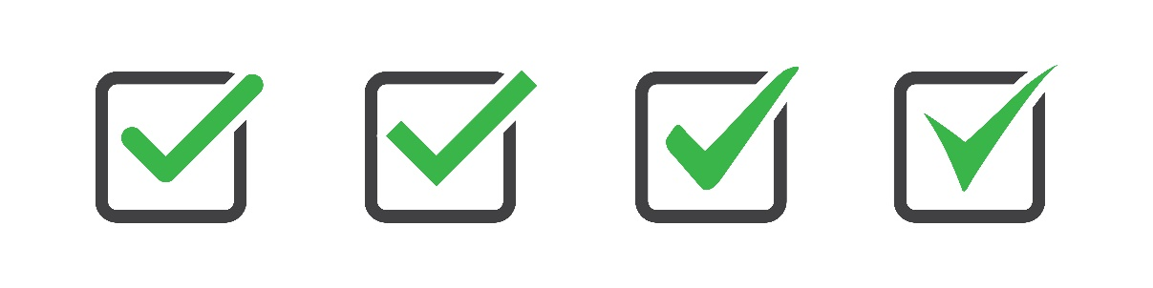

- Provision of manual handling training, capturing increased numbers of health care support workers (HCSW) and new recruits from overseas (nurses)  - Introduction of health & safety key performance indicators  - Successful recruitment to health & safety team increasing resources  - Supporting network of fit test trainers, increasing overall compliance in our hospital sites  - Providing support at an all Wales and HB level for the implementation of a new DATIX ‘One for Wales’ incident reporting module  - Maintain and improve H&S training – RIDDOR – electrical safety  - Development of base line training for managers/supervisors  - Review of policies and procedure  - Site reviews/tours in conjunction with operational managers and trade unions  - Electric safety training developed by SBUHB adopted across NHS Wales and uploaded to ESR  - RIDOOR training to improve compliance with regulations  - Reviews of Health Board Risk Registers throughout the year  - Health and Safety training for Executives & Directors | - Maintaining system for case management support for staff affected by violence and aggression  - Participating and responding to internal audit and agreeing actions to address identified areas of limited assurance  - Promotion of H&S through Health and Safety Operational Group  - Promotion of fire safety through the fire safety group  - Provision of assurance to the HB Health & Safety Committee  - H&S team have supported staff returning to working undertaking specific risk assessments and recommending adjustments to facilitate their return, number of assessments vary year on year  - Development of fire evacuation plans, including drawings  - Fire risk assessment completion 100% compliant  - Supporting service groups in all areas of H&S, Fire, Manual Handling and Case Management  - Delivery of manual handling training and support for MH coaches  - Return to a 2 day course for manual handling as indicated in all Wales MH passport scheme guidance  - Undertaken deep dives for. Fire, DSE, V&A, RIDDOR and COSHH

- Health & Safety Governance Structure

  - Health and Safety Management Arrangements
SBUHB Health and Safety Management Arrangements Chart
SBUHB Health Board
Chief Executive
Board Level Director – H&S Specific Risk
Key
Line Management
Strategy, Advice, consultation etc
(*) Dependant upon Management Structure

Staff
Ward and Departmental Managers
Trade Unions/ Safety Representatives
Competent Advice – Occupational Health etc.
Board Level Director H&S
Management Functions: Service Groups SBUHB-wide functions
Senior Managers (*)/ Management Team (*)

Health & safety governance is as important as any other governance. It is a fundamental part of an organisation’s overall risk management function which is a key responsibility of directors. Failure to manage health and safety risk effectively has both human and business costs. The price of failure can be the damaged lives of workers, patients, their families, as well as direct financial costs, damage to reputations and the risk of legal prosecution.

  - Health & Safety Committee/Group Structure

SBUHB Board

SBUHB Health & Safety Committee

SBUHB Health & Safety Operational Group (Consultative Forum)

SBUHB Support Services/Estates H&S Groups

SBUHB Health, Safety Fire Safety Group

SBUHB Service Group H&S Groups

Service Group Departments -Wards

Estates Specialist Groups

The Health & Safety Committee/Group structure has been established for the health board, with clear links to service groups and specialist areas i.e. fire and estates to plan, manage and monitor organisational compliance with statutory health and safety requirements. Given the positive work undertaken by the HB health and safety committee that was specifically introduced following Abertawe Bro Morgannwg UHB/Swansea Bay UHB receiving improvement notices in 2018/19. The Health Board has reviewed its board assurance committees with the HSOG having a change in reporting and will report through to the Quality and Safety committee in 2023/24 and aligns to committee structures in other health boards.

- Training compliance

  - Online Health and Safety Training

Throughout the year steady progress has been made on overall training compliance. The majority of training has been provided remotely via teams or through the electronic staff records (ESR) system. The Welsh Government and Swansea Bay UHB have provided targets for training compliance and this is a minimum of 85%, with all service groups reporting compliance figures throughout the year covering H&S subjects listed:
- Health & Safety
- Manual Handling
- Violence & Aggression
- Fire Safety Training

All service groups have reported challenges in their ability to improve compliance levels due to sick absence, respiratory infections, vacancy factor and general operational pressures. All service groups have put measures in to improve on current compliance levels of training and there has been steady progress throughout the year.

The following charts show the training performance by service group for 2022/23 financial year.

Chart 1. Mental Health and Learning disabilities

Chart 2. Morriston Service Group

Chart 3. Neath, Port Talbot and Singleton Service Group

Chart 4. Primary Care and Therapies Service Group

All service groups have recognised the challenges throughout the year and also the need to increase compliance to at least 85% where this has not currently been achieved, and have action plans in place to increase training compliance going forward. This will be monitored through the HSOG and reported to the Quality and Safety Committee in the HSOG key issues reports in 2023/24.

The health boards patient profiles in acute settings has changed, there are more patients presenting with difficult and challenging behaviours. Therefore, the training has been reviewed in some settings i.e. elderly care and traumatic brain injury unit within the Neath, Port Talbot, Singleton service group, who have agreed to pilot specific training developed in the Mental Health & Learning disabilities service group and looks at these specific behaviours and has proved successful in mental health & LD settings. This will be regularly monitored, with a full review during 2023/24.

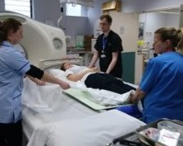
  - Manual Handling Training

SBUHB Manual Handing policy sets out two training systems that work together to meet the guidelines and training needs of the organisation provide induction training and maintain competency in the workplace this includes:-

- 2 day Induction Foundation Manual Handling Training
- Competency assessment in the workplace delivered by Manual Handling Coaches (MHC)
Throughout the year the manual handling team have provided manual handling induction training and training for our international nurses arriving each month to ensure they have the skills required to undertake the tasks they will encounter during their operational work. Staff are also supported by the network of manual handling coaches based throughout the service groups.

- Bariatric training covering complex handling cases in theatres, working with consultants and nursing staff to maintain safe manual handling techniques to minimise risk of injury to staff and patients  - Theatres – Use a unique prone hoisting method for TEO rectal surgery (highly challenging and complex manual handling and hoisting of a patient in a prone position under anaesthetics)  - ITU – Physio team rapidly implemented a prone manual handling technique to assist in ITU and wards for patients with respiratory infections  - Development of SOP for the reduction of risk for patients with long waits on ambulances to influence change  - Manual Handling Strategic Lead has taken up Chair of the all Wales manual handling group (2 yrs.) | - Patient falls with query spinal cord fracture ‘off the floor lifting flat hoist training’ – This was bespoke training in the safe use of specialist equipment required for hoisting triple immobilised patient with suspected spinal cord fracture off the floor.  - Major contributors to the total bed management framework  - Development of risk assessment to assist with the transition to the new total bed management contract  - Developed and implemented specialist courses for theatre, bariatric rehabilitation discharge, paediatrics, estates, catering, domestics, district nurses and maternity  - Support of complex urgent manual handling assessment and support across the acute and community are left to the Strategic MH adviser  - Reviews of MH DATIX incidents with complex needs
- Fire Management
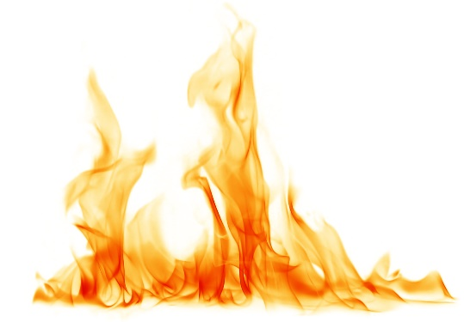
The Health Board have commissioned fire compartmentation surveys for Morriston and Singleton hospitals, with our PFI partner surveying Neath, Port Talbot hospital. A work programme for NPTH has been in place throughout 2022/23 and is 95% complete. The remaining works will be completed in 2023/24.
The fire team, estates and capital are working with shared services specialist estates services (Fire) to evaluate the surveys and develop work programmes for Morriston and Singleton hospitals. Work programmes to address any issues identified will be picked up through estates discretionary capital, estates funding advisory board (EFAB) and capital schemes going forward. Singleton survey final report will be received during 2023/24, so once received, this will be added to the overall programme.

The fire team continues to maintain a 100% compliance in completing risk assessments and have provided support at service group health & safety and fire meetings. Also participated in site tours with operational management and trade union colleagues. Worked with operational management on developing and implementing fire evacuation plans that include drawings.

A full review of the fire risk assessment questions and answers has been undertaken, and from this changes made. Information now provided is more in depth and gives the manager and/or estates staff more information to enable development of action plans to complete issues identified. Regular meetings have been scheduled with estates throughout the year to monitor estates actions completed and identify works where capital is required to address.

  - Fire Audit Submission

The submission this year covers all main hospital sites across the Health Board as well as LD Bungalows and some Primary Care buildings. The submission has involved interviews with senior Managers in all the relevant Hospitals and covers acute, Mental Health and Learning Disability and Primary Care sectors. The Audit looks at costs of achieving compliance with Fire code, Policy, Management, Maintenance and Training issues.

  - Fire Warden Training

Progress has been made in identifying Fire Wardens throughout the Health Board. Where gaps are identified training has been provided, this is through face to face at each site, with the option of TEAMs where this is beneficial for the service i.e. Learning Disabilities. This has generated a positive response and received good feedback.

- NWSSP Audits

The health board have not received any health and safety, fire or estates audits during the year, however, there are actions identified on audits carried out in previous year and the team are working through these and updated the shared services audit tracker software to ensure actions are completed and closed. This will continue throughout 2023/24 until all actions have been addressed and this will be monitored through the fire safety group, health and safety operational group and reported to the quality and safety committee.

- Enforcing Authority Audits/Inspections

There were no formal inspections or audits undertaken by the Health and Safety Executive or the two fire authorities (Mid and West Wales Fire & Rescue Services – South Wales Fire & Rescue Services) that are responsible for the geographical area that Swansea Bay UHB provide services during 2022/23.
- Incidents - RIDDOR

The Health Board records incidents on DATIX risk management software system, where staff and managers input information and undertake investigations. Throughout the year incidents are reported through the delivery group health & safety meetings and the HSOG, with higher category incidents including RIDDOR incidents reported through to the Health & Safety committee. The system enables the Health Board to analyse the data, identifying types of incidents, trends and enables identification of lessons learnt from investigations.
As anticipated following the reduction in incidents reported during 2021/22 due to COVID-19, there has been an increase in incident rate during 2022/23 of 33% overall.

Chart 6. All incident rates (Staff) 2022 – 2023 (10 & above reported)

Chart 7. Identifies incidents by Service Groups & corporate Groups 2022 - 2023

Chart 8. Top six staff incidents for 2022/23

Violence and aggression as an overall category covers several sub categories and perception on where these occur normally points to emergency departments due to this being the main access point for various conditions, however, this is not the case as is highlighted in chart 9 showing V&A incidents by speciality and excludes mental health and learning disabilities.

RIDDOR reports are a legal requirement with specific guidance on what is a reportable incident, dangerous occurrence or reportable disease, all of which need to be reported to the Health and Safety Executive within prescript timeframes. During 2022/23 the Health Board reported 50 RIDDOR incidents, two of which were classed as dangerous occurrences as being reportable.

A breakdown of the RIDDOR incidents is shown in chart 10 and comparisons with previous years in chart 11.
Chart 10. RIDDOR breakdown by type

Chart 11. RIDDOR breakdown by type and by financial year 2022/23

Reporting of Injuries, Diseases and Dangerous Occurrence Regulations puts a requirement on the organisation to report specific injuries and dangerous occurrences to the health and safety executive via an online portal. The HB has complied with this throughout the year and have reported 47 staff related RIDDOR’s during 2022/23 and 3 for patients. The majority of the reported incidents were for over 7 day’s absence. A breakdown of categories:

- Over 7 days
- Struck by object
- Slip, Trip and fall
- Manual Handling
- Burns
- Assault
- Others (Dangerous Occurrence)

  - Case Management
SBUHB is part of the all Wales case manager group and in 2021 NHS Wales (CEO) along with the four Police forces in Wales, Crown Prosecution reaffirmed their commitment to the NHS Anti-Violence Collaborative ‘Obligatory response to violence in healthcare’ this document sets out the responsibilities of the partners when dealing with violent or aggressive incidents relating to NHS staff. Its focus is on those incidents which need to be addressed by the criminal justice system and builds on previous agreements in Wales.
Within the health and safety team support is provided by the case manager to victims of violence & aggression, with additional support through the wider H&S team if required. The case manager also acts as the single point of contact (SPOC) for the health board and attends all Wales meetings to share learning and best practice.
There are several actions that can be taken, ranging from discussions/behavioural contract through to prosecution. Sanctions issued:
- 26 anti-social behavioural orders (ASBO)
- 6 Behavioural contracts/letters
- No prosecutions pursued
- Health and Safety Risk Register

The Health Board Risk Register (HBRR) includes high risk health and safety risks, these are monitored through the Health & Safety Committee, with appropriate updates provided. At the end of March 2023 the following H&S risks remain on the HBRR:

- HBRR Ref number: 64 – Insufficient resource and capacity of the health, safety and fire function (score of 16)
- HBRR Ref number: 41 - Fire Regulation Compliance, Uncertain position in regard to the appropriateness of the cladding applied to Singleton Hospital in particular (as a high rise block) in respect of its compliance with fire safety regulations (score 16)
- HBRR Ref number: 13 - Health & Safety Compliance – Environment of Premises. Risk relates to compliance in terms of appropriate accommodation in line with Health and Safety Regulations (score 16)

The scores have remained the same throughout the year for two of the three risk, with a reduction in HBRR 64 reduced to a score of 16 in 2022/23. This was primarily due to the recruitment of additional health and safety resources in January 2023.

In addition to the Health Board risk register there are delivery unit risk registers, these are presented to the Health and Safety Operational group for review at each of the meetings throughout the year. In total there are 11 risks, six of which have reduced risks scores and five have remained the same during 2021/22 as shown in chart 12.

- Policies and Procedures

Policies and procedure are taken through the scrutiny of the HSOG and H&SC and approved during 2022 – 2023:

- Managing Contractors Policy
- Violence and Aggression Policy

- Estates and Other Groups monitoring compliance



The Health Board has a number of sub-groups/specialist groups that report through to the HSOG, these are:

- Electrical Safety Group
- Ventilation Safety Group
- Piped Medical Gas Safety Group
- Asbestos Management Group
- Water Safety
- Estates Fire Safety
- Occupational Health Surveillance Group

Regular reports received outlining the compliance levels in the estates speciality groups with a constant message on the challenges with resources in all disciplines.

Occupational health attend periodically to cover specific areas i.e. respiratory functions.

The updates from estates highlighting various challenges within the last report highlighting:

  - Electrical - Low Voltage (LV) & High Voltage (HV)

Authorised persons (AP) have been appointed for Morriston & Singleton hospitals, however, due to retirements and resignations this continues to be a challenge with current resources.

A recent 6 FACET survey has identified and clarified the non-compliance to WHTM’s, with the health board in the process of finalising its estates strategy that will aim to address backlog maintenance and compliance

Estates have in place an estates risk register, with electricity being one of the risk identified. This covers capacity of infrastructure, distribution boards and wiring.

The HB has appointed an authorised engineer for HV that is external to the HB and have also appointed an HV AP with limited duties internally.

  - Ventilation Systems

Resource continue to provide challenges in this area with loss of staff from the estates department. Issues have been highlighted in the authorised engineers (AE) annual report and also in the recent 6 FACET survey undertaken. With the age and condition on the ventilation plan raised as not being compliant. On-going recruitment and development of staff to fill AP posts continues.

  - Piped Medical Gases

The Piped Medical Gases Group are working with clinical colleagues to pilot test around nitrous oxide with a view to remove this service and move to bottled supplies to reduce losses to atmosphere, this will continue in to 2023/24. The Group are developing awareness training for senior nursing staff about the management and responsibilities for medical gases in a ward environment, this will be rolled out in 2023/24.

We have Authorised Person’s (AP) appointed for the site; however, there is still a shortage on AP’s. This has been exacerbated as a result of the vacancies within the department.

  - Asbestos Management

The HB has an asbestos register as part of its asbestos management and there are plans in place to remove, enclose and/or manage. Singleton hospital poses the biggest risk, with significant amounts of asbestos being present in the void areas. Although identified and managed, outside licensed contractors are used to undertake works in suspected or known asbestos areas. Where major refurbishments are carried out, it is recommended that the asbestos be removed where practicable to do so.

  - Water Safety

Over the year positive progress has be made against the water safety plan. Water risk assessments have been undertaken and works progressing well against the actions identified. The health board have secured funding through EFAB to continue the works identified throughout 2023/24.

  - Estates Fire Safety

There are several areas highlighted in the estates risk register under fire. Fire compartmentation and fire alarm systems. Both of these have been identified and funding through EFAB has been agreed, with works commencing in 2023/24 and 2024/25 financial year. Compartmentation surveys have been completed, with the singleton final report scheduled to be received in August 2023.

- Conclusion
SBUHB has established a clear governance structure, which has seen improvements in exception reporting to identify key areas of challenge and report against agreed key performance indicators.

The Health Board has made positive steps with robust governance structures being put in place, increasing and maintaining compliance in fire risk assessment completion with 100% achieved in 2022/23. Risk registers monitored and risks reduced overall. Improved reporting from service groups and the introduction of deep dives, focussing on key areas/topics. Working collaboratively with trade union colleagues and undertaking joint visits/assessments.

The annual report has provided a brief overview and outlined some of the key achievements, however, this is the start of the journey and the HB will need to further develop and invest in resources to address the challenges already identified and those that will follow.

Areas/topics to assist the HB going forward include but, not exhaustive:
- Further develop structures/resources to meet the legislative requirements
- Develop and introduce a robust SB H&S and Fire audit/inspection programme
- Roll out health and safety training for staff with H&S management responsibilities
- Monitor and update fire risk assessment actions
- Follow up on incident investigations and identify route causes and share lessons learned
- Further develop fire risk assessments to capture appropriate information
- Review and update specific training i.e. RIDDOR to improve understanding and compliance
- Work collaboratively with other health boards to develop all Wales systems i.e. Manual Handling passport
- Further develop of single COSHH data base and audit programme
- Attend service group H&S meetings
- Review and further develop HSOG risk register
- Incident reporting & investigation – Ensuring training is if fit for purpose/accessible
- Review training needs analysis for health and safety related categories.
- Work with estates on KPI compliance covering:

- Water safety  - Ventilation  - Asbestos management | - Medical Gas Pipeline safety  - Electrical safety (LV)  - Fire Safety (Compartmentation – fire alarms)

- Produce H&S annual report for 2023/24 by August 24.

Health and safety management is key to SBUHB to actively monitor and develop appropriate controls to maintain the health, safety and wellbeing of our staff, patients and visitors who use our facilities.

- Recommendations

Health and Safety Operational Group/Committee are asked to: -

- NOTE the Health and Safety Annual Report 2022-2023 and the positive progress that has been made since the inception of SBUHB and also the collaborative working with our Trade Union colleagues.
- APPROVE the Health and Safety Annual Report 2022-2023.

