

Meeting Date | 24th September 2024 |  | Agenda Item |  |  | 5.2
Report Title | Deep Dive Review of Suicide Prevention Quality Priority
Report Author | Jayne Whitney, Suicide Prevention Quality Improvement Lead
Report Sponsor | Hazel Powel – Acting Executive of Nursing
Presented by | Jayne Whitney, Suicide Prevention Quality Improvement Lead
Freedom of Information | Open
Purpose of the Report | This report provides an update on progress against the Suicide Prevention quality priority to date, goals for the coming period and outlines how work to reduce the risk of suicide within our workforce will be incorporated into business as usual by 1st April 2025.
Key Issues | - Suicide Prevention has been a health board quality priority since 2021.  - GMOs for 2021 – 2024 outlined in Appendix 1  - Agreement needed with Workforce and stakeholders for the organisational Development to agree the future model of suicide prevention training within the organisation.  - Future model of Sharing Hope being developed based on an external evaluation of the impact of the programme.  - Regional Partnership Board to lead on population health work to reduce the risk of suicide within our communities.
Specific Action Required  (Please choose one only) | Information | Discussion |  | Assurance | Approval
Specific Action Required  (Please choose one only) | ☐ | ☐ |  | ☒ | ☐
Recommendations | - Take assurance from the Sharing HOPE team revisiting and remodelling the service to create a sustainable model with funding available. Arts in Health will continue to lead on this development.  - Consider the principles for the future training model for Suicide Prevention, including REACT training. Paper will be presented to the Quality Priority Programme Board (QPPB) September 2024.  - Consider this report as the final focussed review for the Quality and Safety Committee, a report of any outstanding areas will be provided to the September QPPB.

Quality Priority – SUICIDE PREVENTION

- INTRODUCTION

This report outlines progress against the Suicide Prevention Quality Priority, noting achievements and the focus of activity from 2021 –2024 in order to embed the improvements into business as usual within the organisation. Therefore, all work streams are underpinned by a collaborative approach and will be presented within this report. This is the last deep dive for Suicide Prevention as we move away from a quality priority approach to business as usual.

- BACKGROUND

Suicide Prevention become a quality priority in 2021 and a lead for supporting this work came into post in January 2022. The main function of the role was to implement a quality improvement approach across the health board. This was achieved by using the ‘Talk to Me 2-strategy’ structure and framework along with appropriate NICE guidelines across Swansea Bay Health Board and focussing on priority care providers, places and people.

NHS STAFF – SUICIDE AND RISK OF MENTAL HEALTH ISSUES
Evidence on NHS staff post-Covid found an increase of mental health issues such as moral trauma, self-harm, anxiety, depression, burn out and stress leading to the risk of suicide. Research continues to suggest the rise of suicide amongst at risk groups such as female nurses, critical care workers and ethnic minority groups.
The focus of the quality priority work has been driven by identification of early signs of mental health issues within all our staff groups and targeting those most at risk. This has involved interventions based on compassion, anti-stigma, trauma informed support and normalising a culture based on open and transparent conversations, whilst encouraging our staff to reach out to each other and the population we serve. Awareness and prevention training has been based on knowing the signs, asking the question/having the conversation and becoming equipped with resources to signpost whilst keeping people safe.

Delivery of Quality Priority

Delivery of the quality priority to date has focussed on the following key areas:

- Reduction of the risk of staff suicide through promoting help-seeking behaviours.
- Increased awareness of the risk of suicide through delivery of training programme for health board staff.
- Contribution to multi-agency working through the Multi-agency Group (MAG).

This has been led through a health board wide steering group, co-ordinated by the Suicide Prevention Quality Improvement Lead.

Key achievements to date include:

- Sharing HOPE has successfully won awards for Best Staff Wellbeing initiative both locally and nationally. To date 1297 staff have engaged with Sharing HOPE since its launch in April 2022. There have been 160 engagement events across the health board. Sharing HOPE has been a gateway in highlighting staff who require further assessment within wellbeing service’s and helped identify staff that are struggling and possibly at risk of suicide and mental wellbeing issues.
- Collaborative approaches and working with SBUHB wellbeing services and Mental Health Learning and Development training team. Suicide prevention training in the delivery of React & Suicide Prevention & TRiM awareness (trauma response to individual staff and teams) Level 1. This includes a health board wide approach as well as bespoke sessions within priority places and people such as Emergency Department, Child Health & Primary care.
- Destigmatising mental health across our staff groups and our population with partnership working to deliver sessions with Time to change Wales. Both TRiM and Time to change Wales reaching the final of the NHS awards 2023. The relaunch of mental health for managers training.
- Having a wider lens over the referrals to staff wellbeing and data capturing staff having transparent and open discussions regarding suicidal ideation and sign posting for support.
- Engagement with priority places and people – QI project established at HMP Swansea.
- Continued working together with third sector and partnership working – presenting within platforms from a collaborative approach such as offering bespoke awareness and training to South Wales Police (SWP). Engagement within public forums such as World Mental Health Day SBUHB community event, presenting at the Swansea PSB Safeguarding partnership event.
- A digital data system allowing for measures and outcomes updated on a monthly basis on all the main themes and projects that fall under the umbrella of suicide prevention. Dashboard now in place where stakeholders input the data and will automatically update the dashboard. This will allow to continue to have a 6 monthly/yearly review of activity.
- A digital resource hub accessible to all staff on Suicide Prevention established, including governmental information and strategies, cross-sectoral resources and third sector & voluntary organisations highlighting collaborative support networks both locally and nationally.

Sharing HOPE: The Art of Healing Together

Sharing HOPE is an arts project across the Health Board available to all staff groups. Its aim is to highlight the power of sharing stories & capturing Covid recovery, moral trauma and destigmatising of mental health. Differing art forms can create an arena for healing from the impact of the Pandemic and can facilitate staff recovery. The project focuses on engaging with high-risk areas of care, which evidence notes as being female staff nurses, those working in high-risk environments and critical care workers.
Initially it was hoped to engage with 100 staff through the project, we have surpassed this target to date 1297 staff have engaged with Sharing HOPE since its launch in April 2022. There have been 160 engagement events across the health board. These include bespoke session, within high-risk environments, staff wellbeing events and World Suicide Prevention events across hospital sites and staff and community beach sculpture events which involved families of staff.
Drop in events have been held for all staff at Neath Port Talbot Hospital, Morriston Library, and family beach days during the summer of 2023. Many new sessions have been available during 2024 including focussed session within mental health services at Cefn Coed Hospital and on line groups for staff.
Sharing HOPE Exhibition July 2024

An exhibition at Neath Port Talbot Hospital organised by Johan Skre the health boards art co-ordinator and artists from Sharing HOPE. The exhibition showcased art work created by staff during sharing HOPE sessions over the past two years. The exhibition was opened by the new chair Jan Williams. The event was a huge success and open for all staff, public and patients to attend daily. 168 people visited the exhibition from 2nd July – 12 July 2024
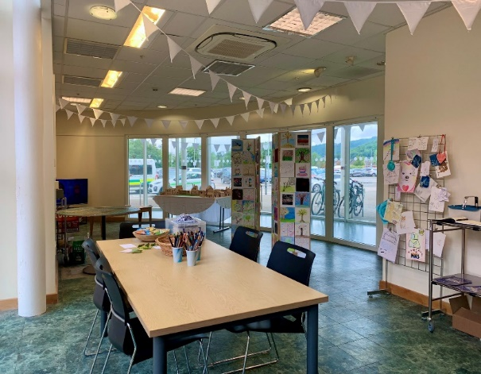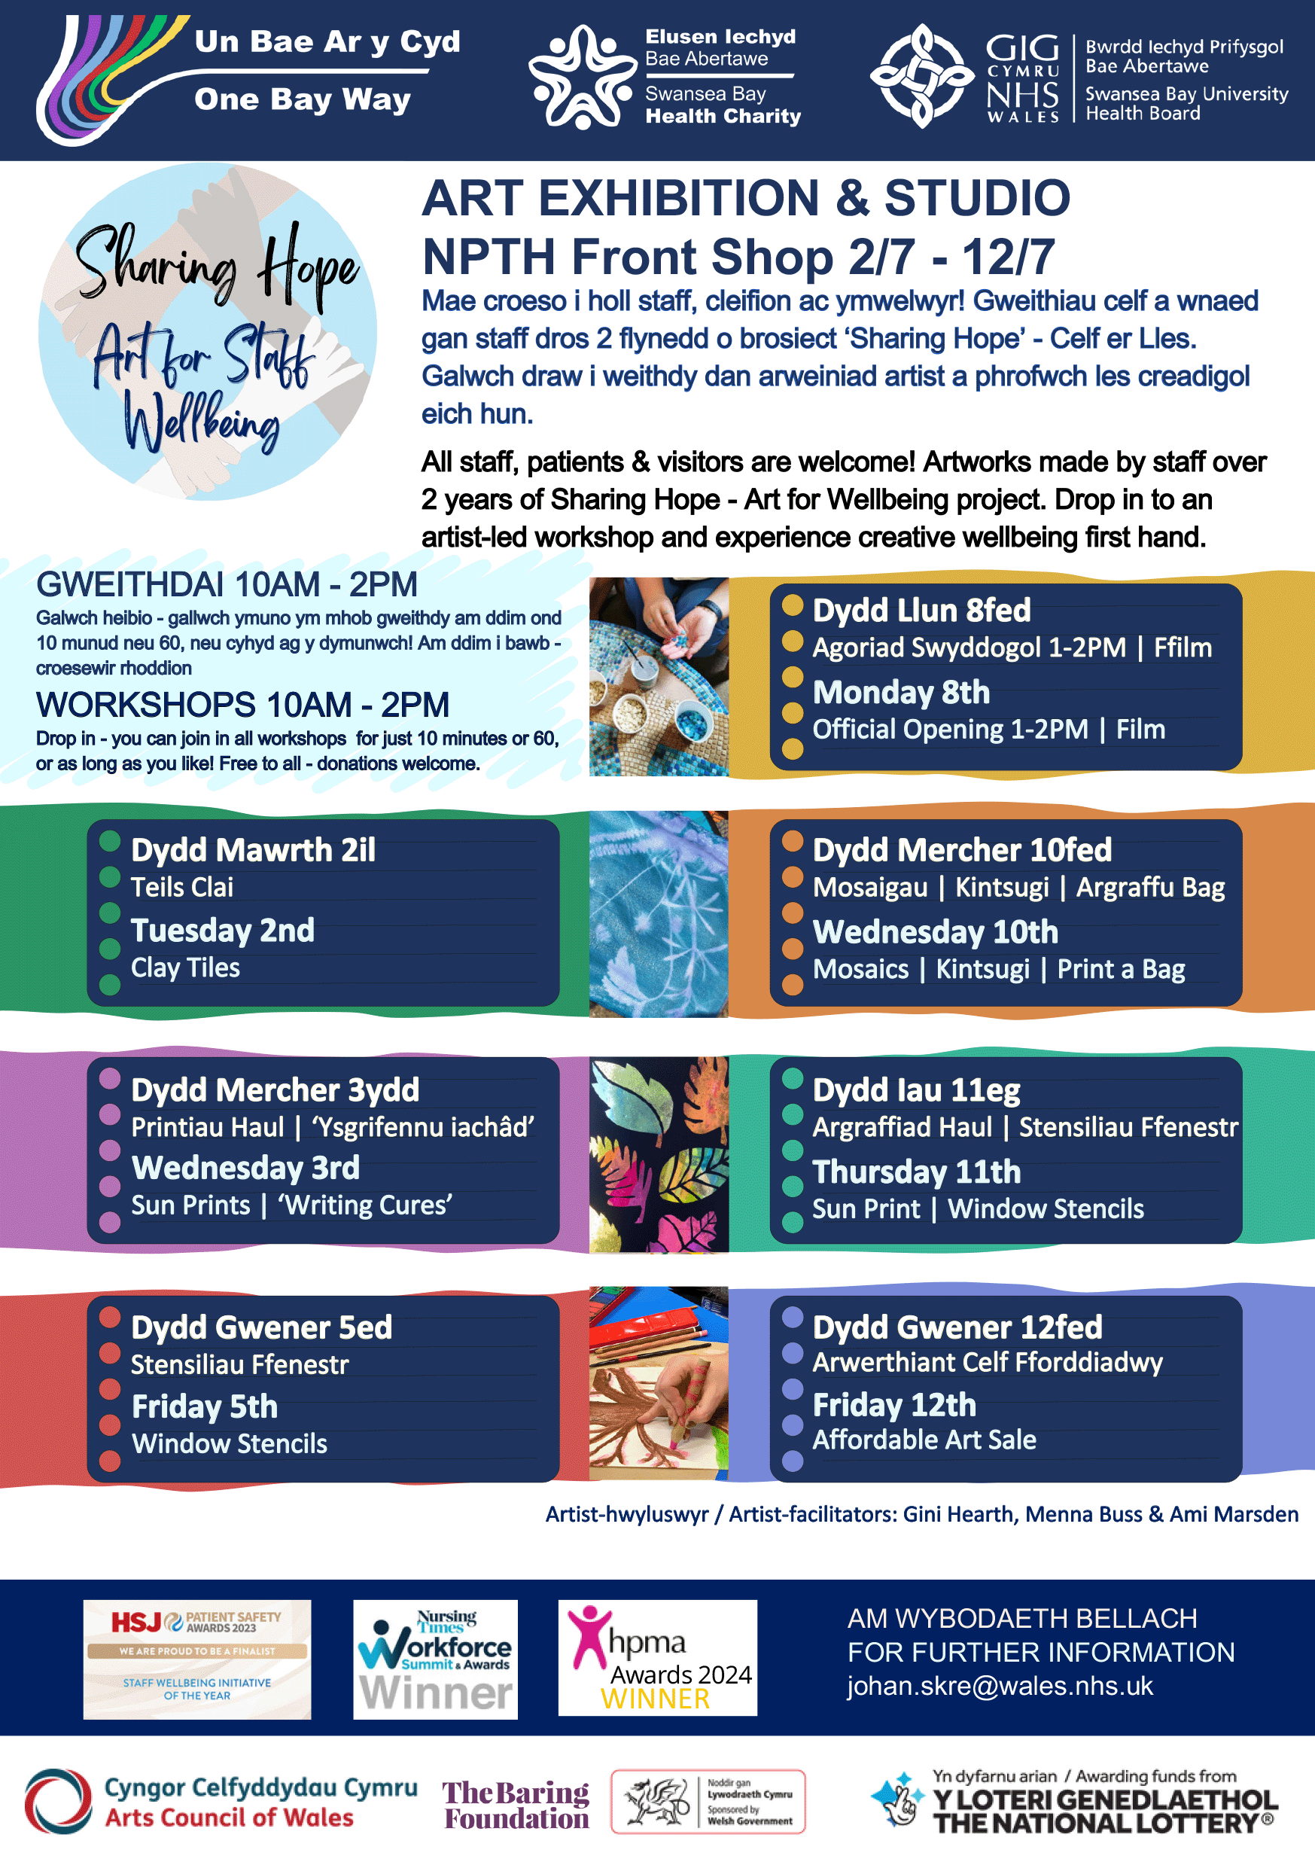

Next steps
- Outcomes of external evaluation to be completed.
- A model for Sharing HOPE with limited funding secured will be completed.
- Sharing HOPE will now be led by Arts in Health
LAUNCH OF REACT (HOW TO HAVE A PSYCHOLOGICALLY SAVVY CONVERSATION WITH COLLEAGUES & SUICIDE AWARENESS & PREVENTION TRAINING.
The graph below is the cumulative total of SBUHB staff attending React & Suicide Prevention level 1 since 2022 and showcases the increase of training since September 2022.
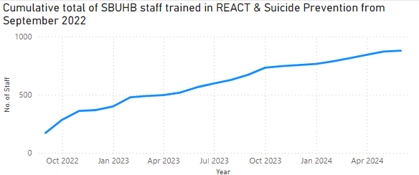

- A deep dive evaluation of React & Suicide prevention training level 1 in January 2024 showed excellent outcomes and transition from training into practice for both React and Suicide Prevention, (Appendix 2).
- Discussions on how to sustain training is being reported to the September QPPB and a workshop with stakeholders is being arranged to gather thoughts and ideas for the training to have longevity.
The number of Attended REACT & Suicide Prevention Inductions for newly qualified nurses from October 2022 to June 2024 = 533.

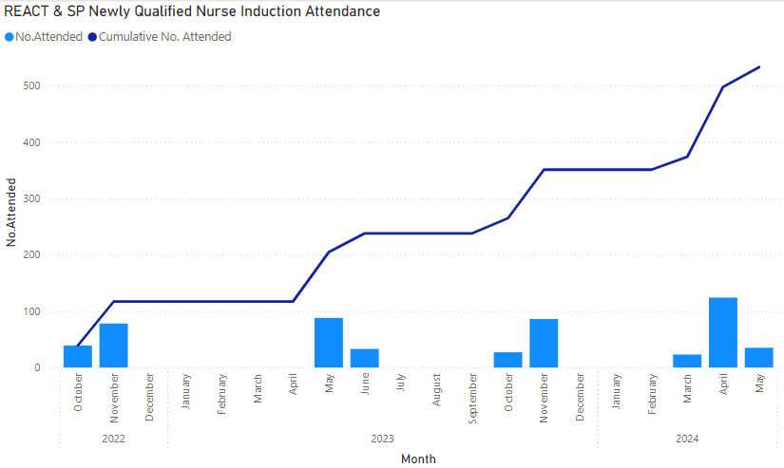
The total number of people attended REACT and Suicide Prevention training including inductions for newly qualified nurses from September 2022 to November 2023 = 1938

Total number of staff attendance from September 2022 to June 2024

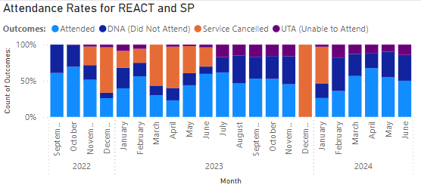

REACT & Suicide Prevention Trajectories

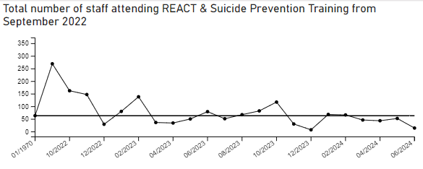
REACT TRAINING
Total number of staff trained up to Oct 2021 = 874
Training since Nov 2021 onwards is in the below chart = 2829
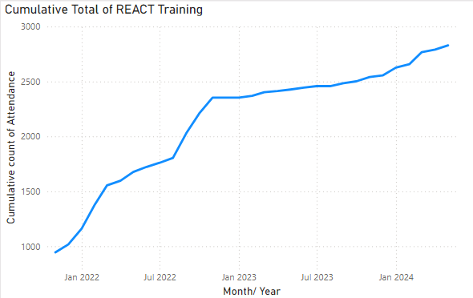

BASELINE DATA ON STANDALONE SUICIDE AWARENESS & PREVENTION TRAINING
Total number of staff trained up to Aug 2021 = 167
Training since Sept 2021 to Aug 2022 is in the below chart = 720
The React and Suicide Awareness Training combined in September 2022
5909 of our staff have been trained in the recognition of the risk of suicide
878 staff attended REACT & Suicide Prevention Training from Sep 22 to June 2024
145 staff attended REACT & Suicide Prevention Training (Bespoke) Managers Pathway from May 2023
887 staff attended Suicide Prevention training including Nurses inductions from Oct 18 to Aug 22
533 newly qualified Nurses induction attended for REACT & Suicide Prevention from Oct 22 to June 24
2957 staff attended Bespoke REACT training from Oct 21 to June 24
263 NPT Primary care staff attended bespoke BT4L (Protective time by learning) Mar 23
49 Swansea Bay Cluster PLTS attended (Protective learning) Nov 23 Suicide Prevention Training
95 attended Child Health Bespoke session since June 2023
37 attended Emergency Department bespoke session since October 2023
13 attended GP Trainee medical
32 attended – Swansea University - Health Management Students

The total number of staff attended training including newly qualified staff and bespoke sessions.
The number of Health Board Staff is approximately 12,500 this indicates approximately 47.27% of the workforce has received REACT and Suicide Prevention training.
REFERRALS TO WELLBEING
It was agreed that as part of the Suicide Prevention work that data and measurements were to be reported monthly for referrals to wellbeing for Mental Health from 2022 onwards. The hypothesis would expect to see an increase of referrals in terms of early intervention for staff.
Total number of referrals for MH = 2225
Number of MH Initial Contact sessions delivered – 1956
To normalise the language of suicide and encourage staff to have open and transparent conversations. The cases of staff divulging thoughts of suicide since 2022.
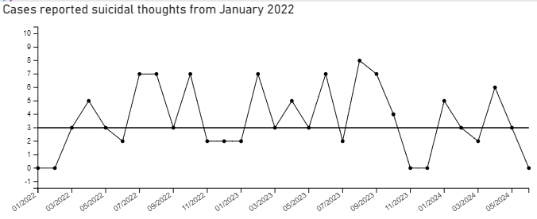
Total staff reporting suicidal thoughts in past 7 days from March 2022 = 108 (This question was introduced to staff in March 2022).
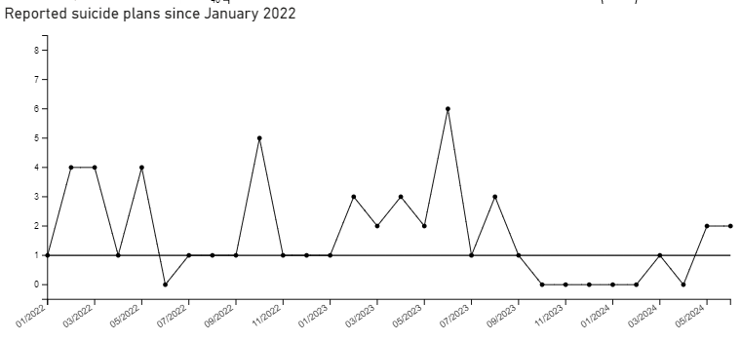
Total staff reporting plans to end life from January 2022 = 51
Due to the new Wellbeing & Occupational referral system – data for November is unavailable as there are issues on how to extract this information.
TIME TO CHANGE WALES
Time to change focusses on reducing stigma regarding mental health for patient care and staff.
Total number of staff trained up to Aug 2022 = 231
Training sessions to commence September through to December 2022 (training sessions are sporadic in nature due to the training programmes available from time to change Wales).
From January 2022 – A total of 1060 staff members have attended the Time to Change Wales sessions.
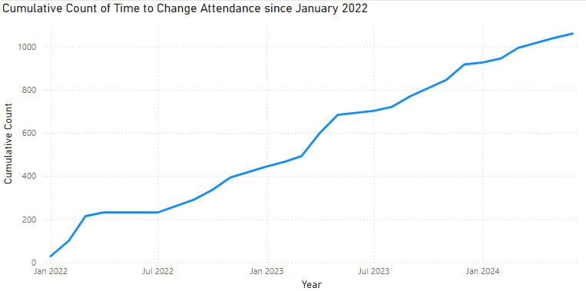
TRiM
It was agreed that activity relating to the Trauma Informed Pathway would support the suicide prevention work and highlight areas where TRiM responses have been held for early identification and intervention for staff trauma and PTSD of which is associated with high levels of mental health and suicide within NHS staff.
70 TRiM supporters to date since July 2021
Since May 2023 there have been 69 TRIM responses.
Slides depict TRiM Trained Staff
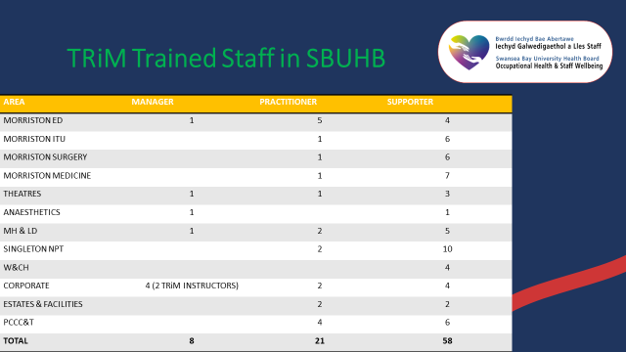
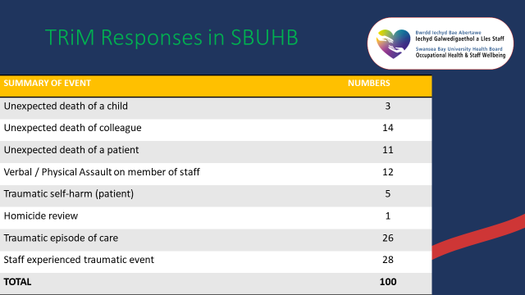
Slide above are TRiM responses since its launch

SBUHB Suicide and Self Harm strategical planning

The Suicide and Self Harm Welsh Government Strategy has now reached consultations stage. The objective is for SBUHB to start formulating its own strategy for Suicide Prevention and Self Harm. Having a strategy in place with RPB to support this will develop a mapping process against all the work currently in progress and link this across services such as CAMHs, Drug & Alcohol, Mental Health and third sector to identify gaps and develop action plans. This is key to progressing Suicide Prevention as business as usual with a focus on robust planning within population health approaches across the whole health board.

- GOVERNANCE AND RISK ISSUES

A workshop is being arranged with stakeholders within service groups in August to establish training needs required. A paper is being provided to the September QPPB on training. A dashboard is now situ so that service groups and relevant stakeholders can take ownership of populating monthly data that will l automatically update a dashboard

- FINANCIAL IMPLICATIONS

Mental Health division will be taking the lead to progress with Tier 2 and level 3 training. Tier 2 training is training that will need be sourced from an external training provider.

- RECOMMENDATION

- Take assurance from the Sharing HOPE team revisiting and remodelling the service to create a sustainable model with funding available. Arts in Health will continue to lead on this development.
- Consider the principles for the future training model for Suicide Prevention, including REACT training. Paper will be presented to the Quality Priority Programme Board (QPPB) September 2024.
- Consider this report as the final focussed review for Quality and Safety Committee, a report of any outstanding areas will be provided to the September QPPB.

Governance and Assurance

Link to Enabling Objectives  (Please choose) | Supporting better health and wellbeing by actively promoting and empowering people to live well in resilient communities
Link to Enabling Objectives  (Please choose) | Partnerships for Improving Health and Wellbeing |  | ☒
Link to Enabling Objectives  (Please choose) | Co-Production and Health Literacy |  | ☒
Link to Enabling Objectives  (Please choose) | Digitally Enabled Health and Wellbeing |  | ☒
Link to Enabling Objectives  (Please choose) | Deliver better care through excellent health and care services achieving the outcomes that matter most to people
Link to Enabling Objectives  (Please choose) | Best Value Outcomes and High-Quality Care |  | ☒
Link to Enabling Objectives  (Please choose) | Partnerships for Care |  | ☒
Link to Enabling Objectives  (Please choose) | Excellent Staff |  | ☒
Link to Enabling Objectives  (Please choose) | Digitally Enabled Care |  | ☒
Link to Enabling Objectives  (Please choose) | Outstanding Research, Innovation, Education and Learning |  | ☒
Health and Care Standards
(Please choose) | Staying Healthy |  | ☒
(Please choose) | Safe Care |  | ☒
(Please choose) | Effective Care |  | ☒
(Please choose) | Dignified Care |  | ☒
(Please choose) | Timely Care |  | ☒
(Please choose) | Individual Care |  | ☒
(Please choose) | Staff and Resources |  | ☒
Quality, Safety and Patient Experience
The aim of the Suicide Quality Project is to aid suicide prevention underpinned by the Welsh Government Strategy Talk to me 2 and appropriate NICE guidelines.
- Educating a workforce to recognise the early signs & symptoms of an acute depressive illness.
- Compassionate employer with recognition of suicide risk throughout all tiers of management and clinical staff
- Educate a workforce who are able to recognise early indicators of suicide & self-harm amongst the population we serve and staff groups.

Financial Implications
As noted above
Legal Implications (including equality and diversity assessment)
None identified.
Staffing Implications
Staff Mental Health, Staff Suicide, Moral Trauma, absenteeism, presentism, and compassionate fatigue.
Long Term Implications (including the impact of the Well-being of Future Generations (Wales) Act 2015)
To continue to educate stakeholders on suicide prevention and awareness underpinned by the Welsh Governments Talk to me 2 Strategy:
- Local Health Boards & Local Authorities working in partnership with the 3rd sector, service users with lived experience, clinicians, and professionals.
- Focus on priority care providers, priority places and priority people.
- Knowing the signs, asking the question, and signposting to timely resources and support.
Report History |  | Management Board May 2023, 10th January 2024
Appendices |  | Appendix 1 GMOS for from 2021 – 2024.  Appendix 2 Deep Dive Evaluation on React & Suicide Prevention Level 1 Training

