High quality EOLC and requirements and challenges – applicable to adult and paediatric palliative and end of life care, although specifics may differ
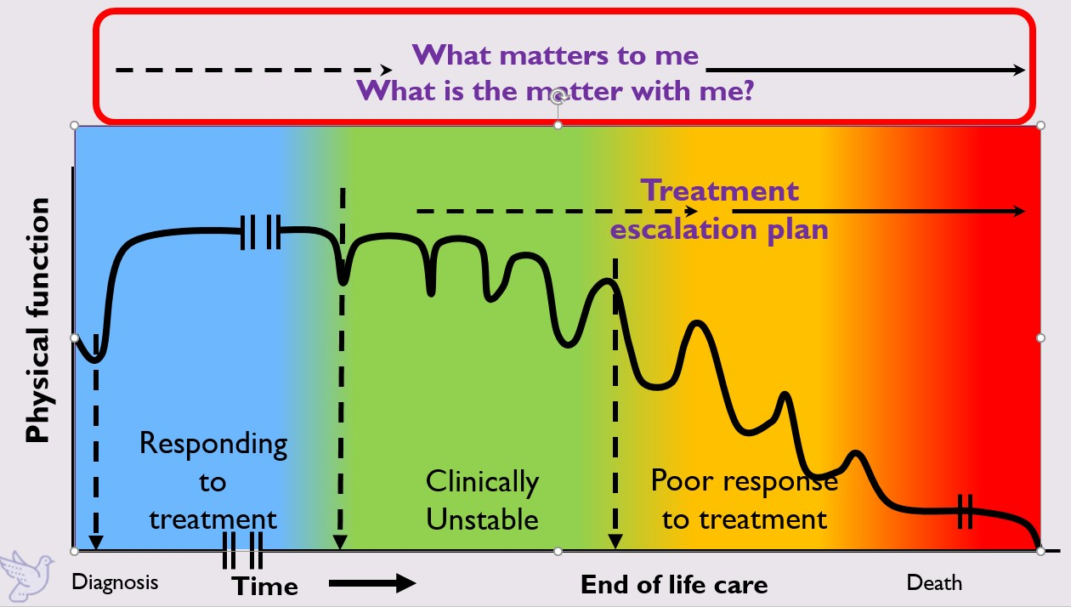
Last 12 months without Robust A&FCP | Last 12 months with co-ordinated robust A&FCP
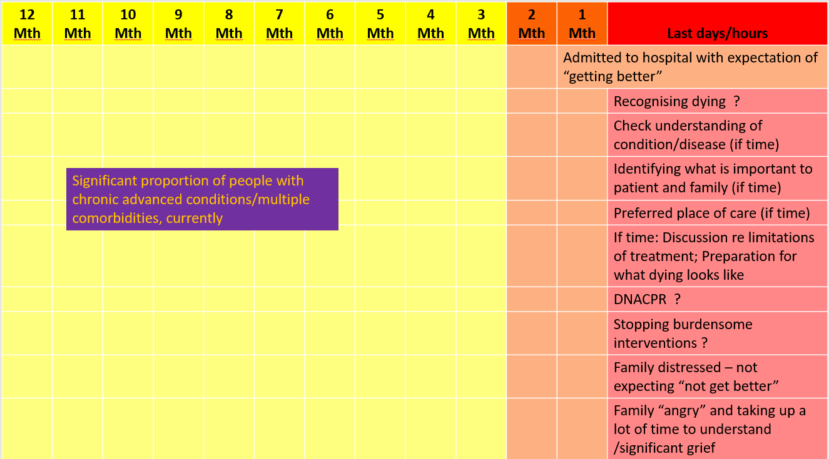 | 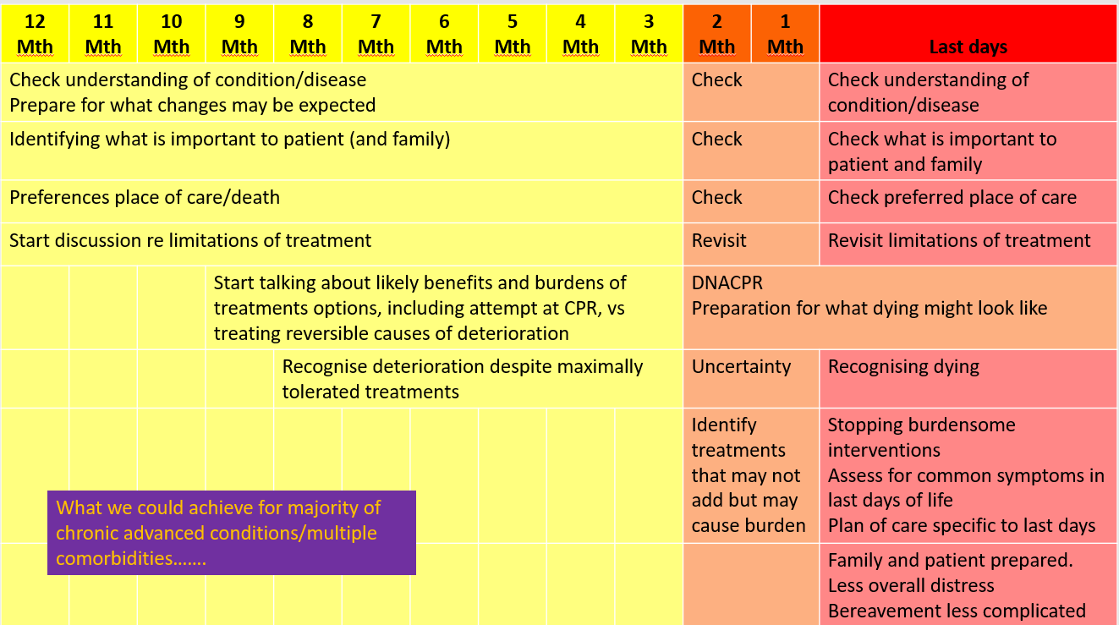

Activity promoting high quality EOLC | What is needed to support this activity | Challenges
Clinical willingness to explore future with patients, including a time when treatments may no longer be effective | Communications skills training – serious illness conversation, dealing with uncertainty  Permission from HB to consider non-active treatment options  Time to undertake these often difficult conversations  Confidence in support mechanism to support patient and those important to the patient as follow on – eg CNSs, GPs, DNs, IT systems to share “what has been discussed so far” | Public and healthcare provider culture of expectations of “getting better” and “no-one needs to die”  “Someone else will do it”  Myths that talking about needs of person who is not getting better = giving up or failing or making death happen earlier  Support mechanisms not always in place/familiar for accessing these resources  IT systems in silos
Patients and families willingness to explore future, including a time when treatments may no longer be effective | Public health education/information available in all care settings- HB website, DNACPR/A&FCP leaflets (GP practices, outpatient setting, wards, etc) | Public and healthcare provider culture of expectations of “getting better” and “no-one needs to die”  Bad publicity and suspicion over end of life care provision – Liverpool Care Pathway, blanket DNACPR decision making in care homes, etc
Clinical agreement on indicators of changing phase of illness for individuals with chronic and progressive conditions, eg  - End stage organ failure (renal, heart, respiratory, liver, etc)  - Progressive neurological conditions  - Malignant disease  - Dementia | Time to consider currently available prognostic indicators / prediction indicator guides (Gold Standard Framework/ Supportive and Palliative Care Indicators Tool) and make minor modifications, if any are needed  Make these Swansea Bay indicators widely available across all care setting to support clinicians in day to day working | Variability in patients’ response to treatments  Variable clinical experience of clinical teams -  Prioritisation of this activity against direct clinical are
Early recognition of changing phase of illness, failing treatments. | Clinical assessment and continuity of care  Sharing of information of treatments and impacts across care providers  Well functioning palliative care register activity, frailty register, other GP registers  Functioning enhanced service for care homes | Public and healthcare provider culture of expectations of “getting better” and “no-one needs to die”  Patient information systems not communicating with each other across care settings  Saturation of services, eg primary care - ?new ways to meet needs
Clinical teams use of All Wales documents supporting and recording advance and future care planning | Education/awareness of tools  Ease of completion and sharing of completed tools for all involved in patient care  Witnessing successful utilisation of tools, to make a difference  Robust administration/IT systems to upload documents to sharing platform | “Someone else will do it”  Time required to have conversations and document well  IT systems currently do not allow easy sharing of documents  Clinical areas have inadequate IT resources to scan and share documents
Clinical confidence and competence to have difficult conversations – serious illness conversation, uncertainty, DNACPR decision making, treatment escalation plans, mental capacity, etc | Education/communication skills training  Time to have those conversations  Written information to support /back up conversation  Confidence is support structures for patients after conversation | Recognition of deterioration/failing treatment  Recognition of clinicians own limitations and training needs  Public culture – expectation to get better  Myths that talking about needs of person who is not getting better = giving up or not trying or will make death come earlier  Limited written information available
Clinical confidence in accessing support structures to support patients making different choices/treatment options | Robust structures in place with flow charts to support across HB  Referral and access criteria for health and social care providers  To include clinical care, emotional and spiritual support, practical support  HB assurance around variation in clinical decision making appropriate for individualised care in last weeks of life | Variety of resources with different criteria across care settings  Unfamiliar third sector resources  Changing third sector environment  Health care professionals’ concerns re: litigation around not following “guidelines and protocols”
HB IT systems to support sharing of conversation around A&FCP | Promotion of one IT system to hold “one source of the truth”  Standardisation of documentation to support sharing across care settings | DHCW resistance to supporting storage of A&FCP on All Wales platforms  IT systems designed in silos and connectivity options limited  Low prioritisation of EOLC IT needs against other HB priorities
HB projects/business cases to include section of how this supports P&EOLC / what we will build in to support high quality EOC/A&FCP | HB management board/strategy/finance department/NMB/LMC include P&EOLC considerations when viewing papers, policy, schemes - where none is offered by the authors, require EOLC Clinical advisor input | HB is a big organisation. With individuals having “good ideas”, quick fixes, often without the HB priorities in mind, or misunderstanding potentially small tweak in action/plan could impact positively on P&EOLC – eg Safer Board Round – “would we be surprised if this patient died in next 2-3days?”
Education programmes for palliative and end of life care embedded into HB Learning and Development programme | Mandated training - communications skills, serious illness conversations/uncertainty  Mandated training for cohort of HCP around EOLC  Mandated training for cohort of HCP around DNACPR decision making and recording  Creation of role specific education programmes | Training mandated by HB? or All Wales?  Mandatory training requirements already arduous - ?role of streamlining for specific roles  Assessment of training needs  Availability of suitable resources to support training
Robust and reliable data to support understanding of patient journeys  Robust and reliable data to support understanding of patient journeys (cont) | Identification of data points/set  Identification of systems to automate data collection  Creation of dashboard that can be interrogated by all clinical and management teams  Engagement with National Audit of Care at End of Life  Annual review of Datix for EOLC – incidents, complaints and compliments  Medical Examiner feedback and learning from deaths panel | Access to data sources  ONS data – no patient identifiers, Swansea Bay, Swansea or NPT division (currently no access due to DHCW not completing requirement for contract to access data  HB data – deaths in hospital only  HB data includes Bridgend data  ONS data includes Ty Olwen deaths as hospital deaths not hospice deaths  No reliable data on DNACPR / A&FCP activity  – All Wales platforms not facilitate sharing activity  - ACP notification in WCP – secondary care only and only notify once, so up-dates not visible  Care decision guidance use – dependent upon ME process – unreliable  Palliative Care register activity – no requirement for GPs to provide data on numbers of patients on register and meeting activity  DN service activity data – not fully incorporated into HB digital systems – scheduling platform and Excel spreadsheets  Fast Track applications – no complete record of numbers applied and approved and timescales  No formal recording of preferred place of care/death  Interrogation of ESR for training activity – not helpful  NACEL audit significant commitment for case note review  NACEL audit only reviews secondary care (excluding Cefn Coed and Tonna)  Datix – difficult to navigate  ME process – less focused on quality of care in last days of life than other clinical activity  Awaiting full incorporation of deaths in community setting

