Children in Wales registered with the children’s hospices and the All Wales Managed Clinical Network for Children’s Palliative Care.
Initial report on findings. November 2023.

Data
The postcodes of those children and young people (0-17) in Wales with life limiting conditions who are registered with one of the following services were gathered for analysis: -
- Hope House Children’s Hospice
- Tŷ Gobaith Children’s Hospice
- Tŷ Hafan Children’s Hospice
- All Wales Managed Clinical Network for Children’s Palliative Care (AWMCN)
The total numbers of registered CYP 0-17 is as follows: -
Registered with Hope House only | 56
Registered with Tŷ Gobaith only | 61
Registered with Hope House/Tŷ Gobaith and the AWMCN | 9
Registered with Tŷ Hafan only | 194
Registered with Tŷ Hafan and the AWMCN | 84
Registered with the AWMCN only | 59
Total CYP 0-17 in Wales | 463

Total registered with Hope House & Ty Gobaith | 126
Total registered with Tŷ Hafan | 278
Total registered with the AWMCN | 152

Local Health Boards
When broken down by Local Health Board area, the distribution is as follows: -
LHB | Population | CYP | Principal Areas
Aneurin Bevan | 591,225 | 72 | Blaenau Gwent, Caerphilly, Monmouthshire, Newport, Torfaen
Betsi Cadwaladr | 698,369 | 114 | Anglesey, Conwy, Denbighshire, Flintshire, Gwynedd, Wrexham
Cardiff and Vale | 469,413 | 96 | Cardiff, Vale of Glamorgan
Cwm Taf Morgannwg | 445,190 | 69 | Bridgend, Merthyr Tydfil, Rhondda Cynon Taf
Hywel Dda | 385,615 | 36 | Carmarthenshire, Ceredigion, Pembrokeshire
Powys | 132,447 | 20 | Powys
Swansea Bay | 389,372 | 56 | Swansea, Neath Port Talbot
 |  | 463

Map Key
Registered with Hope House only Registered with Tŷ Gobaith only
Registered with HHTG and the AWMCN Registered with Tŷ Hafan and the AWMCN
Registered with Tŷ Hafan only Registered with the AWMCN only

Maps
Registered CYP 0-17 vs Population Density Heat Map
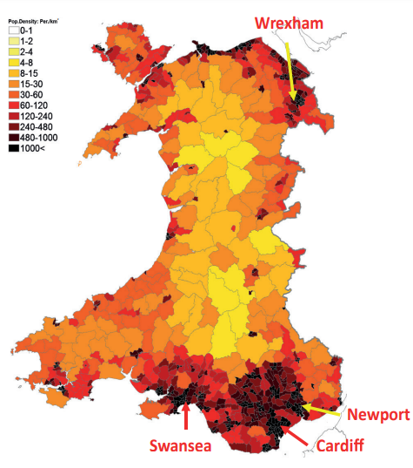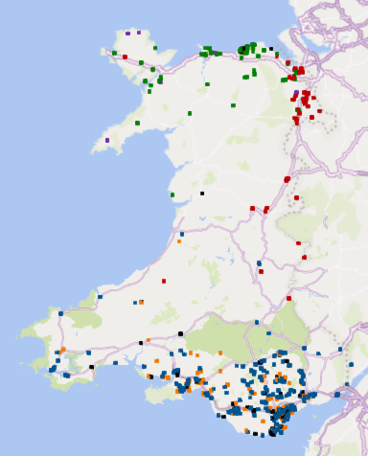

Registered CYP 0-17 by Local Health Board
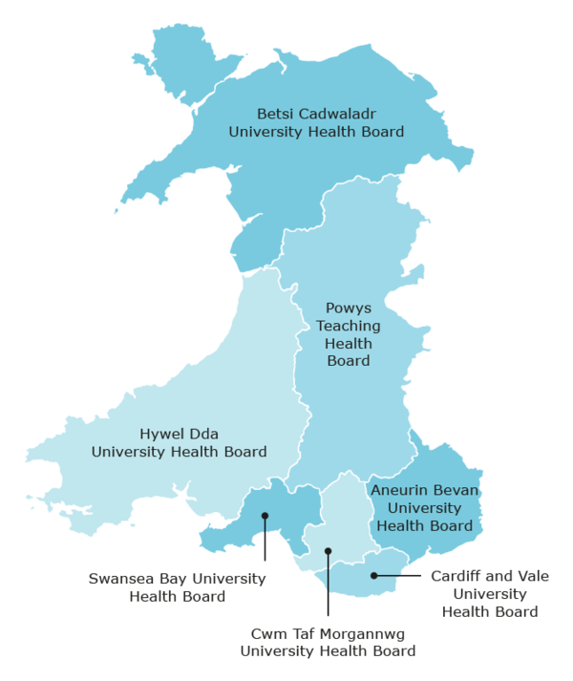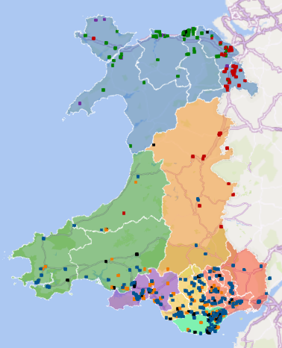

Prevalence
Demographic and prevalence data were drawn from, “Children with a Life-limiting or Life-threatening condition in Wales: Trends in prevalence and complexity” (Fraser, Bedendo & Jarvis, 2023).
The following data is from the above research, with cases being the “number of children and young people with life-limiting conditions” aged 0-17 in 2019.
Local Health Board | Cases | Principal Areas
Aneurin Bevan | 776 | Blaenau Gwent, Caerphilly, Monmouthshire, Newport, Torfaen
Betsi Cadwaladr | 751 | Anglesey, Conwy, Denbighshire, Flintshire, Gwynedd, Wrexham
Cardiff and Vale | 616 | Cardiff, Vale of Glamorgan
Cwm Taf Morgannwg | 624 | Bridgend, Merthyr Tydfil, Rhondda Cynon Taf
Hywel Dda | 364 | Carmarthenshire, Ceredigion, Pembrokeshire
Powys | 119 | Powys
Swansea Bay | 405 | Swansea, Neath Port Talbot
 | 3,655

Reach
The table below shows the total number of CYP 0-17 registered with Tŷ Hafan, Hope House/Tŷ Gobaith and the AWMCN by Local Health Board compared to the above prevalence data: -
Local Health Board | Prevalence | Registered | Reach
Powys | 119 | 20 | 17%
Cardiff and Vale | 616 | 96 | 16%
Betsi Cadwaladr | 751 | 114 | 15%
Swansea Bay | 405 | 56 | 14%
Cwm Taf Morgannwg | 624 | 69 | 11%
Hywel Dda | 364 | 36 | 10%
Aneurin Bevan | 776 | 72 | 9%
 | 3,655 | 463 | 13%

When broken down by service, the data is as follows: -
Local Health Board | Prevalence | Tŷ Hafan |  | HH/TG |  | AWMCN
Local Health Board | Prevalence | Reg. | Reach | Reg. | Reach | Reg. | Reach
Powys | 119 | 4 | 3% | 15 | 13% | 1 | 1%
Cardiff and Vale | 616 | 76 | 12% | 0 | 0% | 46 | 7%
Betsi Cadwaladr | 751 | 0 | 0% | 110 | 15% | 13 | 2%
Swansea Bay | 405 | 49 | 12% | 0 | 0% | 28 | 7%
Cwm Taf Morgannwg | 624 | 58 | 9% | 0 | 0% | 25 | 4%
Hywel Dda | 364 | 30 | 8% | 1 | 0% | 16 | 4%
Aneurin Bevan | 776 | 61 | 8% | 0 | 0% | 23 | 3%
 | 3,655 | 278 | 8% | 126 | 3% | 152 | 4%

Crossover
The table below shows the proportion of children registered with the children’s hospices who are also registered with the All Wales Managed Clinical Network for Children’s Palliative Care (AWMCN).
Local Health Board | Total registered with a children’s hospice | Also registered  with AWMCN | Percentage
Swansea Bay | 49 | 21 | 43%
Hywel Dda | 31 | 11 | 35%
Cardiff and Vale | 76 | 26 | 34%
Cwm Taf Morgannwg | 58 | 14 | 24%
Aneurin Bevan | 61 | 12 | 20%
Betsi Cadwaladr | 110 | 9 | 8%
Powys | 19 | 0 | 0%
 | 404 | 93 | 23%

The table below shows the proportion of children registered with the All Wales Managed Clinical Network for Children’s Palliative Care (AWMCN) who are also registered with the children’s hospices.
Local Health Board | Total registered with AWMCN | Also registered with a children’s hospice | Percentage
Swansea Bay | 28 | 21 | 75%
Betsi Cadwaladr | 13 | 9 | 69%
Hywel Dda | 16 | 11 | 69%
Cardiff and Vale | 46 | 26 | 57%
Cwm Taf Morgannwg | 25 | 14 | 56%
Aneurin Bevan | 23 | 12 | 52%
Powys | 1 | 0 | 0%
 | 152 | 93 | 61%

A consolidated summary of the above data is as follows: -

Initial thoughts for further consideration.
Hospice Reach.
- Between 8% and 16% of the estimated cohort of children with a life limiting condition in any Health Board area are registered with one of the Childrens hospices. The lowest ‘Reach’ is in Hywel Dda and Aneurin Bevan Health Board and the highest is in Powys.

- There does appear to be some correlation with the presence of children’s hospice services within or close to a Health Board Area and reach. Hope House on the border of Powys, Ty Hafan within Cardiff and the Vale and Ty Gobaith within Betsi Cadwaladr. The two health boards where reach is lowest; Hywel Dda and Aneurin Bevan are geographically further from the hospices.
What is the determining factors in the hospices ‘reaching’ children with LLC?
Hypothesis: Physical distance to the hospices is a significant determining factor for families of children with LLC registering with the hospices.
AWMCN reach.
- The reach of the AWMCN ranges from 1% in Powys to 7% Cardiff and Vale.

What are the determining factors in the AWMCN ‘reaching’ children with palliative care needs and for the variation seen?
Hypothesis: The presence of a specialist paediatric palliative care service in the Health Board Area is a significant determinant in engaging families of children with palliative care needs with the AWMCN team.
Crossover.
- There is significant variation between health boards in the proportion of children registered with the children’s hospices who are also registered with the All Wales Managed Clinical Network for Children’s Palliative Care.
If children are presenting to the hospices with similar conditions and levels of complexity across Wales then what is the reason for the variation in crossover between children registered with the hospices and the AWMCN in different health boards?

- There is significant variation between health boards in the proportion of children registered with the All Wales Managed Clinical Network for Children’s Palliative Care (AWMCN) who are also registered with the children’s hospices.
If the assumption is correct that all children registered with the AWMCN meet the criteria for Hospice support, then what are the reasons for such variation?

