Meeting Date | 24 September 2024 |  | Agenda Item |  |  | 5.3
Report Title | Deep Dive End of Life Care
Report Author | Sue Morgan, Senior Responsible Officer, End of Life Care  Emma Smith, Quality Improvement Information Manager
Report Sponsor | Hazel Powell, Deputy Director Nursing and Patient Experience
Presented by | Sue Morgan, Senior Responsible Officer, End of Life Care
Freedom of Information | Open
Purpose of the Report | To provide an update on the goals, methods and outcomes for the End of Life Care (EOLC) quality priority and the requirements for these to be transferred into business as usual.
Key Issues | - Since End of Life Care has become a Quality Priority the following has been achieved:  - Education training programmes established; has reached approximately 5000 members of staff.  - NACEL (National Audit of Care at the End of Life) audit has shown improved results year on year since 2021.  To take EOLC from a quality priority to business as usual continues to require significant system changes to promote advance and future care planning, and sharing of this across all care setting. (See Appendix 1)
Specific Action Required  (please choose one only) | Information | Discussion |  | Assurance | Approval
Specific Action Required  (please choose one only) | ☐ | ☐ |  | ☒ | ☐
Recommendations | It is recommended that End of Life Care remains and quality and safety priority until March 2025, with a particular focus on the  - What excellent end of life care looks like (appendix 1)  - digital opportunities to share advance and future care planning/one source of the truth across all care settings (information platforms),  - digital opportunities to understanding patient/family experience (data)

END OF LIFE CARE FOCUSSED REVIEW

- INTRODUCTION
The Health Board identified End of Life Care (EOLC) as one of its quality priorities in 2021. Since then progress has been made in a number of areas, including education of staff regarding EOLC. This paper will outline what has been achieved so far for the EOLC quality priority, the focus in 2024/2025 and the actions required to incorporate this into business as usual.

- BACKGROUND
Approximately 1% of the population of Swansea Bay dies each year (just in excess of 4000 deaths per year). Approximately 75% of those deaths have an element of predictability – chronic conditions, frailty, dementia, malignant disease. If we are able to identify those who are likely to die in the next six to twelve months we are able to support them to consider what is important to them (“what matters to me”) and help them to understand their clinical progression (“what is the matter with me?”). With those consideration, alongside understanding the treatment options, and what benefits and burdens of those options (including no active treatment) we can identify treatment escalation plans. Evidence demonstrates that with robust advance and future care planning six out of seven patients die outside the acute hospital setting.

The Leadership Alliance for Care of Dying People highlights the five priorities of the dying person are that the dying process is recognised, this is sensitively communicated, the dying person, and those important to them are involved in decision about treatment, the needs of the dying person (and those important to them) are actively explored and an individual, holistic plan of care, is agreed, co-ordinated and delivered with compassion. (Appendix 2)

This is also the focus of the 2021 update of the NICE quality Standard (QS 13).

Late identification of the dying person results in people being admitted to hospital as with the expectation of “getting better” when they are approaching the last weeks of life. The necessary conversations to prepare patients and those important to them are condensed into a short period, and often patients are continuing to have investigations and intervention when there is little chance that these will be helpful (as demonstrated in the last 12 months of life calendar below in Appendix 1).

If we are able change health care professional and public culture to start planning for a time when treatments, are no longer going to be helpful, we can change that calendar and outcome for patients (and those important to them).

By making every contact count, building on A&FCP, patients have greater autonomy, choice and control over treatments; there are fewer unwanted or futile invasive interventions/treatments (and hospital admissions). The enhanced proactive decision making improves the quality of end of life care and reduces burdens on family members (and eases their bereavement).

Since making end of life care a quality priority, the Health Board has seen an increase in the proportion of its population dying outside of the hospital setting. However, our ED department continues to receive a significant number of attendees who are in the last days of life, when there are limited realistic treatment options. With additional enhancement of recognising patients are failing treatments, and discussions around treatment escalation, and sharing these with other clinical teams, it is expected that patients and those important to them will decide to remain at home, supported by community services for their last days of life.

- GOVERNANCE AND RISK ISSUES

HB GMOs for End of Life Care 2023-24

The table displays the focus of the EOLC quality and safety priority. The availability of data and being able to present it in a format that is effective in monitoring impact has been a challenge.

Goal | Methods | Outcomes | Target | Status
End of Life Care (EoLC)  Increase proportion of Swansea Bay residents receiving the right care at the right place at the right time in the last year, months, weeks, days of life | Increased correct identification of people who may be in the last year of life | Increase % of deaths outside of hospital  Increase % of patients on the palliative care register | Baseline data still being understood  0.40% on Palliative care register by March 2024 | Increase in number of death outside hospital- on track  % on Palliative Care Register- unable to gather data, but improvement in processes to support
 | Increase Advance & Future Care Planning across all care settings | Increase in the number of advance future care plans recorded in WCP​ | 100 A&CP WCP notifications per month by March 2024 | We did not achieve 100 per PCM by March 2024 but have seen an increase to 60
 | Increased correct identification of people who may be in the last days of life | Increase in the % and number of cases reviewed by the Medical Examiner who have a CDG Document in place​  Decrease % of deaths within 48hrs of emergency attendance | 55% of deaths with a CDG by March 2024  Baseline data still being understood | We have not been able to access this data.  However we have seen a significantly improved picture within our NACEL audit findings
 | Increase the number of staff given education and training to support high quality EOLC | Increase number of staff receiving education and training in recognition and management of patients approaching EOLC from 1yr down | 3500 total staff trained (1000 within the year) | Over 5000 staff trained
 | Identify and produce systems that support sharing of advance and future care planning across all care settings | Systems enabled to share end of life care/advance & future care planning information across platforms | At least 1 system able to share across care settings | This action is off track

The overarching goal is to provide the right care in the right place at the right time, with the right team for people in the last days of life. An assessment of aspects of patient journey that may impact our ability to achieve this is shown in the fishbone analysis and include lateness in recognising the changing phases of illness and limited advance and future care planning activity and ability to share this across care settings,

A fishbone analysis was undertaken in order to identify areas requiring improvement. The outcome of the improvement work streams is as follows:

Method: Increased correct identification of people who may be in the last year of life

Outcome: Increased proportion of deaths of Swansea Bay residents dying out of acute setting

Ideally, our overall aim would be to increase the proportion of Swansea Bay residents dying in their preferred place of death. However, preferred place of death is not currently a data item that we are able to systematically record. The proxy measure we have used is the proportion of Swansea Bay residents dying outside of hospital setting (home/care home/ Tŷ Olwen). The data acquisition has been difficult due to HB and ONS data not being aligned. In addition, the ONS data has not been available since April 2024 due to all Wales contract issues.

The baseline median until June 2023 is that 55% of Swansea Bay residents die outside of hospital, and we aimed to see an increase in this by 1% by March 2024. This outcome has been achieved and over the year between April 2023 and March 2024, 57.5% of the deaths of Swansea Bay population was outside of the hospital setting.

Outcome: Increase number of patients included on GP Primary Care Palliative Care Register

The Palliative Care Register has been demonstrated as an effective platform to support robust A&FCP. Running a Palliative Care Register is a requirement of the core GP contract, and includes having an MDT meeting at least every two months.

Within Swansea Bay, 0.22% of the Swansea Bay GP registered population were on the register (March 2022). However, there has been considerable variation in this activity across the HB.

As part of the Safe Care Collaborative, Swansea Bay explored increasing the use of the Primary Care Palliative Care Register in three GP clusters. The proportion of each GP populations on the Palliative Care Registers in these three clusters ranged from 0.14% to 0.26%. Unfortunately, this detail reporting is longer required/collected by the HB/Welsh Government.

The aim in 2023-24 was to increase the Palliative Care Register to 0.40% (which would be approximately half of the people with chronic progressive conditions who are likely to die in the next six to twelve months.

The Primary Care Clinical lead for End of life care produced guidance co-ordinating the Palliative Care Register and two monthly meetings, and this was shared with all Swansea Bay GP Practices (after being approved by the LMC). As part of the project we had agreed with the GP practices of the three clusters that they share their information for us to understand progress.

We achieved an improvement in the reliability of running the MDT meetings and the MDT members’ engagement in the MDT meetings improved as it illustrated below.

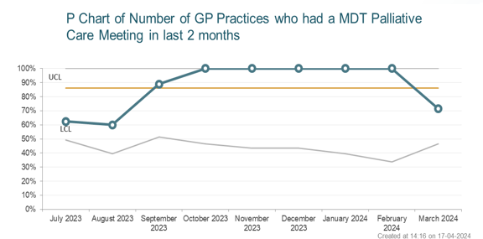
However, it was identified that there were barriers to increasing the number of patients included on the palliative care registers, as the resources available to the GP practices to undertake the work of supporting A&FCP has reached saturation.
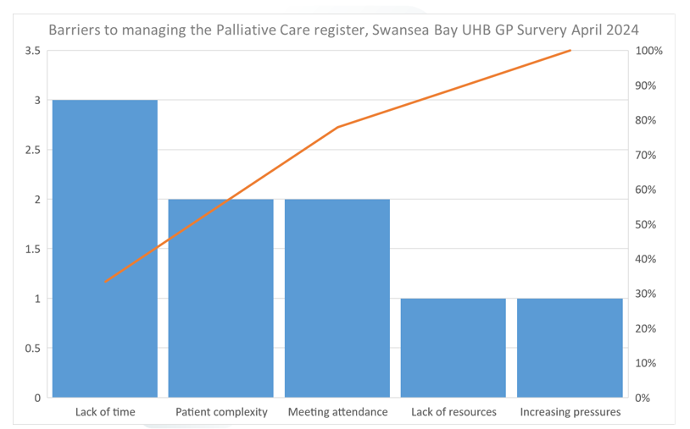

In addition, GP practices are dependent upon other clinicians to flag up patients who may be suitable for inclusion on the Palliative Care Registers; those who are beginning to fail treatments.
Method: Increase Advance & Future Care Planning across all care settings

Outcome: Increase number of ACP notifications in WCP

As a proxy measure for this we have used the number of advance care plan notifications within Welsh Clinical Portal each month. This is a facility for primary and secondary care, yet in reality, accessing WCP within primary care is cumbersome, and requires additional effort to sign into the system. Consequently, the A&FCP activity recorded in WCP excludes the activity undertaken within primary care.

The number of new notifications per month was in the region of 10 per month before the QS Priority. We have seen an initial increase and has now settled at approximately 60 new notifications per month.

We have achieved this outcome.

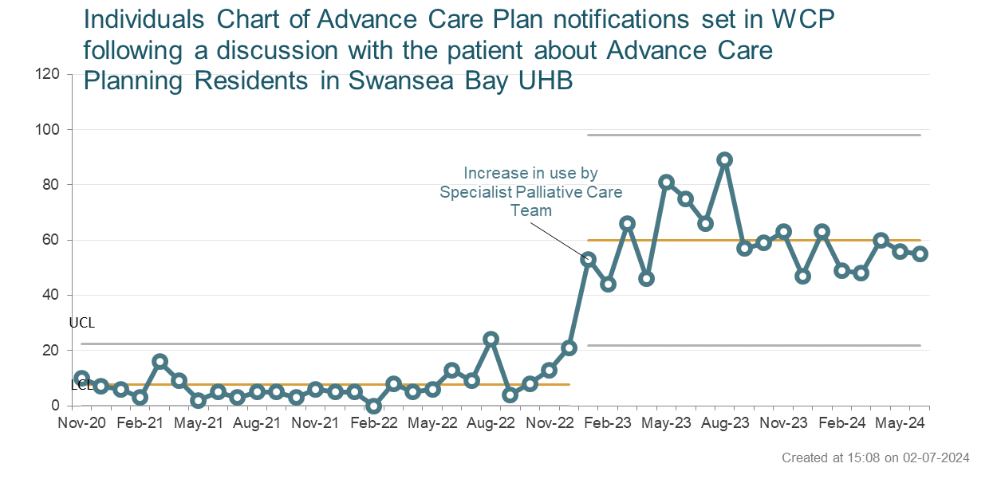

Method: Correct identification of people who may be in the last days of life

It had been anticipated, as the number of End of Life Care Champions increased across the HB, the earlier the diagnosis of dying and the greater opportunity to “change gear” and focus on the five priorities of the dying person (and those important to them). Similarly, as the advance and future care planning increased then different decisions may be made in the last days of life, reducing the numbers of people attending ED in the last couple of days of life.

Outcome: Increase the number of deaths supported with the care decision guidance.

When it is recognised that someone is dying, and in the last days of life, the Care Decision Guidance supports conversations and clinical decision making, preparing the patient and family for the impending death. There is a change in focus of care to reduce burdensome interventions and ensure physical, emotional, spiritual and social needs are supported (for the patient and family).

The Medical Examiner’s team has been recording these data. However, access has been unreliable and we have not been able to incorporate this data into the HB’s data warehouse until recently. The Care Decision Guidance is not utilised widely within primary/community care setting.

We have not been able to identify the anticipated increased use of the care decision guidance tool.

With the changes to the National Audit of Care at End of Life (NACEL), we now have evidence of changing gear to focus on the five priorities of the dying person being collected throughout the year – both case note reviews and quality survey (feedback from family and others important to the patient). This national audit looks at care in the last days of life of people dying in the hospital setting.

For this round of the NACEL audit we have been able to harness much more service user feedback than in previous years. The data from the quality survey (service user feedback) is included in the appendix 3 and the report organised under the headings of the five priorities of the dying person

The highlight of the NACEL audit is that those important to the dying person score the care in the last days of life in Swansea Bay above average for all priorities of the dying person. Overall rating of care and support given by the hospital to the dying person was scored as excellent in 75% and good in another 18%. The overall rating of care and support given to those important to the dying patient was excellent 70% and good 18%.

Supporting communication through translation services or offering Welsh language services when English is not the first language is the only element of the Quality Survey that Swansea Bay did not perform as well as other hospital services across England and Wales.

It is interesting that the family and others important to the patient feedback does not correlate with the documentation within both the clinical case note and the Welsh Nursing Care Record. For example, service users (quality survey) reported that a member of staff explained to the person that they were likely to die in the next few days in 50% of responders. Yet it is not evident within the clinical record that conversations have taken place with the dying person. There is good evidence of having this conversation with family members, but not with the dying person. There is some work to be undertaken to understand this mismatch.

Additional opportunities for increasing identification of the dying person – Safer Board Round - Would we be surprised if this person died in the next two to three days? If not, what are information needs, preferences, should we be changing gear?
Outcome: Reduce the number of death within 48 hours of ED attendance

As A&FCP progresses, it is anticipated that as people come closer to dying, they are more focused on the priorities of the dying person and less on what emergency care might add. Thus, fewer people will chose to be admitted and GPs/GPOOH will be better equipped to understand what is important to the person and treatment escalation options, reducing the dilemma that they often face – the patient/family and carer are keen to remain at home whilst the GP/GPOOH feels pressure to admit, just in case there is some reversibility.

The following graph shows proportion of admissions to ED where the patient dies in ED or as an inpatient within 48 hours of attending. The data is not perfect, and requires some refining.

We have not achieved this outcome.

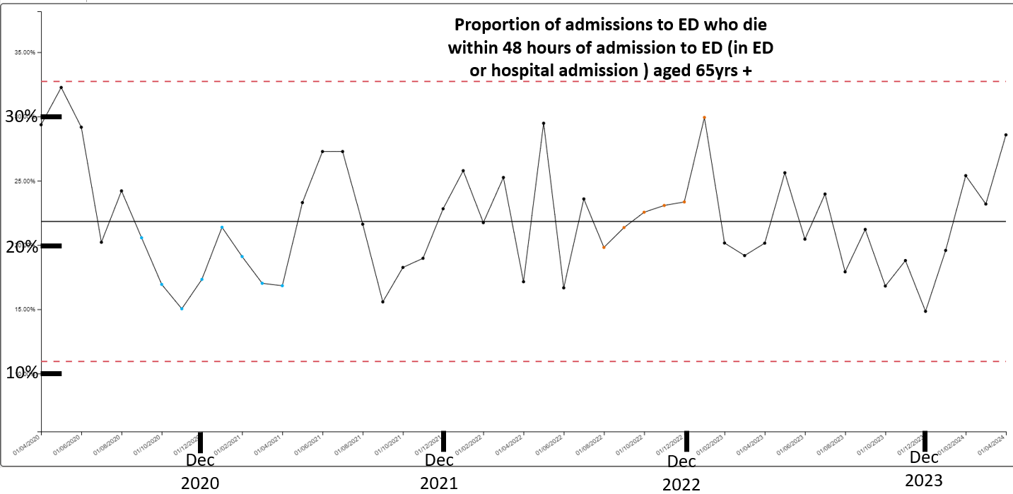

Method: Education and training to support high quality EOLC

Outcome: Increase the number of staff receiving education and training in recognition and management of patients approaching EOLC

Over the last year we have continued to reach a significant number of HB staff, providing resources to support care in the last year/days of life. This includes supporting care homes. There is a challenge to access this data through ESR, and consequently the PARASOL team has developed its own database of training (with the support of the Quality Improvement team). The various education programmes around end of life care has reached 5000 staff, across all care settings.
We have achieved this outcome.
We are currently working with the University to assess the impact of this training, both on staff trained and patient outcomes.
Methods: Identify and produce systems that support sharing of advance and future care planning across all care settings
This remains a significant challenge and a barrier to being able to support patients across all care settings; being able to advance A&FCP that has taken place in one setting in any other setting (making every contact count).
Cross referencing different information platforms for “one source of the truth” impacts more widely than end of life care.
Appendix 4 demonstrates the teams that need access to details of A&FCP for the patients and what is visible to them, through HB and all Wales systems.

Other issues/risks
Changes to the All Wales Managed Clinical Network for Childrens Palliative Care.
Reduction in access to Tŷ Hagan for respite for children from Swansea Bay, leaving a gap in the support provided to the children and their families. This is not currently on the HB risk register. Currently over 50 children would be impacted.
The AWMCN preliminary report is included in the Appendix 5.
Healthcare Inspectorate Wales report on DNACPR
The review has included input from clinicians and patients/families and examination of DNACPR forms. It identified concerns in all elements of the communication and decision making process, as well as sharing the decision with other clinical teams.
The report has identified 17 recommendations for each health board and for the All Wales A&FCP group to address. Many of the recommendations are already included in the HB’s Q&S priority work. The Action plan to be finalised but builds on much of the work already being under taken as the QS Priority.
The HIW Report is included in the Appendix 6.
Dying matters week- ‘The way we talk about Dying Matters’
This year’s Dying Matters week focused on the language that we use and the conversations we have, around death and dying – specifically between healthcare professionals and patients, their carers and their families. There is also confusion about who should have these conversations due to lack of confidence and taboos around discussing end of life and death. The aim is to ensure that the person gets that information and support that they need.
All of the Dying Matters week events were arranged and supported by the End of Life Parasol team and the Care After Death team. We decided that because last year we held our main event in Morriston hospital that this year we wanted to take it into the community. This year the event took place in the Waterfront Museum in Swansea as well as ‘pop up’ events in hospital sites. Feedback from attendees and stakeholders was very positive.
Digital/Data access
Continues to be a challenge – for example
- Outcome for DN palliative patients
- Fast Track – CHC
- Place of death for Care home residents

Access to medications
Awaiting progression

Palliative and End of Life Care National Programme
Developing standards for specialist services
Treatment Escalation Plan
Wards in Morriston, Neath Port Talbot and Singleton hospitals beginning to engage.

Patient information
Supporting communication – DNACPR, A&FCP, My Life My Wishes

Public facing page on HB internet site
In development

Learning from Deaths
Themes being fed back to Service groups

Mainstreaming Quality Priority work-streams

Whilst we have made considerable progress within the quality priority, we are not yet in a position to move to business as usual. Given the momentum achieved to date, we aim to be in a position where we can move to mainstreaming this priority from April 2025.

In order to progress EOLC Quality Priority work and embed it as business as usual the following need to be in place, as a minimum
- EOLC dashboard is made available at service group level in order for them to monitor their key metrics
- Service Groups (SG) to include EOLC within their annual work-plans
- EOLC training is built into service group workforce and organisational development plans
- Completion of all outstanding actions within the internal audit review of End of Life Care, including those allocated to Digital Intelligence’s work-plan
- The development of cross care settings informatics systems to support advance and future care planning is included within Digital Intelligence

- FINANCIAL IMPLICATIONS

The potential cost savings of robust advance and future care planning and changing patient pathways in the last week/days of life have not been explored within the HB. As six out of seven people with robust A&FCP die outside of hospital the reduction in pressure on acute and emergency services could be significant, without cost savings of hospital bed days and reduced futile investigations/interventions.

The emotional savings of patients and families being better prepared for end of life care, and reduced complex grief impact on society

However there is also a requirement of some investment into the advance and future care planning process – investment of time early in the patient journey for understanding what is important to the person and to explore treatment escalation.

Similarly high quality patient/public information in a format that patients can access, can support those communication needs.

- RECOMMENDATION

Swansea Bay has seen delivery of end of life care in the hospital setting that service users report as high quality (compared with the rest of England and Wales). However there remain significant strategic challenges that prevent us from reaching a greater number of people with chronic and progressive conditions that may change their treatment decisions.

It is recommended that End of Life Care remains and quality and safety priority until March 2025, with a particular focus on the
- What excellent end of life care looks like (appendix 1)
- digital opportunities to share advance and future care planning/one source of the truth across all care settings (information platforms),
- digital opportunities to understanding patient/family experience (data)

Governance and Assurance

Link to Enabling Objectives  (please choose) | Supporting better health and wellbeing by actively promoting and empowering people to live well in resilient communities
Link to Enabling Objectives  (please choose) | Partnerships for Improving Health and Wellbeing |  | ☐
Link to Enabling Objectives  (please choose) | Co-Production and Health Literacy |  | ☐
Link to Enabling Objectives  (please choose) | Digitally Enabled Health and Wellbeing |  | ☐
Link to Enabling Objectives  (please choose) | Deliver better care through excellent health and care services achieving the outcomes that matter most to people
Link to Enabling Objectives  (please choose) | Best Value Outcomes and High Quality Care |  | ☐
Link to Enabling Objectives  (please choose) | Partnerships for Care |  | ☐
Link to Enabling Objectives  (please choose) | Excellent Staff |  | ☐
Link to Enabling Objectives  (please choose) | Digitally Enabled Care |  | ☐
Link to Enabling Objectives  (please choose) | Outstanding Research, Innovation, Education and Learning |  | ☐
Health and Care Standards
(please choose) | Staying Healthy |  | ☐
(please choose) | Safe Care |  | ☐
(please choose) | Effective Care |  | ☐
(please choose) | Dignified Care |  | ☐
(please choose) | Timely Care |  | ☐
(please choose) | Individual Care |  | ☐
(please choose) | Staff and Resources |  | ☐
Quality, Safety and Patient Experience
There is only one chance to get end of life care right, and how people die lives on in the memory of those left behind.

Ensuring that the HB has systems and processes in place to support high quality end of life care is essential for us to promote advance and future care planning, with the improved patient experience, better co-ordination of care and more efficient care, with reduced futile and unnecessary care. There is less complex grief and improved mental health of family and others important to the dying person.
Financial Implications
Investment made into Quality Priority in 2021, this investment remains as potholders as it funds 1 x CNS educator.

Legal Implications (including equality and diversity assessment)
The HIW report on DNACPR highlights several risks around ensuring the right approach for all residents of Swansea Bay and includes provisions for individual with different needs.

Staffing Implications
The Quality Priority funds one nurse educator within the PARASOL service.

Long Term Implications (including the impact of the Well-being of Future Generations (Wales) Act 2015)
Wellbeing of future generation
Impact of difficult/unprepared end of life – consequences on mental health and ability to contribute to society
How people die live on the memory of those left behind (including our staff)

Report History |  | Management Board August 7th 2024
Appendices
Appendix 1 |  | Requirements for EOLC business as usual
Appendix 2 |  | Five Priorities of the Dying Person
Appendix 3 |  | NACEL service user feedback
Appendix 4 |  | Digital platforms and sharing A&FCP
Appendix 5 |  | Swansea Bay Paediatric provisions for EOLC
Appendix 6 |  | HIW report on DNACPR in adult

