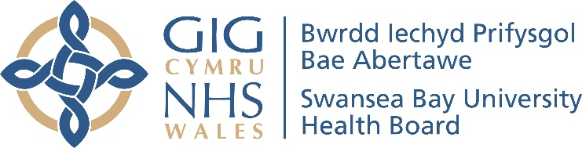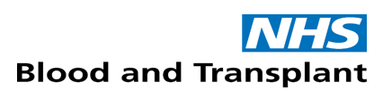

Swansea Bay Organ Donation Annual Report

2024-25

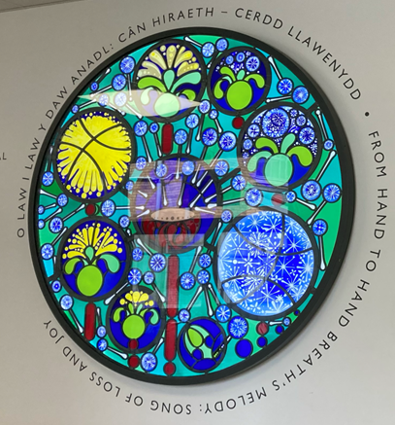

Contents Page

Item | Page Number
Foreword | 3
Meet the Team | 4
Activity in 2024-25 | 5
Sue and Andrew’s Story | 9
Governance and Finance | 10
Conclusion | 11

Foreword

Welcome to the organ donation annual report 2024-25, an opportunity for us to celebrate those who have helped to save or better the lives of others through the gift of organ donation.

The decision to be an organ donation is a difficult one, and even more so for the families left behind who have to consent following the death of their loved one.

Being an organ donor can help so many people and there are two forms it can take.

A solid organ donor donates organs such as kidneys, liver, lungs, pancreas, bowel and heart, potentially helping up to nine people. While a tissue donor, someone who gives heart valves, skin, bones and tendons for example, can benefit as many as 50 people, including children born with heart defects, while up to 10 people can be helped by two cornea donations.

If organs are not suitable for solid organ transplant, or there is no recipient available for solid organ, organs and/or tissues can be used for scheduled purposes, such as research, education or training related to human health, clinical audit, quality assurance and performance assessment, which has the potential to benefit many patients in the future.

As you will read later in the report, not everyone can be an organ donor, which is why it is important we take time to recognise those who are, as it is a precious gift to others, providing hope to patients and families who otherwise had none.

We are really grateful to each and every one of our donors and families who supported organ donation. At a time when they were trying to process the news that they were about to lose someone special, they took the time to think about the good that could come of the death and help other families to have better outcomes.

This cannot be underestimated, and while not all donations will be able to go ahead, we are grateful they were prepared to try.

 | 
Dr Richard Evans  Executive Medical Director/Deputy Chief Executive  Executive Lead for Organ Donation | Jackie Davies  Independent Board Member  Chair of the Organ Donation Committee

Meet the Team
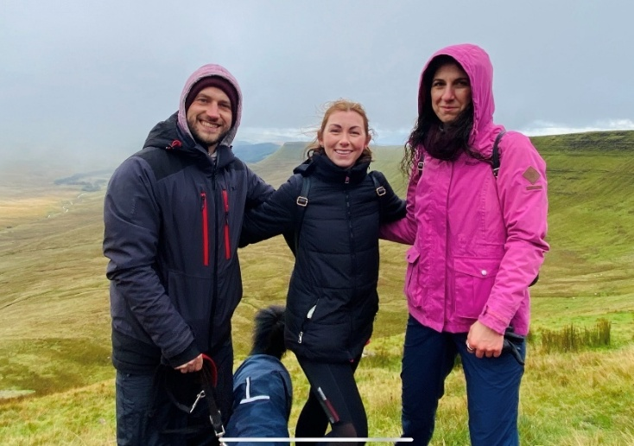
We are lucky within Swansea Bay to have such a dedicated team supporting organ donation. We have two specialist nurses for organ donation (SNOD), Damien Stevens and Jessica Becker, who are funded through the NHS Blood and Transplant Service, and a Clinical Lead for Organ Donation (CLOD), Dr Anita Jonas.

Deemed consent for organ donation, also known as an opt-out system, means that in the absence of an expressed decision (either to donate or not to donate), a person's consent to organ donation is presumed. This system is in place in England, Wales, Scotland, and Northern Ireland. In essence, if someone doesn't register their decision on the NHS Organ Donor Register, it will be assumed they agree to donate their organs upon death.

When the team become aware of a patient who might be eligible to be an organ donor, Damien or Jessica talk with the families about what they would like to do, and we can’t underestimate how difficult a time this is. No pressure is put on families to support to organ donation. The SNODs and CLOD are there to explain the process and answer any questions or concerns the family may have, as well as provide specialist support during this time.

But the role doesn’t stop there, as the team are constantly raising awareness of organ donation across the health board, with examples this year including:
- Creating a bedside teaching booklet for campions to support bedside nurses;
- Regular teaching in the emergency department, end-of-life care service and nurse inductions;
- Attending conferences and study days presenting complex cases and sharing learning with others;
- Theatre simulation.


Organ Donation Week is an opportunity to plan activities which promote organ donation locally and nationally. This year it took place between 23rd and 29th September 2024, during which the team climbed Pen Y Fan as part the ‘Turn Peaks Pink’ event, which saw 100 people recruited to the challenge of climbing one of six mountains to turn the peaks pink at 2pm on 27th September 2024. Closer to home, the team had stalls across our hospital sites to host discussions and share patient stories, highlighting the impact organ donation can have for families.
Activity in 2024-25

Our organ donation activity takes place at Morriston and Singleton hospitals, as this is where patients likely to be suitable will be treated. The majority of patients are in Morriston, as it is only neonatal donors in Singleton, which are rare. We are a level two centre, based on the number of donors we can expect to have each year, which is between six and 12. We only work with the donor patients, and their organs can be given to patients anywhere in the UK. Any kidney transplant recipients in south-Wales will be operated on in the specialist centre in Cardiff, while Welsh recipients of other organs will be operated on in specialist centres across UK.

Not everyone who dies can be an organ donor, and most people don’t die in a way which makes them suitable. In Swansea Bay, it is only patients who are intubated and ventilated, and pass away in critical care, who are suitable for referral to the NHS Blood and Transplant Organ Donation Services Team for solid organ donation. And even for those patients who do die in this way, other criteria may mean they cannot donate, for example if they had certain medical conditions. Age is rarely a factor, with babies able to donate from 37 weeks adjusted gestation (their age if you take away any additional weeks due to prematurity), up to 85 years of age.

There is no age limit for tissue donation and these patients are also able to consent from the ward, without needing to be ventilated.

In 2024-25, 93 patients were referred to the NHS Blood and Transplant’s organ donations services team, 43 of which met the referral criteria and could be included in the potential donor audit. From this, we had 13 consented donors, of which 12 were able to donate, benefiting 31 patients across the UK, with 24 kidneys, 10 livers, two pancreas, two hearts and two sets of lungs. In addition to these donors, were several tissues donors - five heart valves and eight corneal were donated.

However, we have seen an increase in the number of referrals and donors in the last few years, as the chart below shows:

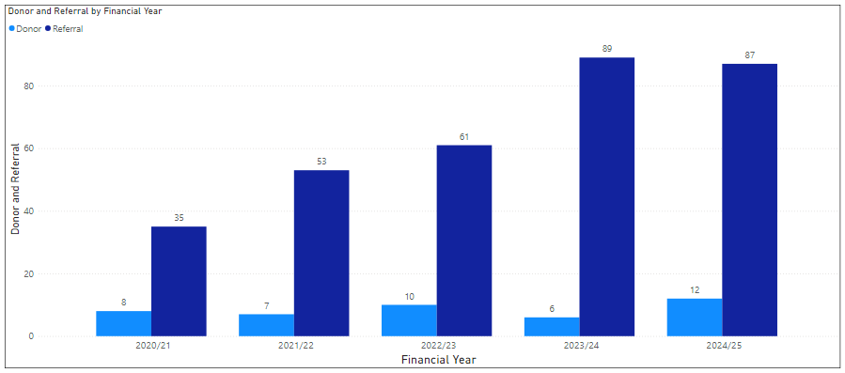
And this chart shows that our activity is above the national average is most areas, demonstrating the commitment and the support shown to organ donation in Swansea Bay.

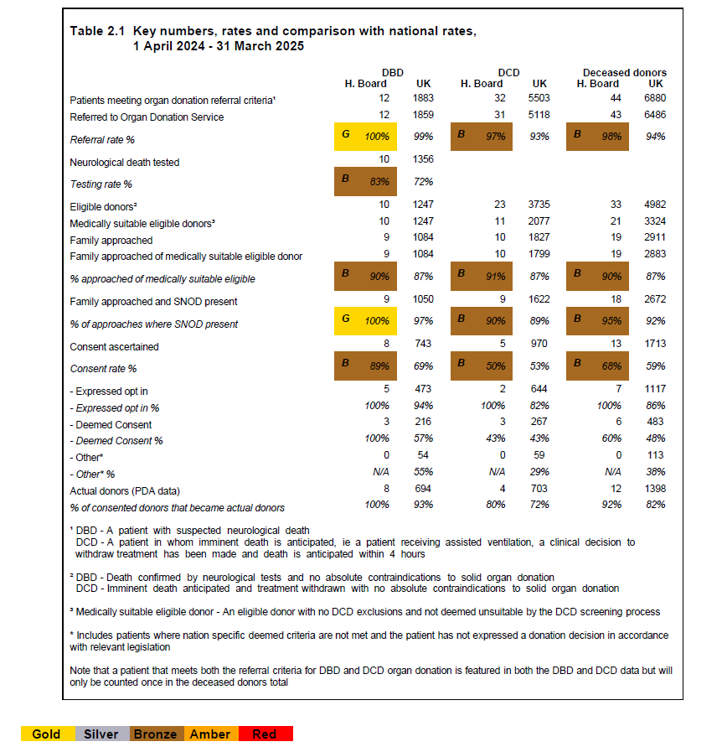

There are two types of solid organ donor:
- Donation after Brain Death (DBD) – donation after brain death happens when the patient was diagnosed dead by neurological criteria;
- Donation after Cardiac Death (DCD) – patients have experienced cardiac death, meaning heart and respiratory functions have stopped.

The tables below show the activity in 2024-25 for each of these groups of patients:

Donation after Brain Death (DBD)

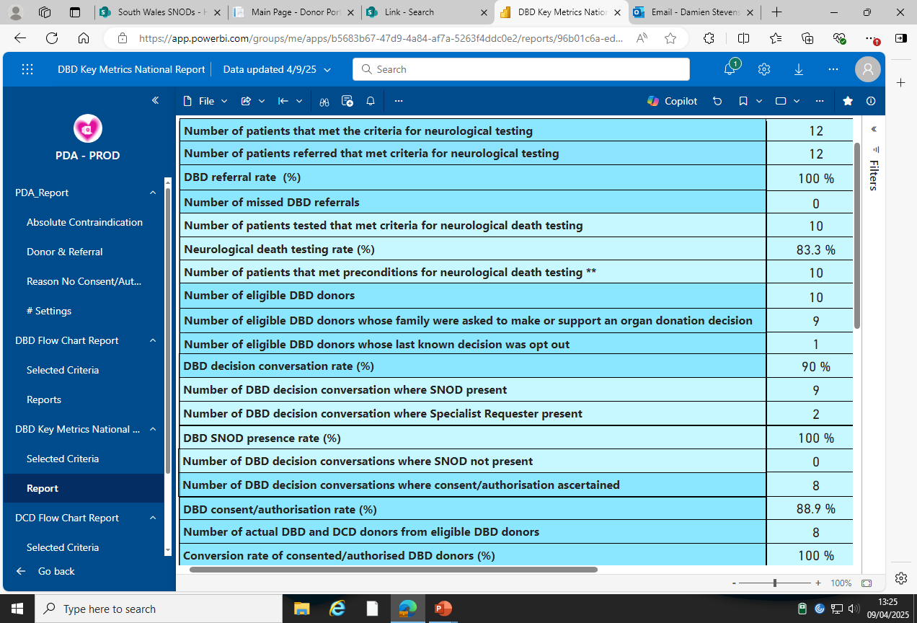

Donation after Cardiac Death (DCD)

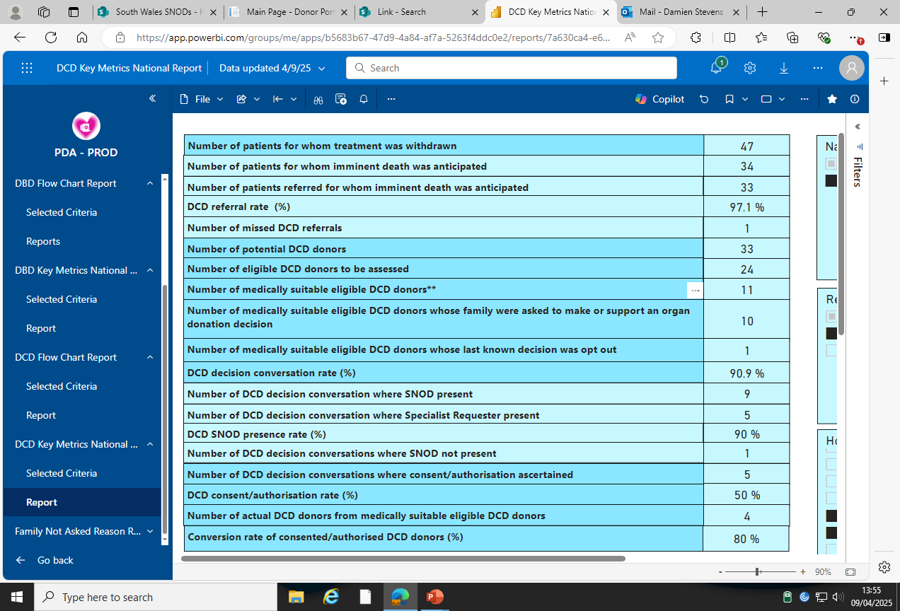

In some cases, the referred patients were not suitable for organ donation as they had other illnesses, such as active cancer, or further tests showed their organs were unsuitable for transplant. However, for some, the family chose not to consent. This can be for a variety of reasons, which will always be respected, but the main themes for 2024-25 were:
- The patient had registered a decision not to be an organ donor or had previously expressed a wish not to donate;
- Family unsure what the patient would have wanted;
- Religious/cultural beliefs;
- Length of time the process would take.

Sue and Andrew’s Story

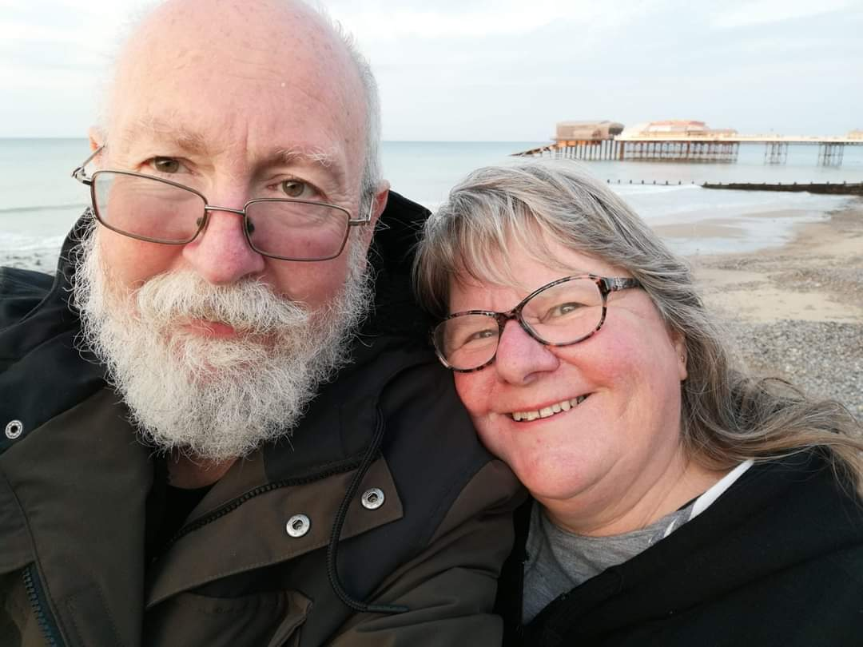
Andrew’s collapse came as a shock, but when it became evident that he wouldn’t make it, we knew what he would have wanted. As a family we’ve always spoken openly about death. Not in a morbid way, but it is something that is going to happen to all of us. We know what sort of funeral each of us wants, where we would like our remains placed and how we feel about organ donation.

Andrew was the most generous and loving person I’ve ever met, and we knew that he wanted to continue helping people as he had all through his life.

The approach from the organ donation staff was so gentle and thoughtful. They explained our options and we didn’t feel under any pressure. The decision wasn’t difficult for us, because we already knew Andrew’s wishes, but it feels like a very strange situation. We had delays while we waited for family members to come back from abroad, and where there were some medical complications, but we were quietly kept informed at all time, without us feeling rushed.

We were able to spend a lot of time with Andrew over a few days and were all there when the life support was turned off and he left us. Staff helped us to make handprints, and put together a memory box for our first grandchild, who had been born just weeks before Andrew was taken ill. We felt that Andrew was cherished.

I chose not to, but some of the family accompanied Andrew’s body down to the operating theatre when the time came. They found the process very dignified and respectful and were pleased to be with him in his final journey.

Over the following months we were kept up to date with what had happened and received phone calls checking how we were doing. We never felt abandoned.

We are grateful, that with the help of the organ donation staff, what was undoubtedly a tragedy for our family had some sort of positive outcome. That is some comfort.

Governance and Finance

In 2008, the health board established its Organ Donation Committee following the publication of the report ‘Organs for Transplants: A Report from the Organ Donation Taskforce’. Chaired by an independent member of the board, it meets quarterly and covers areas including:

- Data;
- SNOD/CLOD updates;
- Training and education;
- Promotion of organ donation
- Implementation of national policies and strategies;

Members include:
- SNODs;
- CLOD;
- ICU nurses;
- Multi-faith chaplaincy;
- Care after death team;
- Donor family;
- Medical Director’s department representative.

The committee did meet quarterly, with meetings in April, June, September and December 2024. Attendance is good, with a range of members attending each meeting to bring different perspectives to the discussion.

The next stage for 2025-26 is to enhance reporting into the health board, through the Quality and Safety Committee, which will highlight the work of the organ donation team in the health board.

Finance is also discussed at the meetings and while there is no direct allocation of money to health boards, there is a central pot to which we can submit bids via a QR code, for funding to support organ donation activity.

Some of the recent successful bids for Swansea Bay include:
- Monies for training neonates and palliative care staff;
- Refurbished care after death relatives’ room;
- Pebbles for families with the words hope, love etc which are well received and given out by the chaplaincy service;
- New story board received regarding eye donation, which will be placed in the memorial area at Morriston;
- Bereavement counselling.

Conclusion

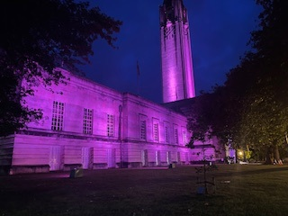
We’d like to finish this year’s annual report with a thank you to those who have donated their organs and their families for supporting this decision, giving others the chance of a life they would not have had otherwise.

Across Wales, 173 people benefitted from a solid organ donation, but 20 patients died while on the transplant list, so there is more to do to raise awareness.

We know no-one likes to think about what comes next and having these conversations is hard, but if you talk about your wishes early, you can help your loved ones make the right decision for you when you are gone.

If you want any further information, please visit the NHS Blood and Transplant Service website.



