10. Workforce Updates and Actions
This section of the report provides further detail on key workforce measures. Caveats and Limitations (C&L) detailed beneath data in each section.

Staff sickness rates - Percentage of sickness absence rate of staff (two metrics provided, ‘rolling 12 month’ and ‘in month’)  Sickness absence target – 5.5% | % of full time equivalent (FTE) days lost to sickness absence  Caveat & Limitations;- Report generated Nov 2023, within SBUHB (Performance Team) for substantive and FTC employee types. Data source – ESR.  Target of 5.5% added as blue line
Current Performance
- Health Board total for in month sickness absence for September 23 decreased from the last reporting period (7.01% July 23, 7.05% August 23) to 6.69%
- In comparison to September 22 (7.10%) there was an improvement of 0.41% in month
- Anxiety/stress related absence remained the highest reason for absence, with MSK second. This is consistent across NHS Wales and is a long term pattern.
- Mental Health and Learning Disabilities Service Group had the highest in month percentage absence in September 23 at 8.70%. This has increased from last reporting period (July 23 at 7.28%). Morriston were next at 6.72% (which shows a decrease from last reporting period July 23 6.82%), followed by Neath Port Talbot/Singleton 6.37% and Primary, Community and Therapies at 5.32%
- Short-term sickness for Sept 23 was 2.31%, an increase from last reporting period (1.77% July 23)
- Long-term sickness for September 23 improved to 4.37% from last reporting period (5.25% in July 23)

Actions for Next Period
Current focus on areas with high absences rates, examples of initiatives to support our employees:
- HR team and managers encouraged to attend Healthy Working Wales session in December 23 on Understanding and Managing MSK conditions (currently the Health Board’s second highest reason for absence)
- Time table for sickness absence audits across hot spots areas
- Best Practice Review continues to improve our employee relations processes
- Stress at work session for the HR Team facilitated by Legal and Risk will be held in November 2023

Staff Health and Wellbeing
The services continue to develop prudent processes and multi-disciplinary working to maximise resources and maintain waiting times within KPI’s. The resignation of our full-time Occupational Health Doctor is being managed with support from Medical HR, Procurement and All Wales colleagues to ensure a sustainable service.
- NHS Shared Services Partnership audit of Sickness Absence recommended updated evaluation report of Staff Wellbeing clinical interventions to demonstrate efficacy – to complete by Feb 2024
- Occupational Health (OH) have been supporting the Staff Flu and Covid campaign led by the Immunisation Service – 20.6% of front-line staff had received the vaccination as 31/10/23. The OH Nursing team provided intensive support at the start of the campaign and are continuing to offer Flu Vaccinations within the Occupational Health Departments
- Plans to appoint a Band 6 OH Nurse to undertake staff health checks within a ‘prevention/early intervention’ approach to staff health and wellbeing – interviews taking place Nov ‘23
- Triage process developed during the previous reporting period now implemented to support reducing waiting times for Staff Wellbeing Service – to become ‘business as usual’ as now able to offer first contact within 5 working days
- Currently implementing Opas-G2, new National OH System that will reduce waits for clinical services and pre-employment health clearances

Mandatory & Statutory Training-  Percentage compliance for all completed Level 1 competencies within the Core Skills and Training Framework by organisation  Mandatory & Statutory Training target – 85% | % of compliance (Headcount) with Core Skills and Training Framework  C&L;- Report generated Nov 2023, within SBUHB (Performance Team) for substantive and FTC employees. Data source – ESR (OLM Module). Accuracy levels subject to local maintenance and validation standards.  Target of 85% added as blue line
Current Performance
- Since October 2015 there has been a Health Board focus on addressing low compliance in M&S training. Compliance rates in 2015 were 24.19%. Compliance rates for the Health Board as of October 2023 are now much improved at 87.27% which is above the Welsh Government target of 85%
- Compliance against the 14 core competencies has increased to 87.9% with Medical & Dental continuing to be the lowest performing area, although they have seen another increase to 61.25%. Estates and Facilities being the next lowest at 83.21% however there has been improvement here with an increase of 1.5% since our previous report. WOD currently stands at 90.28%. AHP’s remain the highest performing area, which stands at 92.95%.
- The range across the service groups is between Morriston at 82.15% and PCST at 92.03%
- ESR E-Learning announcements are available via ESS My Learning Page, the announcements pane offers resources for assisting with accessing ESR E-Learning, a link to the Mandatory & Statutory SharePoint page and announcements of Changes to Statutory & Mandatory E-Learning requirements
- ESR E-Learning Drop-in Support Sessions have now concluded for 2023. An evaluation of the sessions provided will be carried out to review uptake and feedback provided by attendees to establish the need going forward in 2024
- Outstanding SIP updates still pose a challenge for line managers in monitoring compliance levels. This is being picked up locally

Actions for Next Period
Subscription to Learning Certification and Enrolment onto Statutory/Mandatory Courses (E-Learning) – Previous issues with ESR Learning Certification subscription have now been resolved. Residual issues are due to user error which are being supported on a case-by-case basis via Action Point and direct point.

- MH&LD (90.43%) - Clinical Directors to continue to focus on improvement of mandatory training for Medical staff which is a contractual requirement
- NPTS (89.25%) - Whilst the overall compliance rate for the group is positive the compliance rate for Medical Staff Group remains a challenge however, there has been an improvement over the last period with the improvements driven by targeted intervention from Clinical Leads and Directors
- PCCT (92.03%) –The Service Group is currently compliant as they are over the 85% compliance rate.
- Morriston (82.15%) - The divisions have devised action plans to achieve their targets regarding M&S, and the ASDs request updates from their teams regularly in relation to progress. On a monthly basis the divisions are required to provide updates on their progress to management board in the performance reviews
- Finance & Estates (88.48%) - On-going support is being provided to Estates staff who are finding it difficult to complete the training. i.e., allocating time and resources
- Facilities (83.58%) - On-going support is being provided to Facilities staff who are finding it difficult to complete the training. i.e., allocating time and resources.

Vacancies  Medical and Nursing and Midwifery | Vacancies (FTE) Aug 2023 to Oct 2023  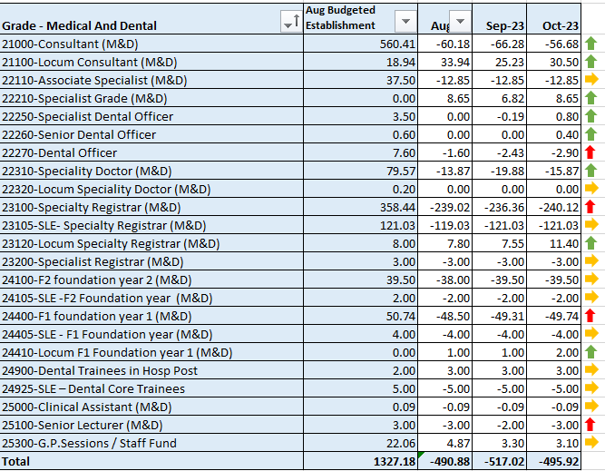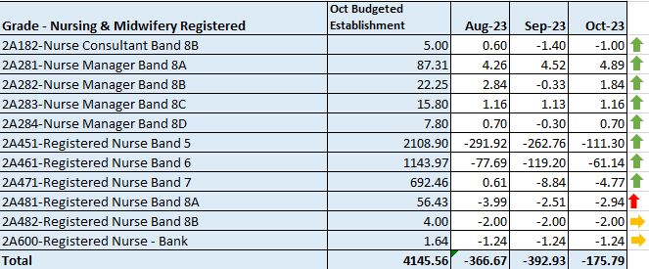  C&L;- Report generated 18 Sep 2023, within SBUHB (ESR Team), using currently available methodology. Data source – ESR (Workforce) and General Ledger (Finance). We compare the SIP v’s the finance ledger, appreciating limitations on accuracy in some areas. Accuracy levels are subject to local validation practices based on budget holders intelligence. N.B. a 12 month project (ESR Establishment control) has commenced which will harmonise vacancy data including Grade detail shown above.
Current Performance
- Latest cohort of circa 19 overseas nurses due to arrive by end of November. Further cohorts are being carefully planned as vacancies for general Band 5 nurses have mostly been recruited in terms of active pipeline, as per feedback from Service Groups. Focus is now on more specialist areas.
- Circa 70 newly qualified nurses (NQNs) due to qualify in March 24 have recently been allocated posts with the Health Board via Student Streamlining Process (SSP).
- The Central Recruitment Team have supported some key areas with difficulties to fill for example: the team have supported to onboard 22 Midwives (15 from the preceptorship) to support the vacancies within this service
- The Central Resourcing team have been engaging with local colleges to encourage applications from students. Links have also been made with a local Care Homes that was due to close to help support those staff identify alternative employment
- Temporary agency costs have greatly reduced due to the efforts to recruit to both Band 5 nursing vacancies and Medical vacancies

Actions for Next Period
- Overseas Nurse recruitment business case for 2024/25 to be finalised and submitted to Management Board
- Pre-employment checks for NQNs commencing in March 24 to be undertaken as soon as details transferred from SSP team
- Meetings to take place to scope out short term recruitment plans for MH&LD (Band 2,3,4,5) and PCT Service Groups (Band 2,3,4,5) for Central Resourcing team to support following expansion of service
- ED is another hot spot area being supported by the Central Resourcing team

Recruitment  Metrics provided by NWSSP. Comparison with all-Wales benchmarking  Target 44 days | Vacancy Creation to Conditional Offer October 2023 (working days: excluding outliers) T13  C&L;- Report generated Sep 2023, by NWSSP (Recruitment). Data source – TRAC system. Outliers are excluded. This is day to day vacancy management.
Current Performance
- Swansea Bay UHB overall performance was below target in October and an improvement on last reported performance, and our monthly average over the last 12 months remains in target. In addition our performance for conditional offer to ready for start date start date remained broadly within target expectations
- The Central Resourcing Team continue to focus efforts on the recruitment of acute ward based HCSW’s and Band 5 nurses as well as providing support to specific difficult to recruit to posts (see above) and vacancy gap has closed significantly evidenced by significant reduction in nurse temporary agency spend
Current KPI’s (Oct 23) comparing SBUHB averages vs the CRT on HCSW recruitment is 72 days vs 54 days based on average time taken from vacancy creation to unconditional offer

Actions for Next Period
- HRBP’s continue to discuss with Service Groups opportunities to reducing the lag between the date termination of posts are being requested versus date a TRAC entry was initiated.
- The Central Resourcing Team will continue focusing on the recruitment of B5 nurses, B2 ward based HCSW’s and assisting in overseas nurse recruitment. In addition, they are assisting in the recruitment of newly qualified nurses, via the all Wales Student Streamlining process. As well as specific identified hard to recruit to posts.
- Meetings to take place to scope out short term recruitment plans for MH&LD and PCT Service Groups for Central Resourcing team to support following expansion of service (see above)
- For doctors we continue to recruit overseas on a post by post basis

Turnover  % turnover by occupational group | Period Turnover Rate (Swansea Bay) – 01 Nov 2022 - 31 Oct 2023  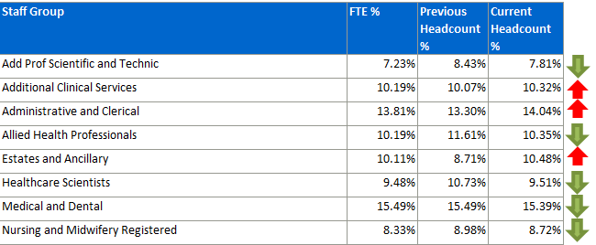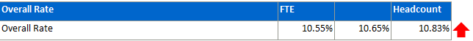  C&L;- Report generated Sep 2023, within SBUHB (ESR Team). Data source – ESR (Workforce). Small risk of margin of error due to late communication of terminations. Report excludes Bank, Locum, Honorary & Widow/Widower, Junior M&D staff. Internal movement not included – measure is about leaving Swansea Bay UHB.
Current Performance
- Organisationally our turnover has increased marginally in this reporting period (from 10.65% to 10.83%).
- It is important to recognise that this is reporting on a 12 month rolling period of turnover.
- There has been an overall increase in Estates and Ancillary turnover this period (8.71% to 10.48%). It is important to recognise, that this is a 12 month rolling figure. This increase does not represent a recent spike. Intelligence indicates that this relates to retirements and the odd resignation. A review has not highlighted a concern. Indeed, the service has supported a number of retire and returns which is positive. The figure impacting this 12 month rolling period relate to October 2022.
- Admin and Clerical turnover remains the highest rate at 14.04%. This is due to a service transfer of ‘Delivery Unit’ consisting of 75 individuals in March 2023 from SBUHB to Public Health Wales. This large peak will continue to influence the 12 month rolling figure until March 2024.
- N.B. there has been a recent movement of certain Medical and Dental staff linked to the SLE rotations. We are working with the teams to better understand this. .
- This scenario is under investigation as it has created a spike in M&D turnover due expected activity as they move around HB’s as part of their standard rotation
- Other categories are either stable or improving.

Actions for Next Period
Actions which will feed into Turnover improvement are currently being led by two ongoing focus groups – Recruitment and Retention, and Flexible Working Group.
- Flexible Working Group introductory meetings are taking place, to identify means of improving retention by reducing attrition attributable to flexibility.

PADR  % staff who have a current PADR review recorded  PADR target – 85% | % of staff (Headcount) who have had a PADR in previous 12 months  C&L;- Report generated Sep 2023, within SBUHB (Performance Team). Data source – ESR (OLM Module). Accuracy levels subject to local maintenance and validation standards.  Target of 85% added as blue line
Current Performance
- Staff who have had a Personal Appraisal and Development Review (PADR) at the end of this time period stands at 65.9% which is a 1.2% decrease since the last reporting figures.
- Primary Care and Community Service Group are showing 78.9% compliance, Mental Health and Learning Disabilities 71.8% compliance, Neath Port Talbot Singleton 68.4% compliance, Morriston 58% compliance, Finance and Estates has compliance of 66.1% and WOD 67.2%.

Actions Planned for Next Period
- MH&LD - Plans to be put in place to identify dedicated time to meet with all staff for objectives and development and to prioritise the 359 staff that have not received a PADR and ensure ESR records are updated.
- NPTS – The service group continues to focus on its PADR improvement plan. Discussions have been initiated with teams to focus on the quality of the PADR experience for both managers and employees (note this ESR sourced data does not yet include the new portfolio of services). There will be a focus on improving the PADR experience of employees in the Additional Clinical Support staff group.
- PCCT - Workforce is liaising with Leads within areas of non-compliance to agree and draw up a recovery trajectory, and the group provide a monthly breakdown of their PADR Compliance to ensure accountability.
- Morriston - Each division is mapping a planned trajectory to show monthly increases that will achieve the 85% target as well as putting in place targeted plans where areas have been identified as having low compliance. Data is being cleansed to rectify anomalies found attributing individuals to incorrect cost centres.
- Estates and Facilities - PADR compliance rates within Estates Services have increased to 89.15%. Facilities has a lower compliance rate, so focused interventions have been undertaken to support group PADR’s to help address this.

Operational Casework  Number of current operational cases. | C&L;- Report generated Nov 2023, within SBUHB (Workforce Digital). Data source – ER Tracker. Accuracy levels subject to local maintenance and validation standards.
Current Performance
- No. of open Formal Disciplinaries since the last reporting period has raised somewhat to 51 in Oct. Levels still remain lower than over previous months. 9 cases were closed in month versus 15 opened, which accounts for the slight rise in overall total.
- Number of Formal Grievances decreased again from 25 to 23.
- Formal Capabilities have risen since July, from 1 at that time, to 5 currently.
- ET’s currently sat at 5 total. This is in line with the average for the HB, and given the extended length of time this case type would normally exist over, it is still considered low for such a large organisation.

Actions for Next Period
- A number of actions are on-going in line with the Best Practice Review, workshops arranged over the next 3 months jointly with our Trade Unions facilitated by HEIW and Legal & Risk covering the following: Respect and Resolution (11 December 23) and Managing Disciplinary (Early 24).
- HR Operational share point site has been developed and is now live, which includes policies and toolkits, for all the main employee relations management processes. This will be launched over the next period.
- Investigation Officer Training facilitated by Legal and Risk to be held in January 2024.

