
HEIW ALL WALES RETENTION PROGRAMME
Introduction
Retention is a vital part of sustaining and growing our NHS workforce to meet the increasing and changing demands on services. In recent years our staff have been leaving the NHS at an increased rate, and the reasons for this have been widely documented (1). This means that as a system we need to focus attention and resources on the retention of our existing workforce as well as the development and expansion of the future pipeline. Retention has been recognised as a key theme and set of actions in the National Workforce Implementation Plan.
What is Retention?
The research demonstrates that retention of staff is affected by many factors. This includes external factors such as pay, terms and conditions, pensions, which are set by government, and a range of internal factors which affect how staff experience work. The focus of the HEIW Retention Programme is on how staff experience work, recognising the multiplicity of factors that affect this including staff engagement; flexible working; wellbeing; leadership and culture; CPD; career pathways.
Case for Change
Poor retention has many consequences including: quality and safety of care; staff wellbeing; excess costs of temporary staffing; reduced value of investment made in education and training; increased transactional costs in covering vacancies. It is often referred to in the context of the “leaky bath” where we are pouring in new recruits, newly qualified students, and trainees, at the same time as our current workforce are leaking out. The worsening retention position in the nursing workforce has been a particular concern.
NHS England established a Retention Programme in 2020, which works to support and help organisations and systems with evidence-based interventions that achieve real tangible improvements in staff retention. Through the programme they have identified the need for targeted interventions for different career stages and that bundles of high-impact actions which are more effective than single actions. Whilst adopting a whole workforce approach the programme has also a particular focus on the nursing and midwifery workforce.
Although retention activities already feature in many of the themes of the Workforce Strategy for Health and Social Care, we believe that a specific retention programme would add value to the work currently going on at national and local level and is essential in the context of current deficits and financial recovery. This is closely aligned to our work on developing compassionate cultures and leadership, ensuring that we are developing the working environments that make staff want to stay.
Programme Aim and Objectives
The aim of the programme is to improve retention of our workforce as a key plank of our current and future workforce supply. This encompasses all professions and disciplines.
The programme aims to achieve this by:
- Providing targeted support and resources for employers based on best practice – (this will include a funded local retention improvement lead for each delivery organisation).
- Increasing awareness and understanding of good retention practice amongst line managers, management teams and Boards.
- Developing, sharing and embedding best practice in retention supported by a QI/community of practice approach.
- Balancing generic and profession specific support on retention, and targeting hot spots.
- Supporting employers to develop effective retention improvement plans that suit local circumstances.
- Increasing visibility of retention metrics supported by Board level reporting.
Roles and Responsibilities
Retention needs to be locally driven but supported through a national framework. An effective response to retention requires a system wide approach with clear roles for HEIW and employing organisations as outlined in the diagram below:
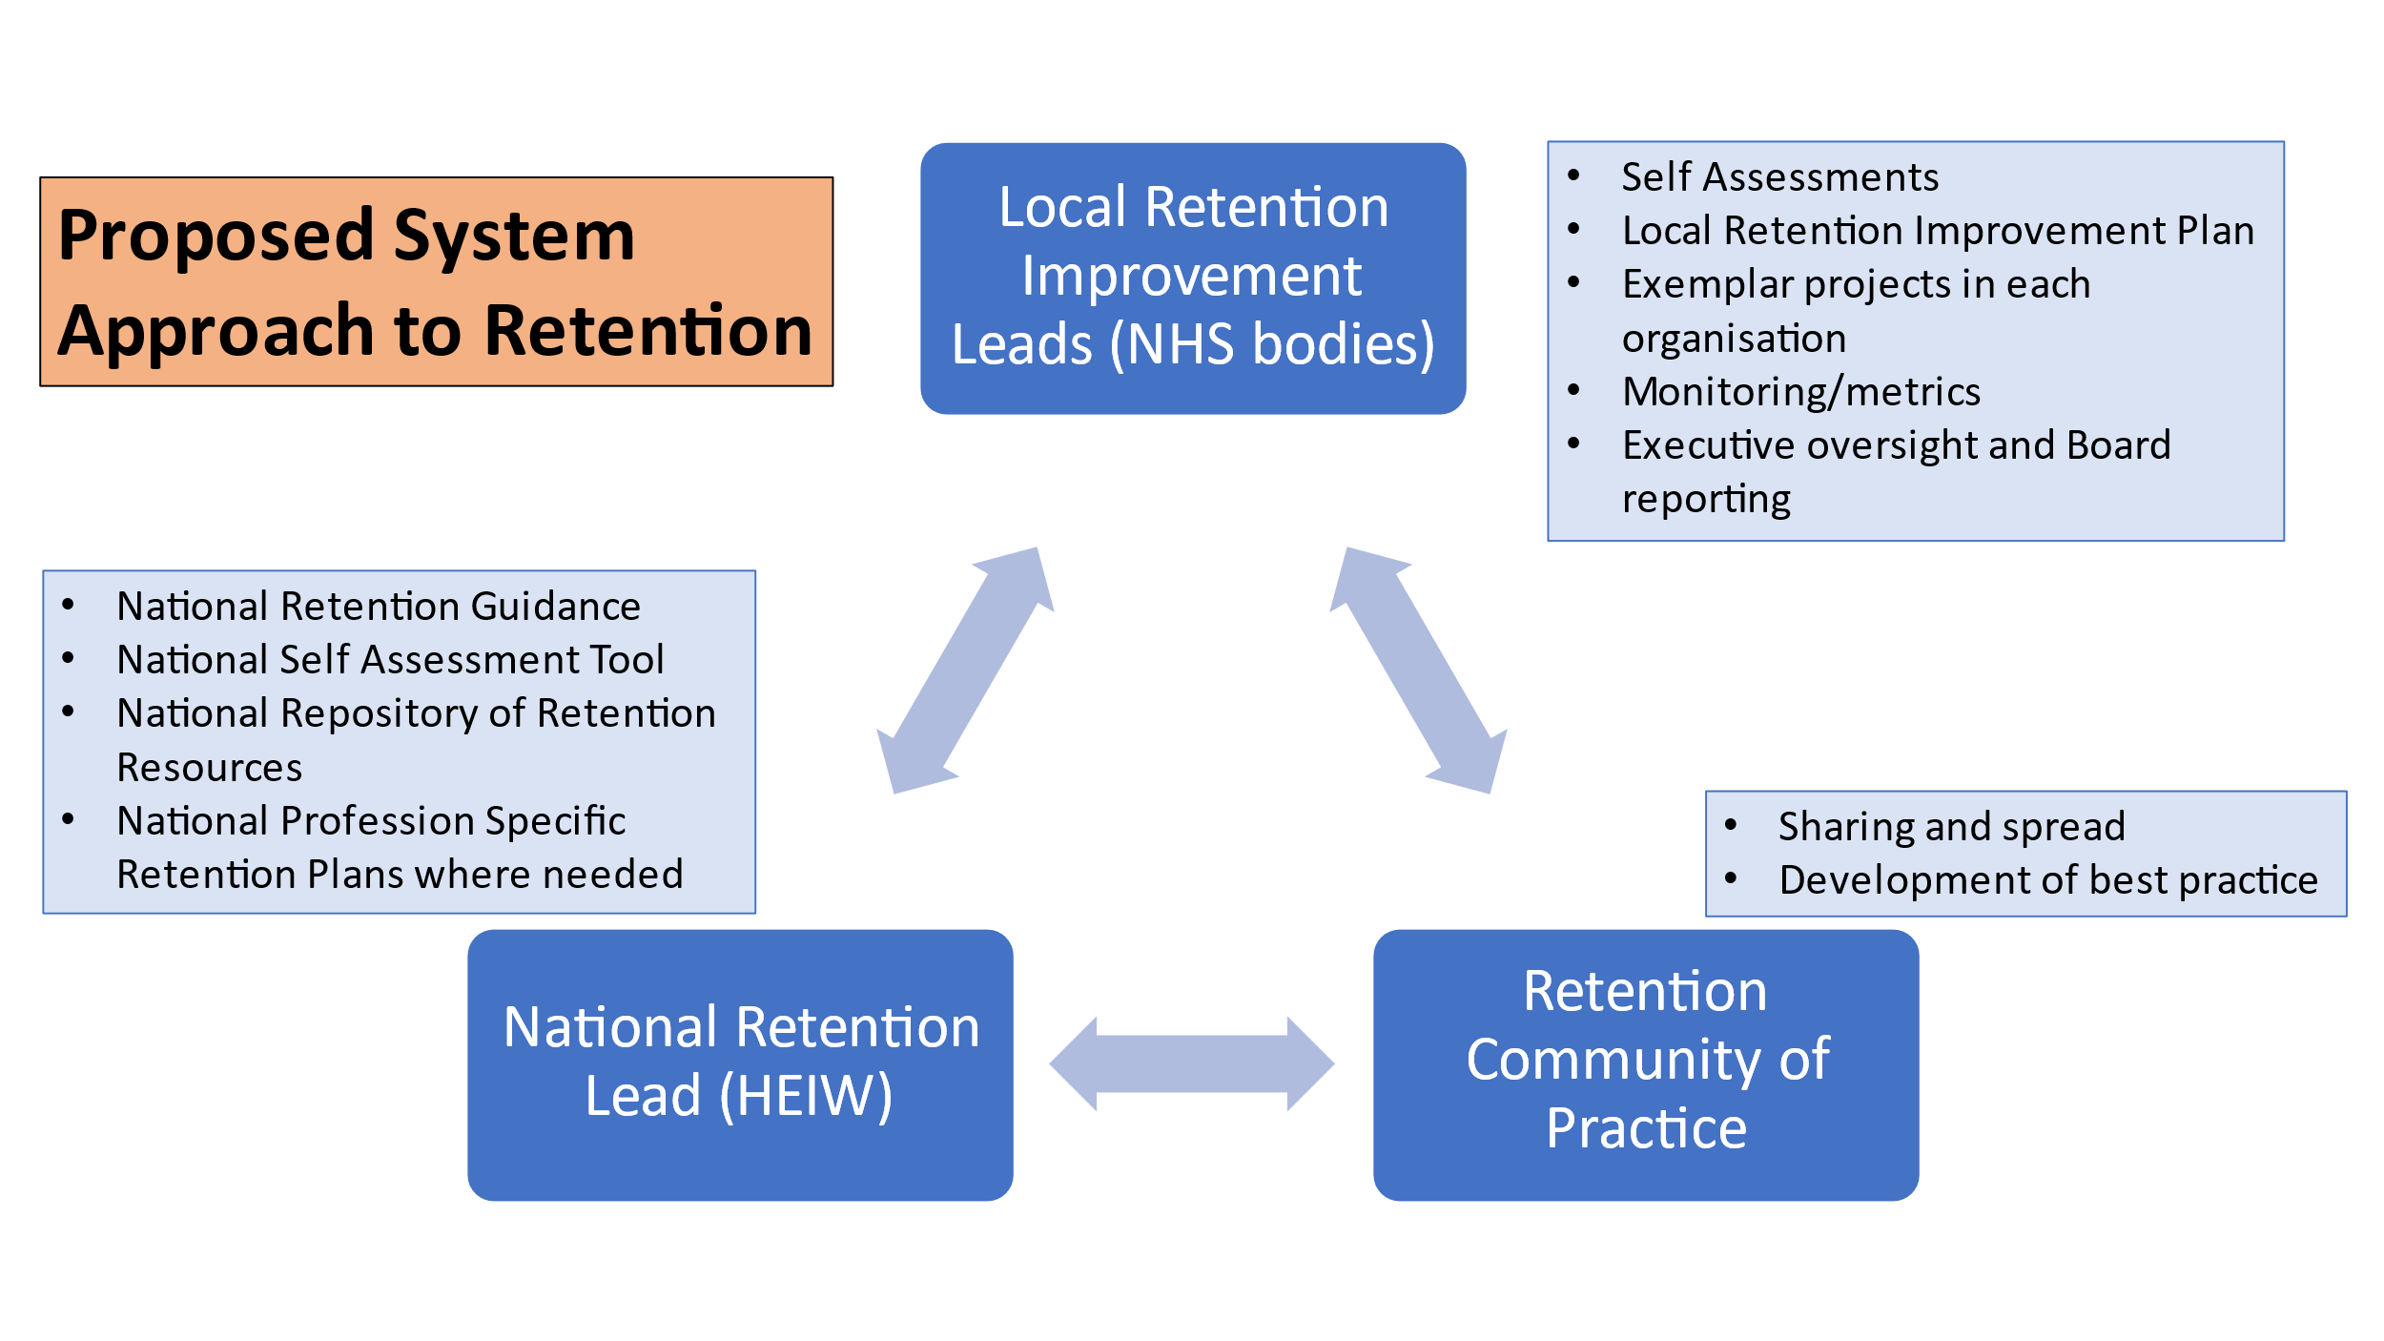
NHS bodies are already addressing retention in various ways, so the approach needs to build on and strengthen existing work. Therefore, completing a local self-assessment is key to inform local priorities whilst also ensuring that there is visibility and attention to a consistent set of retention metrics at Board level and national level.
Resources and Guidance
We have reviewed and adapted some of the products from the NHS England programme. This has resulted in the development of:
- Retention good practice guidance. This provides advice and signposting to resources that can help line managers in particular consider how to embed good retention practice in their areas
- A self-assessment tool. This will support organisations and teams in identifying strengths and gaps in their local retention activities to inform the development of local retention plans.
These resources will be available on the HEIW website from 25th September
Nurse Retention Plan
The nurse retention has been developed as part of the strategic nursing workforce plan. It is also a specific deliverable in the National Workforce Implementation Plan and linked to the non pay measures of the pay deal. Following approval by the Nursing Workforce Plan Steering Board which includes RCN, WG, and Health Board representatives this is being launched on 25th September.
Programme Infrastructure
The Programme will adopt a QI approach based on the following:
- Local Retention leads to be identified for each organisation. To support this HEIW will fund dedicated local retention leads in the 7 Health Boards, WAST and Velindre for 2 years, based on a common expectations agreement for roles and deliverables.
- A national retention lead will be established within the HEIW Leadership and Succession Team, to lead the creation of a HEIW Retention Hub.
- QI training and support for leads and community of practice will be provided.
We will aim to provide a small innovation fund to provide further support for local projects when the programme is up and running.
Measurement and benefits
It will be important to agree a core set of system metrics to monitor and evaluate the impact of the retention programme. These could include:
- the NHS leaver rate
- demographic data of workforce and leavers
- turnover rates and reasons for leaving
- sickness rates
- retention related staff survey questions
- agency spend.

In addition, more specific process measures will be considered to support this, for example, stay interviews, exit interviews and flexible working approvals.
The Programme will provide advice on these measures to Directors of Workforce and OD as there is an expectation that these are visible at Board level.
Key Milestones
- September – HEIW launch Programme and Nurse Retention Plan
- October – HEIW and local organisations to recruit /identify Retention Leads
- November – HEIW to establish Community of Practice meeting monthly to support organisations with next milestones
- December – Local organisations to complete Self Assessment
- January – Local organisation to refresh/complete Retention Improvement Plans based on self assessment – implementation commences
- March – review of progress against Nurse Retention Plan

END

