

DIGITAL PROCUREMENT POLICY

This Policy has been screened for relevance to equality. No potential negative impact has been identified so a full equality impact assessment is not required.

Document Author: Stephen Morgan, Head of Service Delivery
Approved by: Digital Services Management Group
Approval Date: TBC
Review Date: 3 Years
Document No: HB130

DISCLAIMER
When using this document please ensure that the version you are using is the most up to date either by checking on the Health Board’s Intranet site for any new versions or if the review date has passed, please contact the author.

Revised April 2023: Amendments

Organisation name changed from ABMU to SBU

Name of Document changed from ‘ICT Procurement Policy’ to ‘Digital Procurement Policy’

Rebranding from ‘IT Portal’ to ‘myITPortal’ within the document.

Rebranding from ‘ICT’ to ‘Digital’ within the document.

Rebranding from ‘IT Security’ to ‘Cyber’ within the document.

Section 6.3 – New section added regarding ‘Supply Chain Cyber Assurance’ (CSIA)

Section 6.6 - CSIA and Data Protection Impact Assessment (DPIA) information added to this section.

Section 9 – Contact details for the Digital Service Desk updated from ‘43636’ to
Ext 44400 or 01639 684400

Section 10.1.1 – Information pointing to PC specifications being found on the intranet has been removed. Individual quotes are supplied.

Section 10.1.4 – Information regarding the reference supplied by Digital has been removed and replaced with information on Equipment suppliers.

Section 10.1.5 – Information on digital equipment specifications have been removed from this section and has been replaced by advice on procuring network attached devices.

Section 10.2.2 – Section updated on the use of Fax machines and alternative solutions available.

Section 10.2.5 – Information on the enterprise agreement for software and subscription-based software had been added. Information on ‘licence pack charge’ has been removed.

CONTENTS PAGE
- Background 4
- Policy Statement 4
- Scope 4
- Aims & Objectives 4
- Introduction 4
- Policy Principles 5
  - Agreed Standards 5
  - Standing financial instructions 5
  - Supply Chain Cyber Assurance 6
  - Replacement Programme 6
  - New equipment 6
  - New/replacement of digital hardware/software for Specialised Medical Equipment 6
  - New projects 7
6.8 Laptop/tablet users 7
6.9 Endowment Funds 7
6.10 WEEE Regulations 7
- Roles and Responsibilities
  - All purchasers or computer hardware & software 7
  - Procurement Department 7
- Implementation/Policy compliance 7
- Contacts 8
- Procurement of Digital Hardware and Software 8
  - Specifications 8
  - Ordering 9
  - Delivery 10
  - Installation 11
- Policy Review 11
Appendix 1 – Flowchart for requesting Digital equipment 12
Appendix 2 – Network Data Point request process 13
Glossary 14

DIGITAL PROCUREMENT POLICY

Background

This policy has been developed to provide a consistent approach to the management and appropriate procurement of digital equipment throughout the Health Board.

Policy Statement

Swansea Bay University Health Board (the “Health Board”) recognises that there is a wide variety of digital equipment available that is essential for staff to carry out their duties effectively, efficiently, and safely. There is a wide range of technology available for staff to primarily use for official business purposes which remains the property of the organisation.

Scope

This policy covers the procurement of digital equipment throughout the Health Board as itemised in section 10 below. This policy refers to all staff who raise requisitions on behalf of Service Delivery Units, Directorate’s and individual departments throughout the Health Board from Capital and Revenue funds.

Aims and Objectives

The aim of this policy is to provide a framework setting out the Health Board’s commitment to the provision of digital equipment as an aid to safe working practices and to ensure compliance with relevant legislation. The objectives of this policy are to ensure digital equipment is procured and managed appropriately across the Health Board and that there are standards and processes in place for the use of this technology.

Introduction

It is the responsibility of the Digital Leadership Group to oversee the implementation of the digital Strategy. This policy provides a framework for the procurement of digital systems, hardware, software, and peripherals within the Health Board and sets out the procedures by which digital procurement and new digital projects will be approved.

The procedure for gaining approval for digital initiatives is dependent on the size of the project. If the project is:

  - Hardware, network access and standard software purchases then follow the route outlined in Section “Procurement of Digital Equipment”

For all other projects, for example the introduction of departmental digital systems, it would be anticipated that a business case would need to be completed. It is the responsibility of the project owner to ensure appropriate digital representation in the preparation of the business case which must include the technical architecture and ongoing support.
requirements. Digital Services reserve the right to prevent connection to the Health Board infrastructure if this is not undertaken.

This policy should be read in conjunction with the Health Board’s Standing Financial Instructions, Standing Orders, and where relevant, the Capital Investment Manual. This policy has been developed in conjunction with NHS Wales Shared Services Partnership (NWSSP) Procurement Department.

Policy principles

  - The Health Board has agreed standards in place for Desktop Personal Computers (PC’s), Laptops, Tablets, software, operating systems, computer networks and peripherals, such as printers. This standardisation is essential as it allows the Health Board’s digital operations department to provide an effective support service. The main benefits of this approach are:

- Desktop Support Staff are familiar with hardware and peripherals, thus speeding up fault finding and installation
- The digital operations department can stock standard items in order to reduce down time and delivery times
- Appropriate software licenses are purchased in compliance with legal requirements
- Network installations are planned and coordinated centrally by experienced network engineers
- Purchases are made from appropriate sources, e.g., framework contracts to ensure governance and compliance with the Health Boards’ Standing Financial Instructions (SFIs) and Standing Orders
- The supply chain for any solutions/vendor should achieve the minimum level of cyber assurance as described in the Cyber Security Policy.

This policy outlines how the above benefits will be achieved to ensure the purchase, delivery and installation of IT equipment is coordinated successfully.

  - Standing Financial Instructions (SFIs) - Capitalisation of digital equipment - To comply with the correct accounting treatment for purchases of digital hardware and software, a revised process for raising requisitions was introduced across the Health Board from 1st November 2010. Most digital purchases will need to be capitalised and, therefore, approved within the Health Board’s Capital Programme. This will apply to any purchase of digital hardware and software e.g., PCs, laptops, Tablets, Printers and Software, where each individual asset is connected to the network, and;

    - has an asset life greater than 1 year, and
    - costs greater than £250 (including non-recoverable VAT)

In line with standing orders and SFIs, all members of staff should declare, to the best of their knowledge, if they, or a close relative, or associate, have a controlling or financial interest in a business, which could impact on the activities of the LHB. All such interests should be declared to the LHB on starting employment, (by way of the job application form), and/or by completing Appendix 3 in SFI schedule 7 (available under the Policies section on the Health Board intranet site).

  - Supply Chain Cyber Assurance - The supply chain for any new solution, provider or vendor should provide suitable and evidenced assurances captured by the Cyber Security Impact Assessment. The supply chain should be committed to the secure development of any product/solution for the whole lifecycle. This includes a commitment to ongoing security updates and enabling features to ensure the security of any data held on the device, such as; data security through TPM modules, modern cryptography.

  - Replacement Programme - The digital operations department within digital services directorate has a technology refresh programme to target priority areas. Additional requests from directorates for replacements will be prioritised by the digital operations department within the available digital discretionary capital funding.

  - New equipment – Equipment for new staff will need to be purchased from capital funding and will require digital support for the lifetime of that device and therefore a cost of £500 per device should be incorporated into the new post funding.
Additional equipment for existing staff must be budgeted for in the same way. Orders for new equipment will not be placed unless there is an agreement for budget transfer to digital services to cover the associated ongoing internal support costs. Managers must seek advice from the digital operations department on suitable equipment and also be aware of lead times for the setup and installation of equipment before the member of staff starts in post. Software costing under £250 must be purchased from departmental revenue. There is a general move from one off costs to subscription, it is therefore more important that departments sign off the revenue implications prior to ordering See the myITPortal for further information.
NB: Capital funding is limited, so digital purchases will be on a case-by-case basis. This is based on the current priorities of the Health Board, the requirements of the role and best value for money.

  - New/Replacement Digital Hardware/Software for Specialised Medical Equipment. Hardware and software for Specialised medical equipment is managed through the existing Medical Equipment Panel capital scheme which is managed by the Head of Medical Equipment Management Services. A Cyber Security Impact Assessment and DPIA should be undertake as per the ‘Security of Information Guidance for the Procurement of Medical Devices’ policy manged by the Medical Devices Committee.

  - New Projects e.g. new services, new build, extension of current services. These will be subject to the normal Business Case/Statement of Need requirements within the Capital Programme.

  - Laptop / Tablet users will not have a desktop PC in addition to their device, unless there is a clinical requirement e.g., a high-resolution monitor required or a pooled device within the department. Laptops / Tablets should be used in conjunction with a docking station and a monitor and keyboard to provide desktop access and satisfy the Health And Safety (Display Screen Equipment) regulation 1992.

  - This policy also applies to purchases using endowment funds. An FCP20 (Financial Control Procedure) covering endowment funds would need to be completed in order to spend the endowment funds.

  - Equipment which is replaced and not suitable for redeployment elsewhere will be disposed of by the digital operations department in compliance with Waste Electrical and Electronic Equipment recycling (WEEE) regulations.

Roles and responsibilities

  - All purchasers of computer hardware and software
It is the responsibility of all staff purchasing computer equipment and software to adhere to the procedures in this policy and to ensure the digital operations department are made aware of and are involved in the specification of all purchases regardless of funding arrangements i.e. including funding from endowment funds, Service Increment For Teaching (SIFT), special monies or any other route.Digital operations department
It is the responsibility of the digital operations department to ensure that all requests for purchases of Digital equipment and software are in line with the Digital Procurement Policy.

Procurement Department
It is the responsibility of the Procurement Department to ensure that all purchases of digital equipment and software are in line with this digital procurement Policy.

Implementation/Policy Compliance
  - This policy will be brought to the attention of all staff responsible for purchasing and procuring digital equipment via email and intranet communications and including a link on the myITPortal which directs staff to the policy. A copy of this policy will be available to all staff via the Health Board’s Intranet policy web pages.

  - Any breaches of this policy will be brought to the attention of the relevant Manager, by the rejection of the order within procurement, whereby they will be advised to abide by this policy.

  - The digital operations department reserve the right to refuse to set up and provide ongoing support for any digital hardware and software purchased outside the guidelines stipulated in this policy.

Contacts

Contact | Number & Location | Advice
Digital Service Desk | Ext 44400 or 01639 684400 | Initial enquiries and advice on specifications.
Procurement  (NWSSP) | Ext 44437 or 01639 684437 | Advice on order progress.

Procurement of Digital Hardware and Software

  - Specification

    - As PC specifications advance rapidly, no specifications are included in this document, but the latest specification will be provided once a quotation has been requested.

    - All digital related hardware and software MUST be specified in collaboration and in line with the recommendations of the Health Board’s digital operations department. A request for equipment must be made via the myITPortal.

    - If there is no reference to the digital operations department on the specification or the requisition, the procurement department will submit the request to the digital operations department for ratification, or rejection before the procurement, thus delaying the purchasing process.

    - Equipment suppliers are also recommended by the digital operations department but may be overridden by the Procurement Department in favour of a better price or service for the same specification of goods. Bulk purchasing of equipment may enable further discounts. Directorates should liaise with the Procurement / Digital operations department to ensure best value.

    - Advice from the digital operations department should also be sought where network attached equipment is being procured. This includes clinical instruments, laboratory analysers, security systems and Closed-Circuit Television (CCTV).

    - A Cyber Security Impact Assessment must be undertaken for the procurement of any new hardware or software which will store any personal data, be network connected or forms part of a Critical Systems as defined by the Network and Information Systems Regulations.

    - A Data Protection Impact Assessment must be undertaken on any new procurement of any hardware or software which will hold or process personal data.

    - Digital equipment tender specifications now include energy saving requirements which adhere to the Energy Star rating or equivalent.

See Appendix 1 for a flowchart describing the above process.

Ordering

All telephony items: such as IPT Telephone Handsets, Wireless phones, telephony licences and Direct Dial lines are normally available from stock and held in the Digital operations department. Costs of standard digital equipment will be recharged to the Directorate upon receipt of a completed and authorised Digital requisition form. Forms are completed on the myITPortal via the My Requests page. Request for items such as monitors, docking stations for laptop / tablets, keyboards and mice will be classed as non-stock revenue items and a quotation will be provided by Digital Procurement and ordered via your own cost centre.

Standard PCs or laptops are likely to fall into the capital approval process route.
See Appendix 1

To request equipment not covered by the above, contact the digital service desk. Your request will be logged on the digital service desk system and a reference number will be provided for your call.

    - Printers – Printer orders must be raised in collaboration with the digital operations department. It is more cost effective and reliable to purchase a heavy-duty network printer and share it between users within a department, rather than purchase individual printers, which have higher running costs (repair, consumables and electricity costs) and wherever possible the Health Board is tactically moving towards Multi-Functional Devices (MFDs) supported by commercially trained engineers and delivering economical running costs. It should also be noted that there are options available for leasing printers which should be discussed with the digital Dept. It is unlikely that individual desk printers will be approved by the digital operations department.

    - Fax machines – Any requests for Fax machines need to be discussed with a member of the digital cyber department after reading the Health Boards Fax Policy. The use of fax machines is discouraged and approval unlikely due to confidentiality issues. Digital services can advise on alternative methods of transmission of documentation e.g. scan and e-mail, Move-IT file transfer etc.

    - Network points – All new network points require a survey. A survey will only be carried out when agreement that there is a budget available from the directorate. For budgetary purposes each network point will cost approximately £300 + VAT. Please see Appendix 2 for the Network point ordering process.

    - Telephone handsets – Telephone handsets may be procured directly through the digital dept and cross charged. Please log a call via myITPortal. for prices and ordering.

Refer to the ‘Telephone Use Policy’ for ordering Mobile phones.

Software
        - Separate requisitions need to be raised for software and hardware.
        - Software less than £250 – please follow route in appendix 1 after requesting a call reference number from the Digital Service Desk.
        - The Health Board has an enterprise agreement for desktop licences. This licence agreement is based on a user basis and covers devices assigned to a member of staff e.g. Laptop and smart phone.
        - Some software may require an annual Subscription.

Delivery
    - Where departments have used their own revenue to purchase digital equipment for less than £250 – delivery locations should be agreed with the digital operations department. If installation is required, then a service desk call should be logged using the myITPortal.

    - Hardware and software which costs over £250 will either be ordered by the digital operations department or delivered from stock. Delivery destinations will be to the Digital operations department directly and checked for damage and compliance with the ordered specification before being set up and transported to its destination.

Installation

    - The digital operations department has a standard set-up procedure for new hardware, software and systems. This procedure ensures the equipment is configured correctly and that all IT security measures are addressed. This includes anti-virus software and security marking the equipment. Laptops and Tablet computers will also have encryption software loaded.

    - The Digital operations department will not install software or hardware unless it is a standard specification, or a bespoke specification purchased in collaboration with the Digital operations department.

Policy Review

Whilst this policy will be formally reviewed within three years of its approval, should any amendments be required in the interim these will be duly considered initially through the Digital Services Management Group (DSMG).




Appendix 1 1
Item delivered to agreed location. Items then
added to stock mgt system and receipted on Oracle.
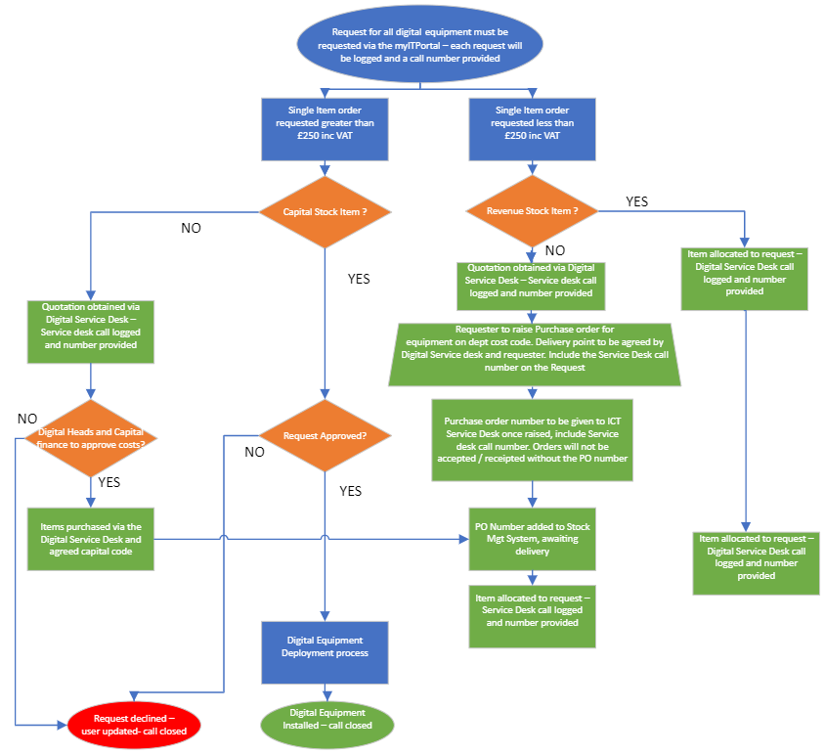

Revenue Stock Items less than
£250 inc VAT that can be recharged to revenue budgets include :-

- IPT telephone handsets + licence
- Direct Dial telephone lines
- Voicemail licences

Capital Stock Items greater than £250 inc VAT that cannot be recharged to revenue budgets :-

- Desktop PC bundle (PC/ MultiMedia monitor / keyboard and mouse)

- Laptop bundle (Laptop / Multimedia monitor / docking station / keyboard / mouse / carry case)

- Printers – Mono duplex printers stocked only for medium use. Individual requests for printers will be on a case by case basis in line with Centralised Secure Printing

If a user request extra items such as
- Software Licences
- Extra monitor
- Extra docking stations / keyboard + mouse
- Carry case or protective case

These will be classed as non stock revenue Items and quotation will be provided and ordered via your own funding

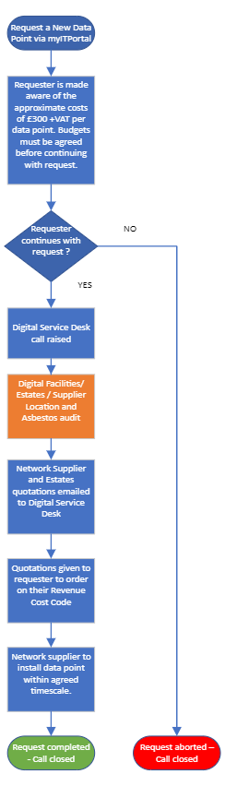

Appendix 2

Network Data Point Request Process

Glossary
CCTV | Closed Circuit Television
IT | Information Technology
MFD | Multi-Functional Devices
NWSSP | NHS Wales Shared Services Partnership
PCs | Personal Computers
SFI | Standing Financial Instruction
SIFT | Service Increment for Teaching (payments for Medical Students)
WEEE | Waste Electrical and Electronic Equipment

