


Meeting Date | 14 June 2023 |  | Agenda Item |  |  | 3.3
Report Title | RISP FBC Workforce and Digital perspective
Report Author | Alexandra Simmonds (Radiology Services Manager)  Gareth Westlake (Assistant Director of Digital Services)
Report Sponsor | Kate Hannam (Morriston Service Group Director)  Matt John (Director of Digital)
Presented by | Gareth Westlake (Assistant Director of Digital)  Alexandra Simmonds
Freedom of Information | Open
Purpose of the Report | To present the Radiology Informatics System Procurement (RISP) Full Business Case (FBC). The report highlights the key elements of the National RISP business case from a Workforce and Digital perspective.
Key Issues | - The current Picture Archiving & Communication System (PACS) contract supporting the delivery of the clinical radiology service in Wales is coming to the end of its tenure, with the first Health Board deployment order expiry in November 2024.  - The ambition of WG and NHS organisations is to achieve a seamless end-to-end electronic solution that enables the Radiology service to deliver a high quality, safe and timely clinical imaging service for the patients of Wales  - The OBC was approved by the HB in Nov 2021 and, following a procurement exercise, all Health Boards endorsed a recommendation that Philips be awarded a contract for Picture Archiving & Communication System, Radiology Information System and Patient Dose Management System for a period of five years, with an option to extend for a further two years, in annual increments  - The Health Board approved the RISP full business case in May 2023. It is anticipated that the contract will be awarded in June 2023 with design, build and testing completed by April 2024.  - Philips require all organisations to sign their respective deployment orders before they will commence with the design.  - The first Health Board will go live in September 2024 with SBUHB planned go live in May 2025. As such, there is very little contingency in the plan.  - In addition to a number of quality and safety benefits that will be realised as a result of the implementation the FBC estimates that, once fully implemented, there will be £2.2m non cash releasing benefits pa realised across Wales. It is anticipated that there will be significant operational benefits within SBU and local detailed benefits plans will be established as the project commences.  - The implementation will require staff within the Radiology, and to a lesser extent, the wider workforce to undergo a period of significant change as they adapt to new software, complete training and develop skills required for full operability of the new system.  - A small project team will be recruited to support the implementation process.  - It is envisaged that the digital enablement of the service will allow workforce requirements to be streamlined in the future, due to the many efficiencies within the system. The solution will also improve quality and safety, improve data availability which will lead to improved decision making and process/workflow redesign.
Specific Action Required  (please choose one only) | Information | Discussion |  | Assurance | Approval
Specific Action Required  (please choose one only) | ☐ | ☐ |  | ☒ | ☐
Recommendations | Members are asked to:  - Note the necessity to replace the existing PACs system  - Note the intention to achieve the vision of a seamless end-to-end electronic solution that enables the Radiology service to deliver a high quality, safe and timely clinical imaging service for the patients of Wales  - Note the potential productivity/cash releasing savings and the non-financial that RISP will enable once the system is developed. Radiology and Digital Services will continue to identify the opportunities the new shared platform presents to enable transformational change within Radiology service provision  - Note the requirement for Radiology and Digital Services to continue to identify the opportunities the new shared platform presents to enable transformational change within Radiology service provision  - Note the impact on the workforce during the implementation period and in the period of subsequent service transformation  - Note the Approval of the Full Business Case by the Health Board in May
Radiology Information System Procurement – Full Business Case – Workforce and Digital Perspective

- INTRODUCTION
Due to the current PACS contract with Fuji ending in 2023/2024, the Radiology Informatics System Procurement (RISP) Programme was set up in 2019 to procure a replacement Picture Archiving & Communication System (PACS) and provide options for a replacement Radiology Information System (RIS) for all health boards in Wales.

A national OBC was developed by the programme and was approved by the SBU Health Board in November 2021. The OBC outlined the need to replace the existing PACS due to the end of the current contract and the need to improve current systems to enable the modernisation of Radiology services across Wales.

In January 2023, in the RISP Programme Board, all Health Boards endorsed a recommendation that Philips be awarded a contract for PACS, RIS and PDMS for a period of five years, with an option to extend for a further two years, in annual increments. The Health Board approved the FBC at its public meeting on May 25th 2023.

This report summarises the key elements of the National RISP business case and highlights the Workforce and Digital perspective.

- BACKGROUND
All Health Boards and Trusts in NHS Wales use the following main systems:
The Picture Archiving and Communications System (PACS) is a storage and distribution platform, which collates all imaging investigations performed on patients. This is the clinical interface that enables the analysis of all imaging performed, including complex reformatting, disease progression analysis and measurement. The ultimate output is the production of a clinical report for the referring clinicians.
The Radiology Information System (RIS) is a national system developed and supported by Digital Health and Care Wales (DHCW). It is known as Welsh Radiology Information System (WRIS) and supports the scheduling of radiology investigations, provides a clinical record of all imaging investigations performed on patients including the radiology report; and holds data that underpins health boards’ ability to generate business reports and statistics on performance.
Radiology is a high throughput, capital intensive service so having effective IT systems plays an essential role in delivering efficient radiology services that maximise the use of expensive equipment. The current configuration of Radiology departments, along with their associated systems and infrastructure in Wales, confines the delivery of care within traditional organisational boundaries. Both PACS and WRIS are deployed within health board boundaries and health board reorganisation with the associated organisational arrangements have made transition more difficult because of this siloed approach.
The current radiology IT systems (PACS/ RIS):
- Are disparate, with disjointed approaches to coding, administrative process, data collection and analysis and do not enable service planning on a strategic or national basis
- Do not facilitate cross boundary working resulting in variation in the delivery of radiology services across NHS Wales health boards and trusts that leads to increased waiting time for scans or delays to reporting and diagnosis.
- Make it difficult to share patient information easily between health boards and trusts both within Wales and England, impacting on acute/emergency care, MDT’s and leading to inefficient care. Manual workarounds are in place to enable the right information to be available for use in the right place, at the right time but these are relatively inefficient and contribute to delays and increased clinical risk.
- Do not provide sufficient ability to extract pure, live data that supports effective business intelligence, thus limiting the services ability to achieve operational excellence.
- Do not allow modern e-referral pathways to be achieved, thus limiting pathway optimisation.
Given these challenges, there is an increasing need to identify an informatics solution that will support the delivery of an imaging workflow that will provide an efficient and effective Radiology service for the population and all patients within Wales.

The Radiology Informatics System Procurement (RISP) Programme was set up in 2019 to procure a replacement Picture Archiving & Communication System (PACS) and provide options for a replacement Radiology Information System (RIS) for all health boards in Wales.

A national OBC was developed by the programme that recommended the procuring of a supplier full service management solution for PACS, PDMS (Patient Dose Management System) and RIS (with the option to incorporate ETR (Electronic Test Requests) and results acknowledgement. The OBC was approved by the SBU Health Board in November 2021.

In January 2023, in the RISP Programme Board, all Health Boards endorsed a recommendation that Philips be awarded a contract for PACS, RIS and PDMS for a period of five years, with an option to extend for a further two years, in annual increments. Based on this decision the Programme have developed a FBC for consideration and approval by all Health Boards. The National FBC can be found at Appendix 1.

The RISP business case was presented to and approved by the SBU Health Board in May 2023. It is anticipated that the contract will be awarded in June 2023 with design, build and testing completed by April 2024. The first Health Board will go live in September 2024 with SBUHB planned to go live in May 2025.

- BENEFITS

The cost benefit analysis in the FBC concluded that, following the procurement, the preferred option continues to offer optimal value for public money, following the results of the procurement process and development of more detailed cost and benefits analysis.

The national case outlines that investment in RISP will deliver a range of financial and non-financial benefits due to more streamlined workforce, increased automation, greater accuracy and reliability, and reduced reliance on paper-based systems. This will result in benefits such as:
- Improved patient safety due to the more accurate records which will reduce the risk of repeat examinations and inappropriate radiation dosage and better support personalisation of dose assessments.
- Contribution to earlier diagnosis leading to better patient experience and outcomes due to reduced turnaround time from referrals to reporting, and more effective MDT working.
- Improved workforce experience and greater staff satisfaction due to more efficient and effective ways of working.
- Productivity gains worth £2.2m across Wales due to reduced need for manual interventions to manage activities such as referrals, reporting and providing MDT images. It should be noted that these are not expected to be cash releasing.
- Use of cloud-based system leading to greener and more efficient use of energy.

The case outlines a number of benefit criteria with expected outcomes from the implementation of the solution that are summarised in the table below.
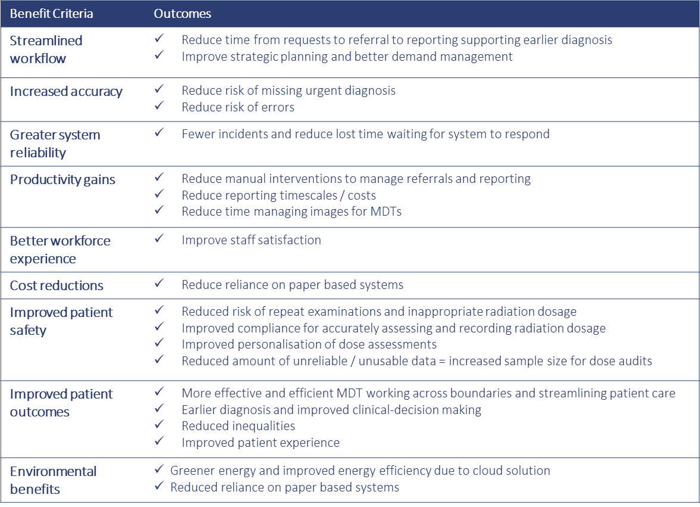
The FBC outlines that these outcomes will also deliver productivity gains of £2.2m p.a. across Wales once the solution has been fully implemented. The FBC outlines that the productivity gains are not expected to be cash releasing.
A detailed analysis of the benefits has been extracted from the FBC and can be in Appendix 2. The below table summarises the benefits identified that realise the productivity gains across Wales. It is estimated that once implemented there would be productivity gains within SBU of between £200 and £250k pa.

ID | Description | Measure | Target Improvement | Value  £’000
B02 | Reduced manual intervention to manage referrals | Time spent on request handling | 80% reduction in time spent manually transcribing requests | £852k p.a.
B04 | Reduced manual intervention for reporting and acknowledgement | Time spent on process for the acknowledgement of urgent referrals | 50% improvement | £65k p.a.
B05 | Reduced reporting costs | Average time between subsequent reports | Between 1% - 5% improvement | £1,127k
B11 | Reduced reliance on paper-based systems leading to paper, printing and manual storage cost savings | Expenditure on paper, printing and manual storage | 80% improvement | £11k p.a.
B23 | Improved ability to accurately and frequently access radiation dosage to evidence statutory compliance | Time saved manual vs automated audits | 80% improvement | £19k p.a.
B26 | Improved personalisation of dose assessments | Time spent dealing with patients flagged for skin injury review | 75% improvement | £5k p.a.
B10 | Effective and efficient MDT meetings supporting cross Health Board boundary workings and streamlining patient care | Time spent managing images for MDTs | Save 2 minutes per number of transfers | £113k p.a.

For SBUHB it is anticipated that while at this stage there are no worked up cash releasing benefits , there will be significant gains in terms of improved operational processes. The improved efficiency and business intelligence will enable productivity to be optimised on a daily basis. Furthermore the wide spread implementation of electronic referrals will enable significant reductions in referral to scan times, which will support early diagnosis and treatment in other specialties. During the implementation process there will be a strong emphasis on benefits identification and realisation with a focus on realisation of cash releasing benefits in addition the significant quality and safety benefits already defined within the case.

Artificial Intelligence (AI) Consideration

The delivery of an AI solution is out of scope for the business case. Clearly, there is a huge potential for AI in diagnostics moving forward, but the decision not to specifically include AI solutions within the scope of RISP was primarily because at the point of programme scoping there were relatively few CE marked applications for primary diagnostic reading available to be deployed into routine clinical practice. However, the Philips solution does include AI enabled clinical workflow tools as part of its “Intellispace Portal” advanced visualisation platform.
Obviously, this position on AI is likely to change over the lifetime of the contract so the ability to integrate with future 3rd party AI platforms as they are deployed across NHS Wales has been included in the contract. Additionally, Philips have a programme for working with AI vendors to ensure compatibility of the solutions and the ability to integrate them seamlessly into the clinical workflows. These can be added into the solution through the change control process either locally or nationally as required.
AI related benefits were not formally included in the case as it was difficult to get baseline metrics to benchmark against.

Workforce Consideration

The delivery of the RISP project will have significant benefits to workforce within Radiology and also outside the service. The initial impact will require staff within the service to undergo a period of significant change as they adapt to new software, complete training and develop skills required for full operability of the new system. Externally there will also be the need to adapt to new workflows and learn new processes, for example in Primary Care with the adoption of e-referrals verses the current paper referrals.
To support the above a small number of new staff will be recruited to ensure that effective local project management and implementation of the RISP project occurs.
In terms of broader benefits to the workforce, the software is cloud based and houses reactive and live business intelligence to support staff to make decisions about workflow. Examples of this are improved availability of images for MDT and live activity data regarding capacity and demand, in essence enabling the workforce to work at the top of their license more easily.
There is also a suggestion that the digital enablement of the service will allow workforce requirements to be streamlined in the future, due to the many efficiencies within the system. This could not be mapped prior to the project award but will be mapped within the service post implementation.
In summary, while there will the period of change and training impacting the overall workforce, there are significant benefits to be realised as a result. These benefits will support efficiency and also improve morale across the workforce through provision of modern, usable solutions that make the working day easier for all staff groups involved.

- GOVERNANCE AND RISK ISSUES

The RISP Programme sits within the portfolio of Digital Health and Care Wales following transfer from the NHS Wales Health Collaborative in January 2023. The programme is managed in accordance with the OGC Managing Successful Programmes and PRINCE2 standards
.
The Programme Board reports to the national Chief Executive Management Team (CEMT) , which comprises the Chief Executive Officers of the health boards, Trusts and Special Health Authorities in Wales. The Programme also reports to the National Imaging Strategy Programme Board.
A RISP Programme Board is well established whose remit is to provide oversight and direction and to review and assure the Programme’s progress. The governance arrangements for the Programme are shown below in the Management Case.
The SRO for the RISP Programme is Matt John, Director of Digital for SBUHB. SBUHB is also represented at a national level by Dr Tishi Ninan.

A local Implementation Group has been established within Swansea Bay with representation from the National Team, Radiology service, Digital and Finance. As the project progresses formal project management governance arrangements will be put in place and will report into Management Board via the Digital Leadership Group.

The FBC outlines the high level risks as shown in the table below.

In addition to the risks in the national FBC the following local risks have been identified. Management of both national and local risks with be through the national and local governance structures outlined above.

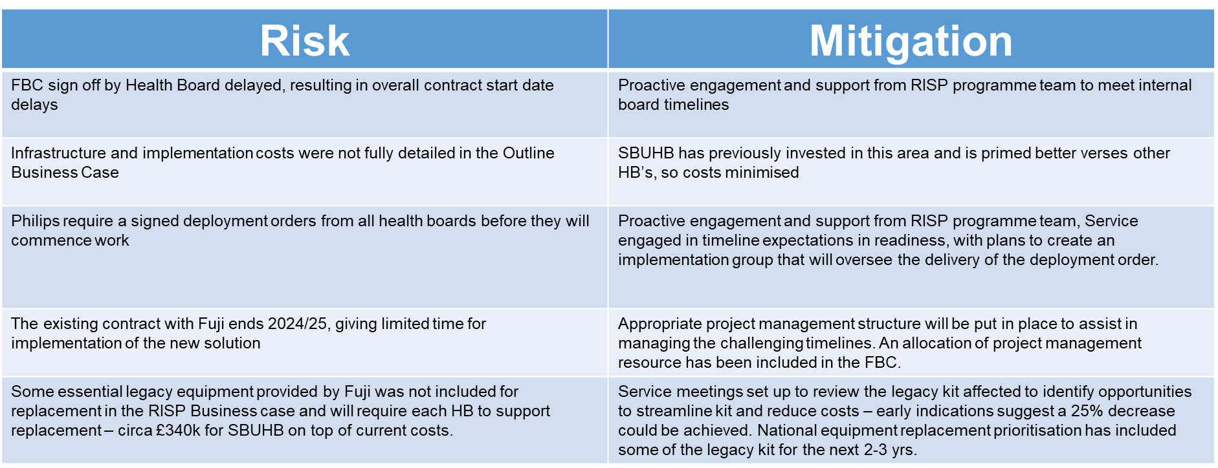

- FINANCIAL IMPLICATIONS

The total capital cost allocated to SBUHB is £2,806k. It is assumed in the FBC that this cost will be funded by WG.

The table below summarises the revenue implications for SBU from the RISP implementation.

The table shows that total revenue impact over the life of the contract is £346k.

The table also shows there is at total non-recurrent investment requirement from the HB during the implementation period (2023/26) of £592k which includes £214k needed for the dual running costs of the systems.

The Health Board has included £115k recurrently in the financial plan to support RISP. This means that there is a net additional investment requirement of £325k between 2023-26. It also means that the £115kpa will no longer need to be provided once the solution is implemented releasing a total of £805k back to the financial position for the remainder of the contract.

- RECOMMENDATION

Performance and Finance Committee Members are asked to:
- Note the necessity to replace the existing PACs system
- Note the intention to achieve the vision of a seamless end-to-end electronic solution that enables the Radiology service to deliver a high quality, safe and timely clinical imaging service for the patients of Wales
- Note the potential productivity/cash releasing savings and the non-financial that RISP will enable once the system is developed. Radiology and Digital Services will continue to identify the opportunities the new shared platform presents to enable transformational change within Radiology service provision

- Note the requirement for Radiology and Digital Services to continue to identify the opportunities the new shared platform presents to enable transformational change within Radiology service provision

- Note the impact on the workforce during the implementation period and in the period of subsequent service transformation

- Note the Approval of the Full Business Case by the Health Board in May

ASSURE the RISP Full Business Case and approval process

Governance and Assurance

Link to Enabling Objectives  (please choose) | Supporting better health and wellbeing by actively promoting and empowering people to live well in resilient communities
Link to Enabling Objectives  (please choose) | Partnerships for Improving Health and Wellbeing |  | ☐
Link to Enabling Objectives  (please choose) | Co-Production and Health Literacy |  | ☐
Link to Enabling Objectives  (please choose) | Digitally Enabled Health and Wellbeing |  | ☐
Link to Enabling Objectives  (please choose) | Deliver better care through excellent health and care services achieving the outcomes that matter most to people
Link to Enabling Objectives  (please choose) | Best Value Outcomes and High Quality Care |  | ☐
Link to Enabling Objectives  (please choose) | Partnerships for Care |  | ☐
Link to Enabling Objectives  (please choose) | Excellent Staff |  | ☐
Link to Enabling Objectives  (please choose) | Digitally Enabled Care |  | ☐
Link to Enabling Objectives  (please choose) | Outstanding Research, Innovation, Education and Learning |  | ☐
Health and Care Standards
(please choose) | Staying Healthy |  | ☐
(please choose) | Safe Care |  | ☐
(please choose) | Effective Care |  | ☐
(please choose) | Dignified Care |  | ☐
(please choose) | Timely Care |  | ☐
(please choose) | Individual Care |  | ☐
(please choose) | Staff and Resources |  | ☐
Quality, Safety and Patient Experience
Financial Implications
The all Wales cost of the solution for the life time of the contract is £31m (including implementation). It is assumed that the capital cost and a proportion of the non revenue costs associated with implementation will be funded by WG. The revenue implications for SBU in the approved OBC was estimated to be £1.54m over the live of the contract. The revenue costs in the FBC have reduced to £0.34m over the contract life. There is at total non-recurrent revenue investment requirement from the HB during the implementation period (2023/26) of £592k which includes £214k needed for the dual running costs of the systems. These costs are partially offset by a cost reduction on the cost of the current solutions of £0.25m over the remainder of the contract. These cost implications do not take into account the £115k pa provisioned within the HB financial plan. It should be noted that not included in the FBC is the requirement to replace £350k of legacy equipment within Radiology. Work is ongoing to reduce this requirement and potential funding sources.
See above for more detail.

Legal Implications (including equality and diversity assessment)
An Equality Impact Assessment (EQIA) has been developed for the RISP Programme.

Staffing Implications
Radiology staff will be required to adopt the new system and nationally agreed standards.

Long Term Implications (including the impact of the Well-being of Future Generations (Wales) Act 2015)
N/A

Report History
Appendices |  | Appendix 1 - National RISP FBC  Appendix 2 – FBC Benefits realisation table

