10. Workforce Updates and Actions
This section of the report provides further detail on key workforce measures.
Staff sickness rates- Percentage of sickness absence rate of staff |  |  | % of full time equivalent (FTE) days lost to sickness absence
Current Performance
- Health Board total for in month sickness absence for March 23 improved from the last reporting period (7.46% January 23 and 7.02% February 23) to 6.76%.
- In comparison to March 22 (8.36%) there was an improvement of 1.60% in month.
- Anxiety/stress related absence remained the highest reason for absence, with Infectious disease second and other MSK the third.
- All service group in month sickness absence rates continue to improve from the December position.
- Neath Port Talbot and Singleton Service Group had the highest in month percentage absence in March 23 at 6.84%. Morriston Service Group were next at 6.78%, followed by Mental Health/Learning Disabilities at 6.54% and Primary Communities and Therapy at 6.06%.
- Short-term sickness for March 23 was 3.23%, a slight increase from February 23 (2.45%) and January 23 (2.61%). Long-term sickness for March improved to 3.53% from February 23 (4.57%) and January 23 (4.97%).

Actions for Next Period
General
Current focus on areas with high absences rates. Examples of initiatives to support our employees.

Mental Health and Learning Disabilities
- Service group additional investment into additional TRIM resources from February 23
- Staff stress and anxiety survey completed and outcome reviewed. This will be linked in with the outcomes of the Big Conversation and Guardian site visits. Working collaboratively with Organisational Development colleagues to implement actions from the findings, from June 23.
- Monthly directorate attendance management meetings will be held
- Lunch and learn sessions for managing attendance at work, set up from May 23
Support Services and Estates
- Reward and recognition week commencing 19 June 23. A series of events have been planned to reward and thank staff, in recognition of the Estates and Facilities day on 21 June 23.
- Men's health awareness week commencing 12 June 23. A series of events have been planned in collaboration with Well-being colleagues across Estates and Support Services.

Morriston including Theatres
- Open invitation for Guardian visits across the site from May 23
- International nurse recruitment support network being implemented
- Senior team listening events rolled out from May 23
- Sickness audits being rolled out from hot spot areas from May 23

Neath Port Talbot/Singleton

- Open invitation for Guardian visits across the sites from May 23
- Focused deeper dive into staff group reasons for absence and maximising attendance to commence from June 23

Primary Communities and Therapies

- Sickness absence hot spot reviews undertaken and concluded in December 23. This was re-viewed in March 23 and development plan being rolled out from May 23, including;

- Roll out of further Managing attendance at work training from May 23
- Sickness audits in hot spot areas to commence from June 23
- Bi-monthly wellbeing champion meetings

Staff Health and Wellbeing

- Piloting of Tailored Adjustment complete and plan to roll out to identify areas in liaison with HR colleagues during June/July 2023
- Permanent funding agreed April ’23 to fund full-time Band 7 OT to support staff with Long Covid and other LTC’s that will contribute to retention in work/return to work for sickness absentees. Plan to appoint after job evaluation - July 2023
- Developing Comms with support from CEO to increase awareness of staff Wellbeing offer – updates in April/May Team Briefs and article submitted for May’s Bay News – plans to meet with DICE to explore developing Comms further – June 2023
- Time to Change Wales (TTCW) is a national campaign to end the stigma and discrimination faced by people with mental health problems, funded by WG. The HB is a Pledge Employer and is continuing to work with TTCW to deliver training to challenge mental health stigma in the workplace
- TRiM/React and Suicide awareness training for managers/colleagues continuing – June/July 2023

Mandatory & Statutory Training-  Percentage compliance for all completed Level 1 competencies within the Core Skills and Training Framework by organisation |  |  | % of compliance with Core Skills and Training Framework
Current Performance
- Since the last performance report, compliance against the 13 core competencies has remained static at 84%.
- The Staff Group Medical & Dental continue to be the lowest performing area, standing at 53% compliance, with Estates and Facilities being the next lowest at 80.7%. Although it should be noted both these areas have shown a 3% improvement on last reporting period.
- Staff Group Allied Health Professionals remain the highest performing area, which stands at 92.8%. WOD currently stands at 88.9%.
- The range across the service groups is between Morriston at 79% and Primary Care and Community Services at 90.6%
- [Ongoing] There have been significant changes to directorate and corporate area structures, as there will continue to be in line with proposed structure changes that will be taking place across the health board for a significant period to come. It has also been highlighted by key individuals from directorates and corporate areas that on closer inspection of staff in post structures, work needs to be carried out at a local level to ensure accuracy as some structure changes have not been reflected in their staff in post lists.

Actions for Next Period
Auto Subscription to Learning Certification and Enrolment onto Statutory/Mandatory Courses (E-Learning) – This function has been problematic in ESR for a while where the auto enrolment process has been voiding the process due to multiple courses (Welsh Language and English Language) being available for enrolment . Julie Rogers, Programme Manager, Shared Services has advised that come 1st April 2023, Subscription to Learning Certifications and enrolment onto Statutory/Mandatory Training will resolve.
ESR Support Calendar - this has been made available via Mandatory & Statutory Training (sharepoint.com) this function allows staff to book onto one to one 30 minute support sessions via MS Teams where staff can share their ESR screens and together we can work through issues they are dealing with for enrolling onto the correct training, enrolling the correct way and ensuring their compliance is updated correctly.

By HB L5, the Service Group figures are:

- MH&LD (87.7%) - Clinical Directors to continue to focus on improvement of mandatory training for Medical staff and reminding all staff that undertaking M&S training is a contractual requirement.
- NPTS (85.6%) - The Service Group is focusing on supporting Medical and Dental staff to improve their compliance.
- PCCT (90.6%) –The Service Group is currently compliant as they are over the 85% compliance rate.
- Morriston (79%)- The divisions have devised action plans to achieve their targets regarding M&S, and the ASDs request updates from their teams regularly in relation to progress. On a monthly basis the divisions are required to provide updates on their progress to management board in the performance reviews
- Estates and Facilities - On-going support is being provided to Estates and Facilities staff who are finding it difficult to complete the training. i.e., allocating time and resources.

Vacancies  Medical and Nursing and Midwifery |  |  | Vacancies Feb 23 to Apr 2023  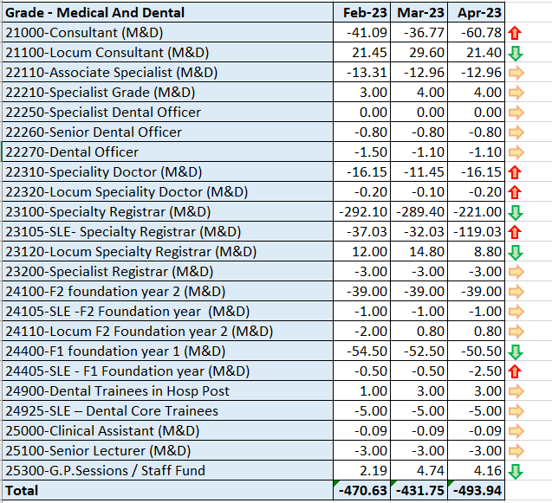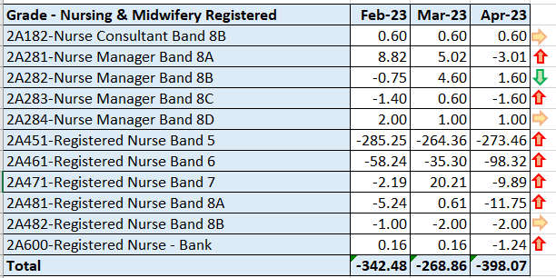
Current Performance
- Covid specific measures in terms of recruitment have ended and normal levels of local and corporate recruitment are now re-established.
- Focus of recruitment to Imms programme is still being closely monitored in a very fluid workforce plan.
- Overseas nurse recruitment continues and the plan to recruit 350 nurses in 22/23 has been met of which 220 have so far arrived with us. The business plan to recruit a further 300-350 in 23/24 has been approved and interviews have commenced.

Actions for Next Period
- Further overseas nurse interviews will continue throughout the next period.
- A proportion of next years nurses will be recruited via the all Wales overseas nurse recruitment project
- Our next cohort of circa 32 overseas nurses is due to arrive at the start of June, depending on visa processing delays
- We are scoping with WG if overseas recruitment is necessary for medical staff.

Recruitment  Metrics provided by NWSSP. Comparison with all-Wales benchmarking |  | Vacancy Creation to Conditional Offer April 2023 (working days: excluding outliers) T13  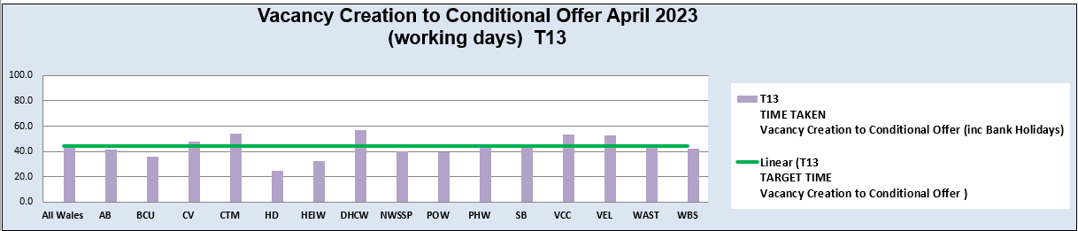
Current Performance
- Although Swansea Bay UHB overall performance was above target in February, our monthly average over the last 12 months remains in target.
- The central Resourcing team continue to focus efforts on the recruitment of acute ward based HCSW’s and Band 5 nurses as well as providing support to specific difficult to recruit to posts.
- Current KPI’s (April 23) comparing SBUHB averages vs the CRT on HCSW recruitment is 76 days vs 40 days based on average time taken from vacancy creation to unconditional offer.

Actions for Next Period
- HRBP’s have been asked to discuss with Service Groups with a view to reducing the lag between the date termination of posts are being requested versus date a TRAC entry was initiated.
- The central resourcing team will continue focussing on the recruitment of B5 nurses, B2 ward based HCSW’s and assisting in overseas nurse recruitment. In addition they are assisting in the recruitment of newly qualified nurses, via the all Wales Student Streamlining process. As well as specific identified hard to recruit to posts.
- A proposal to extend the work of the central resourcing team is being considered and if accepted will manage the recruitment of all B5 nurses and HCSW’s across the four Service Groups
- For doctors we continue to recruit overseas on a post by post basis.

Turnover  % turnover by occupational group |  | Period Turnover Rate – 01 May 2022 - 30 Apr 2023 – Excludes Bank, Locum, Honorary & Widow/Widower, Junior M&D staff  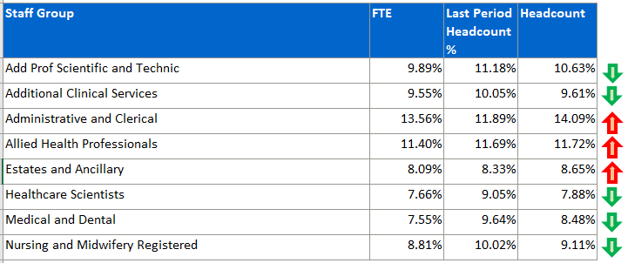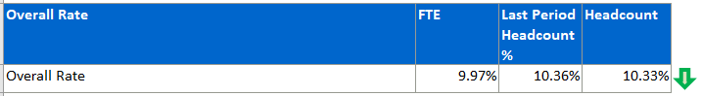
Current Performance
- Key clinical Staff Groups are seeing further reductions in Turnover for this period with the exception of AHP’s which have a slight increase.
- For those which have reduced, the pattern is fairly healthy with a minimum 0.5% decrease up to a substantial 1.27% decrease for Healthcare Scientists

Actions for Next Period
In terms of follow up to the Turnover Analysis conducted towards the end of last year;-
Recommendation:- Collaboration with NWSSP Payroll to reject ‘Other/Not Known’ and ‘Relocation’ categories on termination forms, to be replaced with more relevant reasons
  - Meeting held with Payroll to discuss rejection of ‘Other/Not Known’, Payroll expressed some concerns with this course of action. We are looking to identify further options for solution. Improvement in data quality re ‘Relocation’ would require a separate process to include contact with originating manager and further discussion on an individual basis. This would likely need to be picked up locally.
Recommendation:- Review Line Manager training and development for handling resignations to ensure that appropriate discussions are held. This would enable reasons for leaving to be established with certainty, and mitigation considered in cases where a resignation may be avoidable.
  - Plan to link in with L&OD to explore possibility of including in Footprints and Bridges.
Recommendation:- Raise staff and manager awareness of support available via policies and processes to compensate for personal circumstances.
  - Collaboration with Operational HR has identified a definitive list of supportive Policies which can be spotlighted in HB wide Comms, and potentially included in ongoing manager training pathways e.g. Footprints and Bridges.
PADR  % staff who have a current PADR review recorded |  | % of staff who have had a PADR in previous 12 months
Current Performance
- Staff who have had a Personal Appraisal and Development Review (PADR) at the end of this time period stands at 72.1% which is a 3% increase since the last reporting figures. All the service groups have shown an improvement since the last reporting period.

Service Group figures:
- Primary Care and Community Service Group are showing 85.9% compliance, Mental Health and Learning Disabilities 79% compliance, Neath Port Talbot Singleton 70.1% compliance, Morriston 65.9% compliance, Finance and Estates has compliance of 53.5% and WOD 75%.
- It is important to note that establishment figures used to reflect these percentages include staff who have been employed on short term contracts, with a high proportion who are due to cease employment in over coming months, or have limited time left on their contract.
- [Ongoing] There have been significant changes to directorate and corporate area structures, as there will continue to be in line with proposed structure changes that will be taking place across the health board for a significant period to come. It has also been highlighted by key individuals from directorates and corporate areas that on closer inspection of staff in post structures, work needs to be carried out at a local level to ensure accuracy as some structure changes have not been reflected in their staff in post lists.

Actions Planned for Next Period
- MH&LD - Managers have been encouraged to arrange to meet with staff who still require a PADR and Managers must take responsibility for ensuring they have rolling plans in place to meet with staff. They have also been reminded that PADRs can take place over Teams.
- NPTS –The focus remains on improving the PADR compliance rate within the Additional Clinical Service and Nursing and Midwifery Staff Groups. The service group continues to focus on its PADR improvement plan.
- PCCT - The group have requested that PADR performance needs to achieve compliance as a minimum (85%), and Workforce has contacted Leads within areas of non-compliance to agree and draw up a recovery trajectory.
- Morriston - Each division is mapping a planned trajectory to show monthly increases that will achieve the 85% target as well as putting in place targeted plans where areas have been identified as having low compliance. Data is being cleansed as a number of anomalies have been found that are against the wrong cost centres so have not been picked up within the reporting that is sent to the divisions, this is in the process of being rectified.
Operational Casework  Number of current operational cases. |  | 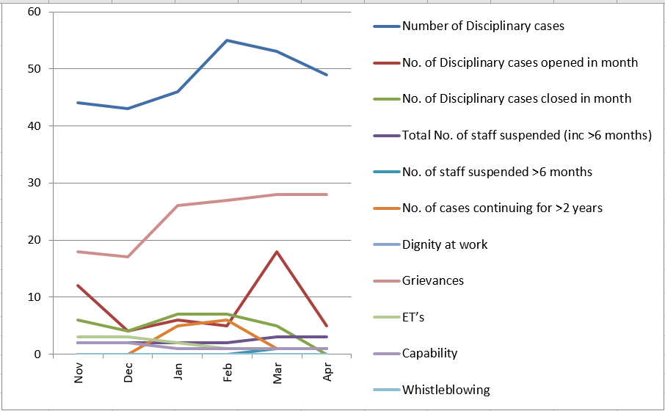
Current Performance
- No. of open Disciplinaries as at 1st March has increased slightly. This includes cases that have closed and new cases opened during the period. 1 case remains open over 2 years. 4 cases remain open over 12 months.
- Number of Grievances has increased to 24.
- Capability has reduced to 1 case.
- ET’s received by the Health Board remain at 3, still very low in comparison to the number of employees. Although it is acknowledged that advance notice has been received from Legal & Risk of other potential claims that have been issued.
- 1 whistleblowing case remains open.
Actions for Next Period
- A Best Practice Review is being implemented which arises from feedback received from the HR Operations Team, Business Partnering Team and the Trade Unions. This will include creation of principles for how we will manage our employee relations which will form part of Our Big Conversation. It will include workshops over the next 12-18 month period jointly with our Trade Unions facilitated by HEIW and Legal & Risk covering the following: Avoidable employee harm in investigations, Respect & Resolution and Managing Disciplinary to begin with.
- We have also started to really focus on our partnership relationship with our trade unions which have a significant impact on our employee relations. We have been working together with our trade union colleagues to start to agree some principles with a focus on good employee relations practice:
  - putting people at the centre of what we do;
  - being champions of the process; and
  - establishing what Just is for our One Bay Way.
- A Learning from Events process is being considered to allow us to continuously learn from all aspects of formal employee relations processes.
- Data currently only collected at the formal stages of the Respect and Resolution policy, difficult to capture any issues resolved informally
- Continue to challenge formal submissions to check whether informal resolution has been sought in line with the ethos of the policy
- Re-enforce advice to managers to utilise the decision tree when providing advice to managers around potential conduct issues
- Work ongoing to ensure E&D data is recorded on ER tracker and updating the system to reflect changes to policies
- IO team continuing to hold a high caseload which includes Respect & Resolution investigations, R&R investigations by their nature are complex and take a significant amount of time to investigate and conclude work to ensure E&D data is recorded on ER tracker and updating the system to reflect changes to policies

