10. Workforce Updates and Actions
This section of the report provides further detail on key workforce measures. Caveats and Limitations (C&L) detailed beneath data in each section.

Staff sickness rates- Percentage of sickness absence rate of staff  Sickness absence target – 5.5% |  |  | % of full time equivalent (FTE) days lost to sickness absence  Caveat & Limitations;- Report generated Sep 2023, within SBUHB (Performance Team). Data source – ESR.
Current Performance
- Health Board total for in month sickness absence for July 23 increased from the last reporting period (5.87% May 23, 6.30% June 23) to 6.78%.
- In comparison to July 22 (9.35%) there was an improvement of 2.57% in month.
- Anxiety/stress related absence remained the highest reason for absence, with MSK second.
- All service group in month sickness absence rates increased from the last reporting period.
- Increase of reported COVID-19 related absences.
- Mental Health and Learning Disabilities Service Group had the highest in month percentage absence in July 23 at 7.28%. Morriston were next at 6.82%, followed by Neath Port Talbot/Singleton 6.45% and Primary, Community and Therapies at 6.27%.
- Short-term sickness for July 23 was 2.15%, an increase from May 23 of 0.45%. This includes an increase in covid related absence which we are seeing across the organisation. Long-term sickness slightly increased from 4.41% to 4.62% between May and July 23.

Actions for Next Period
Current focus on areas with high absences rates, examples of initiatives to support our employees:
- Monthly catch ups with Assistant Business Partner, Directorate Manager and Lead Nurse to review Directorate Action plans in Mental Health and Learning Disabilities.
- Attendance overview provided in monthly service group board meetings
- Appointment to a further Sickness, Governance & Training Officer post covering Morriston Portering this is in addition to the other Sickness, Governance
Training Officer post which will now focus on Domestic sickness absence.
- Time table for sickness absence audits across hot spots areas
- Manager/Supervisors attending Courageous Conversations and Menopause training during September/October in Support Services and Estates.
- Hot spot absence work has been undertaken with current focus on Singleton Engineering, monthly meetings held to review sickness absence cases. Deep Dive analysis to be undertaken into these areas and action plans developed.
- Well-being day in Morriston Service Group
- Open invitation for Guardian visits across Neath Port Talbot and Singleton Service Group sites.

Staff Health and Wellbeing
- Tailored Adjustment training sessions to support managers and increase retention of staff is now on OH&WB SharePoint for October and November 2023 – additional OH&WB staff to be trained to deliver this.
- Band 7 OT recruited Sept ‘23 enabling extra capacity for Long Covid and other LTC’s during the next quarter and will contribute to retention in work/return to work for sickness absentees.
- TRiM/React and Suicide awareness training for managers/colleagues continuing – Oct-Dec 2023 dates on SharePoint with continued TRiM support for critical incidents. MH&LD have invested in additional TRiM resource based on the success of this model in supporting staff and helping to reduce sickness absence.
- Plans to appoint Band 6 OH Nurse to undertake staff health checks as ‘prevention/early intervention’ approach to staff health and wellbeing – advertise post October 2023
- Triage process developed during August now implemented to support reducing waiting times for Staff Wellbeing Service – to evaluate/adapt during Sept - Dec ‘23.
Mandatory & Statutory Training-  Percentage compliance for all completed Level 1 competencies within the Core Skills and Training Framework by organisation  Mandatory & Statutory Training target – 85% |  |  | % of compliance (Headcount) with Core Skills and Training Framework  C&L;- Report generated Sep 2023, within SBUHB (Performance Team). Data source – ESR (OLM Module). Accuracy levels subject to local maintenance and validation standards.
Current Performance
- Since the last performance report, the number of core competencies have increased to 14 this includes NHS|LANG|Welsh Language Awareness - 3 Years. Compliance against the 14 core competencies has increased to 86.2%
- The Staff Group Medical & Dental continue to be the lowest performing area however they have seen another increase of 2.45% overall. The reported figure now is 58.14%, a pilot improvement plan has been initiated in the Morriston Service Group for the Medical and Dental Staff by Manju Krishnan, Interim AMD Quality & Safety (Morriston Service group). Estates and Facilities being the next lowest at 81.71%. On-going support is being provided to staff who are finding it difficult to complete the training i.e. Allocating time and resources.
- Staff Group Allied Health Professionals remain the highest performing area, which stands at 91.32%. WOD currently stands at 89.95%
- The range across the service groups is between Morriston at 81.90% and Primary Care and Community Services at 90.81%
- There have been significant changes to directorate and corporate area structures, as there will continue to be in line with proposed structure changes that will be taking place across the health board for a significant period to come. It has also been highlighted by key individuals from directorates and corporate areas that on closer inspection of staff in post structures, work needs to be carried out at a local level to ensure accuracy as some structure changes have not been reflected in their staff in post lists. This challenge will continue as the changes take place.

Actions for Next Period
Auto Subscription to Learning Certification and Enrolment onto Statutory/Mandatory Courses (E-Learning) – This function has been problematic in ESR for a while where the auto enrolment process has been voiding the process due to multiple courses (Welsh Language and English Language) being available for enrolment . Julie Rogers, Programme Manager, Shared Services has advised that this has now been resolved, although there are a small number of staff still experiencing difficulties with this process.
ESR Support Calendar - this been made available via Mandatory & Statutory Training (sharepoint.com) this function allows staff to book onto one to one 30 minute support sessions via MS Teams where staff can share their ESR screens and together we can work through issues they are dealing with for enrolling onto the correct training, enrolling the correct way and ensuring their compliance is updated correctly. This function has been very well received with more than 50 initial bookings, leading onto further follow up support being made available to staff

By HB L5, the Service Group figures are:

- MH&LD (90.62%) - Clinical Directors to continue to focus on improvement of mandatory training for Medical staff and reminding all staff that undertaking M&S training is a contractual requirement.
- NPTS (87.95%) - Whilst the overall compliance rate for the group is positive the rate for Medical staff is still significantly lower than in other staff groups. The Service Group is using the Medical Workforce Boards as a forum to understand how it can work with this staff group to improve compliance with mandatory training and we have seen an improved compliance rate of 67.84%
- PCCT (90.81%) –The Service Group is currently compliant as they are over the 85% compliance rate.
- Morriston (81.90%)- The divisions have devised action plans to achieve their targets regarding M&S, and the ASDs request updates from their teams regularly in relation to progress. On a monthly basis the divisions are required to provide updates on their progress to management board in the performance reviews
- Finance & Estates (87.48%) - On-going support is being provided to Estates and Facilities staff who are finding it difficult to complete the training. i.e., allocating time and resources.
Vacancies  Medical and Nursing and Midwifery |  |  | Vacancies (FTE) Jun 2023 to Aug 2023  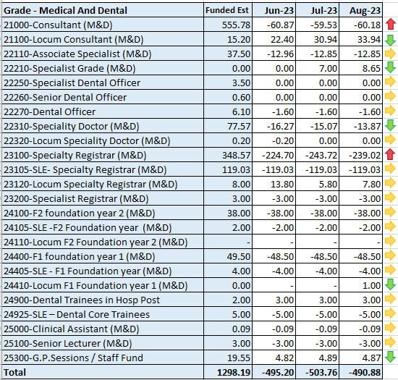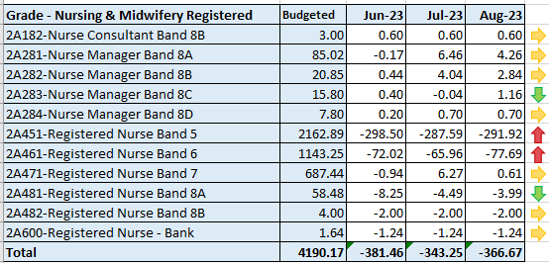  C&L;- Report generated 18 Sep 2023, within SBUHB (ESR Team), using currently available methodology. Data source – ESR (Workforce) and General Ledger (Finance). We compare the SIP v’s the finance ledger, appreciating limitations on accuracy in some areas. Accuracy levels are subject to local validation practices based on budget holders intelligence. N.B. a 12 month project (ESR Establishment control) has commenced which will harmonise vacancy data including Grade detail shown above.
Current Performance
- Focus of recruitment to Immunisation programme is still being closely monitored in a very fluid workforce plan.
- The business plan to recruit a further 300-350 in 23/24 has been approved and interviews have commenced however interviews have currently been postponed as service groups are reporting that based on current predictions they will not require further nurses currently.
- 138 student nurses have been recruited via Student Streamlining Process and are currently being onboarded
- A cohort of 19 overseas nurses arrived with us in July and commenced OSCE training

Actions for Next Period
- Discussions being had to establish how many further Overseas nurses are needed to be recruited for 23/24 and also plans to be agreed for 24/25
- Our next cohort of circa 32 overseas nurses is due to arrive by the end of September, depending on visa processing delays
- We are continuing to scope with WG if overseas recruitment is necessary for medical staff.
- Shortlisting for nurse students due to qualify in March will be completed in September via the SSP process and our predicted allocation of newly qualified nurses who will take up jobs with us in March/April 24 will be confirmed
Recruitment  Metrics provided by NWSSP. Comparison with all-Wales benchmarking |  | Vacancy Creation to Conditional Offer August 2023 (working days: excluding outliers) T13  C&L;- Report generated Sep 2023, by NWSSP (Recruitment). Data source – TRAC system. Outliers are excluded. This is day to day vacancy management.
Current Performance
- Swansea Bay UHB overall performance was on target in August, and our monthly average over the last 12 months remains in target. In addition our performance for conditional offer to ready for start date start date was the best out of all other Health Boards in August
- The central Resourcing team continue to focus efforts on the recruitment of acute ward based HCSW’s and Band 5 nurses as well as providing support to specific difficult to recruit to posts.
- Current KPI’s (July 23) comparing SBUHB averages vs the CRT on HCSW recruitment is 78 days vs 50 days based on average time taken from vacancy creation to unconditional offer.

Actions for Next Period
- HRBP’s have been asked to discuss with Service Groups with a view to reducing the lag between the date termination of posts are being requested versus date a TRAC entry was initiated.
- The central resourcing team will continue focusing on the recruitment of B5 nurses, B2 ward based HCSW’s and assisting in overseas nurse recruitment. In addition they are assisting in the recruitment of newly qualified nurses, via the all Wales Student Streamlining process. As well as specific identified hard to recruit to posts.
- The proposal to extend the scope of the central resourcing team has been accepted and recruitment to new vacancies has commenced. Discussions will then commence with MH&LD and PCT service groups to understand their specific B5 nurse and HCSW recruitment needs in order to develop a recruitment plan.
- For doctors we continue to recruit overseas on a post by post basis.

Turnover  % turnover by occupational group |  | Period Turnover Rate (Swansea Bay) – 01 Sep 2022 - 30 Aug 2023  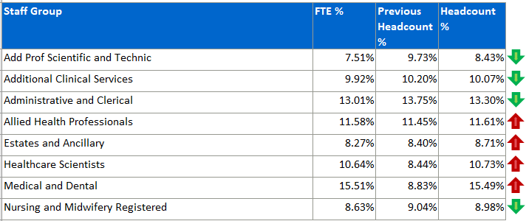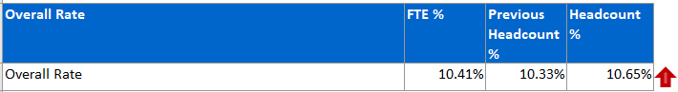  C&L;- Report generated Sep 2023, within SBUHB (ESR Team). Data source – ESR (Workforce). Small risk of margin of error due to late communication of terminations. Report excludes Bank, Locum, Honorary & Widow/Widower, Junior M&D staff. Internal movement not included – measure is about leaving Swansea Bay UHB.
Current Performance
- A&C continued improvement, Add Prof Scientific and NMC have shown a new improvement, with ACS and NMC reversing the increase seen in last period, now also showing improvement in Turnover rates
- AHP showing a slight increase this period along with Estates and Ancillary
- Medical and Dental showing a larger increase moving from 8.83% Headcount turnover to 15.40% this period.

Actions for Next Period
Actions which will feed into Turnover improvement are currently being led by two ongoing focus groups – Recruitment and Retention, and Flexible Working Group.
- Flexible Working Group introductory meeting took place this month, with an outline of intention i.e. to identify means of improving retention by reducing attrition attributable to flexibility.
PADR  % staff who have a current PADR review recorded  PADR target – 85% |  | % of staff (Headcount) who have had a PADR in previous 12 months  C&L;- Report generated Sep 2023, within SBUHB (Performance Team). Data source – ESR (OLM Module). Accuracy levels subject to local maintenance and validation standards.
Current Performance
- Staff who have had a Personal Appraisal and Development Review (PADR) at the end of this time period stands at 67.1% which is a 0.2% decrease since the last reporting figures.
- Primary Care and Community Service Group are showing 80.52% compliance, Mental Health and Learning Disabilities 77.59% compliance, Neath Port Talbot Singleton 63.84% compliance, Morriston 60.70% compliance, Finance and Estates has compliance of 68.20% and WOD 69.49%.
- It is important to note that establishment figures used to reflect these percentages include staff who have been employed on short term contracts, with a high proportion who are due to cease employment over coming months, or have limited time left on their contract.
- [Ongoing] There have been significant changes to directorate and corporate area structures, as there will continue to be in line with proposed structure changes that will be taking place across the health board for a significant period to come. It has also been highlighted by key individuals from directorates and corporate areas that on closer inspection of staff in post structures, work needs to be carried out at a local level to ensure accuracy as some structure changes have not been reflected in their staff in post lists.

Actions Planned for Next Period
- MH&LD - Plans to be put in place to identify dedicated time to meet with all staff for objectives and development and to prioritise the 359 staff that have not received a PADR and ensure ESR records are updated.
- NPTS – Management teams in the NPTS Service Group are provided with detailed PADR performance information to help support improved PADR rates. Divisional monthly workforce groups are used to monitor PADR performance.
- PCCT - The group have requested that PADR performance needs to achieve compliance as a minimum (85%), and Workforce has contacted Leads within areas of non-compliance to agree and draw up a recovery trajectory.
- Morriston - Each division is mapping a planned trajectory to show monthly increases that will achieve the 85% target as well as putting in place targeted plans where areas have been identified as having low compliance. Data is being cleansed to rectify anomalies found attributing individuals to incorrect cost centres.
- Estates and Facilities - PADR rates have declined within Facilities to 54.58%. The Senior Team will now be dedicating their time to focus on PADR’s and in particular the adoption of the group PADR approach to improve compliance. Monthly board meetings are continually used to monitor hotspots, identify barriers and agree solutions. Compliance has improved within Estates to 82.35%. Estates Senior Team have taken the same approach and compliance figures have improved within Estates to 86.78%.
Operational Casework  Number of current operational cases. |  | C&L;- Report generated Sep 2023, within SBUHB (Workforce Digital). Data source – ER Tracker. Accuracy levels subject to local maintenance and validation standards.
Current Performance
- No. of open Formal Disciplinaries since the last reporting period has decreased from 55 in May 23 to 51 in July 23. This includes cases that have closed and new cases opened during the period.
- Number of Formal Grievances decreased from July 23, from 30 to 25. It is noted there has been a few collective grievances aligned to proposals for change.
- Formal Capability recorded as 1 case.
- ET’s decreased to 5. (1 ET claim withdrawn and 1 further claim went to Full Hearing at the Employment Tribunal with success in strike out of the claim in August 23, where all claims were dismissed, 1 historical medical case added). There are 2 historical ACAS early conciliation claims and a further ACAS claim expected in the near future.

Actions for Next Period
- A number of actions are on-going in line with the Best Practice Review, this includes review of the decision tree, learning from events process and development of toolkits for managers.
- Workshops have been arranged for the next 3 months jointly with our Trade Unions facilitated by HEIW and Legal & Risk covering the following: Avoidable employee harm in investigations (23 October 23), Managing Disciplinary (30 November 23) and Respect and Resolution (11 December 23).
- Whistleblowing session is to be held on 20 September organised by The Employment Team @ Legal and Risk Services for Workforce and OD team.
De-brief session with all witnesses who attended the recent Employment Tribunal will be held over the next period to review and implement any lessons learnt.

