

HEALTH BOARD RISK REGISTER
February 2024



HEALTH BOARD RISK REGISTER
SUMMARY OF ASSESSED RISKS

Impact/Consequences | 5 |  |  | 53: Compliance with Welsh Language Standards | 60: Cyber Security
Impact/Consequences | 4 |  |  | 37: Operational and strategic decisions are not data informed  51: Nurse Staffing Levels Act (Section 25B) Risk Revised | 27: Digital Transformation to Deliver Sustainable Clinical Services  36: Electronic Patient Record  64: H&S Infrastructure  90: GDPR Subject Access Requests  97: Disruption due to Industrial Action | 03: Workforce Recruitment of Medical and Dental Staff  81: Midwifery Staffing levels  89: Healthcare Nursing Staff Levels (HMP)
Impact/Consequences | 3
Impact/Consequences | 2
Impact/Consequences | 1
C X L |  | 1 | 2 | 3 | 4 | 5
 |  | Likelihood
Risk Register Dashboard

Strategic Objective | Risk Reference | Description of risk identified | Initial  Score | Current Score | Trend | Controls | Last Reviewed | Scrutiny Committee
1. Demonstrably Improved Quality, Safety & Reduced Harm | 51  (1759) | Nurse Staffing (Wales) Act (Section 25B wards) Scope of risk revised and risk score adjusted  Risk of Non Compliance with the Nurse Staffing (Wales) Act | 16 | 12 | Risk Scope Revised | Risk Scope Revised | February 2024 | Workforce OD & Digital Committee
 | 53  (1762) | Welsh Language Standards  Failure to fully comply with all the requirements of the Welsh Language Standards, as they apply to the University Health Board. | 15 | 15 |  |  | February 2024 | Health Board  (Welsh Language Group)
2. Delivering an Excellent Staff Experience | 3  (843) | Workforce Recruitment  Risk of failure to recruit medical & dental staff | 20 | 20 |  |  | February 2024 | Workforce OD & Digital Committee
3. Services working effectively through a systems approach | 97  (TBC) | Disruption due to Industrial Action (In Committee Risk)  Notice has been received from the BMA of planned industrial action by junior doctors. There is a risk that inadequate numbers of staff will be available during strike days to sustain the safe delivery of services. This could result in the closure of services and/or the increased incidence of avoidable harm during the period (with potential additional impact on service performance during the recovery period). The industrial action applies across substantive, bank and agency staff. | 20 | 16 |  |  | February 2024 | Performance & Finance Committee
3.1  Primary & Community Care | 89  (3071) | Healthcare Nursing Staff Levels (HMPS)  There is a risk that the men in HMP Swansea will not receive the appropriate standard of care. This is due to the fact that the nursing establishment within the prison no longer fully meets the changed demographics and numbers of men being detained. | 20 | 20 |  |  | February 2024 | Quality & Safety  Committee
3.6. Children, Young People & Maternity Services | 81  (2788) | Critical Staffing Levels: Midwifery  Unplanned absences resulting from long and short-term sickness, alongside maternity leave, have resulted in critical staffing levels, which undermine the ability to maintain the full range of expected services safely, increasing the potential for harm, poor patient outcomes and/or choice of birthplace. Poor service quality or reduction in services could impact on organisational reputation. | 25 | 20 |  |  | February 2024 | Quality & Safety  Committee
5. Adopting and Developing Innovative Digital Solutions to Support Care Delivery | 27  (1035) | Digital Transformation to Deliver Sustainable Clinical Services  Inability to deliver sustainable clinical services due to lack of resources to deliver sustainable Digital Transformation and services. There are insufficient resources to invest in the delivery of the SBU Digital strategy; support the growth in utilisation of existing and new digital solutions; replace existing technology infrastructure or software at the end of its useful life. | 16 | 16 |  |  | February 2024 | Workforce OD & Digital Committee
 | 36  (1043) | Storage of Paper Records  Failure to provide adequate storage facilities for paper records then this will impact on the availability of patient records at the point of care. Quality of the paper record may also be reduced if there is poor records management in some wards. | 20 | 16 |  |  | February 2024 | Workforce OD & Digital Committee
 | 37  (1217) | Information Led Decisions  Risk that operational and strategic decisions are not data informed. | 16 | 12 |  |  | February 2024 | Workforce OD & Digital Committee
 | 60  (2003) | Cyber Security (In Committee Risk)  The level of cyber security incidents is at an unprecedented level and health is a known target. | 20 | 20 |  |  | February 2024 | Workforce OD & Digital Committee
 | 90  (2796) | Non-compliance with UK-GDPR Article 15 regarding Subject Access Requests (SARs), along with other health record’s requests for disclosure of personal data The Health Board does not have adequate resources to deal with the sustained increase in volume and complexity of subject access /access to health records requests received from requestors. The ICO are already involved with a number of breaches and complaints in this area and there is the potential for future enforcement action if significant improvements are not made. | 16 | 16 |  |  | February 2024 | Workforce OD & Digital Committee
7. Delivering Care in Safe, Modern Environments | 64  (2159) | Health and Safety Infrastructure  Insufficient resource and capacity of the health, safety and fire function to maintain legislative and regulatory compliance. | 20 | 16 |  |  | February 2024 | Quality & Safety  Committee

Datix ID Number: 843  Health & Care Standard: Staff & Resources 7.1 Workforce |  |  | HBR Ref Number: 3  Risk Target Date: 31st March 2024 | Current Risk Rating  4 x 5 = 20
Objective: Delivering an Excellent Staff Experience |  | BAF Ref: 2 | Director Lead: Debbie Eyitayo, Director of Workforce and OD  Assuring Committee: Workforce OD & Digital Committee
Risk: Workforce recruitment of medical & dental staff |  |  | Date last reviewed: February 2024
Risk Rating  (consequence x likelihood):  Initial: 5 x 4 = 20  Current: 4 x 5 =20  Target: 4 x 3 = 12 | 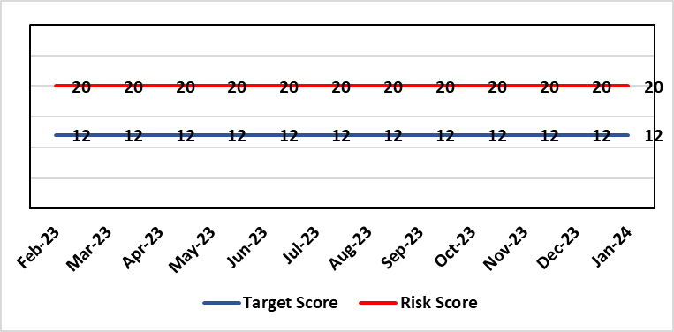 |  | Rationale for current score:  National shortages of numbers in some areas can lead to:  - Inability to recruit sufficient numbers of trainees to fulfil rotas on all sites  - Inability to attract non training grades to complete rotas  - Inability to fill Consultant grade posts in some specialties with adverse effects on patient safety and employer relations. Inability to recruit sufficient registered nursing staff.
Level of Control  = 70% |  |  | Rationale for target score:  This remains a challenge and is also a national problem.
Date added to the HB risk register
April 2012
Controls (What are we currently doing about the risk?) |  |  | Mitigating actions (What more should we do?)
- Regular monitoring of recruitment position with reports to Executive Team and Board via Medical Director and Medical Workforce Board.  - Specialty based local workforce boards established to monitor and control specific issues. The HB Workforce OD & Digital Committee will seek assurance of medical workforce plans to maintain services.  - Engagement of the Deanery about recruitment position.  - Weekly workforce delivery meetings with CEO to review progress against critical medical and clinical posts  - Working with specialist agency and head hunters to improve chances to fill hard to recruit posts  - Working with a marketing agency to develop a branding and attraction campaign for the health board. |  |  | Action |  | Lead | Deadline
 |  |  | Medical training initiatives pursued in a number of specialties to ease junior doctor recruitment |  | Director W&OD | 31/03/2024
 |  |  | The Medical Workforce Board continues to monitor recruitment and junior doctor’s rotas. |  | Director W&OD | 31/03/2024
 |  |  | Continue to recruit internationally. |  | Director W&OD | 31/03/2024
 |  |  | Continue to work with head hunters |  | Director W&OD | 31/03/2024
Assurances (How do we know if the things we are doing are having an impact?)  - General situation monitored through W&OD Committee  - Communication with Deanery  - Recruitment campaigns  - Monitoring by Executive Teams and specialty based local workforce boards  - Workforce planning and deployment taskforce meetings with service groups  - Weekly workforce delivery meetings with CEO as above |  |  | Gaps in assurance (What additional assurances should we seek?)  Locum cover  Adequate supply of doctors who can work in this country  Ability to flexibly deploy doctors in training.  Dedicated work between workforce and finance to review and confirm budgeted medical workforce establishment by service group to confirm SIP and vacancy factor.
Additional Comments / Progress Notes
March.2024: Workforce team reviewing & refreshing risk entry for March HBRR.

Datix ID Number: 1035  Health & Care Standard: Effective Care 3.1 Clinically Effective Care |  |  | HBR Ref Number: 27  Risk Target Date: 31st March 2024 |  | Current Risk Rating  4 x 4 = 16
Objective: Adopting and Developing Innovative Digital Solutions to Support Care Delivery |  | BAF Ref: 5 | Director Lead: Matt John, Director of Digital  Assuring Committee: Workforce OD & Digital Committee
Risk: Digital Transformation  Inability to deliver sustainable clinical services due to lack of resources to deliver sustainable Digital Transformation and services. There are insufficient resources to:  - Invest in the delivery of the SBU Digital strategy  - Support the growth in utilisation of existing and new digital solutions  - Replace existing technology infrastructure or software at the end of its useful life. |  |  | Date last reviewed: February 2024
Risk Rating  (consequence x likelihood):  Initial: 4 x 4 = 16  Current: 4 x 4 = 16  Target: 5 x 2 = 10 | 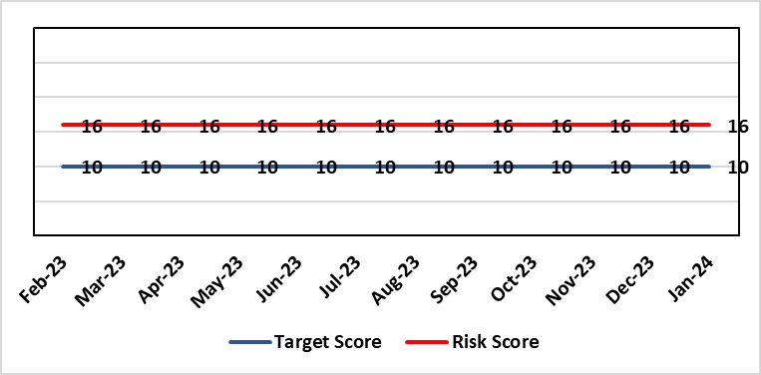 |  | Rationale for current score:  C – Reliance on digital ways of working has increased. Loss of IT service has a greater impact on ability to provide clinical care. Lack of investment in new digital solutions to make services more effective will mean clinical service provision will become unsustainable.  L- Reduction in capital funding in 2022/23/24 has increased the likelihood of HB not being able to replace aging infrastructure such as the network equipment. There is a £15m capital requirement over the next 3 years. Acceleration of the CTM SLA disaggregation has been proposed and there are further pressures on revenue funding. The shift to cloud and software as a service contracting models will increase the requirement for revenue funding to deliver digital transformation and ongoing services.
Rationale for target score:
C – Of failure will increase as the reliance and proliferation of the use of digital solutions increases.
L – Investment will mean the support mechanisms, rate of failure and ability to deliver solutions that meet the needs of users will improve sustainable digital services. There will however always be an inherent risk of failure of IT solutions.
Level of Control
= 50%
Date added to the HB risk register
2012
Controls (What are we currently doing about the risk?) |  |  | Mitigating actions (What more should we do?)
- Digital Strategy has been approved by the Health Board and outlines requirements  - HB Capital priority group considers digital risks for replacement technology which is fed into the annual discretionary capital plan  - Digital Services prioritisation process is in place Digital Leadership Group provides the overarching governance to the delivery of the Digital Strategic Plan including financial considerations.  - Digital Services Management Group assesses current service provision and flags risks and issues  - Digital Services revenue requirements are included in 2023/24 annual plan |  |  | Action | Lead |  | Deadline
 |  |  | Continue to develop the 10yr investment plan that has been submitted to WG, which will inform the Health Board IMTP submission. | Assistant Director of Digital: Business Management and Information Governance |  | 29/03/2024
 |  |  | Refresh the Digital Strategy including a high level investment plan to set out vision for the Health Board | Assistant Director of Digital: Business Management and Information Governance |  | 31/5/2024
Assurances (How do we know if the things we are doing are having an impact?)  - Internal Audit Program assesses Digital in 4 areas annually |  |  | Gaps in assurance (What additional assurances should we seek?)  - Lack of certainty over future capital and revenue funding streams makes planning and implementation difficult/less effective.
Additional Comments / Progress Notes
15/03/2024 – Digital Strategy redevelopment process has completed. The strategy will go to Board for approval in May 2024

Datix ID Number: 1043  Health & Care Standard: Effective Care 3.1 Clinically Effective Care |  |  | HBR Ref Number: 36  Risk Target Date: 31st March 2024 |  | Current Risk Rating  4 x 4 = 16
Objective: Adopting and Developing Innovative Digital Solutions to Support Care Delivery |  | BAF Ref: 5 | Director Lead: Matt John, Director of Digital  Assuring Committee: Workforce OD & Digital Committee  For information: Quality & Safety Committee
Risk: Paper Record Storage  Lack of a single electronic record means there is greater reliance on the provision of the paper record. If we fail to provide adequate storage facilities for paper records, then this will impact on the availability of patient records at the point of care. Quality of the paper record may also be reduced if there is poor records management in some wards. There is an increased fire risk where medical records are stored outside of the medical record libraries. |  |  | Date last reviewed: February 2024
Risk Rating  (consequence x likelihood):  Initial: 4 x 5 = 20  Current: 4 x 4 = 16  Target: 3 x 3 =9 | 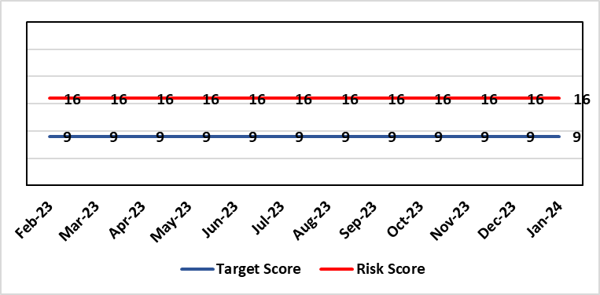 |  | Rationale for current score:  C - Inability to find records for patients could delay care/increase length of stay over 15 days. Could also mean patients receive incorrect treatment. Increased risk of fire where records are stored outside of the medical record libraries.  L - we know this happens from incidents raised
Level of Control  = 70% |  |  | Rationale for target score:  C - The increased development and adoption of the digital record will reduce the need for the paper health record being available at the point of care.  L - The increased development and adoption of the digital record, the introduction of RFID and the approach to management of the paper record identified in the Business case process should reduce the amount of paper required to be stored and managed.
Date added to the HB risk register
June 2016
Controls (What are we currently doing about the risk?) |  |  | Mitigating actions (What more should we do?)
- There is a plan in place to increase the functionality of the electronic record to document patient care. The delivery of the plan is overseen by the Digital Leadership Group and progress provided to Management Board. (Supported by individual project boards as appropriate).  - Records managed by the Medical Records libraries are RFID tagged and location tracked.  - Medical Record libraries are regularly risk assessed for fire by health and safety.  - Alternative offsite storage arrangements have been identified.  - All records must be documented on the Information Asset Register (IAR). |  |  | Action | Lead |  | Deadline
 |  |  | Amended: Re-develop a joint outline Business Case for centralisation of the health records | Head of Health Records & Clinical Coding |  | 31/03/2024
 |  |  | Welsh Government sign off for long term conditions retention of records | Head of Health Records & Clinical Coding |  | 30/04/2024
Assurances (How do we know if the things we are doing are having an impact?)  - RFID has been implemented for the acute record improving the management and storage of records  - Health Records performance reports developed in line with RFID technology  - Attainment of the Tier 1 Health Board target for clinical coding completeness which relies on the timely availability and quality of the Paper record and electronic sources  - Monitoring complaints and incident reporting.  - Electronic record is being implemented in accordance with the plan eg implementation of WNCR, ETR, HEPMA etc. |  |  | Gaps in assurance (What additional assurances should we seek?)  Investment required supporting the delivery and operational costs of the Digital strategy.  Reliance on DHCW for delivery of the solution for a fully electronic patient record.  Impact of the Infected Blood Enquiry on the Health Boards ability to destroy notes.  Process for ensuring clinical adoption of electronic ways of working and cessation of adding information to the paper record that is already available electronically needs to be agreed and enforced by the Health Board.  Impact of the infected Blood Inquiry on the health boards ability to destroy notes and the change in the records code of practice is being reviewed by the Director of Digital.
Additional Notes
07/12/2023 – Currently exploring another potential site for the relocation of the Health Records Service., no firm decisions have been made at present.
15/03/2024 - Business case has been approved at Management Board pending confirmation of funding under IMTP sign off.
15/03/2024 - National collaboration has concluded that the retention period for long term conditions of 20 years only applies to Primary Care records. A paper will be taken through local governance for assurance in Q1 2024/25.

Datix ID Number: 1217  Health & Care Standard: Effective Care 3.1 Safe & Clinically Effective Care |  |  | HBR Ref Number: 37  Risk Target Date: 30th June 2024 |  | Current Risk Rating  4 x 3 = 12
Objective: Adopting and Developing Innovative Digital Solutions to Support Care Delivery |  | BAF Ref: 5 | Director Lead: Matt John, Director of Digital  Assuring Committee: Workforce OD & Digital Committee
Risk: Operational and strategic decisions are not data informed:  - Business intelligence and information already available is not utilised  - Users are unable to access the information they require to make decisions at the right time  - Gaps in information collection including patient outcome measures |  |  | Date last reviewed: February 2024
Risk Rating  (consequence x likelihood):  Initial: 4 x 3 = 12  Current: 4 x 3 = 12  Target: 4 x 2 = 8 | 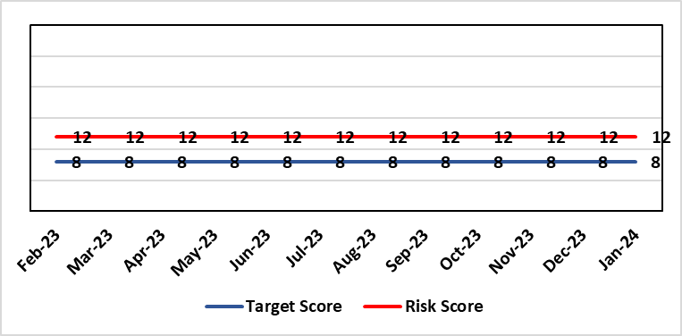 |  | Rationale for current score:  C – Opportunity cost of not acting on data could mean opportunities for improvement are missed, failures are not identified in a timely manner resulting in adverse national publicity and/or delays in care/increased length of stay.  L - Dashboard utilisation is lower than would be anticipated. Management Board have approved the investment for 4 BI partners to work with the SDGs to become more data driven.
Level of Control  = 70% |  |  | Rationale for target score:  C- Will remain the same or increase due to increased reliance in information  L- Investment in BI will lead to more information be available and used. The higher the use of information at operational level will lead to better quality data.
Date added to the HB risk register: June 2016
Controls (What are we currently doing about the risk?) |  |  | Mitigating actions (What more should we do?)
- BI partner roles have been funded and will be introduced to support the SDGs to become more data driven.  - COVID19 Dashboards Developed and utilised to inform the decision making process at Gold  - The Health Board has invested in interactive dashboards with the addition of the Power BI Business Intelligence software and infrastructure to support it.  - 33 dashboards in place including Cancer, Patient Flow, Outpatients, Mortality, Clinical Variation, Primary & Community Care Delivery Unit Dashboard and Ward Dashboard  - Safety Huddle implemented in Morriston has improved data quality and improved operational working  - Information Dept. working with Planning and Finance leads to develop meaningful indicators, utilising dashboards to present information in a user friendly way  - New technologies being reviewed for advanced analytics and integration into a new Health Board analytics platform.  - Health Board has representation on national groups such as the Advanced Analytics Group (AAG), all Wales Business Intelligence and Data Warehousing Group and Welsh Modelling Collaborative. |  |  | Action | Lead |  | Deadline
 |  |  | Additional development of self-service dashboards | Assistant Director of Digital Intelligence |  | Completed
 |  |  | Create Community of Practice for Power BI knowledge sharing across Health Board. A forum has been established for shared learning and expertise across Digital Intelligence, Health Care Systems Engineering and Values Based Healthcare. | Assistant Director of Digital Intelligence |  | 28th February 2024  Completed
 |  |  | Appointments of BI partners to vacant posts | Assistant Director of Digital Intelligence |  | Completed
 |  |  | Start of 2nd tranche of Data Literacy Module Manager’s Pathway program | Assistant Director of Digital Intelligence |  | 31st May 2024
 |  |  | Certified Analytical Programme with access to self- service datasets | Assistant Director of Digital Intelligence |  | 30th June 2024
Assurances (How do we know if the things we are doing are having an impact?)  More evidence based and proactive decisions being made.  Dashboard technology; assist in developing indicators / triangulating information to identify issues |  |  | Gaps in assurance (What additional assurances should we seek?)  Culture of the organisation needs to change to focus on information and Business intelligence for operational rather than reporting purposes. Capability of operational staff to utilise the tools and capacity to act on the intelligence provided.
Additional Comments / Progress Notes
15/01/2024 - Self-service dashboard has been completed, action closed; risk target date extended to 30th June 2024.
15/03/2024 - A forum has been established for shared learning and expertise across Digital Intelligence, Health Care Systems Engineering and Values Based Healthcare.
15/03/2024 – Vacant Business Intelligence Partner roles have been appointed to

Datix ID Number: 1759  Health & Care Standard: Staff & Resources 7.1 Workforce |  |  | HBR Ref Number: 51  Risk Target Date: 30th April 2024 | Current Risk Rating  4 x 3 = 12
Objective: Demonstrably Improved Quality, Safety & Reduced Harm |  | BAF Ref: 1 | Director Lead: Gareth Howells, Executive Director of Nursing  Assuring Committee: Workforce OD & Digital Committee
Risk: Non Compliance with Nurse Staffing Levels Act (2016) – Section 25B Wards  The Nurse Staffing Levels (Wales) Act 2016 (NSLWA) legally requires the health board to make provision for appropriate nurse staffing levels within their nursing services. In accordance with section 25B, there is a duty to calculate nurse staffing levels in adult and paediatric acute medical and surgical inpatient wards. There is a risk we may not meet these requirements fully due to increased acuity, unplanned staff absence and vacancies. The potential impact of this maybe non-compliance with the ‘Act’, poor patient outcomes and experience, and suspension of services. |  |  | Date last reviewed: February 2024
Risk Rating  (consequence x likelihood):  Initial: 4 x 4 = 16  Current: 4 x 3 = 12  Target 3 x 2 = 9 | 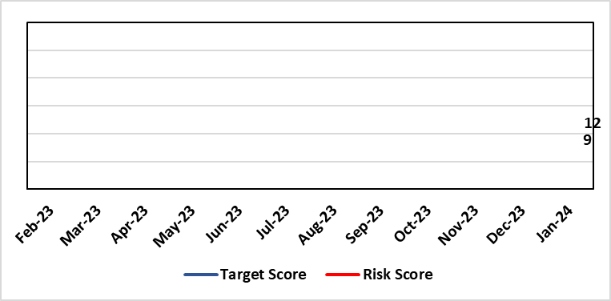 |  | Rationale for current score:  - The scope of the risk has been reviewed to disaggregate the 25B reportable wards as part of the NSLWA to enable clearer identification of risk of non-compliance with the’ Act’ from the aggregated risk across all nurse staffing areas of inadequate staffing levels previously scored 20.  - There has been a steady decline in the number of vacancies across the 25B wards as a result of successful international recruitment and student streamlining  - The Service Group risk assessments for 25B wards reported at the NMSSAIG 24.01.2024 are as follows:  - Morriston Service Group – 9 (previously 12)  - NPTSSG – 9 (unchanged)  - Paediatrics: In-patient wards – 16 (previously reported 12) increased risk due to vacancies, sickness and maternity leave
Level of Control  = |  |  | Rationale for target score:  - The health board has the required structures and processes in place to provide reassurance to the Board that SBUHB is compliant under the Act and as such are allocating resources accordingly.  - Health boards are duty bound to take all reasonable steps to maintain nurse staffing levels.  - Ward skill mix, recruitment and induction plans impacting on ward  - Projected continued decrease in vacancies by end of 2024.
Date added to the HB risk register
November 2018
Scope Refreshed:
January 2024
Controls (What are we currently doing about the risk?) |  |  | Mitigating actions (What more should we do?)
The Health board has put the following controls in place:  - The designated person as part of the requirements of the ‘Act’ is the Executive Director of Nursing & Patient Experience  - The responsibility for decisions relating to the maintenance of the nurse staffing level rests with the health board is based on evidence provided by, and the professional opinions of the Executive Directors with the portfolios of Nursing, Finance, Workforce, and Operations  - Bi-annual calculations undertaken across all Section 25B wards using the triangulated methodology which Service Groups formally present at Executive led scrutiny panels with representation from Nursing, Workforce and Digital and Finance Colleagues.  - The Ward Sister / Charge Nurse, Senior Nurses and Group Nurse Director continuously assess the situation and keep the designated person formally apprised  - The health board has representation at the All-Wales Nurse Staffing Group and its sub groups to ensure the organisation is aware of national updates  - The Board receive a bi-annual report - May (agreed Once for Wales) and November (mandatory). The 3 yearly mandatory paper to Welsh Government is due May 2024.  - Workforce planning & redesign, training and development. Recruitment and retention continues. HB Workforce Group has been set up and links to HEIW Retention Work stream, HB representatives on HEIW Group are Associate Head of HR, Recruitment and Retention Manager and Matron, Corporate Recruitment. Workforce plans have been developed by Service Group Nurse Directors and each Service Group agrees staffing, with consideration of all reasonable steps to maintain the nurse staffing level  - Work assessing the impact of the 'Team around the Person' continues on a HB and All Wales basis.  - Rostering Policy - the Service Groups have a robust roster scrutiny process that is undertaken to ensure roster efficiency and appropriate utilisation of temporary staff.  - The health board has a nursing retention plan and actively supports the Retire and Return policy.  - SafeCare has been implemented, the All Wales SOP remains a working document as understanding evolves.  - Service Groups continue daily staffing huddles and daily staffing tool and escalate as appropriate. |  |  | Action |  | Lead | Deadline
 |  |  | Student Streamlining and Overseas recruitment |  | Executive Director of Nursing | 31/12/2024  Monthly ongoing
 |  |  | Review of workforce, consider more diverse skill mix, including development of Band 3 and Band 4 roles. Bi-annual re-calculations of inpatient wards have resulted in the addition of Band 3 and 4 roles within the NSA templates. These posts are being recruited into, there is a need for training and supervision for these new posts. Development of Service Group workforce plans to support an overall Corporate Workforce Plan. |  | Executive Director of Nursing | 31/12/2024
Assurances (How do we know if the things we are doing are having an impact?)  - Ongoing robust recruitment and retention plans in place to reduce vacancies in key clinical areas.  - Accurate reporting of acuity data and governance around sign off.  - Agreed establishments are funded.  - E-Rostering implemented and roster scrutiny undertaken, ensuring effective staff allocation.  - All Wales Templates are visible informing patients/visitors of planned roster on all Section 25B wards. Patient Information available on all Section 25B wards, Service Groups have access to all HEIW documents via a SharePoint  - Bi-annual Board reports, provide assurance and outline compliance and any key risks, submitted in November and May each year, with three yearly report to Welsh Government due May 2024.  - The Health Board Nursing and Midwifery Safe Staffing Assurance and Improvement Group (formally the Nurse Staffing Act Steering Group, amended July 2023) meets on a bi-monthly basis, ensuring risks from all Service Groups are presented, discussed and escalated as appropriate at each meeting. This group is chaired by an Associate Director of Nursing and reports to Nursing and Midwifery Board and the Workforce, Organisational Development and Digital Committee  - Service Group risk assessments have been updated and disaggregated into 25B and 25A areas to enable clear risk assessment and escalation of specific risks to ensure robust governance and risk assurance  - There is a clear process for scrutiny during bi-annual re-calculations and at any other time when wards require a re-calculation, for example: change to ward purpose, increased bed numbers or increase patient acuity  - SafeCare system has been implemented. Support given to help embed the system into everyday use. Use of SafeCare linked to daily staffing huddles.  - Historical information and all reporting templates available on a share drive |  |  | Gaps in assurance (What additional assurances should we seek?)  - Issue remains regarding Information Technology barriers around the capture of data required for the Act on an All- Wales and Health Board basis. All Wales work with Allocate (Safecare) to improve reporting capabilities of Safecare, via a dashboard continued to progress, SBU is pilot site for testing. Update to Allocate system received, working with rostering team and BCU NSA Lead to check accuracy of reporting.  - Ongoing work across Wales to ensure IT systems are compatible with each other for operational and reporting purposes.
Additional Comments / Progress Notes
Section 25B wards covered by this risk:
NPTSSG | Morriston Service Group
Ward 2  Ward 4  Ward 12  Ward A  Ward E  Paediatric: Ward M and Oakwood Ward | Ward A, B, W and Clydach Ward  Ward C, Cyril Evans Ward, Dan Danino Ward  Powys Ward, Tempest Ward  Cardigan Ward  Ward K, L, R, T and Pembroke Ward  Ward D, E, F, G, H, J, S and Gower Ward

For information – 25A areas not covered by this risk include (These are managed within Service Groups and would be escalate for Executive consideration as appropriate).
Morriston Service Group | NPTSG | Mental Health & Learning Disabilities | Community Areas
Critical care areas – GITU & CITU  Short stay and assessment areas  AMU,SDMU  Emergency Department | Neonates  Theatres  Ward B, C, D NPTH | Mental Health and Learning Disabilities | District Nursing  Health Visiting  Gorseinon Hospital  Ty Olwen
Midwifery is not covered as part of the NSLWA – Refer to Midwifery Staffing Risk ID 2788 (HBR 81)
24/01/2024: Discussed and agreed in Nurse and Midwifery Safe Staffing Assurance and Improvement Group (NMSSAIG) on 24th January 2024.
The scope of this risk has changed. The description has been refreshed to clarify that only those services covered under Section 25B of the Act are within its scope.
Work is being undertaken to review risks in services outside this section of the Act (including Neonates and MH&LD where staffing level risks have been highlighted previously) in order to reflect separately on HBRR as appropriate.

This also includes ensuring the relevant clinical services achieve the required standards set out in the all Wales district nursing and mental health principles as well and the BAPM standards for Neonatal Units and Birth rate plus,

Datix ID Number: 1762  Health & Care Standard: Staff & Resources 7.1 Workforce |  |  | HBR Ref Number: 53  Risk Target Date: 31st March 2024 |  | Current Risk Rating  5 x 3 = 15
Objective: Demonstrably Improved Quality, Safety & Reduced Harm |  | BAF Ref: 1 | Director Lead: Hazel Lloyd, Director of Corporate Governance  Assuring Committee: Health Board (Welsh Language Group)
Risk: Welsh Language Standards  Failure to fully comply with all the requirements of the Welsh Language Standards, as they apply to the University Health Board. |  |  | Date last reviewed: February 2024
Risk Rating  (consequence x likelihood):  Initial: 5 x 3 = 15  Current: 5 x 3 = 15  Target: 3 x 3 = 9 | 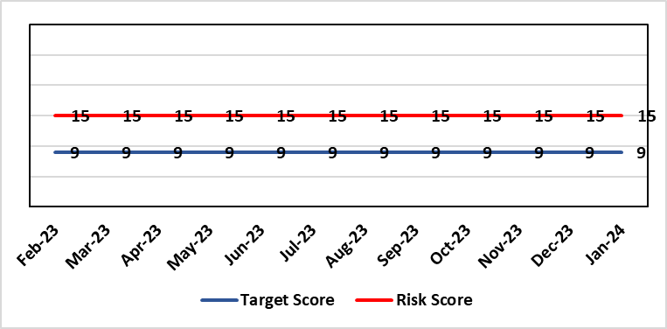 |  | Rationale for current score:  As a consequence of an internal assessment of the Standards and their impact on the UHB, it is recognised that the Health Board will not be fully compliant with all applicable Standards. This position has been confirmed/verified via an independent baseline assessment.
Level of Control  = 60% |  |  | Rationale for target score:  Working through its related improvement plan the likelihood of noncompliance will reduce as awareness and staff training in response to the Standards, is raised.
Date added to the HB risk register
November 2018
Controls (What are we currently doing about the risk?) |  |  | Mitigating actions (What more should we do?)
- An independent baseline assessment of the Health Board’s position against the Standards has been undertaken. This is in addition to the Health Board’s own self-assessment.  - Work to implement the recommendations contained within the above baseline assessment has commenced.  - An online staff Welsh Language Skills Survey has been launched.  - Close constructive working relationships are in place with the Welsh Language Commissioner’s Office  - Strong networks are in place amongst WLO across NHS Wales to inform learning and development of responses to the Standards.  - Proactive communication and marketing activity is being undertaken across the Health Board to raise awareness of Welsh language compliance, customer service standards and training opportunities.  - Meetings of the Welsh Language Standards Delivery Group have recommenced (March 2022) |  |  | Action | Lead |  | Deadline
 |  |  | Recruit to current vacancy within the Welsh language Translation Team. | Welsh Language Officer |  | 31/03/2024
Assurances (How do we know if the things we are doing are having an impact?)  - Compliance with Statutory requirements outlined in Welsh Language Act and related Standards.  - Meetings with the Welsh Language Commissioner.  - Self-Assessment against the requirements of More Than Just Words.  - Production of an Annual Report. |  |  | Gaps in assurance (What additional assurances should we seek?)  Formal and regular reporting to the Board will recommence with the production of the next annual report.
Additional Comments / Progress Notes
Dec 2023: The long-standing vacancy within the Translation Team has now been filled, with a substantive appointment being made with effect from 01/12/2023. However a further translator has now handed in their notice and will leave the Team on 02/01/2024. A recruitment exercise to fill this post is now underway.

Datix ID Number: 2159  Health & Care Standard: Safe Care 2.1 Managing Risk & Promoting Health & Safety |  |  | HBR Ref Number: 64  Risk Target Date: 31st March 2024 | Current Risk Rating  4 X 4 = 16
Objective: Delivering Care in Safe, Modern Environments |  | BAF Ref: 7 | Director Lead: Darren Griffiths, Director of Finance & Performance  Assuring Committee: Quality & Safety Committee
Risk: Health & Safety Infrastructure  Insufficient resource and capacity of the health, safety and fire function within SBUHB to maintain legislative and regulatory compliance for the workforce and for the sites across SBUHB. . |  |  | Date last reviewed: February 2024
Risk Rating  (consequence x likelihood):  Initial: 5 x 4 = 20  Current: 4 x 4 = 16  Target: 4 x 3 = 12 | 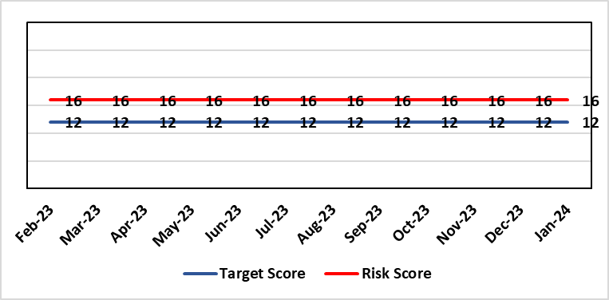 |  | Rationale for current score:  The Health Board received 12 Health & Safety Executive (HSE) improvement notices during 2019-20 covering various Health & Safety legislative breaches covering a range of areas. There is the potential for future multiple notices for not meeting legislative requirements. Score reduced to 16.
Level of Control  = 70% |  |  | Rationale for target score:  Compliance with the notices and to have sufficient resources to implement a sustainable health and safety provision to support the legal requirements of the Health Board and demonstrate that suitable resources are in place to undertake the roles and responsibilities of the department, also to undertake suitable and sufficient training, provide corporate overview/audit to ensure practices are being employed in the workplace.
Date added to the HB risk register
September 2019

Controls (What are we currently doing about the risk?) |  |  | Mitigating actions (What more should we do?)
- Assistant Director of Health and Safety in post to support strengthening and develop the H&S function to support the organisation. Business case submitted for additional resources.  - Health and Safety Operational Group and the Health and Safety Committee monitor compliance. Refreshed the Fire Safety Group with additional controls in place.  - Fire risk assessments are being prioritised with temporary additional resources put in place in March 2021 to reduce the number of FRA overdue.  - Fire training in place and fire wardens in place  - Fire risk assessment schedule in place for the next 12 months to maintain 100% compliance of completion and is regularly reviewed |  |  | Action |  | Lead | Deadline
 |  |  | It has been agreed to identify posts to progress recruitment on a phased approach over the next 12/24 months. This will be dependent upon availability of funding. |  | Assistant Director of H&S | 31/03/2024
Assurances (How do we know if the things we are doing are having an impact?)  - Monitoring through the appropriate group/committees (H&S committee) to receive assurance and or identify gaps for key compliance and adherence to applicable legislation.  - Site visits/tours to identify compliance and gaps in compliances. |  |  | Gaps in assurance (What additional assurances should we seek?)  Agreement of funding for resources identified in business case to implement structure in business case by Q2/3 2022/23 financial year.
Additional Comments / Progress Notes
15/12/2023: The H&S team will have an additional MH trainer/advisor from 15/01/2024, increasing establishment by 0.5wte. No change to risk score.
06/02/2024: Due to the resignation of a fire advisor and the timeframe to recruit another, there is no change in the current risk rating.

Datix ID Number: 2788  Health Care Standards: 7.1 Workforce |  |  | HBR Ref Number: 81  Risk Target Date: 30/04/2024 |  | Current Risk Rating  5 x 4 = 20
Objective: Children, Young People & Maternity Services |  | BAF Ref: 3.6 | Director Lead: Gareth Howells, Executive Director of Nursing  Assuring Committee: Quality & Safety Committee  For Information: Workforce OD & Digital Committee
Risk: Critical staffing levels – Midwifery  Unplanned absences resulting from long and short-term sickness, alongside maternity leave, have resulted in critical staffing levels, which undermine the ability to maintain the full range of expected services safely, increasing the potential for harm, poor patient outcomes and/or choice of birthplace. Poor service quality or reduction in services could impact on organisational reputation. |  |  | Date last reviewed: February 2024
Rationale for current score:
The vacancy position has improved further and for Band 5 & 6 registered staff there are no vacancies. Some aspects of service provision continue to be suspended and this is subject to review currently. In view of this the risk was reduced from 25 to 20 initially. Whilst the service is now over-established with registered midwives, the score remains as high risk (20) due to unregistered vacancies (which we are recruiting to) and unavailability (due to parenting leave and sickness). There are improved numbers of registered midwives per shift with most shifts achieving the required 14 midwives.
Risk Rating  (consequence x likelihood):  Initial: 4 x 5 = 20  Current: 5 x 4 = 20  Target: 4 x 4 = 16 | 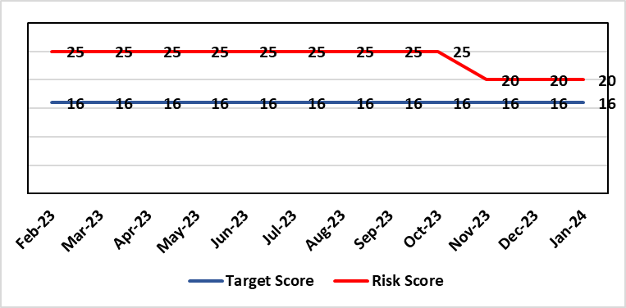
Level of Control  = % |  |  | Rationale for target score:  It is intended that through actions currently identified to address vacancies we can reinstate services fully and reduce the likelihood of the need to suspend elements further.
Date added to the risk register
12/10/2021
Controls (What are we currently doing about the risk?) |  |  | Mitigating actions (What more should we do?)
- Service Group Nurse Director chairs fortnightly roster scrutiny meetings to ensure effective deployment of staff.  - All midwives are working at the hours they require up to full time.  - Specialist midwives and management redeployed to support clinical care as required  - Birth rate plus Intrapartum acuity tool completed 4 hourly to guide safe service provision and escalation;  - Escalation meeting held daily during the week to review rotas and reallocate staff as required chaired by Head of Midwifery  - Morning safety huddle for community midwifery teams  - Morning safety huddle for obstetric unit generates RAG-rated daily acuity and shares this with the Service Group for its daily meeting.  - Additional shifts offered via Bank, additional hours and overtime at enhanced rates  - Utilisation of off-contract midwifery agency authorised by Executive Director of Nursing  - Open advert for recruitment on TRAC (recruitment system)  - On-Call Manager Rota in place.  - Continue to suspend services in the FMU (Freestanding Midwifery Unit) at Neath Port Talbot Hospital.  - International recruitment campaign initiated with MEDACS.  - Offer of additional support worker shifts particularly in the postnatal area for additional support for women  - Maternity Care Assistance (MCA) role in place to support Midwives in providing care in women and their families.  - Regular communication with stakeholders includes: Early warnings to Welsh Government; Verbal and formal communication with Llais; Internal communications on home births, RCM updates; weekly staff briefings and bulletins.  - Maternity Services Improvement & Assurance Board has been instated, meeting fortnightly, chaired by NPTS Nurse Director. This will report into the Midwifery & Neonatal Service Performance Board in place chaired by EDON |  |  | Action | Lead |  | Deadline
 |  |  | Advertising for Community Team Leaders (Band 7) to support plans to re-open services in Neath Port Talbot. | Community Matron / Consultant Midwife |  | 30/04/2024 (expected in post)
 |  |  | Shortlisting 5 WTE (whole time equivalent) Band 2 HCA (health care assistant) positions at Singleton. | Obstetric Matron |  | 31/03/2024 (expected in post)
 |  |  | Developed Escalation Policy – to be ratified. | HOM |  | 31/01/2024
 |  |  | Gateway review in place in relation to reinstatement of community services, first point is recruitment of band 7 community team leaders | HOM |  | End February 2024
Assurances (How do we know if the things we are doing are having an impact?)  The following assurance mechanisms in place currently:  Birth-rate Plus Intrapartum acuity tool completed 4 hourly  Daily staff escalation meetings chaired by Head of Midwifery which considers sickness & other absences and daily review of safety and quality outcomes. The Group Head of Quality Safety & Risk is supporting daily oversight of Datix incidents. The following red flag events are monitored:  • Delayed or cancelled elective caesarean sections;  • Missed or delayed care incidents;  • Delayed or cancelled induction of labour;  • Delay of 2 hours or more between admission for induction of labour and beginning of process;  • Delay of 30 minute or more between presentation and triage.  Birthrate Plus assessment outcome (last internal assessment Oct 2023 – now compliant) |  |  | Gaps in assurance (What additional assurances should we seek?)
Additional Comments / Progress Notes
24/01/2023: Actions completed: Development and dissemination of the organisational change to practice (OCP). Phase 1 consultation period closed. Outcome has been reviewed and further work undertaken to resolve; and OCP Phase 2 consultation period closed 24th Oct 2023 – Outcome reviewed and actions complete; Response to both OCPs issued to staff.
Transformational work is ongoing within community services to reinstate services in NPT Freestanding Midwifery Unit. Maternity Services Improvement & Assurance Board has been instated, meeting fortnightly, chaired by Neath Port Talbot Service Group Nurse Director. This will report into the Midwifery & Neonatal Service Performance Board in place chaired by Executive Director of Nursing. Re-opening of services will be subject to gateway review process.

The Risk Score for Critical Midwifery Staffing remains at 20 (ID 2788) with community intrapartum pathways remaining suspended to mitigate staffing constraints. There were a number of control measures and actions already in place to mitigate staffing shortfalls with additional actions put in place to support safe staffing. The following continue:

- Continued enhanced bank rate with rolling recruitment advert
- Proactive engagement with agencies to determine agency capacity and block bookings
- Central resourcing team fast tracking on-boarding recruitment
- Open rolling advert for registered midwives
- Twice weekly oversight at 1pm Safe Staffing Huddle, chaired by HOM or DHOM
- Addition of a focused Safety Huddle at 9.30 am attended by Ward Managers, Matrons, Deputy Head of Midwifery, Head of Midwifery, Lead Midwife for Quality and Intrapartum Lead Midwife to highlight safety events, emerging risks, acuity
- An agreement to “over establish” in the coming months to provide further support during this period of transition.

Workforce Investments - A phased investment of £750K confirmed

The Head of Midwifery has been substantively recruited into and to strengthen midwifery leadership, and in line with the Royal College of Midwives manifesto to introduce Director of Midwifery posts, the post of a Clinical Director of Midwifery will be introduced as part of the Service Group structure to strengthen strategic and operational delivery of maternity services.

Table 1 identifies the current vacancy position in the Maternity Service

Obstetric Unit
Band | Title | Vacancy
Band 7 | Ward Manager | 0.74 WTE
Band 5/6 | Registered Midwife | 0
Band 3 | Maternity Care Assistant | 0
Band 2 | Health Care Assistant | -7.21 WTE

Datix ID Number: 3071  Health Care Standards: Staff & Resources 7.1 Workforce |  |  | HBR Ref Number: 89  Target Risk Date: 31/06/2024 | Current Risk Rating  4 x 5 = 20
Objective: Primary & Community Care |  | BAF Ref: 3.1 | Director Lead: Gareth Howells, Executive Director of Nursing (lead) / Deb Lewis, Chief Operating Officer (support)  Assuring Committee: Quality & Safety Committee
Risk: Healthcare Nursing Staff Levels at HMP Swansea  There is a risk that the men in HMP Swansea will not receive the appropriate standard of care. This is due to the fact that the nursing establishment within the prison no longer fully meets the changed demographics and numbers of men being detained. The maximum operational capacity of the Prison can reach circa 480 men. The Health Board investment into the Prison is based on delivering services to 250 men. This was also highlighted as a risk in the June 2022 HIW governance review. In addition there is no head room built into the Prison nursing establishment so periods of sickness, leave and study renders the roster short. |  |  | Date last reviewed: February 2024
Risk Rating  (consequence x likelihood):  Initial: 4 x 5 = 20  Current: 4 x 5 = 20  Target: 2 x 2 = 4 | 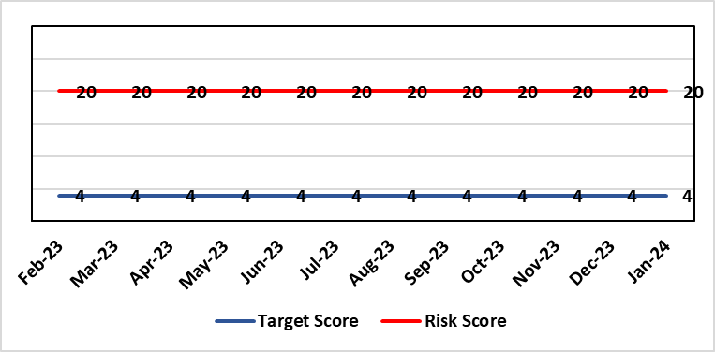 |  | Rationale for current score:  Consequence major – unable to fully deliver on the recommendations of HIW due to low healthcare staffing numbers, further impacted during periods of sickness or absence as no headroom. Recommendations also raised in Prison & Probation Ombudsman reports. Likelihood expected – suboptimal care provided on a daily basis.
Level of Control  = % |  |  | Rationale for target score:  Consequence minor – With sufficient staffing numbers the prison will be able to deliver on HIW recommendations and fully implement the actions in the Health Delivery Plan. Likelihood unlikely – With full establishment and headroom, suboptimal care is less likely.
Date added to the risk register
30/11/2022
Controls (What are we currently doing about the risk?) |  |  | Mitigating actions (What more should we do?)
Daily communication with the Governor about the availability and priority of healthcare nursing staff.  Pharmacy technician role established – can administer drugs to support nursing establishment.  Agreed that Health Care Support Workers to be 2nd checkers for CD drugs and to support substance withdrawal monitoring (awaiting accreditation).  Bank and agency staff are used in a limited way, when skillset allows.  E-roster implemented and scrutinised with regular reporting to Service Group Patient Safety & Compliance Group.  Escalation for overtime and additional hours to fill shortfalls. |  |  | Action | Lead | Deadline
 |  |  | HCSW second checkers of CDs to be accredited externally. | Healthcare Lead | 31/03/2024
 |  |  | Management Board paper to be presented setting out the current position and next steps. | Service Group Director (PCT) | 29/02/2024
 |  |  | Fresh Gap analysis to be undertaken to identify staffing shortfall and set out further proposals to address. | Service Group Director (PCT) | 30/04/2024
Assurances (How do we know if the things we are doing are having an impact?)  Prison feedback and complaint process  Progress reporting on action plans through Service Group PS&C Group, and Health Board Q&S structures (via Patient Safety & Compliance Group). |  |  | Gaps in assurance (What additional assurances should we seek?)  Implementation and reporting of clinical audits. Audit framework for HMP Swansea in development - Clinical Pathways/Audits and Health Promotion groups taking forward.
Additional Comments
27/11/2023: The Health care leads have only the capacity to support the clinical and operational aspects whilst performance, assurance and health promotion work is secondary. PCTG has not been able to identify recurrent funding post the 31st March 2023 to bolster the nurse roster. Action to establish task & finish group added. This will meet in early January 2024 and will focus on the following areas:
• Scope of the development work
• Current staffing challenges
• Clinical pathway development
• Benchmark with other models of care
• Specific areas of focus - Priority areas
• Who needs to be involved
• Updating Management Board
• Progress against the HIW Action plan
• Funding moving forward
22/01/2024: Actions Completed: Discussion in relation to internal sources of funding following cessation of the SLA with CTM – the Mental Health In-Reach team are now dedicated to Swansea; Task and finish group established between PCTSSG & MHLDSG – Executive Director of Nursing in Chair; Through Prison Partnership Board opportunities to implement the recommendations of HIW and Health Delivery Plan explored and progress reviewed at PCT Q&S Group – the Task & Finish Group is now reviewing opportunities and a programme of work set out as above.

A paper is being developed for presentation to the Management Board setting out the current position; this is to be followed by fresh gap analysis and proposals on how to address staffing issues and take forward the remaining work including the actions agreed within the Health Delivery Plan.

Two groups – Clinical Pathways/Audits and Health Promotion Groups have been established to take forward actions. Discussion is underway with Public Health colleagues to explore additional funding to cover vaccination and the Liver Plan.

Datix ID Number: 2796  Health Care Standards: Effective Care Standard 3.5 Record Keeping |  |  | HBR Ref Number: 90  Target Risk Date: 30th April 2024 |  | Current Risk Rating  4 x 4 = 16
Objective: Adopting and Developing Innovative Digital Solutions to Support Care Delivery |  | BAF Ref: 5 | Director Lead: Matt John, Director of Digital  Assuring Committee: Workforce OD & Digital Committee
Risk: Non-compliance with UK-GDPR Article 15 regarding Subject Access Requests (SARs), along with other health records requests for disclosure of personal data  The Health Board does not have adequate resources to deal with the sustained increase in volume and complexity of subject access /access to health records requests received from requestors. The ICO are already involved with a number of breaches and complaints in this area and there is the potential for future enforcement action if significant improvements are not made. Misfiling and redaction are major issues for Health Records, IG and Health Professionals. SAR breaches have led to successful compensation claims and media interest. |  |  | Date last reviewed: February 2024
Rationale for current score:
C – The Health Board has a statutory requirement to comply with UK GDPR and Data Protection Act 2018. This includes compliance with an individual’s Right to Access their personal data. The Information Commissioner has the power to take enforcement action, including substantial monetary penalties, for non-compliance. A number of complaints regarding the handling of SARs within SBUHB have been highlighted in both the mainstream media and on social media, leading to a loss of trust in the Health Board with damage to staff and Health Board reputation.
L- The Health Board does not have adequate resources to deal with the sustained increase in volume and complexity of SARs received from both patients and staff. There are inconsistent processes across the Health Board, with varying levels of robustness regarding legislative compliance. The increased use of various digital applications has impacted the volume and complexity of content and the ability to retrieve the personal data required to comply with SARs. The process for ensuring information is appropriately reviewed and redacted has become far more complex and resource intensive increasing the likelihood of personal data breaches and/or non-compliance with legal timescales. The ICO are already involved with a number of complaints in this area and there is an increased potential for future enforcement action if significant improvements are not made.
Risk Rating  (consequence x likelihood):  Initial: 4 x 4 = 16  Current: 4 x 4 = 16  Target: 4 x 2 = 8 | 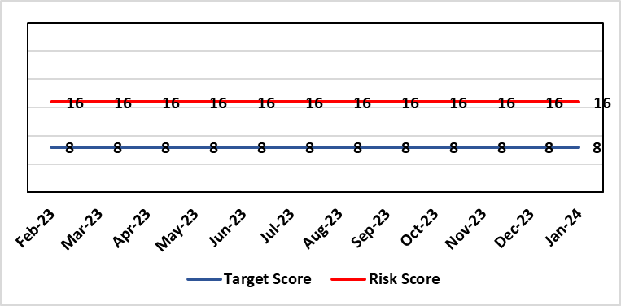
Level of Control  = 50% |  |  | Rationale for target score:  C – As above  L – Additional resources would allow the organisation to make significant improvements to the process by which SARs are managed. Being able to adequately comply with legislative requirements reduces the likelihood of enforcement action and fines from the ICO, as well as minimising the risk of reputational damage.
Date added to the risk register
Jan 2023
Controls (What are we currently doing about the risk?) |  |  | Mitigating actions (What more should we do?)
- SAR (Subject Access Request) Task & Finish Group established  - Prioritisation of workload  - Existing policies and processes in place (to be reviewed & updated)  - Advice sought from Legal and Risk on complex cases  - Legal and risk completing redaction tasks on complex and lengthy cases  - Quarterly SARs report submitted to IGG (Information Governance Group) |  |  | Action | Lead |  | Deadline
 |  |  | Re-establish SAR Working Group to perform GAP analysis and produce action plan | Data Protection Officer |  | 31st July 2024
 |  |  | Implement priority tasks outlined within the action plan within agreed timescales | Data Protection Officer |  | 31st December 2024
Assurances (How do we know if the things we are doing are having an impact?)  - Quarterly IGG chaired by SIRO (Senior Information Risk Owner) and attended by Deputy Caldicott Guardian and Data Protection Officer  - Quarterly briefing from IGG to Management Board & Workforce OD & Digital Committee  - IG governance structures in place with key roles and responsibilities established e.g. SIRO, Caldicott Guardian (Deputy), DPO (Data Protection Officer) |  |  | Gaps in assurance (What additional assurances should we seek?)  Recent internal audit identified the requirement to invest in resources to address gap in assurance.
Additional Comments / Progress Notes
09/10/2023 – SAR Lead starting date confirmed as the 30th October 2023.
16/11/2023 – SAR Policy approved by WODDC in October 2023. Previous action to review all SAR documentation amended to indicate re-establishment of SAR working Group to perform gap analysis.

Risk Score Calculation

For each risk identified, the LIKELIHOOD & CONSEQUENCE mechanism will be utilised. Essentially this examines each of the risks and attempts to assess the likelihood of the event occurring (PROBABILITY) and the effect it could have on the Health Board (IMPACT). This process ensures that the Health Board will be focusing on those risks which require immediate attention rather than spending time on areas which are, relatively, a lower priority.

This indicates whether there has been an increase / decrease in risk score since the previous month’s HBRR.

