Meeting Date | 10 April 2025 |  | Agenda Item |  |  | 2.4
Name of Meeting | Workforce and OD Committee
Report Title | Progress Report - Management of Sickness Absence (Maternity Services (NPTSSG))
Report Author | Kathy Greaves, Clinical Director of Midwifery
Report Sponsor | Ceri Gimblett – Service Group Director NPTSSG and Deb Lewis, Chief Operating Officer
Presented by | Kathy Greaves, Clinical Director of Midwifery
Freedom of Information | Open
Purpose of the Report | To set out the progress on the actions identified to improve the management of sickness absence across Maternity Services. The information will cover:  - Data analysis: An analysis of the current sickness absence performance data for Maternity Services (available as of February 2025).  - Progress against planned actions: An overview of progress against agreed actions to improve the management of sickness absence across the service.
Key Issues | Drivers for improving staff availability and sickness absence rates across the Maternity Service:  - Previous Maternity Services Board papers have referred to both the Health Inspectorate Wales (HIW) Reports and Welsh Government Enhanced Monitoring Terms of Reference documents that have identified the need to improve staff availability across the Maternity Service to support the delivery of safe and effective care.  - The Welsh Government requires Health Boards to put in place plans to achieve the <5% target absence rate across all services.  - Recognise and accept the evidence that demonstrates staff health and wellbeing has an impact on staff engagement and experience, and how this enables organisational productivity, individual performance and ultimately the quality of patient care and outcomes across the Maternity Service. The NHS Wales Staff Health and Wellbeing – A Best Practice Guide should be used across the service as an enabler to unlock the benefits of improving staff Health and Wellbeing.
Specific Action Required  (please choose one only) | Information | Discussion |  | Assurance | Approval
Specific Action Required  (please choose one only) | ☒ | ☐ |  | ☒ | ☐
Recommendations | - ACKNOWLEDGE the progress the Service Group is taking to address the findings of the deep dive sickness exercise to improve the management or sickness absence and support employee wellbeing across Maternity Services.  - BE ASSURED progress against the action plan is on track.  - AGREE to an update being provided to the Workforce and OD Committee in October 2025.

MANAGEMENT OF SICKNESS ABSENCE – MATERNITY SERVICES (NPTSSG)
1.Data Analysis – Current / Updated Sickness Absence Rates
This report will provide an update on the current sickness absence rates within the Registered Midwife and Additional Clinical Services (Maternity Health Care Assistants, Maternity Care Assistants, Nursery Nurses) staff groups, working across all teams within the Maternity Service.

Additional Clinical Services | - Overall, absence levels over the last year have fluctuated with a peak in May 2024 at 20.44%. Improved absence levels have been observed in January 2025 (10.98%) and February 2025 (10.65%).  - During October and December 2024, the increased absence rates were impacted by seasonal illnesses (specifically the absence reason ‘cold, cough, flu- influenza’).
Registered Midwives | - Overall, absence levels over the last year have fluctuated with a peak in December 2024 at 9.83%. January 2025 has seen an improved position with absence at 8.64% which has further improved in February 2025 to 8.46%.  - An improvement in Midwife availability across the rosters has been sustained since our last report on 24th October, 2024  - Shifts remain compliant with Birthrate+ over 85%.

The graphs below show the sickness absence trend for Additional Clinical Services and Registered Midwives from 03/24 – 02/25. As predicted, absences in 11/24 and 12/24 have been impacted by seasonal illness (specifically the absence reason ‘coughs, colds flu-influenza’).

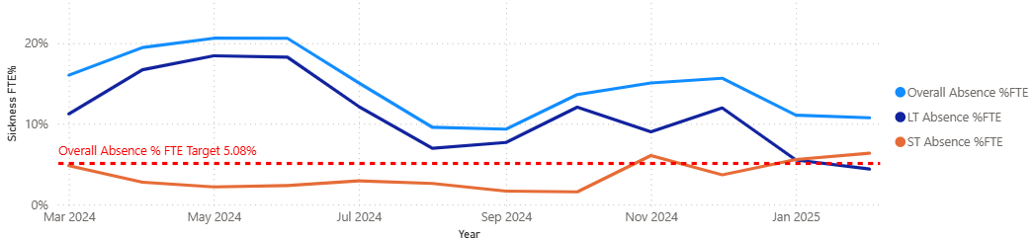
Sickness absence - Additional Clinical Services

Sickness absence - Registered Midwives
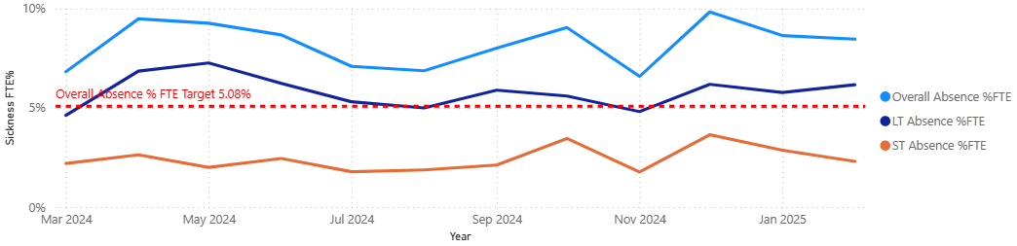

2.Sickness Absence Improvement Actions - Progress

Following the presentation of the previous report at the October 2024 Workforce and OD Committee meeting, the service has focused on developing the Sickness Management Improvement Plan so that the implementation phase can commence in February 2025. The service has continued to make progress with the additional actions that will support the implementation and impact of the Sickness Management Improvement plan. The progress against each of these actions is detailed below:

Ref | Improvement Action | Timescales | Improvement Measures | Responsible Person | Progress
1.0 | Develop Sickness Management Improvement Plan / Monitoring and Evaluation arrangements (on MatNeo Silver agenda 25/3/25) | 11/24 – 12/24  MatNeo Silver 25/3/25 | Workforce KPIs / Staff Feedback / Quality KPIs / Birthrate+ compliance | Head of Midwifery | On track
2.0 | Implementation of Sickness Management Improvement Plan / Monitoring and Evaluation (MatNeo Silver) | From 02/25 | Workforce KPIs / Staff Feedback / Quality KPIs / Birthrate+ compliance | Head of Midwifery | On track
3.0 | Weekly open staff sessions | Weekly | Workforce KPIs / Quality KPIs | Head of Midwifery | On track
4.0 | MatNeo Staff Feedback Newsletter (Quarterly) | Quarterly | Workforce KPIs / Quality KPIs | Clinical Director of Midwifery | On track
5.0 | Guardian Service Visits (planned by Guardian Service) | On going | Guardian Report | Head of Midwifery | On track
6.0 | Guardian Service Feedback | Monthly | Guardian Report | Clinical Director of Midwifery | On track
7.0 | RCM Caring for you Charter | On going | Workforce KPIs / Quality KPIs | Head of Midwifery | On Track
8.0 | Develop Staff Experience, Wellbeing and Retention Plan (to be approved by MatNeo Silver) | 03/25 | Workforce KPIs / Quality KPIs | Head of Midwifery | On Track, will monitor through Maternity Bronze Business Meeting
9.0 | Implementation of Staff Experience, Wellbeing and Retention Plan | 04/25 | Workforce KPIs / Quality KPIs | Head of Midwifery | On track
10.0 | Sickness Absence Summit Meetings | On going | Workforce KPIs / Birthrate+ compliance | Head of Midwifery | On track
11.0 | Sickness Absence Audit Recommendations - Immediate Action Plan (1.1-1.7) | 12/24  7/7 specific actions completed however service continues to monitor implementation. | Workforce KPIs / Quality KPIs | Head of Midwifery | On track
12.0 | Implementation of the Leadership Development Plan  MatNeo Gold approved the proposal 01/25 | 03/25 – 03/26 | Workforce KPIs / Staff Feedback / Quality KPIs | Associate Service Group Director – Children, Young People and Women’s Health | On track
13.0 | Follow up Sickness Management Audit and subsequent review of recommendations | 03/25 | Workforce KPIs / Birthrate+ compliance | Head of Midwifery / HR Business Partner Team | On track
14.0 | Formal 6-month review of the Sickness Management Improvement Plan  Review to go to MatNeo Gold | 08/25 – 09/25 | Workforce KPIs / Staff Feedback / Quality KPIs | Head of Midwifery / HR Business Partner Team | On track
15.0 | Sharing of Learning outcomes to benefit other services within the Health Board | 07/25 – 01/26 | Workforce KPIs / Staff Feedback / Quality KPIs | Head of Midwifery / HR Business Partner Team | On track

Members are asked to:
- ACKNOWLEDGE the progress the Service Group is taking to address the findings of the deep dive sickness exercise to improve the management or sickness absence and support employee wellbeing across Maternity Services.
- BE ASSURED progress against the action plan is on track.
- AGREE to an update being provided to the Workforce and OD Committee in October 2025.

Governance and Assurance

Link to Enabling Objectives  (please choose) | Supporting better health and wellbeing by actively promoting and empowering people to live well in resilient communities
Link to Enabling Objectives  (please choose) | Partnerships for Improving Health and Wellbeing |  | ☐
Link to Enabling Objectives  (please choose) | Co-Production and Health Literacy |  | ☐
Link to Enabling Objectives  (please choose) | Digitally Enabled Health and Wellbeing |  | ☐
Link to Enabling Objectives  (please choose) | Deliver better care through excellent health and care services achieving the outcomes that matter most to people
Link to Enabling Objectives  (please choose) | Best Value Outcomes and High Quality Care |  | ☐
Link to Enabling Objectives  (please choose) | Partnerships for Care |  | ☐
Link to Enabling Objectives  (please choose) | Excellent Staff |  | ☒
Link to Enabling Objectives  (please choose) | Digitally Enabled Care |  | ☐
Link to Enabling Objectives  (please choose) | Outstanding Research, Innovation, Education and Learning |  | ☐
Health and Care Standards
(please choose) | Staying Healthy |  | ☐
(please choose) | Safe Care |  | ☐
(please choose) | Effective Care |  | ☐
(please choose) | Dignified Care |  | ☐
(please choose) | Timely Care |  | ☐
(please choose) | Individual Care |  | ☐
(please choose) | Staff and Resources |  | ☒
Quality, Safety and Patient Experience
The improvement plan should contribute to improved employee availability and have a positive impact on staff health and wellbeing and ultimately quality, safety and patient experience.
Financial Implications
There are potential financial implications linked to absence.
Legal Implications (including equality and diversity assessment)
Staffing Implications
The improvement plan should contribute to improved employee availability and have a positive impact on staff health and wellbeing.
Long Term Implications (including the impact of the Well-being of Future Generations (Wales) Act 2015)
Report History |  | Previous report was presented at the October 2024 WOD Committee.
Appendices |  | N/A

